Leveraging Neural Networks for Real-time Anomaly Detection in Big Data Streams

Ricardo Moran
IT Faculty
CCT College
Dublin, Ireland
2022253@cct.student.ie

Abstract— The main goal of this research was to explore how neural networks can detect real time anomalies, within big data streams. The NSL-KDD dataset was used as a reference for the investigation. Various neural network structures were evaluated ranging from simple to complex, to see how well they could identify anomalies during real time operations. One notable achievement of this study is that it demonstrated the model’s performance when dealing with hardware limitations. This was made possible by using a simplified version of TensorFlow. The study also highlights the adaptability and flexibility of neural networks in computational settings. The findings emphasize the potential of neural networks in industries that heavily rely on real time data processing, such, as finance and cybersecurity. Overall, this research suggests a future where data irregularities can be accurately and quickly identified.
Keywords— Neural Networks, Anomaly Detection, Big Data Streams, Real-time Analysis, Data Streaming, Internet of Things (IoT), Deep Neural Networks (DNN), Data Integrity, Data Processing, Apache Spark, TensorFlow Lite, NSL-KDD Dataset, Intrusion Detection Systems (IDS), Model Training, Data Preprocessing, Machine Learning, Deep Learning

INTRODUCTION
In today’s age, where most of our interactions and transactions happen online the concept of data streaming has become extremely important. Data streaming refers to the transmission of data in an order usually based on time [1]-[3]. This flow of ordered data represents events or changes that provide insights, for businesses. Examples include activity logs from web browsers, sensor data and financial transaction records.
While data streaming can refer to any flow of data the term "data streaming" takes it up a notch. It highlights the high-speed nature of this process, where huge volumes of data are transmitted at rates [4]-[6]. This is in contrast to batch processing methods that handle datasets at fixed intervals. The dynamic nature of data streaming becomes apparent when considering the multitude of sources, like Internet of Things (IoT) devices that can simultaneously transmit amounts of data [7].
The importance of data streaming cannot be emphasized enough. With the rise of the Internet of Things (IoT) various devices, ranging from health monitors, to home security systems continuously transmit data [4], [6]. These streams, whether they contain statistics or real time motion tracking have transformed industries such as online shopping, website engagement and location-based services.
However, this flood of data presents a range of challenges [9]. Traditional data processing systems often struggle to keep pace with the speed and enormous volume of data streams. Ensuring data integrity performing real time analysis and managing storage become concerns [1], [4]. Additionally due to the nature of these data streams anomalies can occur, highlighting the need, for detection mechanisms [1], [2], [9].
Anomalies or unusual occurrences are easily noticeable when they deviate from what's considered normal. In the context of data streams an anomaly refers to any data point or a series of data points that significantly differ from the patterns observed in the data [11]. These anomalies could indicate phenomena ranging from issues, in data collection tools to instances of uncommon activity like fraudulent financial transactions or network traffic intrusions [12].
It is crucial to detect these anomalies in time. Failing to detect them or experiencing delays can result in losses, whether financial, reputational or operational. For example, in sectors such, as finance or cybersecurity timely identification of anomalies can prevent fraud or thwart potential cyberattacks [12]. In the realm of Internet of Things (IoT) where devices continuously transmit data recognizing anomalies can help enable maintenance and prevent system failures [13].
In the past when it came to detecting anomalies in streaming data distance-based density based and clustering algorithms were commonly used. While these algorithms had some success, they often faced difficulties when dealing with the amount of data and its dynamic nature. This resulted in delayed or inaccurate detections [11],[12]. However, with advancements in technology, intelligence deep neural networks (DNN) have emerged as a promising solution to overcome these challenges [13]. Unlike traditional methods, DNNs have the ability to automatically learn patterns and relationships within the data. This makes them well suited for identifying evolving anomalies in real time data streams.
This shift towards embracing DNNs for anomaly detection reflects a trend; the growing dependence on networks to address complex challenges that involve large amounts of data. Neural networks possess a capability to model patterns and offer a robust solution, for detecting anomalies in streaming data [14].
Neural networks, a branch of machine learning have gained recognition, for their capability to model and process intricate datasets. At their core neural networks are models inspired by the network of neurons in the human brain [15]. They consist of interconnected nodes or "neurons" that handle and transmit information. These networks possess the ability to learn and adjust enabling them to identify patterns within amounts of data. This makes them especially well-suited for tasks such as recognizing images and speech, natural language processing and notably detecting anomalies [16].
When it comes to anomaly detection neural networks excel for several reasons. Their deep architectures allow them to automatically extract features from data without requiring manual intervention. This is particularly advantageous when dealing with data like streaming data, where traditional methods might struggle due to its sheer volume and complexity [16]. Additionally neural networks can adapt to changing patterns in the data, making them resilient against evolving anomalies or threats [17].
One of the standout uses of networks, in anomaly detection is their fusion models. These models combine various types of neural network architectures, such as recurrent networks to improve the accuracy and effectiveness of detecting anomalies especially in areas like network security [15]. By leveraging the strengths of each architecture fusion models offer a precise approach to detecting anomalies.
This research paper aims to compare and evaluate network models for real time anomaly detection in big data streams. It also seeks to analyze the requirements for data storage, management and processing that are necessary for effective real time anomaly detection. Furthermore, this study will provide insights into selecting the neural network for specific problem sets and elaborate on the technological components that influence these networks performance in a big data environment. The primary research question addressed is; How do different neural network models perform when applied to real time anomaly detection, in data streams? Additionally, what are the crucial considerations regarding data storage, management and processing that impact their effectiveness?
To put it simply neural networks are, at the forefront when it comes to detecting anomalies in data streams. In this paper we will delve into how these neural networks are used for real time anomaly detection in data streams. We will explore the existing research, on neural networks, data streaming and how they intersect in the realm of anomaly detection.

Literature Review
In years anomaly detection has become increasingly popular as we see an influx of data being generated in various fields ranging from industrial systems, to social media platforms. As technology advances in the realm of data and Industry 4.0 the challenges and complexities associated with identifying anomalies have also evolved.

Traditional Machine Learning Approaches
Conventional techniques like clustering, decision trees and support vector machines have been widely used for anomaly detection [20],[22],[24]. For example in wireless sensor networks, machine learning techniques have played a key role in handling noisy and unreliable data [24]. While these methods are effective, they often struggle with the high dimensionality and real time requirements of modern data streams.

Deep Learning Innovations
The emergence of deep learning has brought about an era of new techniques for detecting anomalies [21],[22],[25]. Neural networks, including architectures like CNNs, RNNs, LSTMs and GANs have demonstrated their ability to handle patterns and large volumes of data [21],[23]. In particular there has been promising progress in using neural networks to detect anomalies in big data streams [19]. The integration of deep neural networks as presented in [25] shows a trend towards combining multiple neural network architectures to achieve better performance.

Ensemble and Hybrid Techniques
Hybrid systems that combine both machine learning and deep learning techniques have emerged as potential game changers in anomaly detection [26],[27]. These systems aim to leverage the strengths of models while mitigating their weaknesses. For example the research discussed in [26] introduced a system specifically designed for media platforms by combining multiple classifiers to effectively identify anomalies. Similarly ensemble techniques highlighted in [19] make use of detection models demonstrating the power of collective intelligence, in anomaly detection.

Challenges and Limitations
Despite the progress made there are still challenges that need to be addressed in the field of anomaly detection. One of these challenges is ensuring the reliability of real time anomaly detection, in complex industrial systems considering how interconnected and intricate these modern industrial processes can be [22]. Additionally social media platforms present their own set of challenges due to their vast and ever changing nature. It becomes particularly crucial to consider the trust that users place in the content shared on these platforms [27].

Future Directions
There are several works that hint at future directions, in anomaly detection. One idea is to incorporate practical case studies and benchmarking results as mentioned in references [21] and [23]. This approach could make the research more relatable and applicable. Additionally exploring the patterns of users and entities in data streams and understanding how anomalies take advantage of these behaviours could provide an understanding of real world challenges as highlighted by references [26] and [27].

Dataset Description
The NSL-KDD dataset is an enhanced version of the known KDD'99 dataset, specifically designed for intrusion detection systems (IDS). In today’s cybersecurity domain intrusion detection has become essential. Having a dataset like NSL-KDD helps researchers benchmark and compare various intrusion detection methodologies. Since modern IDS solutions heavily rely on data driven approaches like neural networks and machine learning techniques NSL-KDD serves as a resource, for experimental validation purposes.

Chatacteristics of the Dataset
NSL-KDD comprises various data files, each catering to different experimental setups:

- LIST OF NSL-KDD DATASET files and their description
Name of the file | Description
KDDTrain+.ARFF | The full NSL-KDD train set with binary labels in ARFF format
KDDTrain+.TXT | The full NSL-KDD train set including attack-type labels and difficulty level in CSV format
KDDTrain+_20Percent.ARFF | A 20% subset of the KDDTrain+.arff file
KDDTrain+_20Percent.TXT | A 20% subset of the KDDTrain+.txt file
KDDTest+.ARFF | The full NSL-KDD test set with binary labels in ARFF format
KDDTest+.TXT | The full NSL-KDD test set including attack-type labels and difficulty level in CSV format
KDDTest-21.ARFF | A subset of the KDDTest+.arff file which does not include records with difficulty level of 21 out of 21
KDDTest-21.TXT | A subset of the KDDTest+.txt file which does not include records with difficulty level of 21 out of 21

- Training Data: The full training set (KDDTrain+.TXT) includes attack-type labels and difficulty levels. A 20% subset of this full training set is also available (KDDTrain+_20Percent.TXT).
- Test Data: The complete test set (KDDTest+.TXT) encompasses attack-type labels and difficulty levels. A subset, KDDTest-21.TXT, omits records with the maximum difficulty level of 21 out of 21.
Each record in the dataset is representative of different network connections, characterized by various features like protocol type, service type, and flag status. The dataset also includes binary labels, distinguishing between normal and attack connections, as well as detailed attack-type labels.

Rationale for Choosing NSL-KDD

The selection of NSL-KDD for this study is motivated by several factors:

- Improvements Over KDD'99: NSL-KDD addresses some inherent issues of the KDD'99 dataset. Notably, it eliminates redundant records in the training set, ensuring that classifiers aren't biased towards more frequent records.
- No Duplicates in Test Set: The absence of duplicate records in the test sets ensures that evaluation results aren't skewed by methods which might perform better on frequently occurring records.
- Balanced Record Selection: The NSL-KDD dataset maintains a selection of records such that their distribution across difficulty levels is inversely proportional to their occurrence in the original KDD dataset. This ensures a broader and more balanced evaluation scope for various machine learning techniques.
- Reasonable Dataset Size: The dataset's size is manageable, allowing experiments to run on the entire set without necessitating random sub-sampling. This ensures consistency and comparability across different research works.

Significance in Anomaly Detection
Identify applicable funding agency here. If none, delete this text box.
The NSL-KDD dataset stands out for its ability to represent a variety of network intrusions, which makes it highly valuable, for detecting anomaly activities. This dataset not only distinguishes between normal and abnormal behaviours but also categorizes the specific type of attack allowing for a more nuanced assessment of detection methods.
Moreover upon analysing the KDD dataset it became evident that a majority of learning algorithms could accurately classify a large portion of the records. This suggests that while classifying a portion of the data might be relatively straightforward the real challenge, in anomaly detection lies in identifying those subtle and infrequent anomalies.

Methodology
This section will explain the step, by step approach took in this study to tackle the challenges of detecting anomalies in big data streams using neural networks in real time. Dealing with big data streams can be complex, so it’s crucial to have an comprehensive methodology that allows to accurately and promptly identify anomalies. This section will dive into various stages of the research process including understanding the datasets attributes, selecting and training of neural network models. Moreover will provide insights, into how real time simulations was achieved by using Apache Spark and how the performance was evaluated for this approach. The methodology is designed to be replicable so that other researchers can validate our findings and build upon them.

Understanding Attribute Type
Before diving into preprocessing, the dataset was analysed to discern the types of attributes it comprised. Such an understanding is essential since different attribute types demand distinct preprocessing techniques. For example, numerical attributes might require scaling, whereas categorical ones could benefit from encoding.
- Basic features of individual TCP connections
Attribute Name | Description | Attribute Type
duration | Length of time duration of the connection | Real number
protocol_type | Protocol used in the connection | Categorical
service | Destination network service used | Categorical
flag | Status of the connection – Normal or Error | Categorical
src_bytes | Number of data bytes transferred from source to destination in single connection | Real number
dst_bytes | Number of data bytes transferred from destination to source in single connection | Real number

- Content features within a connection suggested by domain knowledge
Attribute Name | Description | Attribute Type
land | if source and destination IP addresses and port numbers are equal then, this variable takes value 1 else 0 | Binary
wrong_fragment | Total number of wrong fragments in this connection | Real number
urgent | Number of urgent packets in this connection. Urgent packets are packets with the urgent bit activated | Real number
hot | Number of „hot‟ indicators in the content such as: entering a system directory, creating programs and executing programs | Real number
num_failed_logins | Count of failed login attempts | Real number
logged_in | Login Status : 1 if successfully logged in; 0 otherwise | Binary
num_compromised | Number of ``compromised' ' conditions | Real number
root_shell | 1 if root shell is obtained; 0 otherwise | Real number
su_attempted | 1 if ``su root'' command attempted or used; 0 otherwise | Real number
num_root | Number of ``root'' accesses or number of operations performed as a root in the connection | Real number
num_file_creations | Number of file creation operations in the connection | Real number
num_shells | Number of shell prompts | Real number
num_access_files | Number of operations on access control files | Real number
num_outbound_cmds | Number of outbound commands in an ftp session | Real number

- Traffic features computed using a two-second time window
Attribute Name | Description | Attribute Type
is_host_login | 1 if the login belongs to the ``hot'' list i.e., root or admin; else 0 | Binary
is_guest_login | 1 if the login is a ``guest'' login; 0 otherwise | Binary
count | Number of connections to the same destination host as the current connection in the past two seconds | Real number
srv_count | Number of connections to the same service (port number) as the current connection in the past two seconds | Real number
serror_rate | The percentage of connections that have activated the flag s0, s1, s2 or s3, among the connections aggregated in count | Real number
srv_serror_rate | The percentage of connections that have activated the flag s0, s1, s2 or s3, among the connections aggregated in srv_count | Real number
rerror_rate | The percentage of connections that have activated the flag REJ, among the connections aggregated in count | Real number
srv_rerror_rate | The percentage of connections that have activated the flag REJ, among the connections aggregated in srv_count | Real number
same_srv_rate | te The percentage of connections that were to the same service, among the connections aggregated in count | Real number
diff_srv_rate | The percentage of connections that were to different services, among the connections aggregated in count | Real number
srv_diff_host_rate | The percentage of connections that were to different destination machines among the connections aggregated in srv_count | Real number

- Traffic features computed with respect to the host
Attribute Name | Description | Attribute Type
dst_host_count | Number of connections having the same destination host IP address | Real number
dst_host_srv_count | Number of connections having the same port number | Real number
dst_host_same_srv_rate | The percentage of connections that were to the same service, among the connections aggregated in dst_host_count | Real number
dst_host_diff_srv_rate | The percentage of connections that were to different services, among the connections aggregated in dst_host_count | Real number
dst_host_same_src_port_rate | The percentage of connections that were to the same source port, among the connections aggregated in dst_host_srv_c ount | Real number
dst_host_srv_diff_host_rate | The percentage of connections that were to different destination machines, among the connections aggregated in dst_host_srv_count | Real number
dst_host_serror_rate | The percentage of connections that have activated the flag s0, s1, s2 or s3, among the connections aggregated in dst_host_count | Real number
dst_host_srv_serror_rate | The percent of connections that have activated the flag s0, s1, s2 or s3, among the connections aggregated in dst_host_srv_c ount | Real number
dst_host_rerror_rate | The percentage of connections that have activated the flag REJ, among the connections aggregated in dst_host_count | Real number
dst_host_srv_rerror_rate | The percentage of connections that have activated the flag REJ, among the connections aggregated in dst_host_srv_c ount | Real number

Data Preprocessing
Data preprocessing plays an important role, in machine learning as it ensures that raw data is transformed appropriately to be suitable for modelling. To maintain the integrity and consistency of the dataset the following tasks were executed.
- Merging Training and Testing Datasets: Discrepancies were found in some attributes between the training and testing datasets. These differences can pose challenges especially when using techniques like one-hot encoding. To address this the training and testing datasets were merged into a DataFrame. This ensured that all potential categories were considered during steps.
- Dataset Partitioning: After merging the dataset was divided into three subsets; training, validation and a set for simulating streaming scenarios. This partitioning provided datasets for model training, validation and simulating real world streaming scenarios.
- Scaling Numerical Attributes: Models involving distance computations or optimization algorithms can be sensitive, to the scale of attributes. To overcome this issue the MinMaxScaler from the scikit learn library was used. I fitted this scaler exclusively on the training data. Then used it to transform numerical attributes in the training, validation and streaming simulation datasets.

Model Selection and Training
In the pursuit of achieving optimal performance for binary classification on the dataset, various modelling techniques were employed. This section delves into the specifics of each model, from the establishment of a baseline to intricate neural network architectures.
Baseline Model:
Logistic Regression was used to establish a foundational performance metric. For binary classification, this model, despite its simplicity, achieved an accuracy of 0.9569.
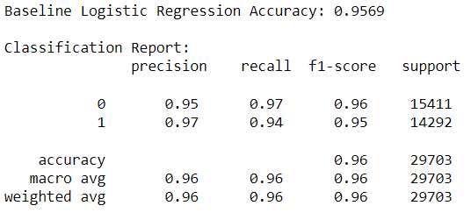
- Classification report for Baseline Logistic Regression
Dense Feedforward Architectures:

- Dense Feedforward Architecture (Model 1)

- Model Architecture: Comprised an input layer with 122 neurons (ReLU activation), two hidden layers with 64 and 32 neurons respectively (both with ReLU activation), followed by dropout layers to prevent overfitting. The output layer had a single neuron with a sigmoid activation function.
- Training Parameters: The model was trained using the Adam optimizer, binary cross-entropy loss, for 10 epochs with a batch size of 32.
- Performance: Achieved a validation accuracy of 98.70 %.
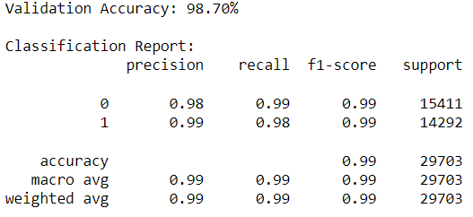
- Classification report for Neural Network Model 1
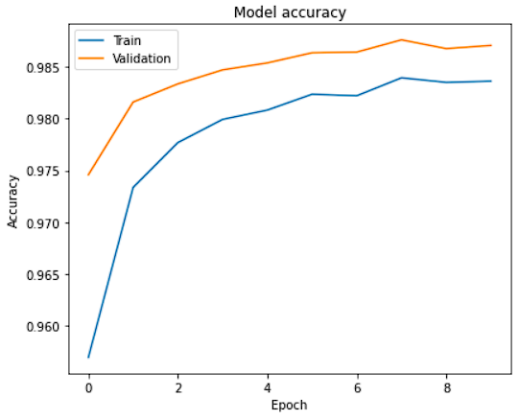
- Accuracy Graph for Model 1
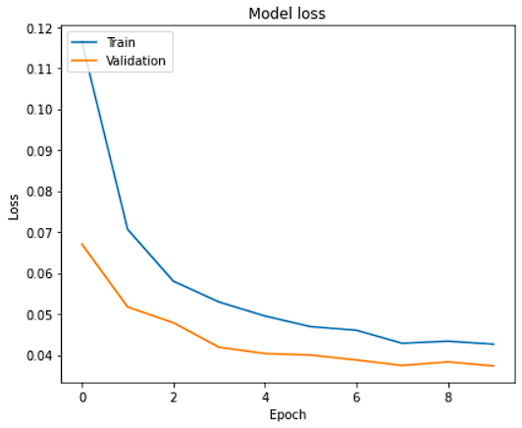
- Loss Graph for Model 1
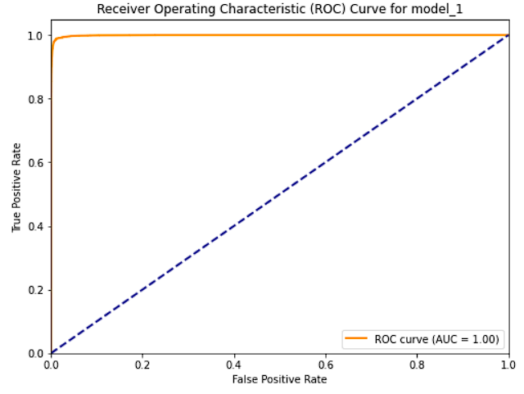
- ROC Curve for Model 1

- Simplified Dense Feedforward Architecture (Model 2)

- Model Architecture: Featured an input layer with 122 neurons (ReLU activation) and a single hidden layer with 64 neurons (ReLU activation). The output layer, as usual, had a single neuron with a sigmoid activation.
- Performance: The model produced a validation accuracy of 98.89 %.

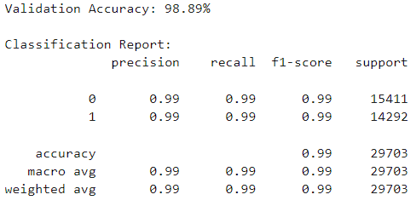
- Classification report for Neural Network Model 2
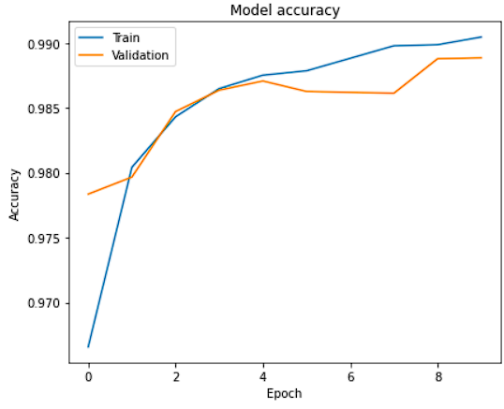
- Accuracy Graph for Model 2
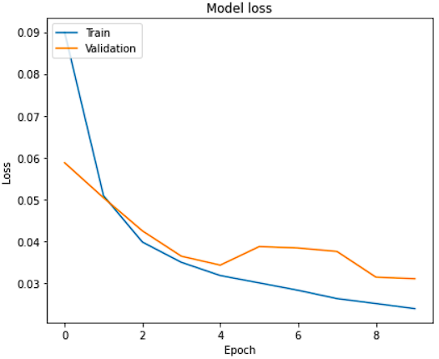
- Loss Graph for Model 2
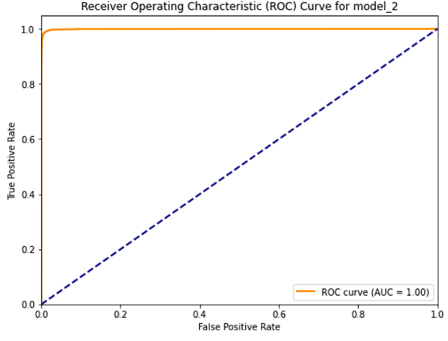
- ROC Curve for Model 2

- Dense Feedforward with Batch Normalization (Model 3)

- Model Architecture: This variant incorporated batch normalization layers and utilized the tanh activation function. It had two hidden layers with 64 and 32 neurons respectively, both with tanh activation, interspersed with batch normalization layers.
- Training Parameters: The RMSprop optimizer was chosen for training, along with binary cross-entropy loss. The model underwent training for 10 epochs with a batch size of 32.
- Performance: Recorded a validation accuracy of 98.70 %.
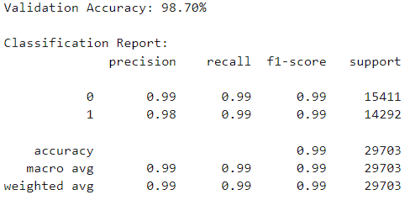
- Classification report for Neural Network Model 3
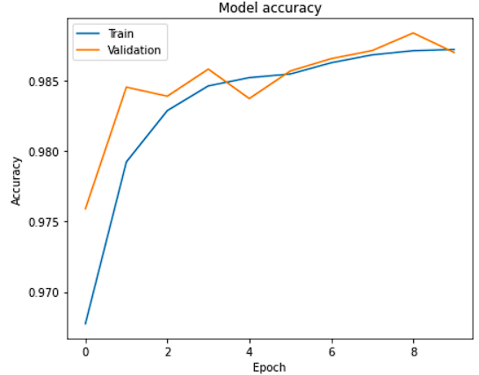
- Accuracy Graph for Model 3
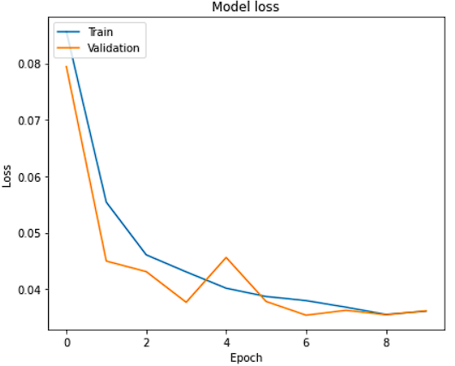
- Loss Graph for Model 3
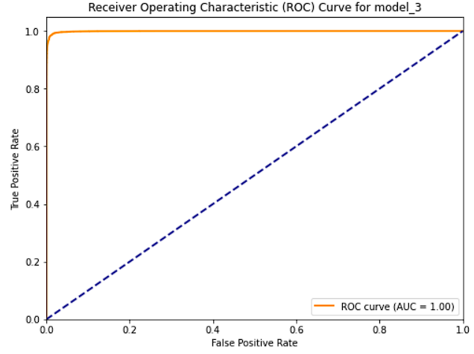
- ROC Curve for Model 3

- Enhanced Feedforward with LeakyReLU and Increased Complexity (Model 4)

- Model Architecture: This model was characterized by its depth and the use of the LeakyReLU activation function. It included three hidden layers with 256, 128, and 64 neurons respectively. Dropout layers with a rate of 0.5 were used after the first and second hidden layers to mitigate overfitting.
- Performance: The model showcased a validation accuracy of 98.76 %.
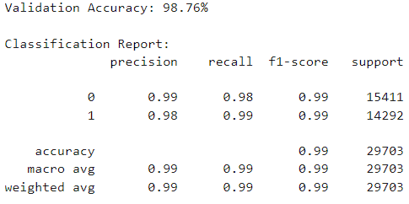
- Classification report for Neural Network Model 4
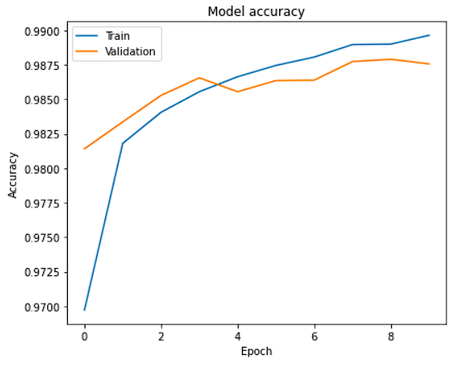
- Accuracy Graph for Model 4
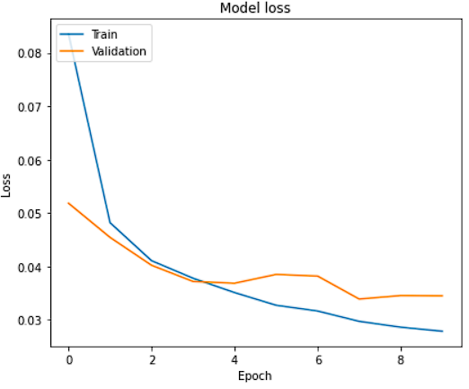
- Loss Graph for Model 4
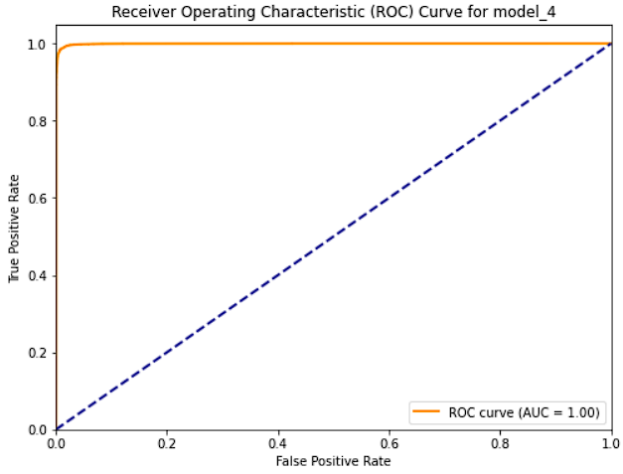
- ROC Curve for Model 4

For each model, the architecture details, training parameters, and performance metrics were meticulously recorded. By exploring these models, insights were gathered regarding the strengths and limitations of each approach, enriching the understanding of how different architectures and parameters affect performance.

Model Comparison and Selection
After training multiple models, it's essential to systematically compare their performances to select the most suitable one for the problem at hand. This section delves into the comparison metrics and the rationale behind the model selection.
- Performance Metrics:
The primary metric for comparison was accuracy, which provides a straightforward indication of a model's overall correctness. Additionally, the precision, recall, and F1-score for each class were considered, offering insights into the models' capabilities to correctly classify each class without bias.
- Model Performances:
- Logistic Regression (Baseline): Achieved an accuracy of 95.69%.
- Dense Feedforward (Model 1): Recorded a validation accuracy of 98.70%.
- Simplified Feedforward (Model 2): Demonstrated a validation accuracy of 98.89%, slightly better than its more complex counterpart.
- Batch Normalization Feedforward (Model 3): Matched the performance of Model 1 with a validation accuracy of 98.70%.
- Enhanced Feedforward with LeakyReLU (Model 4): Achieved a validation accuracy of 98.76%, bridging the gap between the traditional and simplified architectures.
- Selection Criteria:
While accuracy is certainly a factor it's not the only thing that matters. The simplicity of the model how long it takes to train and its ability to make predictions, on data without overfitting were also considered for the model selection. There were models that perform similarly but have high training times and levels of complexity which influenced the model selection decision.
- Final Model Selection:
When it comes to the selection, the Simplified Feedforward model (Model 2) was found to be particularly impressive. Despite being less complex than Model 1 it achieved the validation accuracy. Its simplicity suggests prediction times and better performance on unseen data.
In conclusion all of the models performed well but the Simplified Feedforward architecture (Model 2) stood out as a contender for evaluation and potential deployment due to its optimal balance, between performance and simplicity.

Real-time Anomaly Detection using Apache Spark
The objective of this section is to utilize Apache Spark for real time anomaly detection using trained models to gain immediate insights, from streaming data.
- Initializing Apache Spark
The setup was done on an Ubuntu distribution with Anaconda and Jupyter Notebook which made library management and Python compatibility seamless. The session was started using Spark with an application name, “AnomalyDetection” to keep track of the streaming tasks.
- Data Loading and Model Initialization
The streaming data was saved with the name “EncodedStreamingDataset.csv” and then loaded into a Spark DataFrame. Then converted it into a Pandas DataFrame for manipulation.
Regarding the model due to hardware limitations, on the virtual Ubuntu distribution there were some challenges with the format. To overcome these constraints and ensure a solution the TensorFlow Lite version was used, which's a more streamlined version of TensorFlow. This required converting the model format to .tflite. Once loaded the TensorFlow Lite model named “OptimizedNeuralNetwork.tflite” was loaded for real time predictions.
- Real-time Streaming Simulation
Two main functions, stream_data and handle_data, were created to simulate the streaming environment:
stream_data: Simulates the data stream by sending samples to a queue, with a slight delay imitating real world data streaming.
handle_data: Processes the data from the queue, performs operations on it and uses the TensorFlow Lite model to make predictions. The predicted results are then added to a list for evaluation.
By using two threads. One for producing (streaming) the data and another for consuming (handling) it. Were able to emulate a real time processing environment. The producer thread sent data samples to the queue while the consumer thread pulled from the queue processed the data and executed predictions.
- Performance Evaluation
Processed data was evaluated to calculate the model’s accuracy on the streaming data. It performed as expected at 98.9%. This result highlights how well the model can maintain its capabilities in real time scenarios providing immediate and reliable insights, into streaming data.
- Visualization
To gain an understanding of how the model predicts outcomes on streaming data a confusion matrix was created for a representation of its performance.
This visual depiction gave an understanding of the detections, True Positives, True Negatives, False Positives, and False Negatives made by the model when processing real time data.
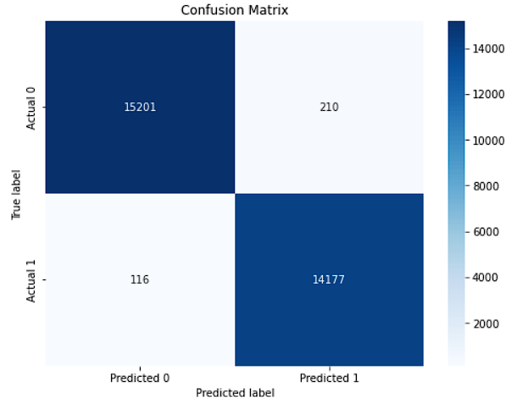
- Confusion matrix representation of the model's performance on streaming data

Critical Evaluation
The process of utilizing networks to detect anomalies in time big data streams as described in the previous sections provides a wealth of valuable insights, challenges and opportunities. This evaluation aims to shed light on the strengths, limitations and implications of the methodologies and findings presented.

Strengths of the Approach

- Thorough Analysis of the Dataset: The meticulous examination of the NSL-KDD dataset ensured an understanding of its characteristics and intricacies. This foundational knowledge played a role in customizing the neural network models to suit the specific attributes of the dataset.
- Exploration of Various Models: The research did not confine itself to a neural network structure. By evaluating models ranging from feedforward networks to more complex architectures with batch normalization and LeakyReLU activations the study conducted an extensive exploration of potential solutions.
- Real-time Simulation: The utilization of Apache Spark for simulating real time anomaly detection is praiseworthy. This approach does not only test the model performance, under controlled conditions. Also replicated real world scenarios thereby enhancing the practical relevance of this study.

Limitations and Challenges

- Dataset Constraints: While the NSL-KDD dataset is an improvement over its predecessor, it still has inherent limitations. The dataset's age and the potential lack of representation of modern network intrusions might affect the model's efficacy in contemporary scenarios.
- Model Complexity: Some of the neural network architectures, though high-performing, are complex. In real-world applications, the computational cost of such models might be a concern, especially when rapid anomaly detection is crucial.
- Generalization Concerns: The models were trained and validated on a specific dataset. Their ability to generalize to other datasets or more diverse data streams remains an area for further exploration.

Implications and Future Directions

- Industry Application: The research's findings have significant implications for industries reliant on real-time data streams, such as finance, cybersecurity, and IoT. Implementing such neural network models can revolutionize their anomaly detection mechanisms.
- Model Optimization: Future research can delve into optimizing the neural network architectures further, making them more computationally efficient without compromising on accuracy.
- Exploration of Other Datasets: To enhance the models' robustness and generalization capabilities, training and validation on diverse datasets, representing various types of data streams, would be beneficial.

Conclusion
This investigation together with the technical simulation of the use of neural networks for anomalies detection in big data streams has been an amazing journey. During the “Dataset Description” section the intricacies of the NSL-KDD dataset were presented which helps to understand how complex anomalies can be, then at the “Real-time Anomaly Detection using Apache Spark” section it was demonstrated how to simulate the streaming data and how to further analyse this data streams on real time which revealed critical insights.
One of the most notable achievements of this investigation was the demonstration of how consistent and resilient a trained neural network model can be despite the hardware limitations. It was demonstrated how the trained model remained effective during the real time implementation. Additionally, this research showcased the adaptability and versatility of neural networks models to less than optimal hardware setups, thanks to optimized version like TensorFlow lite which are able to maintain the accuracy of the model while optimizing the operations.
Furthermore, this investigation has clearly shown the practicality of leveraging neural networks for anomaly detection. As presented on this document, different structures were evaluated raging from simple to advanced ones and the outcomes were optimal in all of them which speaks volumes about their potential for real world applications.
Finally, this investigation has also shed light on the implications of these technologies. There are several industries that now rely on up to the minute data, such as finance and cybersecurity which can now benefit from these technologies. It was demonstrated that the chance to develop advanced anomaly detection methos with high accuracy, speed and efficiency is not within our grasp.
In conclusion this research does not only confirms the potential of deep neural networks for real time detection of anomalies in big data streams, it also opens the doors for future investigations. Despite some challenges were faced during this project the results have been truly satisfying. Now, with technology constantly progressing, new methodologies are emerging and with them new opportunities for anomaly detection in big data streams. This promises a future where data anomalies will be identified and resolved with precision and speed.

References
- Cloud Software Group, Inc. (n.d.). What is Data Streaming? [online] TIBCO Software. Available at: https://www.tibco.com/reference-center/what-is-data-streaming [Accessed 7 Sep. 2023].
- Snowflake Inc. (n.d.). Data Streams. [online] Snowflake. Available at: https://www.snowflake.com/guides/data-streams [Accessed 7 Sep. 2023].
- Roddewig, S. (2023). Data Stream: Use Cases, Benefits, & Examples. [online] blog.hubspot.com. Available at: https://blog.hubspot.com/website/data-stream [Accessed 7 Sep. 2023].
- Amazon Web Services, Inc. (n.d.). What Is Streaming Data? | Amazon Web Services (AWS). [online] Amazon Web Services, Inc. Available at: https://aws.amazon.com/streaming-data/ [Accessed 7 Sep. 2023].
- Rouse, M. (2017). Big Data Streaming. [online] Techopedia.com. Available at: https://www.techopedia.com/definition/31752/big-data-streaming [Accessed 7 Sep. 2023].
- G. Psaltis, A. (2017). Streaming Data.pdf - Free Download PDF. [online] kupdf.net. Available at: https://kupdf.net/download/streaming-datapdf_5a34f5ace2b6f50c243c669f_pdf [Accessed 7 Sep. 2023].
- DoubleCloud (2023). Introduction to Data Streaming: What It Is, and Why Is It Important? [online] double.cloud. Available at: https://double.cloud/blog/posts/2023/05/what-is-data-stream/ [Accessed 7 Sep. 2023].
- Confluent, Inc. (n.d.). What is Streaming Data? How Real-Time Data Streams Work. [online] Confluent. Available at: https://www.confluent.io/learn/data-streaming/ [Accessed 7 Sep. 2023].
- Baig, A. (2023). 10 Data Streaming Challenges Enterprises Face. [online] DATAVERSITY. Available at: https://www.dataversity.net/10-data-streaming-challenges-enterprises-face-today/#:~:text=The%20main%20challenge%20when%20dealing [Accessed 7 Sep. 2023].
- Oswill, D. (n.d.). 5 Challenges to Deploying Real-Time Data Streaming Platforms | IEEE Computer Society. [online] IEEE COMPUTER SOCIETY. Available at: https://www.computer.org/publications/tech-news/trends/5-challenges-to-deploying-real-time-data-streaming-platforms [Accessed 7 Sep. 2023].
- Moso, J.C., Cormier, S., de Runz, C., Fouchal, H. and Wandeto, J.M. (2023). Streaming-Based Anomaly Detection in ITS Messages. Applied Sciences, 13(12), p.7313. doi:https://doi.org/10.3390/app13127313.
- Lu, T., Wang, L. and Zhao, X. (2023). Review of Anomaly Detection Algorithms for Data Streams. Applied Sciences, 13(10), p.6353. doi:https://doi.org/10.3390/app13106353.
- Iglesias Vázquez, F., Hartl, A., Zseby, T. and Zimek, A. (2023). Anomaly detection in streaming data: A comparison and evaluation study. Expert Systems with Applications, 233, p.120994. doi:https://doi.org/10.1016/j.eswa.2023.120994.
- Munir, M., Chattha, M., Dengel, A. and Ahmed, S. (n.d.). A Comparative Analysis of Traditional and Deep Learning-based Anomaly Detection Methods for Streaming Data.
- AlDahoul, N., Abdul Karim, H. and Ba Wazir, A.S. (2021). Model fusion of deep neural networks for anomaly detection. Journal of Big Data, 8(1). doi:https://doi.org/10.1186/s40537-021-00496-w.
- Albuquerque Filho, J.E.D., Brandao, L.C.P., Fernandes, B.J.T. and Maciel, A.M.A. (2022). A Review of Neural Networks for Anomaly Detection. IEEE Access, 10, pp.112342–112367. doi:https://doi.org/10.1109/access.2022.3216007.
- AWS (n.d.). What is a Neural Network? AI and ML Guide - AWS. [online] Amazon Web Services, Inc. Available at: https://aws.amazon.com/what-is/neural-network/ [Accessed 11 Sep. 2023].
- IBM (n.d.). What are Neural Networks? [online] www.ibm.com. Available at: https://www.ibm.com/topics/neural-networks [Accessed 11 Sep. 2023].
- Moso , J., Cormier , S., de Runz , C., Fouchal , H. and Mwangi , J. (n.d.). Streaming-Based Anomaly Detection in ITS Messages. Article.
- Lu, T., Wang , L. and Zhao, X. (n.d.). Review of Anomaly Detection Algorithms for Data Streams. Article.
- Iglesias , F., Hartl , A., Zseby , T. and Zimek , A. (n.d.). Anomaly detection in streaming data: A comparison and evaluation study. Article.
- Munir, M., Ali , M., Dengel, A. and Ahmed, S. (n.d.). A Comparative Analysis of Traditional and Deep Learning-based Anomaly Detection Methods for Streaming Data. Article.
- DE ALBUQUERQUE , J., BRANDÃO, L. and MACIEL, A. (n.d.). A Review of Neural Networks for Anomaly Detection. Article.
- Haque, A., Chowdhury, M.N.-U.-R., Soliman, H., Sahinur , M., Fatima, T. and Ahmed, I. (n.d.). Wireless Sensor Networks anomaly detection using Machine Learning: A Survey. Article.
- AlDahoul, N., Abdul , H. and Saleh , A. (2021). Model fusion of deep neural networks for anomaly detection. Article.
- VELÁSQUEZ , D., PÉREZ, E., OREGUI, X., ARTETXE , A., MANTECA, J., ESCAYOLA , J., TORO, M., MAIZA, M. and SIERRA , B. (2022). A Hybrid Machine-Learning Ensemble for Anomaly Detection in Real-Time Industry 4.0 Systems. Article.
- Rahman, Md.S., Halder, S., Uddin, Md.A. and Kumar , U. (2021). An efficient hybrid system for anomaly detection in social networks. Article.
- Hiranya, L. (2020). Most Important things of ‘NSL-KDD’ data set. [online] Medium. Available at: https://medium.datadriveninvestor.com/did-you-know-the-famous-data-set-called-nsl-kdd-293b39420c74#:~:text=This%20data%20set%20is%20an [Accessed 30 Sep. 2023].
- Ingre , B. and Yadav , A. (2015). Performance Analysis of NSL-KDD dataset using ANN. [Article] Available at: https://www.researchgate.net/publication/309698316_Performance_analysis_of_NSL-KDD_dataset_using_ANN [Accessed 3 Oct. 2023].
- L.Dhanaba and Shantharajah, Dr.S.P. (2015). A Study on NSL-KDD Dataset for Intrusion Detection System Based on Classification Algorithms. [Article] Available at: https://e-tarjome.com/storage/btn_uploaded/2019-07-13/1563006133_9702-etarjome-English.pdf [Accessed 31 Sep. 2023].

