


AIA 2023

Artificial Intelligence in Astronomy

UNESP-Campus of Guaratinguetá

08/25/2023

Program 2023

Schedule | Activity | Speaker
8:45-9:00 hours | Opening talk | Dr. Valerio Carruba (Unesp)
9:00-10:00 hours | Intelligence in remote sensing image analysis | Dr. Thales Korting (INPE)
10:00-10:15 hours | The connection of continuum emission and emission lines in galaxy spectra | Dr. Laerte Sodré (IAG-USP)
10:15-10:30 hours | Photometric Synthesis of Stellar Populations with Deep Learning | Mr.Vitor Cernic (IAG-USP)
10:30-11:00 hours | Poster session + Coffee break
11:00-12:00 hours | NVIDIA Platform for AI and Astronomy Applications (remote talk) | Dr. Pedro Mário Cruz e Silva (NVIDIA)
12:00-12:45 hours | Lunch break
12:45:13:00 hours | Employing GPU and MPS for Enhanced Integration of Celestial Body Orbits  (remote talk) | Dr. Evgeny Smirnov (Independent researcher, Spain, Belgrade Astronomical Observatory)
13:00-13:15 hours | Machine Learning-based Image Classification for Identifying Retrograde Resonances in Binary Star Systems  (remote talk) | Msc. Gabriel Caritá (INPE)
13:15-13:30 hours | An Optimized Training Approach for Meteor Detection with an Attention Mechanism to Improve Robustness on Limited Data | Mr. Victor Yukio Shirasuna (UNICAMP)
13:30-13:45 hours | Time Series Prediction for Orbit Classification and Drag Approximation | Dr. Safwan Aljbaae (INPE)
13:45-14:00 hours | Deep learning classification of asteroids in g-type secular resonances | Dr. Valerio Carruba (UNESP)
14:00-15:00 hours | Computing the Universe with Wolfram Language | Dr. Daniel Carvalho (WOLFRAM)
15:00-16:00 hours | Workshop on IA and ML with the software Mathematica | Dr. Daniel Carvalho (WOLFRAM)
16:00-16:15 hours | Closing remarks

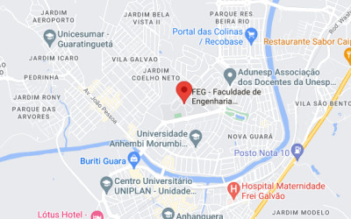
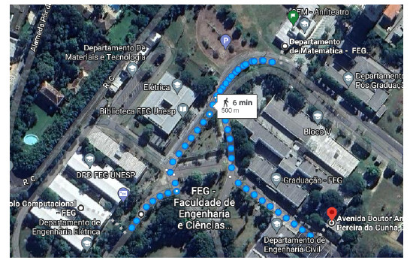

Distance to the location of the Mathematica workshop: 5 minutes
Distance to the restaurant: 6 minutes

Useful Links
AIA 2023: https://aiafeg2023.github.io/AIA.2023/
GDOP research group website: https://www.dinamicaorbital.org/
MASB research group website: https://valeriocarruba.github.io/Site-MASB/

Organization
Scientific Committee
Valerio Carruba (UNESP)
André Leon Sampaio Gradvohl (UNICAMP)
Annibal Hetem (UFABC)
Laerte Sodré (IAG/SPAnet)
Luiz Antonio Celiberto Junior (UFABC)
Rafael Santos (INPE)
Roberto Bertoldo Menezes (IMT)
Rodrigo Nemmen (IAG)

Local Committe
Valerio Carruba (UNESP)
Othon C. Winter (UNESP)
Daniela C. Mourão (UNESP)
Ernesto Vieira-Neto (UNESP)
Safwan Aljbaae (INPE)
Rita de Cássia Domingos (UNESP)
Abreuçon A. Alves (UNESP)
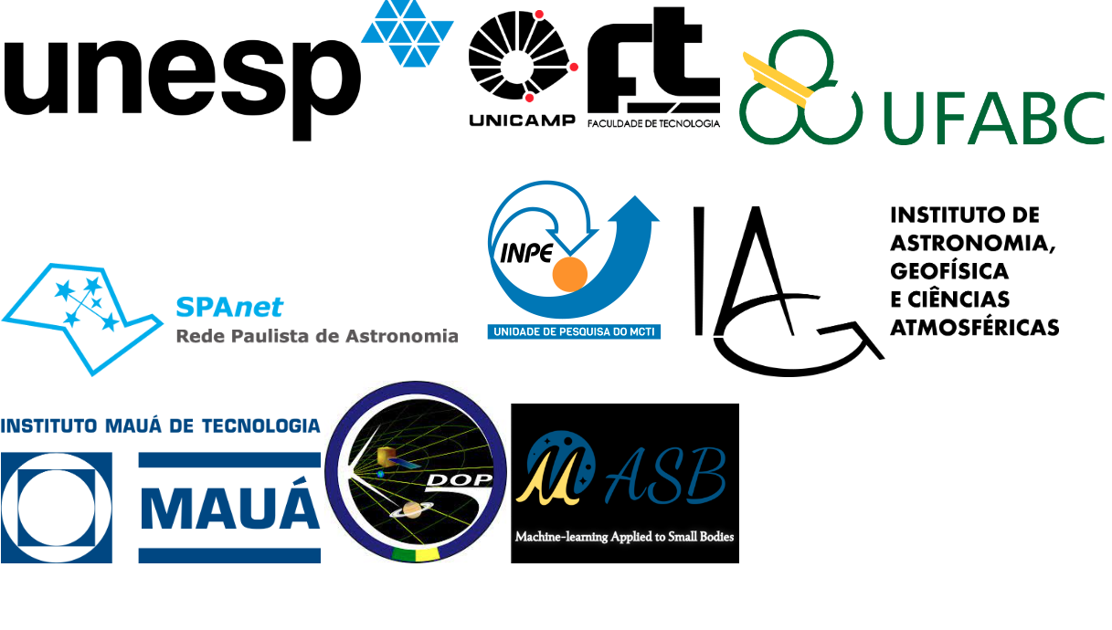
Abstracts: Oral Contributions

Intelligence in remote sensing image analysis
Dr. Thales Korting (INPE)

The possibilities of artificial intelligence grow rapidly. Accompanying this evolution is a great challenge for researchers. Image processing techniques can benefit from advances in pattern recognition, especially in the area of neural networks. Some deep learning methods, from convolutional networks to recent segmentation models, stand out in citations due to good results, even though they have not gone through the scientific rigor of peer analysis. On the other hand, certain image analyzes can have promising results only with the use of simpler techniques, starting from simple thresholds on the available data. The purpose of this presentation is to provide an overview of selected techniques for remote sensing image analysis, and the balance between artificial and natural intelligence needed to advance image interpretation.

The connection of continuum emission and emission lines in galaxy spectra
Dr. Laerte Sodré (IAG-USP)

We present a machine learning procedure to investigate the connection between emission lines and the spectral continuum in galaxy spectra which is agnostic with respect to the source of line excitation, star-formation or nuclear activity. We know a priori that there is some connection between a galaxy continuum and its emission lines pattern. We explore this connection with a deep learning model by establishing a mapping between the galaxy continuum and the emission line equivalent widths for the sample discussed by Werle et al. (2019) of SDSS galaxies with GALEX photometry. We show that we are able to estimate equivalent widths with good accuracy and, moreover, we are able to partially reproduce the BPT diagram. This suggests that the ionization source responsible for the emission lines somewhat let an imprint in the galaxy continuum.

Photometric Synthesis of Stellar Populations with Deep Learning
Mr. Vitor Cernic (IAG-USP)

Using machine learning techniques, we were able to obtain parameters of stellar populations from galaxy photometry. Based on data from the S-PLUS photometric survey, we compared several regression models including Random Forest, XGBoost and Neural Networks, to understand which one could best estimate the parameters of stellar populations. We used data analysis techniques to create a robust training set close to reality, considering missing data and several calibrations. We obtained a very well-trained neural network that was able to estimate 9 parameters of stellar populations with a low error (0.09 dex for stellar mass). During the next months we will apply this model to different surveys, such as S-PLUS and CHANCES, to obtain parameters of galaxies never discovered before.

NVIDIA Platform for AI and Astronomy Applications
Dr. Pedro Mário Cruz e Silva (NVIDIA)

The NVIDIA AI platform has become an indispensable tool for astronomers in recent years, allowing them to tackle complex problems that were previously impossible to solve. In this talk, we'll explore the many ways the NVIDIA AI platform is being used in astronomy, from galaxy formation simulations to exoplanet detection and beyond. We'll discuss the advantages of using GPUs for AI and HPC applications in astronomy and provide examples of how NVIDIA technology is being used to accelerate data analysis and manage large volumes of astronomical data. We'll also highlight some of the key challenges and limitations of using AI in astronomy, and discuss future directions for research in this exciting field. Overall, this talk will provide a comprehensive look at NVIDIA's platform for AI and its applications in astronomy and demonstrate how this technology is transforming our understanding of the universe.

Employing GPU and MPS for Enhanced Integration of Celestial Body OrbitsDr. Evgeny Smirnov (Belgrade Astronomical Observatory, Independent Researcher, Spain)

The proliferation of machine-learning techniques has led to a significant increase in the development of software optimised for GPU usage. Conventionally, astronomers carry out computations on CPU or clusters of computers. Nonetheless, the utilisation of GPU along with MPS can markedly enhance the efficiency of these computations. To illustrate, the widely-used library, Rebound, which many researchers employ for orbit integration, operates solely on CPU. The findings presented in this study showcase the noticeable improvement in computation time and resource usage when GPU is harnessed.

Machine Learning-based Image Classification for Identifying Retrograde Resonances in Binary Star Systems
MSC Gabriel Caritá (INPE)

Understanding resonances in celestial mechanics is essential for comprehending the dynamics of planetary or stellar systems. This study focuses on the development of an image classification model for the classification and identification of retrograde resonant configurations in binary star systems within the planar circular restricted three-body problem (PCR3BP). During the training process, a comprehensive dataset is created, which includes both empirical and non-empirical resonant configurations for a range of mass ratios. This dataset serves as the foundation for training the image classification model. The model is trained to recognize and learn the distinguishing features and patterns that are characteristic of retrograde resonances. Through iterative training iterations, the model fine-tunes its parameters to improve its ability to accurately classify various types of retrograde resonances, including second- and third-order resonances, as well as the circular orbit region. Our developed image classification model proves to be highly valuable in the analysis of Poincaré sections, showcasing its proficiency in accurately distinguishing between various resonant patterns based on the provided information.

An Optimized Training Approach for Meteor Detection with an Attention Mechanism to Improve Robustness on Limited Data
Mr. Victor Yukio Shirasuna (UNICAMP)

Convolutional neural networks have been extensively adopted for meteor detection. However, when dealing with limited available data, these networks may show a lack of robustness when correctly classifying new real-world images. This study proposes an optimized training approach of a pre-trained model with an attention mechanism to achieve better generalization results in such a scenario. We compare two architectures, an optimized base model and another version with an attention mechanism. Furthermore, we present a new and publicly available optical meteor dataset that merges several public data sources. We used the merged dataset to train classification models combined with a stratified five-fold cross-validation strategy to determine the reliability of the prediction. The experimental results from both architectures showed good and similar performance. To further determine the best architecture, we performed an additional analysis with visual explanations in new observations. The architecture with an attention mechanism was the best model achieving a false alarm ratio of 0.026 and an accuracy of 0.97.

Time Series Prediction for Orbit Classification and Drag Approximation
Dr. Safwan Aljbaae (INPE)

Time series prediction is a well-studied problem with numerous applications in various domains. With the advent of neural networks and frameworks like TensorFlow, it has become possible to generate highly performant machine learning models. In this work, we apply a time series prediction approach using Neural Networks implemented in Python with Keras and TensorFlow to classify orbits near the Near-Earth asteroid Apophis, taking into account the effects of changes in its spin state caused by terrestrial torques during close encounters with our planet. Our method is based on establishing a relationship between the difficulty of prediction and orbital stability. This enables us to isolate the most regular orbits and classify them accordingly. We find a strong correlation between the Time-Series prediction approach and established methods such as the Mean Exponential Growth factor of Nearby Orbits (MEGNO) or the classical Perturbation Map.

Additionally, we introduce a Machine Learning approach that utilizes a time series forecasting model to predict daily variations in solar activity and planetary amplitude. This represents an initial step towards a more comprehensive dynamical study aimed at reducing uncertainty in drag estimation due to atmospheric density estimation. We explore both a simple naive method and a Convolutional Neural Network (CNN) to evaluate their performance in this context. To ensure accurate forecasts at each time step, we employ the walk-forward validation method. This approach trains the model as new data becomes available, allowing us to make the best possible predictions. We evaluate the performance of our models using appropriate evaluation metrics and analyze the results in comparison with established methods.

The outcomes of our study demonstrate the efficacy of the Neural Networks-based time series prediction approach in classifying orbits near Apophis and its correlation with MEGNO and Perturbation Map methods. Moreover, the machine learning approach shows promise in predicting daily variations in solar activity and planetary amplitude, contributing to the broader understanding of the asteroid’s dynamics.

Deep learning classification of asteroids in g-type secular resonances
Dr. Valerio Carruba (UNESP)

Linear secular resonances happen when there is a commensurability between the precession frequency of the pericenter, g, or longitude of the node, s, of an asteroid and a planet. Non-linear resonances are higher-order combinations of these frequencies. Here, we studied the three most diffusive g-type non-linear secular resonances using Artificial Neural Networks. We identified a population of more than 2100 resonant objects in the g-2g₆+g₅ and g-3g₆+2g₅ resonances. This allows the creation of a Convolutional Neural Network model for the g-2g₆+g₅ resonance, able to predict the status of several thousands of asteroids in seconds. We identified 12 new possible dynamical groups among the resonant population, including the 5507 and 170776 families, which have both estimated ages of less than 7 My. These are the two first-ever identified young families in resonant configurations of the investigated resonances, which allows setting limits on their original ejection velocity field.

Computying the Universe with Wolfram Language
Dr. Daniel Carvalho (WOLFRAM)

Workshop topics:

- WolframLanguage
- Functional programming
- Notebook exploratory computing environment
- Rating
- Regression
- Cluster
- Neural Networks
- Image processing
- Cloud computing
- Interactive interface

Abstracts: Poster Contributions

Narrow-band photometric redshifts and its application to galaxy clusters
Dr. Erik Vinicius Rodrigues de Lima (IAG-USP)

The distance to celestial objects is of fundamental importance for several different kinds of study in astronomy, from the characterization of galaxies in groups to identifying the environments in the Large-Scale Structure. This distance is related to a measurable quantity, the redshift, via the Hubble-Lemaitre Law. A fast and cost effective way of obtaining this information is via photometric surveys, which can probe millions of objects at a fraction of the time needed for a spectroscopic survey to do the same. In this poster we will present our recent results related to machine-learning photometric redshifts obtained using a Bayesian Mixture Density Network, able to provide accurate single-point estimates and well-calibrated probability distribution functions (PDFs), with the photometry from the Southern Photometric Local Universe Survey (S-PLUS). We also show an application of this method to the identification of low- and mid-range redshift (from 0.1 to 0.7) clusters using photometry only, and discuss future prospects and potential applications of this method to objects in other redshift ranges.

Imbalanced classification applied to asteroid resonant dynamics
Dr. Valerio Carruba (UNESP)

Machine learning (ML) applications for studying asteroid resonant dynamics are a relatively new field of study. Results from several different approaches are currently available for asteroids interacting with the z₂ , z₁, M1:2, and ν₆ resonances. However, one challenge when using ML to the databases produced by these studies is that there is often a severe imbalance ratio between the number of asteroids in librating orbits and the rest of the asteroidal population. This imbalance ratio can be as high as 1:270, which can impact the performance of classical ML algorithms, that were not designed for such severe imbalances. Various techniques have been recently developed to address this problem, including cost-sensitive strategies, methods that oversample the minority class, undersample the majority one, or combinations of both. Here, we investigate the most effective approached for improving the performance of ML algorithms for known resonant asteroidal databases. Cost-sensitive methods were found to either improve or not affect the outcome of ML methods and should always be used, when possible. The methods that showed the best performance for the studied databases were SMOTE oversampling plus Tomek undersampling, SMOTE oversampling, and Random oversampling and undersampling. Testing these methods first could save significant time and efforts for future studies with imbalanced asteroidal databases.

Application of Machine Learning to determine the nature of exo-ring stability
MSC. Giovana Ramon Luiz Neto (UNESP)

The star J1407 (1SWASP J140747.93-39454.6) displayed a complex series of eclipses lasting 56 days. The hypotheses given to this event was the passage of the edge of a planetary disk or a circumstellar disk of a brown dwarf. In this work, the nature of a possible ring system around an unobserved gigantic exoplanet, which would have hidden this star, was analyzed. To study the J1407b system, due to the large number of variables involved, still unknown in this problem, such as, for example, mass and eccentricity of the planet, inclination and extension of the disk, several numerical models were created considering the gravitational interaction between the star, the planet and the ring particle. In order to optimize the classification of stable systems that explain the eclipse, Machine Learning methods were applied, such as the Random Forest, to analyze the databases obtained through numerical simulations. In this way, it was possible to refine the ranges of predetermined parameters through observational data.
Investigation of natural radiation at Meaípe beach (ES) using a neural network.
Dr. Miriam Mathias Gigi (IAG -USP).

Meaipe beach, located in Espírito Santo, is considered a region with high levels of low-dose natural radiation. The radioactivity at this site comes from monazite sands rich in thorium (232 Th). Even though the beach is known as a therapeutic resort, studies on this region show disagreement about the effects of radon (220 Rn) on health. Care must be taken because the intensity of gamma radiation presents space-time variability over Meaípe beach, in which specific values cannot be generalized to the whole beach. With this, the main objective of this study is to understand and map the temporal and vertical variation of the intensity of gamma radiation on the beach of Meaípe with the aid of an artificial neural network. It is also intended to establish a possible statistical relationship between the intensity of gamma radiation and meteorological variables measured in the field.

Characterization of planetary interiors using machine learning
Dr. Yeva Gevorgyan de Mendonça (IME/USP)

We propose to use machine learning techniques (supervised learning) to characterize the interior structures of moons and planets. Neural networks are an optimal choice to approach the interior characterization of moons and planets, since they can approximate any arbitrary nonlinear relations between some input and output values. The idea is to create a large training data set of (10⁶-10⁷) synthetic planets with interiors composed of rigid and liquid cores, different mantle and crustal structures by randomly varying the size, the density and the stratification of each layer but preserving the total mass. The models used to construct the planets as training data should allow immediate computation of radial profiles of density and pressure. Possible set of equations is: the condition of hydrostatic equilibrium; the equation for the mass of an infinitesimal spherical shell; state equation that should be specified for each layer depending on the layer material behaviour. For each planet we can calculate the fluid Love number k₂ using the propagator matrix approach (k₂ here stands for the 2nd-degree fluid Love number, which is defined as a Love number for a planet in hydrostatic equilibrium that responds as a fluid). The profiles together with the body mass, radius and k₂ can then be used to train a neural network. The trained neural networks will be used to infer plausible layered structures for the body from observables like radius, mass and fluid tidal Love number. It will first be tested on bodies of our Solar System to see how well it predicts the observational data. The neural network approach can then be used to predict the interior structure of distant moons and planets employing the available observables.

Optimization of artificial neural networks models applied to the identification of images of asteroids' resonant arguments
Rita C. Domingos (Unesp)

The asteroidal main belt is crossed by a web of mean motion and secular resonances that occur when there is a commensurability between fundamental frequencies of the asteroids and planets. Traditionally, these objects were identified by visual inspection of the time evolution of their resonant argument, which is a combination of orbital elements of the asteroid and the perturbing planet(s). Since the population of asteroids affected by these resonances is, in some cases, of the order of several thousand, this has become a taxing task for a human observer. Recent works used convolutional neural network (CNN) models to perform such task automatically. In this work, we compare the outcome of such models with those of some of the most advanced and publicly available CNN architectures, like the VGG, Inception, and ResNet. The performance of such models is first tested and optimized for overfitting issues, using validation sets and a series of regularization techniques like data augmentation, dropout, and batch normalization. The three best-performing models were then used to predict the labels of larger testing databases containing thousands of images. The VGG model, with and without regularizations, proved to be the most efficient method to predict labels of large datasets. Since the Vera C. Rubin observatory is likely to discover up to four million new asteroids in the next few years, the use of these models might become quite valuable to identify populations of resonant minor bodies.

