* Step1: Visit the below Link - <https://www.oracle.com/database/technologies/xe-prior-release-downloads.html>
* Step 2: Click Database 11g2 ExpressEdition for Windoss, after which you’ll find different versions of Oracle for different OS. Download the Files according to your OS.
* Graphical user interface, application

  Description automatically generated  
     
  **Step 3**: After Clicking the Download Button, the page will be directed to *Login* Screen where you’ll need to *Sign In* in Oracle Account. If you don’t have one, then you must *Sign Up*, because without that you won’t be able to download the Files.  
  Graphical user interface, text, application, email

  Description automatically generated  
  A screenshot of a phone

  Description automatically generated with medium confidence  
     
  **Step 4**: Create an account using your personal email ID and then again sign into the website.
* Repeat the same steps for both the Files and Download them.  
  After downloading the files Successfully, you’ll find both Files in Downloads Folder where it will be in *Compressed Form*, so you’ll need to Extract them.
* Step 5: Now, after the file has been successfully downloaded, you can view the file in the file explorer.

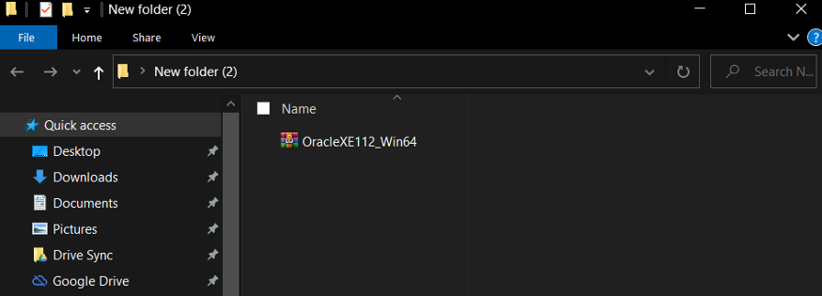

Step 6: You are now required to extract the file present in the zip file. So, in order to unzip the file, right-click the zipped file and click on ’Extract files…’ options as shown in the image below.

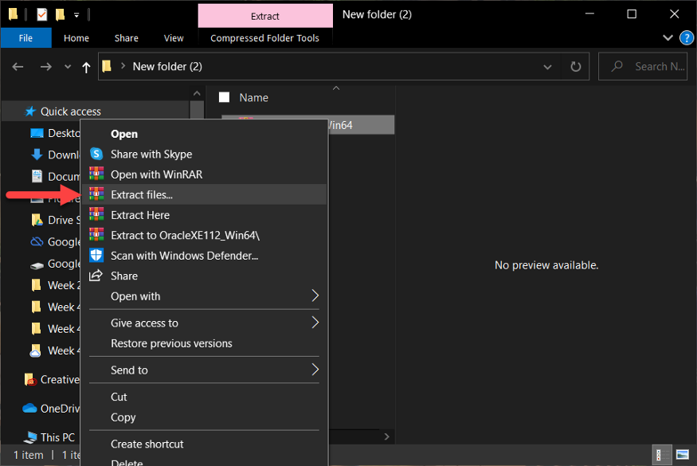

Step 7: After you have extracted your file, you can view the contents present in the zip file as shown in the image below.

Step 8: Now, go inside the folder name ‘DISK1’. Here, execute the ‘setup’ file as shown in the image below. It might ask you to provide your system password – please provide your password in the dialogue box to proceed further.

*Note: After you execute the setup file. A window appears as shown in the image below.*

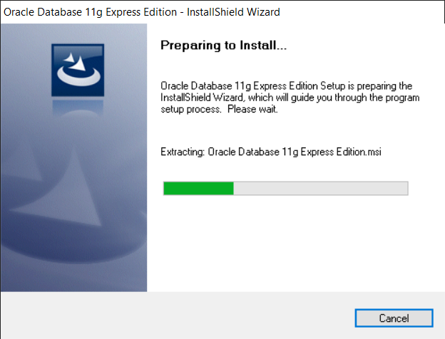

Step 9: Now, ‘Oracle Database 11g Express Edition — Install Wizard’ appears as shown in the image below. Here, click on the ‘Next’ button.

Step 10: Here, in the License Agreement, select ‘I accept the terms in the license agreement’. Then, finally, click on the ‘Next’ button.

Step 11: Here, you can click on the ‘Browse…’ button in order to change the location where you are willing to install the Oracle.

*However, you can leave the location as default and carry out the installation process from ‘Step 11’.*

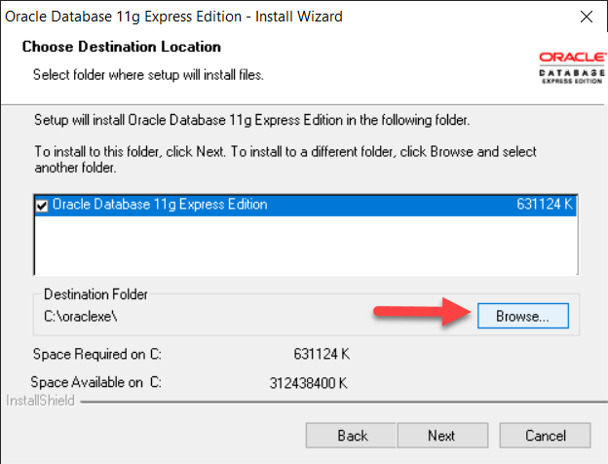

Step 12: Here, you can select the location where you are willing to install the files. After you have selected a suitable location, you can click on the ‘OK’ button.

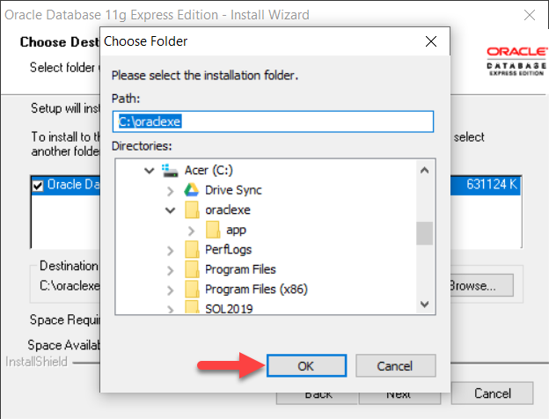

Step 13: After selecting the file location, you can click on the ‘Next’ button.

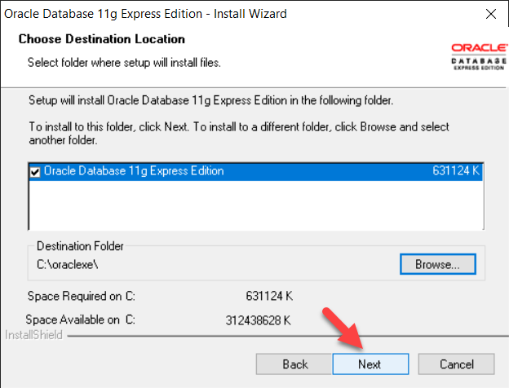

Step 14: Now, you are required to enter the password for the Oracle database. However, in this stage, you are required to provide a password mandatorily. For instance: ‘admin123’.

Please make sure that you remember your password as the same password will be used for both SYS and the SYSTEM database accounts.

Step 15: Here, in ‘Summary’, you are required to click on the ‘Install’ button.

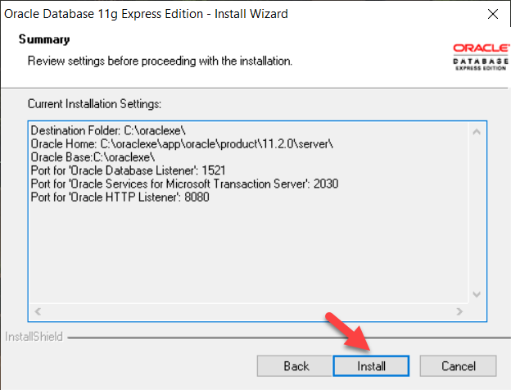

*Note: Now, your installation of Oracle Database 11g Express Edition begins as shown in the image below.*

Step 16: Finally, the ‘Install Shield Wizard’ is complete. Hence, you can now click on the ‘Finish’ button.

Step 17: Now, search for the ‘Task Manager’ in your PC.

*Note: You can also open ‘Task Manager’ by pressing ‘Ctrl + Alt + Delete’ in your keyboard.*

Step 18: In the ‘Task Manager’, you can go to the ‘Services’ as shown in the image below.

Step 19: In ‘Services’, start all the services of Oracle. Hence, for starting a service, you are required to right-click the service and select ‘Start’ as shown in the image below. For instance: ‘OracleXEClrAgent’.

Step 20: In your PC, you are required to search for ‘SQL Command Line’ as shown in the image below.

Step 21: For ensuring that the installation has been carried out successfully, let us try to log in to the system. Hence, for connecting to the system, you can execute the query provided below.

connect system

Step 22: Here, you are now required to enter your password. For instance: ‘admin123’

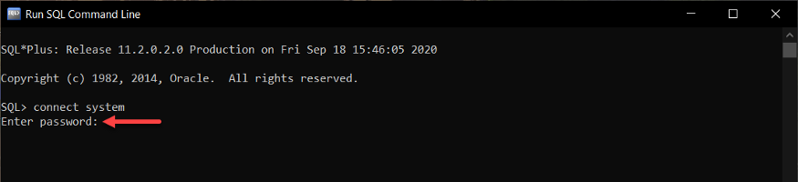

Step 23: You are now connected to the system.

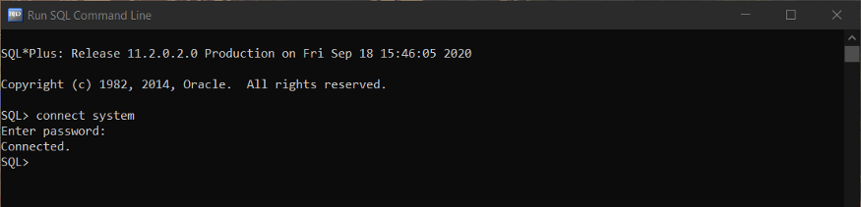

<https://www.oracle.com/tools/downloads/sqldev-downloads.html>

