**ESP32-CAM and Roboflow Integration**

1. **Capture Image at Scheduled Times:**  
   Configure ESP32-CAM to capture images at the following specified times:
   * 6:30 AM
   * 11:30 AM
   * 4:30 PM

After capturing the image, send it to the Roboflow Cloud for processing using a pretrained YOLOv8 model. The image has to appear in the interface of Roboflow, such as:

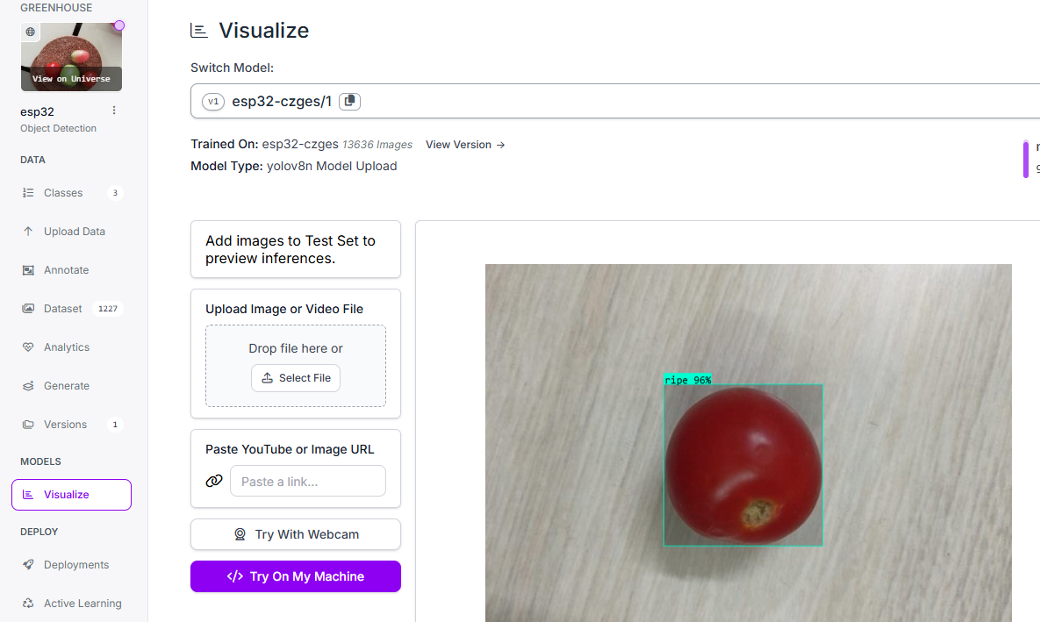

1. **Deep Sleep Optimization:**  
   Between scheduled capture times, ESP32-CAM should remain in the **Deep Sleep State** to conserve power.
2. **Roboflow Integration:**  
   Ensure the captured images are uploaded to the Roboflow interface for processing. YOLOv8 will analyze the images to identify ripe tomatoes.
3. **Data Handling:**  
   YOLOv8 will return information (likely in JSON format) to the ESP32-CAM. The ESP32-CAM must:
   * Process the received JSON data (if needed).
   * Calculate the percentage of ripe tomatoes relative to the total number of tomatoes identified in the image (including green, unripe, and ripe).
   * Example Calculation: If YOLO detects 60 tomatoes and 20 are classified as ripe, the returned value should indicate **30% ripe tomatoes**.
4. **GSM Communication Setup:**
   * Establish a connection to the Roboflow Cloud using a GSM module (**SIM900 MINI V4.0 GSM**) connected to an ESP32-WiFi module.
   * Specifications of the ESP32-WiFi module:
     + Model: ESP-WROOM-32
     + Chip: ESP32-D0WD-V3 (revision v3.1)
     + Identifier: R 211-161007 | FCCID: 23232323232
5. **Bluetooth Communication:**  
   Implement Bluetooth communication to enable data exchange between the ESP32-CAM and ESP32-WiFi modules.