IT System Analysis, Digital Transformation Strategy for a Retail Business:

Current Systems;
The landscape features of the system can be slow, fragmented POS terminals, a legacy e-commerce platform, and manual, error-prone inventory procedures. These systems lead to lost sales, customer frustration, and inefficiencies due to outdated technology and lack of real-time integration. Best practices dictate not only routine software/hardware updates but also evaluating whether the architecture supports future growth—cloud-based or hybrid solutions are favored for scalability and reducing on-premise maintenance burdens.

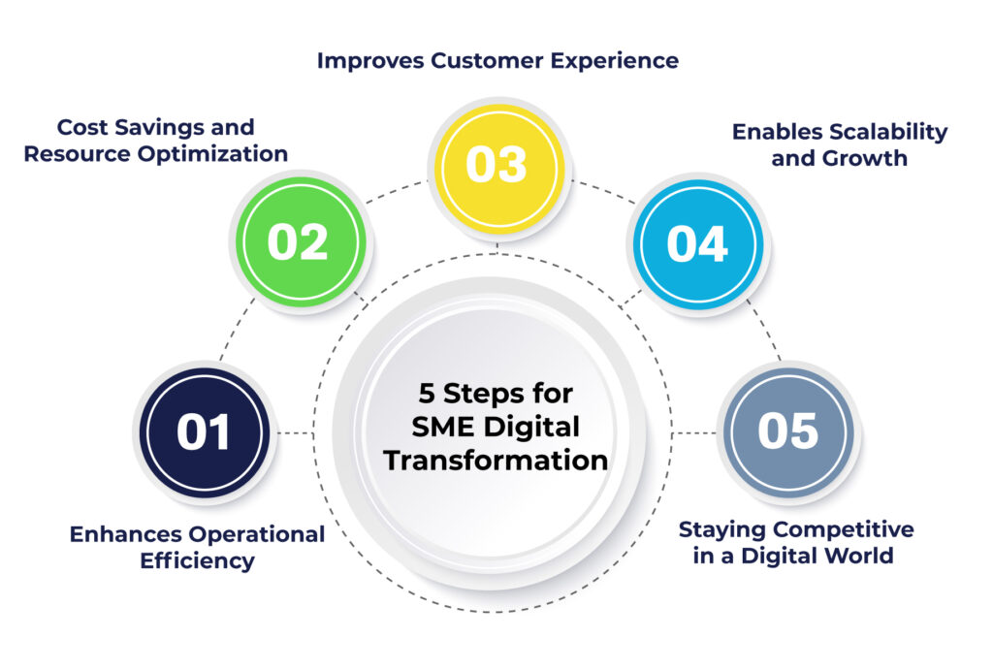
Modernization Insights;
- Prioritize cloud-native or hybrid POS architecture for seamless growth.
- Ensure integrations across systems (POS, e-commerce, CRM) to unify operations.
- Incorporate robust security and routine backups to guard business continuity.

Stakeholder ;
Stakeholder goals remain consistent: faster transactions, real-time data, unified customer profiles, and omnichannel support. The requirements are refined by best practices:Modern Functional and Non-Functional Requirements:
- All sales transactions processed in under 3 seconds with uptime >98.95%.
- Real-time inventory and unified customer data across all touchpoints.
- API-first platform for integration; compliance with standards (GDPR, PCI-DSS) for data security.
- Scalability plan for expanding locations and digital traffic.
This alignment directly addresses previous pain points, setting a foundation for future expansion without costly rewrites.
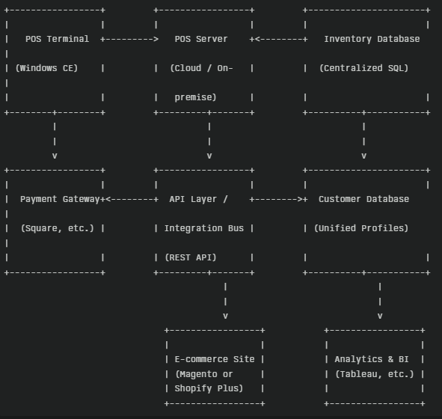
metrics-based comparison, showing strategic tradeoffs:
Solution | Functional Fit (40%) | Scalability (20%) | Cost (20%) | Implementation Risk (10%) | Vendor Viability (10%) | Weighted Score
Salesforce Tableau | 10/10 | 10/10 | $350k | 15 | High | Over
Shopify Square | 8/10 | 7/10 | $250k | 10 | Moderate | Ranges
Custom Microservices | 9/10 | 10/10 | $330k | 25 | Niche | Variables -Not constant
Leverage Shopify Plus + Square POS for fast deployment, low upfront cost, and immediate omnichannel capability. For expansion past 100 stores, a phased migration to Salesforce (or similar) is recommended, minimizing risk while laying a scalable foundation.

Risk Analysis;
cloud-based nature ensures technical fit, economic viability (positive NPV over five years), as wll as manageable training requirements. Plan for “dry runs” and staff pilots, and codify mitigation for outages and migration errors, backups, and service-level agreements (SLAs).

Risk Mitigation;
- Multi-stage data migration with validation.
- Rolling staff training for minimal disruption.
- SLA-backed cloud vendors and rollback protocols.

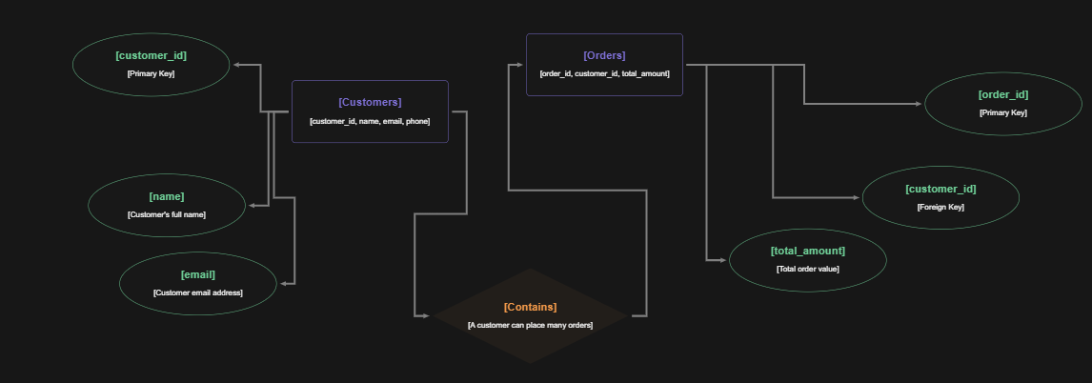
Visualization:
- Process flows showing streamlined checkout, inventory, and customer engagement.
- Entity-Relationship for unified data structures.
- system interaction.

Implementation Roadmap
Milestone | Timeline | Key Activities
Requirements/Training | Month 1-2 | Stakeholder workshops, training
Vendor & Infra Setup | Month 3-4 | Vendor onboarding, cloud setup
Migration/Pilots | Month 5-6 | Data migration, pilot locations
Full Rollout/Support | Month 7-8 | Multi-store launch, staff support
Review/Optimize | Month 9-10 | Performance review, fine-tuning

KSD.

