Title: HEOR Data-Use Request
Project Owner: | Date: 3/5/2026
Agency Contact(s):

Purpose:
This data-use request packet is the reference for the following information:
The data being presented is derived from the Adelphi Real World CIDP Disease Specific Programme ™(DSP), a real-world, cross-sectional survey of CIDP patients and their neurologists, conducted in the United States of America between September 2022 and April 2023. The surveys are an independent data source and were not designed to address any pre-specified research questions or hypotheses. Physicians completed data for up to their next ten consecutively consulting patients. Those same patients voluntarily completed a self-report survey. The use of the following data from these surveys is intended to support and amplify the messaging around disease burden and treatment satisfaction on CIDPProgress.com.

The 3 claims for approval:
- Claim 1: 61% of treated patients with CIDP required supportive aids*
- Claim 2: Nearly half of the time, patients and physicians reported different levels of satisfaction with their CIDP treatment†‡
- Claim 3: When there was disagreement, 87% of the time physicians were more satisfied than patients†‡§

Footnotes:
*Data derived from Adelphi Real World’s CIDP I Disease Specific Programme™, a real-world, cross-sectional survey including all treated patients with CIDP (n=62) and their neurologists in the US, conducted between September 2022–April 2023. Data is shown for where matched physician-reported and patient-reported data are available. Patients who were on treatment were prescribed immunoglobulins, corticosteroids, nonsteroidal immunosuppressants, biologics, neuropathic pain therapies, or plasmapheresis.
†Data derived from Adelphi Real World’s CIDP I Disease Specific Programme™, a real-world, cross-sectional survey including patients with CIDP (n=76) and their neurologists in the US, conducted between September 2022–April 2023. Data is shown for where matched physician-reported and patient-reported data are available. 52 patients and physicians had overall treatment satisfaction data. To assess treatment satisfaction, patients and physicians used slightly different Likert scales: completely satisfied/satisfied/neither/dissatisfied/completely dissatisfied (patients) versus very satisfied/somewhat satisfied/neither/somewhat dissatisfied/very dissatisfied (physicians). This analysis assumes that the different Likert scales completed by patients and physicians can be treated as equal.
‡Treatments included immunoglobulins, corticosteroids, nonsteroidal immunosuppressants, biologics, neuropathic pain therapies, or plasmapheresis.
§Patients and neurologists reported different levels of satisfaction in 46.2% of cases. When there was disagreement in satisfaction, 87% of the time physicians were more satisfied than patients: (13.5% + 26.9%) / 46.1% = 87%.

Use(s):

Example use cases (HCP materials):
- Single use on the DSE website
- Integration into short-form assets that support or drive to the DSE website, such as emails or banners

All creative agencies could leverage these messages; it’s based on the discretion of the PO/MRC to place them where they are most acceptable.
Content:

Content of Claim 1 is derived from the Adelphi CIDP DSP Supportive Aids Analyses.

As shown in Table 1 of the analyses (run in August 2025):
- Requirement of mobility aids/home modifications/support (n=62):
  - Yes, required mobility aid: 38 (61%)

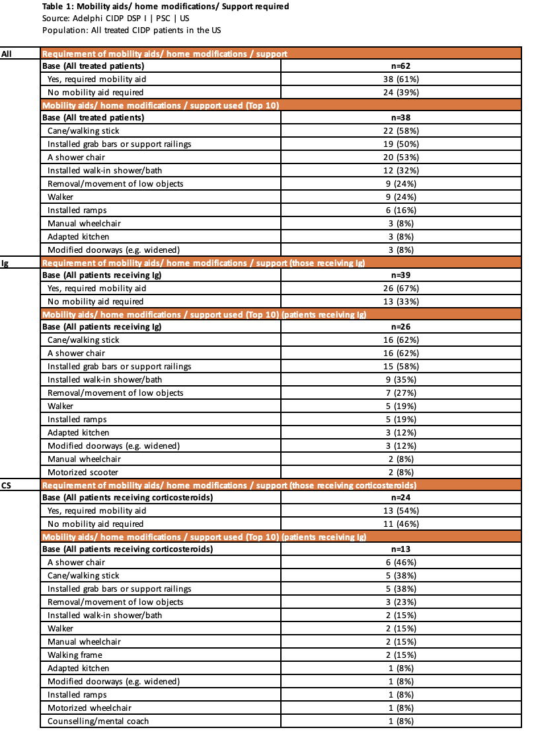

Content of Claims 2 and 3 is derived from Adelphi CIDP DSP data tables provided by the SHE team:

As shown in the following table:
- Correspondence between patient and physician-reported treatment satisfaction:
  - Nearly half of the time, patients and physicians reported different levels of satisfaction with their CIDP treatment (1.9% + 13.5% + 1.9% + 26.9% + 1.9% = 46.1%)
  - When there was disagreement, 87% of the time physicians were more satisfied than patients: (13.5% + 26.9%) / 46.1% = 87%

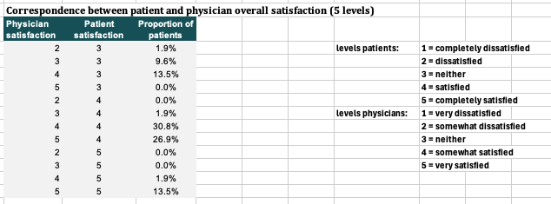

Example data presentation below:

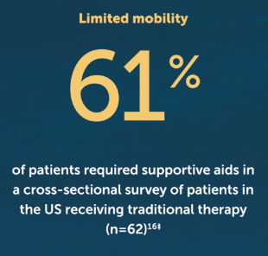

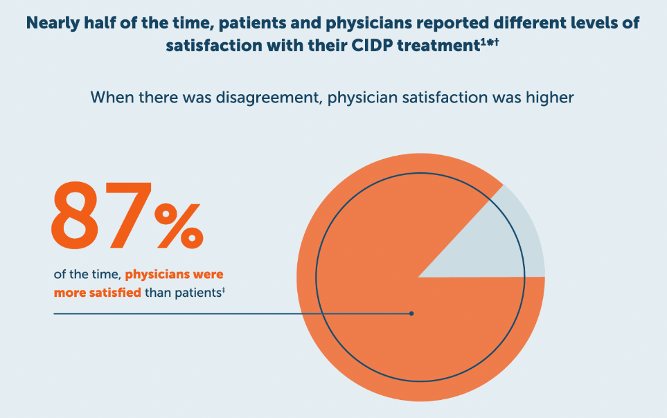

References:
- Adelphi CIDP DSP Supportive Aids Analyses for treated patients
  - Table 1: Supportive aids
- Adelphi CIDP DSP data tables provided by the SHE team
  - Correspondence between patient and physician overall satisfaction
Talking Points/Take-home Messages:

- 61% of treated patients with CIDP required supportive aids
- Nearly half of the time, patients and physicians reported different levels of satisfaction with their CIDP treatment
- When there was disagreement, physicians were more satisfied than patients
Checklist for additional requirements to appropriately describe analyses:
- Data Source
- Logic behind metric
- Business rules (xx months, xx population)
Approval
U.S. HEOR Subject Matter Expert | Name:
 | Date:

