AI/CRV 2026 Venue and Transportation Guide
Simon Fraser University, Burnaby Campus
Campus | SFU Burnaby campus / SFU Transit Exchange
On-Campus Accommodation | Courtyard Residence / The Simon
Off-Campus Hotel | Executive Plaza Hotel Coquitlam, 405 North Road

Venue map
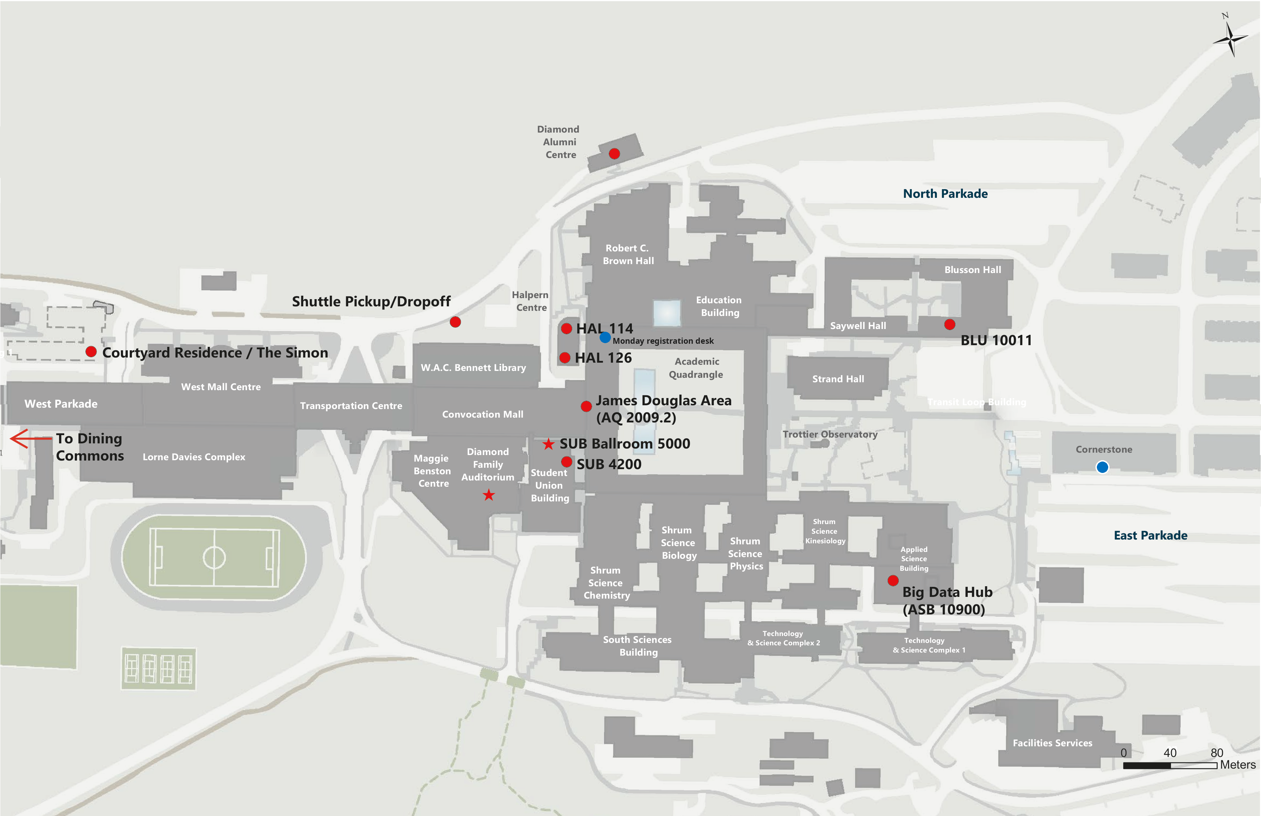
- AI main room: Diamond Family Auditorium
- CRV main room: SUB Ballroom 5000
- Registration desk: AQ North Corridor (Monday), Diamond Family Auditorium (Tuesday – Friday)
- Other venue areas:
- Student Union Building (SUB 4200 and SUB Ballroom 5000)
- Halpern Centre
- BLU 10011
- Big Data Hub (ASB 10900)
- Monday workshops and special tracks: Halpern Centre 126/114, SUB 4200, BLU 10011, and ASB 10900.
- Lunches are at Dining Commons. On-campus accommodations include Courtyard Residence / The Simon.
- Poster printing: Cornerstone, marked with the blue dot on the map.
- Shuttle pickup/dropoff: marked near the Transportation Centre / Halpern Centre area.
- Program details: View the full schedule

Getting to SFU Burnaby Campus from Off-Campus Hotel
The Executive Plaza Hotel Coquitlam, is a 10-minute to 25-minute drive from the SFU Burnaby Campus.

Shuttles
- Advance sign-up is required. Each shuttle has a capacity of 50 passengers.
- Confirmed shuttle riders will receive a small sticker on their conference badge. Volunteers may check for this sticker at the shuttle pickup point, especially on Wednesday.
- Confirmed riders should arrive at the shuttle pickup point at least 10 minutes before departure. Seats that are not claimed close to departure time may be released to waitlisted attendees.
- If a shuttle reaches capacity, additional sign-ups will be placed on the waitlist in order of submission.
- Campus pickup/dropoff: use the Shuttle Pickup/Dropoff point shown on the venue map above.
- Hotel pickup/dropoff: Executive Plaza Hotel Coquitlam.
Shuttle sign-up link: AI/CRV 2026 Shuttle Sign-Up Form
Day | Times
Monday, Tuesday, Thursday, Friday | 7:45 AM - Executive Plaza Hotel -> SFU  6:00 PM - SFU -> Executive Plaza Hotel
Wednesday | 7:45 AM - Executive Plaza Hotel -> SFU  6:00 PM, 6:15 PM, 6:30 PM, 6:45 PM, 9:30 PM, 10:00 PM - SFU -> Executive Plaza Hotel

Public Transit
- Travel from Executive Plaza Hotel to SFU Transit Exchange is usually about 32-49 minutes by transit, depending on the route, wait times, and traffic.
- Google Maps or TransLink may suggest several route options depending on departure time.
- Return trip: use the same route in reverse.
- Check Google Maps or TransLink Trip Planner before travelling for live schedules.
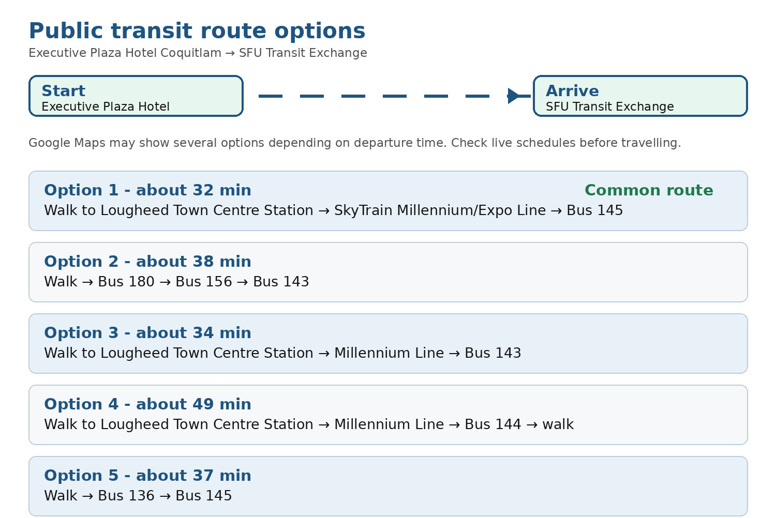
Route options from Executive Plaza Hotel Coquitlam to SFU Transit Exchange. Options and travel times may change; attendees should check live schedules before travelling.
Route and schedule links: TransLink Trip Planner | Route 145 schedule | Route 143 schedule | Route 144 schedule | Route 136 schedule
Fare and payment: The hotel-to-campus route is normally a one-zone trip if starting from Lougheed Town Centre Station. Current adult one-zone fares are $3.35 by cash/contactless or $2.70 with Compass Stored Value. TransLink accepts Compass Card/Ticket, contactless cards, mobile wallets, and cash on buses. TransLink fare details

Getting to SFU Burnaby Campus from Vancouver International Airport (YVR)
- The SFU Burnaby Campus is about a 45-minute to 90-minute drive from the Vancouver International Airport, depending on traffic.
- From Vancouver International Airport (YVR) to SFU Burnaby by public transit: take the Canada Line from YVR-Airport Station toward downtown Vancouver, then connect to SkyTrain/bus service toward SFU. A common route is Canada Line -> Waterfront/Expo Line -> Production Way-University Station -> Bus 145 -> SFU Transit Exchange.
- Use TransLink Trip Planner or Google Maps on the travel day for the fastest route, since the best connection can change by time of day.
- Travellers leaving YVR by Canada Line may be charged the YVR AddFare in addition to the regular transit fare.
Useful links: YVR public transportation | TransLink YVR AddFare

Parking Information
- Parking at SFU Burnaby is paid parking. There is no free parking on campus.
- Recommended parking area for attendees near the main conference area: West Parkade / West Lot, subject to availability and signage.
- Current West Parkade online parking rates shown in Honk include approximately $5.10 for 1 hour, $9.85 for 2 hours, $14.60 for 3 hours, and $19.35 all day. Rates may change; attendees should check SFU parking/Honk before driving.

Useful links: SFU visitor parking | SFU parking rates | West Parkade online parking rates

