AI - System Architecture

Student Profile

ANU Course Prerequisites

Degree builder

Wikipedia-enhanced Course Ontology

Degree enrolment information

Programs and Courses Data

Search Connector

Wikipedia Data

Subject Interests

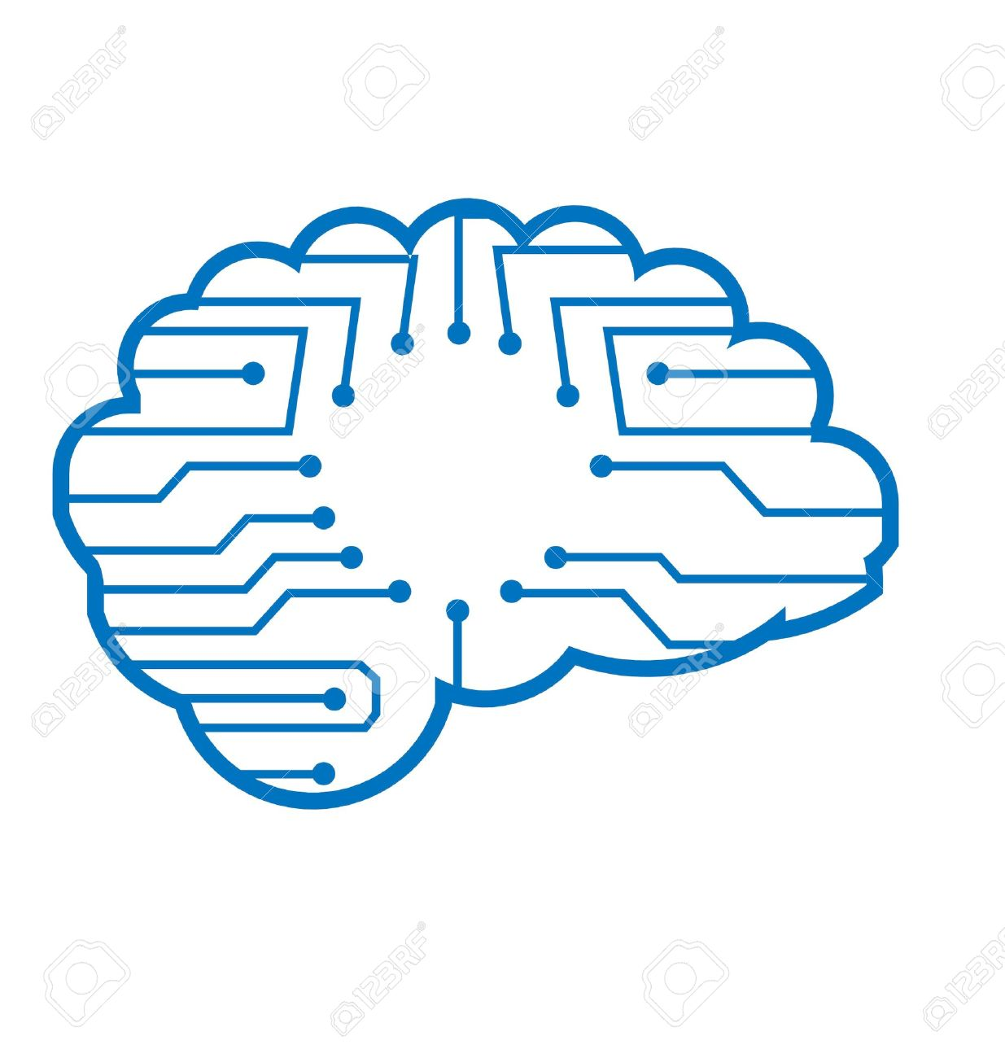

Wikipedia-enhanced Course Ontology

Lucene Connector

Wikipedia Data

Elastic Search

**Intelligent Search**

Programs and Courses Data

TFIDF Transform

Alexa Integration