Simple LED Circuit
v1.0

Project - Memento
From


www.aid-iot.com
Inordinate Industrial Innovations Pvt Ltd.
BP-5, MLU Plots, DDA, Bindapur, Dwarka, New Delhi, 110059
Table of Contents
1. Aim 3
2. Components Required 3
3. Theory 3
3.1 How an LED works 3
3.2 Why a series resistor is essential 3
3.3 Choosing the resistor value 3
3.4 Reading the resistor colour code 4
4. Circuit Diagram 5
5. Procedure 5
5.1 Identify the components before wiring 5
5.2 Build the circuit 5
5.3 Power up and measure 6
6. Observations 6
7. Calculations 6
8. Result 7
9. Precautions 7
10. Troubleshooting 7
11. Review Questions 7

1. Aim
To build a simple series circuit in which a single light emitting diode (LED) is lit from an external power supply, with the current limited by one series resistor, and to verify the resistor value by measurement and calculation.

2. Components Required
Ref | Qty | Component | Specification
D1 | 1 | LED, 5 mm | Red, forward voltage about 2.0 V, forward current 10 to 20 mA
R1 | 1 | Resistor | 330 ohm, 1/4 W, 5 percent tolerance
J1 | 1 | 2-pin screw terminal | 5.08 mm pitch, for the power input wires
- | 1 | Regulated DC supply | 5 V, current limit set to 100 mA if available
- | 1 | Digital multimeter | For voltage and current measurement
- | 1 | Breadboard and jumper wires | Or stripboard, for trial assembly
Note The 330 ohm value assumes a 5 V supply and a red LED. Section 3.3 shows how to work out the correct value for any supply voltage and LED colour.

3. Theory

3.1 How an LED works
A light emitting diode is a semiconductor diode that emits light when current flows through it in the forward direction. Like any diode it conducts in one direction only. The two leads are not interchangeable:
- The anode (A) is the positive lead. On a new LED it is the longer lead.
- The cathode (K) is the negative lead. It is the shorter lead, and the plastic body is flattened on that side.
Connected the right way round the LED conducts and lights. Connected backwards it blocks current and stays dark, and in this low-voltage circuit no harm is done - simply turn it around.

3.2 Why a series resistor is essential
An LED is a current-operated device, not a voltage-operated one. Once the supply reaches the forward voltage, the current through the LED rises extremely steeply for a very small further increase in voltage. A red LED that drops about 2.0 V at 10 mA may pass several hundred milliamperes at 2.2 V.
If an LED is connected straight across a 5 V supply, nothing limits that current except the internal resistance of the supply and the leads. The current rises far beyond the rated 20 mA and the LED is destroyed, usually within a second.
The series resistor solves this. It takes up the difference between the supply voltage and the LED forward voltage, and because a resistor obeys Ohm’s law, that voltage difference across a known resistance sets a predictable current.
Note Never connect an LED directly across a power supply without a series resistor. This is the single most common way of destroying an LED.

3.3 Choosing the resistor value
Apply Kirchhoff’s voltage law around the loop. The supply voltage equals the voltage across the resistor plus the voltage across the LED:
Vs = V_R + V_f

so V_R = Vs - V_f
The resistor and the LED are in series, so the same current flows through both. From Ohm’s law:
Vs - V_f
R = ------------
I
For this experiment, with a 5 V supply, a red LED of forward voltage 2.0 V and a chosen current of 10 mA:
R = (5.0 - 2.0) / 0.010
= 3.0 / 0.010
= 300 ohm
300 ohm is not a standard value, so the next standard value above it is used. Choosing the next value up is deliberate: a slightly larger resistor gives slightly less current, which is safe. A smaller one gives more current, which is not.
Standard value chosen: R1 = 330 ohm

Actual current = (5.0 - 2.0) / 330
= 0.00909 A
= 9.09 mA
Check the power the resistor must dissipate, so that a 1/4 W part is adequate:
P_R = I^2 x R
= (0.00909)^2 x 330
= 0.0273 W = 27.3 mW
27.3 mW is well under the 250 mW rating of a 1/4 W resistor, so the part will not even feel warm.
The table below gives the calculation for other common combinations, all at a target current of 10 mA:
Supply | LED colour | V_f (typical) | Calculated R | Standard value
5 V | Red | 2.0 V | 300 ohm | 330 ohm
5 V | Yellow / green | 2.2 V | 280 ohm | 330 ohm
5 V | Blue / white | 3.2 V | 180 ohm | 220 ohm
3.3 V | Red | 2.0 V | 130 ohm | 150 ohm
3.3 V | Blue / white | 3.2 V | 10 ohm | 22 ohm (dim, see note)
12 V | Red | 2.0 V | 1000 ohm | 1 k ohm
Note A blue or white LED on a 3.3 V supply leaves almost no headroom, because the forward voltage is nearly the whole supply. The brightness then varies wildly with small supply changes. Use a 5 V supply for blue and white LEDs.

3.4 Reading the resistor colour code
A 1/4 W resistor is marked with four coloured bands. Read from the end where the bands are closest to the lead. The first two bands are digits, the third is the number of zeros to add, and the fourth is the tolerance.
Value | Band 1 | Band 2 | Band 3 (multiplier) | Band 4 (tolerance)
150 ohm | Brown (1) | Green (5) | Brown (x10) | Gold (5 percent)
220 ohm | Red (2) | Red (2) | Brown (x10) | Gold (5 percent)
330 ohm | Orange (3) | Orange (3) | Brown (x10) | Gold (5 percent)
1 k ohm | Brown (1) | Black (0) | Red (x100) | Gold (5 percent)
So the 330 ohm resistor used here reads orange, orange, brown, gold: 3, 3, then one zero, giving 330 ohm at 5 percent tolerance. Always confirm with a multimeter if the colours are hard to judge.

4. Circuit Diagram
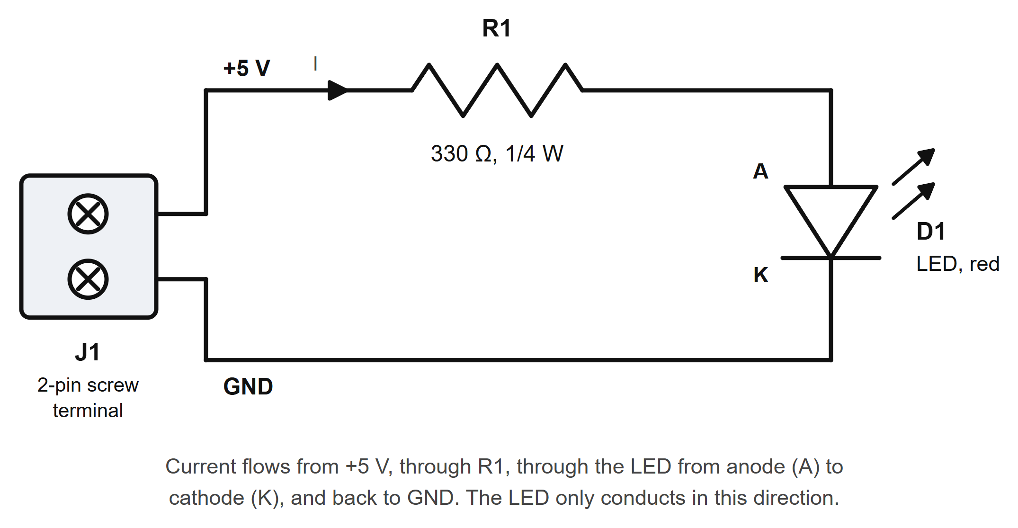
Figure 1 - LED circuit with series current-limiting resistor
The circuit is a single series loop. Starting at the positive terminal of J1, the current passes through R1, then through D1 from anode to cathode, and returns to the negative terminal of J1. Because it is a series circuit, the same current flows through every component.

5. Procedure

5.1 Identify the components before wiring
- Identify the LED leads. The longer lead is the anode (positive). The shorter lead, on the flattened side of the body, is the cathode (negative).
- Read the resistor colour bands and confirm the value is 330 ohm (orange, orange, brown, gold).
- Measure the resistor with the multimeter on the resistance range. A 5 percent 330 ohm part should read between 313 and 347 ohm. Record the measured value.
- Set the bench supply to 5 V with the output switched off. If the supply has an adjustable current limit, set it to about 100 mA.

5.2 Build the circuit
- Place the screw terminal J1 at the edge of the breadboard or stripboard.
- Connect one wire from the positive terminal of J1 to one end of R1.
- Connect the other end of R1 to the anode (long lead) of the LED.
- Connect the cathode (short lead) of the LED back to the negative terminal of J1.
- Strip about 6 mm of insulation from the two supply wires and clamp them under the screws of J1 - the screw must tighten onto bare copper, not onto insulation.
- Check the whole loop against Figure 1 before applying power. Confirm in particular that the resistor is in series with the LED and not across it.

5.3 Power up and measure
- Switch on the supply. The LED should light steadily.
- Measure the supply voltage across J1 and record it as Vs.
- Measure the voltage across the resistor and record it as V_R.
- Measure the voltage across the LED and record it as V_f.
- Calculate the current as I = V_R / R, using your measured resistor value.
- If the meter has a current range, switch off, break the loop, connect the meter in series, switch on again and compare the measured current with your calculated figure.
- Switch off the supply before dismantling.
Note To measure current the meter must be in series, which means breaking the circuit. Never place a meter set to a current range across a component - the current range is close to a short circuit and will blow the meter fuse.

6. Observations
Record your readings in the table below.
Quantity | Symbol | Measured value | Unit
Resistor value (measured) | R |  | ohm
Supply voltage | Vs |  | V
Voltage across resistor | V_R |  | V
Voltage across LED | V_f |  | V
Current, calculated as V_R / R | I |  | mA
Current, measured in series | I |  | mA
LED state | - |  | lit / not lit

7. Calculations
Work through the following with your own measured figures.
- Check Kirchhoff’s voltage law: V_R + V_f should equal Vs. Any small difference is measurement error plus the voltage dropped in the leads.
- Calculate the current from I = V_R / R.
- Compare that with the current you measured in series. The two should agree within the tolerance of the resistor and the accuracy of the meter.
- Calculate the power dissipated by the resistor, P_R = I squared times R, and confirm it is below the 250 mW rating of a 1/4 W part.
- Calculate the power dissipated by the LED, P_LED = V_f times I.
A worked example using the nominal figures:
Vs = 5.00 V V_f = 2.00 V R = 330 ohm

V_R = 5.00 - 2.00 = 3.00 V
I = 3.00 / 330 = 9.09 mA
P_R = 0.00909^2 x 330 = 27.3 mW
P_LED= 2.00 x 0.00909 = 18.2 mW

8. Result
The LED circuit was assembled and the LED lit from a 5 V supply. The current was limited to approximately 9 mA by a 330 ohm series resistor, which agrees with the value calculated from Ohm’s law. Kirchhoff’s voltage law was verified around the loop, and the resistor power dissipation was confirmed to be well within the rating of a 1/4 W component.

9. Precautions
- Never connect an LED to a supply without a series resistor.
- Observe LED polarity. The long lead is the anode and goes towards the positive supply through the resistor.
- Confirm the supply is set to 5 V before switching it on. A higher voltage with the same resistor gives a proportionally higher current.
- Do not exceed the LED maximum forward current, typically 20 mA for a standard 5 mm part.
- Switch the supply off before changing any connection.
- Tighten the screw terminals onto bare conductor, never onto insulation, and tug each wire gently to confirm it is held.
- Check the supply polarity at J1. Reversed supply will simply leave the LED dark in this circuit, but the habit matters once other components are involved.

10. Troubleshooting
Symptom | Likely cause | What to do
LED does not light at all | LED connected the wrong way round | Switch off and reverse the LED. The long lead goes to the resistor.
LED does not light at all | Open circuit somewhere in the loop | Measure the voltage at each junction, or check continuity with the supply off.
LED does not light at all | Wire clamped on insulation at J1 | Re-strip the wire and clamp on bare copper.
LED is very dim | Resistor value too high | Confirm the colour code. 3.3 k ohm instead of 330 ohm gives about a tenth of the current.
LED is very dim | Supply voltage too low | Measure Vs at the terminal block, not at the supply front panel.
LED flashes then goes out | Supply current limit tripping | Check for a short across the LED or resistor.
LED lit briefly then dark for good | Resistor missing or short-circuited | The LED has almost certainly failed. Fit a new LED and the correct resistor.
Resistor becomes hot | Resistor value far too low, or supply far too high | Switch off immediately and recalculate the value from section 3.3.

11. Review Questions
- What happens, and why, if the LED is connected the wrong way round in this circuit?
- Why must the current-limiting resistor be placed in series with the LED rather than in parallel with it?
- The 330 ohm resistor is replaced with 100 ohm on the same 5 V supply. Calculate the new current, and state whether the LED is within its 20 mA rating.
- Calculate the resistor needed for a blue LED with a forward voltage of 3.2 V, running at 15 mA from a 5 V supply. Give the nearest standard value.
- Does it matter whether the resistor is placed on the anode side or the cathode side of the LED? Justify your answer.
- Why is an LED described as a current-operated device, and what practical difference does that make to how it is driven?
- The supply is changed from 5 V to 12 V and the resistor is left at 330 ohm. Calculate the new current and the new power dissipated in the resistor. State whether a 1/4 W resistor is still adequate.

