

AIDA Data Rescue Hackathon Proposal
Ajman University
From Messy Data to Machine Learning

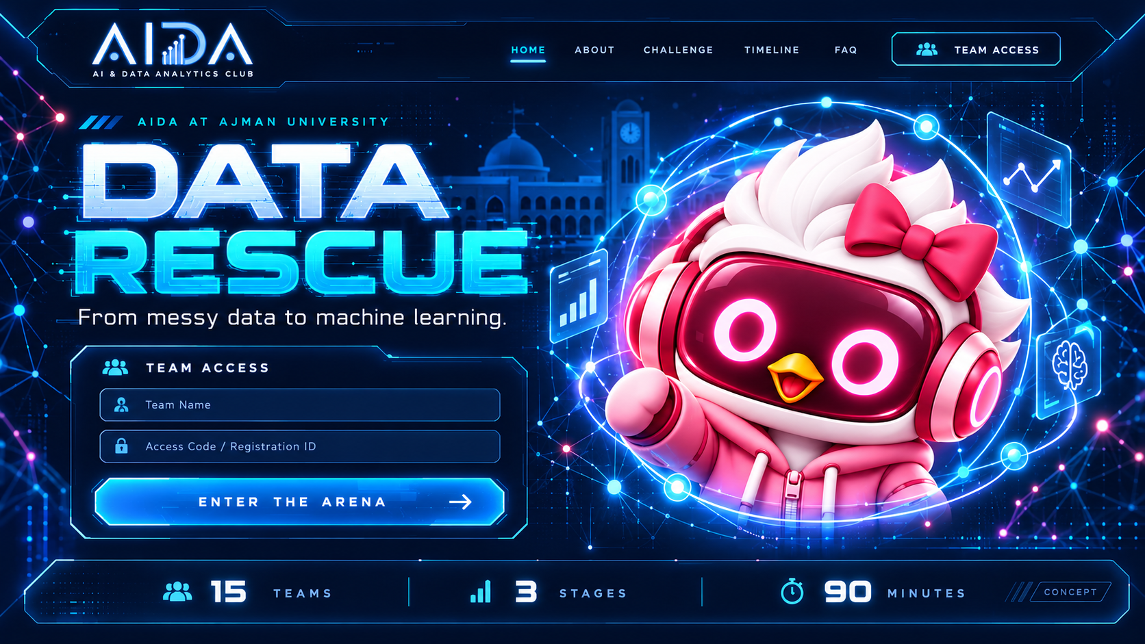
Concept image for the proposed participant experience
Decision requested | Proposed event
Approval | University lab, 45 students, sponsor outreach
Format | 15 teams of three using one computer per team
Duration | 90 minutes, including 60 minutes of competition
Funding ceiling | AED 4,000; sponsorship preferred
Preparation | Four weeks after approval

Prepared by the AI and Data Analytics Club

Executive Summary
The AI and Data Analytics Club requests approval to run AIDA Data Rescue, a 90-minute educational hackathon for 45 Ajman University students working in 15 teams. Participants will clean synthetic campus-equipment data, construct labels from maintenance records, and train a small neural network through three timed stages. The competition is designed for students with basic Python and pandas experience; starter code keeps the focus on data quality and model improvement.
We request a computer lab with 15 team computers and two spares, internet access, a projector, a faculty supervisor, two judges, one technical operator, and three student volunteers. We also request permission to approach sponsors through university-approved channels. The proposed spending ceiling is AED 4,000. No funding, sponsorship, venue, or infrastructure is currently assumed to be confirmed.

Approval Requested
- Approve the event concept, participant capacity, format, and four-week preparation period.
- Reserve a suitable university computer lab and technical support for a rehearsal and the event.
- Authorize institutional sponsor outreach led by a faculty adviser, Student Life, or the Ajman University Innovation Center.
- Approve a spending ceiling of AED 4,000, subject to university purchasing and sponsorship rules.

Expected Learning Outcomes
- Recognize missing values, malformed numeric data, duplicates, impossible readings, and identifier inconsistencies.
- Create reliable labels by normalizing and joining a separate outcome log.
- Prevent data leakage by fitting preprocessing only on the training partition.
- Use validation accuracy and binary cross-entropy loss to compare neural-network experiments.
- Explain technical decisions and work responsibly with limited AI assistance.

Event Participants and Staff
Role | Count | Main responsibility
Students | 45 | Compete in 15 teams of three
Faculty supervisor | 1 | Academic oversight and final decisions
Judges | 2 | Review evidence and approve scores
Technical operator | 1 | Manage clock, platform, incidents, and judging
Student volunteers | 3 | Registration, room support, and participant questions

Competition Format
The official competition lasts 60 minutes. Three stages run for 20 minutes each, followed by 30 minutes for final scoring, provisional results, awards, and photographs. Registration, login checks, the guide, and environment checks happen before the official clock starts.
Time | Activity | AI access
00:00 to 20:00 | Stage 1 Rescue the Data | Unlocks at 05:00
20:00 to 40:00 | Stage 2 Build the Labels | Unlocks at 25:00
40:00 to 60:00 | Stage 3 Train and Improve | Unlocks at 45:00
60:00 to 70:00 | Final scoring and verification | Closed
70:00 to 80:00 | Publish provisional results | Closed
80:00 to 90:00 | Awards and photographs | Closed

Stage 1 Rescue the Data
Students normalize identifiers and numerical values, remove duplicate copies, convert impossible readings to missing values, and document an imputation strategy. Learned imputation values must come from the fixed training partition.
Criterion | Points
Schema, parsing, units, and ranges | 10
Deduplication and identifier preservation | 10
Missing-value handling and data-quality report | 10

Stage 2 Build the Labels
Students clean and join a separate maintenance-outcome log. Corrective repair confirmed maps to 1; inspection complete with no corrective repair maps to 0. Unmatched records must be reported. Outcome text, record IDs, and target values cannot be model features.
Criterion | Points
Correct labels matched to records | 15
Fixed split and target-leakage prevention | 10
Usable numerical input and consistent preprocessing | 5

Stage 3 Train and Improve
Students begin with a 12 input, 16 hidden, 8 hidden, and 1 output PyTorch network. They may tune the learning rate, batch size, dropout, weight decay, hidden widths, and epoch count up to 50. Each training run is limited to 120 seconds on identical CPU resources.
Criterion | Points
Private-test accuracy | 20
Private-test binary cross-entropy loss | 10
Reproducible model and preprocessing | 5
Explanation of two experiments | 5

Dataset Design
Campus Equipment Rescue is a fictional dataset created for education. It contains no student information, personal data, or confidential university records. The task is to predict whether a piece of equipment requires corrective maintenance within seven days.
Component | Specification
Unique records | 10,000
Participant development file | 8,200 rows: 8,000 unique records plus 200 duplicate copies
Training and validation | 6,000 training and 2,000 validation records
Private test set | 2,000 records held by organizers
Input variables | 12 numeric equipment readings
Target | needs_maintenance, created by students
Outcome log | 8,000 development records
Observed positive rate | 49.05 percent

Input Variables
Variable | Meaning
temperature_c | Equipment temperature
ambient_temperature_c | Ambient temperature
vibration_mm_s | Vibration velocity
current_a | Electrical current
voltage_v | Electrical voltage
humidity_pct | Relative humidity
pressure_bar | Operating pressure
rotation_rpm | Rotation speed
daily_runtime_hours | Daily operating time
equipment_age_months | Equipment age
days_since_service | Time since service
load_pct | Operating load

Controlled Data Problems
- Approximately 5 percent of feature cells are missing.
- Some numeric values contain units or extra spaces.
- A small number of readings exceed published physical ranges.
- Two hundred duplicate copies are mixed into the development file.
- Record identifiers and maintenance statuses use inconsistent spacing and capitalization.
The organizers retain a clean reference dataset, private test labels, and a corruption manifest. Participant downloads exclude those files.

Scoring and Fairness
The judges compute scores from frozen submissions and actual predictions. Participants cannot score their own private-test results. A fresh isolated run must reproduce the submitted artifacts before the model receives reproducibility points.

Metric Formula
Accuracy points = 20 x clamp((accuracy - 0.50) / 0.40, 0, 1). Loss points = 10 x clamp((ln(2) - loss) / (ln(2) - 0.30), 0, 1). Accuracy is expressed as a fraction. The clamp function limits each normalized value to the interval from zero to one.
The reference implementation completed in approximately 4.4 seconds on a local CPU. It reached 88.8 percent validation accuracy, validation loss of 0.273, private-test accuracy of 87.7 percent, and private-test loss of 0.281. These results support a practice target of at least 85 percent validation accuracy and validation loss no greater than 0.40.

Tie Resolution
Ties are resolved by private-test accuracy, then private-test loss, then the Stage 1 score. If teams remain tied, they share the placing and the related prize pool is divided equally.

Submission Rules
- The server clock controls the shared event deadline and opens each scheduled stage for every team.
- A valid Stage 1 or Stage 2 submission immediately opens the next stage for that team.
- Teams may replace a submission only while that stage remains their active stage; the latest accepted receipt counts.
- Autosave preserves work but does not count as submission.
- At the deadline, the last explicitly submitted version is frozen.
- A missed stage earns zero for that stage but does not block later work when the schedule reaches it.
- Previous-stage code remains visible as a read-only snapshot.

Manual Review
Automated checks verify row coverage, schema, ranges, labels, preprocessing metadata, model execution, and private-test metrics. Faculty judges review the imputation rationale and the explanation of two experiments. No leaderboard is published until the judges approve the evidence and the technical operator records a reason for every score.

Limited AI Assistance
Each team receives one built-in AI prompt in each stage, for a maximum of three prompts per team and 45 successful responses across the event. The assistant supports learning by explaining a concept, interpreting a short error, or suggesting an experiment. It cannot access the dataset, run code, edit files, or complete the full pipeline.
Rule | Limit
Unlock time | Five minutes after each stage begins
Prompt size | 80 whitespace-separated words and 1,000 characters
Response size | 160 displayed words
Illustrative code | No more than five lines
Follow-up conversation | Not available
Unused prompts | Do not carry forward
Model settings | Same organizer-selected model for all teams

Control Measures
- The server atomically claims one prompt for each team and stage.
- Duplicate clicks return the same claimed request state.
- A provider failure allows the same prompt to be retried; it does not create a second prompt.
- The system instruction restricts the assistant to conceptual help and a short response.
- Only the built-in assistant is permitted on supervised university computers.
- If AI fails for every team, the organizer pauses the shared event clock and logs the incident.
Prompt and response limits reduce the chance that the assistant completes the work, but they cannot guarantee this. The scoring rubric therefore rewards reproducibility and a short explanation of the team’s own experiments.

Participant Platform
The implemented desktop-first website includes team login, dataset preview and downloads, a guide sheet, a Python editor, console output, training metrics, a server-synchronized timer, AI prompt controls, autosave status, submission receipts, prior-stage snapshots, and organizer controls.
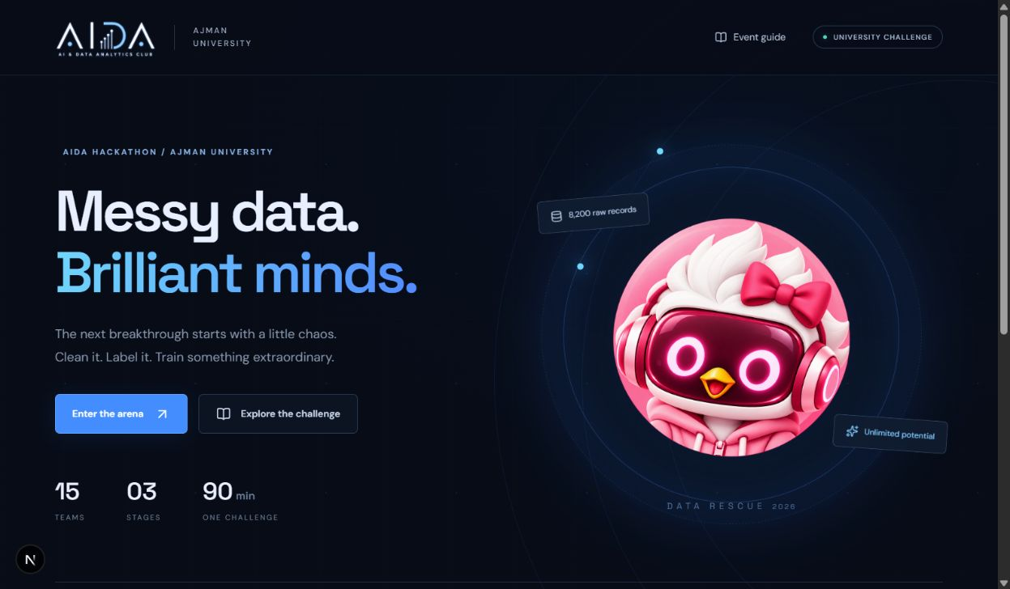
Implemented local website landing page
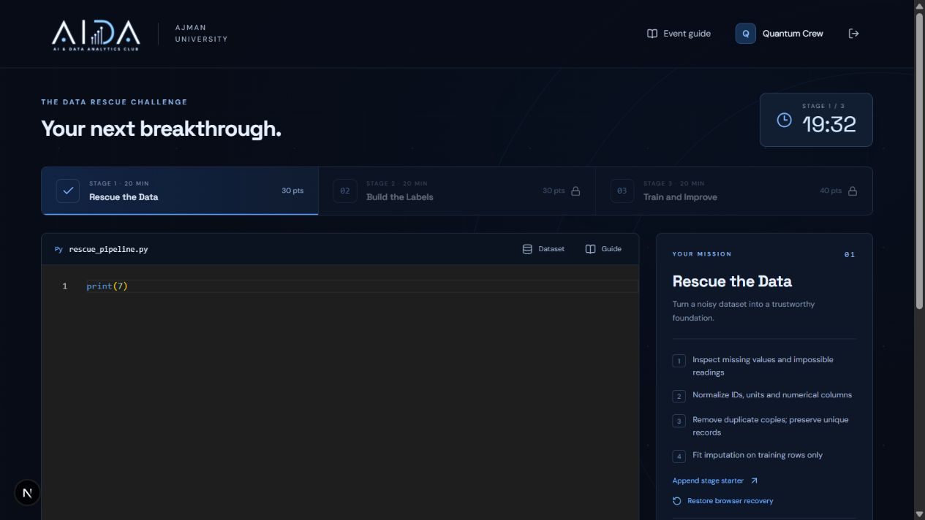
Implemented participant workspace

Platform Architecture

Visual Design
The interface uses the supplied AIDA logo, deep navy surfaces, electric blue borders, cyan highlights, connected-node patterns, and the supplied mascot without recoloring it. Motion is disabled when the operating system requests reduced motion. The one-minute warning does not interrupt typing.
Subsystem | Implementation
Web application | Next.js and TypeScript on Vercel
Code editor | Monaco Editor, packaged locally
Identity and durable state | Supabase Auth and Postgres
Submission artifacts | Private Supabase Storage bucket
Python execution | One isolated Vercel Sandbox per active team
Machine learning | Pinned CPU PyTorch environment
AI help | OpenAI Responses API, server-side only
Judging | Fresh isolated run followed by trusted inference and scoring

Security and Integrity
- Participant code runs in a remote microVM with outbound network access denied.
- Application secrets and private test labels are never mounted into participant environments.
- Team requests are authenticated on the server; one team cannot read another team’s work.
- Supabase row-level security is enabled and direct browser access to event state and artifacts is revoked.
- The OpenAI API key, Supabase service credential, and Vercel credential remain server-side.
- The judging system supplies private test features to trusted inference only; scoring labels remain outside the execution sandbox.
- A 120-second command timeout, two CPU threads, file allowlists, and 10 MB artifact limits constrain runs.
- Audit records capture event-control actions and submission receipts.

Hosting Requirements
Vercel’s published Hobby allowance permits 10 concurrent sandboxes, which is below the 15-team requirement. The event therefore needs a paid Vercel allocation or approved university infrastructure. Supabase currently lists a free plan for rehearsal and a Pro plan starting at USD 25 per month. Final procurement must verify current prices and university rules before purchase.

Deployment Status
The application, dataset generator, reference model, scoring scripts, and deployment configuration are complete locally. A cloud deployment is not active because the connected Supabase account contains no project and no Vercel project credentials were supplied. The project fails closed when those services are absent; participant code is never executed on the organizer’s computer.

Budget Request
The figures below are planning allowances rather than supplier quotations. No expenditure is currently approved. University facilities, equipment, staff time, and platform development are requested in kind.
Item | Calculation | AED
First-place prize | AED 400 x 3 students | 1,200
Second-place prize | AED 250 x 3 students | 750
Third-place prize | AED 150 x 3 students | 450
Refreshments | 55 people x AED 12 | 660
Trophies or medals | Allowance | 150
Printing and signs | Allowance | 100
Hosting and execution | Event and rehearsal allowance | 200
LLM API usage | Event and testing allowance | 50
Subtotal |  | 3,560
Contingency | 10 percent | 356
Estimated total |  | 3,916
Requested ceiling | Rounded | 4,000

Lower Cost Option
A technical-only version can target AED 300 by using university facilities, digital certificates, no catering, and donated prizes. A zero-cash event requires confirmed in-kind compute, AI access, and prizes before registration opens.

Prize Conditions
Monetary prizes should not be advertised until funding is secured. Product or voucher prizes should provide equal value to all three students on a winning team. Shared placings divide the relevant prize pool equally.

In Kind Requests
- Computer lab with 15 team computers and two spares.
- Stable internet connection and a projector.
- Technical rehearsal access before the event.
- Faculty supervisor, two judges, one technical operator, and three volunteers.
- Institutional sponsor introductions and purchasing support.

Sponsor Approach
Sponsor outreach should start with university relationships. A faculty adviser, Student Life, or the Ajman University Innovation Center should make or approve introductions. The club should present the event as a pilot and avoid offering a long-term official sponsor title without university approval.
Organization | Proposed request | Contact route
Ajman University Innovation Center | Introductions, mentors, judges, or infrastructure | auic@ajman.ac.ae; +971 6 705 6481
Ajman Bank | Approximately AED 2,400 for prizes | University partnership owner; then info@ajmanbank.ae
Mbank | Prizes, guest judge, or educational vouchers | University office managing the existing AU-Mbank relationship
AUIC startups and suppliers | Refreshments, printing, or technology gifts | Introduction through AUIC or Student Life

Suggested Packages
Package | Request | Recognition subject to approval
Lead sponsor | AED 2,400 | Approved logo placement, acknowledgement, and award invitation
Supporting sponsor | AED 1,000 | Acknowledgement and event invitation
Technology partner | AED 300 to 600 or in kind | Acknowledgement for compute, API credits, or vouchers

Draft Sponsor Message
Subject: Sponsorship request for AIDA Data Rescue at Ajman University
Dear [Name],
The AI and Data Analytics Club at Ajman University is seeking support for AIDA Data Rescue, a 90-minute educational hackathon for 45 students. Fifteen teams will clean a deliberately messy dataset, construct labels from evidence, and train a neural network in a supervised university lab.
We invite [Organization] to support student prizes, refreshments, technology costs, or a guest judge. The proposed lead contribution is AED 2,400, which funds all three winning teams. Any recognition, logo placement, or public announcement will follow Ajman University approval.
We would welcome a short meeting to share the scoring rubric, technical controls, schedule, and expected student outcomes. Thank you for considering this request.
Sincerely,
AI and Data Analytics Club
Ajman University

Preparation Schedule
Week | Work | Completion evidence
1 | Obtain approval; confirm venue and faculty roles; freeze dataset and reference solution | Signed approval path, room request, validated dataset
2 | Configure cloud services; test login, timer, submissions, and AI quotas | Deployment checklist and service test results
3 | Add final branding; prepare volunteers and judging workflow; contact sponsors | Rehearsal script, judge guide, sponsor status
4 | Run a 15-team rehearsal; calibrate targets; freeze rules and funding | Signed readiness checklist and incident plan

Readiness Checklist
- Fifteen teams can execute code concurrently with identical resources.
- Beginner pilot teams can complete each stage within 20 minutes.
- The baseline model trains within two minutes.
- Cleaning improves data quality without target leakage.
- Judges reproduce submissions and private-test scores.
- Teams cannot read private labels or another team’s files.
- AI unlocks and quotas survive duplicate requests, refreshes, and provider failures.
- Deadlines reject late submissions and preserve accepted versions.
- All submissions are judged within the first ten minutes after competition.
- Animations do not interfere with editing or accessibility.
- Spending alerts, environment shutdown, and the outage procedure have been rehearsed.

Acceptance Results Completed Locally
Check | Result
TypeScript and production build | Passed
Timing, prompt, scoring, and progression unit tests | 8 of 8 passed
Authentication, team isolation, progression, and data-gating API checks | 12 of 12 passed
Dependency security audit | 0 known vulnerabilities after pinning
Reference model private-test accuracy | 87.7 percent
Reference model private-test loss | 0.281
Cloud concurrency rehearsal | Pending paid Vercel and Supabase configuration

Risks and Controls
Risk | Control
Cloud service interruption | Organizer pauses the shared clock, records the incident, and applies the same adjustment to every team.
Late or lost work | Five-second autosave, browser recovery copy, durable remote revisions, and explicit submission receipts.
AI assistant completes too much work | Short response, five-line code maximum, no tools, no dataset access, one prompt, and explanation points.
Data leakage | Fixed split, training-only preprocessing checks, private labels outside sandboxes, and trusted inference.
Unequal computing resources | One remote two-vCPU sandbox per team with the same image and timeout.
Sponsor funding is delayed | Do not advertise cash prizes; use the AED 300 technical-only option or postpone registration.
Student code is unsafe | Isolated microVMs, denied outbound network, no application secrets, timeouts, and artifact limits.
Scores are disputed | Frozen receipts, rerunnable code, audit records, published formulas, faculty review, and a ten-minute question period.

Decision and Signatures
Approval permits the club to begin the four-week preparation schedule and institutionally approved sponsor outreach. Event publication and prize advertising remain conditional on confirmed venue, technical capacity, judging staff, and funding.
Decision | Name and signature | Date
Approved / Not approved
Dean or authorized representative
Faculty supervisor
Student Life representative
Technical readiness confirmation

Administrative Details
Field | To be completed
Event date
College
Venue
Registration opening
Registration closing
Faculty supervisor
Technical operator

Visual Concepts
These generated images show the intended visual direction. They are concepts rather than screenshots of the working application. The preceding platform section contains screenshots of the implemented local website.
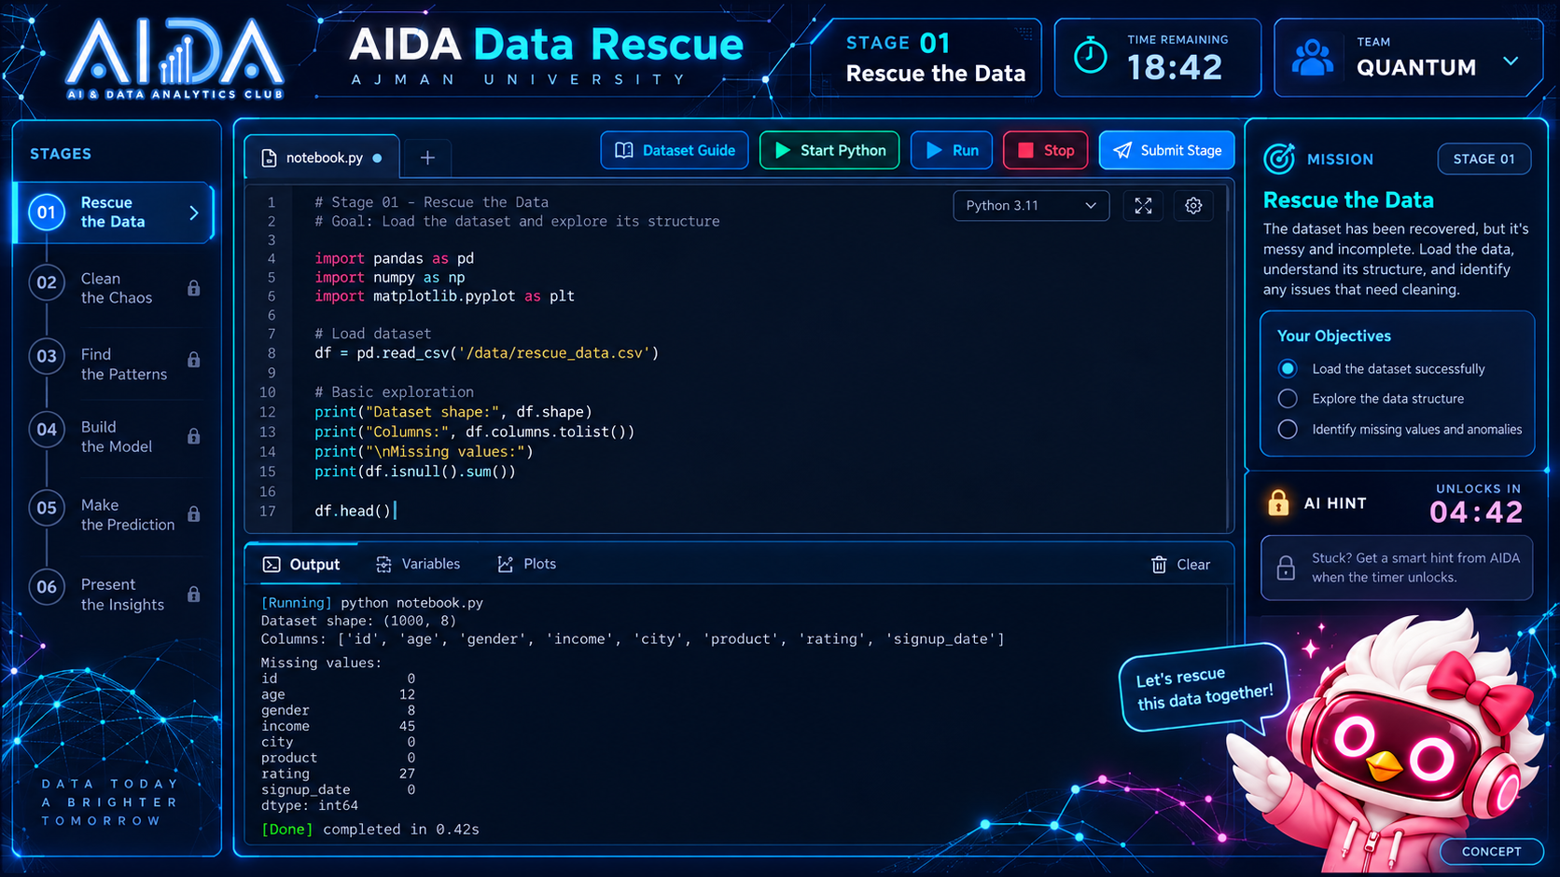
Concept for the participant workspace
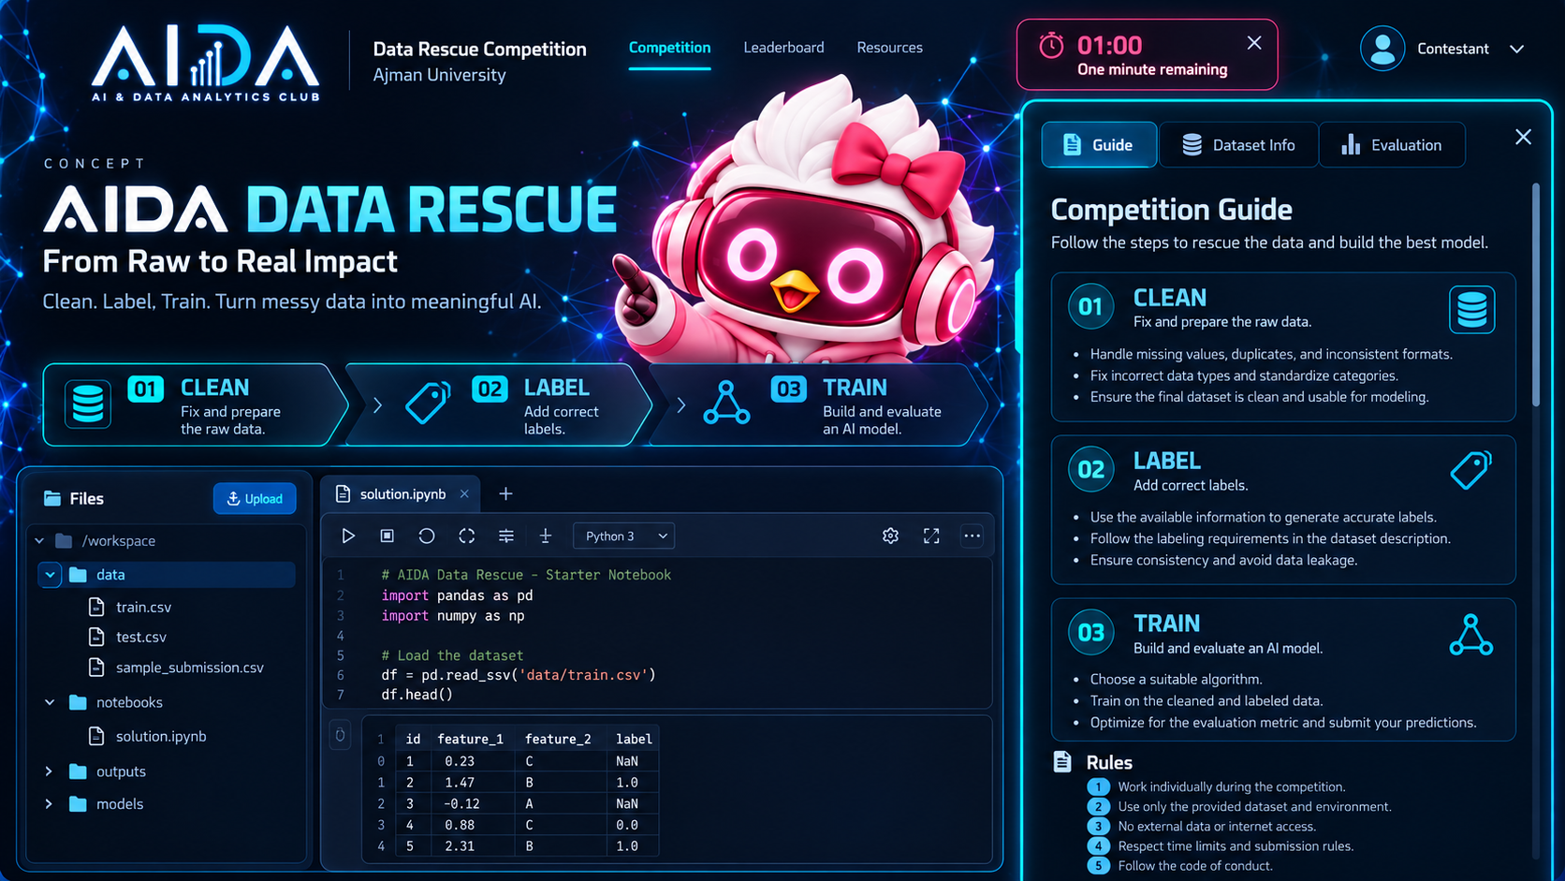
Concept for the guide and time warning
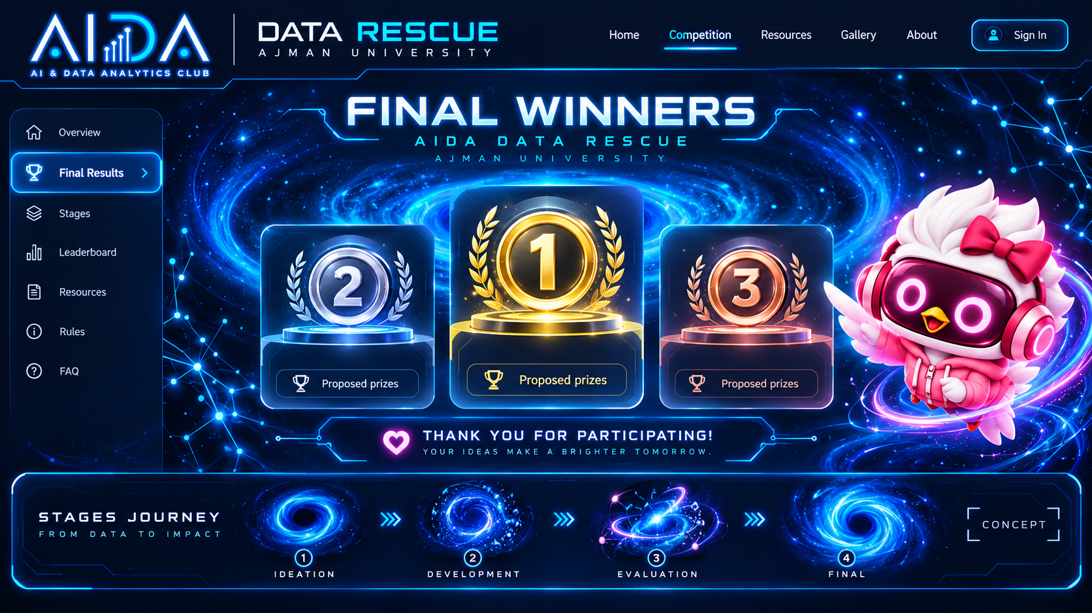
Concept for the transition and results experience

Sources
Ajman University Innovation Center
https://auic.ajman.ac.ae/
Contact information and partnership role.
Ajman University and Ajman Bank
https://www.ajman.ac.ae/en/mou/ajman-bank
Existing university relationship.
Ajman Bank customer service charter
https://www.ajmanbank.ae/site/customer-service-charter.html
General inquiry contact route.
Ajman University and Mbank
https://www.ajman.ac.ae/en/news/2024/mbank-develops-strategic-partnership-with-ajman-university-to-offer-academic-and-professional-development-programs-to-university-students
Existing partnership concerning student development.
Vercel Sandbox pricing and quotas
https://vercel.com/docs/sandbox/pricing
Current concurrency, duration, and usage information; verify before purchase.
Supabase pricing
https://supabase.com/pricing
Current plan information; verify before purchase.
OpenAI Responses API
https://developers.openai.com/api/reference/resources/responses/methods/create
Server-side AI response configuration.
Pricing and quotas can change. The organizing team must verify current provider terms, university procurement rules, sponsor approval, and data-protection requirements before deployment or purchase.

