Database Requirements

|  |  |
| --- | --- |
| REQ No.  1 | Project  Core – Database |

Abstract

| **Rev** | **Date** | **Author** | **Status** |
| --- | --- | --- | --- |
| 1 | 09/21/2015 |  | start |
| 2 |  |  |  |
| 3 |  |  |  |
|  |  |  |  |
|  |  |  |  |

Distribution List

|  |  |
| --- | --- |
| **Reviewers** | **FYI** |
|  | Ji Lucas |

Table of Contents

1. Introduction 4

2. Related Documents/Links/People 4

3. Glossary 4

4. Enhancement Scope 4

4.1. Goals and Objectives 4

4.2. In Scope 4

4.3. Out of Scope 4

4.4. Assumptions 4

4.5. Constraints 4

4.6. Dependencies 5

4.7. Risks 5

5. Requirements 5

5.1. Database 5

5.1.1. Database Scope 5

5.1.2. Current Database Schema 5

5.1.3. Tables & Fields 5

5.2. Users 6

5.2.1. User related tables 6

5.2.2. New user related tables 6

5.2.3. New Crisis related tables 7

5.3. Non-functional 9

5.3.1. Security 9

5.3.2. Testing 9

Issues/Questions 9

6. Revision History 9

# Introduction

AIDR & Micromappers needs to have centralized database to utilize data for dashboard and for performance extension. The current 4 databases will be merged into 1 database to have rich dataset.

# Related Documents/Links/People

References in the text throughout this document appear in square brackets (e.g., [1], [JS]).

| **Reference** | **Document/Link/Person/Application** |
| --- | --- |
|  | MicroMappers http://clickers.micromappers.org/ |
|  | AIDR http://aidr-dev.qcri.org/AIDRFetchManager/ |
|  |  |
|  |  |
|  |  |
|  |  |
|  |  |
|  |  |

# Glossary

| **Term** | **Definition** |
| --- | --- |
| AIDR |  |
| MicroMappers |  |
|  |  |
|  |  |
|  |  |

# Enhancement Scope

## Goals and Objectives

## In Scope

## Out of Scope

## Assumptions

## Constraints

## Dependencies

## Risks

# Requirements

The following subsections define software requirements. Each requirement is labeled as follows:

* **ID.** The unique identifier for the requirement.
* **Requirement.** A clear and concise description of the requirement.
* **Source.** A cross-reference to the source of the requirement.
* **Cat**egory**.** A classification for the requirement using the selections from Table 1.

Table - Requirement Categories

| **Category** | **Description** |
| --- | --- |
| **M**andatory | Required minimum functionality. |
| **O**ptional | Nice to have and will be implemented if time permits. |
| **F**uture | Will not be implemented now but should be considered for a future enhancement. |
| **D**ropped | Requirement determined to be completely out of scope **after** baseline. |
| **E**xisting | Functionality already present in the software (for documentation purposes). |
| **Op**erational | Will not be addressed in the software (documented for training purposes). This requirement should have a related item in the issue list in order to identify an owner. |

## Database

### Database Scope

* Merge duplicate tables
* Normalize/de-nomalize tables
* Extension of table field for the future development

### Current Database Schema

* AIDR-Fetch-Manager : data collection/user schema
* AIDR-Predict : data classifier, user, model schema
* AIDR-Analysis : basic low level of tagged info
* AIDR-Scheduler :Pybossa interaction, user reponses. Geo tagged info schema

### Tables & Fields

* Each table unique id field name will be always id
* Any foreign key is “tablename” _ id. For example, collection.id 🡺 collection_id

## Users

### User related tables

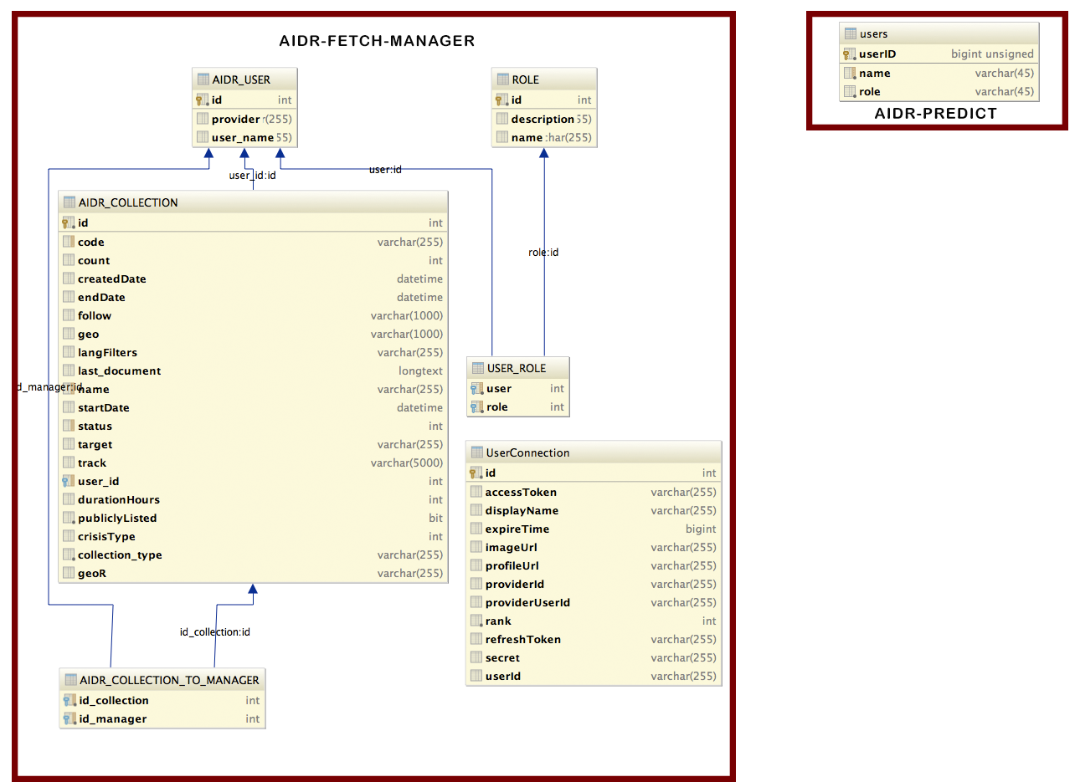

| **Table** | **Source** |
| --- | --- |
| AIDR_USER | aidr-fetch-manager |
| USER_ROLE | aidr-fetch-manager |
| ROLE | aidr-fetch-manager |
| AIDR_COLLECTION_MANAGER | aidr-fetch-manager |
| UserConnection | aidr-fetch-manager |
| users | aidr-predict |

### New user related tables

| **Table** | **Field** | **Old Field** |  | **Database** |
| --- | --- | --- | --- | --- |
| role | id | id | key | aidr-predict |
| role | description |  |  | aidr-predict |
| role | level | name | * admin * normal * qa | aidr-predict |
| role | created | new |  | aidr-predict |
| role | updated | new |  | aidr-predict |

| **Table** | **Field** | **Old Field** |  | **Database** |
| --- | --- | --- | --- | --- |
| account | id | id | key | aidr-predict |
| account | name | user_name | unique | aidr-predict |
| account | provider | provider |  | aidr-predict |
| account | local | new |  |  |
| account | api_key | new | unique |  |
| account | created | new |  | aidr-predict |
| account | updated | new |  | aidr-predict |

| **Table** | **Field** | **Old Field** |  | **Database** |
| --- | --- | --- | --- | --- |
| account_role | id | new | key |  |
| account_role | account_id | user | key | aidr-predict |
| account_role | role_id | role | key | aidr-predict |
| account_role | created | new |  | aidr-predict |
| account_role | updated | new |  | aidr-predict |

| **Table** | **Field** | **Old Field** |  | **Database** |
| --- | --- | --- | --- | --- |
| collection_assocation | collection_id | crisis_id |  | aidr-predict |
| collection_ assocation | account_role_id | key |  | aidr-predict |
| collection_ assocation | created |  |  | aidr-predict |
| collection_ assocation | updated |  |  | aidr-predict |

### New Crisis related tables

| **Table** | **Field** | **Old Field** |  | **Database** |
| --- | --- | --- | --- | --- |
| collection | id | id |  | aidr-predict |
| collection | code | code |  | aidr-predict |
| collection | name | name |  | aidr-predict |
| collection | collection_type | crisisType |  |  |
| collection | current_count | count |  |  |
| collection | created |  |  |  |
| collection | started |  |  |  |
| collection | ended |  |  |  |
| collection | follow |  |  |  |
| collection | geo_filter_option |  |  |  |
| collection | lang_filter_option | langfilter |  |  |
| collection | last_document | lastdocument |  |  |
| collection | status |  |  |  |
| collection | target |  |  |  |
| collection | track |  |  |  |
| collection | duration_hours | durationHours |  |  |
| collection | listing_option | publiclyListed |  |  |
| collection | source_type | collection_type |  |  |
| collection | geo_restriction_option | geoR |  |  |
| collection | isMicroMapperEnabled | isMicroMapperEnabled |  |  |
| collection | isTrashed | isTrashed |  |  |
| collection | owner_id | user_id |  |  |
| collection | updated | new |  |  |
|  |  |  |  |  |

| **Table** | **Field** | **Old Field** |  | **Database** |
| --- | --- | --- | --- | --- |
| collection_log | id | id |  | aidr-predict |
| collection_log | collection_id |  |  | aidr-predict |
| collection_log | count |  |  | aidr-predict |
| collection_log | ended |  |  | aidr-predict |
| collection_log | follow |  |  | aidr-predict |
| collection_log | geo_filter_option |  |  | aidr-predict |
| collection_log | lang_filter_option |  |  | aidr-predict |
| collection_log | started |  |  | aidr-predict |
| collection_log | track |  |  | aidr-predict |
| collection_log | updated_by |  |  | aidr-predict |

| **Table** | **Field** | **Old Field** |  | **Database** |
| --- | --- | --- | --- | --- |
| custom_ui_template | collection_id | crisisID |  | aidr-predict |
| document | collection_id | crisisID |  | aidr-predict |
|  |  |  |  |  |
|  |  |  |  |  |

## Non-functional

### Security

| **ID** | **Requirement** | **Source** | **Cat** |
| --- | --- | --- | --- |
| .1 |  |  |  |

### Testing

| **ID** | **Requirement** | **Source** | **Cat** |
| --- | --- | --- | --- |
| .1 |  |  |  |

# Issues/Questions

| **Issue #** | **Issue/Resolution Description** | **Date/Status** |
| --- | --- | --- |
|  |  |  |
|  |  |  |
|  |  |  |
|  |  |  |
|  |  |  |
|  |  |  |
|  |  |  |

# Revision History

Changes to the text of this document are indicated by bars in the outside margin adjacent to the affected text.

| **Date** | **Change Description** |
| --- | --- |
|  | Initial draft. |
|  |  |
|  |  |
|  |  |