MicroMappers Business Intelligent Portal

|  |  |
| --- | --- |
| REQ No.  1 | Project  MM_BI_PORTAL |

Abstract

| **Rev** | **Date** | **Author** | **Status** |
| --- | --- | --- | --- |
| 1 | Nov. 18, 2015 | Ji Lucas | First draft |
| 2 |  |  |  |
|  |  |  |  |

Distribution List

|  |  |
| --- | --- |
| **Reviewers** | **FYI** |
| Ji Lucas |  |

Table of Contents

1. Introduction 4

2. Related Documents/Links/People 4

3. Glossary 4

4. Scope 4

4.1. Goals and Objectives 4

4.2. In Scope 4

4.3. Out of Scope 4

4.4. Assumptions 4

4.5. Constraints 4

4.6. Dependencies 5

4.7. Risks 5

5. Requirements 5

5.1. RESTful API 5

5.2. Rate Limiting 5

5.3. Operations 6

5.4. Domain Model 6

5.5. UI 7

5.6. Non-functional 10

5.6.1. Security 10

5.6.2. QA/Testing 10

Issues/Questions 10

6. Revision History 10

MM_BI_PORTAL

# Introduction

# Related Documents/Links/People

References in the text throughout this document appear in square brackets (e.g., [1], [JS]).

| **Reference** | **Document/Link/Person/Application** |
| --- | --- |
|  |  |
|  |  |
|  |  |
|  |  |
|  |  |
|  |  |
|  |  |
|  |  |

# Glossary

| **Term** | **Definition** |
| --- | --- |
| AIDR | Artificial Intelligence for Disaster Response : <http://aidr-dev.qcri.org/AIDRFetchManager/>  To use the application, user has to have twitter account |
| MicroMappers | A cloned customized of Pybossa platform for tagging by Digital Humanitarians http://clickers.micromappers.org/ |
| Clickers | Twitter data that is collected by AIDR based on configuration. AIDR Collection output |
|  |  |
|  |  |

# Scope

## Goals and Objectives

Admin users should be able to modify all clickers settings based on her/his needs. Each clicker’s setting should be managed easily and quickly and, any setting changes should notify related applications in real time.

In addition, admin users should be able to overview clicker’s status easily.

## In Scope

* Only authorized admin users can access the site
* Admin users should be able to overview all clickers
* Admin users should be able to sort all clickers by name, date, and status.
* Clicker setting should be configurable

## Out of Scope

## Assumptions

## Constraints

## Dependencies

## Risks

# Requirements

The following subsections define software requirements. Each requirement is labeled as follows:

* **ID.** The unique identifier for the requirement.
* **Requirement.** A clear and concise description of the requirement.
* **Source.** A cross-reference to the source of the requirement.
* **Cat**egory**.** A classification for the requirement using the selections from Table 1.

Table 1 - Requirement Categories

| **Category** | **Description** |
| --- | --- |
| **M**andatory | Required minimum functionality. |
| **O**ptional | Nice to have and will be implemented if time permits. |
| **F**uture | Will not be implemented now but should be considered for a future enhancement. |
| **D**ropped | Requirement determined to be completely out of scope **after** baseline. |
| **E**xisting | Functionality already present in the software (for documentation purposes). |
| **Op**erational | Will not be addressed in the software (documented for training purposes). This requirement should have a related item in the issue list in order to identify an owner. |

## RESTful API

The RESTful API is located at:

http://{aidr.qcri.org}/aidrdata/api

* It expects and returns JSON.
* Required to have **API-KEY** to authenticate & authorize the operation.
* **API-KEY** should be in the **request** headers

## Operations

| **ID** | **Requirement** | **Source** | **Cat** |
| --- | --- | --- | --- |
| .1 |  |  | M |
| .2 |  |  | M |
| .3 |  |  | M |
| .4 |  |  | M |
|  |  |  |  |
|  |  |  |  |
|  |  |  |  |

## Domain Model

## UI

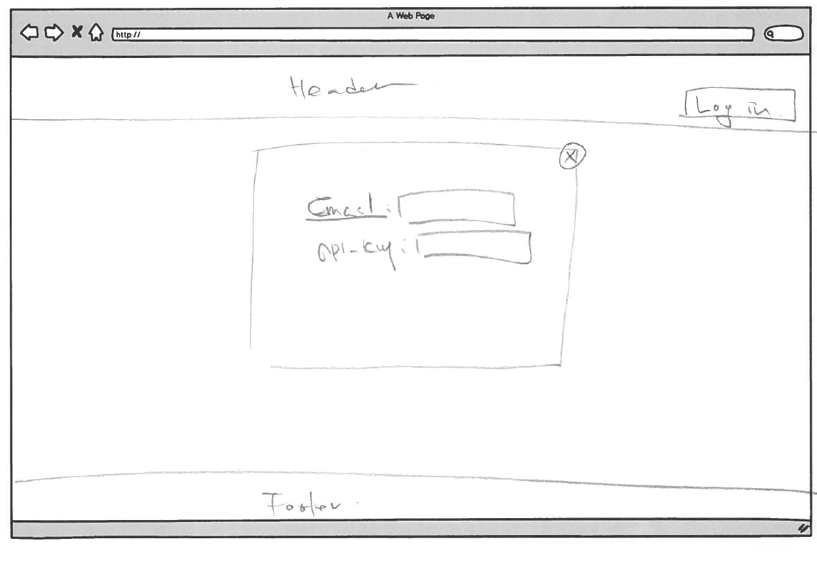

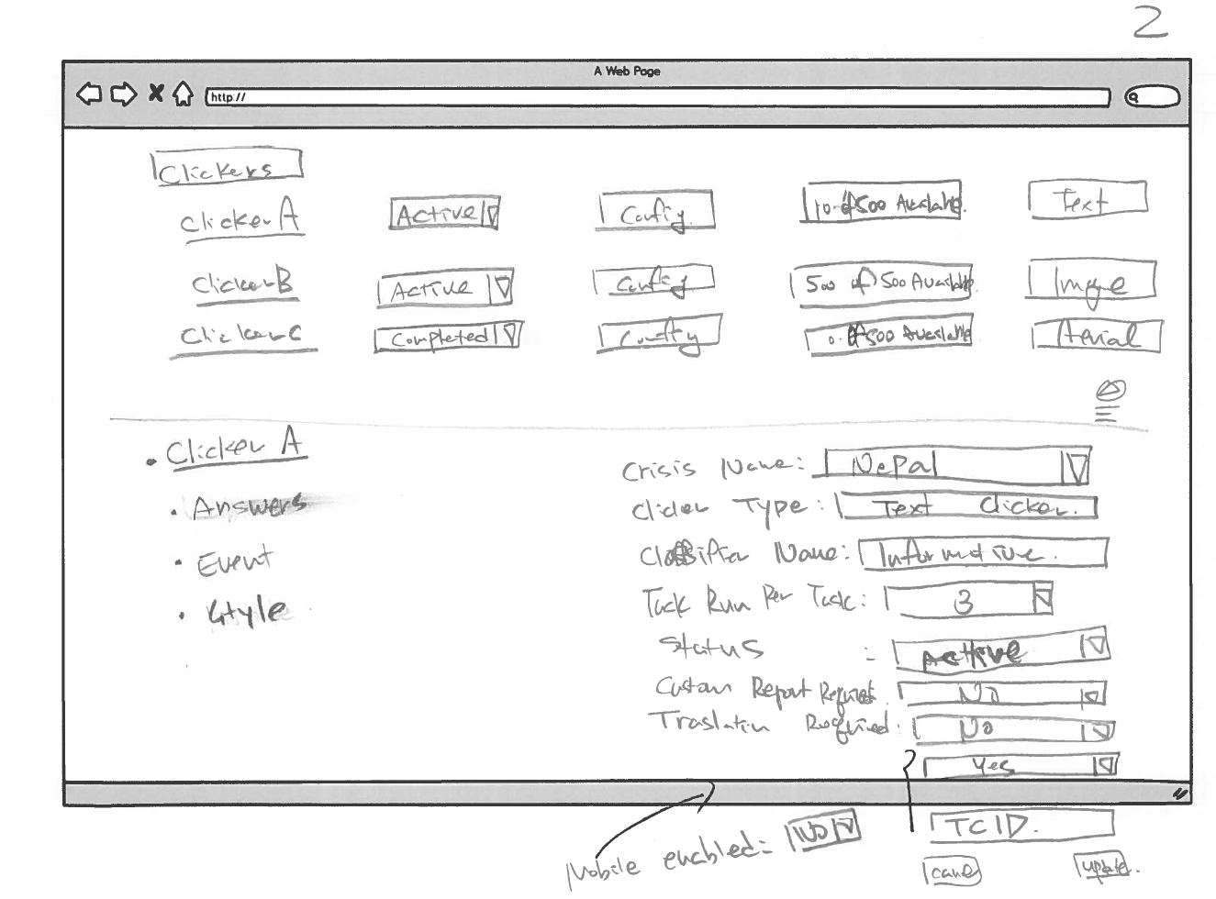

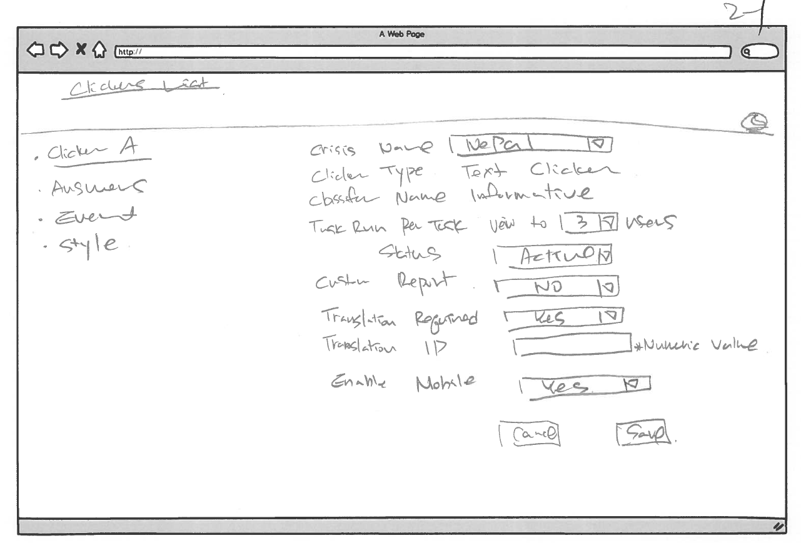

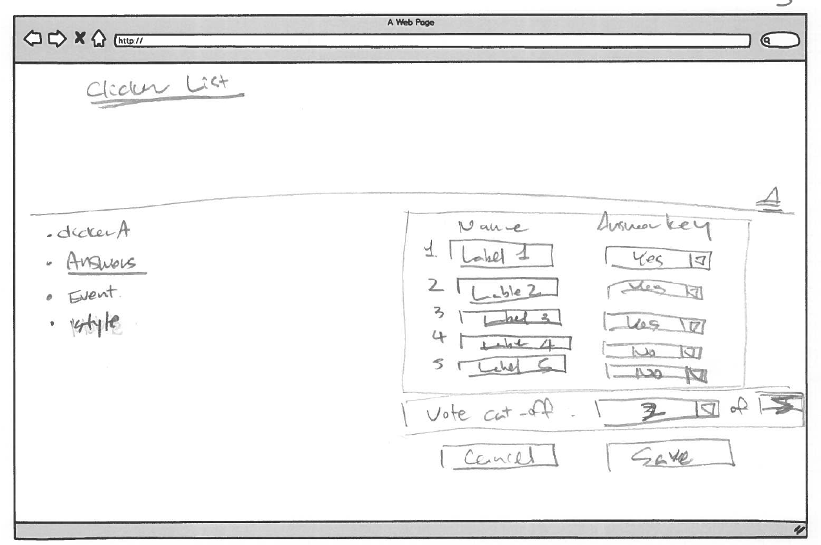

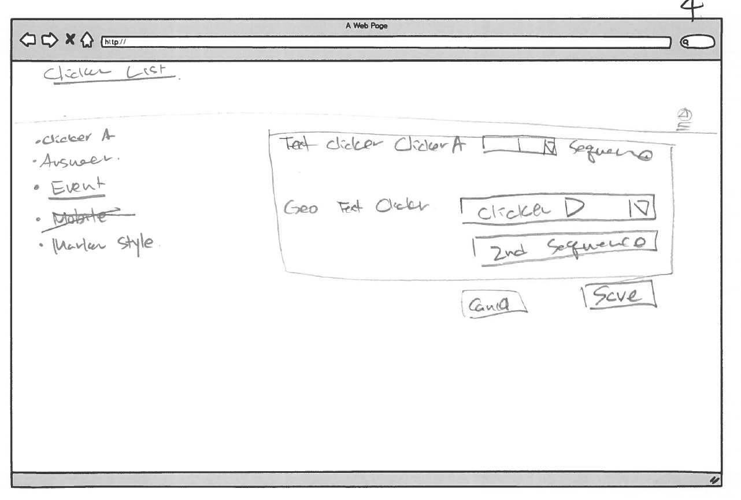

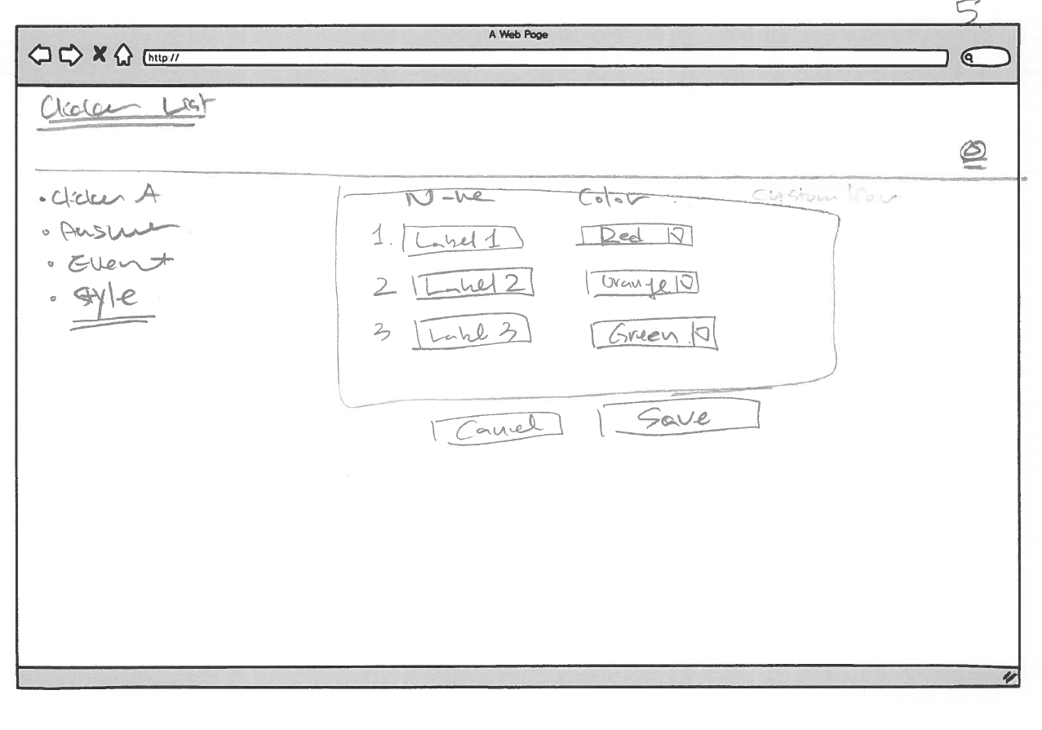

## Non-functional

### Security

| **ID** | **Requirement** | **Source** | **Cat** |
| --- | --- | --- | --- |
| .1 | *SSO login* |  | M |

### QA/Testing

| **ID** | **Use Case** | **Date/Status** |
| --- | --- | --- |
| .1 |  |  |
| 2. |  |  |

# Issues/Questions

| **Issue #** | **Issue/Resolution Description** | **Date/Status** |
| --- | --- | --- |
|  |  |  |
|  |  |  |
|  |  |  |
|  |  |  |
|  |  |  |
|  |  |  |
|  |  |  |

# Revision History

Changes to the text of this document are indicated by bars in the outside margin adjacent to the affected text.

| **Date** | **Change Description** |
| --- | --- |
| 10/01/2015 | Initial draft. |
|  |  |
|  |  |