Single Sign On

|  |  |
| --- | --- |
| REQ No.  1 | Project  SSO |

Abstract

| **Rev** | **Date** | **Author** | **Status** |
| --- | --- | --- | --- |
| 1 | Dec. 01, 2015 | Ji Lucas | First draft |
| 2 |  |  |  |
|  |  |  |  |

Distribution List

|  |  |
| --- | --- |
| **Reviewers** | **FYI** |
| Ji Lucas |  |

Table of Contents

1. Introduction 4

2. Related Documents/Links/People 4

3. Glossary 4

4. Scope 4

4.1. Goals and Objectives 4

4.2. In Scope 4

4.3. Out of Scope 4

4.4. Assumptions 4

4.5. Constraints 4

4.6. Dependencies 5

4.7. Risks 5

5. Requirements 5

5.1. RESTful API 5

5.2. Rate Limiting 5

5.3. Operations 6

5.4. Domain Model 6

5.5. UI 7

5.6. Non-functional 10

5.6.1. Security 10

5.6.2. QA/Testing 10

Issues/Questions 10

6. Revision History 10

Single Sign On

# Introduction

# Related Documents/Links/People

References in the text throughout this document appear in square brackets (e.g., [1], [JS]).

| **Reference** | **Document/Link/Person/Application** |
| --- | --- |
|  |  |
|  |  |
|  |  |
|  |  |
|  |  |
|  |  |
|  |  |
|  |  |

# Glossary

| **Term** | **Definition** |
| --- | --- |
| AIDR |  |
| MicroMappers |  |
| Clickers |  |
| AIDR DATA |  |
| MicroMaps |  |
| User Agreement sample |  |

# Scope

## Goals and Objectives

## In Scope

* Single Sign On via twitter, Facebook, Google
* TOS has to be accepted
* Show twitter tos
* Crisis Computing ToS Should be enforced to any download or any data downloadable pages.
* ToS, Privacy policy and data policy has to be provided.

## Out of Scope

## Assumptions

## Constraints

## Dependencies

* AIDR
* AIDR-DATA
* MICROMap

## Risks

# Requirements

The following subsections define software requirements. Each requirement is labeled as follows:

* **ID.** The unique identifier for the requirement.
* **Requirement.** A clear and concise description of the requirement.
* **Source.** A cross-reference to the source of the requirement.
* **Cat**egory**.** A classification for the requirement using the selections from Table 1.

Table 1 - Requirement Categories

| **Category** | **Description** |
| --- | --- |
| **M**andatory | Required minimum functionality. |
| **O**ptional | Nice to have and will be implemented if time permits. |
| **F**uture | Will not be implemented now but should be considered for a future enhancement. |
| **D**ropped | Requirement determined to be completely out of scope **after** baseline. |
| **E**xisting | Functionality already present in the software (for documentation purposes). |
| **Op**erational | Will not be addressed in the software (documented for training purposes). This requirement should have a related item in the issue list in order to identify an owner. |

| **ID** | **Requirement** | **Source** | **Cat** |
| --- | --- | --- | --- |
| .1 | User shouldn’t be able to see any aidr-data until sign-in |  | M |
| .2 | User should be able to sign in twitter, facebook, gmail |  | M |
| .3 | User should be able to enter his/her email via profile page |  | M |
| .4 | User’s info should be stored into the DB |  | M |
| .5 | User’s activity should be traced and should be stored into DB |  | M |
| .6 | The system should displace tOS when user signin or try to download |  | M |
| .7 | **For** tweet, daily limit is max 50000 / user. |  | M |
| .8 | Only one download per day per user due to the .7 |  | M |
| .9 | Admin can bypass 50000 download restriction |  | M |
| .10 | If user doesn’t sign-in, the system redirect users to sign-in page |  | M |
| .11 | If user is not active more than 30min, the session has to be killed. And, re-login is required |  | M |
| .12 | Capture user ip into database |  | M |
| .13 | Aidr interactive download page should have ToS, privacy policy, data policy link |  | M |
| .14 | Once user login, user should be able to browser data dictionary/UI. Otherwise, user shouldn’t be able to see any info |  | M |
|  |  |  |  |
|  |  |  |  |
|  |  |  |  |
|  |  |  |  |

## UI

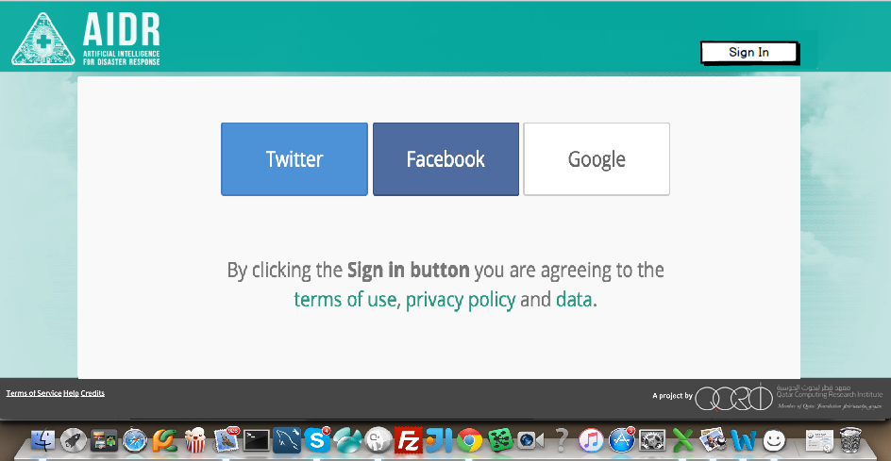

## Database

Table : account_log

|  |  |
| --- | --- |
| Column | Description |
| id | identity |
| created_at | Sign-in date/time |
| account_ip | Option, get user’s ip |
| login_port | Login from, aidr,aidr-data or microMap |

Table : download_activity_log

|  |  |
| --- | --- |
| Column | Description |
| id | identify |
| account_id |  |
| collection_id |  |
| created_at | Download date/time |

## Non-functional

### Security

| **ID** | **Requirement** | **Source** | **Cat** |
| --- | --- | --- | --- |
| .1 |  |  | M |

### QA/Testing

| **ID** | **Use Case** | **Date/Status** |
| --- | --- | --- |
| .1 |  |  |
| 2. |  |  |

# Issues/Questions

| **Issue #** | **Issue/Resolution Description** | **Date/Status** |
| --- | --- | --- |
|  |  |  |
|  |  |  |
|  |  |  |
|  |  |  |
|  |  |  |
|  |  |  |
|  |  |  |

# Revision History

Changes to the text of this document are indicated by bars in the outside margin adjacent to the affected text.

| **Date** | **Change Description** |
| --- | --- |
| 12/01/2015 | Initial draft. |
|  |  |
|  |  |