Skybox Requirements

|  |  |
| --- | --- |
| REQ No.  1 | Project  Skybox |

Abstract

Skybox will provide satellite imagery in the Guyana rainforest, Rupununi and middle/uppper Mazaruni regions about 9-10 months. During the period, MicroMappers will fetch these imagery to customized aerial clicker. Then, digital volunteers will identify all mining activities including illegal mining that is causing rapid deforestation, sedimentation and contamination.

| **Rev** | **Date** | **Author** | **Status** |
| --- | --- | --- | --- |
| 1 | 26/01/2015 |  | start |
| 2 |  |  |  |
| 3 |  |  |  |
|  |  |  |  |
|  |  |  |  |

Distribution List

|  |  |
| --- | --- |
| **Reviewers** | **FYI** |
| Ji Lucas  Patrick  Heather |  |

Table of Contents

1. Introduction 4

2. Related Documents/Links/People 4

3. Glossary 4

4. Enhancement Scope 4

4.1. Goals and Objectives 4

4.2. In Scope 4

4.3. Out of Scope 4

4.4. Assumptions 4

4.5. Constraints 4

4.6. Dependencies 4

4.7. Risks 5

5. Requirements 5

5.1. Database 5

5.1.1. Database Scope 5

5.1.2. Database Schema 5

5.2. Application Requirements 5

5.2.1. Architect & Design 5

5.2.2. Application Layer Deign 5

5.2.3. Limitation 5

5.2.4. General Requirements 5

5.2.5. Data Details 6

5.2.6. Sample Data 6

5.3. Client Applications 6

5.3.1. Scope 6

5.3.2. Requirement 6

5.4. Non-functional 6

5.4.1. Security 6

5.4.2. Testing 6

Issues/Questions 6

6. Revision History 7

Skybox

# Introduction

This requirement is for services from Google Skybox Imagery to a customized aerial clicker. Then, from data output of aerial clicker that is produced by digital volunteers to visual results.

# Related Documents/Links/People

References in the text throughout this document appear in square brackets (e.g., [1], [JS]).

| **Reference** | **Document/Link/Person/Application** |
| --- | --- |
|  |  |
|  |  |
|  |  |
|  |  |
|  |  |
|  |  |
|  |  |
|  |  |

# Glossary

| **Term** | **Definition** |
| --- | --- |
| Skybox |  |
| MicroMappers |  |
| geotiff |  |
| geotools api | Open source java gis toolkits http://geotools.org/ |
|  |  |

# Application Architect

## High level design

We will receive imagery in target areas for 9months bi-weekly. The system should get imageries automatically, then, the system should generate smaller tiles and generate json feed files for aerial clicker for crowd-sourcing. All crowd-sourcing data should be evaluated based on BI rule and push to map for data output result.



## In Scope

* Imagery should split into small tiles/images to render
* Small tiles should have its original Imagery association. And, its associated info should be accessible publically.
* Smaller tiles should have geo-reference info including bounding box.
* The process should generate json format file to feed aerial clicker.
* Skybox Aerial clicker’s task publishing should be handed by MicroMappersPybossa
* Skybox Aerial clicker’s task importing should be handed by MicroMappersPybossa
* Skybox Aerial clicker requires 3 votes at least
* MicroMappers will filter 2 of 3 votes per one task from the completed tasks.
* The filtered tasks should send as final result outputs.

## Out of Scope

## Assumptions

* Skybox imagery should be geo-fenced geotif

## Constraints

## Dependencies

* MM_API should be available

## Risks

# Requirements

The following subsections define software requirements. Each requirement is labeled as follows:

* **ID.** The unique identifier for the requirement.
* **Requirement.** A clear and concise description of the requirement.
* **Source.** A cross-reference to the source of the requirement.
* **Cat**egory**.** A classification for the requirement using the selections from Table 1.

Table 1 - Requirement Categories

| **Category** | **Description** |
| --- | --- |
| **M**andatory | Required minimum functionality. |
| **O**ptional | Nice to have and will be implemented if time permits. |
| **F**uture | Will not be implemented now but should be considered for a future enhancement. |
| **D**ropped | Requirement determined to be completely out of scope **after** baseline. |
| **E**xisting | Functionality already present in the software (for documentation purposes). |
| **Op**erational | Will not be addressed in the software (documented for training purposes). This requirement should have a related item in the issue list in order to identify an owner. |

## Database

### Database design

It will be design of mm_media that handles all media type in the future. For skybox integration process, the system will handle geotif data.

### Database Schema

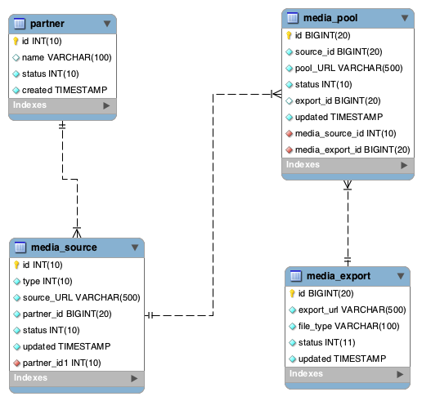

## Application Requirements

### Architect & Design

### Application Layer Deign

### Limitation

### General Requirements

| **ID** | **Requirement** | **Source** | **Cat** |
| --- | --- | --- | --- |
| .1 | The system will be use open source java gis toolkits to generate smaller tiles. The specific library is org.geotools.utils.coveragetiler. |  | M |
| .2 | The system will generate 600 x 600 dimension tiles. |  | M |
| .3 | The system will post sliced images to google picasa |  |  |
| .4 | The system will generate json files to feed Aerial clicker. |  |  |
| .5 | Each json file will hold max. 1000 records only. |  |  |
|  |  |  |  |
|  |  |  |  |
|  |  |  |  |
|  |  |  |  |
|  |  |  |  |
|  |  |  |  |
|  |  |  |  |
|  |  |  |  |

### Data Details

### Sample Data

N/A

## Client Applications

### Scope

### Requirement

## Non-functional

### Security

| **ID** | **Requirement** | **Source** | **Cat** |
| --- | --- | --- | --- |
| .1 |  |  |  |

### Testing

| **ID** | **Requirement** | **Source** | **Cat** |
| --- | --- | --- | --- |
| .1 |  |  |  |

# Issues/Questions

| **Issue #** | **Issue/Resolution Description** | **Date/Status** |
| --- | --- | --- |
|  | The coordinates below are based on community monitoring on the ground in Guyana:  1.97324, -59.62253  2.01511, -59.53439  2.02430, -59.20491  3.05985, -59.32707 | Feb. 17, 2015 |
|  |  |  |
|  |  |  |
|  |  |  |
|  |  |  |
|  |  |  |
|  |  |  |

# Revision History

| **Date** | **Change Description** |
| --- | --- |
|  | Initial draft. |
|  |  |
|  |  |
|  |  |