Translators Without Borders

|  |  |
| --- | --- |
| No.  1 | Project  Translators without borders |

Abstract

| **Rev** | **Date** | **Author** | **Status** |
| --- | --- | --- | --- |
| 1 | 10/03/2015 |  | start |
| 2 |  |  |  |
| 3 |  |  |  |
|  |  |  |  |
|  |  |  |  |

Distribution List

|  |  |
| --- | --- |
| **Reviewers** | **FYI** |
| JI LUCAS  Rebecca Petras  Kamal Shah  Jason Grimes  Dan Landy | MicroMappers Team |

Table of Contents

1. Introduction 4

2. Related Documents/Links/People 4

3. Glossary 4

4. Application Design 4

4.1. High Level Application Design 4

4.2. Database 6

4.3. Application Design 7

4.4. Client Application 7

4.5. In Scope 7

4.6. Out of Scope 7

4.7. Assumptions 7

4.8. Constrains 7

4.9. Dependencies 7

4.10. Risks 7

5. Requirements 7

5.1. Requirement Spec. 8

5.2. Non-functional 8

5.2.1. Security 8

5.2.2. QA/Testing 8

Issues/Questions 9

6. Revision History 9

Translators without borders

# Introduction

# Related Documents/Links/People

References in the text throughout this document appear in square brackets (e.g., [1], [JS]).

| **Reference** | **Document/Link/Person/Application** |
| --- | --- |
|  |  |
|  |  |
|  |  |
|  |  |
|  |  |
|  |  |
|  |  |
|  |  |

# Glossary

| **Term** | **Definition** |
| --- | --- |
|  |  |
|  |  |
|  |  |
|  |  |
|  |  |

# Application Design

## High Level Application Design



## Database

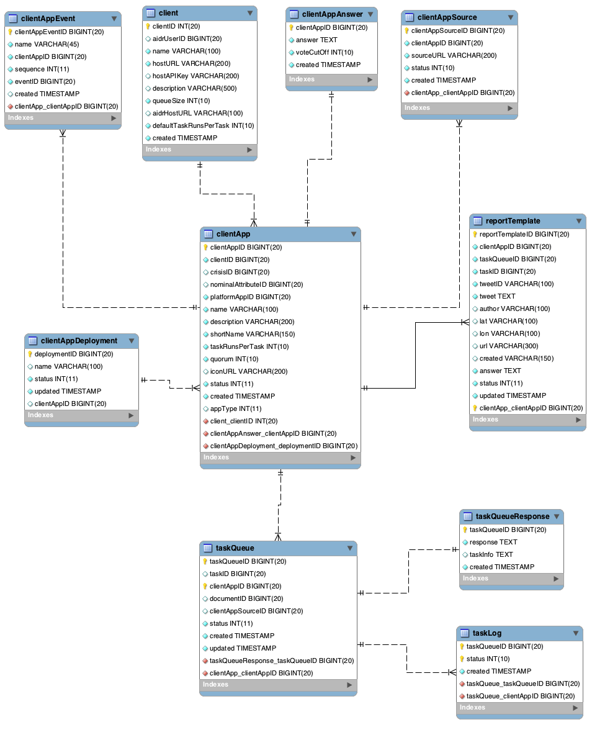

|  |  |  |
| --- | --- | --- |
| TABLE NAME | DESCRIPTION | NOTE |
| clientApp | holds each clicker configuration |  |
| taskQueue | holds all available & completed tasks |  |
| taskQueueResponse | holds completed task responses |  |
| reportTemplate | holds task info with answer that is used to generate geo clicker’s data feed |  |
| clientAppAnswer | Holds answers and answer business logic | Need to re-structure json |
|  |  |  |

## Application Design

## Client Application

## In Scope

## ­Out of Scope

## Assumptions

## Constrains

## Dependencies

## Risks

# Requirements

The following subsections define software requirements. Each requirement is labeled as follows:

* **ID.** The unique identifier for the requirement.
* **Requirement.** A clear and concise description of the requirement.
* **Source.** A cross-reference to the source of the requirement.
* **Cat**egory**.** A classification for the requirement using the selections from Table 1.

Table 1 - Requirement Categories

| **Category** | **Description** |
| --- | --- |
| **M**andatory | Required minimum functionality. |
| **O**ptional | Nice to have and will be implemented if time permits. |
| **F**uture | Will not be implemented now but should be considered for a future enhancement. |
| **D**ropped | Requirement determined to be completely out of scope **after** baseline. |
| **E**xisting | Functionality already present in the software (for documentation purposes). |
| **Op**erational | Will not be addressed in the software (documented for training purposes). This requirement should have a related item in the issue list in order to identify an owner. |

## Requirement Spec.

| **ID** | **Requirement** | **Source** | **Cat** |
| --- | --- | --- | --- |
|  |  |  |  |

## Non-functional

### Security

| **ID** | **Requirement** | **Source** | **Cat** |
| --- | --- | --- | --- |
| .1 |  |  |  |

### QA/Testing

| **ID** | **Requirement** | **Source** | **Cat** |
| --- | --- | --- | --- |
| .1 | Staging server information  DEPLOYMENT NAME  QCRICL1LinuxVM2  PUBLIC VIRTUAL IP (VIP) ADDRESS  23.102.28.40  INPUT ENDPOINTS  QCRICL1LinuxVM2 : 23.102.28.40:8081 - Glassfish applications  QCRICL1LinuxVM2 : 23.102.28.40:4848 - Glassfish server access via UI  QCRICL1LinuxVM2 : 23.102.28.40:80 - Taken  QCRICL1LinuxVM2 : 23.102.28.40:8090 - MicroFilters Application  QCRICL1LinuxVM2 : 23.102.28.40:5000 - MicroMappers Pybossa server  QCRICL1LinuxVM2 : 23.102.28.40:22 - Taken  Mysql Access(MicroMappers Core) :  Port :3306, port is opened.   |  |  | | --- | --- | | **User Name** | **PassWord** | | twb_dev | sgh!78rtw |   postgreSQL Access(MicroMappers - Pybossa) :  Port : 5432  dbSchema : pybossa   |  |  | | --- | --- | | **User Name** | **PassWord** | | twb_dev | sgh!78rtw |   Glassfish Access :  Port :4848, it is opened.   |  |  | | --- | --- | | **User Name** | **PassWord** | | admin | admun |   Account: sudo access is granted   |  |  | | --- | --- | | **User Name** | **PassWord** | | twb_dev | sgh!78rtw | |  |  |
| .2 | Test locally against staging MicroMappers-pybossa  Aidr_scheduler.client table:  hostURL : update with staging server info |  |  |

# Issues/Questions

| **Issue #** | **Issue/Resolution Description** | **Date/Status** |
| --- | --- | --- |
|  |  |  |
|  |  |  |
|  |  |  |
|  |  |  |
|  |  |  |
|  |  |  |
|  |  |  |

# Revision History

| **Date** | **Change Description** |
| --- | --- |
|  | Initial draft. |
|  |  |
|  |  |
|  |  |