# ARTV2- Documentation

Automated Rodent and Whisker tracking is an open-source software for tracking rodents and whiskers from videos. AWRT is developed in C# with WPF using a MVVM design pattern to allow the code to be modular and usable with other projects and allowing for new code to be added easily to the project.

AWRT can read in .AVI video formats. This document will provide documentation and usage of the software. It will be split into two sections; processing a single video and batch processing videos.

Contents

ARTV2- Documentation 1

Single Video Usage 4

New Session 4

Frame 4

ROI 4

Binary Threshold 4

Gap Distance 4

Motion Threshold 4

Interaction Threshold 4

Motion Length 4

Find Whiskers 4

Outer Boundary 4

Preview 5

Ok 5

Cancel 5

Whisker Settings 6

Crop Scale Factor 6

Resolution Increase Scale Factor 6

Interpolation Type 6

Remove Duds 6

Minimum whisker threshold – 256 Max 6

Lower Bound 6

Upper Bound 6

Preview 6

Ok 6

Processed Data View 7

File – Save 7

File – Load 7

File – New 7

Large Image 7

Export Raw Data 7

Show Data 7

Single Video Data Screen 8

Start frame 8

End frame 8

Original Frame Rate 8

Units to MM 8

Smoothing function 8

Repeat Smoothing 9

Use DFT for frequency 9

Batch Process multiple video 10

New Session 10

Batch Process View 10

Add File 10

Add Folder 10

Remove File 10

Clear List 10

Process 10

Batch Export 10

Settings 10

Videos to run at once 10

Settings 11

Preview Image 11

Gap Distance 11

Binary Threshold 11

Binary Threshold 2 11

ROI 11

Whisker Settings 11

Ok 11

Cancel 11

Whisker Settings 12

Crop Scale Factor 12

Resolution Increase Scale Factor 12

Interpolation Type 12

Remove Duds 12

Minimum whisker threshold – 256 Max 12

Lower Bound 12

Upper Bound 12

Preview 12

Ok 12

Review 13

Preview Image 13

Start 13

End 13

Save 13

Export Raw 13

Export Mean Whiskers 13

Batch Export 14

Original Frame Rate 14

Units to MM 14

Smoothing function 14

Repeat Smoothing 14

Use DFT for frequency 14

# Single Video Usage

This program allows users to load a single or multiple .AVI video files to be processed. This section will cover usage with a single video file.

## New Session

To begin, press file and new. This will ask you to load in a video file to process. Beginning a new session.

### Frame

This allows you to scrub through the video file, frame by frame, with the adjacent image changing to that file.

### ROI

The ROI is the region of interest. It is automatically calculated when the video is processed but it can be changed by using the buttons provided.

#### Set

This allows you to choose a new region of interest within the video frame. This can be useful if you wish to observe one part of the video.

#### Remove

This will remove the set ROI and return it to the default choice.

### Binary Threshold

This allows you to change the threshold of the video, to allow better see the rodent within the video, and for whisker tracking.

### Gap Distance

This allows you to change the gap points between points that have been detected on the rodents head.

### Motion Threshold

Set the threshold for the motion detection

### Interaction Threshold

Set a threshold for the interaction Detection

### Motion Length

Set a length for the motion detection

### Find Whiskers

This check box, is for if you wish to find whiskers within the video.

### Outer Boundary

This displays the outer boundary of the region of interest.

### Preview

This will update the images on the side of the screen, showing the rodents outline, outer boundary, the thresholded image and the motion of the mouse.

### Ok

Will begin to process the video.

### Cancel

Will cancel processing the video.

## Whisker Settings

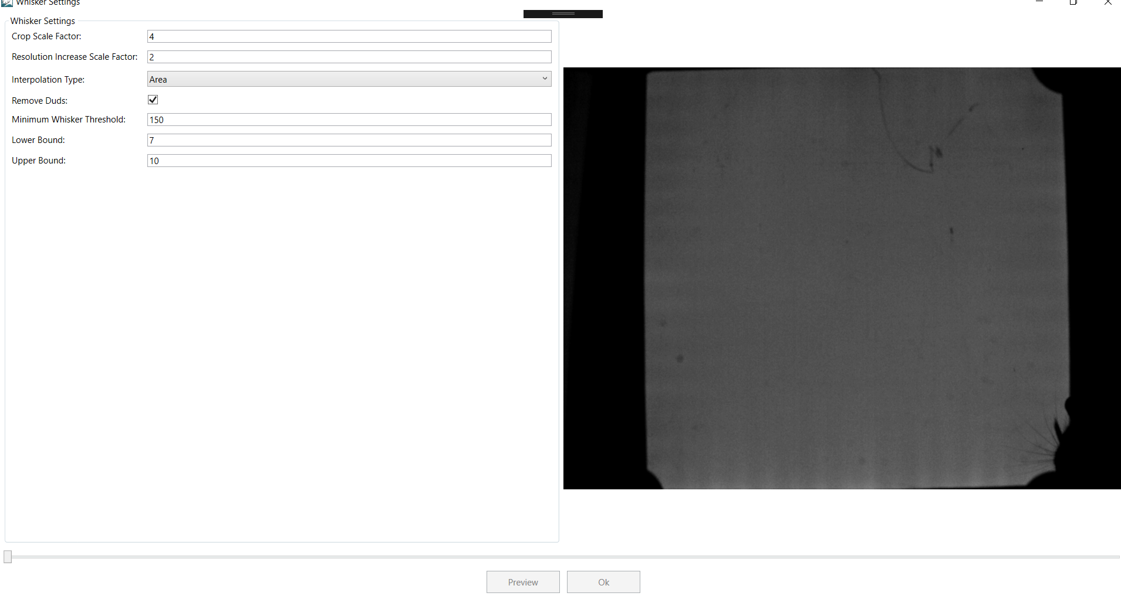This allows you to change settings within the software to detect whiskers in an image. It will only detect whiskers and allow you to preview the image after it has detected a rodent body in the image. Process can also take some time.

### Crop Scale Factor

Crop Factor effects the cropping of the whiskers

### Resolution Increase Scale Factor

The factor to which to increase the image by using bilinear interpolation. The default setting is 2x

### Interpolation Type

The interpolation type to use while finding whiskers. There are 5 filters: Area, Cubic, Lanczos, Nearest Neighbour and Linear.

### Remove Duds

Remove dud whiskers if selected. Or selects the non-dud ones.

### Minimum whisker threshold – 256 Max

A minimum whisker threshold for the colour of the whisker. It ranges between 0 and 255.

### Lower Bound

Select the lower bound for the threshold for the whiskers

### Upper Bound

Select the upper bound for the threshold for the whiskers

### Preview

This will update the images on the side of the screen, showing the rodents outline, outer boundary and the whiskers on the image.

### Ok

Will process the video to detect whiskers.

## Processed Data View

After the data is processed, it is displayed in a main view. Allowing you to scrub through the video frames, export data and view the data.

### File – Save

This allows you to save the processed video to file as an ARTV2 file. Which can be loaded back into the software.

### File – Load

For loading the ARTV2 file.

### File – New

Allows you to work on a new video.

### Large Image

The large image in the view, displays a frame from the video. It displays the frame number of the image, the outer boundary of the image, the rodent outline, whiskers and the movement of the mouse.

The yellow line is the boundary of the rodent.

The redline is the outer boundary.

The blue line is the calculated movement of the rodent, based on a central point between the tail and the head.

The red circle denotes the central point on the mouse,

If whiskers were detected:

Whiskers are displayed as lines on the image and a central point is displayed on the head.

### Export Raw Data

Exports the average data of the video for whisker and rodent movement

### Show Data

This displays the data calculated from the video in a separate screen.

## Single Video Data Screen

This screen displays the data calculated across the whole video, displaying the various statistics, and two graphs of the average angle of the whiskers. This view also allows you to calculate statistics over a selection of frames. Choosing a smoothing function and other settings to calculate the data.

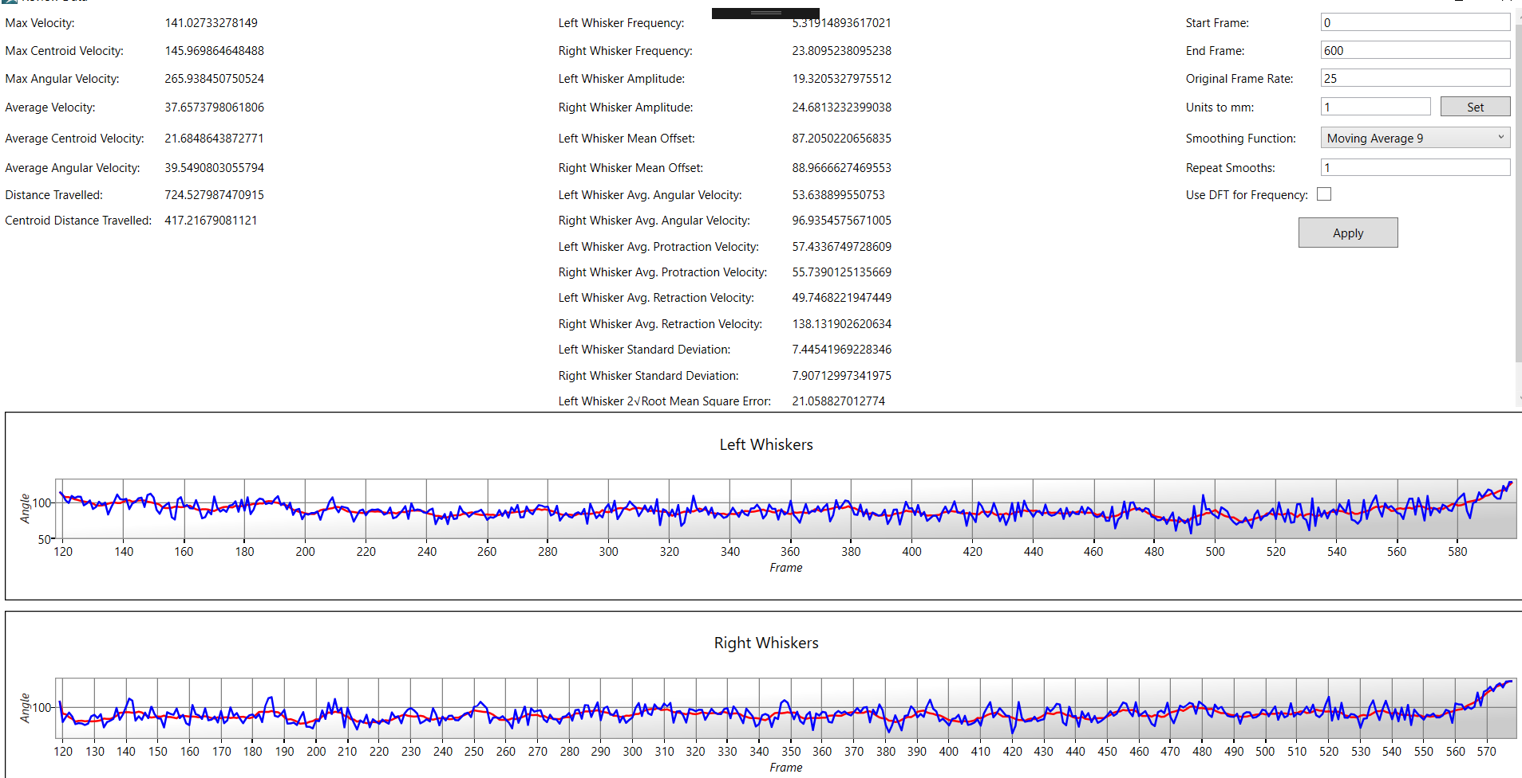Stats calculated over the frame include:

* Max velocity:
* Max Centroid Velocity
* Max Angular Velocity
* Average Velocity
* Average Centroid Velocity
* Average Angular Velocity
* Distance travelled
* Centroid Distance Travelled

Whisker stats calculated include:

* Left whisker frequency
* Right whisker frequency
* Left whisker amplitude
* Right whisker amplitude
* Left whisker mean offset
* Right whisker mean offset
* Left whisker average angular velocity
* Right whisker average angular velocity
* Left whisker average protraction velocity
* Right whisker average protraction velocity
* Left whisker average retraction velocity
* Right whisker average retraction velocity

Statistics are calculated by adjusting the following:

### Start frame

The frame from which you wish to first calculate the statistics.

### End frame

The frame from which you want to end the calculations at.

### Original Frame Rate

Adjust the frame rate to the frame rate of the video

### Units to MM

Adjust the units that are used to be as accurate as possible.

### Smoothing function

A smoothing function to smooth the data.

### Repeat Smoothing

How often to smooth the data.

### Use DFT for frequency

A check box for is the user would like to use the Discrete Fourier Transform function for the frequency for the data.

# Batch Process multiple video

Batch processing allows multiple videos to be processed, instead of a single video at a time. This section will cover the process of using batch processing.

## New Session

To begin, press file and batch process. This will take you to a new screen to add videos etc.

## Batch Process View

This view allows for videos to be process and the data for each of the videos to be reviewed as well.

### Add File

This allows you to add a video file to the list of videos to be batch processed.

### Add Folder

This allows for a folder with videos to be added automatically to the list to be batch processed

### Remove File

This will remove a selected file

### Clear List

This will clear the list of videos

Get Output Folder

You can load your processed files from here.

Allows you to select a video that you saved your results in.

### Process

This will process the videos within the list, using parameters that have been set in the settings.

### Batch Export

This will export the results of the processing out, a batch at a time.

### Settings

You can adjust the parameters within the settings, on how you would like the rodent to be detected and if you wish for whiskers to be detected.

### Videos to run at once

You can choose the amount of videos you wish to be processed at once. Processing more videos will use more resources on the computer.

## Settings

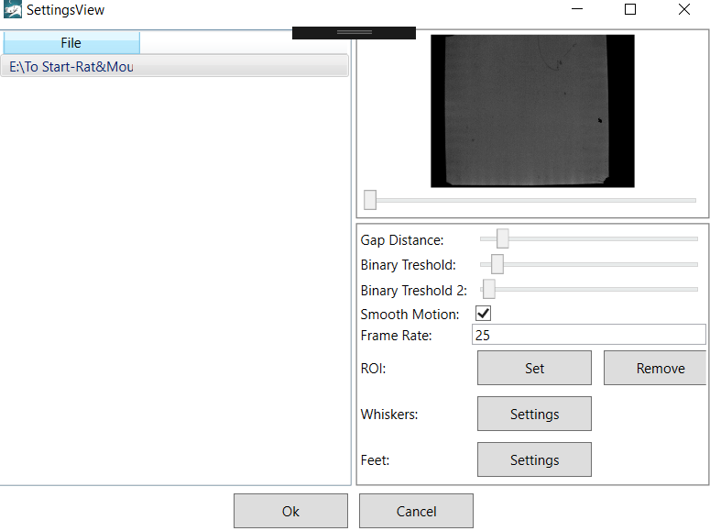

This view allows you to set the settings for each of the video for how you would like it to be processed.

### Preview Image

This displays a preview image with a frame from the video. It automatically updates if settings are adjusted in the settings such as threshold or keypoint gap. A slider is provided to allow users to scrub through the video file, frame by frame, with the preview window updating.

### Gap Distance

This allows you to change the gap points between points that have been detected on the rodents head.

### Binary Threshold

This allows you to change the threshold of the video, to allow better see the rodent within the video, and for whisker tracking.

### Binary Threshold 2

This allows you to include another binary threshold on the image to see the rodent within the video, and for whisker tracking.

Smooth Motion

A check box, for if you wish tracking to be smooth or calculated on a frame by frame basis.

### ROI

The ROI is the region of interest. It is automatically calculated when the video is processed but it can be changed by using the buttons provided.

#### Set

This allows you to choose a new region of interest within the video frame. This can be useful if you wish to observe one part of the video.

#### Remove

This will remove the set ROI and return it to the default choice.

### Whisker Settings

This button will open a new view to adjust the parameters for searching for whiskers.

### Foot Settings

This button will open a new view to adjust the parameters for searching for whiskers.

### Ok

Will save the settings for the video to be processed.

### Cancel

Will not save the settings and exit the view.

## Whisker Settings

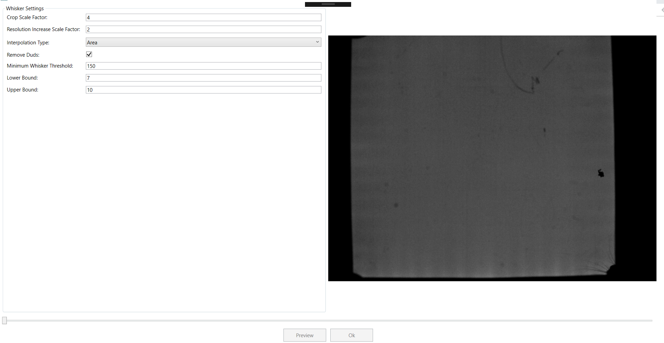This allows you to change settings within the software to detect whiskers in an image. It will only detect whiskers and allow you to preview the image after it has detected a rodent body in the image. Process can also take some time.

### Crop Scale Factor

Crop Factor effects the cropping of the whiskers

### Resolution Increase Scale Factor

The factor to which to increase the image by using bilinear interpolation. The default setting is 2x

### Interpolation Type

The interpolation type to use while finding whiskers. There are 5 filters: Area, Cubic, Lanczos, Nearest Neighbour and Linear.

### Remove Duds

Remove dud whiskers if selected. Or selects the non-dud ones.

### Minimum whisker threshold – 256 Max

A minimum whisker threshold for the colour of the whisker. It ranges between 0 and 255.

### Lower Bound

Select the lower bound for the threshold for the whiskers

### Upper Bound

Select the upper bound for the threshold for the whiskers

### Preview

This will update the images on the side of the screen, showing the rodents outline, outer boundary and the whiskers on the image.

### Ok

Will save the settings for the whiskers to be detected.

## Foot Settings

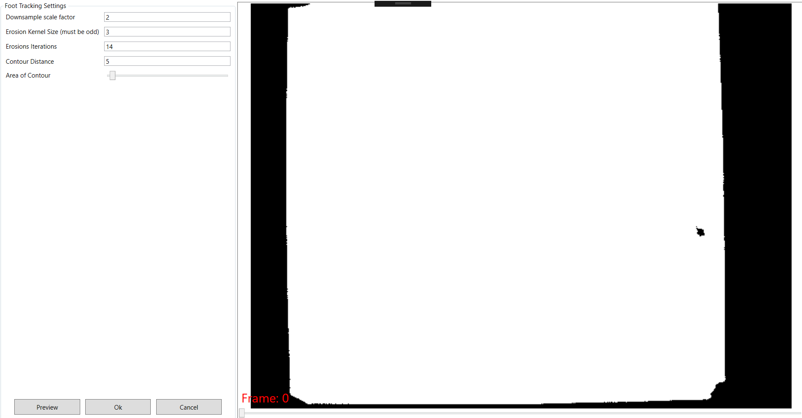This allows you to change settings within the software to detect feet in an image. It will only detect feet and allow you to preview the image after it has detected a rodent body in the image. Process can also take some time.

### Downsample Scale Factor

The factor to which to decrease the image resolution by using bilinear interpolation. The default setting is 2x

### Erosion Kernel Size

The size of the kernel to erode the image, the larger the kernel, the more that is eroded.

### Erosion Iterations

The number of times to erode an image

### Contour Distance

This is the distance between contours of the eroded image, and which to make into a foot

### Area of Contour

Any contour with an area less than the specified amount, will be discarded.

### Preview

This will update the images on the side of the screen, showing the rodents outline, outer boundary and the feet on the image.

### Ok

Will save the settings for the feet to be detected.

## Review

After the videos have been processed, they can be individually reviewed by pressing the r next to the video.

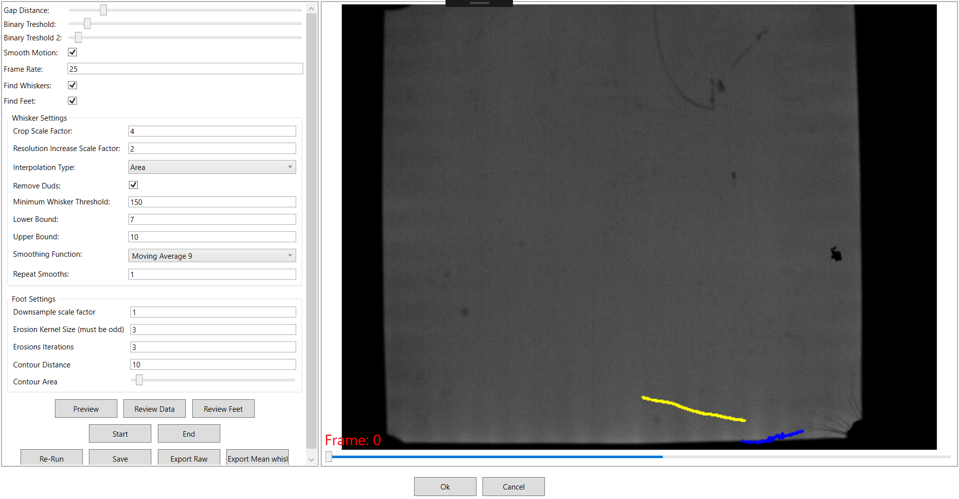This takes you to a new screen, that allows you view the settings used to process the video and make adjustments.

They use the same settings as in the Settings and Whisker Settings. However, there are slight differences as it allows you to deselect whisker tracking and not choose a new ROI.

There are other changes too.

### Preview Image

The preview image in the view, displays a frame from the video. It displays movement of the nose point, central point between the mouse and tail and whiskers.

The yellow line is the calculated movement of the rodent, based on a central point between the tail and the head.

The blue line is the calculated movement of the rodent, based on the nose point of the mouse.

The red circle denotes the central point on the mouse, and the nose point.

If whiskers are detected:

Whiskers are displayed as lines on the image.

### Review Data

This allows you to review the data, exactly the same as that in the single video exploration.

Review Feet

This allows the user to manually review the foot data and export a CSV with all of the Data.

### Start

The end button allows a user to select an start frame from the slider.

### End

The end button allows a user to select an end frame from the slider.

Re-run

This will re process the video, from the frames selected in the slider menu.

### Save

Overwrites the original AWRT file

### Export Raw

Exports the raw data as a csv for all of the whiskers, and body and head points.

### Export Mean Whiskers

Exports the mean whisker data as a csv file.

## Batch Export

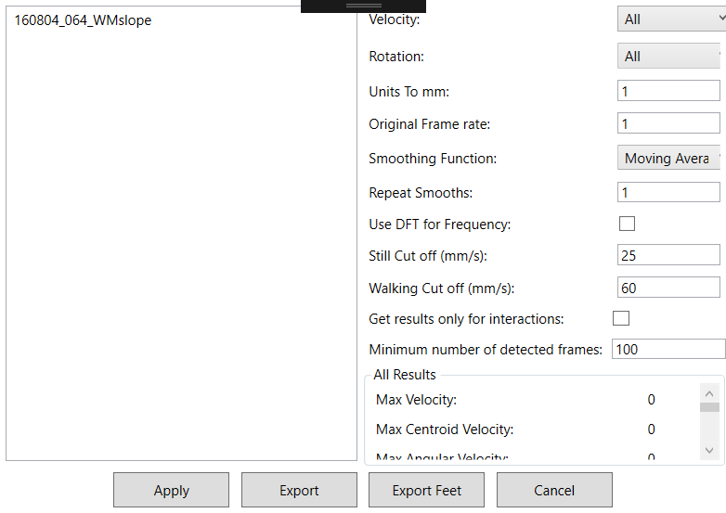

Exports the data that from processed from the videos, including the stats:

Stats calculated over the frame include:

* Max velocity:
* Max Centroid Velocity
* Max Angular Velocity
* Average Velocity
* Average Centroid Velocity
* Average Angular Velocity
* Distance travelled
* Centroid Distance Travelled

Whisker stats calculated include:

* Left whisker frequency
* Right whisker frequency
* Left whisker amplitude
* Right whisker amplitude
* Left whisker mean offset
* Right whisker mean offset
* Left whisker average angular velocity
* Right whisker average angular velocity
* Left whisker average protraction velocity
* Right whisker average protraction velocity
* Left whisker average retraction velocity
* Right whisker average retraction velocity

Statistics are calculated by adjusting the following:

### Original Frame Rate

Adjust the frame rate to the frame rate of the video

### Units to MM

Adjust the units that are used to be as accurate as possible.

### Smoothing function

A smoothing function to smooth the data.

### Repeat Smoothing

How often to smooth the data.

### Use DFT for frequency

A check box for is the user would like to use the Discrete Fourier Transform function for the frequency for the data.

### Export Foot Data

This exports the average foot data for each of the clips being processed.

Data can be excluded by choosing the appropriate data from the panels on the side.

## Summary of Statistics Exported

|  |  |  |  |
| --- | --- | --- | --- |
| **Name** | **Units** | **Definition** | **References** |
| Body movement measures: calculated from the nose and head points and the centre of mass. | | | |
| Distance | mm | Total distance travelled by the nose tip of the mouse, per clip. Converted from pixels to mm before exporting results. |  |
| Centroid Distance | mm | Total distance travelled by the centre of mass of the mouse, per clip. Converted from pixels to mm before exporting results. | Hewitt et al., 2018 |
| Max Speed | mm/s | Speed is calculated frame-by-frame using distance divided by time, and this is the maximum speed. The number is divided by 1000 to bring it to the speed associated with high-speed cameras. |  |
| Max Angular Speed | deg/s | Angular Speed is calculated frame-by-frame using angle travelled divided by time, and this is the maximum speed. The number is divided by 1000 to bring it to the speed associated with high-speed cameras. The angle is calculated from the nose-to-head vector with the vertical. |  |
| Average Speed | mm/s | Speed is calculated frame-by-frame using distance divided by time, and this is the mean of all the frames. The number is divided by 1000 to bring it to the speed associated with high-speed cameras. | Hewitt et al., 2018 |
| Average Angular Speed | deg/s | Angular Speed is calculated frame-by-frame using angle travelled divided by time, and this is the mean of all the frames. The number is divided by 1000 to bring it to the speed associated with high-speed cameras. The angle is calculated from the nose-to-head vector with the vertical. | Hewitt et al., 2018 |
| Average Centroid Speed | mm/s | Centroid speed is calculated frame-by-frame using distance divided by time, and this is the mean of all the frames. The number is divided by 1000 to bring it to the speed associated with high-speed cameras. | Hewitt et al., 2018;  Simanaviciute et al., 2020 |
| Max Centroid Speed | mm/s | Centroid speed is calculated frame-by-frame using distance divided by time, and this is the maximum speed. The number is divided by 1000 to bring it to the speed associated with high-speed cameras. |  |
| Whisker movement and position measures: calculated from the per-frame angular position data that is made between the whiskers and the mid-point of the head. | | | |
| Left/Right Whisker Frequency | Hz | The number of full whisk cycles (peak to peak) per second, calculated using an auto-correlogram of the mean left and mean right angular positions. Calculated separately for left and right whisker sides. | Hewitt et al., 2016;  Gillespie et al., 2019 |
| Left/Right Whisker Mean Angular Position | degrees | The mean angular position from all tracked whiskers. Calculated separately for left and right whisker sides. Can be used to calculate whisker asymmetry, as the difference between left and right mean angular position. | Gillespie et al., 2019;  Perkon et al., 2011; Clack et al., 2012; Pammer et al., 2013; Ahissar and Knutsen, 2008; Sofroniew et al., 2014 |
| Left/Right Whisker Average Angular Speed | deg/s | Whisker Angular Speed is calculated frame-by-frame using angle travelled divided by time from the mean angular position traces, and this is the mean of all the frames. Calculated separately for left and right whisker sides. | Hewitt et al., 2018 |
| Left/Right Whisker Average Retraction Speed | deg/s | Whisker Angular Speed is calculated frame-by-frame using angle travelled divided by time from the mean angular position traces, and this is the mean of all the backward moving whiskers. Calculated separately for left and right whisker sides. | Gillespie et al., 2019 |
| Left/Right Whisker Average Protraction Speed | deg/s | Whisker Angular Speed is calculated frame-by-frame using angle travelled divided by time from the mean angular position traces, and this is the mean of all the forward moving whiskers. Calculated separately for left and right whisker sides. | Gillespie et al., 2019 |
| Clip Duration | frames | The number of frames tracked per clip. |  |
| Left/Right Whisker Spread | degrees | Whisker spread is calculated in every frame as the Standard Deviation of all tracked whisker angular positions per side. Frames that have only 0-1 whiskers tracked are removed and then a mean is taken. Calculated separately for left and right whisker sides. | Gillespie et al., 2019;  Updated here to remove 0-1 whisker frames |
| Left/Right Peak-to-peak Amplitude | degrees | The Standard Deviation of the angular positions, multiplied by 2x√2 (standard deviation of the angular positions). Calculated separately for left and right whisker sides. Only suitable if whisking is cyclic. | Chatfield, 2003;  Grant et al., 2014;  Gillespie et al., 2019 |
| Left/Right Whisker Max Angle | degrees | Maximum angular position. Calculated separately for left and right whisker sides. Can be used to calculate maximum amplitude, as the difference between min and max angle. |  |
| Left/Right Whisker Min Angle | degrees | Minimum angular position. Calculated separately for left and right whisker sides. Can be used to calculate maximum amplitude, as the difference between min and max angle. |  |