Contents

Ant Tracking - Documentation 2

GUI Usage 3

Settings 5

Display 5

Process 5

Export Stats 5

Settings 6

Clip Limit 6

Grid Size 6

Blur Size 6

Threshold 6

Block Size 6

Min Area 6

Max Area 6

Reset Settings 6

Crop Image 7

Select ROI 8

Process 10

# Ant Tracking - Documentation

This software is for the automated tracking of ants, to be used by researchers and students. This software is open-source and can be found on github for download. I t has been designed to be modular and usable with other projects and allowing for new code to be added easily to the project.

This software can read AVI and MP4 video formats. This document will provide documentation and usage of the software.

# GUI Usage

This program allows users to load a single to load a single video to track ants. To begin, press file and load video. This will prompt the user to select a video to track.

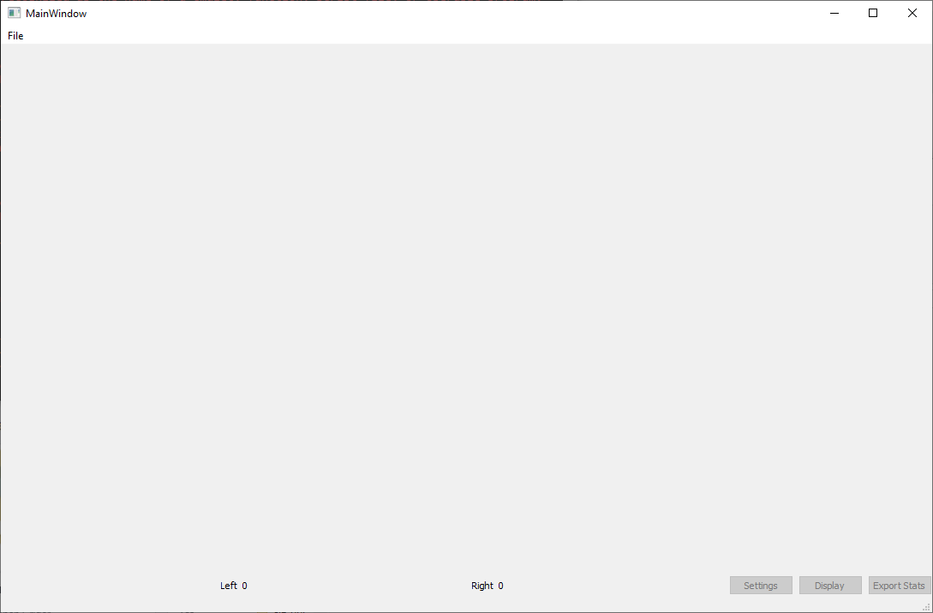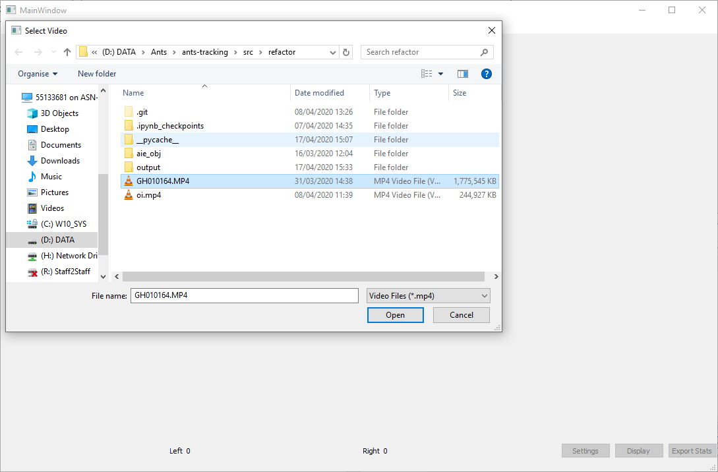

Once a video has been the video will appear within the Graphical Interface.

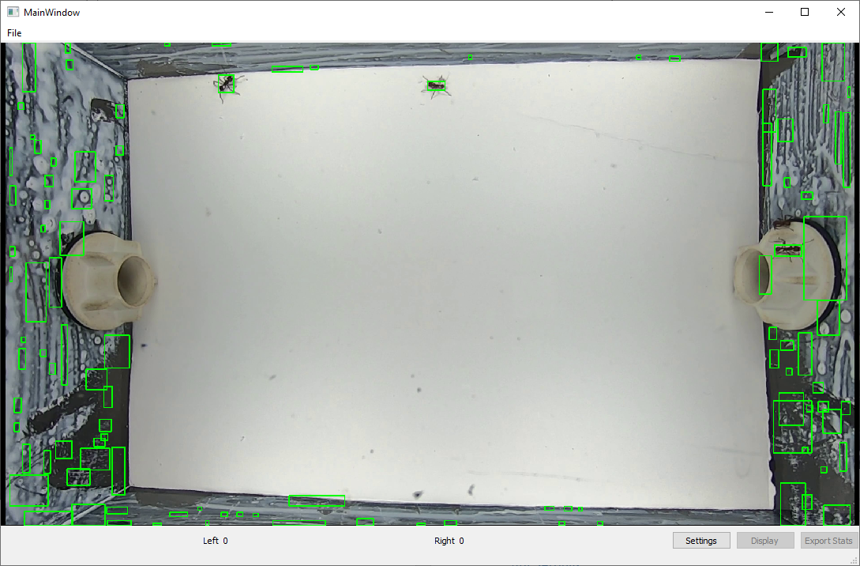

The interface has 3 buttons:

### Settings

This will open a new window and allow the user to select settings to be used for tracking the ant. Good settings have been set as default, but it needs the user to select regions of interest on where to track the ants from.

### Display

When a region of interest has been selected, this will allow the user to watch the video being processed in real time within the viewer.

### Export Stats

This allows you to export any stats of the tracked ants, that have been processed from the video.

## Settings

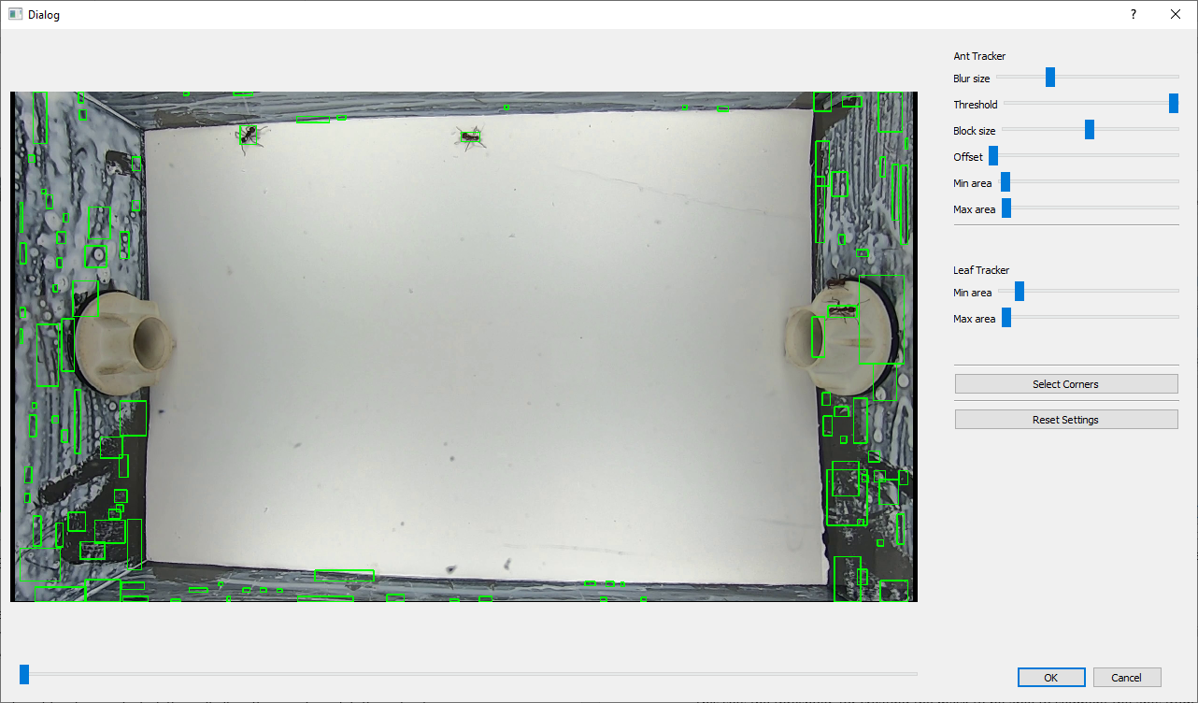This allows you to change settings within the software to detect ants in the image. It will only detect potential ants, but allow you to change settings to better select the ants and remove false positives.

## Ant Settings

### Blur Size

This slider sets the amount that the image is blurred by. This eliminates false positive detections, but too high a blur and it won’t detect the ants.

### Threshold

This sets the threshold, for creating the mask to be able to segment the ants from the image.

### Block Size

This sets the size of the area, that is used to calculate the a threshold value. A too low or large size, may increase false positives.

### Min Area

This determines the minimum area of the bounding box that is tracked.

### Max Area

This determines the maximum area of the bounding box that is tracked.

### Reset Settings

This will reset the settings to the default settings.

## Leaf Settings

### Min Area

This determines the minimum area of the bounding box that is tracked.

### Max Area

This determines the maximum area of the bounding box that is tracked.

### Selecting Corners

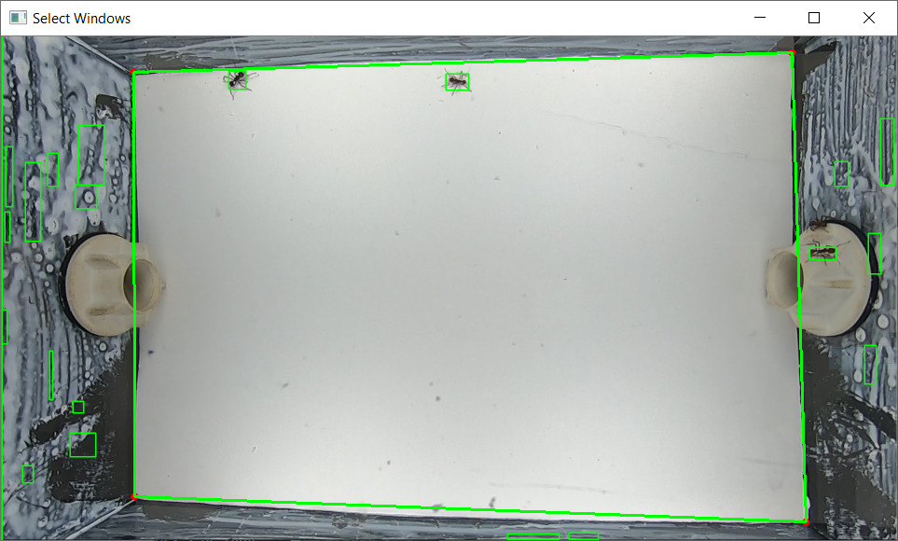

This window allows the user to select the corners of the box. This will crop the image to only being the box corners. This helps to speed up processing time, and remove false positives. This will also calibrate the image, so it is then possible to calculate a measurement per pixel, that can be used to deduce the distance the ant has moved within the scene.

You can select the corners by left clicking on the corners, and the lines and circle will be drawn as you select more corners. By right clicking, it will remove the last chosen corners.

When they have selected this, it will update on the settings window.

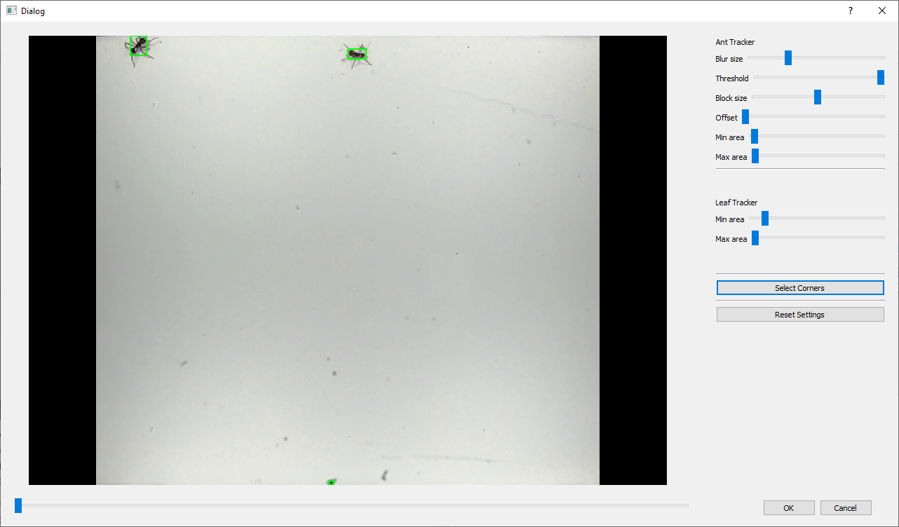

Export Stats

Data exported from this program, includes the ants/leaf ID, x and y coordinates as the ants cross the box floor. It also contains the total distance covered by the ant and its speed.

The file is exported as a pandas csv file in a pickle format. This is so that a csv file is not needed for each individual ant, and allows for the arrays to be read back in as normal for python.

It can be read in RStudio as well.

First you must install the Reticulate library:

**install.packages('reticulate')**

As well as install pandas. If you are asked to install a mini conda environment, its encouraged to install that as well.

**py_install("pandas")**

To read the pickle file in Rstudio you need to point towards the pickle_reader.py that comes with this code.

**require("reticulate")**

**source_python("read_pickle.py")**

**pickle_data <- read_pickle_file("your_file.pickle")**

The data is now loaded into RStudio for you.