**Simple Idea:**

A linear platformer with a 3 part jump similar to that of Mario’s jump in Mario 64. 3D third person.

**The Jump:**

The first jump is just a regular jump.

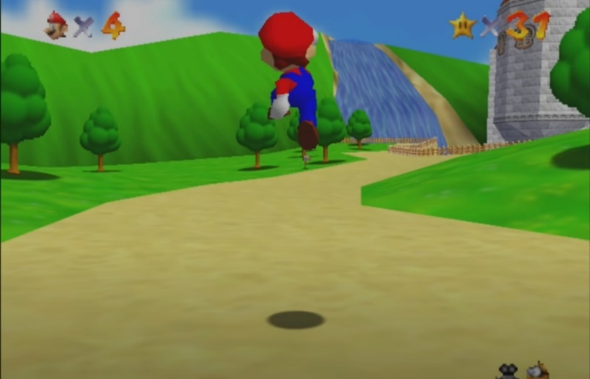

If you jump again right after you hit the ground, you jump higher.

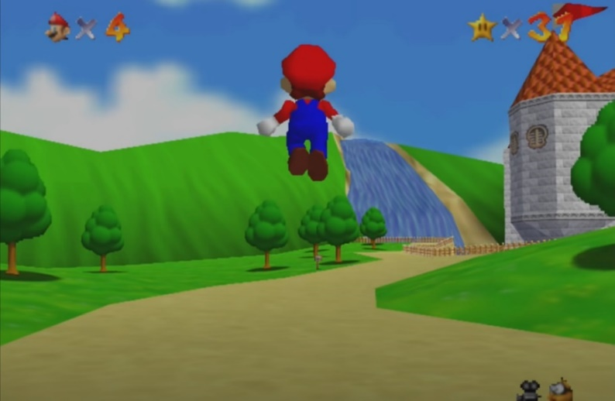

If you jump a third time while moving, you jump even higher. (without the front flip)

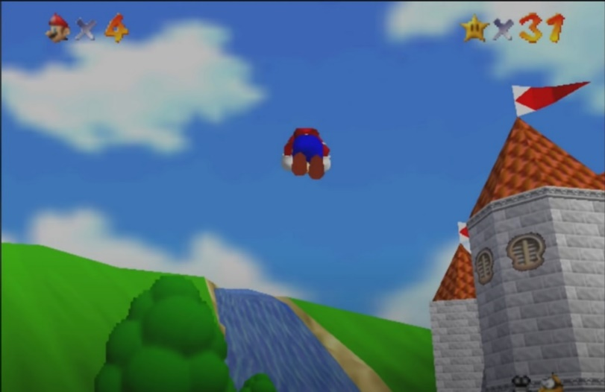

More detail on Marios jump - <https://youtu.be/zCxpzIiUJIg?t=120>

**Level Layout / Structure:**

The level design will be inspired by of Super Mario Bros Wii but in a full 3D environment.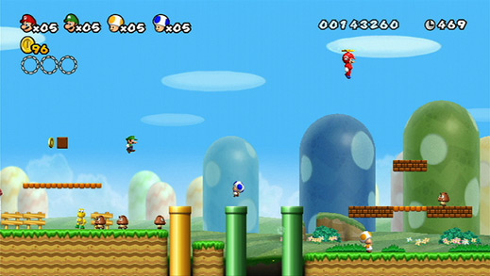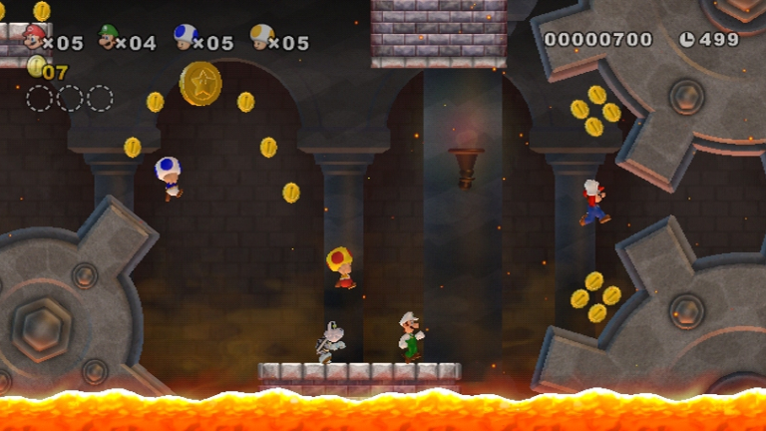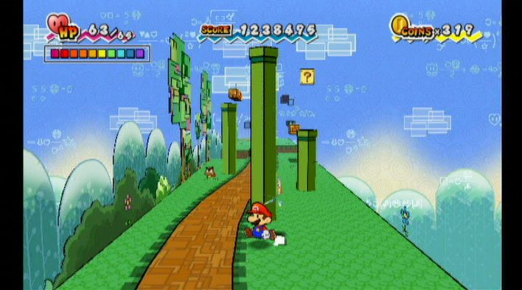

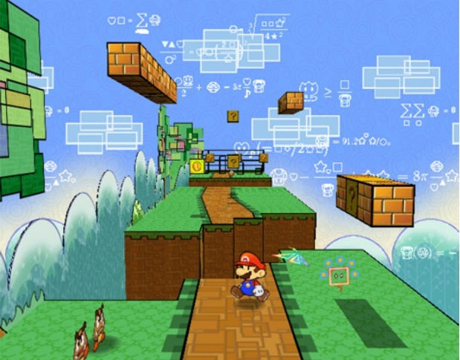

There most likely won’t be enemies unless I have time to and there won’t be multiplayer.

The platforms in Mario levels follow a blocky design.

How Mario levels are designed, my levels will follow this design aproach. <https://www.youtube.com/watch?v=e0c5Le1vGp4&ab_channel=GameMaker%27sToolkit>

**Visual Style:**

Simple, plastic like look.

Objects and the world should look smooth and solid, with little detail, like Lego.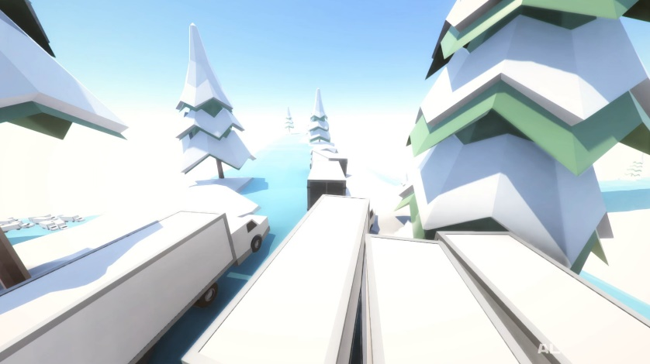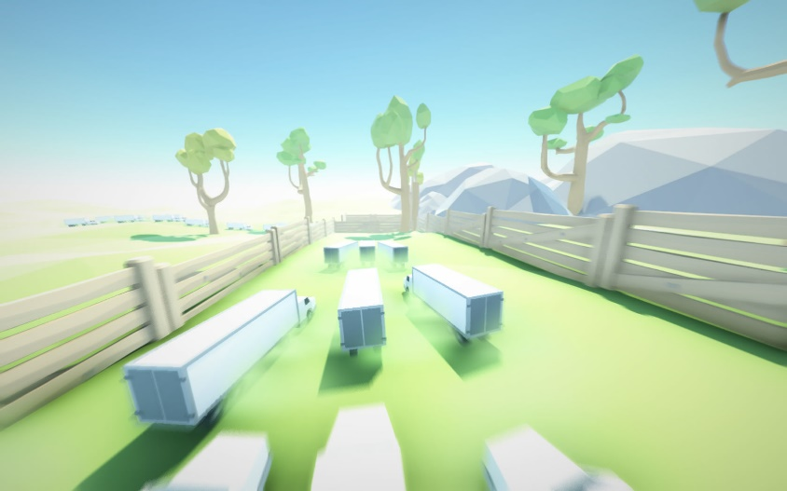

Cluster Truck has a very simple visual style, barely any detail, just simple plain colours, and simple shapes.

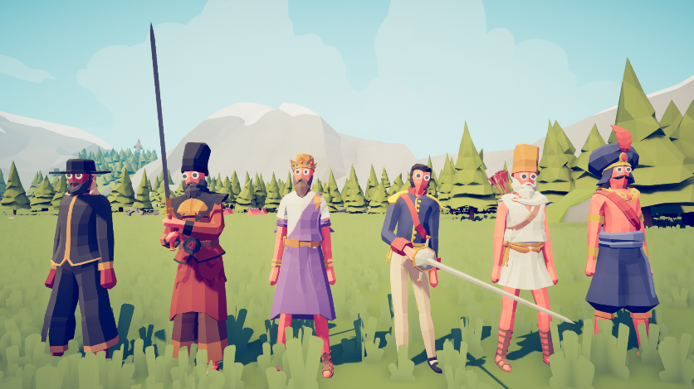

Totally Accurate Battle Simulator also has a very simple, minimal detail, plain colours and simple shapes visual style to it.