https://assetstore.unity.com/packages/templates/packs/free-horror-game-kit-108847#content

Slenderman Style of game with 4 items to collect which are needed to escape, while being hunted by the evil being

Items:   
- Engine,  
- Wheel,   
- Battery,  
- Key

A car is used to escape when all items have been collected. you can only interact with car once you have all 4 items.

Aim of the game is to escape.

Your sanity goes down while you play, you gain some sanity when you find an item. The lower your sanity the more aggressive the entity gets

Item ideas

Slenderman Game Style creepy horror

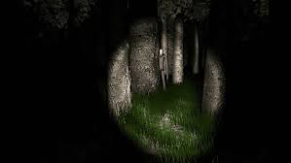

In Dead By Daylight, you have to activate 4 generators to escape while being hunted, in my game, instead of generators, the player collects 4 items.