# **GDD – Train to Teasan**

Contents

GDD – Train to Teasan 1

Project Overview – Train to Teasan 4

1-Line Summary 4

Description 4

Target Market 4

Competitor Analysis 4

Design Pillars 4

Gameplay Design 5

Synopsis of Gameplay 5

Game Mode - Exploration 5

Description 5

Objectives / Goals 5

Game Loops 5

Game Mechanics 5

Mechanics List 6

Movement - Walking 6

Progression – Piece Collection 6

Progression – Tea Making 7

Rules & Systems 7

User Interface & Controls 9

User Interface Design 9

Tea Pot/Silhouette Assembly 9

Dialogue Box UI 9

Inventory UI 9

Feedback Systems 9

Controls 9

Game Content 10

Content Types 10

Cultures/Tea Masters 10

Points of Interest 10

Tea Ware Collection 10

Kintsugi Teapot 10

Project Overview – Train to Teasan

### 1-Line Summary

Explore 3 different tea cultures in a stylistic journey through dream-like tea worlds and craft your own tea.

### Description

A first-person narrative game where you are on a train and are approached by tea making strangers, telling you tales about their favourite teas, their experiences and stories as they make tea for you.  
   
As the stories begin from each stranger, the scenery around you changes, transporting you to their experiences and tea making lessons in a dreamlike world.

### Target Market

* Tea Connoisseurs/Enthusiasts
* Casual/Indie Gamers
* Purveyors of diverse cultures

### Competitor Analysis

* There is a lack of tea themed marketing games, and tea-based games in general.
* Of the games that do exist (2; Ampu-Tea and Tea Party, both on Steam) they do not have Tea as an experience but more as a mention and/or incident.
* Other brands have targeted casual gamer audiences like McDonalds, Pepsi, Burger King, etc...
* However, they were met with mixed success, for the most part they were simple to make and play, failing to capture audiences in the long term (long term; allowing to open a potential market for Brands to make Games for their products)

### Design Pillars

* **Cultural Experience** – Learn about unique aspects of different cultures
* **Tea is Real Story -** Our design and game, story is centred around tea/tea is the focus
* **Simplicity and Accessibility** –A focus on easy and simple gameplay for players to immerse in the culture and history of tea

## Gameplay Design

### Synopsis of Gameplay

The player starts in a train carriage, they can see 3 distinct individuals spread out in the train. The player will speak to the tea masters and be told about the tea they are preparing. They will then offer it for the player to drink.

After having drunk the tea, the player is transported to the dreamworld where a new narration begins that is about the tea’s history and cultural significance. The player must collect pieces of puzzles unique to each culture. Once the player has completed each puzzle, they are transported back to the real world. The player must complete all 3 dreamworlds to be able to make tea for the Tea Masters in a series of interactive minigames at the end to win their approval. Once the tea has been served the game is complete.

Game Mode - Exploration

Description

Exploration: The player can explore both the carriage and the dreamworld

Objectives / Goals

* **Exploring the dreamworld**  
  The player must speak to the Tea Masters to be able to explore the Dreamworld
* **Collect the dreamworld items**  
  In the dreamworld, the player must collect all the pieces to complete a puzzle and return to the real world
* **Making tea for the Tea Masters**  
  Player must complete a series of simple minigames to make tea for the Tea Masters

#### 

#### Game Loops

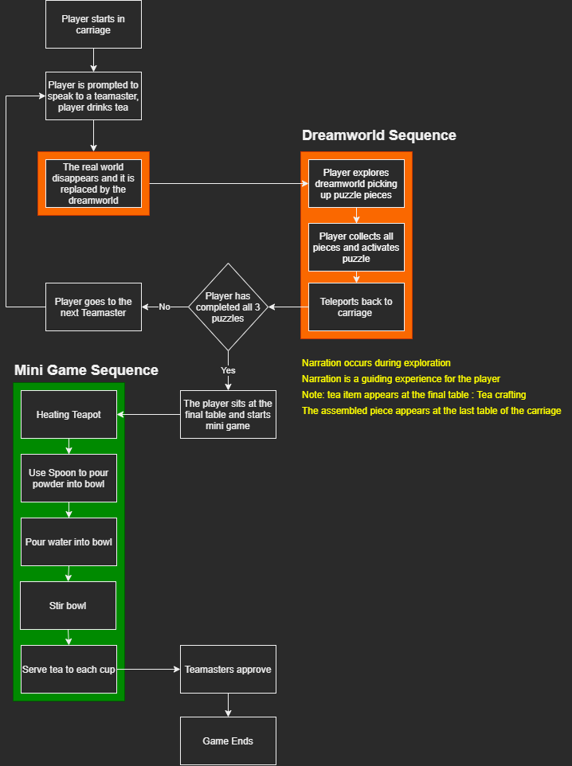

### Game Mechanics

Mechanics List

* Dialogue
  + Tea Masters
  + Voice Over during Dreamworld sequence
* Tea Crafting
  + Player makes tea for Tea Masters
    - Water heating
    - Matcha pouring
    - Matcha stirring
* Object Interaction
* Piece Collection
* Movement

#### Movement - Walking

**Summary: A simple WASD controller for the player to walk through the game**

**Details:**

* No jumping
* No running
* As for the above, we are eliminating any need for frenetic and fast action movements

#### Progression - Piece Collection

**Summary:** Each of the Dreamworlds have items to collect to be able to complete their unique puzzles to be able to comeback to the real world and access the last booth for the tea making mini game

**Details:**

* Pieces are spread throughout the levels
* Once all the pieces are collected, the player interacts with the puzzle to solve

**Related mechanics & systems:**

* Once all pieces are collected/puzzle completed, it activates the scene transition system
* A hint system is activated if the player is idle for too long

#### Progression – Dreamworld Puzzle

**Summary:** At the end of each dreamworld the player completes a small puzzle from the items they collected in the level

**Details:**

* Missing letters placed in simple incomplete crossword
* Coloured powder is thrown onto a mannequin representing the Holi Festival

**Related mechanics & systems:**

* Puzzle activates after all items are collected in the dreamworld
* Scene transitions after completing the puzzle

#### 

#### Progression – Tea Making

**Summary:** After the player has experienced the 3 dreamworlds, they sit down and make tea for the Tea Masters

**Details:**

* There are Tea Ware pieces found at the end table
* The player interacts with simple minigames
* The game ends after the tea is served to the tea masters

**Related mechanics & systems:**

* Sound is played to prompt the player to take a seat
* The level transitions to the tea masters sitting across

### Rules & Systems

**To Explore Dreamworlds**

* For the player to explore the dreamworld, they must speak to the Tea Masters

**Returning to the Carriage**

* For the player to return, they can only do so if they collect pieces in the Dreamworld and solve the puzzles

## User Interface & Controls

### User Interface Design

The dialogue box is minimalistic with a translucent background and clear lettering

#### C:\Users\s200471\AppData\Local\Microsoft\Windows\INetCache\Content.MSO\4A9C8274.tmp

The collection UI is also simplistic, and in keeping with the minimalistic theme, it will have a translucent background

### 

### Feedback Systems

**The player will receive prompts through sound**

* If the player is near a Tea Master, the Tea Master will ask the player to sit

**The player will also see a text prompt indicating the player can sit**

* Once the player has been asked by the Tea Master, a text can appear telling the player to ‘Sit’

### Controls

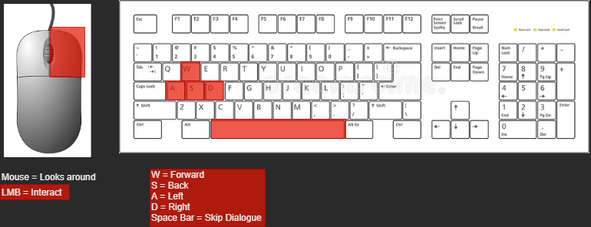

## Game Content

### Content Types

* Cultures/Tea Masters
* Points of Interest
* Tea ware Collection

### Cultures/Tea Masters

Britain Culture

* A British Royal guard

Indian Culture

* Indian Man Tea Man

Japanese Culture

* Geisha

### Points of Interest

Train carriage interior

British Garden

* Hedge Maze
* Fountain
* Cottage
* Rosebush intersection

Indian Garden

* Elephant Statue (animal)
* Traditional Style Stall (Spice)
* Temple
* Mannequin

Japanese Garden

* Pagoda
* Cherry Blossom Tree
* Japanese gate (Torii)
* Zen Garden

### Collection - Tea ware

Kintsugi Teapot

* A traditional Japanese teapot that has been broken. The player will repair it using the kintsugi method, which celebrates the history and the cracks instead of concealing them.
* Used the make tea at the end of the game.

Crossword Segment

* Tiles of letters to complete a crossword at the end of the hedge maze in Britain Dreamworld

Holi festival coloured bags

* Bags of three different powdered item to use to colour the mannequin at the end of the Dreamworld