Chocolate Chip Muffin: Programming Basics for Machine Learning



Lesson 3 Basic

# Root

Root 1

Working with Implementations and !Architectures 2

Github repo 2

Jupyter Notebook 2

Working with HTML and LaTEX on jupyter notebook 3

Google Colab 3

Alternatives 3

Running Example- Google colab 3

Running example- Jupyter notebook on your local environment 4

Installation 4

Dependencies 4

Python 4

Other Links 5

Works Cited 6

## Working with Implementations and !Architectures

**The Great chocolate chip muffin problem**

Hi There I would like to buy a chocolate chip muffin

Baker gives me this I was expecting this

(Chocolate muffin with chips) (Regular muffin with chips)

 

Both types of muffin can be considered as “Chocolate Chip Muffin”. They are both implementation of a great original idea. (I Still think my choice is correct)

In Computer Engineering we work with implementations of programming language (not language itself)

In machine learning (data engineering) we work with implementation of model/architecture not (SOTA) architecture itself.

Unless of course you are yourself trying to improve the language/framework or architecture or contributing to it in some form.

## Github repo

<https://github.com/AIEdX>

## Jupyter Notebook

Jupyter (IPython) notebook files are simple JSON documents, containing text, source code, rich media output, and metadata. Each segment of the document is stored in a cell.[1]

Advantages

* Interleave Code and Comment cell.
* Great to showcase proof of concepts or demonstration of experimental setup.
* Can create complete book style lessons for education with theory and code in same notebook.
* Runs in a browser and it’s easy to share notebooks.
* Great for instant and shallow debugging.
* Its not an IDE (Integrated Development Environment)

Disadvantages

* Its not an IDE (Integrated Development Environment)!

Jupyter notebooks are basically small text files that can be opened with any editor or with WordPad/notepad

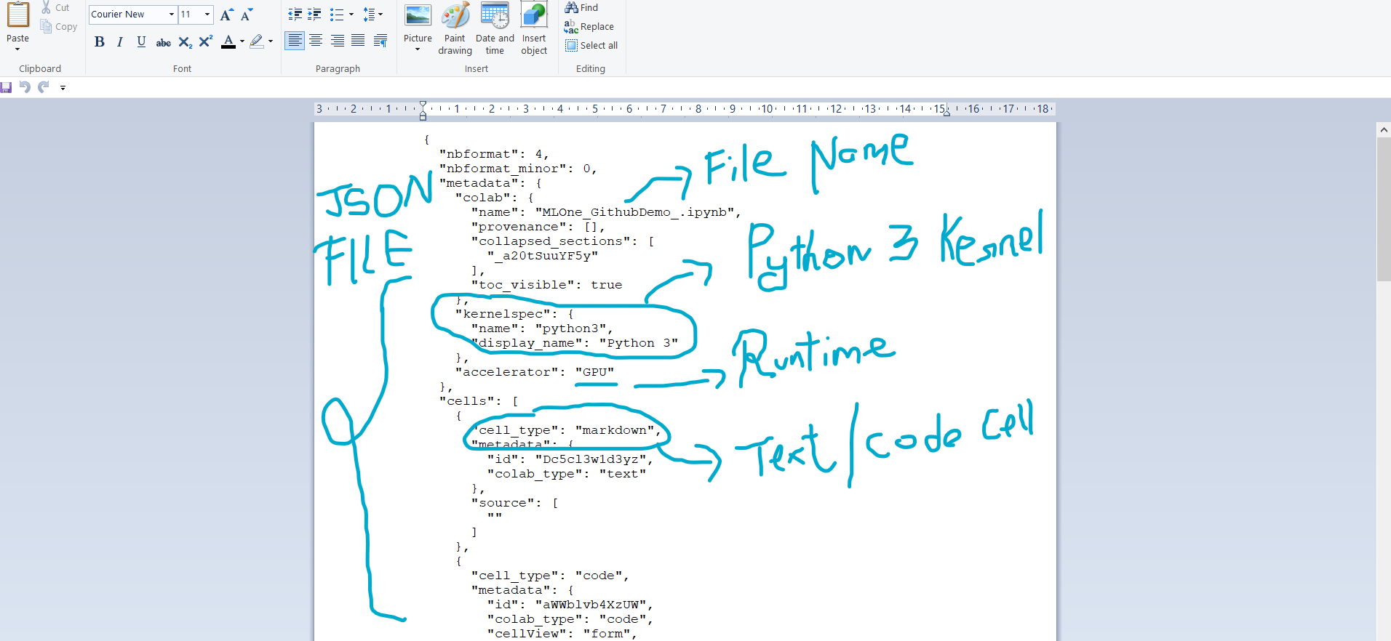

## Working with HTML and LaTEX on jupyter notebook

You can easily work with Latex and Mathjax and write equations and mathematical expressions with ease.

### Google Colab

#### Alternatives

* Paperspace
* Amazon SageMaker
* Kaggle
* Many More!!!!!

#### Running Example- Google colab

#### Running example- Jupyter notebook on your local environment

# Installation

## Dependencies

## Python

Adding Path using existing script

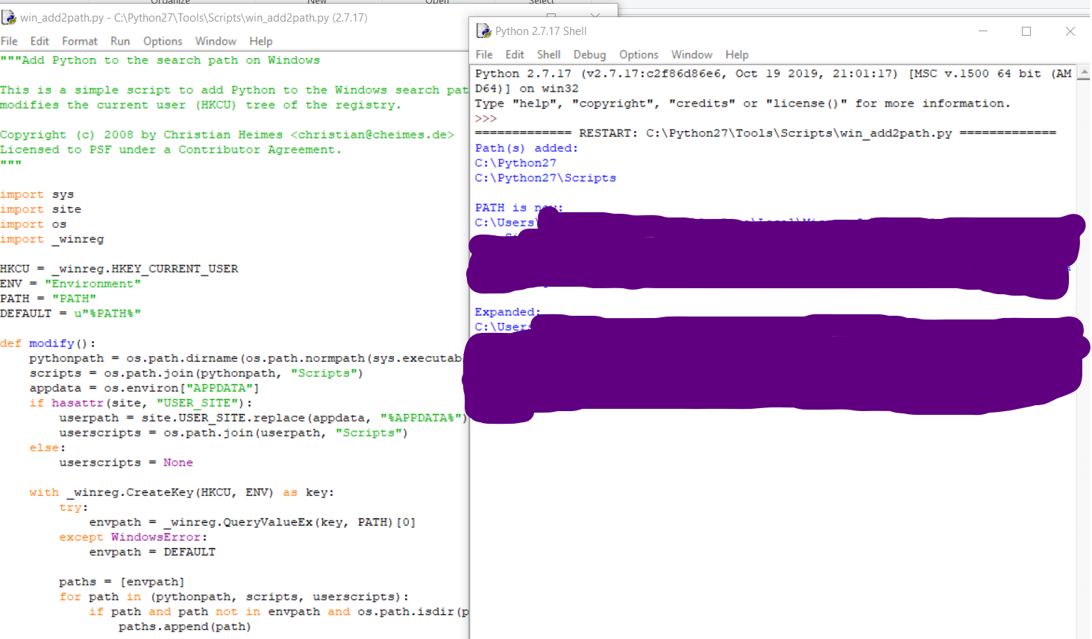

# Other Links

1. <https://ujjwalkarn.me/2016/08/11/intuitive-explanation-convnets/>

# Works Cited

Google . (2020). *Object Detection at Tensorflow Hub*. Retrieved from Tensorflow Hub: https://www.tensorflow.org/hub/tutorials/object_detection#

Jupyter. (n.d.). *MathJax Latex*. Retrieved from https://jupyter-notebook.readthedocs.io/en/stable/examples/Notebook/Typesetting%20Equations.html

*Jupyter Notebook*. (n.d.). Retrieved from https://nbformat.readthedocs.io/en/latest/