Week03-Day02-Assignment-Answers.
Here is the JIRA integration.
Workflow : URL—Email—Apikey should be given as input
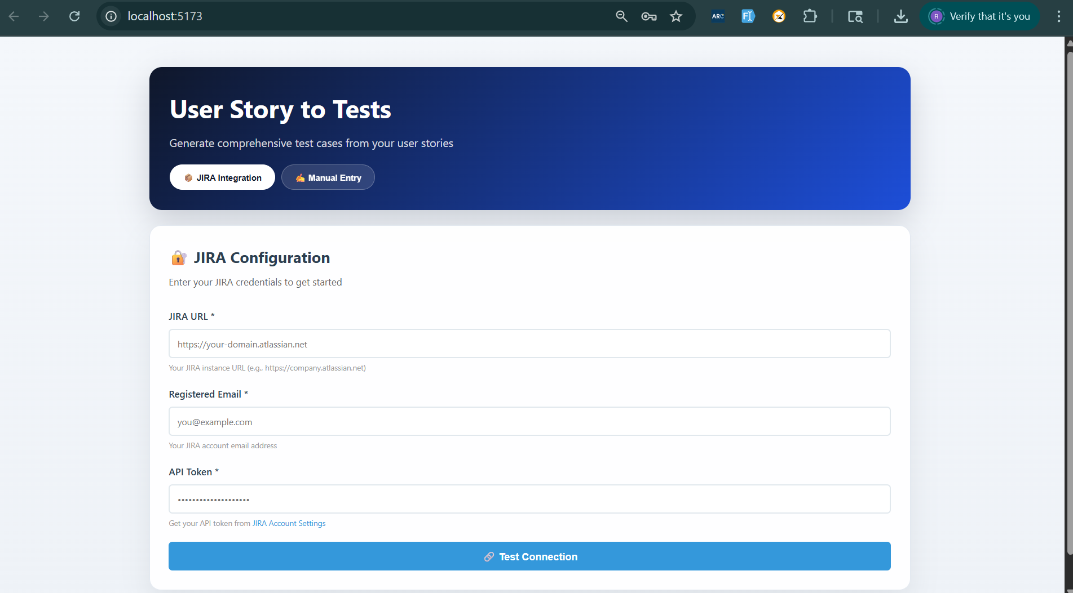
Once JIRA login successfully. Choose projects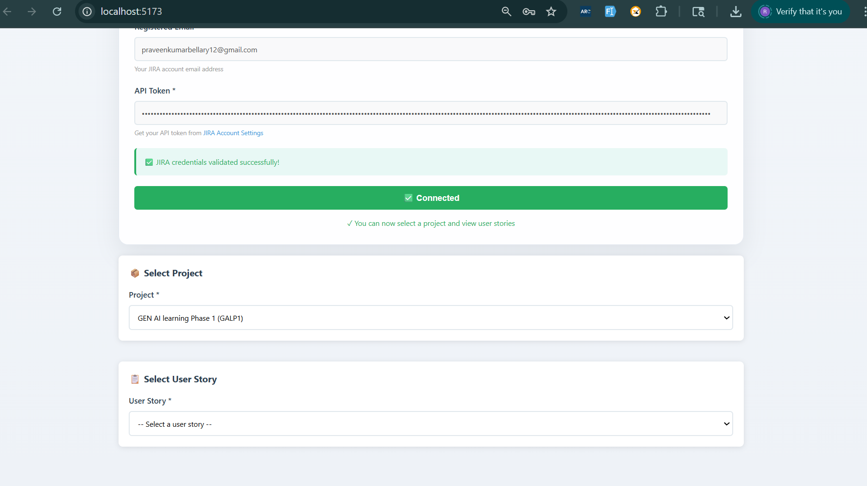
Project selected : User stories will be displayed from project.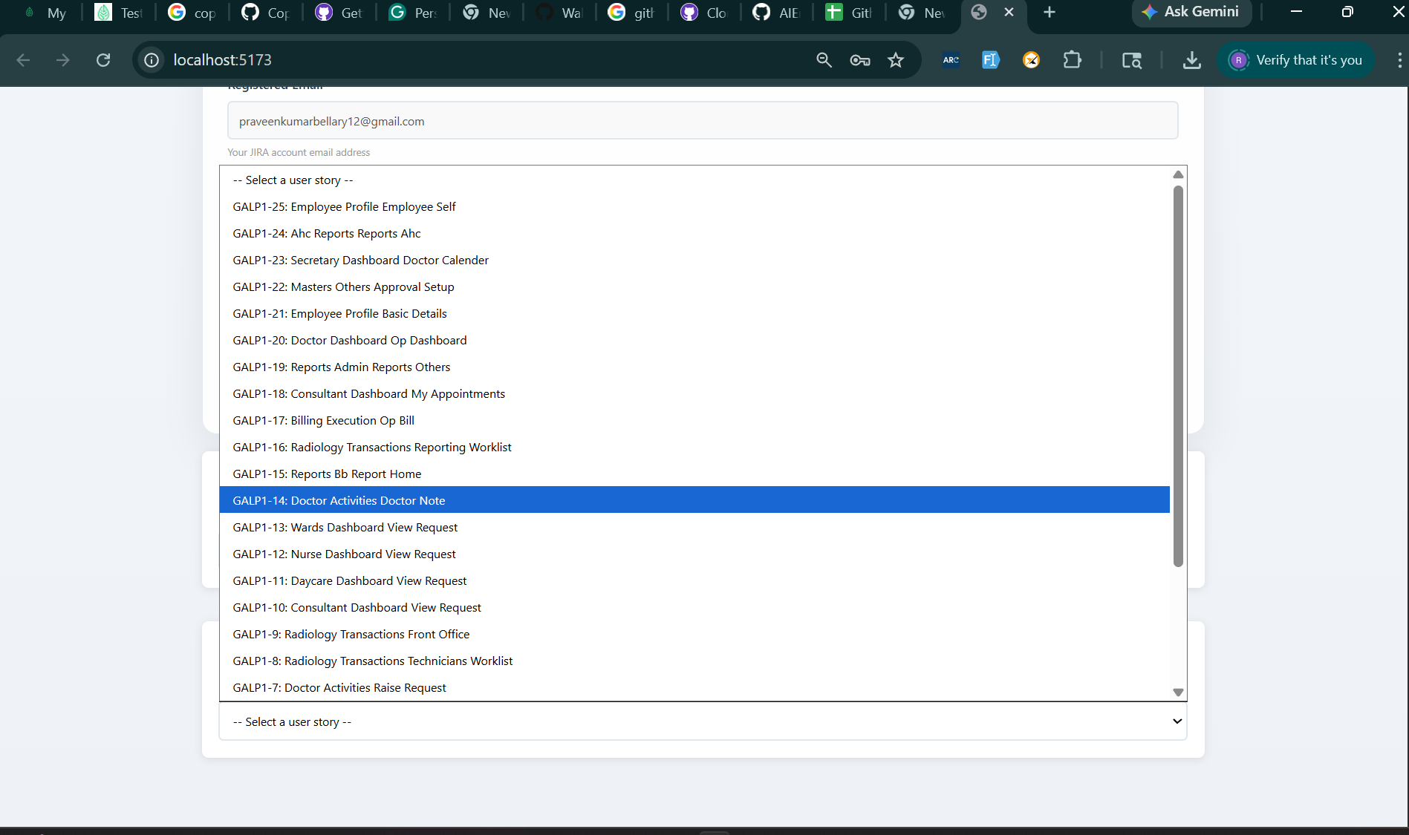
Userstory is selected and clicked on generate Testcases.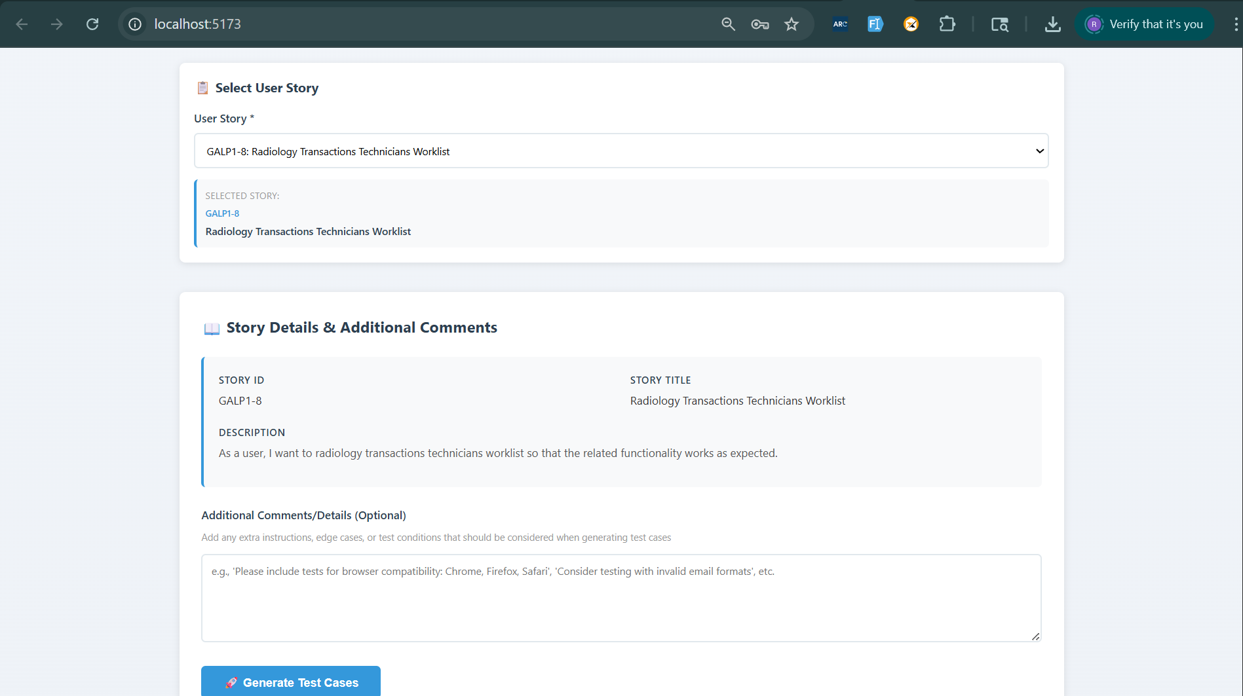

Manual Testcases generated. 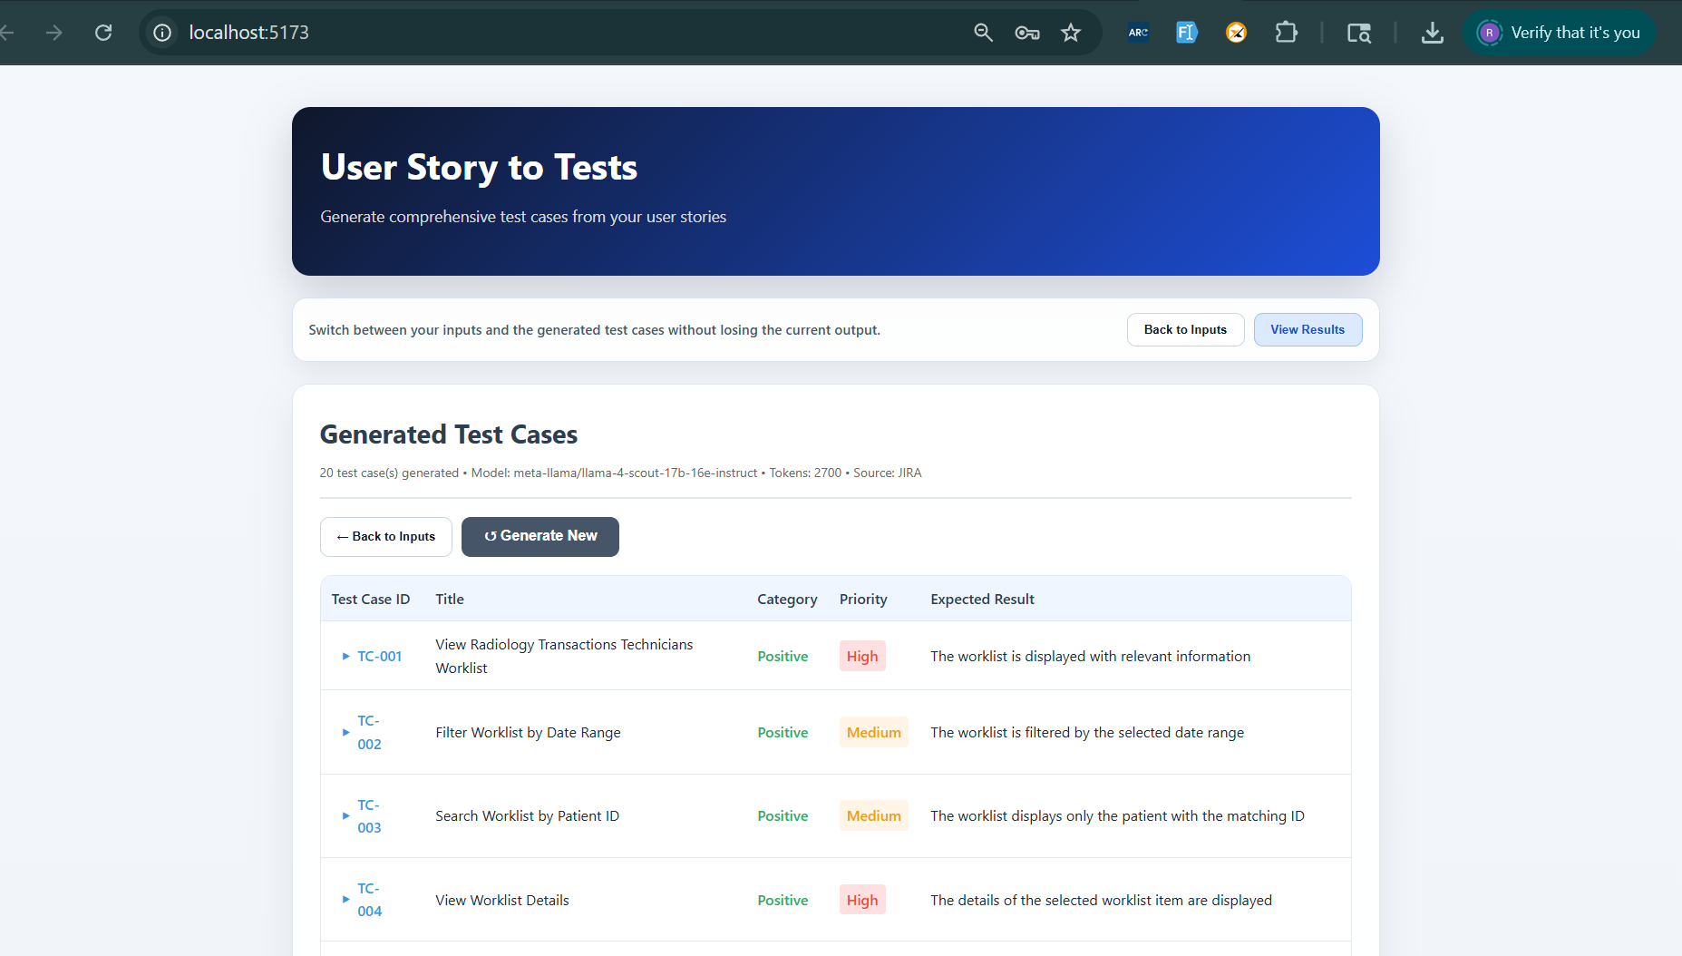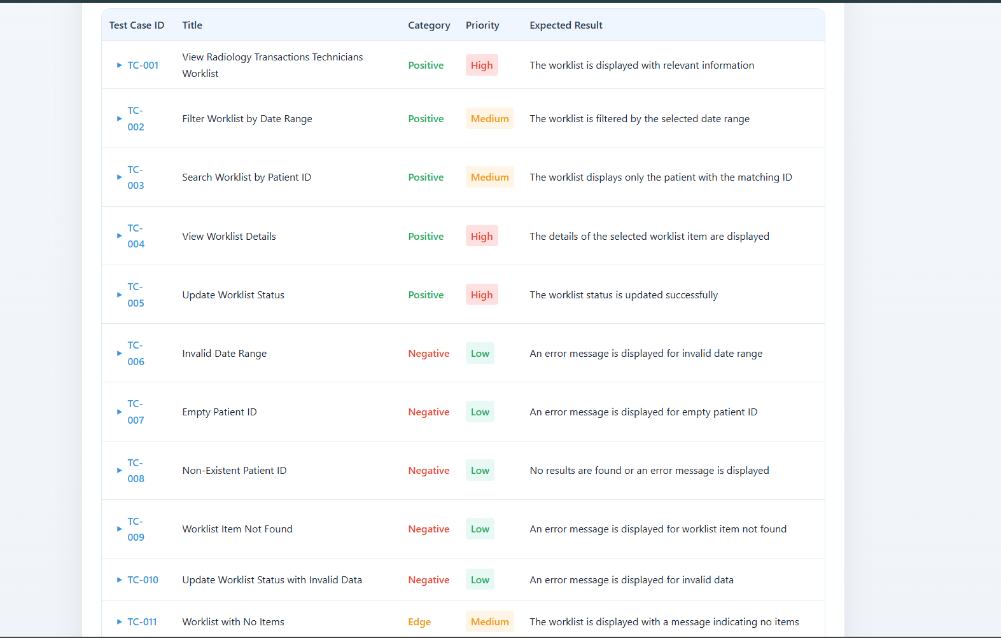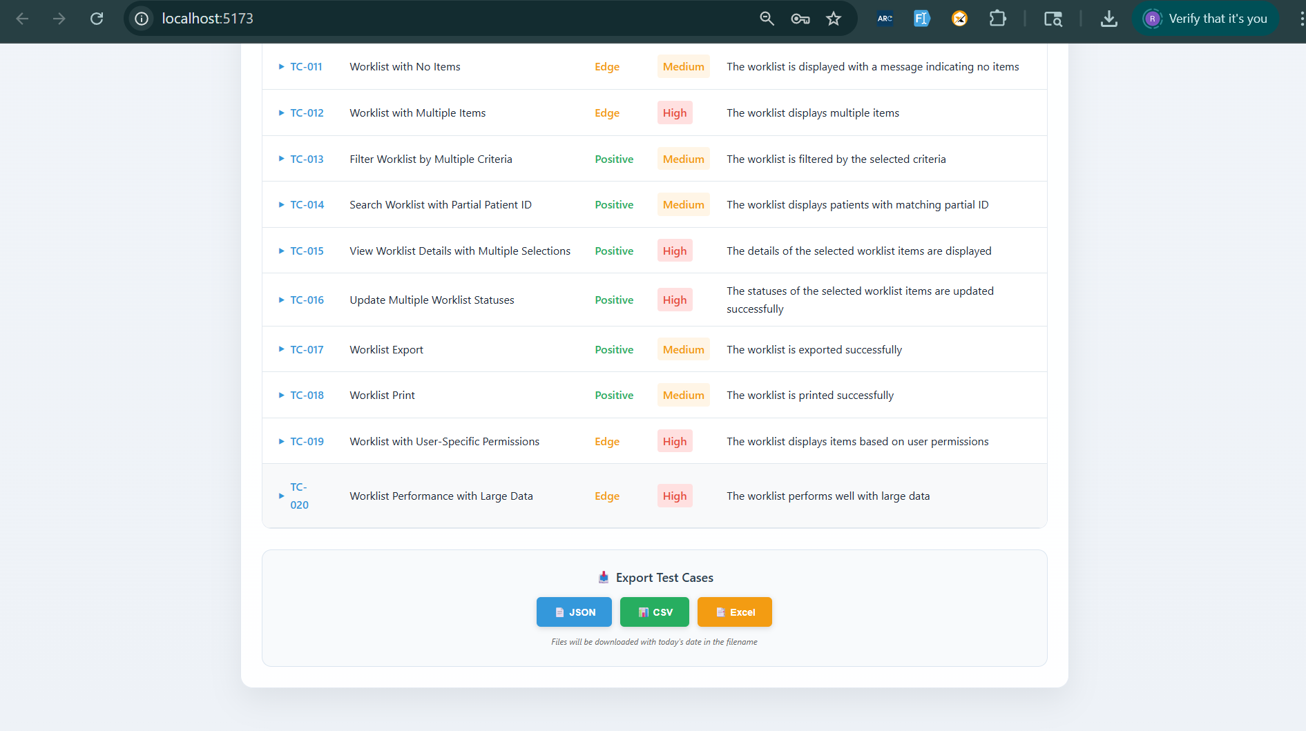
Exported to Excel :

