哈尔滨工业大学

<<数据库系统>>
实验报告之二

(2021年度春季学期)

姓名： | 杨君豪
学号： | 1181000516
学院： | 计算机学院
教师： | 高宏

实验二 使用高级语言操作MySQL数据库

实验目的
学会使用高级语言访问MySQL数据库，并进行查询。

实验环境
MySQL关系数据库管理系统、C++编译器。
本次实验主要利用C语言访问MySQL数据库，也可以使用JAVA，PHP等其他语言。不允许使用ORM。
我使用的是C语言

实验过程及结果
1.
/*第1题:查询员工号*/
printf("\n第1题\n");
printf("参加了项目编号为PNO的项目的员工号，其中PNO为C语言编写的程序的输入参数\n");
printf("Input PNO:");
scanf("%s", str1);
mysql_query(&mysql_conn, strcat(fore1,strcat(str1,"\"")));

mysql_result = mysql_store_result(&mysql_conn);
int num_row = mysql_num_rows(mysql_result);
int num_col = mysql_num_fields(mysql_result);

for (int f1 = 0; f1 < num_row; f1++) {
//MYSQL_ROW提取的是一个字符数组
MYSQL_ROW mysql_row = mysql_fetch_row(mysql_result);

for (int f2 = 0; f2 < num_col; f2++)
{
printf("%s", mysql_row[f2]);
}
printf("\n");
}
/* Free the result to release the heap memory*/
mysql_free_result(mysql_result);
结果截图:
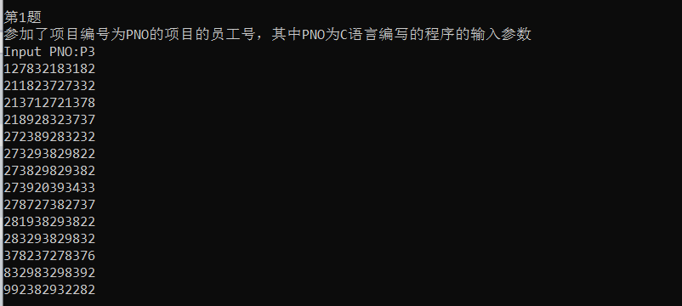

2.
/*第2题*/
printf("\n第2题\n");
printf("参加了项目名为PNAME的员工名字,其中PNAME为C语言编写的程序的输入参数\n");
printf("Input project name:");
char str21[300] = "SELECT DISTINCT ename from employee NATURAL join project where pname = \"";
char str22[50];
char str23[50];
scanf("%s", str22);
strcat(str22, " ");
scanf("%s", str23);
strcat(str22, str23);

strcat(str21, str22);
strcat(str21, "\"");
// puts(str21);
// puts("SELECT DISTINCT ename from employee NATURAL join project where pname = \"哈工大寝室改造\"");
// mysql_query(
// &mysql_conn, "select project.pno from project where project.pname = \"SQL Project\" and project.pno=works_on.pno");
mysql_query(&mysql_conn, str21);
char cnm[100] = "where pno in (SELECT DISTINCT pno from works_on NATURAL join project WHERE PNAME = \'SQL Project\')";
mysql_result = mysql_store_result(&mysql_conn);
num_row = mysql_num_rows(mysql_result);
num_col = mysql_num_fields(mysql_result);

for (int f1 = 0; f1 < num_row; f1++) {
//MYSQL_ROW提取的是一个字符数组
MYSQL_ROW mysql_row = mysql_fetch_row(mysql_result);

for (int f2 = 0; f2 < num_col; f2++)
{
printf("%s\t", mysql_row[f2]);
}
printf("\n");
}

/* Free the result to release the heap memory*/
mysql_free_result(mysql_result);
结果截图:
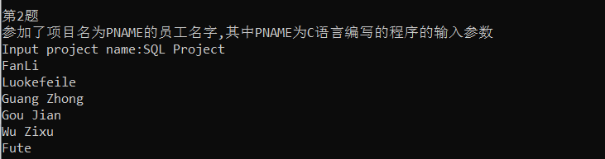

3.
printf("\n第3题\n");
printf("在DNAME工作的全体人员姓名和地址,其中PNAME为C语言编写的程序的输入参数\n");

printf("请输入DNAME:");
char str31[300] = "select ename,address from employee NATURAL join department where dname = \'";
char str32[50];
char str33[50];
scanf("%s", str32);
strcat(str32, " ");
scanf("%s", str33);

strcat(str32, str33);
strcat(str31, str32);
strcat(str31, "\'");
//puts(str31);
mysql_query(&mysql_conn,str31);

mysql_result = mysql_store_result(&mysql_conn);
num_row = mysql_num_rows(mysql_result);
num_col = mysql_num_fields(mysql_result);

for (int f1 = 0; f1 < num_row; f1++)
{
MYSQL_ROW mysql_row = mysql_fetch_row(mysql_result);

for (int f2 = 0; f2 < num_col; f2++)
{
printf("%s\t", mysql_row[f2]);
}
printf("\n");
}

//Free the result to release the memory
mysql_free_result(mysql_result);
结果截图:
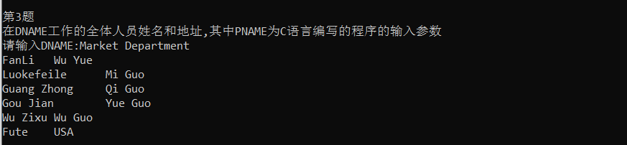

4.
/*第4题攻坚*/
printf("\n第4题\n");
printf("在DNAME工作且工资低于SALARY元的员工名字和地址，其中DNAME和SALARY为C语言编写的程序的输入参数\n");

char str41[300] = "select ENAME,ADDRESS from department NATURAL join employee where salary<";
char str42[50];
char str43[50];
char str44[50];
printf("Input salary and dname:");
scanf("%s",str42);
strcat(str41, str42);
strcat(str41, " and dname = \"");

scanf("%s", str43);
strcat(str41, str43);
scanf("%s",str44);
strcat(str41, " ");
strcat(str41,str44);
strcat(str41, "\"");
//puts(str41);
mysql_query(&mysql_conn,str41);

mysql_result = mysql_store_result(&mysql_conn);
num_row = mysql_num_rows(mysql_result);
num_col = mysql_num_fields(mysql_result);

for (int f1 = 0; f1 < num_row; f1++)
{
MYSQL_ROW mysql_row = mysql_fetch_row(mysql_result);
for (int f2 = 0; f2 < num_col; f2++)
{
printf("%s\t",mysql_row[f2]);
}
printf("\n");
}

/*Free the result to release the memory*/
mysql_free_result(mysql_result);

结果截图:
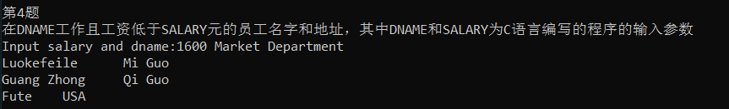

5.
/*第5题*/
printf("\n第5题\n");
printf("没有参加项目编号为PNO的项目的员工姓名，其中PNO为C语言编写的输入参数\n");
char str51[300] = "select DISTINCT ename from employee where essn not in(select DISTINCT essn from employee NATURAL join works_on where pno = \"";
char str52[50];
printf("Input PNO:");
scanf("%s",str52);

strcat(str51,str52);
strcat(str51, "\")");
puts(str51);
puts("select DISTINCT ename from employee where essn not in(select DISTINCT essn from employee NATURAL join works_on where pno = \"P1\")");
mysql_query(&mysql_conn,"select DISTINCT ename from employee where essn not in(select DISTINCT essn from employee NATURAL join works_on where pno = \"P1\")");

mysql_result = mysql_store_result(&mysql_conn);
num_row = mysql_num_rows(mysql_result);
num_col = mysql_num_fields(mysql_result);

for (int f1 = 0; f1 < num_row; f1++)
{
MYSQL_ROW mysql_row = mysql_fetch_row(mysql_result);
for (int f2 = 0; f2 < num_col; f2++)
{
printf("%s\t",mysql_row[f2]);
}
printf("\n");
}
mysql_free_result(mysql_result);
结果截图:
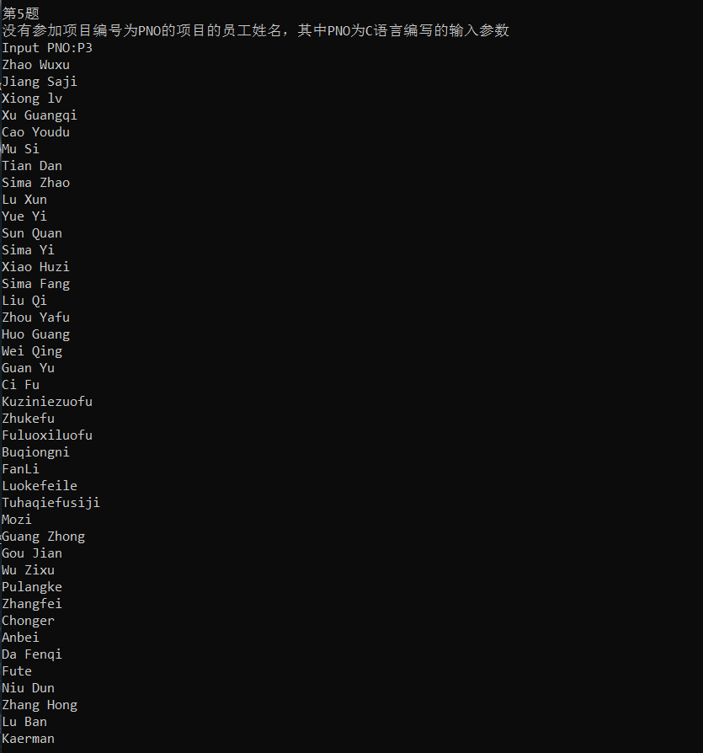

6.
/*第6题*/
printf("\n第6题\n");
printf("由ENAME领导的工作人员的姓名和所在部门的名字，其中ENAME为C语言编写的程序的输入参数\n");
printf("Input ename:");
char str61[300] = "select DISTINCT ename,dname from employee Natural join department where superssn in (select DISTINCT essn from employee where ename = \"";
char str62[50];
char str63[50];
scanf("%s", str62);
scanf("%s", str63);
strcat(str62, " ");
strcat(str62, str63);
strcat(str62, "\")");
strcat(str61, str62);

//char suka[1000] = "select DISTINCT ename,dname from employee NATURAL join where superssn = (select DISTINCT essn where ename = \"张红\")";
mysql_query(&mysql_conn,"select DISTINCT ename,dname from employee Natural join department where superssn in (select DISTINCT essn from employee where ename = \"Zhang Hong\")");

mysql_result = mysql_store_result(&mysql_conn);
num_row = mysql_num_rows(mysql_result);
num_col = mysql_num_fields(mysql_result);

for (int f1 = 0; f1 < num_row; f1++)
{
MYSQL_ROW mysql_row = mysql_fetch_row(mysql_result);
for (int f2 = 0; f2 < num_col; f2++)
{
printf("%s\t",mysql_row[f2]);
}
printf("\n");
}

mysql_free_result(mysql_result);
结果截图:
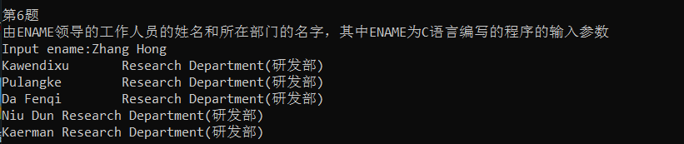

/*第7题*/
printf("\n第7题\n");
printf("至少参加了项目编号为PNO1和PNO2的项目的员工号，其中PNO1和PNO2为C语言编写的程序的输入参数:\n");
printf("Input PNO1,PNO2:");
char str71[300] = "select employee.essn from employee,works_on w1,works_on w2 where employee.essn = w1.essn and w1.essn = w2.essn and w1.pno = \"";
char str72[50];
char str73[50];
scanf("%s", str72);
strcat(str71, str72);
strcat(str71, "\" and w2.pno = \"");
scanf("%s", str73);
strcat(str71, str73);
strcat(str71, "\"");
mysql_query(&mysql_conn,"select employee.essn from employee,works_on w1,works_on w2 where employee.essn = w1.essn and w1.essn = w2.essn and w1.pno = \"P1\" and w2.pno = \"P2\"");

mysql_result = mysql_store_result(&mysql_conn);
num_row = mysql_num_rows(mysql_result);
num_col = mysql_num_fields(mysql_result);

for (int f1 = 0; f1 < num_row; f1++)
{
MYSQL_ROW mysql_row = mysql_fetch_row(mysql_result);
for (int f2 = 0; f2 < num_col; f2++)\
{
printf("%s\t", mysql_row[f2]);
}
printf("\n");
}

mysql_free_result(mysql_result);

结果截图:
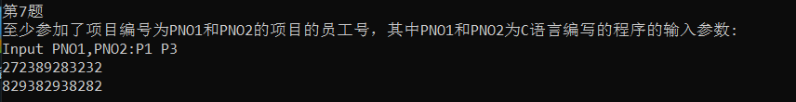

/*第8题*/
printf("\n第8题\n");
printf("员工平均工资低于SALARY元的部门名称，其中SALARY为C语言编写的程序的输入参数");
printf("Input salary");

char str81[300] = "select dname from department NATURAL join employee group by dname having avg(salary)<";
char str82[50];
scanf("%s", str82);

strcat(str81, str82);

mysql_query(&mysql_conn, str81);

mysql_result = mysql_store_result(&mysql_conn);
num_row = mysql_num_rows(mysql_result);
num_col = mysql_num_fields(mysql_result);

for (int f1 = 0; f1 < num_row; f1++)
{
MYSQL_ROW mysql_row = mysql_fetch_row(mysql_result);
for (int f2 = 0; f2 < num_col; f2++)
{
printf("%s\t", mysql_row[f2]);
}
printf("\n");
}
mysql_free_result(mysql_result);

结果截图:

/*第9题*/
printf("\n第9题\n");
printf("至少参与了N个项目且工作总时间不超过HOURS小时的员工名字，其中N和SALARY为C语言编写的程序的输入参数\n");
printf("Input hours,N:");
char str91[300] = "select ename from employee NATURAL join works_on group by essn having sum(hours) < ";
char str92[50];
char str93[50];

scanf("%s", str92);
strcat(str91, str92);
strcat(str91, " and count(*) >=");

scanf("%s", str93);
strcat(str91,str93);

mysql_query(&mysql_conn,str91);

mysql_result = mysql_store_result(&mysql_conn);
num_row = mysql_num_rows(mysql_result);
num_col = mysql_num_fields(mysql_result);

for (int f1 = 0; f1 < num_row; f1++)
{
MYSQL_ROW mysql_row = mysql_fetch_row(mysql_result);
for (int f2 = 0; f2 < num_col; f2++)
{
printf("%s\t", mysql_row[f2]);
}
printf("\n");
}
mysql_free_result(mysql_result);
结果截图:

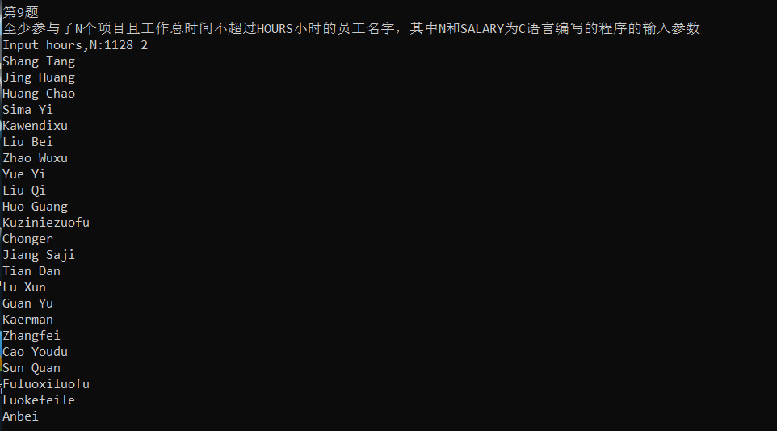

四、实验心得
1.本次实验着重考察了使用高级语言访问数据库并且查询的能力，尤其是首先让我配环境废了我九牛二虎之力，从code blocks上配置库老是失败到转战visual studio code,还是不行，最后在CSDN上反复试错找到一篇博客，按照上面的提示终于把libmysql这些文件配置好了，然后又发现数据库查询输出的是乱码，又是一通查资料发现原来电脑设置里要使用unicode字符集，前前后后花了三个整天把环境搭建好，结果数据库访问的时候又遇到了无法识别中文字符串问题，不得已把一些中文的字符改成拼音，一波三折之后终于把实验做完了，我感到我做这个实验做得太慢了我还要加快速度。
2.通过这次实验我体会到了自身数据库基础的薄弱以及平时养成的散漫、不珍惜事件的愚蠢脑残行为的可耻，同时，我还需要学习更多数据库知识，需要练更多题目来充实自己的大脑，在此感谢老师，助教的付出和帮助！

