Module 3: Planning

GraphPlan
Contributor: Justa Tirkey, 21CS02011

Objective
The objective of this model is to use the graph plan algorithm to automatically generate a valid and logical ordering sequence. The graft plan should be able to support the conversational actions flow. Given a formal domain of actions and problems statement it should be able to plan for 2 to 3 Steps.

Algorithm Steps
- parser.py reads and normalizes the initial state, goal, and action definitions from the input JSON files
- planning_graph.py begins constructing the planning graph with alternating literal levels and action levels.
- It inserts all applicable actions at each level whose preconditions are satisfied.
- Adds no-op actions to preserve existing literals across levels.
- Computes mutex relations (both action mutex and literal mutex) to rule out incompatible combinations.
- graphplan.py continues expanding the planning graph until all goal literals appear together without mutex conflicts.
- It performs a backward search to choose supporting actions for each goal while ensuring all preconditions are met.
- It extracts a valid deterministic plan if a consistent non-mutex action set exists at every level.
- Triggers additional graph expansion when extraction fails, repeating until a solution is found or no further progress is possible.
- Save the output in file final_plan.txt.

Input Variables and Evidence Used
The input to the GraphPlan algorithm consists of two JSON files:
- domain.json
This file defines all emotional-support actions along with their preconditions and effects / postcondition
- Problem.json
This file specifies Initial state and the goal state. Example: These inputs fully determine how the planner must transform the initial state into the target supportive emotional state.

Example
For this test case, the chatbot begins with no supportive actions performed. The initial state includes all negative literals indicating that the student has not yet been greeted, acknowledged, comforted, or encouraged. The goal is to reach a state where the student is Comforted and BoostedConfidence, which requires correctly ordering the actions due to dependencies such as:
- Comfort requires prior acknowledgment
- Boosting confidence requires comfort or guidance
- Acknowledgment requires greeting
This makes the test scenario non-trivial and ensures that GraphPlan must work through multi-step reasoning and mutex relationships.
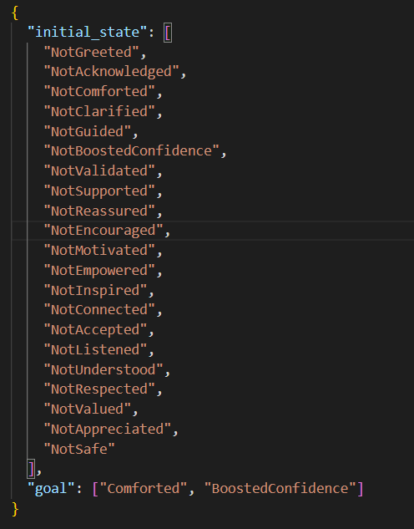

Output
The output generated is for each time stamp. In each time stamp I also have propagated the useful no operation. This makes it easy for debugging and backtracking.
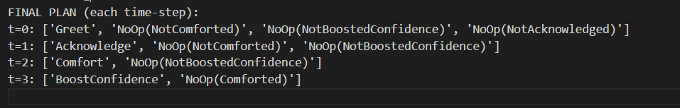
The plan shows a valid sequence of actions that satisfies all preconditions and achieves both goal literals. The tutor first greets the student, enabling acknowledgment. After acknowledgment, the Comfort action becomes valid. Finally, once the student is comforted, the system performs BoostConfidence, completing the required supportive emotional state. The plan is deterministic and respects all mutex constraints, demonstrating that GraphPlan successfully identified a correct action sequence for this conversational setting.

Partial Order Planning
Contributor: Likhitha, 21CS02009

Objective
The objective of this module is to automatically plan the next few conversational steps for an emotionally aware chatbot.
Instead of replying to the student message one step at a time, the POP planner helps the system think ahead like a human mentor.
It constructs a sequence of helpful actions such as greeting the student, acknowledging their feelings, comforting them, probing for clarification, guiding them, or boosting their confidence.
Using Partial Order Planning (POP) allows the chatbot to stay flexible, because the student’s next response may influence the order or need for some actions.
POP plans ahead while keeping the ordering loose enough to adapt to the real conversation flow.

Algorithm Steps
- Start by creating two special steps:
  - Start (contains all initial facts)
  - Finish (requires all goal facts)
- Add an ordering constraint:
Start -> Finish
- Put all unmet goals of Finish into an open-goals list
- While the open-goals list is not empty:
  - Pick one unsatisfied precondition (consumer, required_fluent)
  - Check if an existing step already produces the required fluent
  - If not:
    - Find an operator whose add-effects contain that fluent
    - Create a new step based on that operator
    - Insert the new step before Finish
    - Add ordering constraints:
Start -> new_step -> Finish
    - Add the new step’s preconditions into the open-goals list
  - Add a causal link from the producer step to the consumer step
  - Add an ordering constraint ensuring the producer happens before the consumer
- After all open goals are supported:
  - Remove any steps that do not participate in any causal link
  - Perform transitive reduction to keep only the minimal required ordering constraints
- Output the plan containing:
  - Steps
  - Causal links
  - Minimal ordering constraints

Input Variables and Evidence Used
The POP planner uses the following key inputs:
1. Detected Emotion
The student’s message (e.g., “I don’t understand anything, I’m lost”) is classified as an emotion such as:
- confused
- sad
- angry
- insecure
- overwhelmed
- demotivated
- bored
- etc.
Naive Bayes classifier from module 1 will be used to detect the emotion.
2. Emotion to Goals Mapping
Each emotion corresponds to a set of conversational goals the chatbot must achieve.
Example:
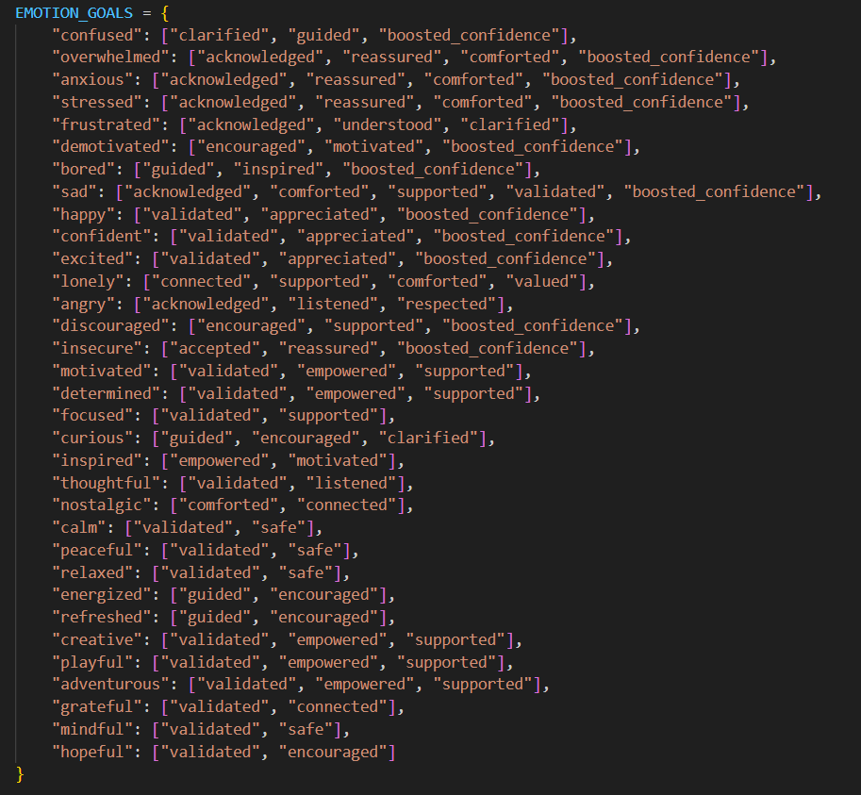
The POP planner must achieve all goals for that emotion.
3. STRIPS-style Operator Library (Actions)
Each conversational action is defined using:
- preconditions
- add effects
Examples:
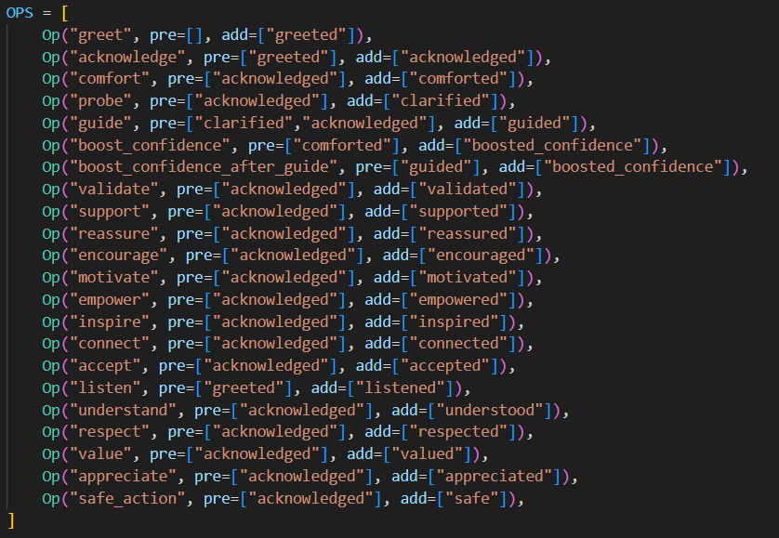
These operators form the building blocks of the POP plan.

Example
Emotion Tested: confused
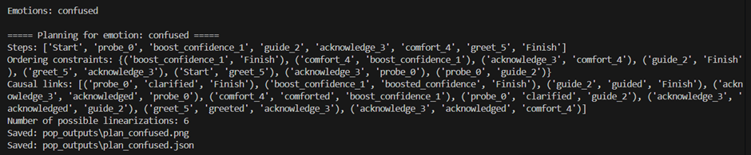
This is a non-trivial test case because:
- It requires multiple sequential actions
- Some actions depend on the effects of earlier actions
- Goals include:
  - clarified
  - guided
  - boosted_confidence
- The planner must create multiple causal chains
- Confidence boosting can be achieved only after guiding
- The plan contains several interacting constraints
This ensures the test exercises the core capabilities of the POP planner.

Output
Steps:
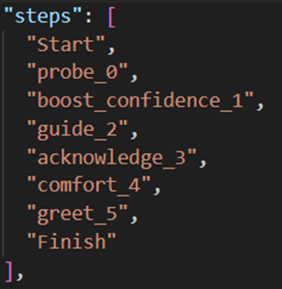
Ordering Constraints:
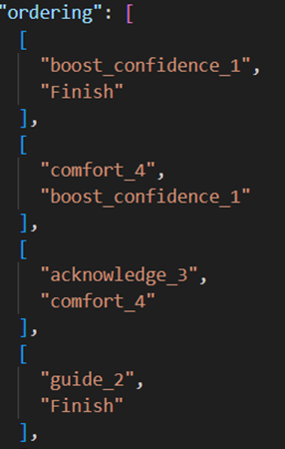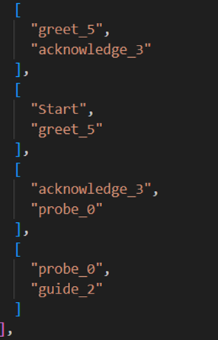
Causal Links:
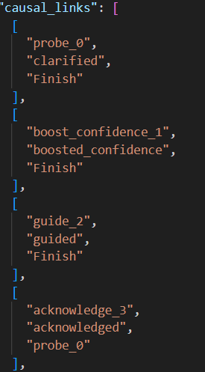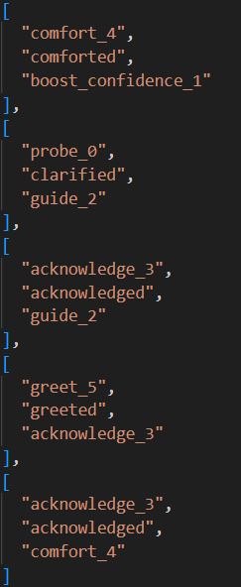
Number of Valid Linearizations: 2
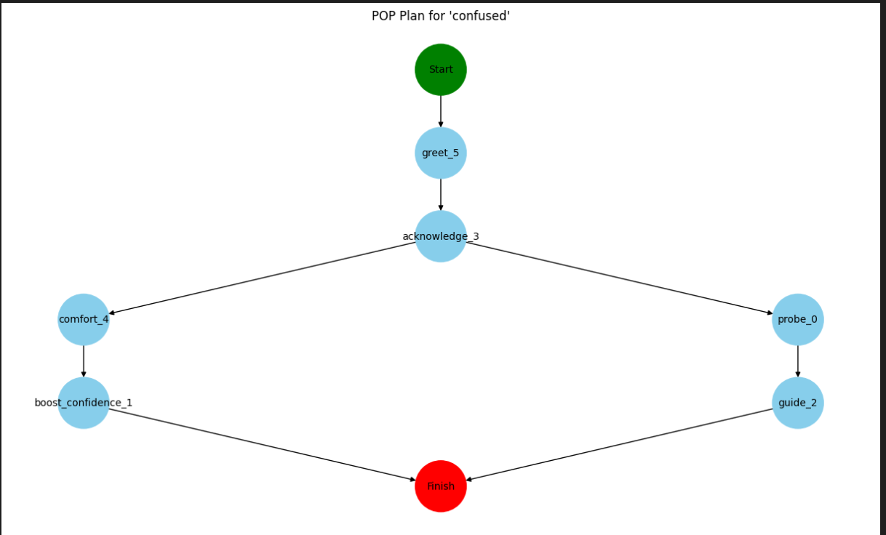
The POP planner determined that in order to help a confused student, the chatbot must:
- Greet them
- Acknowledge their confusion
- Probe to get clarity about the problem
- Guide them with the appropriate explanation
- Boost their confidence after the guidance
POP generates a partial-order plan, not a rigid linear script.
This means only the actions that depend on each other are ordered strictly, while others remain flexible.
Because of this, the planner found 2 valid execution sequences, showing that POP can adapt to different student reactions while still satisfying the overall goals.
This flexibility makes POP much more suitable than GraphPlan for real conversations where the next student message may change what the chatbot should do next.

Comparison of GraphPlan and POP for Multi-Step Emotional Support Planning
GraphPlan produces a strictly ordered plan where each step must occur in the exact sequence determined during planning. This rigidity comes from how GraphPlan constructs alternating layers of literals and actions, enforcing a timeline where action A must happen before action B if B’s preconditions appear only after A’s effects. Such structure works well when conversations follow predictable patterns, but it limits the system’s ability to adapt when the student replies in an unexpected emotional state. Once GraphPlan commits to a sequence, changing even one part such as skipping “Comfort” because the student suddenly sounds confident cannot be accommodated without recomputing the entire plan from scratch.
Whereas POP approaches flexibility in an entirely different manner. Instead of imposing a timeline, POP only specifies ordering when logically required. If two actions do not depend on each other, POP leaves them unordered, allowing the execution engine to choose the most appropriate order at runtime depending on the student’s emotional response. This partial ordering makes the plan inherently adaptable. When the student expresses new emotions or clarifies their needs, the system can adjust the plan locally by adding or removing causal links without discarding the entire plan. Thus, POP aligns much better with the dynamic and unpredictable nature of emotional-support conversations.

Final Comparison Table
Metric | GraphPlan (Path-Based Plan) | POP (Partial-Order Planner)
Plan Structure | Strict, total-ordered plan | Flexible, partially ordered plan
Adaptability to Emotional Changes | Low - requires full replanning | High - only local adjustments needed
Execution Flexibility | Forced sequence even when unnecessary | Multiple valid execution orders
Causal Explanation | Implicit in graph layers | Explicit causal links
Real-World Suitability | Good for deterministic tasks | Best for dynamic emotional interactions

