**WHAT IS AIINU TOKEN**

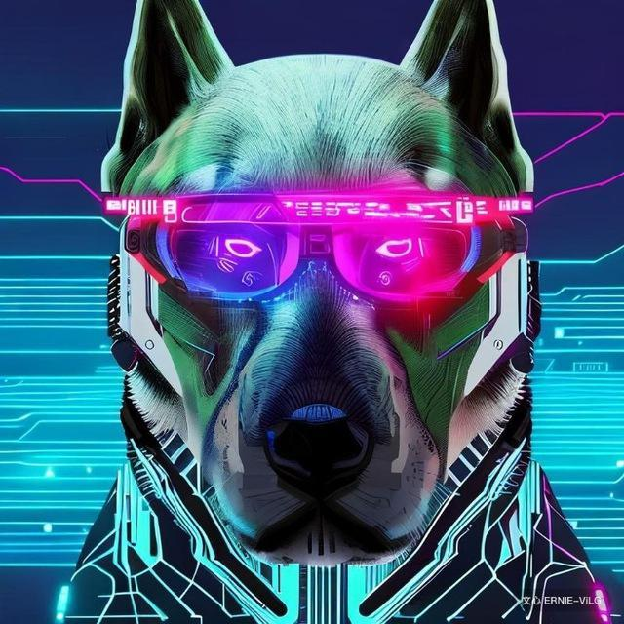

AIINU is an upcoming cryptocurrency project on Arbitrum powered by AI chatbot and blockchain technology. This project seeks to create a decentralized ecosystem which enables users to buy, sell, and pay with this token while benefiting from advanced services such as AI chatbot, NFTs, and swap

**ABOUT AIINU AI CHATBOT**

The AI chatbot will be available to all users, allowing them to communicate with each other safely and securely. With its wide range of services, AIINU will be a powerful tool for business operations, trading and investments. With the growing interest in cryptocurrency, AIINU is sure to open up new possibilities and opportunities for investors.

**AIINU NFT**

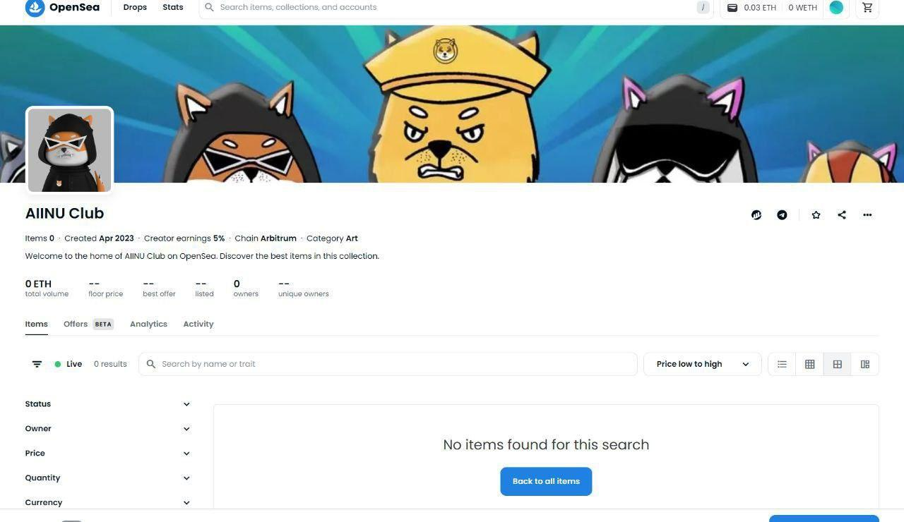

**Aiinu NFT is one of the most unique NFT with utility**

**And Total supply of 10000**

**NFT Airdrop coming**

**And Also NFT will be staked with a Cool reward**

Link: **NFT:** [**https://opensea.io/collection/aiinu-club/drop**](https://opensea.io/collection/aiinu-club/drop)

**TOKEN DISTRIBUTION:**

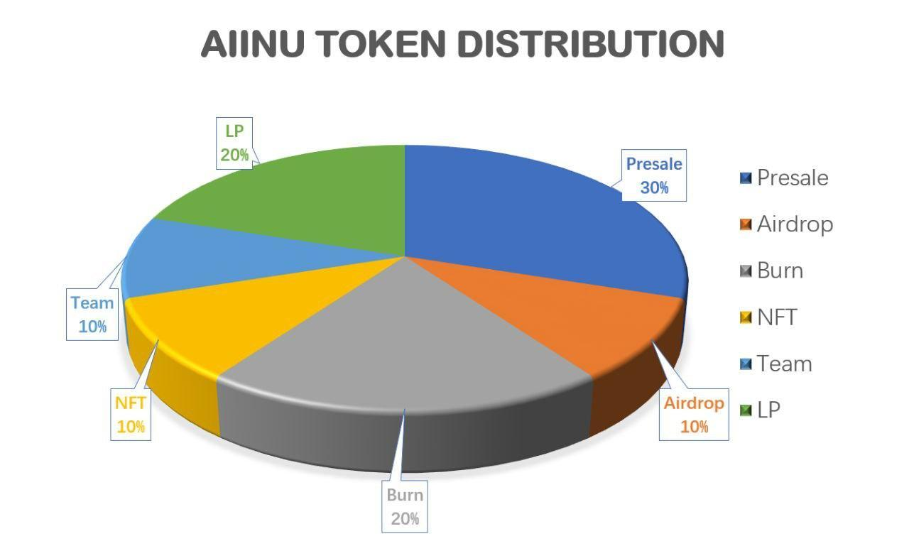

**Distribution:**

**10% market +3%lp +2%staking**

**TAX:**

**5% BUY**

**10% SELL**

**Roadmap**

**Q2:**

**\*TG and Twitter Creation**

**\*Website launch**

**\*launch on arb**

**\*promotion**

**Q3:**

**\*NFT launch**

**\*Swap**

**\*CMC/CG**

**Q4:**

**\*Cex listing**

**\*AI chatbot**

**\*Merchandise**

**\*Partnership**

**Q5:**

**Roadmap v2…**

## Twitter:https://twitter.com/aiinu_arb

## https://twitter.com/aiinu_arb

## Global Group: https://t.me/AIINUEN

## China Group：https://t.me/AIINUARB