**Poseidon**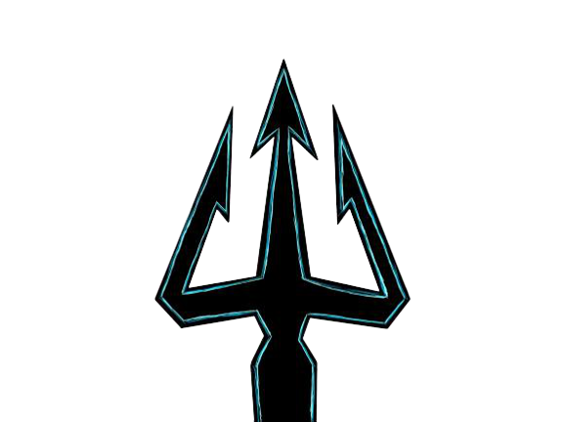

Content

Team 2

Introduction

Stages of development 3

3.1. The start of the project 3

3.2 Planning 4

Realization 4

Conclusion 4

**Team**

### Roles in the team

|  |  |
| --- | --- |
| Aleksandar Kostov 9B | Scrum trainer, leader |
| Georgi Kotakov 9B | Backend developer |
| Dimitar Yoldov 9B | Designer |
| Ivaylo Dimitrov 9B | Frontend developer |

**Introduction**

1. What is the product?

The product is a web page which gives information about the different kinds of natural disasters to the reader.

1. Where is it available?

Our work took place in GitHub and in order for the files to be accessible to all the members of the team, they were uploaded in the repository of our project.

Link - [**https://github.com/AIKostov20/POSEIDON**](https://github.com/AIKostov20/POSEIDON)

1. Communication

The communication between our team members was realized through Discord.

1. What technologies are used?

The technologies used are:

* Visual Studio Code as Code Editor
* HTML, CSS & JavaScript for the website
* GitHub for collaborative work
* Discord – communication
* PowerPoint – for making our presentation
* Microsoft Word – for making our documentation.

**Stages of development**

The start of the project

Once formed, we appointed a leader. The leader then assigned the roles to each member of the team according to who would do best in each position, so that our page could be as good as possible. After allocating the tasks, our team decided to find a mentor. After finding a mentor, we started planning the team's meetings so that everyone could be comfortable and we started working on the project.

Our site was created to provide information about the various groups of natural disasters.

Planning

At the first meeting, we decided which platform everyone will be most comfortable communicating with. We stopped at the Discord platform. Once we were ready and connected, each member of the team began to share their ideas on how to imagine the final look of the page. We clarified the basic ideas of what the page would look like and each member of the team started to do their job, of course, we all helped each other when someone needed help.

**Realization**

|  |  |
| --- | --- |
| Използвани пограми и източници на информация | За какво ни трябваха |
| Discord | For communication between the members of the team |
| Github | To upload and link files in a shared environment. |
| Visual studio code | For writing the code of the webpage |
| Procreate | For creating the team logo |
| https://www.vecteezy.com | To obtain images |

**Conclusion**

This project activity showed us that creativity and good work are the most important for the realization of this project. It also shows us that it is very good to know the strengths and weaknesses of each participant so that the roles can be best distributed. If these conditions are met, the final product will be very good and everyone will be satisfied.

BLOCK SCHEME

About us

Home

Content

Heat waves

Drought

Ice storm

Fire Storm

Hailstorm

Cyclone

Tornado

Blizzard

Dust Storm

Cold Wave

Limbic Eruption

Tsunami

Flood

Sinkhole

Landslides

Avalanches

Earthquake

Volcano

Climatological

Hydrological

Meteorological

Geophysical