<http://localhost/chaal3/login.php>

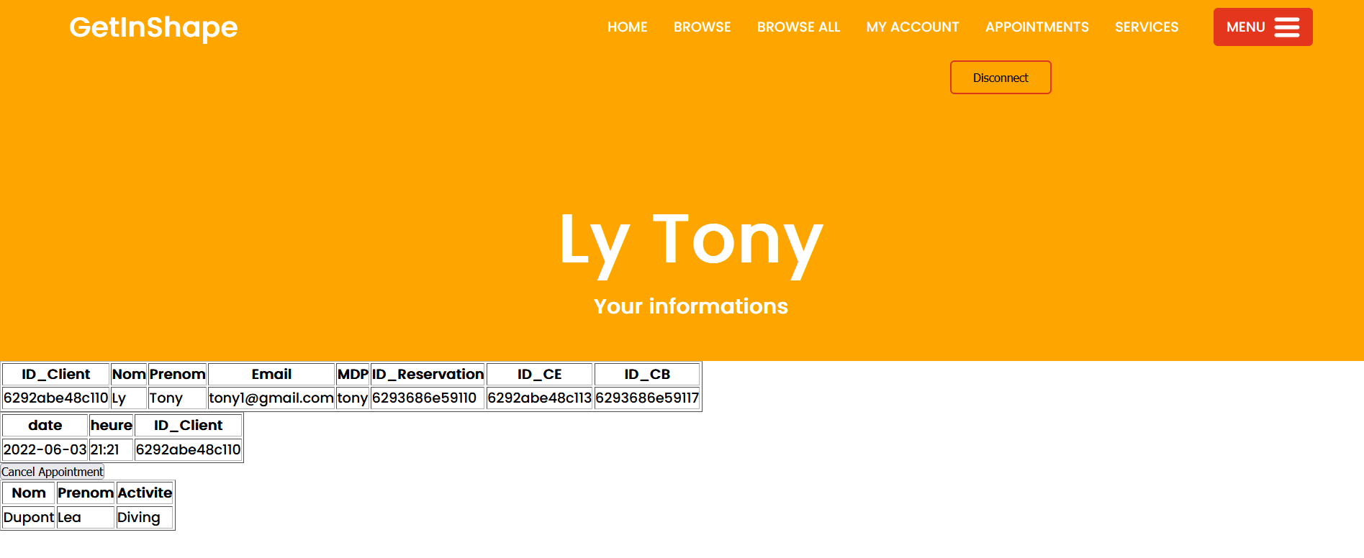

<http://localhost/chaal3/php/admin.php>

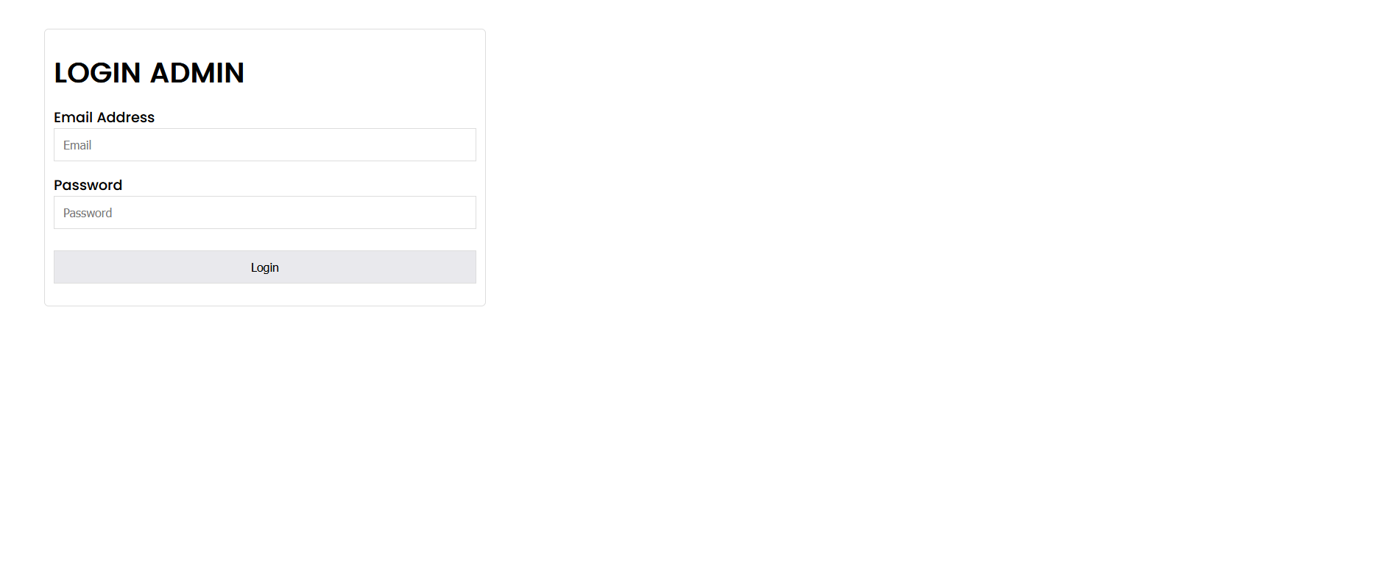

<http://localhost/chaal3/php/adminmenu.php>

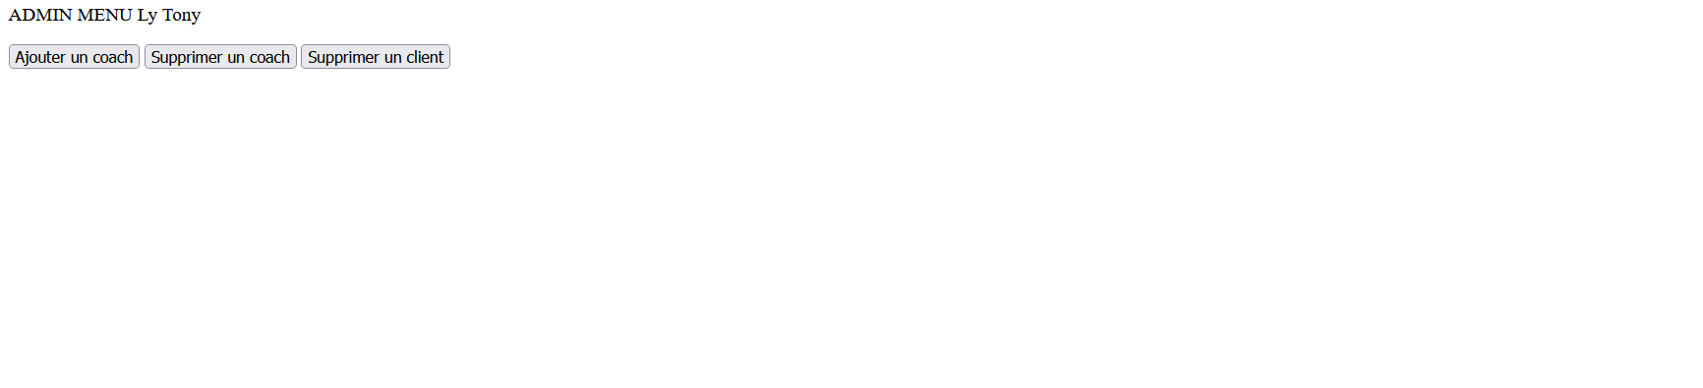

<http://localhost/chaal3/loginCoach.php>

