RAGTune
Evidence-Preserving Governance for RAG Policy Promotion
Under Quality, Cost, Latency, and Risk Constraints
Richard Krueger, Lucas Krause,
Independent open-source research project | August 2026 | Preprint version 0.1.0-rc1
Abstract
Retrieval-augmented generation (RAG) systems are increasingly evaluated with metric suites, benchmark datasets, traces, and automated judges, yet a practical gap remains between measuring a system and deciding whether a proposed policy change is safe to promote. We present RAGTune, an open-source governance and promotion-control framework that treats promotion as a constrained evidence decision rather than a leaderboard choice. RAGTune normalizes evaluator outputs and operational telemetry, applies predeclared quality noninferiority and risk gates, preserves blocked and negative outcomes, validates claim boundaries, and emits machine-readable PROMOTE, BLOCK, REJECT, or INCONCLUSIVE decisions with tamper-evident artifacts. We evaluate the framework across synthetic reproduction, public development and confirmatory corpora, CRAG mock-API and web-document settings, HotpotQA, and bounded local generative-model experiments. The results are deliberately mixed. A bounded CRAG source/retrieval study produced a governance signal, while a behaviorally distinct frozen-observation follow-up found lower operating cost within a predeclared quality margin. HotpotQA showed operational savings accompanied by unacceptable quality loss. A positive CRAG generative slice did not replicate across offsets or models, and a pooled quality-risk guardrail blocked promotion on three of four held-out offsets. In a packaged selector stress test, governed selectors blocked 66% of cases and recorded no quality-loss labels, whereas cost-only, latency-only, and random selectors showed a 25% quality-loss rate. The v0.1.0-rc1 artifact is reproducible from a fresh clone, runs as a hardened Docker governance job, supports external evaluator-style inputs, and verifies run integrity. We do not claim universal governance superiority, RAG Compass superiority, human validation, production readiness, or official platform benchmarking. The contribution is an auditable systems abstraction that converts RAG evaluation into conservative, reproducible promotion control.
Keywords: retrieval-augmented generation; RAG evaluation; AI governance; promotion control; noninferiority; LLMOps; reproducibility
Code and artifacts: github.com/AIM-RAGTune/rag-tuning-governance-public
Release candidate: v0.1.0-rc1 | Commit: ff529005bf7d00a0c3f79ba991563f3923d63205

1. Introduction
Retrieval-augmented generation has become a dominant architectural pattern for connecting language models to current, domain-specific, and attributable evidence [1, 2]. A RAG system, however, is not a single model. It is a configurable pipeline whose behavior depends on document preparation, retrieval depth, routing, reranking, context assembly, generation, abstention, and tool-use policies. Every proposed change therefore creates a multi-objective decision: a policy can be faster but less complete, cheaper but less faithful, more accurate on average but fragile on a protected slice, or attractive on a validation set yet worse on a held-out population.
The evaluation ecosystem has advanced rapidly. RAGAS, ARES, RAGChecker, RAGBench, and related work provide reference-free or labeled metrics, fine-grained diagnostics, and benchmark datasets [3-7]. Observability platforms capture traces, costs, and online feedback [18, 19]. Optimization systems such as DSPy search program or prompt configurations against a metric [9]. These capabilities are essential, but they do not by themselves answer the release question: given several plausible RAG policies and incomplete, heterogeneous evidence, which policy should be promoted, which should be rejected, and when should the system refuse to decide?
RAGTune addresses that decision layer. Its central abstraction is not a new answer-quality metric and not a universal optimizer. It is an evidence-preserving promotion controller. RAGTune ingests native metrics or normalized evaluator exports, associates them with provenance and evidence class, applies hard gates and predeclared decision rules, emits a machine-readable decision, and preserves the supporting and contradicting evidence as an auditable bundle. The design is intentionally conservative: a cheaper or faster policy is not promotable merely because it improves an operational objective; quality preservation, evidence sufficiency, security, leakage, provenance, and claim-boundary requirements must also pass.
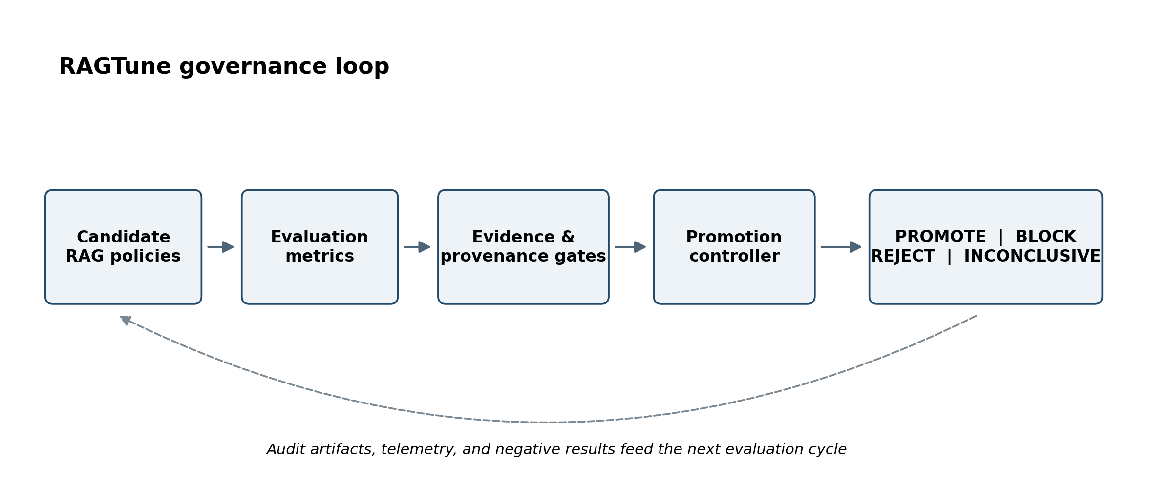
Figure 1. RAGTune converts candidate-policy evidence into an auditable promotion decision and feeds artifacts and negative results back into the next evaluation cycle.
Research question
Can a lightweight, open-source governance layer convert heterogeneous RAG metrics and telemetry into reproducible promotion decisions while reducing false promotion of policies that save cost or latency at unacceptable quality risk?

This paper makes five contributions. First, it defines a promotion-control formalism that separates metric generation from release decisions and uses noninferiority-style quality gates to evaluate operational gains. Second, it introduces an evidence ladder and claim ceiling so that fixture, development, confirmatory, generative, and deployment evidence cannot be silently relabeled. Third, it operationalizes fail-closed governance through machine-readable PROMOTE, BLOCK, REJECT, and INCONCLUSIVE outcomes, an append-only negative-results ledger, and a claim-boundary validator. Fourth, it reports a longitudinal empirical program in which positive, negative, mixed, and refused outcomes are preserved rather than collapsed into a single headline. Fifth, it releases a reproducible implementation with fresh-clone execution, a hardened Docker public-mini job, external-evaluator adapters, deployment templates, artifact-integrity verification, and a tagged release candidate.
The evidence does not support a broad claim that RAGTune finds superior RAG policies. The strongest empirical conclusion is narrower and, we argue, practically important: promotion governance can detect when operationally attractive selectors create quality loss, and a framework designed to refuse those cases provides value even when it cannot identify a stable winning policy. The primary object of evaluation is therefore the governance process itself—its decisions, failure modes, reproducibility, and claim discipline—not the superiority of a particular optimizer such as RAG Compass.

2. Background and Related Work

2.1 RAG systems and evaluation
The original RAG formulation combined parametric sequence models with non-parametric retrieval to improve knowledge-intensive generation and provide more updateable evidence [1]. Subsequent work has expanded RAG into modular systems with query transformation, hybrid search, reranking, routing, adaptive retrieval, tool use, and post-generation verification [2]. This modularity creates a combinatorial policy space and makes system-level evaluation more difficult than evaluating a single model.
RAGAS proposed a reference-free metric suite for retrieval relevance, faithfulness, and generation quality [3]. ARES trains lightweight judges and combines them with a limited set of human annotations through prediction-powered inference [4]. RAGChecker decomposes retrieval and generation into fine-grained diagnostic claims and reports stronger correlation with human judgments than several prior metrics [5]. RAGBench provides a large labeled benchmark and the TRACe framework for actionable evaluation across industry-oriented domains [6]. CRAG stresses factuality, dynamism, long-tail entities, and mock APIs for web and knowledge-graph search [7]. HotpotQA provides multi-hop questions and sentence-level supporting facts, enabling stronger evidence-recall analysis [8]. These systems and datasets substantially improve measurement; RAGTune is designed to consume such measurements rather than replace them.

2.2 Optimization, observability, and testing
DSPy treats language-model programs as parameterized modules and compiles them against a chosen metric [9]. This is complementary to RAGTune: an optimizer proposes or selects candidates; a promotion controller decides whether available evidence permits release. Observability systems such as LangSmith and Phoenix organize datasets, experiments, traces, evaluator scores, latency, feedback, and online monitoring [18, 19]. Again, the distinction is one of primary abstraction. Observability explains what happened; evaluation estimates quality; optimization searches; promotion governance determines whether a candidate is eligible to replace a baseline under explicit constraints.
The broader machine-learning systems literature has long emphasized that model code is only a small fraction of a reliable operational system. Hidden dependencies, configuration debt, feedback loops, and undeclared consumers create maintenance risk [14]. The ML Test Score converts some of this concern into concrete tests and monitoring requirements [15]. RAGTune extends that systems perspective to RAG policy changes: a change should not be judged solely by an aggregate score but by its evidence class, protected regressions, operational effects, reproducibility, and auditability.

2.3 AI risk management and the promotion gap
The NIST AI Risk Management Framework organizes trustworthy AI practices around Govern, Map, Measure, and Manage functions [11], while the Generative AI Profile adapts those practices to generative-system risks [12]. ISO/IEC 42001 specifies organizational requirements for an AI management system [13]. These frameworks motivate lifecycle governance but do not prescribe a RAG-specific promotion algorithm. RAGTune is narrower: it is an executable technical control that sits between measurement and deployment and produces a traceable release decision.
Table 1 positions RAGTune relative to representative adjacent systems. The entries describe primary emphasis, not exclusive capability. Mature platforms may support custom gates or workflows; RAGTune’s contribution is to make promotion, refusal, claim ceilings, and artifact integrity first-class and portable.
System family | Primary emphasis | Typical output | RAGTune relationship
RAGAS / ARES / RAGChecker | Quality and diagnostic evaluation | Metric scores and component diagnoses | Consumes native or exported metrics as governance evidence
RAGBench / CRAG / HotpotQA | Benchmark data and labels | Examples, references, supporting facts, benchmark scores | Uses them as bounded evidence sources with dataset-specific claim ceilings
DSPy and optimizers | Search over prompts, programs, or policies | Candidate configuration maximizing an objective | Treats optimizer output as a candidate, not an automatic promotion
LangSmith / Phoenix | Experiments, tracing, observability, feedback | Runs, traces, evaluator scores, operational telemetry | Normalizes exports and applies promotion/refusal rules
NIST AI RMF / ISO 42001 | Organizational risk-management framework | Governance outcomes, practices, management-system requirements | Implements a narrow technical promotion control consistent with lifecycle governance
RAGTune | Evidence-preserving promotion control | PROMOTE, BLOCK, REJECT, or INCONCLUSIVE plus audit bundle | Coordinates evidence, gates, claim boundaries, and artifact integrity

Table 1. RAGTune complements, rather than replaces, metric, benchmark, optimization, observability, and management-framework layers.

3. Design Goals and Threat Model
RAGTune is designed around a specific failure: false promotion. A false promotion occurs when a candidate policy is deployed because it appears cheaper, faster, or better on an aggregate metric, but the evidence is insufficient, the quality loss exceeds an acceptable margin, a protected slice regresses, or the result depends on invalid provenance or leakage. The symmetric error—false refusal of a useful candidate—also matters, but the current implementation intentionally prefers conservative refusal when quality evidence is weak.
The framework assumes that upstream evaluators can be imperfect and heterogeneous. It therefore does not treat any single metric as ground truth. Instead, each suite declares its metric semantics, direction, weight, evidence class, split structure, and required hard gates. The threat model includes statistical leakage, duplicated examples across splits, post-hoc tuning on confirmatory data, constant or low-information quality signals, unsafe selectors that optimize operational metrics alone, missing provenance, secret or raw-data leakage, and claims that exceed the evidence actually generated.
- Metric risk: evaluator scores may be noisy, constant, weakly calibrated, or insensitive to meaningful policy differences.
- Selection risk: validation-time winners may reverse on held-out data; optimizers may overfit small development sets.
- Operational risk: cost-only or latency-only selection can improve efficiency while degrading answer quality or evidence support.
- Evidence risk: smoke tests, frozen observations, and confirmatory runs support different claim ceilings.
- Reproducibility risk: results may depend on mutable code, unpinned data, local state, or unverified artifacts.
- Publication and security risk: raw licensed text, prompts, answers, credentials, private paths, or unsupported claims may leak into public artifacts.
The design objectives follow from this threat model: (i) make decision criteria explicit before confirmatory evaluation; (ii) separate soft objectives from hard disqualifiers; (iii) preserve negative and blocked outcomes; (iv) make every claim traceable to a result artifact; (v) support external evaluators without making RAGTune dependent on any single vendor or metric library; and (vi) remain deployable as a finite, containerized governance job.

4. RAGTune System

4.1 Policy candidates and normalized evidence
A RAG policy is a named, versioned configuration that can change retrieval depth, endpoints, routing, reranking, context limits, fallback behavior, generator choice, abstention, or selector logic. Policies may be hand-authored, produced by an optimizer, or imported from an external experiment. RAGTune records policy behavior alongside normalized evidence such as answer correctness, faithfulness, context precision or recall, evidence support, abstention correctness, API calls, cost units, latency, failure rate, and protected-regression indicators.
External-evaluator adapters map Ragas-like, DeepEval-like, LangSmith-like, Phoenix-like, generic CSV, and generic JSONL exports into a canonical schema. The v2 adapter demonstration uses sanitized synthetic-shaped exports and does not claim official integration with those platforms. The key architectural point is that evaluator provenance is retained: RAGTune does not appropriate the meaning of upstream metrics; it uses them as declared evidence for a downstream decision.

4.2 Canonical promotion formalism
Let p denote a candidate policy and b the current baseline. Let q(p) be a declared quality metric or composite, c(p) cost, and l(p) latency. For paired evaluation examples, define deltas so positive quality is better and negative operational deltas are improvements:
Δq = q(p) − q(b) Δc = c(p) − c(b) Δℓ = ℓ(p) − ℓ(b)
For experiments using a noninferiority gate, the suite declares a quality-loss margin δ before confirmatory evaluation. In the canonical form, the candidate is quality-noninferior when the lower confidence bound of Δq is no worse than −δ. An operational objective is supported when the relevant confidence interval establishes a reduction in cost or latency. Exact decision rules are suite-specific and stored in configuration; the canonical rule is:
PROMOTE(p) ⇔ hard_gates(p) ∧ LCB(Δq) ≥ −δ ∧ [UCB(Δc) < 0 ∨ UCB(Δℓ) < 0]
The noninferiority concept is borrowed as a decision discipline, not as a claim that RAG evaluation is equivalent to a randomized clinical trial [16, 17]. Its value is procedural: the tolerable loss is declared, the direction of evidence is explicit, and an operational gain is not automatically equated with an acceptable release. When uncertainty straddles a gate, RAGTune returns INCONCLUSIVE rather than converting ambiguity into a win.
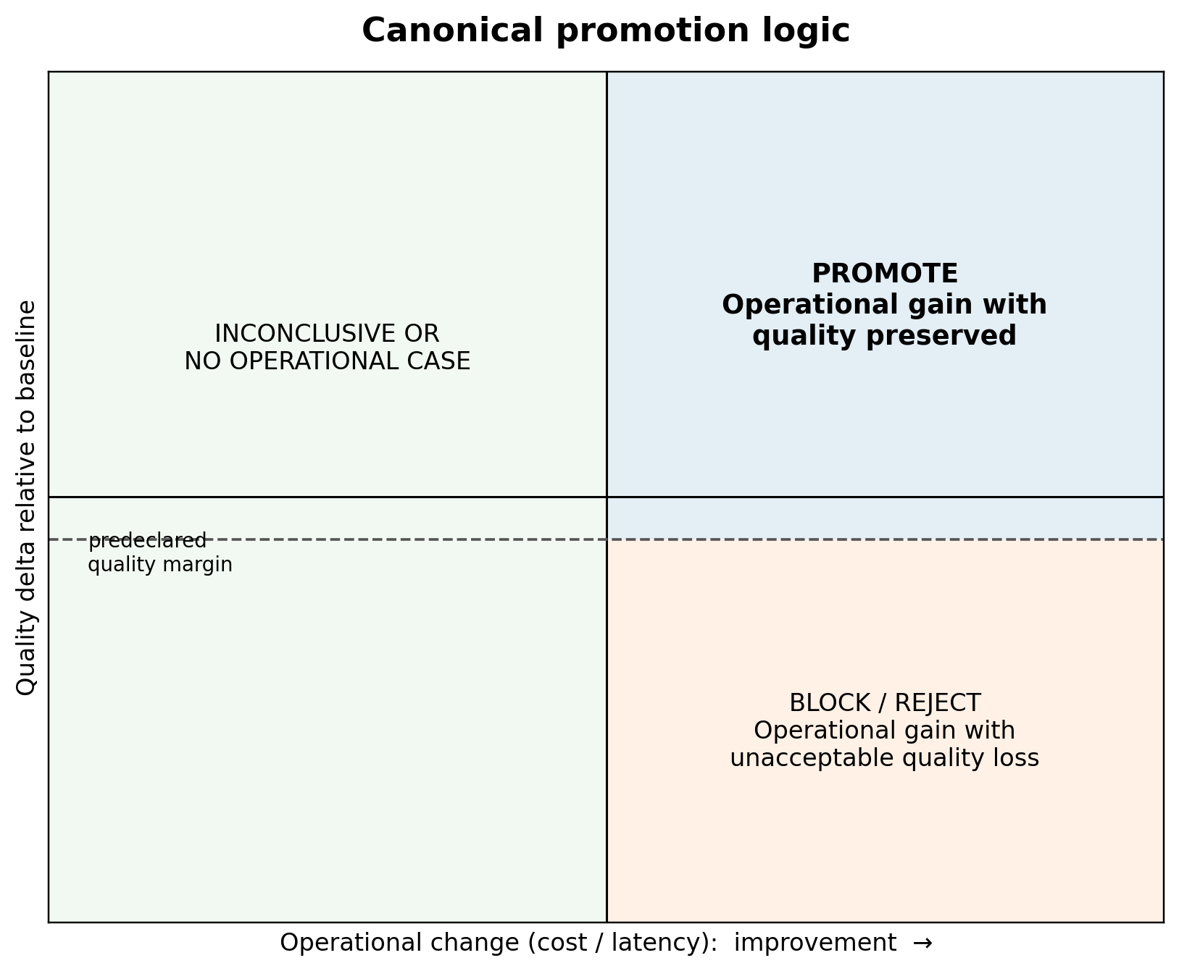
Figure 2. Canonical decision geometry. Operational improvement is promotable only when the predeclared quality-preservation condition and all hard gates pass.

4.3 Hard gates and decision taxonomy
Hard gates are non-compensatory. A policy cannot buy its way past leakage, missing provenance, security disqualification, publication-hygiene failure, or absent quality signal by being inexpensive. This distinguishes governance from a single weighted utility. Weighted utilities remain useful for ranking eligible candidates, but eligibility is determined first.
Decision | Meaning | Typical trigger | Governance consequence
PROMOTE | Evidence supports replacing the baseline within declared scope. | Quality gate passes; operational or risk objective passes; no hard disqualifier. | Candidate may advance with recorded claim boundaries.
BLOCK | Promotion cannot be evaluated safely. | No usable quality signal, leakage, missing provenance, security or hygiene failure. | No deployment claim; blocker and remediation are recorded.
REJECT | Evidence favors retaining the baseline or rejecting the candidate. | Confirmed quality loss, negative held-out result, or protected regression. | Candidate is not promoted; negative evidence remains append-only.
INCONCLUSIVE | Available evidence does not resolve the decision. | Confidence interval crosses threshold, results are mixed, or sample is underpowered. | No promotion; additional evidence may be collected.
ERROR | Execution failed before an auditable decision. | Runtime failure or invalid artifact schema. | Run is not interpreted as scientific evidence.

Table 2. Machine-readable decision taxonomy used by the deployable governance job.

4.4 Evidence classes and claim ceilings
RAGTune associates each run with an evidence class. A fixture proves that code paths execute, not that a policy is superior. A development result can guide design but cannot be relabeled confirmatory. Frozen-observation analyses are useful for ablation but are weaker than independent live collection. Generative evidence requires an actual pinned generator and a usable answer-quality signal. Human validation requires completed annotations. Platform benchmarking requires platform-native execution records. Production readiness requires operational evidence that is not present in the current release.
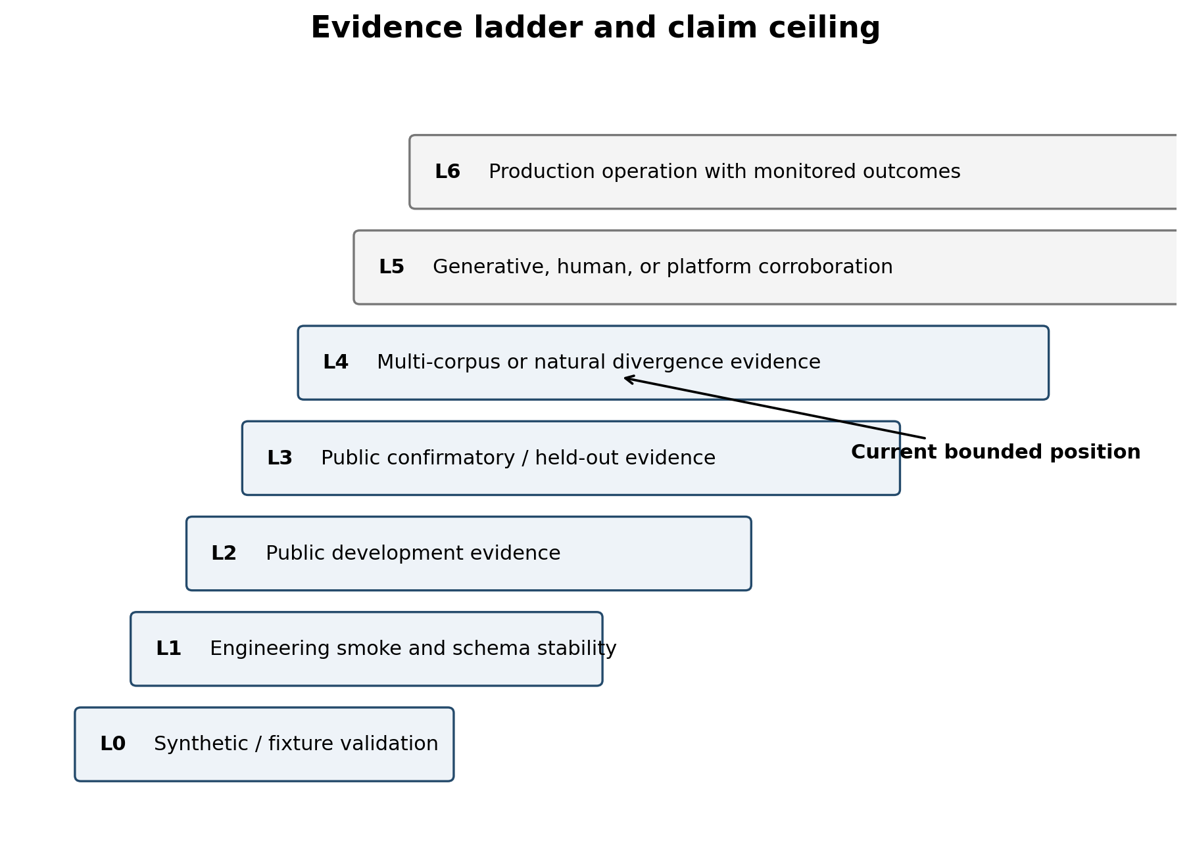
Figure 3. Evidence classes define a claim ceiling. RAGTune currently reaches bounded public and generative evidence in selected settings, but not human, official-platform, or production validation.

4.5 Claim-boundary validation and evidence preservation
The publication validator checks that result language and public artifacts remain consistent with evidence. It scans for raw dataset text, prompts, generated answers, API responses, secrets, private paths, large tracked files, and unsupported claims. It also verifies expected result classes and artifact families. A historical ledger retains positive, negative, blocked, refused, and superseded results. This is not merely documentation hygiene: it prevents a later summary from silently reviving a claim that a statistical audit or held-out run had already narrowed.
One illustrative case was an early offline real-RAG result with a zero-width bootstrap interval. A subsequent row-level reconstruction found only one unique paired delta across 49,850 paired example-seed rows and downgraded the result to aggregate candidate-output evidence. RAGTune preserved the earlier run but explicitly removed its status as calibrated query-level uncertainty. This correction is central to the framework’s scientific posture.

4.6 Artifact integrity and deployable job contract
Every governance job can emit a promotion decision, run manifest, policy summaries, selector comparisons, claim update, validation report, and optional audit bundle. The verify-run command checks required artifacts, schemas, and hashes; the public-mini demonstration reports matching hashes, no raw text files, no secret-like strings, and no private paths. The release candidate also includes fresh-clone reproduction and checksums.
The same finite job contract is packaged for local Docker, Docker Compose, Kubernetes Jobs and CronJobs, Azure Container Apps Jobs, AWS ECS/Fargate and Batch, Google Cloud Run Jobs, and GitHub Actions. Only the local hardened Docker path has been executed; cloud templates are deployment enablement, not live cloud validation.
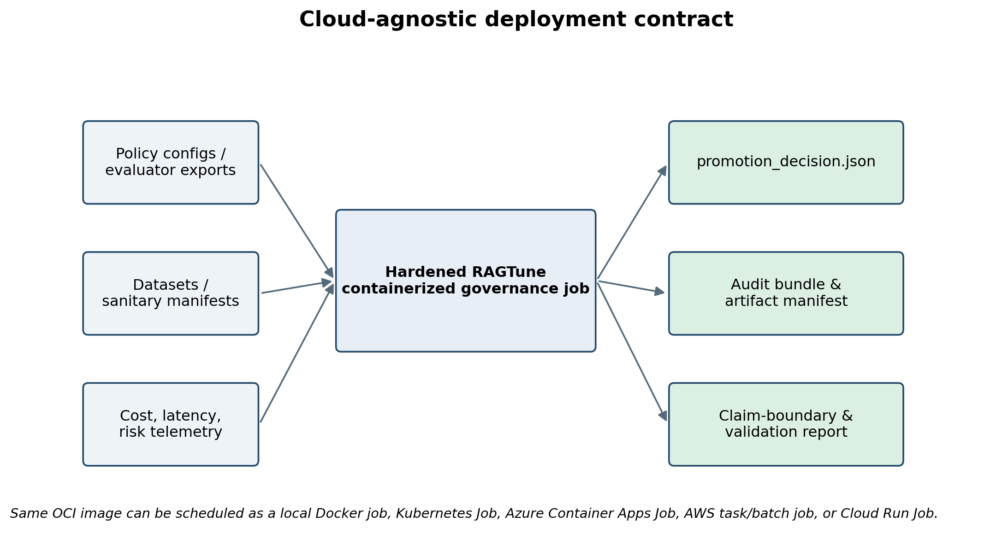
Figure 4. Cloud-agnostic deployment contract. A finite governance job consumes policies and evidence, then emits a decision, audit bundle, and claim-boundary report.

5. Experimental Program

5.1 Longitudinal design
The empirical program evolved through successive attempts to falsify or narrow the project’s claims. Early fixture and synthetic runs verified orchestration and refusal behavior. Public real-RAG development introduced grouped splits, leakage checks, and budget parity. Statistical audits reconstructed row-level evidence. Later phases added corpus-backed retrieval, mock APIs, generative models, behaviorally distinct policies, held-out offsets, external evaluator adapters, selector ablations, fresh-clone reproduction, and container validation.
This sequence is not presented as a single preregistered trial. It is a research-and-engineering program whose artifacts expose how claims changed under stronger tests. The paper therefore distinguishes confirmatory results from development, derived, smoke, and diagnostic evidence. Table 3 summarizes the principal corpora and roles.
Dataset / path | Role in program | Evidence characteristics | Primary limitation
T2-RAGBench | Public end-to-end development | 1,142-query expanded development corpus; behaviorally variable policies | Development evidence; deterministic extractive generation in key runs
MultiHop-RAG | Fresh public confirmatory corpus | 331-query sealed confirmatory test; full corpus-backed path | Governance matched quality-only; no superiority
RAGBench HotpotQA subset | Context-retrieval enablement | Policy-dependent context assembly | Not full source-corpus retrieval in packaged evidence
CRAG web documents | Full corpus-backed retrieval | 2,706 rows, 9,848 web documents, 571 confirmatory rows | Noncommercial research restriction; governance matched quality-only
CRAG mock API | Tool/API routing and generative validation | Live and frozen paths; cost, latency, calls, evaluator mapping | Strongest positive source/retrieval result is bounded; generative results unstable
HotpotQA | Alternate corpus with answer labels and supporting facts | 1,000-example local sample; 249 confirmatory rows in behavioral run | Operational gains were accompanied by quality loss; generative audit remained small
Public mini | Open-source reproduction and fail-closed demo | Synthetic, deterministic, no private data or generator | Onboarding proof, not external empirical evidence

Table 3. Principal datasets and evidence roles. Raw licensed datasets are not redistributed by the public repository.

5.2 Candidate policies and selectors
Candidate policies included static defaults, low and expanded retrieval, adaptive routing, cost- and latency-aware policies, greedy coordinate and regression-aware search, Optuna/TPE, RAG Compass (legacy identifier ragtune_no_fork), constrained optimization, Pareto selection, and governance aliases. Later selector stress tests compared quality-only, cost-only, latency-only, random eligible, static default, RAG Compass, governed noninferiority, risk-guarded, and oracle-style selectors.
RAG Compass is intentionally treated as one candidate among many. It won some early development runs, lost or ranked below alternatives in later public and generative tests, and ranked fifth in the strongest CRAG mock-API result. The current evidence supports no claim of RAG Compass superiority or a clear bounded niche.

5.3 Statistical and governance analysis
Where paired example-level evidence was available, the program used paired bootstrap intervals and win/tie/loss summaries. Grouped or blocked bootstraps were reported only when separately implemented; later validation explicitly rejected copying a query-level interval under multiple labels. Noninferiority margins were declared in suite configuration, commonly 0.01 for composite quality. Selection regret, rank stability, and sensitivity to cost and latency weights were used as diagnostics.
Statistics were subordinate to evidence validity. A narrow interval cannot rescue a constant or duplicated signal. A positive validation result cannot be relabeled confirmatory. A selector that saves latency but breaches quality on a held-out offset is blocked regardless of average utility. The governance unit is therefore the conjunction of metric evidence, split integrity, provenance, hard gates, and claim scope.

5.4 Reproducibility and hygiene controls
The v0.1.0-rc1 repository records a fresh-clone reproduction pass, a hardened Docker public-mini run, 222 passing publication tests, green CI and publication checks, a release manifest, checksums, a verify-run pass, and sanitized hardware characterization. The Docker runtime uses a non-root identity, read-only root filesystem, tmpfs for temporary storage, no-new-privileges, dropped Linux capabilities, resource limits, and no network for the public-mini execution. These controls demonstrate local deployment reproducibility; they do not establish production readiness.

6. Results

6.1 Statistical audit narrowed an early positive signal
An offline public real-RAG grouped-split run originally reported RAG Compass ahead of a validation-selected baseline by 0.0488 with a zero-width bootstrap interval. The subsequent reconstruction found 4,985 unique test examples across 10 seeds but only one unique paired delta. Query, cluster, dataset-blocked, seed, and hierarchical resampling therefore reproduced the same number rather than meaningful uncertainty. The run was retained as descriptive aggregate candidate-output evidence and marked inconclusive for paper-grade query-level inference.
This episode demonstrates the value of an evidence ledger that can narrow a prior result without deleting it. It also motivated explicit checks for nonconstant quality signals and separately implemented grouped statistics.

6.2 Public confirmatory runs often matched or favored non-RAGTune policies
On MultiHop-RAG, the valid 331-query confirmatory run selected RAG Compass under both governed and quality-only aliases, producing a governance delta of zero and a result of noninferior, not superior. Among base optimizers, Optuna/TPE ranked first and RAG Compass third; the selection-regret audit found no logic bug because validation evidence, not held-out hindsight, determined promotion. On CRAG web-document retrieval, both governed and quality-only selection chose top_k_high, again yielding noninferiority without superiority.
The T2-RAGBench development program was more directly negative for RAG Compass. In the larger 1,142-query development run, greedy regression-aware search achieved utility 0.4919 versus 0.4814 for RAG Compass; the delta was −0.01055 with a bootstrap interval of approximately [−0.0250, 0.0055], narrowly beyond the prespecified 0.01 noninferiority margin. These outcomes support optimizer-agnostic governance rather than a favored optimizer narrative.

6.3 CRAG mock-API governance produced the strongest bounded source/retrieval signal
The strongest packaged source/retrieval result used the full CRAG mock-API validation and confirmatory splits. Quality-only selection chose greedy regression-aware search, whereas governance chose top_k_low. On 571 confirmatory examples, the reported governance delta was +0.00100254 with a narrow interval [0.00100227, 0.00100283] and 571 wins. Sensitivity analysis retained the governed choice in 14 of 15 cost-latency settings and matched quality-only only when both cost and latency weights were zero.
This result is bounded in two important ways. First, the ablation attributed the utility difference almost entirely to the declared cost model and a small measured latency difference, with no raw-quality improvement. It is therefore a demonstration that governance can choose a lower-cost quality-tied candidate, not evidence that RAGTune discovered a universally better retriever. Second, Docker reproduced the decision, but some numerical metrics differed. The claim-status ledger consequently labels this the strongest governance result while preserving the need for independent reproduction.

6.4 A behaviorally distinct follow-up strengthened the operational framing but remained derived
A follow-up constructed policies that differed in endpoint routing, API calls, context volume, cost, and latency over sanitized frozen CRAG mock-API observations. Governance selected low_retrieval_single_endpoint, while quality-only selected Optuna/TPE. Composite proxy-plus-evidence quality was 0.00515 lower, within the predeclared 0.01 margin, while measured cost decreased by 2.368 units, latency by approximately 86 ms, and API calls by 1.799 per query. The Pareto frontier contained the governed policy and Optuna/TPE.
This is a stronger operational shape than a tiny weighted-utility difference: it asks whether a materially simpler policy can preserve quality within a declared bound. Nevertheless, it is derived from frozen observations and uses proxy-plus-evidence quality rather than human-calibrated or independently generated answers. We treat it as moderate supporting evidence, not confirmatory replication.

6.5 HotpotQA showed why an operational gain is not enough
The alternate-corpus HotpotQA run used answer labels and supporting-fact evidence. Governance selected expanded_retrieval_multi_context, while quality-only selected bm25_high_k. Governance reduced cost by 2.330 units, context volume by about 346 estimated tokens, and API calls by 1.984 per query. However, final quality decreased by 0.0408 with interval [−0.0911, 0.0126], and answer-correctness F1 decreased by 0.0843 with an interval entirely below zero. The result class was operational gain with quality loss, not promotion.
This negative result is central to the paper. A cost-optimized system could present the same run as an efficiency win. RAGTune records that the predeclared quality noninferiority condition failed and blocks the stronger claim.

6.6 Generative validation was feasible but not stable
A bounded local CRAG generative slice used Ollama with qwen3:8b and the CRAG local evaluator. Across 12 examples and 132 policy-generation rows, all answers were non-empty and quality varied. The governed Pareto selector reduced cost by 3.779 units and latency by roughly 5.97 seconds relative to expanded retrieval, while generated-quality delta was +0.0167 with interval [−0.0364, 0.0363]. This slice met the configured cost-at-equivalent-quality rule.
The result did not generalize. Three deterministic repeats failed to reproduce the cost result. A second local model, gpt-oss:20b, produced usable signals but no positive cost-result slices and had substantial blank-answer behavior. A faster llama3.2:3b path repaired answer emission but still produced no positive cost slices. HotpotQA generative auditing confirmed a nonconstant signal—96 non-empty rows, 39 unique answer hashes, nonzero answer and evidence variance—but the sample contained only 12 examples and the governance result was inconclusive.
Accordingly, the release synthesis is mixed. RAGTune supports local generative evaluation machinery and bounded evidence, not stable generative governance superiority.

6.7 Held-out quality-risk guardrails failed closed
A pooled cross-offset quality-risk guardrail used deployable-only metadata features and held out offsets 0, 24, 36, and 60. Validation gates passed on all four folds, yet held-out quality-loss blocking fired on three. The guardrail reduced API calls and cost in every held-out slice, but no slice established a positive latency result under the strict endpoint, and quality-loss risks remained. The final result class was BLOCKED_HELDOUT_QUALITY_LOSS.
This is a governance success in the narrow sense that a promising validation model was not promoted after failed held-out generalization. It is not an optimization success. The distinction is precisely the paper’s thesis: the value of promotion control appears most clearly when apparent gains do not survive stronger evidence.
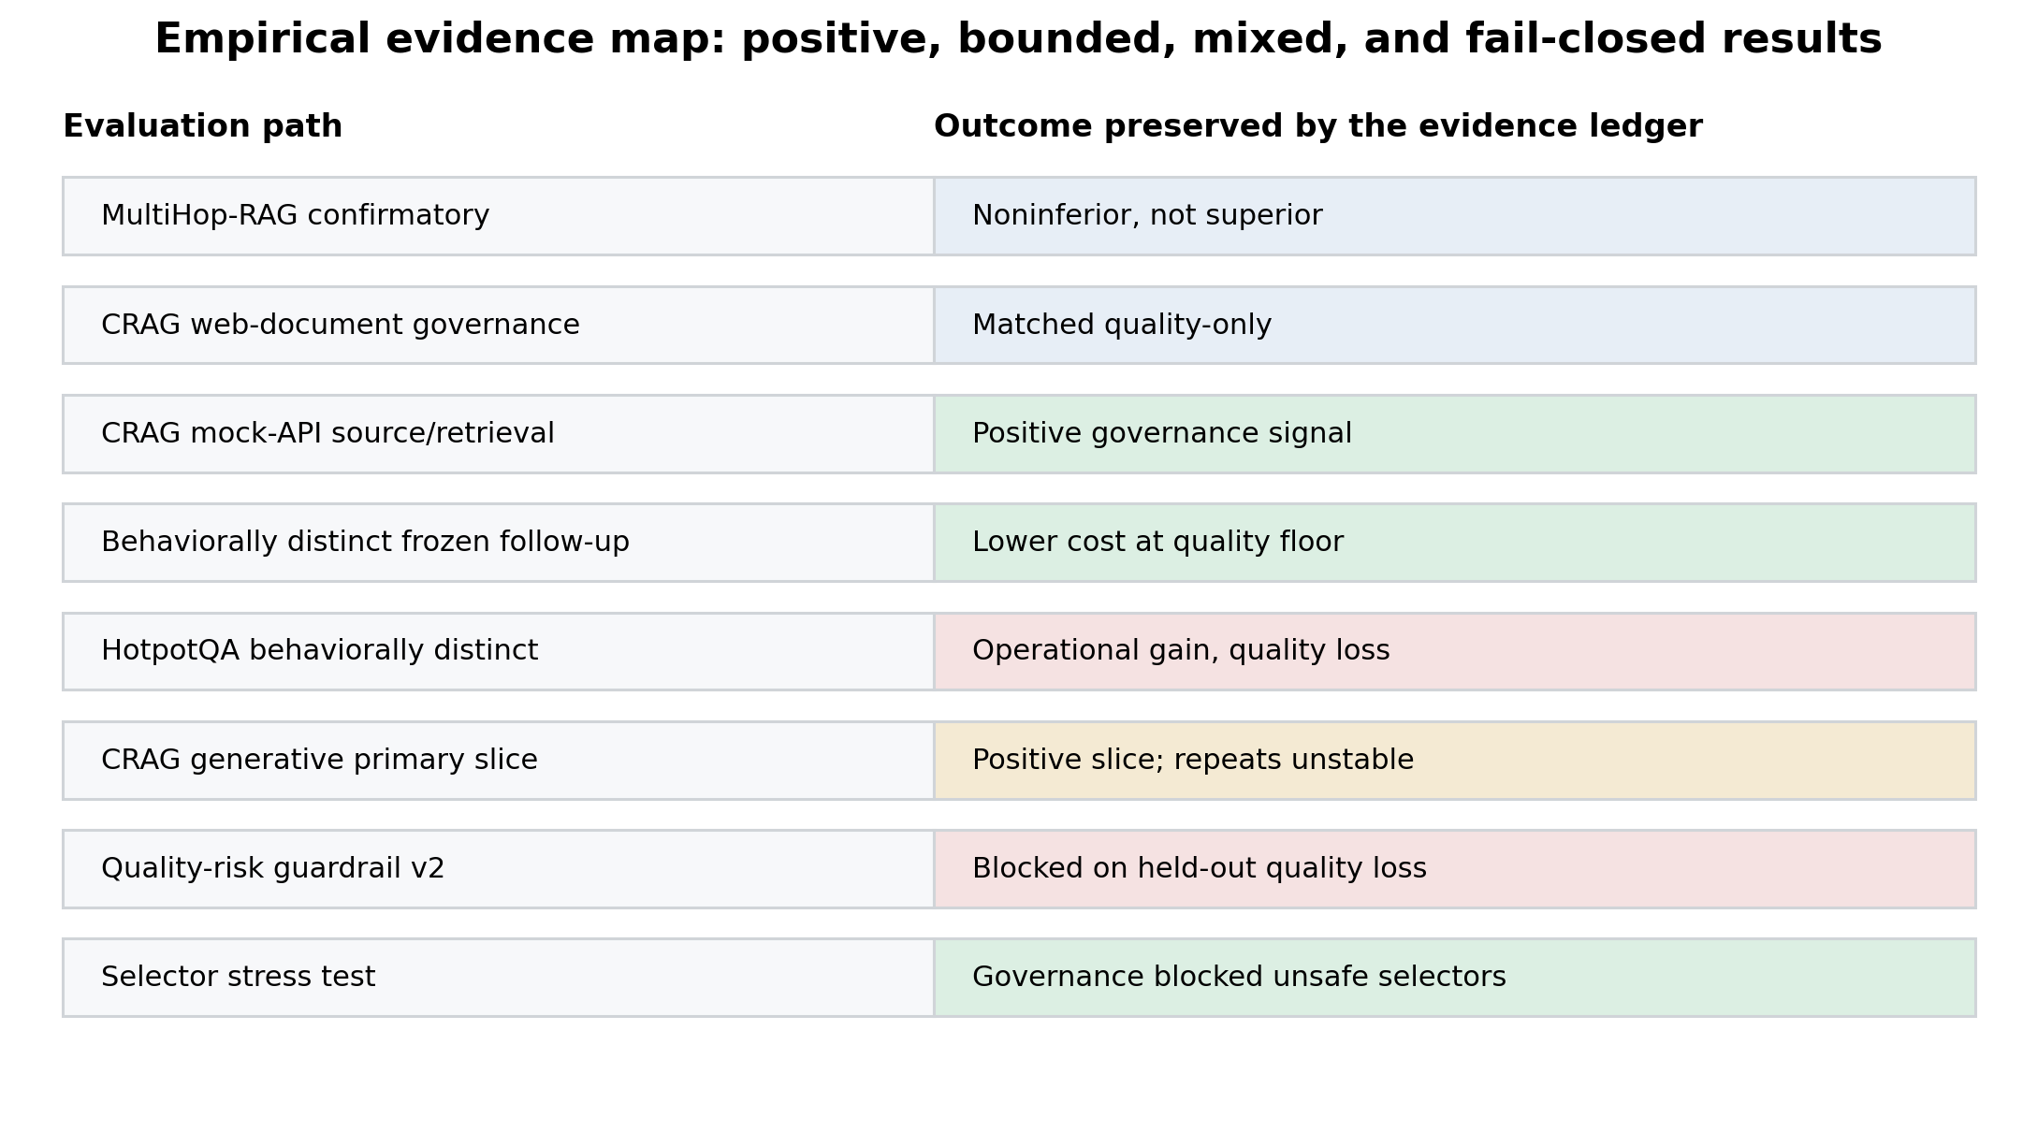
Figure 5. The longitudinal program preserves positive, bounded, mixed, negative, and fail-closed outcomes rather than reducing them to one leaderboard.

6.8 Selector ablation exposed unsafe operational selectors
The packaged selector stress test aggregated available sanitized evidence families and compared nine selector classes. Cost-only, latency-only, and random-eligible selection each had a 25% quality-loss rate and no blocking. Governed noninferiority and risk-guarded selectors blocked 66% of cases and recorded no quality-loss labels. The oracle ceiling had neither blocking nor quality loss. These rates are properties of the packaged stress-test cases, not population estimates, but they illustrate the intended trade-off: governance reduces promotion throughput to avoid observed quality loss.
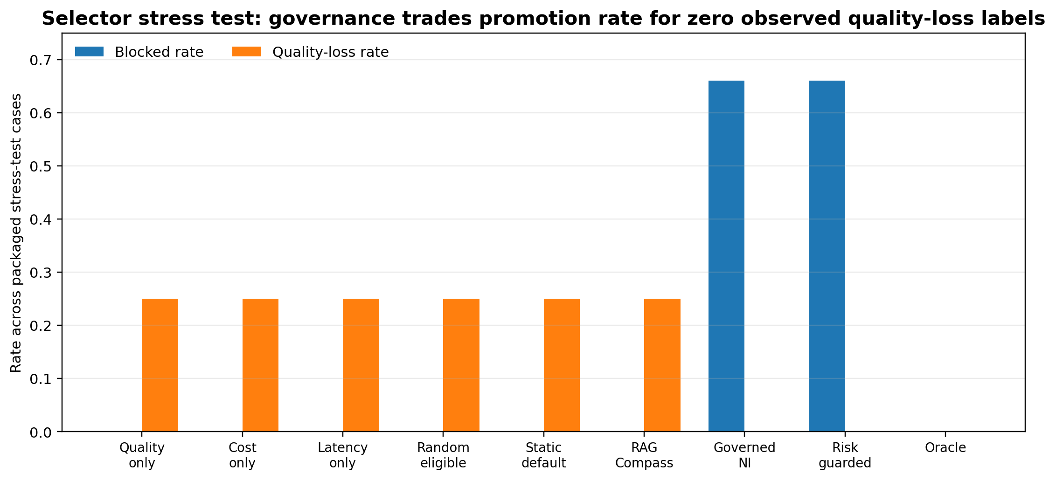
Figure 6. Selector stress-test summary. Governed selectors blocked more often and recorded no quality-loss labels in the packaged cases; cost-, latency-, and random-driven selectors did not block and showed quality loss.

6.9 Reproducibility and deployment results
The RC1 package passed a fresh Git clone reproduction without private data, CRAG, HotpotQA cache, a generator, or cloud credentials. The hardened Docker runtime completed the public-mini governance job. Static Docker validation passed, and the deployment-readiness manifest reports a working container contract, cloud templates, no committed raw data or secrets, and no live cloud claim. The verify-run demonstration checked six artifacts and reported matching hashes, valid schemas, no raw text files, no secret-like strings, and no private paths.
The external-evaluator v2 demonstration normalized twelve synthetic-shaped metrics from Ragas-, DeepEval-, LangSmith-, Phoenix-, CSV-, and JSONL-like formats and generated a promotion decision. This shows schema interoperability, not official integration. The AIM hardware matrix records an arm64 macOS orchestration node and explicitly excludes hostnames, IP addresses, serial numbers, and private paths. Together these results support an open-source systems artifact and release candidate, not production certification.
Evaluation | Scope / N | Primary outcome | Interpretation
MultiHop-RAG confirmatory | 331 confirmatory queries | Governance delta 0; noninferior, not superior | Valid public confirmatory evidence; no governance advantage
CRAG web-document | 571 confirmatory rows | Governed = quality-only = top_k_high | Supports corpus-backed execution; no superiority
CRAG mock API | 571 confirmatory rows | +0.00100254 governance utility; 571/0/0 | Strongest bounded source/retrieval signal; largely cost/latency driven
Frozen behaviorally distinct CRAG | 571 paired observations | Quality −0.00515; cost −2.368; calls −1.799 | Operational shape improved; derived frozen evidence
HotpotQA behavioral | 249 confirmatory rows | Quality −0.0408; cost −2.330; calls −1.984 | Operational gain with quality loss; blocked
CRAG generative primary | 12 examples; 132 generations | Quality +0.0167; cost −3.779 | Positive bounded slice; repeats/models did not reproduce
Guardrail v2 | 4 held-out offsets | 3 quality-loss blocks; 0 positive latency results | Validation success did not generalize; fail-closed
Public mini + Docker | Synthetic deterministic job | Fresh clone, Docker run, decision artifact, verify-run pass | Strong onboarding and systems reproducibility; not external science

Table 4. Principal empirical and systems results. Negative and mixed outcomes are part of the reported evidence.

7. Discussion

7.1 What is novel—and what is not
RAGTune does not introduce a superior faithfulness metric, a new general-purpose optimizer, or a replacement for observability platforms. Its novelty claim is architectural and procedural: it makes promotion control an explicit systems layer with four properties that are rarely packaged together.
First, decision rules are distinct from metrics. Upstream tools can continue to evolve while the release contract remains stable. Second, quality preservation and hard gates precede soft utility ranking. Third, evidence class limits the claim that may be emitted. Fourth, the public artifact validator and verify-run mechanism bind scientific language to machine-readable evidence and artifact integrity.
Individually, none of these ideas is unprecedented. Noninferiority testing is mature [16, 17]; AI risk frameworks call for measurement and management [11-13]; ML systems engineering emphasizes testing and reproducibility [14, 15]. The contribution is their RAG-specific operationalization in an open-source, containerized promotion-control system, plus a longitudinal evidence record showing how the system behaves when positive findings fail stronger tests.

7.2 Value above existing evaluation tools
The empirical evidence does not show that RAGTune evaluates answers better than RAGAS, ARES, RAGChecker, or proprietary platforms. Its value is above the metric layer: it can consume an answer-correctness score from one tool, a faithfulness score from another, cost and latency from traces, and a security disqualifier from a test suite, then apply one auditable promotion contract.
This separation is useful in organizations where multiple teams and platforms produce evidence but release decisions must be consistent. It also makes disagreement visible. A quality-only evaluator may rank a policy first; a constrained optimizer may select another; governance may block both because the quality signal is constant or a protected slice regresses. RAGTune’s output is therefore a decision with reasons and boundaries, not merely another score.

7.3 Negative results as governance evidence
A framework that only reports wins cannot demonstrate refusal discipline. The HotpotQA quality-loss result, failed CRAG generative replications, and Guardrail v2 held-out blocks are not incidental limitations; they are direct tests of whether the system converts attractive operational deltas into unsupported promotions. The selector stress test further suggests that blocking can be a measurable behavior: the governed selectors sacrificed promotion rate and avoided the quality-loss labels observed for naive operational selectors.
This does not establish an optimal false-promotion/false-refusal trade-off. It does establish that the framework can encode and execute a conservative policy. Future work should estimate decision calibration on larger, independently collected corpora and quantify the cost of unnecessary blocking.

7.4 Institutional and enterprise applicability
The product contract is most relevant where RAG changes require defensible release decisions: healthcare policy assistants, financial and insurance knowledge systems, legal research, government services, life-sciences evidence workflows, and internal enterprise copilots. In those settings, the decision question is often not “Which score is highest?” but “Can the proposed change be justified under declared quality, access, latency, cost, and risk constraints?”
RAGTune can be scheduled as a finite governance job in CI/CD or a periodic monitoring workflow. It can evaluate a policy by corpus, use case, user population, or risk tier and emit an artifact suitable for a change record. The current release demonstrates local Docker execution and cloud-agnostic templates; it does not demonstrate live institutional deployment, authorization integration, or production incident response.

8. Limitations and Threats to Validity
The current evidence has substantial limitations.
Empirical breadth. Only a small number of public corpora support full policy-dependent, corpus-backed evaluation in the packaged program. CRAG is restricted to noncommercial research use. RAGBench HotpotQA evidence is context-retrieval rather than a fully reconstructed source corpus in some phases. MultiHop-RAG yielded noninferiority without superiority.
Generative sample size and stability. The positive CRAG generative primary slice contained 12 examples. Repeats and second-model runs did not reproduce the cost result. The HotpotQA generative quality audit v2 reused 96 sanitized generation rows over 12 examples rather than reaching its configured larger target. Broad generative claims are therefore unsupported.
Metric validity. Composite proxy-plus-evidence metrics are not substitutes for human judgment. Even labeled datasets cover only selected dimensions. Human evaluation has not been completed, and evaluator calibration across domains remains open.
Statistical multiplicity and adaptivity. The program is longitudinal and iterative, not one preregistered experiment. Although confirmatory gates and held-out splits were introduced, repeated design changes and exploratory suites create researcher degrees of freedom. The paper responds by preserving the chronology and avoiding a single pooled significance claim.
Dependence and confidence intervals. Some early intervals were low-information or duplicated across rows; those claims were downgraded. Later grouped analyses are reported only when implemented, but many samples remain small and dependent.
Systems validity. Fresh-clone and local Docker execution support reproducibility, not production readiness. No live Azure, AWS, or GCP job has been executed. Security scans are partial, and operational concerns such as authentication, authorization, availability, retention, and incident management require deployment-specific work.
Comparative validity. External evaluator adapters use synthetic-shaped exports; they are not official platform integrations. RAGTune has not been benchmarked against a fully configured LangSmith, Phoenix, Ragas, DeepEval, or RAGChecker promotion workflow. The paper claims interoperability architecture, not superior workflow performance.
Optimizer claims. RAG Compass is not superior in the current evidence. It ranked fifth in the strongest CRAG mock-API result and below alternatives in several public and generative runs. It remains an optional candidate, not the contribution.

9. Reproducibility, Availability, and Responsible Release
The public repository is released under Apache-2.0 for project code. Third-party datasets retain their original licenses; raw CRAG and HotpotQA text is not redistributed. The tagged v0.1.0-rc1 release points to commit ff529005bf7d00a0c3f79ba991563f3923d63205. The repository includes configuration files, sanitized processed artifacts, schemas, scripts, tests, Docker assets, cloud deployment templates, claim tables, and the historical evidence ledger.
A fresh clone can run the public-mini path without private data or model credentials. The hardened Docker job runs as a fixed non-root user with a read-only root filesystem, no-new-privileges, dropped capabilities, resource limits, and no network for the public-mini run. The verify-run command checks artifact manifests and hashes. These mechanisms support independent inspection of the governance contract and its failure modes.
The release is intentionally bounded. It is a research-grade governance engine and systems artifact, not a certified production platform. Human validation, official platform benchmarking, and production operation are explicitly absent. The public claim-status table should be treated as part of the paper’s evidence, not ancillary documentation.
Reproduction command
Clone the tagged repository, install the package, run `ragtune run-public-mini`, execute the hardened Docker public-mini target, and validate the resulting promotion decision with `ragtune verify-run`. Exact commands and expected artifacts are maintained in the repository quickstart and release documentation.

10. Conclusion
RAG evaluation has matured faster than promotion governance. Researchers and practitioners can now measure retrieval relevance, answer correctness, faithfulness, context utilization, latency, cost, and trace behavior with increasingly sophisticated tools. Yet a release decision still requires a separate judgment about evidence sufficiency, acceptable quality loss, operational benefit, protected regressions, provenance, and the scope of the claim that may be made.
RAGTune makes that judgment executable. It normalizes evidence, applies non-compensatory gates, uses predeclared quality margins where appropriate, preserves blocked and negative outcomes, emits machine-readable decisions, validates public claims, and packages the result as a reproducible containerized job. The empirical program does not establish universal governance or optimizer superiority. Instead, it demonstrates a more defensible and operationally useful property: the framework can refuse to promote policies whose apparent efficiency gains do not survive quality, held-out, or evidence-validity checks.
The next scientific priority is not to manufacture a larger win. It is to evaluate promotion-decision calibration on larger independent corpora, add blinded human adjudication, execute official evaluator and platform integrations, and measure the cost of false refusal alongside false promotion. Until then, RAGTune’s strongest contribution is a disciplined systems boundary between “we measured it” and “we are justified in deploying it.”

Appendix A. Decision and Evidence Taxonomy
Table A1 summarizes the evidence-to-claim relationship used throughout the release. The taxonomy is deliberately conservative: higher evidence can support a lower claim, but lower evidence cannot be relabeled upward.
Evidence class | What it establishes | Permitted claim example | Not permitted
Fixture / smoke | Code path, schema, and refusal behavior execute | “Harness runs and artifacts validate.” | Benchmark or quality superiority
Development | Candidate behavior on nonsealed data | “Promising development signal.” | Confirmatory or production claim
Public confirmatory | Held-out result under frozen configuration | “Bounded external signal on this corpus.” | Universal generalization
Frozen-observation derived | Ablation and counterfactual analysis | “Derived operational comparison.” | Independent replication
Generative local | Pinned generator and generated-answer scoring | “Bounded local generative validation.” | Human or platform validation
Human evaluation | Completed blinded annotations | “Human-adjudicated result.” | Production outcome without operations
Platform-native | Actual platform execution and run records | “Platform-executed benchmark.” | Vendor certification
Production | Monitored operational outcomes | “Production evidence in declared environment.” | General safety guarantee

Table A1. Evidence classes and claim ceilings.

Appendix B. Machine-Readable Promotion Decision
The promotion_decision.json schema includes run identifier, suite, timestamp, result class, decision, reason, selected and baseline policies, quality/cost/latency/evidence deltas, risk flags, claim boundaries, artifact URIs, validator status, and schema version. This structure is intended to make a governance result portable across CI/CD, change-management, and artifact-storage systems. A job may finish successfully while returning BLOCK or INCONCLUSIVE; scientific outcome and runtime success are intentionally separate.
Field group | Representative fields | Purpose
Identity | run_id, suite, timestamp_utc, schema_version | Trace the decision to code, config, and evidence.
Decision | decision, result_class, decision_reason | Separate runtime status from scientific/governance outcome.
Selection | selected_policy, baseline_policy | Record what was compared and what, if anything, advances.
Effects | quality_delta, cost_delta, latency_delta, evidence_support_delta | Expose the decision’s empirical basis.
Risk | risk_flags, claim_boundaries, validator_status | Prevent operational gains from overriding disqualifiers.
Artifacts | artifact_uris, manifest hashes | Support independent review and tamper detection.

Table B1. Promotion-decision schema groups.

Appendix C. Current Claim Status
Claim | Status at v0.1.0-rc1 | Evidence boundary
Open-source governance engine | Supported | Fresh clone, CLI, public mini, schemas, tests, Docker job
CRAG source/retrieval governance signal | Supported with boundaries | Strongest mock-API run; cost/latency-driven and noncommercial dataset
Selector governance blocks unsafe choices | Supported as stress-test evidence | Packaged cases; not a population estimate
RAG Compass superiority | Unsupported | Ranks below alternatives in multiple runs
Stable generative cost/latency superiority | Unsupported | Positive primary slice did not replicate
Human validation | Unsupported | No completed annotations
Official platform benchmarking | Unsupported | Adapters/templates only; no platform-native runs
Production readiness | Unsupported | Local hardened Docker validation is not production operation
Hallucination elimination | Unsupported | No such guarantee is tested or claimed

Table C1. Explicitly supported and unsupported claims.

References
[1] P. Lewis, E. Perez, A. Piktus, et al., “Retrieval-Augmented Generation for Knowledge-Intensive NLP Tasks,” Advances in Neural Information Processing Systems, vol. 33, pp. 9459–9474, 2020. arXiv:2005.11401.
[2] Y. Gao, Y. Xiong, X. Gao, et al., “Retrieval-Augmented Generation for Large Language Models: A Survey,” arXiv:2312.10997, 2023; revised 2024.
[3] S. Es, J. James, L. Espinosa-Anke, and S. Schockaert, “RAGAS: Automated Evaluation of Retrieval Augmented Generation,” arXiv:2309.15217, 2023.
[4] J. Saad-Falcon, O. Khattab, C. Potts, and M. Zaharia, “ARES: An Automated Evaluation Framework for Retrieval-Augmented Generation Systems,” arXiv:2311.09476, 2023; NAACL 2024.
[5] D. Ru, L. Qiu, X. Hu, et al., “RAGChecker: A Fine-grained Framework for Diagnosing Retrieval-Augmented Generation,” arXiv:2408.08067, 2024.
[6] R. Friel, M. Belyi, and A. Sanyal, “RAGBench: Explainable Benchmark for Retrieval-Augmented Generation Systems,” arXiv:2407.11005, 2024.
[7] X. Yang, K. Sun, H. Xin, et al., “CRAG—Comprehensive RAG Benchmark,” arXiv:2406.04744, 2024.
[8] Z. Yang, P. Qi, S. Zhang, et al., “HotpotQA: A Dataset for Diverse, Explainable Multi-hop Question Answering,” Proceedings of EMNLP, pp. 2369–2380, 2018. arXiv:1809.09600.
[9] O. Khattab, A. Singhvi, P. Maheshwari, et al., “DSPy: Compiling Declarative Language Model Calls into Self-Improving Pipelines,” arXiv:2310.03714, 2023; ICLR 2024.
[10] J. Chen, H. Lin, X. Han, and L. Sun, “Benchmarking Large Language Models in Retrieval-Augmented Generation,” Proceedings of AAAI, 2024. arXiv:2309.01431.
[11] E. Tabassi, Artificial Intelligence Risk Management Framework (AI RMF 1.0), NIST AI 100-1, National Institute of Standards and Technology, 2023. doi:10.6028/NIST.AI.100-1.
[12] C. Autio, R. Schwartz, J. Dunietz, et al., Artificial Intelligence Risk Management Framework: Generative Artificial Intelligence Profile, NIST AI 600-1, 2024. doi:10.6028/NIST.AI.600-1.
[13] International Organization for Standardization, ISO/IEC 42001:2023, Information Technology—Artificial Intelligence—Management System, 2023.
[14] D. Sculley, G. Holt, D. Golovin, et al., “Hidden Technical Debt in Machine Learning Systems,” Advances in Neural Information Processing Systems, vol. 28, pp. 2503–2511, 2015.
[15] E. Breck, S. Cai, E. Nielsen, M. Salib, and D. Sculley, “The ML Test Score: A Rubric for ML Production Readiness and Technical Debt Reduction,” IEEE International Conference on Big Data, pp. 1123–1132, 2017. doi:10.1109/BigData.2017.8258038.
[16] S. Wellek, Testing Statistical Hypotheses of Equivalence and Noninferiority, 2nd ed., Chapman & Hall/CRC, 2010.
[17] G. Piaggio, D. R. Elbourne, S. J. Pocock, S. J. W. Evans, and D. G. Altman, “Reporting of Noninferiority and Equivalence Randomized Trials: Extension of the CONSORT 2010 Statement,” JAMA, vol. 308, no. 24, pp. 2594–2604, 2012. doi:10.1001/jama.2012.87802.
[18] LangChain, “LangSmith Evaluation Concepts,” documentation, accessed August 2026. https://docs.langchain.com/langsmith/evaluation-concepts.
[19] Arize AI, “Phoenix: AI Observability and Evaluation,” open-source documentation, accessed August 2026. https://arize.com/docs/phoenix/.
[20] AIM-RAGTune Contributors, RAGTune Governance, version 0.1.0-rc1, 2026. https://github.com/AIM-RAGTune/rag-tuning-governance-public.
End of preprint draft

