Mathias Heider
MEEG886
ABSTRACT
We present the AIM Composites Materials Database, an open-source repository of experimental property data for polymers, fibers, and fiber-reinforced composites. The database currently contains over 1,500 material records spanning 445 property types. The system is built on PostgreSQL with a Streamlit frontend deployed on Hugging Face Spaces, together with an extraction pipeline that converts PDF datasheets and research papers into structured database rows using LLMs such as Google Gemini. We describe the database design, system architecture, and user workflows, and introduce a prototype that runs the extraction and validation pipeline on a folder of PDFs autonomously, without human involvement. This work is a joint effort between Clemson University and the University of Delaware.
I would like to thank Venkata Lakshmi K Gudimetla and Abhijit Varanasi for their contributions to the development of the AIM Composites Materials Database. This project would not have been possible without their collaboration and support.

Chapter 1
INTRODUCTION
Machine learning for composites engineering depends on good training data. This includes data for property prediction, inverse design, and process optimization. For thermoplastic composites, that data does not exist in a usable form. Property data is scattered across manufacturer datasheets and journal papers in PDF format and is not easy to access or query. Existing databases such as MatWeb [19] and Ansys Granta MI [21] cover general polymer properties but offer limited coverage of continuous fiber-reinforced thermoplastic laminates and almost no data on how processing conditions affect material properties. For more than a decade, NASA, FAA, industry, and academia have worked to build a central composite database. The result is the Composite Materials Handbook-17 [20], but it is not freely available in a queryable format and focuses mostly on thermoset systems certified for aerospace [22]. No widely accepted open repository for thermoplastic composite property data currently exists.
The AIM Composites Materials Database is our solution to this problem. Our goal is to give researchers a queryable, open repository of polymer, fiber, and composite property data. We also want to use that data to generate training sets for machine learning models in the AIM initiative, including property prediction, process quality modeling, and structural performance simulation.
A database of this kind addresses one of the central bottlenecks for applied AI in manufacturing. Manually extracting thousands of property values from PDFs is not scalable, and the data also needs test conditions, units, and source information to be useful for machine learning. We use a large language model pipeline to convert PDFs into structured database rows. Chapter 3 describes the database design, Chapter 4 the system architecture, and Chapter 5 the user workflows. Chapter 6 covers the current data, Chapter 7 the autonomous prototype, and Chapter 8 the known limitations.
Chapter 2

RELATED WORK
2.1 Extracting Property Data from Papers
Extracting structured data from scientific PDFs is an established research problem. ChemDataExtractor [1] was one of the first comprehensive tools built for the task, applying a pipeline of text-processing steps to extract property values from papers and reporting F-scores of 93.4% for chemical identifiers and 91.5% for property values. Later versions of the pipeline extended the approach to materials science [2], and researchers have used it to build large databases from the literature automatically, including one with over 720,000 stress-strain records [2]. A similar pipeline was later used by Shetty et al. [3], which applied transformer models to extract polymer properties from a large collection of papers.
Large language models (LLMs) have changed how this extraction is done. A model can now be prompted directly and will handle different layouts, units, and formats in a zero-shot manner. Ekuma introduces PropertyExtractor [4], which combines multiple LLMs with prompt engineering to extract and verify material properties automatically. A benchmarking study by Liang et al. [5] found that GPT-4 reaches an F1 of about 0.91 for thermoelectric property extraction. Building on these studies, researchers have found that forcing the model to output a fixed JSON structure rather than free text significantly reduces errors [5, 6]. More recent work goes further and builds full agent pipelines. Banik et al. [7] process around 10,000 full-text papers using multiple LLM agents that check one another, and Cheng et al. [8] built a system that handles text and tables together. Our pipeline builds on these ideas.
2.2 Machine Learning for Composite Properties
Our database is intended to support machine learning models for composite property prediction, an active and growing area of research. Liu et al. [15] used gradient-boosted decision trees to predict the tensile strength of 3D-printed carbon fiber PEEK composites from printing parameters and achieved an R-squared value above 0.8. Fang et al. [16] applied neural networks to the design of multilayer thermoplastic composites. XGBoost has become a common baseline for tabular composite property data [13, 14]. A recurring problem across these papers is that training datasets are small. Most of the models rely on a few hundred values collected by hand from a small number of sources, and the lack of a large open repository is consistently cited as the main bottleneck [13, 14]. Our database is meant to address this gap.
2.3 Storing Sparse Property Data
Composite material data is sparse. Any given paper or report reports only a small fraction of all possible properties, and different sources report different properties. To handle this, we store each property observation as its own row. We drew inspiration from medical informatics, where the same challenge arises with patient data [17, 18]. Nadkarni et al. [17] show that it works well when the set of properties you want to track is open and growing. We find this is similarly true for composite materials. Dinu and Nadkarni [18] study performance at a large scale and identify indexing strategies that keep queries fast. We apply those same strategies to our database to keep it lean and fast.

Chapter 3
DATABASE DESIGN
3.1 How We Organize Materials
Our database is built around thermoplastic composites. We use three tables that reflect how they are made. The Polymers table lists matrix materials such as PEEK, PEI, and PA66. The Fibers table lists reinforcement materials such as carbon fiber. The Composites table brings the two together, storing each material along with its matrix and fiber.
Properties are grouped into sections within each table. Mechanical and Thermal are the most heavily populated, but we also track Electrical, Physical, Optical, Rheological, Processing, and Descriptive properties. In total, 445 property types are tracked across the three tables.
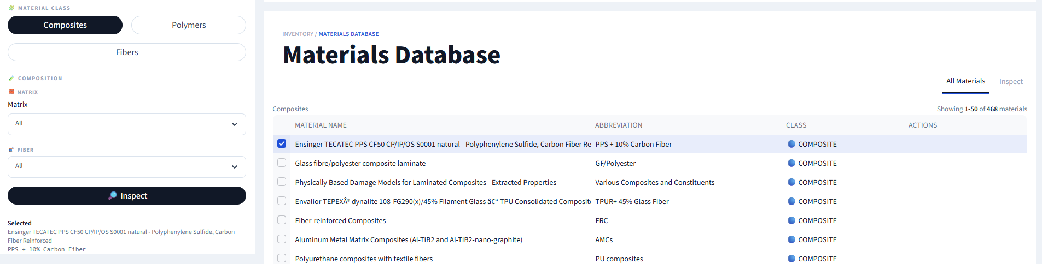
3.2 How We Store the Data
Each property observation gets its own row in the database. Table 3.1 shows an example of the columns we store. Composite data is sparse, so a wide table would mostly be empty cells, and adding a new property would require changing the schema each time. The long format lets us add new properties without schema changes. It also keeps test conditions next to each value, so every observation carries the context needed to interpret it [17, 18].
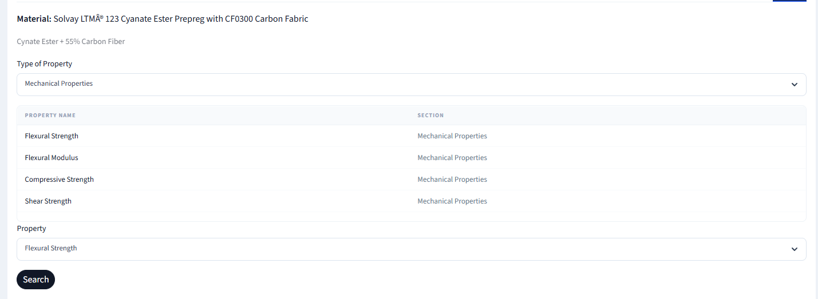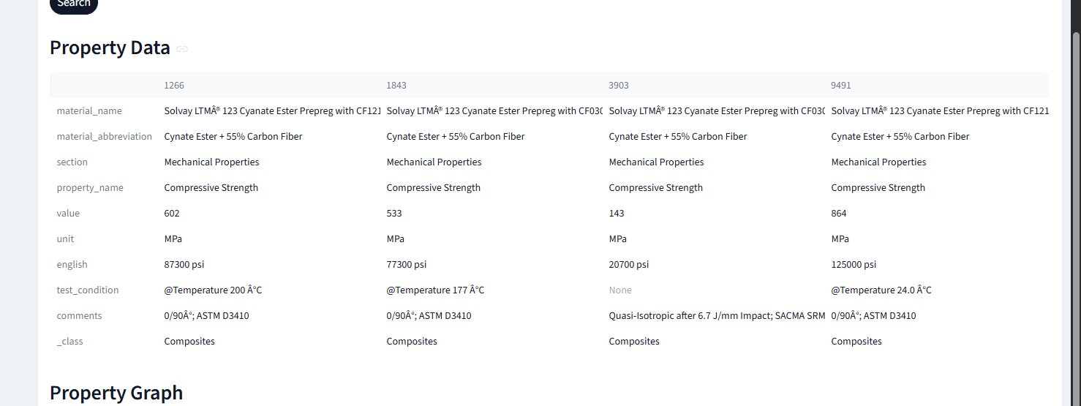
Table 3.1: Property Columns from Website

Chapter 4
SYSTEM ARCHITECTURE
4.1 How the System Is Built
Storage is handled via an external PostgreSQL. Credentials are passed in through local environment variables. The application is a Streamlit web app hosted on Hugging Face. Here we break it down into 3 sections: home, search, and upload. Home gives an overview of the project. Categorized Search is where users filter and browse the full database. Upload Data is where users submit new records. The source code is public on GitHub at github.com/AIM-for-Composites/InDesDatabaseTool, and the live app is on Hugging Face Spaces at huggingface.co/spaces/aim4composites/MaterialsDatabase. 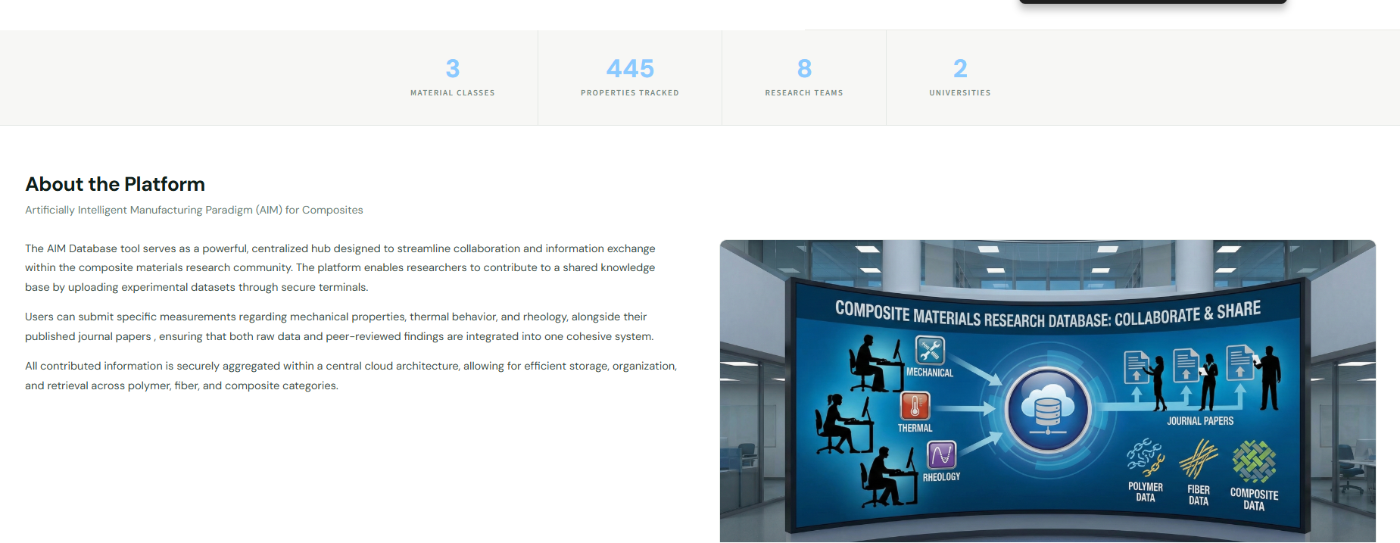
Image 4.1: Home Page

4.2 How We Extract Data from PDFs
Our extraction pipeline is built using LLMs like Gemini 2.5 Flash. However, we can swap the LLM based on SOTA. To extract properties from a PDF, we send the PDF directly to the Gemini API. We set the temperature to 0 to keep the output consistent across runs and supply a fixed JSON structure for the response. At the top level, the structure asks for the material name and abbreviation. It also wants the trade grade and manufacturer. For each property, it asks for the section it belongs to and the property name. The measured value is required. The unit is required. An imperial equivalent is included if the source reports one. Test conditions and any comments round out each entry. We prompt the model as an expert materials scientist and ask it to compile all properties across all categories into a single list. If the API call succeeds, we receive a table that matches our database structure. If it fails, we move on.
We also extract figures from each PDF using PyMuPDF and OpenCV. Each page is converted to an image at 300 DPI. From there, we use edge detection and thresholding to find regions that resemble plots and match each to a nearby caption. For property name matching, we use the all-MiniLM-L6-v2 sentence transformer [9]. We use this to compare how similar two property names are using vector embeddings. The top matches then get verified with another Gemini yes-or-no prompt. This find-then-verify approach is consistent with how recent high-accuracy extraction systems operate, as reported in the literature [5, 6].

Chapter 5
USER WORKFLOWS
Browsing is the simplest way to use the database. Users go to the Categorized Search page and pick a material type, then filter by matrix or fiber. Searching by name or abbreviation brings up a table of results, and clicking any row shows the full property data along with any figures stored for it. Users can also upload their own data in one of two ways. The first is manual entry: users fill out a form to add one property row at a time, which works well for targeted additions that require exact data. The second is the PDF upload workflow. Users drag in a datasheet or paper, and the pipeline runs automatically. Extracted rows appear on screen for review before anything is inserted, and a second tab lets users link any extracted figures to specific properties. For now, admins must approve the data before it goes in. This is the part of the workflow that the autonomous prototype in Chapter 7 is meant to eventually replace.

Chapter 6
CURRENT DATA AND QUALITY
6.1 What We Have
Our database holds over 1,500 material cards and tracks over 400 different property types. The data covers all three material types and was added via a mix of manual entry and PDF upload via our pipeline.
6.2 Data Quality Issues
Going through the data, we found a handful of issues. Unit inconsistency is the first. Some rows use an empty unit field for dimensionless properties, some leave the unit column out entirely, and others embed units directly in the value string, such as "1.50 J/cm NB," which breaks our numeric parsing. The problem is compounded when multiple records of the same material appear with different units.
Multiple rows for the same property at different test conditions also show up. This is intentional, since properties can vary significantly with test conditions and we want to keep those values together. The trade-off is that a simple uniqueness rule on material plus property name no longer applies. Some entries also store information like average values and grades as free text in the comments column rather than in dedicated fields. The most serious gap, however, is the lack of structured source information: most of our data has no associated reference attached to it.

Chapter 7
TOWARD AUTONOMOUS POPULATION
The pipeline still requires a person in the loop. A human has to supply each PDF, select the material type, and approve the extracted rows before anything is added to the database. Our longer-term goal is a system that handles all of this on its own: finding relevant papers online, extracting and validating the data, and either adding it to the database or flagging uncertain cases for human review. We plan to build this using LLM-based agents.
7.1 The System We Want to Build
The first step is paper discovery. Given a goal such as "thermoplastic composites," an agent would query sources such as Google Scholar and arXiv, rank the results by relevance, and download the top candidates. From there, the existing extraction pipeline takes over, since it already handles most text-based PDFs without human help. Each extracted row is then validated. The pipeline checks whether units are present, whether the value falls in a reasonable range for that property, and whether the row already exists in the database. Failed rows go to a review queue with a reason attached. Rows that pass are inserted into the database along with a source record that includes the PDF hash and, when available, the DOI.
7.2 Our Prototype
To test the extraction and validation steps, we built a script called batch_ingest.py. It takes a folder of PDFs and runs through them with no human involvement. For each PDF, it calls our Gemini extractor and then assigns a material type by checking the extracted material name for keywords. If a word like "fiber" appears, the material is assigned to its appropriate category. From there, each row goes through our validation pipeline. It checks units and tries to parse the value as a number. It then compares the value against expected ranges for that property. Duplicates are caught by checking whether a row with the same material name, property name, and test condition already exists. Rows that pass are written to a local SQLite copy of our database, allowing us to test without affecting the live system. Rows that fail go to a CSV file with a reason code. Paper discovery and figure extraction were omitted from this prototype. The goal was to understand how the extraction and validation loop performs before building the rest.
7.3 Results
We tested the prototype on a set of polymer datasheets. Each PDF took between 30 seconds and 1 minute to process, with most of that time spent waiting on the Gemini API. About 15% of rows were flagged for missing units, though most of those were false positives for properties that are correctly unitless, such as Shore D hardness. Roughly 5-10% of rows had units embedded in the value string, which is a real inconsistency introduced by Gemini. A small number of rows had values outside the expected range, usually because the model misread scientific notation or a unit prefix. Re-running the same PDF a second time inserted zero new rows. Overall, the pipeline can run on its own at a manageable cost, and the main failure modes are fixable. The next step is to build a manually labeled ground truth set so we can measure extraction accuracy directly.
7.4 What We Plan to Do Next
Getting from the prototype to a production system means closing a few gaps. Adding a sources table is the most urgent step. Every inserted row needs structured source information attached to it so we can trace values back to their source. We also need a hand-labeled ground truth set to measure our extraction accuracy. The keyword-based material-type assignment works well enough for now, but should eventually be replaced with a small, trained classifier. Paper discovery through Google Scholar, Semantic Scholar, and arXiv will let the system find papers on its own rather than waiting for a user to provide them. We also want to move our validation rules into a config file so domain experts can adjust value ranges without touching the base code.

Chapter 8
LIMITATIONS AND FUTURE WORK
Our system has several known limitations. The most pressing is the lack of structured source information. Until we add a sources table, property values cannot be traced back to where they came from, which limits the database's usefulness for reproducible research and means we do not yet meet open data standards [10]. Addressing this is our top priority.
The system also lacks versioning and access control. Updating a record overwrites it with no history saved, and any user can add data without a formal review step. This will become a bigger problem as more people begin to use the database. On the extraction side, Gemini performs noticeably worse on scanned PDFs and unusual table layouts. Those are the hardest cases in our data and will need better preprocessing and prompting to handle reliably.
Finally, the material abbreviation is currently used as the identity key for each entry. This breaks down when two entries for the same material from different sources use different abbreviations. As the database grows, we will need a more robust way to match materials across sources. The end goal is to use this database to train and test the machine learning models it was designed to support.

REFERENCES
[1] M. C. Swain and J. M. Cole, "ChemDataExtractor: A toolkit for automated extraction of chemical information from the scientific literature," J. Chem. Inf. Model., vol. 56, no. 10, pp. 1894-1904, 2016. doi: 10.1021/acs.jcim.6b00207
[2] J. Mavracic, C. J. Court, T. Isazawa, S. R. Elliott, and J. M. Cole, "ChemDataExtractor 2.0: Autopopulated ontologies for materials science," J. Chem. Inf. Model., vol. 61, no. 9, pp. 4280-4289, 2021. doi: 10.1021/acs.jcim.1c00446
[3] P. Shetty, A. C. Rajan, C. Kuenneth, S. Gupta, L. P. Panchumarti, L. Holm, C. Zhang, and R. Ramprasad, "A general-purpose material property data extraction pipeline from large polymer corpora using NLP," npj Comput. Mater., vol. 9, p. 52, 2023. doi: 10.1038/s41524-023-01003-w
[4] A. Gupta, R. Hoover, and J. Brgoch, "Dynamic in-context learning with conversational models for data extraction and materials property prediction," arXiv:2405.10448, 2024.
[5] Q. Liang, A. E. Gongora, Z. Ren, A. Abdel-Latif, K. G. Reyes, P. R. Brown, S. Srinivasan, and T. Buonassisi, "From text to insight: Large language models for materials science data extraction," arXiv:2407.16867, 2024.
[6] J. Dagdelen, A. Dunn, S. Lee, N. Walker, A. S. Rosen, G. Ceder, K. A. Persson, and A. Jain, "Structured information extraction from scientific text with large language models," Nat. Commun., vol. 15, p. 1418, 2024. doi: 10.1038/s41467-024-45563-x
[7] S. Banik, W. Chen, K. Choudhary, and F. Tavazza, "Automated extraction of material properties using LLM-based AI agents," arXiv:2510.01235, 2025.
[8] Y. Cheng, H. Zhang, and Y. Sun, "From papers to property tables: A priority-based LLM workflow for materials data extraction," arXiv:2604.07584, 2025.
[9] N. Reimers and I. Gurevych, "Sentence-BERT: Sentence embeddings using Siamese BERT-networks," in Proc. EMNLP, 2019. doi: 10.18653/v1/D19-1410
[10] M. Scheffler et al., "Community action on FAIR data will fuel a revolution in materials research," MRS Bull., vol. 48, pp. 1024-1040, 2024. doi: 10.1557/s43577-023-00498-4
[11] National Science and Technology Council, "Materials Genome Initiative Strategic Plan," 2021. Available: https://www.nist.gov/system/files/documents/2021/11/17/MGI-2021-Strategic-Plan.pdf
[12] C. H. Ward, "Materials Genome Initiative: Materials data," NISTIR 8038, NIST, 2014. doi: 10.6028/NIST.IR.8038
[13] A. Dima et al., "Machine learning-driven prediction of composite materials properties based on experimental testing data," Polymers, vol. 17, no. 5, p. 694, 2025. doi: 10.3390/polym17050694
[14] S. Han, H. Zhang, and J. Chen, "Toward accurate machine learning-driven prediction of polymeric composites properties," Mater. Genome Eng. Adv., 2025. doi: 10.1002/mgea.70027
[15] P. Liu, B. Chang, C. Xu, W. Zhang, T. Yang, and T. Wu, "Optimizing 3D printed continuous CF/PEEK composites: A machine learning approach to strength prediction," J. Reinf. Plast. Compos., 2025. doi: 10.1177/07316844251356346
[16] R. Fang, L. Wu, and Z. Sun, "Machine learning-assisted design of multilayer thermoplastic composites," Macromol. Mater. Eng., 2025. doi: 10.1002/mame.202500093
[17] P. M. Nadkarni, L. Marenco, R. Chen, E. Skoufos, G. Shepherd, and P. Miller, "Organization of heterogeneous scientific data using the EAV/CR representation," J. Am. Med. Inform. Assoc., vol. 6, no. 6, pp. 478-493, 2009.
[18] V. Dinu and P. M. Nadkarni, "Exploring performance issues for a clinical database organized using an entity-attribute-value representation," J. Am. Med. Inform. Assoc., vol. 14, no. 1, pp. 60-65, 2007.
[19] MatWeb LLC, "MatWeb material property data," 2024. Available: https://www.matweb.com/
[20] CMH-17 Coordination Group, "Composite Materials Handbook-17," SAE International, 2024. Available: https://www.cmh17.org/
[21] Ansys Inc., "Ansys Granta materials data," 2024. Available: https://www.ansys.com/products/materials
[22] CompositesWorld, "Shared composite material property databases," 2024. Available: https://www.compositesworld.com/columns/shared-composite-material-property-databases

