SOFTWARE ENGINEERING

(MC – 310)

ASSIGNMENT – 3

**AIMAN SIDDIQUA 2K18/MC/008**

**Ques. Explain the steps involved in project planning. Discuss the various factors that affect a project plan.**

**Solution.** The various steps involved in project planning are:

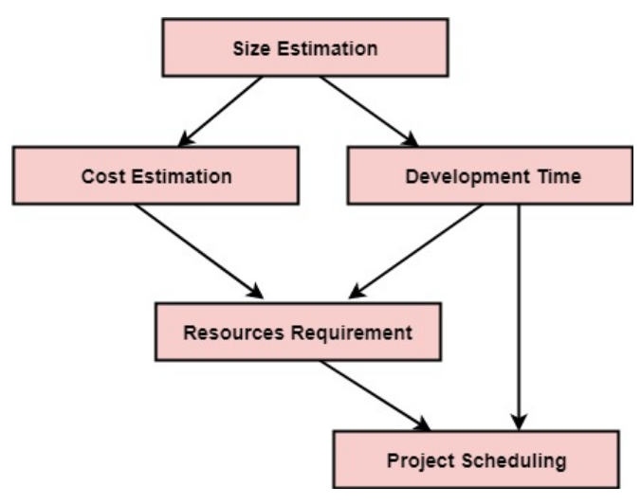

The various factors that affect a project plan are:

**Meet user requirements:** Develop the project according to the user requirements after understanding them.

**Meet schedule deadlines**: Complete the project milestones as described in the project plan on time in order to complete the project according to the schedule.

**Be within budget:** Manage the overall project cost so that the project is within the allocated budget.

**Produce quality deliverables:** Ensure that quality is considered for accuracy and overall performance of the project.

**Ques. What is risk? Mention various risks that can be incurred in a software development project. Discuss how you would manage those risks at different phases.**

**Solution.** Risk is a problem that may cause some loss or threaten the success of the project, but which has not happened yet.

Various risks that can be incurred in a software development project are:

**Dependencies on outside agencies or factors**

* + Availability of trained, experienced persons
  + Inter group dependencies
  + Customer-Furnished items or information
  + Internal & external subcontractor relationships

**Requirement issues**

* + Lack of clear product vision
  + Unprioritized requirements
  + Lack of agreement on product requirements
  + New market with uncertain needs
  + Rapidly changing requirements
  + Inadequate Impact analysis of requirements changes

**Management Issues**

* + Inadequate planning
  + Inadequate visibility into actual project status
  + Unclear project ownership and decision making
  + Staff personality conflicts
  + Unrealistic expectation
  + Poor communication

**Lack of knowledge**

* + Inadequate training
  + Poor understanding of methods, tools, and techniques
  + Inadequate application domain experience
  + New Technologies
  + Ineffective, poorly documented or neglected processes

**Other risk categories**

* + Unavailability of adequate testing facilities
  + Turnover of essential personnel
  + Unachievable performance requirements
  + Technical approaches that may not work

Risk Management Activities include:

1. Risk Assessment

* Risk Identification
* Risk Analysis
* Risk Prioritization

1. Risk Control

* Risk Management Planning
* Risk Monitoring
* Risk Resolution

**Ques. Explain why an object-oriented approach to software development may not be suitable for real-time systems.**

**Solution.** The difficulty of applying the object-oriented model to software development within the real-time systems occur due to the fact that achieving the concurrency response to certain events in the real-time systems require combining the object-centered view with the process centered view.

**Ques. Do software engineers have a professional responsibility to produce code that can be maintained and changed even if this is not explicitly requested by their employer?**

**Solution.** Yes, software engineers have a professional responsibility to produce code that can be maintained and changed even if this is not explicitly requested by their employer. Software development and maintenance are not separate activities. It is important to keep in mind how a system will need to be maintained if, for example, it is a system that is meant to last a long time and will have a revolving-door of developers working on it.

**Ques. “The best programmers do not always make the best software managers.” Explain.**

**Solution.** Management activities such as proposal writing, project planning and personnel selection require a set of skills including presentation and communication skills, organizational skills and the ability to communicate with other project team members.  
  
Programming skills are distinct from these. The programmers have more technical skills than interpersonal skills. Hence the best programmers do not always make the best software managers.

**Ques. Explain why there is a need for risk assessment to be a continuing process from the early stages of requirements engineering through to the operational use of a system.**

**Solution.** There is a need for risk assessment to be a continuing process from the early stages of requirements engineering through to the operational use of a system. The significance is that opportunity and risk generally remain relatively high during project planning (beginning of the project life cycle) but because of the relatively low level of investment to this point, the amount at stake remains low. In contrast, during project execution, risk progressively falls to lower levels as remaining unknowns are translated into knowns. At the same time, the amount at stake steadily rises as the necessary resources are progressively invested to complete the project.

**Ques. Cost estimates are inherently risky, irrespective of the estimation technique used. Suggest four ways in which the risk in a cost estimate can be reduced.**

**Solution.** Ways in which the risk in a cost estimate can be reduced are:

* Obtain a number of independent estimates using different estimation techniques. If these are widely divergent, generate more costing information iterate until the estimates converge.
* For those parts of the system which are hard to estimate, develop a prototype to find out what problems are likely to arise.
* Reuse software to reduce the amount of estimation required and to reduce overall costs.
* Adopt a design to cost approach to development where the system functionality is adapted to a fixed cost.