PRACTICAL – 1

AIMAN SIDDIQUA 2K18/MC/008

AIM: To write a program to find the number of vertices, even vertices, odd vertices and number of edges in a graph.

CODE:

#include <bits/stdc++.h>

**using** **namespace** std;

**class** **Graph**

{

**int** V;

list<**int**> *adj;

**public:**

Graph(**int** V)

{

**this**->V = V;

adj = **new** list<**int**>[V];

}

**void** addEdge(**int** u, **int** v)

{

adj[u].push_back(v);

adj[v].push_back(u);

}

**int** noOfVertices() { **return** **this**->V; }

**int** countEdges()

{

**int** sum = **0**;

**for** (**int** i = **0**; i < V; i++)

sum += adj[i].size();

**return** sum / **2**;

}

**int** evenVertices()

{

**int** count = **0**;

**for** (**int** i = **0**; i < **this**->V; i++)

{

**if** (adj[i].size() % **2** == **0**)

count++;

}

**return** count;

}

**int** oddVertices()

{

**return** **this**->V - evenVertices();

}

};

**int** **main**()

{

**int** V = **5**;

Graph g(V);

g.addEdge(**0**, **1**);

g.addEdge(**3**, **2**);

g.addEdge(**0**, **3**);

g.addEdge(**1**, **3**);

g.addEdge(**2**, **4**);

g.addEdge(**1**, **4**);

cout << "Number of Vertices: " << g.noOfVertices() << endl;

cout << "Number of Even Vertices: " << g.evenVertices() << endl;

cout << "Number of Odd Vertices: " << g.oddVertices() << endl;

cout << "Number of Edges: " << g.countEdges() << endl;

**return** **0**;

}

OUTPUT:

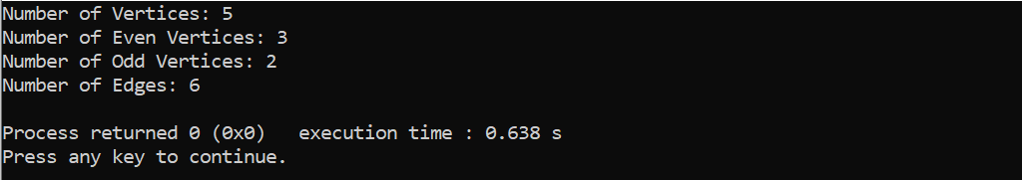

PRACTICAL – 2

AIMAN SIDDIQUA 2K18/MC/008

AIM: To write a program to find union, intersection and ring-sum of two graphs.

CODE:

**UNION**

#include <iostream>

**using** **namespace** std;

**int** V1[] = {**0**, **1**};

**int** V2[] = {**0**, **1**, **2**};

**int** E1[**2**][**2**], E2[**3**][**3**], E3[**5**][**5**];

**void** **Union**(**int** arr1[], **int** arr2[], **int** m, **int** n)

{

cout << "**\n**Set of vertices in union of the graphs G1 and G2 is:**\n**";

**int** i = **0**, j = **0**;

**while** (i < m && j < n)

{

**if** (arr1[i] < arr2[j])

cout << arr1[i++]<<" ";

**else** **if** (arr2[j] < arr1[i])

cout << arr2[j++]<<" ";

**else**

{

cout << arr2[j++]<<" ";

i++;

}

}

**while** (i < m)

cout << arr1[i++]<<" ";

**while** (j < n)

cout << arr2[j++]<<" ";

cout << "**\n**";

**for** (i = **0**; i < n; i++)

{

**for** (j = **0**; j < n; j++)

{

**if** (i < m && j < m && E1[i][j] > E2[i][j])

E3[i][j] = E1[i][j];

**else** **if** (i < m && j < m && E1[i][j] < E2[i][j])

E3[i][j] = E2[i][j];

**else**

E3[i][j] = E2[i][j];

}

}

cout << "**\n**Adjacency matrix of union of graphs G1 and G2 is:**\n**";

**for** (i = **0**; i < n; i++)

{

cout << "**\t**" << i;

}

cout << "**\n\t**";

**for** (i = **0**; i < n; i++)

{

cout << " ";

}

**for** (i = **0**; i < n; i++)

{

cout << "**\n**"

<< i << "|**\t**";

**for** (j = **0**; j < n; j++)

{

cout << E3[i][j] << "**\t**";

}

}

cout << "**\n**";

}

**int** **main**()

{

**int** m = **sizeof**(V1) / **sizeof**(V1[**0**]);

**int** n = **sizeof**(V2) / **sizeof**(V2[**0**]);

**int** i, j, k;

cout << "Enter the adjacency matrix(symmetric) for graph 1:" << endl;

**for** (i = **0**; i < m; i++)

{

**for** (j = **0**; j < m; j++)

cin >> E1[i][j];

}

cout << "**\n**Enter the adjacency matrix(symmetric) for graph 2"<<endl;

**for** (i = **0**; i < n; i++)

{

**for** (j = **0**; j < n; j++)

cin >> E2[i][j];

}

Union(V1, V2, m, n);

**return** **0**;

}

Output

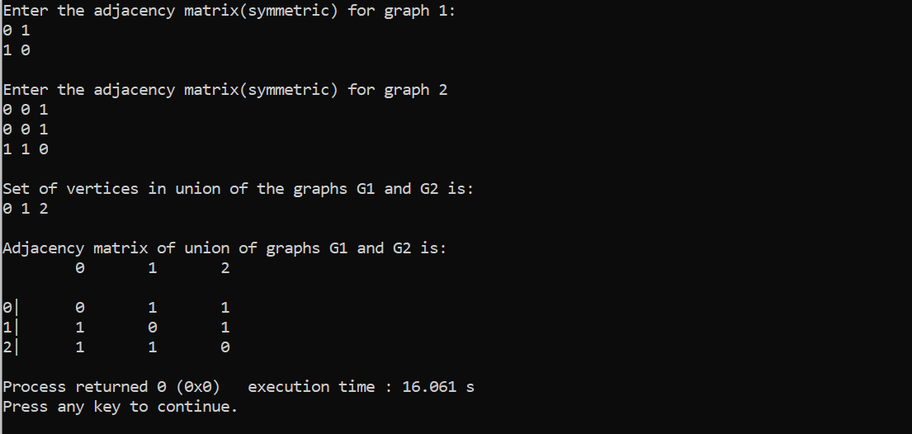

**INTERSECTION**

**void** **intersection**(**int** arr1[], **int** arr2[], **int** m, **int** n)

{

cout << "**\n**Set of vertices in intersection of the graphs G1 and G2 is:**\n**";

**int** i = **0**, j = **0**;

**while** (i < m && j < n)

{

**if** (arr1[i] < arr2[j])

i++;

**else** **if** (arr2[j] < arr1[i])

j++;

**else**

{

cout << arr2[j++]<<" ";

i++;

}

}

cout << "**\n**";

**for** (i = **0**; i < m; i++)

**for** (j = **0**; j < m; j++)

{

**if** (E1[i][j] == E2[i][j])

E3[i][j] = E1[i][j];

**else**

E3[i][j] = **0**;

}

cout << "**\n**Adjacency matrix of intersection of graphs G1 and G2 is:**\n\t**";

**for** (i = **0**; i < m; i++)

cout << i << "**\t**";

cout << "**\n\t**";

**for** (i = **0**; i < m; i++)

cout << " ";

**for** (i = **0**; i < m; i++)

{

cout << "**\n**"

<< i << "|**\t**";

**for** (j = **0**; j < m; j++)

{

cout << E3[i][j] << "**\t**";

}

}

cout << endl;

}

**Output**

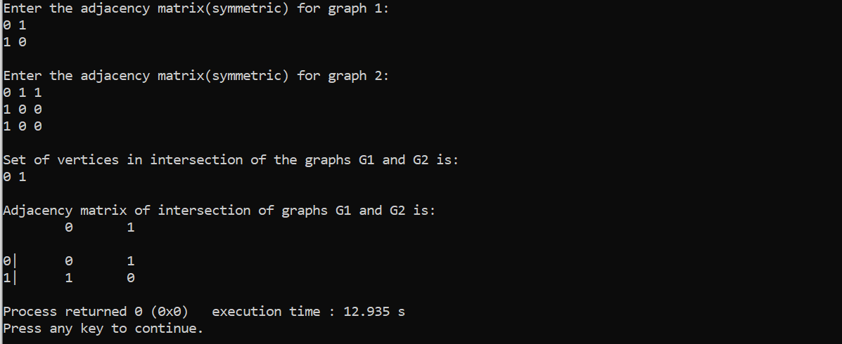

**RING SUM**

**void** **ring_sum**(**int** arr1[], **int** arr2[], **int** m, **int** n)

{

cout << "**\n**Set of vertices in ring sum of the graphs G1 and G2 are:**\n**";

**int** i = **0**, j = **0**;

**while** (i < m && j < n)

{

**if** (arr1[i] < arr2[j])

cout << arr1[i++]<<" ";

**else** **if** (arr2[j] < arr1[i])

cout << arr2[j++]<<" ";

**else**

{

cout << arr2[j++]<<" ";

i++;

}

}

**while** (i < m)

cout << arr1[i++];

**while** (j < n)

cout << arr2[j++];

cout << "**\n**";

**for** (i = **0**; i < n; i++){

**for** (j = **0**; j < n; j++)

{

**if** (i<m && j<m && E1[i][j] == E2[i][j])

E3[i][j] = **0**;

**else** **if** (i<m && j<m && E1[i][j]>E2[i][j])

E3[i][j] = E1[i][j];

**else**

E3[i][j] = E2[i][j];

}

}

cout << "**\n**Adjacency matrix of ring sum of graphs G1 and G2 is:**\n\t**";

**for** (i = **0**; i < n; i++)

cout << i << "**\t**";

cout << "**\n\t**";

**for** (i = **0**; i < n; i++)

cout << " ";

**for** (i = **0**; i < n; i++)

{

cout << "**\n**"

<< i << "|**\t**";

**for** (j = **0**; j < n; j++)

{

cout << E3[i][j] << "**\t**";

}

}

}

Output

