PRACTICAL – 3

AIMAN SIDDIQUA 2K18/MC/008

AIM: To write a program to find the minimum spanning tree of a graph using Prim’s Algorithm.

CODE:

#include <bits/stdc++.h>

**using** **namespace** std;

#define V 5

**int** **minKey**(**int** key[], **bool** mstSet[])

{

**int** min = INT_MAX, min_index;

**for** (**int** v = **0**; v < V; v++)

**if** (mstSet[v] == false && key[v] < min)

min = key[v], min_index = v;

**return** min_index;

}

**void** **printMST**(**int** parent[], **int** graph[V][V])

{

cout<<"Edge **\t**Weight**\n**";

**for** (**int** i = **1**; i < V; i++)

cout<<parent[i]<<" - "<<i<<" **\t**"<<graph[i][parent[i]]<<" **\n**";

}

**void** **primMST**(**int** graph[V][V])

{

**int** parent[V];

**int** key[V];

**bool** mstSet[V];

**for** (**int** i = **0**; i < V; i++)

key[i] = INT_MAX, mstSet[i] = false;

key[**0**] = **0**;

parent[**0**] = -**1**;

**for** (**int** count = **0**; count < V - **1**; count++)

{

**int** u = minKey(key, mstSet);

mstSet[u] = true;

**for** (**int** v = **0**; v < V; v++)

**if** (graph[u][v] && mstSet[v] == false && graph[u][v] < key[v])

parent[v] = u, key[v] = graph[u][v];

}

printMST(parent, graph);

}

**int** **main**()

{

**int** graph[V][V] = { { **0**, **2**, **0**, **6**, **0** },

{ **2**, **0**, **3**, **8**, **5** },

{ **0**, **3**, **0**, **0**, **7** },

{ **6**, **8**, **0**, **0**, **9** },

{ **0**, **5**, **7**, **9**, **0** } };

primMST(graph);

**return** **0**;

}

OUTPUT:

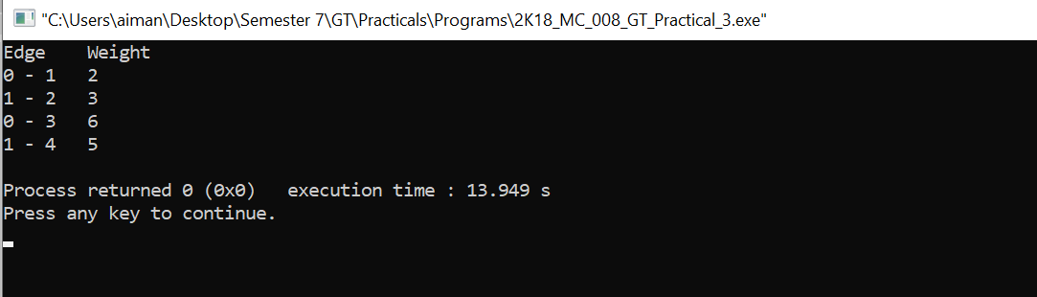

PRACTICAL – 4

AIMAN SIDDIQUA 2K18/MC/008

AIM: To write a program to find the minimum spanning tree of a graph using Kruskal’s Algorithm.

CODE:

#include <stdio.h>

#include <stdlib.h>

#include <string.h>

**struct** Edge {

**int** src, dest, weight;

};

**struct** Graph {

**int** V, E;

**struct** Edge* edge;

};

**struct** Graph* **createGraph**(**int** V, **int** E)

{

**struct** Graph* graph = (**struct** Graph*)(malloc(**sizeof**(**struct** Graph)));

graph->V = V;

graph->E = E;

graph->edge = (**struct** Edge*)malloc(**sizeof**( **struct** Edge)*E);

**return** graph;

}

**struct** subset {

**int** parent;

**int** rank;

};

**int** **find**(**struct** subset subsets[], **int** i)

{

**if** (subsets[i].parent != i)

subsets[i].parent

= find(subsets, subsets[i].parent);

**return** subsets[i].parent;

}

**void** **Union**(**struct** subset subsets[], **int** x, **int** y)

{

**int** xroot = find(subsets, x);

**int** yroot = find(subsets, y);

**if** (subsets[xroot].rank < subsets[yroot].rank)

subsets[xroot].parent = yroot;

**else** **if** (subsets[xroot].rank > subsets[yroot].rank)

subsets[yroot].parent = xroot;

**else**

{

subsets[yroot].parent = xroot;

subsets[xroot].rank++;

}

}

**int** **myComp**(**const** **void**\* a, **const** **void**\* b)

{

**struct** Edge* a1 = (**struct** Edge*)a;

**struct** Edge* b1 = (**struct** Edge*)b;

**return** a1->weight > b1->weight;

}

**void** **KruskalMST**(**struct** Graph* graph)

{

**int** V = graph->V;

**struct** Edge

result[V];

**int** e = **0**;

**int** i = **0**;

qsort(graph->edge, graph->E, **sizeof**(graph->edge[**0**]),

myComp);

**struct** subset* subsets

= (**struct** subset*)malloc(V * **sizeof**(**struct** subset));

**for** (**int** v = **0**; v < V; ++v) {

subsets[v].parent = v;

subsets[v].rank = **0**;

}

**while** (e < V - **1** && i < graph->E) {

**struct** Edge next_edge = graph->edge[i++];

**int** x = find(subsets, next_edge.src);

**int** y = find(subsets, next_edge.dest);

**if** (x != y) {

result[e++] = next_edge;

Union(subsets, x, y);

}

}

printf(

"Following are the edges in the constructed MST**\n**");

**int** minimumCost = **0**;

**for** (i = **0**; i < e; ++i)

{

printf("%d -- %d == %d**\n**", result[i].src,

result[i].dest, result[i].weight);

minimumCost += result[i].weight;

}

printf("**\n**Minimum Cost Spanning tree : %d",minimumCost);

**return**;

}

**int** **main**()

{

**int** V = **4**;

**int** E = **5**;

**struct** Graph* graph = createGraph(V, E);

graph->edge[**0**].src = **0**;

graph->edge[**0**].dest = **1**;

graph->edge[**0**].weight = **10**;

graph->edge[**1**].src = **0**;

graph->edge[**1**].dest = **2**;

graph->edge[**1**].weight = **6**;

graph->edge[**2**].src = **0**;

graph->edge[**2**].dest = **3**;

graph->edge[**2**].weight = **5**;

graph->edge[**3**].src = **1**;

graph->edge[**3**].dest = **3**;

graph->edge[**3**].weight = **15**;

graph->edge[**4**].src = **2**;

graph->edge[**4**].dest = **3**;

graph->edge[**4**].weight = **4**;

KruskalMST(graph);

**return** **0**;

}

OUTPUT:

