PRACTICAL – 6

AIMAN SIDDIQUA 2K18/MC/008

AIM: To write a program to find the shortest path between every pair of vertices in a graph using Floyd-Warshall’s Algorithm.

**CODE**:

#include<bits/stdc++.h>

**using** **namespace** std;

#define N 4

#define INF 100000

**void** **floydWarshall**(**int** g[][N])

{

**int** dist[N][N], i, j, k;

**for** (i = **0**; i < N; i++)

**for** (j = **0**; j < N; j++)

dist[i][j] = g[i][j];

**for** (k = **0**; k < N; k++) {

**for** (i = **0**; i < N; i++) {

**for** (j = **0**; j < N; j++) {

**if** (dist[i][j] > (dist[i][k] + dist[k][j])

&& (dist[k][j] != INF

&& dist[i][k] != INF))

dist[i][j] = dist[i][k] + dist[k][j];

}

}

}

**for** (**int** i = **0**; i < N; i++) {

**for** (**int** j = **0**; j < N; j++) {

**if** (dist[i][j] == INF)

cout << "INF"

<< " ";

**else**

cout << dist[i][j] << " ";

}

cout << endl;

}

}

**int** **main**(){

**int** g[**4**][**4**] = {{**0** ,**5**,INF,**2**},

{INF,**2**,**4**,**1**},

{INF,INF,**0**,**1**},

{INF,INF,INF,**0**}};

floydWarshall(g);

**return** **0**;

}

OUTPUT:

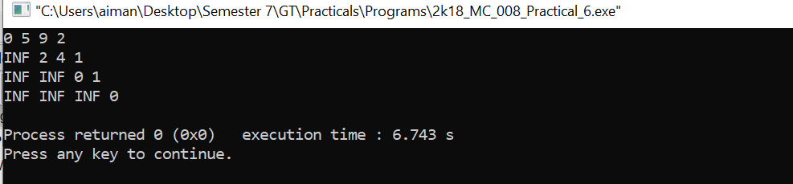

PRACTICAL – 7

AIMAN SIDDIQUA 2K18/MC/008

AIM: To write a program to find the shortest path between two vertices in a graph using Bellaman Ford’s Algorithm.

**CODE**:

#include<bits/stdc++.h>

**using** **namespace** std;

**struct** Edge {

**int** src, dest, weight;

};

**struct** Graph {

**int** V, E;

**struct** Edge* edge;

};

**struct** Graph* **createGraph**(**int** V, **int** E)

{

**struct** Graph* graph = **new** Graph;

graph->V = V;

graph->E = E;

graph->edge = **new** Edge[E];

**return** graph;

}

**void** **BellmanFord**(**struct** Graph* graph, **int** src)

{

**int** V = graph->V;

**int** E = graph->E;

**int** dist[V];

**for** (**int** i = **0**; i < V; i++)

dist[i] = INT_MAX;

dist[src] = **0**;

**for** (**int** i = **1**; i <= V - **1**; i++) {

**for** (**int** j = **0**; j < E; j++) {

**int** u = graph->edge[j].src;

**int** v = graph->edge[j].dest;

**int** weight = graph->edge[j].weight;

**if** (dist[u] != INT_MAX && dist[u] + weight < dist[v])

dist[v] = dist[u] + weight;

}

}

**for** (**int** i = **0**; i < E; i++) {

**int** u = graph->edge[i].src;

**int** v = graph->edge[i].dest;

**int** weight = graph->edge[i].weight;

**if** (dist[u] != INT_MAX && dist[u] + weight < dist[v]) {

printf("Graph contains negative weight cycle");

**return**;

}

}

printf("Vertex Distance from Source**\n**");

**for** (**int** i = **0**; i < V; ++i)

printf("%d **\t\t** %d**\n**", i, dist[i]);

}

**int** **main**()

{

**int** V = **5**;

**int** E = **8**;

**struct** Graph* graph = createGraph(V, E);

graph->edge[**0**].src = **0**;

graph->edge[**0**].dest = **1**;

graph->edge[**0**].weight = -**1**;

graph->edge[**1**].src = **0**;

graph->edge[**1**].dest = **2**;

graph->edge[**1**].weight = **4**;

graph->edge[**2**].src = **1**;

graph->edge[**2**].dest = **2**;

graph->edge[**2**].weight = **3**;

graph->edge[**3**].src = **1**;

graph->edge[**3**].dest = **3**;

graph->edge[**3**].weight = **2**;

graph->edge[**4**].src = **1**;

graph->edge[**4**].dest = **4**;

graph->edge[**4**].weight = **2**;

graph->edge[**5**].src = **3**;

graph->edge[**5**].dest = **2**;

graph->edge[**5**].weight = **5**;

graph->edge[**6**].src = **3**;

graph->edge[**6**].dest = **1**;

graph->edge[**6**].weight = **1**;

graph->edge[**7**].src = **4**;

graph->edge[**7**].dest = **3**;

graph->edge[**7**].weight = -**3**;

BellmanFord(graph, **0**);

**return** **0**;

}

OUTPUT:

