PRACTICAL – 1

AIM: To write a program for linear fit of the curve using MATLAB/Octave.

CODE:

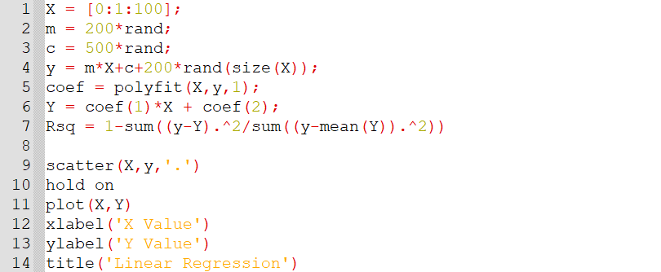

OUTPUT:

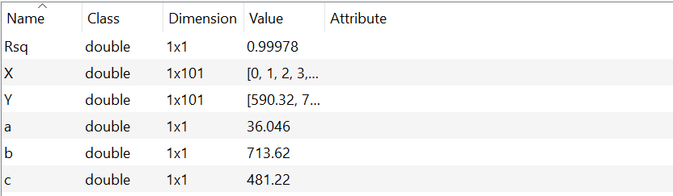

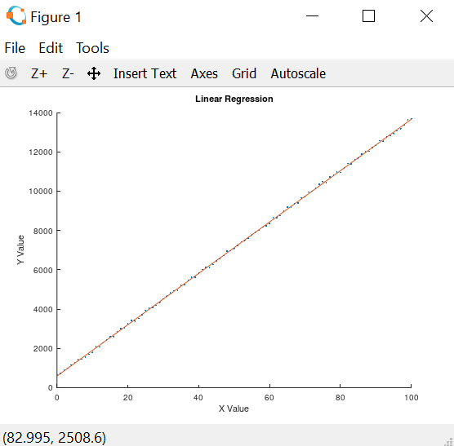

PRACTICAL – 2

AIM: To write a program for quadratic fit of the curve using MATLAB/Octave.

CODE:

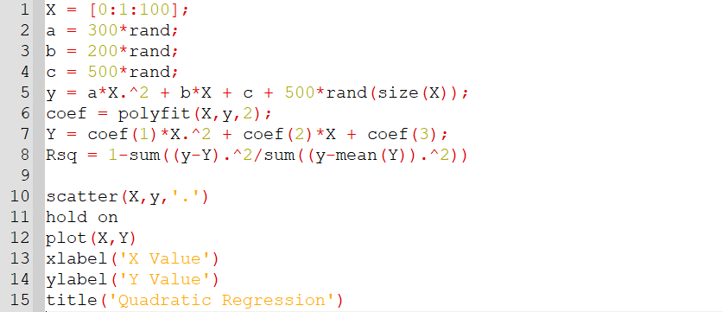

OUTPUT:



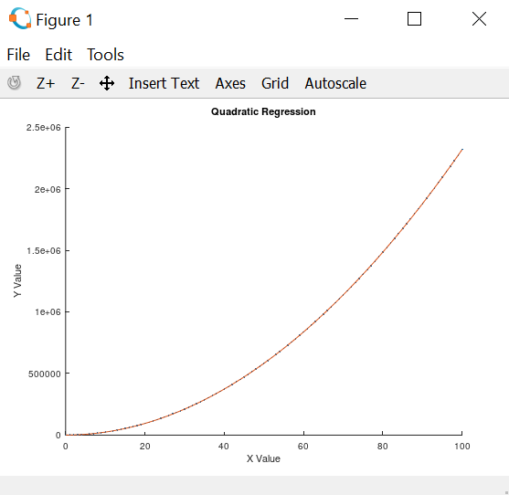

PRACTICAL – 3

AIM: To write a program for cubic fit of the curve using MATLAB/Octave.

CODE:

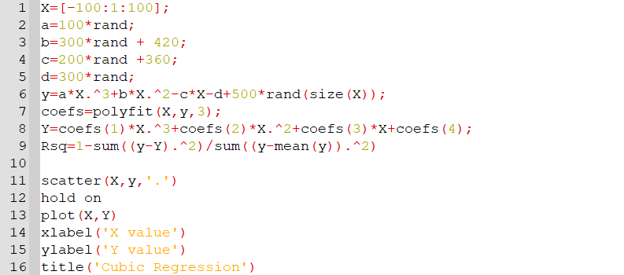

OUTPUT:



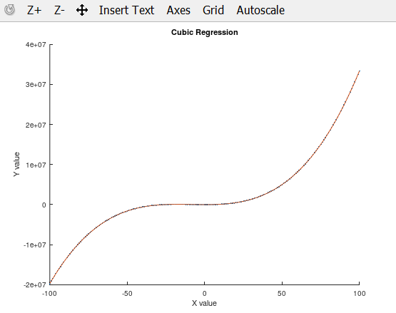

PRACTICAL – 4

AIM: To write a program to find the cubic spline for a data and find its R2.

CODE:

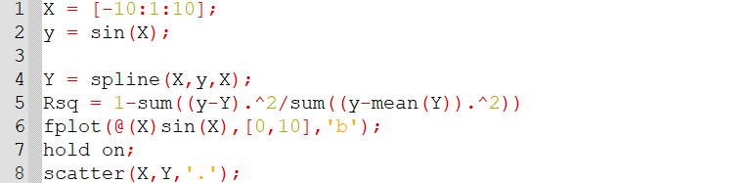

OUTPUT:

