MATHEMATICAL MODELLING AND SIMULATION

PRACTICAL TEST – 3

AIMAN SIDDIQUA – 2K18/MC/008

Q1. Identify the MATLAB statement that could be used to help determine the root of the function x3 – 1 over the interval x = 0 to x = 2.

Ans. b*.* fzero(@(x) x^3–1, [0, 2])

**Q2.** The MATLAB function roots is used in the following statement: p = roots(x)

Ans. b. x is a vector containing the coefficients of a polynomial.

c. p is a vector containing the roots of a polynomial.

Q3.

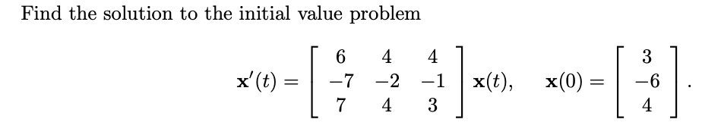

CODE:

syms x1(t) x2(t) x3(t)

A = [**6** **4** **4**; -**7** -**2** -**1**; **7** **4** **3**];

x = [x1; x2; x3];

odes = diff(x) == A*x

[x1Sol(t),x2Sol(t),x3Sol(t)] = dsolve(odes);

x1Sol(t) = simplify(x1Sol(t))

x2Sol(t) = simplify(x2Sol(t))

x3Sol(t) = simplify(x3Sol(t))

C = x(**0**) == [**3**;-**6**; **4**];

[x1Sol(t),x2Sol(t),x3Sol(t)] = dsolve(odes,C)

OUTPUT:

