**DELHI TECHNOLOGICAL UNIVERSITY**



**MATHEMATICAL MODELLING AND SIMULATION**

**MC-407**

**Practical File**

**SUBMITTED BY:**

Aiman Siddiqua

2K18/MC/008

INDEX

1. Program for linear fit of the curve using MATLAB/Octave.
2. Program for quadratic fit of the curve using MATLAB/Octave.
3. Program for cubic fit of the curve using MATLAB/Octave.
4. Program to find the cubic spline for a data and its R2.
5. Program for multiple regression using MATLAB/Octave.
6. Draw some trajectories for predator-prey problem.
7. Program for statistical analysis of data.
8. Program for Monte Carlo method.
9. Program for epidemic model in MATLAB/Octave.

PRACTICAL – 1

AIM: To write a program for linear fit of the curve using MATLAB/Octave.

CODE:

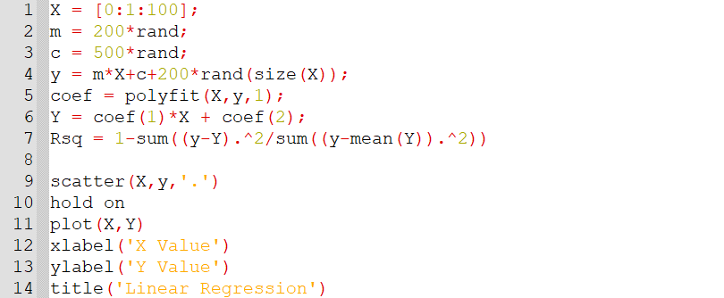

OUTPUT:

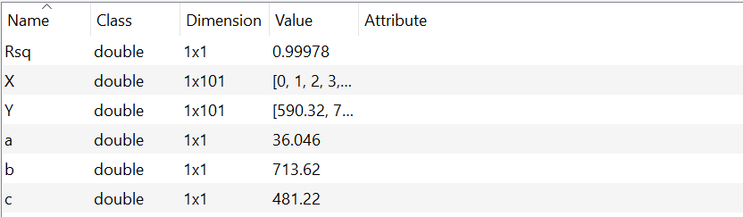

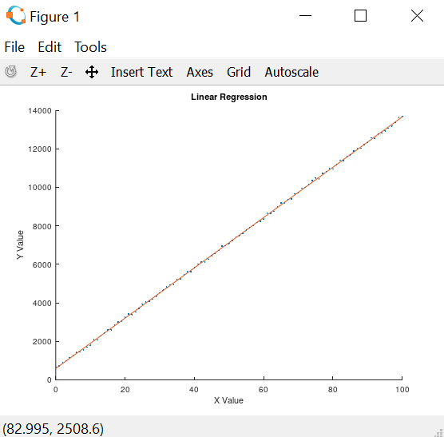

PRACTICAL – 2

AIM: To write a program for quadratic fit of the curve using MATLAB/Octave.

CODE:

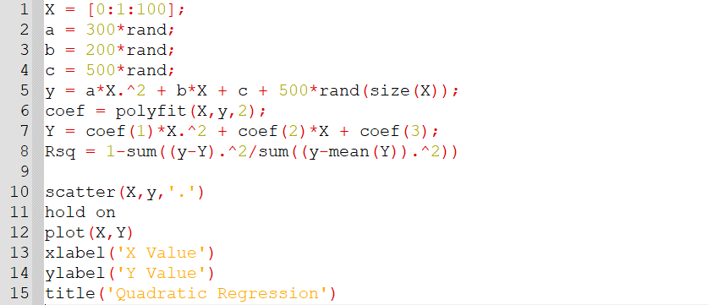

OUTPUT:



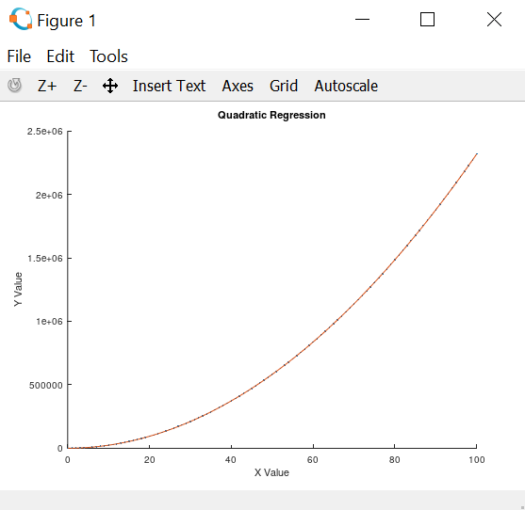

PRACTICAL – 3

AIM: To write a program for cubic fit of the curve using MATLAB/Octave.

CODE:

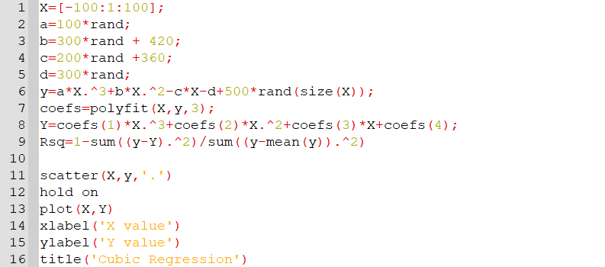

OUTPUT:



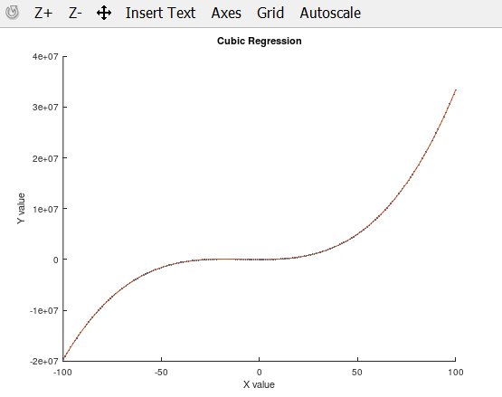

PRACTICAL – 4

AIM: To write a program to find the cubic spline for a data and find its R2.

CODE:

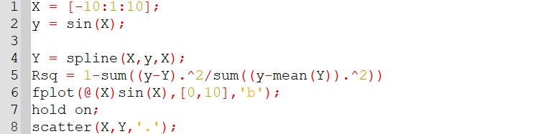

OUTPUT:

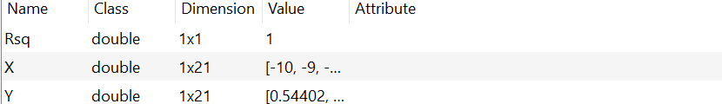

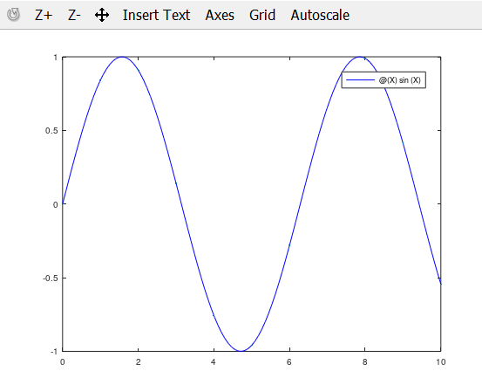

PRACTICAL – 5

AIM: To write a program for multiple regression.

CODE:

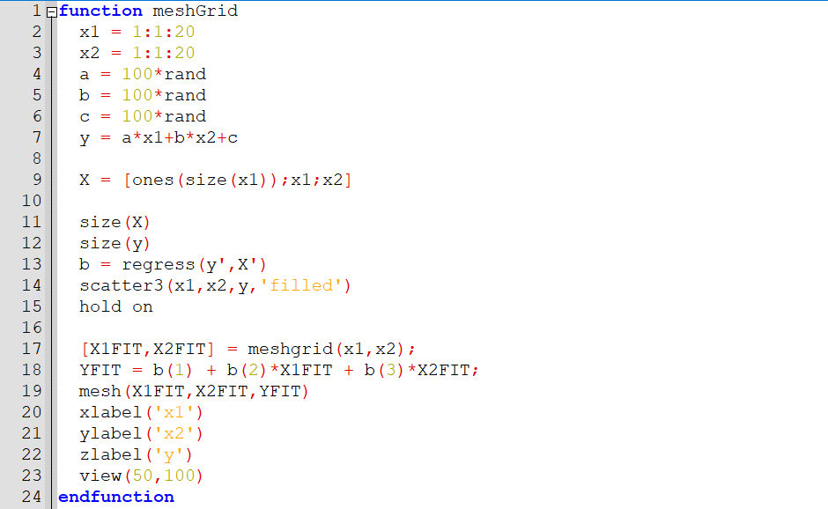

OUTPUT:

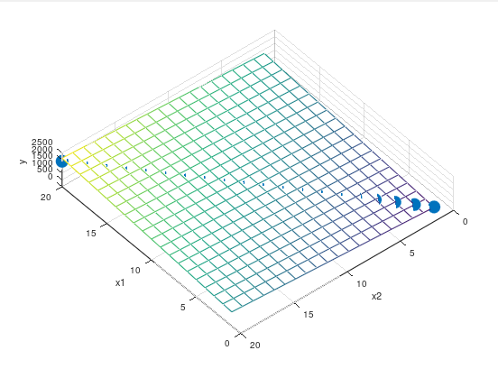

PRACTICAL – 6

AIM: Draw some trajectories for predator-prey problem.

CODE:

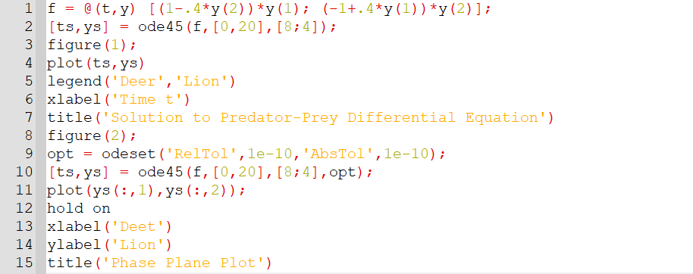

OUTPUT:

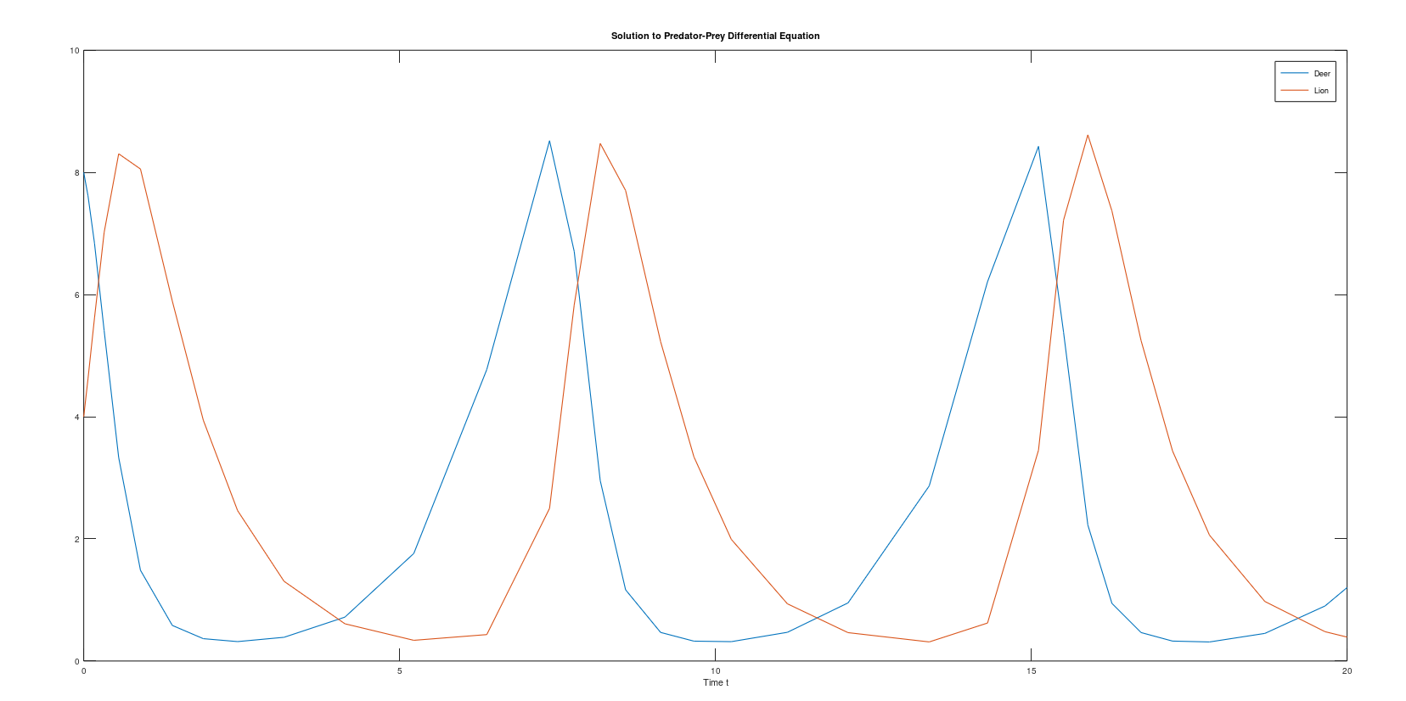

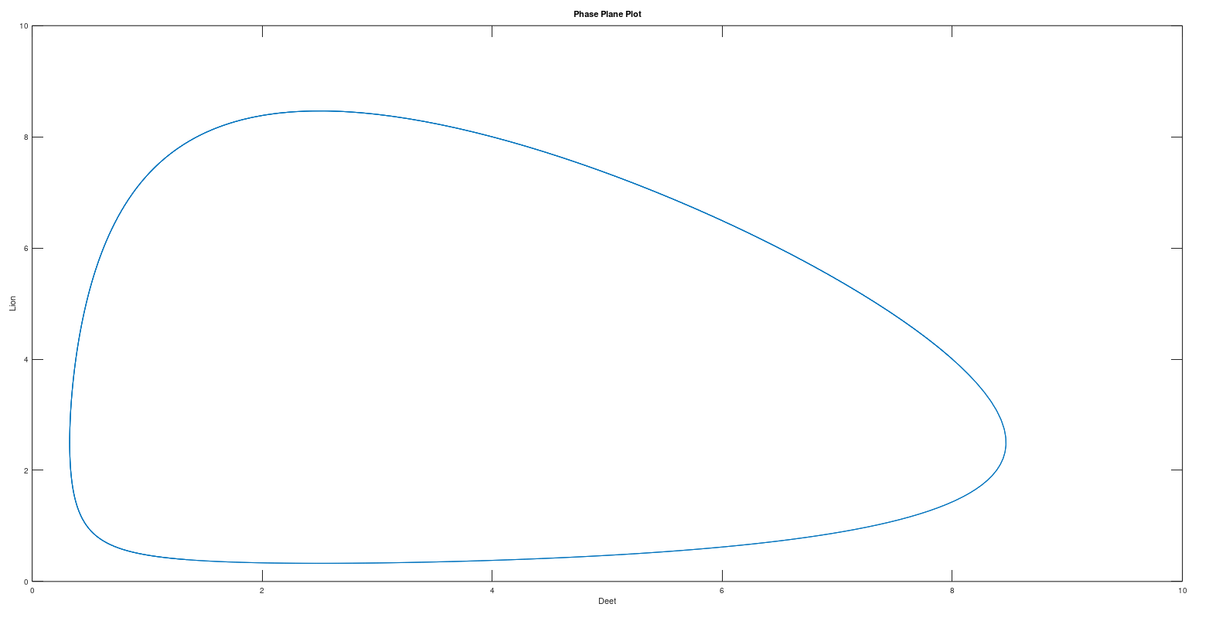

PRACTICAL – 7

AIM: To write a program for statistical analysis of data.

CODE:

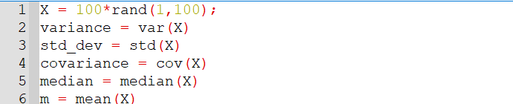

OUTPUT:

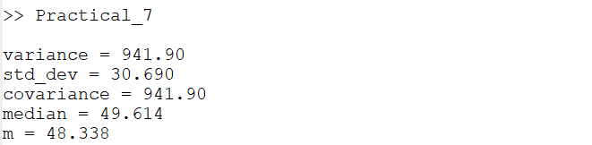

PRACTICAL – 8

AIM: To write a program for monte carlo method.

CODE:

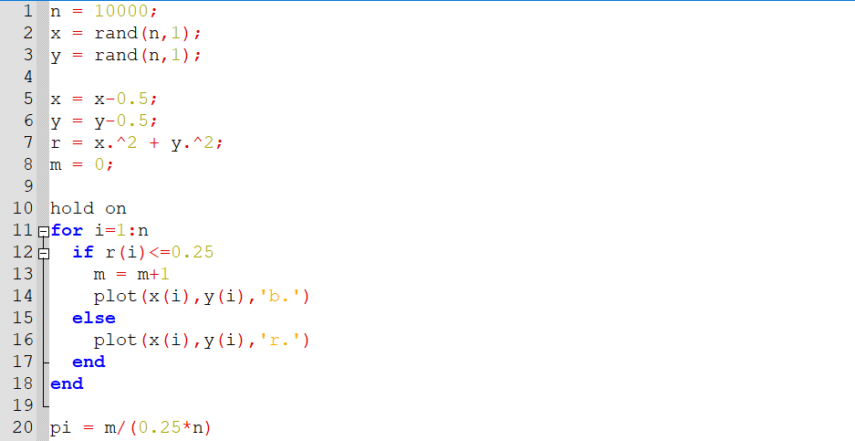

OUTPUT:



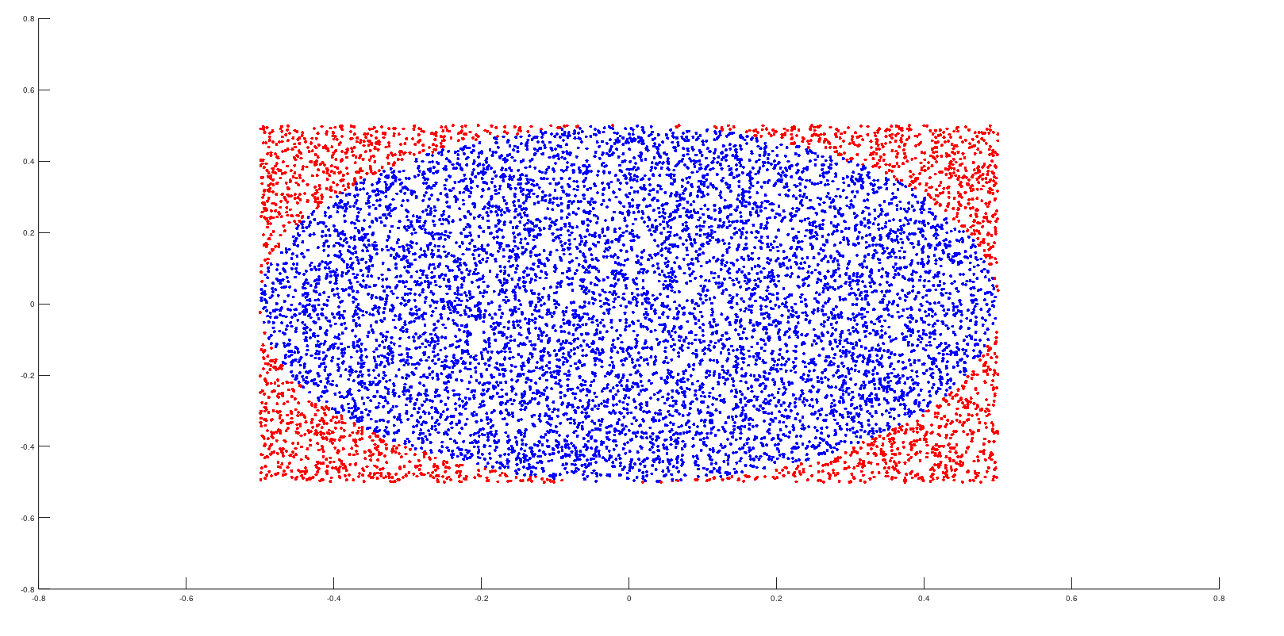

PRACTICAL – 9

AIM: To write a program for epidemic model.

CODE:

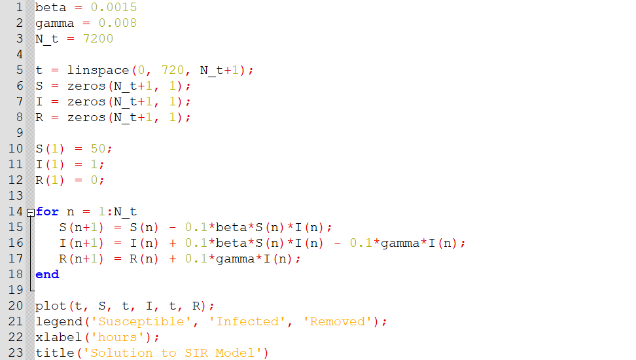

OUTPUT:

