AML23703: Quantum Computing
Tutorial 5
Quantum Measurement and Probability Analysis

Name | Abdul Rahman Khan
USN | 1GA23AI001
Department | Artificial Intelligence and Machine Learning
Semester | VII
Course Code | AML23703
Date | 20-08-2026

Objective
The objective of this tutorial is to treat measurement as a statistical instrument rather than a source of finished answers: to check the Born rule against measured frequencies and quantify the error of a finite sample, to show that the randomness of a qubit depends on the basis it is read in, to observe the collapse caused by measuring one qubit of an entangled pair, and to use measurement counts to recover an unknown angle and to test a bit source for bias.

Theory
A projective measurement returns one basis label, with probability given by the Born rule as the squared modulus of the corresponding amplitude, and leaves the state on whichever basis vector was found. A single shot therefore cannot reveal an amplitude, so the distribution must be rebuilt by repetition, and the estimate p̂ = n/N is a sample proportion with standard error √(p(1−p)/N), shrinking only as 1/√N. This spread is shot noise, distinct from hardware error, which more shots cannot remove. The basis is a choice rather than a property of the state: measuring along X is the same as applying a Hadamard and measuring along Z, since H maps |+⟩ to |0⟩ and |−⟩ to |1⟩, two states that differ only in relative phase. For two qubits, measuring one projects the joint state onto the subspace matching the outcome, so the partner in a Bell pair holds no definite value beforehand yet becomes certain afterwards.

Environment and Required Libraries
All five programs were executed against Qiskit 2.5.2 with the Aer simulator, using only QuantumCircuit, AerSimulator and Statevector, with NumPy for the inverse sine in Exercise 4 and Python's random module for the classical generator in Exercise 5. The figures were plotted from the same recorded counts, so every value in a figure is the value printed above it.

Exercise 1: Easy

Shot-Count Convergence of a Hadamard Superposition
One circuit, a Hadamard followed by a measurement, is run at 100, 1000 and 10000 shots, so nothing changes between rows except the sample size. The last column prints the distance from the theoretical 0.5, and the expected size of that error is known in advance: the standard error at p = 0.5 is 0.5/√N, giving 0.0500, 0.0158 and 0.0050.
Code
"""
Week_05 / T01.py -- Tutorial 5, Easy
Measure a Hadamard-superposition qubit at 100, 1000 and 10000 shots and
tabulate how the measured probability converges to 0.5.
"""

from qiskit import QuantumCircuit
from qiskit_aer import AerSimulator

# 1. Circuit: |0> --H--> (|0> + |1>)/sqrt(2), then measure in the Z basis.
qc = QuantumCircuit(1, 1)
qc.h(0)
qc.measure(0, 0)
print(qc)

sim = AerSimulator()

# 2. Run the SAME circuit with three different shot counts.
print("\n shots | counts(0) counts(1) | P(0) | |P(0) - 0.5|")
print("-" * 58)

for shots in [100, 1000, 10000]:
counts = sim.run(qc, shots=shots).result().get_counts()
n0 = counts.get('0', 0)
n1 = counts.get('1', 0)
p0 = n0 / shots
print(f"{shots:6d} | {n0:8d} {n1:9d} | {p0:.4f} | {abs(p0 - 0.5):.4f}")

print("\nTheoretical P(0) = 0.5")
print("More shots -> smaller error. Shot noise falls off as 1/sqrt(shots).")
Output
┌───┐┌─┐
q: ┤ H ├┤M├
└───┘└╥┘
c: 1/══════╩═
0

shots | counts(0) counts(1) | P(0) | |P(0) - 0.5|
----------------------------------------------------------
100 | 55 45 | 0.5500 | 0.0500
1000 | 489 511 | 0.4890 | 0.0110
10000 | 4988 5012 | 0.4988 | 0.0012

Theoretical P(0) = 0.5
More shots -> smaller error. Shot noise falls off as 1/sqrt(shots).
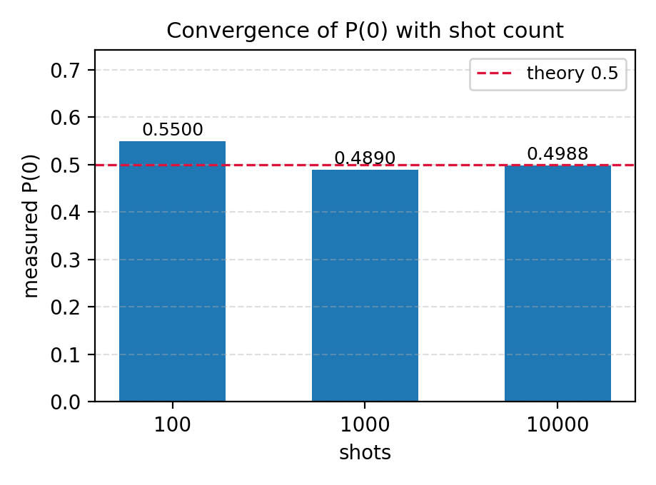
Figure 1.1. Measured P(0) at three shot counts, against the theoretical value of 0.5.

Observation
The measured P(0) was 0.5500, 0.4890 and 0.4988, with errors of 0.0500, 0.0110 and 0.0012 against predicted standard errors of 0.0500, 0.0158 and 0.0050, so each result sits at or inside one standard error. Two points need stating precisely: the estimator is unbiased at every N, so extra shots reduce spread rather than remove an offset, and the gain is slow, a hundredfold increase in shots buying only a tenfold reduction in error. No shot count corrects a systematic fault, since a device with readout bias would converge just as smoothly onto the wrong value.

Exercise 2: Medium

Measuring |+⟩ and |−⟩ in the X Basis
As |+⟩ and |−⟩ are indistinguishable in the computational basis, both states are measured in both bases and all four results tabulated together. The X-basis measurement applies a Hadamard immediately before the measurement, so the existing Z-basis readout returns the X-basis value. One thousand shots per combination is enough that a deterministic outcome cannot be mistaken for a skewed random one.
Code
"""
Week_05 / T02.py -- Tutorial 5, Medium
Prepare |+> and |->, measure them in the X basis (apply H before the
measurement) and interpret the results.
"""

from qiskit import QuantumCircuit
from qiskit_aer import AerSimulator

sim = AerSimulator()
SHOTS = 1000

def measure(state, basis):
"""Prepare |+> or |->, then measure in the Z or X basis."""
qc = QuantumCircuit(1, 1)

if state == '+':
qc.h(0) # |+> = H|0>
else:
qc.x(0)
qc.h(0) # |-> = H X|0>

if basis == 'X':
qc.h(0) # basis change: H maps |+>->|0> and |->->|1>

qc.measure(0, 0)
return sim.run(qc, shots=SHOTS).result().get_counts()

print(f"{SHOTS} shots per experiment\n")
print(" state | basis | counts")
print("-" * 45)

for state in ['+', '-']:
for basis in ['Z', 'X']:
counts = measure(state, basis)
print(f" |{state}> | {basis} | {counts}")

print("\nZ basis: both states look 50/50 random -- the measurement cannot tell them apart.")
print("X basis: |+> always gives 0 and |-> always gives 1 -- fully deterministic.")
print("Randomness is not in the state alone, it depends on the basis you measure in.")
Output
1000 shots per experiment

state | basis | counts
---------------------------------------------
|+> | Z | {'0': 527, '1': 473}
|+> | X | {'0': 1000}
|-> | Z | {'0': 491, '1': 509}
|-> | X | {'1': 1000}

Z basis: both states look 50/50 random -- the measurement cannot tell them apart.
X basis: |+> always gives 0 and |-> always gives 1 -- fully deterministic.
Randomness is not in the state alone, it depends on the basis you measure in.
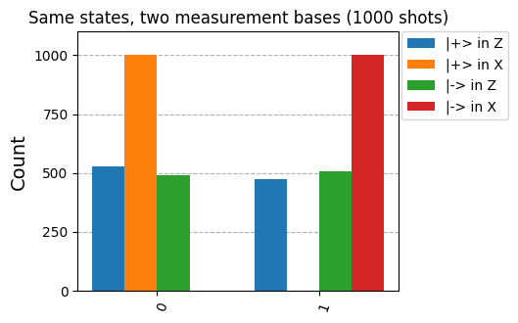
Figure 2.1. The same two states measured in the Z and X bases, 1000 shots each.

Observation
In the Z basis |+⟩ gave 527 zeros against 473 and |−⟩ gave 491 against 509; with a standard error of about 16 counts, both are consistent with a fair coin and neither row separates the states. In the X basis the separation was complete, |+⟩ returning 0 on all 1000 shots and |−⟩ returning 1 on all 1000. A Z measurement squares the amplitudes and so discards the sign that distinguishes the states, while the Hadamard converts that sign into a population difference beforehand. Randomness therefore belongs to the state together with the chosen basis, not to the qubit alone, which is the property BB84 relies on.

Exercise 3: Hard

Partial Measurement of One Qubit of a Bell Pair
The state of the unmeasured qubit is what is asked for, so measuring both qubits and comparing strings would not answer it. Only qubit 0 is measured, and a statevector is saved immediately afterwards so the probabilities of qubit 1 can be read from the collapsed state. Each trial uses a single shot, since the interest is in one particular run, and the baseline probabilities in the intact Bell state are printed first.
Code
"""
Week_05 / T03.py -- Tutorial 5, Hard
Measure only ONE qubit of a 2-qubit Bell pair and analyse the state of the
qubit that was never measured.
"""

from qiskit import QuantumCircuit
from qiskit_aer import AerSimulator
from qiskit.quantum_info import Statevector

sim = AerSimulator()

# 1. Bell pair (|00> + |11>)/sqrt(2) -- BEFORE any measurement.
bell = QuantumCircuit(2)
bell.h(0)
bell.cx(0, 1)
before = Statevector(bell).probabilities([1]) # qubit 1 only
print("Before measurement -> qubit 1: P(0) = %.2f , P(1) = %.2f (unknown)" %
(before[0], before[1]))

# 2. Same Bell pair, but now qubit 0 alone is measured.
def partial_measurement():
qc = QuantumCircuit(2, 1)
qc.h(0)
qc.cx(0, 1)
qc.measure(0, 0) # only qubit 0 -- qubit 1 is left untouched
qc.save_statevector() # state of the pair right after the collapse

result = sim.run(qc, shots=1).result()
bit = list(result.get_counts().keys())[0]
probs = result.get_statevector().probabilities([1]) # qubit 1 only
return bit, probs

print("\nAfter measuring qubit 0 only:")
print(" trial | qubit 0 | qubit 1: P(0), P(1) | qubit 1 state")
print("-" * 55)

for trial in range(1, 6):
bit, p = partial_measurement()
print(f" {trial} | {bit} | {p[0]:.2f}, {p[1]:.2f} | |{bit}>")

print("\nQubit 1 was 50/50 before, but becomes certain the instant qubit 0 is read.")
print("Measuring half of an entangled pair collapses the whole pair.")
Output
Before measurement -> qubit 1: P(0) = 0.50 , P(1) = 0.50 (unknown)

After measuring qubit 0 only:
trial | qubit 0 | qubit 1: P(0), P(1) | qubit 1 state
-------------------------------------------------------
1 | 0 | 1.00, 0.00 | |0>
2 | 0 | 1.00, 0.00 | |0>
3 | 1 | 0.00, 1.00 | |1>
4 | 0 | 1.00, 0.00 | |0>
5 | 1 | 0.00, 1.00 | |1>

Qubit 1 was 50/50 before, but becomes certain the instant qubit 0 is read.
Measuring half of an entangled pair collapses the whole pair.
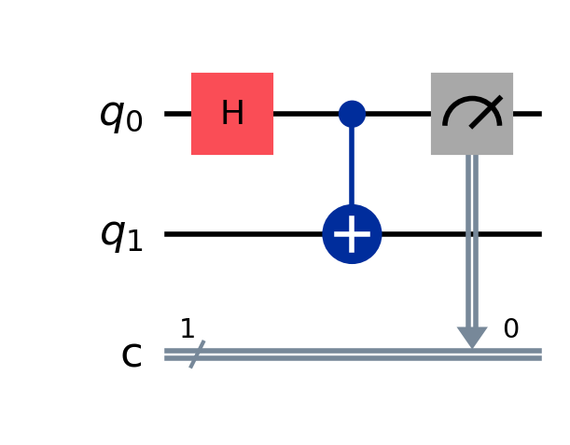
Figure 3.1. The Bell pair with a measurement on qubit 0 only; qubit 1 is left untouched.

Observation
Before measurement qubit 1 gave P(0) = P(1) = 0.50. Across five trials qubit 0 was found as 0, 0, 1, 0 and 1, and qubit 1 came out as exactly 1.00 and 0.00 or 0.00 and 1.00 every time, always agreeing with its partner despite never being measured. Two points need care. The even split beforehand is not a superposition of qubit 1 alone but the reduced description of an entangled qubit, unlike |+⟩ in Exercise 2, which split evenly in Z yet was a definite state another basis read exactly. And nothing was transmitted, since the outcome on qubit 0 was itself random.

Exercise 4: Real World Application

Estimating an Unknown Rotation Angle from Measurement Statistics
Ry(θ) applied to |0⟩ gives cos(θ/2)|0⟩ + sin(θ/2)|1⟩, so P(1) = sin²(θ/2) and the angle is recovered as θ = 2 arcsin√P(1). The program hides an angle, applies it, and estimates it back from counts alone. Propagating the standard error through that relation gives dθ/dp = 1/√(p(1−p)), and the factors cancel exactly, leaving a standard error on θ of 1/√N whatever the angle: 0.1000, 0.0316 and 0.0100 radians.
Code
"""
Week_05 / T04.py -- Tutorial 5, Real-world
An unknown rotation Ry(theta) is applied to |0>. Recover theta using only
measurement statistics (simple single-qubit state tomography).
"""

import numpy as np
from qiskit import QuantumCircuit
from qiskit_aer import AerSimulator

# The hidden angle -- the "experimenter" is not allowed to look at it.
SECRET = np.random.uniform(0, np.pi)

# Ry(t)|0> = cos(t/2)|0> + sin(t/2)|1> => P(1) = sin^2(t/2)
# Inverting that formula gives: t = 2 * arcsin(sqrt(P(1)))

sim = AerSimulator()
print("shots | P(1) measured | estimated theta | error (rad)")
print("-" * 60)

for shots in [100, 1000, 10000]:
qc = QuantumCircuit(1, 1)
qc.ry(SECRET, 0)
qc.measure(0, 0)

counts = sim.run(qc, shots=shots).result().get_counts()
p1 = counts.get('1', 0) / shots
theta = 2 * np.arcsin(np.sqrt(p1))

print(f"{shots:6d} | {p1:.4f} | {theta:.4f} | {abs(theta - SECRET):.4f}")

print(f"\nTrue theta = {SECRET:.4f} rad ({np.degrees(SECRET):.2f} deg)")
print("The angle is never observed directly -- it is inferred from how often '1' appears.")
print("Error shrinks on average as 1/sqrt(shots); one individual row can still wobble.")
print("This is how real hardware is calibrated and how qubit states are characterised.")
Output
shots | P(1) measured | estimated theta | error (rad)
------------------------------------------------------------
100 | 0.0400 | 0.4027 | 0.0236
1000 | 0.0500 | 0.4510 | 0.0247
10000 | 0.0444 | 0.4246 | 0.0017

True theta = 0.4263 rad (24.43 deg)
The angle is never observed directly -- it is inferred from how often '1' appears.
Error shrinks on average as 1/sqrt(shots); one individual row can still wobble.
This is how real hardware is calibrated and how qubit states are characterised.
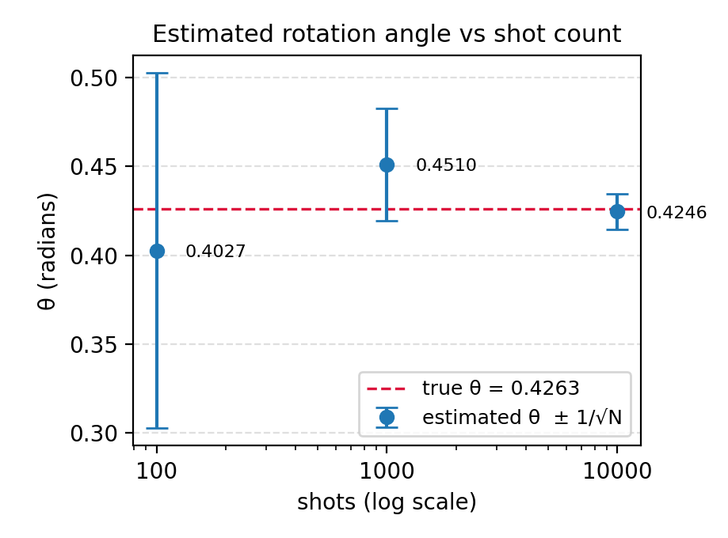
Figure 4.1. Estimated angle at each shot count with its ±1/√N interval, against the true value.

Observation
The hidden angle was 0.4263 radians, or 24.43 degrees, and the estimates were 0.4027, 0.4510 and 0.4246, in error by 0.0236, 0.0247 and 0.0017, all inside their standard errors of 0.1000, 0.0316 and 0.0100. The middle row deserves comment: its error is marginally the larger, which is no contradiction, because what shrinks with N is the interval in which the estimate is likely to fall, not the error of a single draw, as Figure 4.1 shows with intervals shrinking tenfold while the points do not. Two limits apply: one basis returns only amplitude magnitudes, so a relative phase would be invisible, and since sin²(θ/2) is symmetric about π, an angle beyond π would be reported as its reflection.

Exercise 5: Challenge

Distinguishing a Quantum Random Bit Generator from a Biased Classical Source
A decision problem needs a test, a null hypothesis and a threshold fixed before the data is examined. The test is the chi-square goodness-of-fit statistic against the fair model, the null hypothesis is that the source is unbiased, and with one degree of freedom the critical value at the five per cent level is 3.841. Two thousand bits are drawn from each source, since the expected statistic under a bias δ = 2p − 1 is about 1 + Nδ², here roughly 21 and comfortably above the threshold.
Code
"""
Week_05 / T05.py -- Tutorial 5, Challenge
Tell a genuine quantum random bit generator apart from a biased classical
PRNG using a chi-square test: H0 is that the source is unbiased, rejected
when chi2 > 3.841 (1 degree of freedom, 5% significance).
"""

import random
from qiskit import QuantumCircuit
from qiskit_aer import AerSimulator

N = 2000 # bits drawn from each source
CRITICAL = 3.841 # chi-square critical value, df = 1, alpha = 0.05

# --- Source A: quantum. H puts the qubit in an equal superposition. -------
qc = QuantumCircuit(1, 1)
qc.h(0)
qc.measure(0, 0)
counts = AerSimulator().run(qc, shots=N).result().get_counts()
source_A = [counts.get('0', 0), counts.get('1', 0)]

# --- Source B: classical PRNG, secretly biased to 55% zeros. -------------
bits = [0 if random.random() < 0.55 else 1 for _ in range(N)]
source_B = [bits.count(0), bits.count(1)]

def chi_square(observed):
"""Compare observed [n0, n1] with the fair expectation N/2 each."""
expected = sum(observed) / 2
return sum((o - expected) ** 2 / expected for o in observed)

print(f"{N} bits per source, alpha = 0.05, reject H0 if chi2 > {CRITICAL}\n")
print("source | n(0) n(1) | chi2 | verdict")
print("-" * 62)

for name, obs in [(" A ", source_A), (" B ", source_B)]:
x2 = chi_square(obs)
verdict = "BIASED (reject H0)" if x2 > CRITICAL else "consistent with fair"
print(f"{name} | {obs[0]:5d} {obs[1]:5d} | {x2:6.2f} | {verdict}")

print("\nReveal: A = quantum (H + measure), B = classical PRNG biased at p=0.55.")
print("The test flags B because a 5% bias over 2000 bits is far larger than shot noise.")
print("Note 1: a fair source still fails ~5% of runs -- that is the Type-I error rate.")
print("Note 2: this test only catches BIAS. An unbiased but predictable PRNG would")
print(" pass, so real certification also tests correlations and, for true")
print(" quantum randomness, uses Bell-inequality violation.")
Output
2000 bits per source, alpha = 0.05, reject H0 if chi2 > 3.841

source | n(0) n(1) | chi2 | verdict
--------------------------------------------------------------
A | 1017 983 | 0.58 | consistent with fair
B | 1059 941 | 6.96 | BIASED (reject H0)

Reveal: A = quantum (H + measure), B = classical PRNG biased at p=0.55.
The test flags B because a 5% bias over 2000 bits is far larger than shot noise.
Note 1: a fair source still fails ~5% of runs -- that is the Type-I error rate.
Note 2: this test only catches BIAS. An unbiased but predictable PRNG would
pass, so real certification also tests correlations and, for true
quantum randomness, uses Bell-inequality violation.
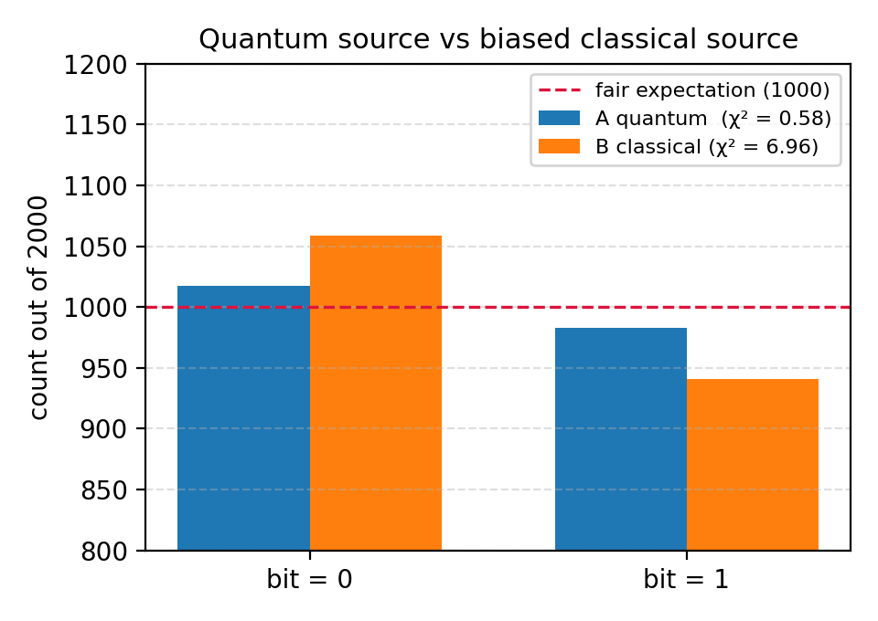
Figure 5.1. Outcome counts from both sources over 2000 bits, against the fair expectation of 1000.

Observation
The quantum source gave 1017 zeros against 983, a statistic of 0.58, so the null hypothesis was not rejected; the classical source gave 1059 against 941, a statistic of 6.96, correctly identifying it as biased. The verdict on the quantum source needs care, since failing to reject is not proving: no bias was detected at this sample size. While the experiment was repeated the quantum source itself exceeded 3.841 on some runs, which is the five per cent Type I rate behaving as specified. The test also examines only marginal frequencies, so a Mersenne Twister would pass while remaining fully predictable, which is why device-independent certification requires a Bell inequality violation.

Conclusion
Measurement was treated throughout as a statistical instrument, with each claim checked against numbers the circuits produced. One Hadamard circuit at three shot counts gave errors of 0.0500, 0.0110 and 0.0012, each within the predicted 0.5/√N. Reading |+⟩ and |−⟩ in two bases turned an apparently fair coin into a deterministic outcome, so randomness had to be attributed to state and basis together. Measuring one qubit of a Bell pair moved its untouched partner from an even split to a certainty in every trial, while the randomness of the measured qubit prevented any signalling. The same statistics recovered a hidden angle of 0.4263 radians as 0.4246, and a chi-square test separated a quantum source at 0.58 from a biased classical source at 6.96. All five programs executed without error on Qiskit 2.5.2 with Aer 0.17.2.

Reflection

Question 1: Why does increasing the number of shots improve the estimate of the underlying probability distribution?
A single measurement returns one outcome rather than a probability, so the distribution has to be rebuilt by repeating the preparation and counting. Each shot is an independent Bernoulli trial and the estimator p̂ = n/N is already unbiased at any N, which identifies what extra shots buy: not the removal of an offset, since there is none, but a reduction in spread. That spread is √(p(1−p)/N) and falls as 1/√N, predicting 0.0500, 0.0158 and 0.0050 for the three rows of Exercise 1, which the observed errors of 0.0500, 0.0110 and 0.0012 track. The square root matters, since a hundredfold increase in shots improves precision only tenfold, and the gain is not guaranteed on any single run, as Exercise 4 showed. Two boundaries apply: more shots address sampling noise only, so a device with a readout bias converges just as smoothly onto a wrong value, and convergence in one basis says nothing about what that basis is blind to.

Question 2: What real-world applications rely on true quantum randomness?
Quantum randomness is needed wherever an adversary must not be able to reproduce the bit stream, since a classical generator is deterministic and anyone who learns its seed knows every bit it will produce. Cryptographic key generation is the clearest case, covering session keys, nonces and initialisation vectors, and failures such as the Debian OpenSSL entropy defect were failures of the generator rather than of the cipher. Quantum key distribution depends on it more sharply, because in BB84 an eavesdropper who could anticipate the basis choices would defeat the protocol while leaving the error rate untouched. Regulated lotteries, certified gaming machines and large-scale Monte Carlo work in finance and physics have similar needs, served by commercial QRNG hardware and public beacons such as the NIST Randomness Beacon. The qualification Exercise 5 forced is that quantum origin is not by itself a guarantee, which is why device-independent certification rests on Bell inequality violation.

