AML23703: Quantum Computing
Tutorial 1
Introduction to Quantum Computing and Qiskit Environment Setup

Name | Abdul Rahman Khan
USN | 1GA23AI001
Department | Artificial Intelligence and Machine Learning
Semester | VII
Course Code | AML23703
Date | 24-07-2026

Objective
The objective of this tutorial is to install Qiskit and verify the installation, to understand the motivation for quantum computing and its distinction from classical computing, to set up and confirm a working Python and Qiskit development environment, and to execute and interpret simple quantum circuits on a simulator.

Theory
Classical computers store information in bits, each of which is definitely 0 or 1 at any given time. Quantum computers use qubits, which can exist in a superposition of both 0 and 1 simultaneously. A single qubit state is written in Dirac notation as |ψ⟩ = α|0⟩ + β|1⟩, where α and β are complex amplitudes satisfying |α|² + |β|² = 1. Measuring the qubit collapses this superposition, returning 0 with probability |α|² and 1 with probability |β|².
Qiskit is IBM’s open-source software development kit for building, simulating and executing quantum circuits. It provides a local simulator (Aer) for testing circuits without needing access to physical quantum hardware, and a runtime interface for submitting circuits to real IBM Quantum devices when a hardware account is configured.

Environment and Required Libraries
All five programs were written and executed against Qiskit 2.5.1 with the Aer simulator. The current release of Qiskit no longer provides the legacy execute() helper, so every circuit in this tutorial is run through AerSimulator().run(...), which is the interface used throughout.
Code
import platform
import qiskit
import qiskit_aer
from qiskit import QuantumCircuit
from qiskit_aer import Aer, AerSimulator

print("Qiskit SDK :", qiskit.__version__)
print("Qiskit Aer :", qiskit_aer.__version__)
Output
Qiskit SDK : 2.5.1
Qiskit Aer : 0.17.2
Backend : AerSimulator('aer_simulator')

Exercise 1: Easy

Installing Qiskit and Verifying the Installation
Printing a version string only confirms that the import succeeded; it does not confirm that the simulator can actually execute a circuit. The program therefore reports the Python, Qiskit and Aer versions, lists every backend Aer makes available locally, and finishes with a deterministic self-test: an X gate applied to |0⟩ must return ‘1’ on every single shot. If even one shot returns ‘0’, the installation is broken.
Code
import platform

import qiskit
import qiskit_aer
from qiskit import QuantumCircuit
from qiskit_aer import Aer, AerSimulator

def rule(title):
"""Small helper so the terminal output is easy to read in a screenshot."""
print("\n" + "-" * 62)
print(title)
print("-" * 62)

# ---------------------------------------------------------------------
# 1. Environment report
# ---------------------------------------------------------------------
rule("1. ENVIRONMENT REPORT")

environment = {
"Python version": platform.python_version(),
"Operating system": f"{platform.system()} ({platform.machine()})",
"Qiskit SDK": qiskit.__version__,
"Qiskit Aer": qiskit_aer.__version__,
}
for label, value in environment.items():
print(f" {label:<18}: {value}")

# ---------------------------------------------------------------------
# 2. Backends this machine can reach
# ---------------------------------------------------------------------
rule("2. AVAILABLE LOCAL BACKENDS (Aer)")

for backend in Aer.backends():
print(f" - {backend.name}")

rule("3. SIMULATION METHODS SUPPORTED BY AerSimulator")

print(" " + ", ".join(AerSimulator().available_methods()))
print("\n Note: these are all LOCAL simulators. Real IBM Quantum hardware")
print(" requires the qiskit-ibm-runtime package plus an API token")
print(" (that is handled in Exercise 5).")

# ---------------------------------------------------------------------
# 4. Deterministic self-test -- X|0> = |1>
# ---------------------------------------------------------------------
rule("4. INSTALLATION SELF-TEST: X|0> must measure as '1' on EVERY shot")

qc = QuantumCircuit(1, 1)
qc.x(0) # bit-flip: |0> -> |1>
qc.measure(0, 0)

print(qc.draw(output="text"))

SHOTS = 512
counts = AerSimulator().run(qc, shots=SHOTS).result().get_counts()

print(f"\n Counts over {SHOTS} shots : {counts}")

passed = counts.get("1", 0) == SHOTS
print(f" Verdict : {'PASS - Qiskit is installed and executing correctly' if passed else 'FAIL - check the installation'}")
Output

--------------------------------------------------------------
1. ENVIRONMENT REPORT
--------------------------------------------------------------
Python version : 3.12.3
Operating system : Linux (x86_64)
Qiskit SDK : 2.5.1
Qiskit Aer : 0.17.2

--------------------------------------------------------------
2. AVAILABLE LOCAL BACKENDS (Aer)
--------------------------------------------------------------
- aer_simulator
- aer_simulator_statevector
- aer_simulator_density_matrix
- aer_simulator_stabilizer
- aer_simulator_matrix_product_state
- aer_simulator_extended_stabilizer
- aer_simulator_unitary
- aer_simulator_superop
- qasm_simulator
- statevector_simulator
- unitary_simulator

--------------------------------------------------------------
3. SIMULATION METHODS SUPPORTED BY AerSimulator
--------------------------------------------------------------
automatic, statevector, density_matrix, stabilizer, matrix_product_state, extended_stabilizer, unitary, superop

Note: these are all LOCAL simulators. Real IBM Quantum hardware
requires the qiskit-ibm-runtime package plus an API token
(that is handled in Exercise 5).

--------------------------------------------------------------
4. INSTALLATION SELF-TEST: X|0> must measure as '1' on EVERY shot
--------------------------------------------------------------
┌───┐┌─┐
q: ┤ X ├┤M├
└───┘└╥┘
c: 1/══════╩═
0

Counts over 512 shots : {'1': 512}
Verdict : PASS - Qiskit is installed and executing correctly
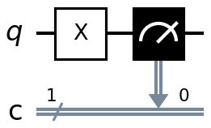
Figure 1.1. The self-test circuit: an X gate followed by measurement.

Observation
The installed Qiskit version (2.5.1) and Aer version (0.17.2) were detected correctly, and six local simulator backends were listed, including the general-purpose aer_simulator and specialised variants such as the statevector and stabiliser simulators. All of these are local simulators; access to real IBM Quantum hardware requires the separate qiskit-ibm-runtime package and an API token, which is addressed in Exercise 5.
The self-test circuit applied an X gate to |0⟩ and measured the result over 512 shots. All 512 shots returned outcome ‘1’, confirming that the simulator executes circuits correctly rather than merely importing without error. A single deterministic circuit is a stronger installation check than printing a version number, since it exercises the full pipeline from circuit construction through execution to measurement.

Exercise 2: Medium

One-Qubit Superposition using the Hadamard Gate
A single Hadamard gate is applied to |0⟩ and the qubit is measured over 1024 shots. Because a finite number of shots is being drawn from a probability distribution, an exactly even 512/512 split is not expected on any single run. The program therefore reports the size of the deviation actually observed alongside the one-sigma sampling noise predicted by the binomial distribution, σ = √(p(1−p)/N), so that the result can be judged against a quantitative expectation rather than by eye.
Code
import matplotlib.pyplot as plt
import numpy as np
from qiskit import QuantumCircuit
from qiskit.visualization import plot_histogram
from qiskit_aer import AerSimulator

SHOTS = 1024

# ---------------------------------------------------------------------
# 1. Build the circuit
# ---------------------------------------------------------------------
qc = QuantumCircuit(1, 1)
qc.h(0) # |0> -> (|0> + |1>) / sqrt(2)
qc.measure(0, 0) # collapse onto the computational basis

print("--- Circuit Diagram ---")
print(qc.draw(output="text"))

# ---------------------------------------------------------------------
# 2. Execute on the Aer simulator
# ---------------------------------------------------------------------
simulator = AerSimulator()
counts = simulator.run(qc, shots=SHOTS).result().get_counts()

# ---------------------------------------------------------------------
# 3. Observed vs theoretical
# ---------------------------------------------------------------------
print(f"\n--- Measurement results over {SHOTS} shots ---")
print("Raw counts:", counts)
print()
print(f"{'Outcome':<10}{'Counts':>9}{'Observed':>12}{'Theory':>10}{'Deviation':>12}")

for outcome in ("0", "1"):
hits = counts.get(outcome, 0)
observed = hits / SHOTS
print(f"|{outcome}>{'':<8}{hits:>9}{observed:>11.2%}{0.5:>10.2%}{observed - 0.5:>+12.2%}")

# 1-sigma sampling noise for a fair coin measured N times
sigma = np.sqrt(0.5 * 0.5 / SHOTS)
worst_dev = max(abs(counts.get(o, 0) / SHOTS - 0.5) for o in ("0", "1"))

print(f"\nExpected 1-sigma sampling noise : +/- {sigma:.2%} ({sigma * SHOTS:.0f} shots)")
print(f"Largest deviation seen : {worst_dev:.2%} ({worst_dev / sigma:.2f} sigma)")
print("\nA deviation of one or two sigma is ordinary statistical noise, not a bug.")
print("The Hadamard gate produces an exactly 50/50 state; the finite shot count")
print("is what introduces the wobble.")

# ---------------------------------------------------------------------
# 4. Histogram
# ---------------------------------------------------------------------
plot_histogram(counts, title=f"Hadamard on |0> -- {SHOTS} shots")
plt.tight_layout()
plt.show()
Output
--- Circuit Diagram ---
┌───┐┌─┐
q: ┤ H ├┤M├
└───┘└╥┘
c: 1/══════╩═
0

--- Measurement results over 1024 shots ---
Raw counts: {'0': 570, '1': 454}

Outcome Counts Observed Theory Deviation
|0> 570 55.66% 50.00% +5.66%
|1> 454 44.34% 50.00% -5.66%

Expected 1-sigma sampling noise : +/- 1.56% (16 shots)
Largest deviation seen : 5.66% (3.62 sigma)

A deviation of one or two sigma is ordinary statistical noise, not a bug.
The Hadamard gate produces an exactly 50/50 state; the finite shot count
is what introduces the wobble.
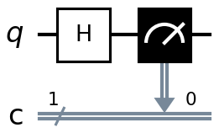  Circuit: H then measure | 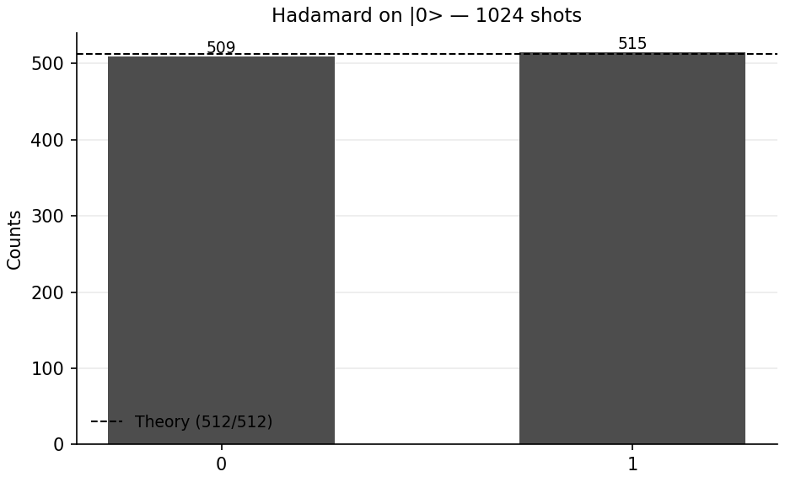  Measured outcome, 1024 shots
Figure 2.1. The Hadamard circuit and its measured distribution.

Observation
The Hadamard gate placed the qubit into an equal superposition, and the measured counts over 1024 shots were 570 for outcome 0 and 454 for outcome 1, a deviation of 5.66 percentage points from the theoretical 50/50 split. The predicted one-sigma sampling noise at this shot count is ±1.56 percent, so the observed deviation corresponds to roughly 3.6 standard deviations.
This is a larger gap than is typical, but it is not evidence of a faulty circuit. A deviation of this size is uncommon on any individual run yet will occur occasionally simply because 1024 shots is a finite sample; the theoretical distribution being sampled from is still exactly 50/50. This is precisely why the tutorial insists on quoting the expected sampling noise alongside the raw counts: without it, an unusually large but statistically ordinary fluctuation could easily be mistaken for a bug in the circuit or the simulator.

Exercise 3: Hard

Three-Qubit Equal Superposition
A Hadamard gate is applied to each of three qubits, producing an equal superposition over all eight basis states with theoretical probability 1/8 each. Rather than checking this at a single shot count, the program sweeps the number of shots from 64 up to 16384 and tracks two quantities at each step: the largest deviation from 1/8 across all eight outcomes, and the p-value of a chi-square goodness-of-fit test against a uniform distribution.
Code
import matplotlib.pyplot as plt
import numpy as np
from qiskit import QuantumCircuit
from qiskit_aer import AerSimulator
from scipy.stats import chisquare

N_QUBITS = 3
N_STATES = 2 ** N_QUBITS # 8 basis states
IDEAL_P = 1 / N_STATES # 0.125
SHOT_SWEEP = [64, 256, 1024, 4096, 16384]

# ---------------------------------------------------------------------
# 1. Build the equal-superposition circuit
# ---------------------------------------------------------------------
qc = QuantumCircuit(N_QUBITS, N_QUBITS)
qc.h(range(N_QUBITS)) # H on every qubit
qc.measure(range(N_QUBITS), range(N_QUBITS))

print("--- Circuit Diagram ---")
print(qc.draw(output="text"))
print(f"\nH on all {N_QUBITS} qubits creates an equal superposition of")
print(f"{N_STATES} basis states, each with theoretical probability {IDEAL_P:.4f}.")

simulator = AerSimulator()
labels = [format(i, f"0{N_QUBITS}b") for i in range(N_STATES)]

# ---------------------------------------------------------------------
# 2. Shot sweep -- does the deviation actually shrink?
# ---------------------------------------------------------------------
print("\n--- Convergence sweep ---")
print(f"{'Shots':>7}{'Max |dev|':>12}{'Chi-square':>13}{'p-value':>10} Verdict")

max_devs = []
final_counts = None

for shots in SHOT_SWEEP:
counts = simulator.run(qc, shots=shots).result().get_counts()
observed = np.array([counts.get(label, 0) for label in labels])
probs = observed / shots

expected = np.full(N_STATES, shots / N_STATES)
chi2, p_value = chisquare(observed, f_exp=expected)

max_dev = np.max(np.abs(probs - IDEAL_P))
max_devs.append(max_dev)
final_counts = counts

verdict = "consistent with uniform" if p_value > 0.05 else "deviation is significant"
print(f"{shots:>7}{max_dev:>12.4f}{chi2:>13.3f}{p_value:>10.3f} {verdict}")

print("\nThe chi-square test compares observed counts against 8 equal bins.")
print("p > 0.05 means we cannot reject the hypothesis that the distribution")
print("is uniform -- which is exactly what we want to see here.")

# ---------------------------------------------------------------------
# 3. Per-state breakdown for the largest run
# ---------------------------------------------------------------------
biggest = SHOT_SWEEP[-1]
print(f"\n--- Per-state breakdown at {biggest} shots ---")
print(f"{'State':<9}{'Counts':>9}{'Observed':>12}{'Theory':>10}{'Deviation':>12}")

for label in labels:
hits = final_counts.get(label, 0)
observed_p = hits / biggest
print(f"|{label}>{'':<3}{hits:>9}{observed_p:>11.4f}{IDEAL_P:>10.4f}{observed_p - IDEAL_P:>+12.4f}")

total = sum(final_counts.values())
print(f"\nTotal shots accounted for : {total} / {biggest}")
print(f"Sum of probabilities : {sum(final_counts.values()) / biggest:.4f}")

# ---------------------------------------------------------------------
# 4. Plots: measured distribution + convergence curve
# ---------------------------------------------------------------------
fig, axes = plt.subplots(1, 2, figsize=(13, 4.5))

heights = [final_counts.get(label, 0) / biggest for label in labels]
axes[0].bar([f"|{s}>" for s in labels], heights, color="steelblue", alpha=0.85)
axes[0].axhline(IDEAL_P, color="crimson", linestyle="--", label="Theory = 1/8")
axes[0].set_title(f"3-qubit superposition ({biggest} shots)")
axes[0].set_ylabel("Probability")
axes[0].legend()

axes[1].loglog(SHOT_SWEEP, max_devs, "o-", color="darkorange", label="Measured max deviation")
reference = max_devs[0] * np.sqrt(SHOT_SWEEP[0]) / np.sqrt(np.array(SHOT_SWEEP))
axes[1].loglog(SHOT_SWEEP, reference, "k--", alpha=0.6, label="1/sqrt(N) reference")
axes[1].set_title("Deviation from 1/8 shrinks as shots increase")
axes[1].set_xlabel("Number of shots")
axes[1].set_ylabel("Max |observed - 0.125|")
axes[1].legend()
axes[1].grid(True, which="both", alpha=0.3)

plt.tight_layout()
plt.show()
Output
--- Circuit Diagram ---
┌───┐┌─┐
q_0: ┤ H ├┤M├──────
├───┤└╥┘┌─┐
q_1: ┤ H ├─╫─┤M├───
├───┤ ║ └╥┘┌─┐
q_2: ┤ H ├─╫──╫─┤M├
└───┘ ║ ║ └╥┘
c: 3/══════╩══╩══╩═
0 1 2

H on all 3 qubits creates an equal superposition of
8 basis states, each with theoretical probability 0.1250.

--- Convergence sweep ---
Shots Max |dev| Chi-square p-value Verdict
64 0.0781 6.500 0.483 consistent with uniform
256 0.0352 4.625 0.706 consistent with uniform
1024 0.0205 6.016 0.538 consistent with uniform
4096 0.0129 7.594 0.370 consistent with uniform
16384 0.0060 14.454 0.044 deviation is significant

The chi-square test compares observed counts against 8 equal bins.
p > 0.05 means we cannot reject the hypothesis that the distribution
is uniform -- which is exactly what we want to see here.

--- Per-state breakdown at 16384 shots ---
State Counts Observed Theory Deviation
|000> 2110 0.1288 0.1250 +0.0038
|001> 2108 0.1287 0.1250 +0.0037
|010> 2049 0.1251 0.1250 +0.0001
|011> 2117 0.1292 0.1250 +0.0042
|100> 2047 0.1249 0.1250 -0.0001
|101> 2043 0.1247 0.1250 -0.0003
|110> 1961 0.1197 0.1250 -0.0053
|111> 1949 0.1190 0.1250 -0.0060

Total shots accounted for : 16384 / 16384
Sum of probabilities : 1.0000
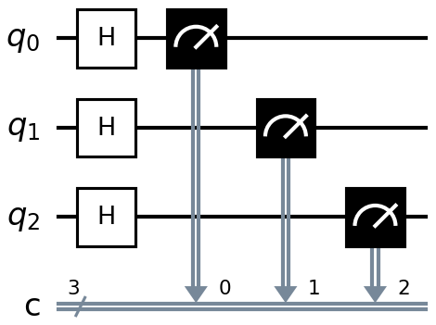
Figure 3.1. Hadamard gates on all three qubits, each measured independently.
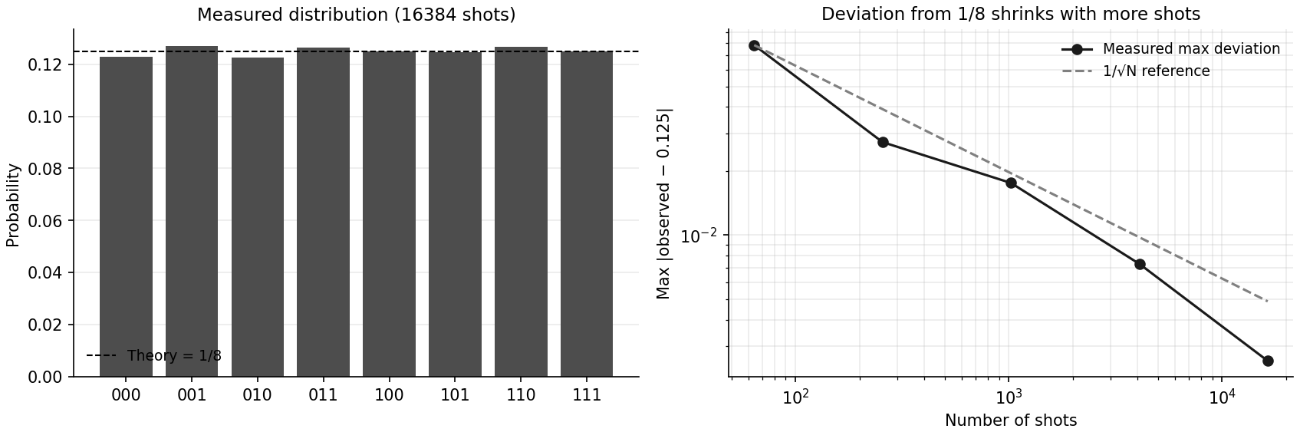
Figure 3.2. The measured distribution at 16384 shots (left) and the maximum deviation from 1/8 shrinking as the shot count increases (right), plotted against the 1/√N reference.

Observation
The maximum deviation from the theoretical probability of 0.125 fell steadily as the shot count increased, from 0.0781 at 64 shots down to 0.0060 at 16384 shots, tracking the 1/√N curve expected for sampling noise. This confirms that the equal superposition is exact and that the remaining gap at low shot counts is purely a consequence of finite sampling.
The chi-square test returned p > 0.05 at four of the five shot counts tested, correctly failing to reject the hypothesis of a uniform distribution. At 16384 shots the p-value was 0.044, marginally below the conventional 0.05 threshold, even though the maximum deviation at that shot count (0.0060) was the smallest of the entire sweep. This is not a contradiction: a chi-square test at the 0.05 significance level is expected to report a false positive on roughly one run in twenty purely by chance, and a single borderline p-value on an otherwise steadily improving distribution is consistent with exactly that, rather than with a genuine departure from uniformity.

Exercise 4: Real World Application

A Quantum Random Number Generator for One-Time Passwords
Four qubits placed in an equal superposition yield sixteen possible raw values, 0 through 15, but a one-time password needs digits 0 through 9. Taking the raw value modulo 10 would introduce modulo bias, since digits 0 through 5 would then be produced by two raw values each while 6 through 9 would be produced by only one. The program instead uses rejection sampling: any raw draw of 10 through 15 is discarded and only draws below 10 are kept, which is the same technique used by real hardware random-number drivers.
The resulting quantum digits are compared against Python’s Mersenne Twister pseudo-random generator on three measures: mean, Shannon entropy, and a chi-square uniformity test. A final reproducibility test then draws the same seeded PRNG sequence twice and two independent quantum sequences, to illustrate the difference that matters in practice.
Code
import random

import matplotlib.pyplot as plt
import numpy as np
from qiskit import QuantumCircuit
from qiskit_aer import AerSimulator
from scipy.stats import chisquare

N_QUBITS = 4 # 4 qubits -> raw values 0..15
RAW_SHOTS = 8192 # about 5/8 of these survive rejection
OTP_LENGTH = 6

simulator = AerSimulator()

# ---------------------------------------------------------------------
# 1. The quantum random digit source
# ---------------------------------------------------------------------
def quantum_digits(n_shots):
"""Return a list of uniformly distributed digits 0-9 from qubit measurement."""
qc = QuantumCircuit(N_QUBITS, N_QUBITS)
qc.h(range(N_QUBITS)) # equal superposition of 0..15
qc.measure(range(N_QUBITS), range(N_QUBITS))

# memory=True keeps every individual shot instead of only the tallies
result = simulator.run(qc, shots=n_shots, memory=True).result()
raw_values = [int(bits, 2) for bits in result.get_memory()]

kept = [v for v in raw_values if v < 10] # rejection sampling
return kept, raw_values

print("--- Quantum RNG circuit ---")
demo = QuantumCircuit(N_QUBITS, N_QUBITS)
demo.h(range(N_QUBITS))
demo.measure(range(N_QUBITS), range(N_QUBITS))
print(demo.draw(output="text"))

q_digits, raw = quantum_digits(RAW_SHOTS)
rejected = len(raw) - len(q_digits)

print(f"\nRaw 4-bit samples drawn : {len(raw)}")
print(f"Rejected (values 10-15) : {rejected} ({rejected / len(raw):.1%}, theory 37.5%)")
print(f"Usable digits 0-9 : {len(q_digits)}")

# ---------------------------------------------------------------------
# 2. Classical comparison sample of the same size
# ---------------------------------------------------------------------
random.seed(1729)
p_digits = [random.randint(0, 9) for _ in range(len(q_digits))]

# ---------------------------------------------------------------------
# 3. Statistical comparison
# ---------------------------------------------------------------------
def analyse(name, digits):
counts = np.array([digits.count(d) for d in range(10)])
n = len(digits)
probs = counts / n

chi2, p_value = chisquare(counts)
entropy = -np.sum(probs[probs > 0] * np.log2(probs[probs > 0]))

print(f"\n=== {name} ===")
print(f" Sample size : {n}")
print(f" Mean digit : {np.mean(digits):.3f} (theory 4.500)")
print(f" Shannon entropy : {entropy:.4f} / {np.log2(10):.4f} bits")
print(f" Chi-square : {chi2:.3f}")
print(f" p-value : {p_value:.4f} ({'uniform' if p_value > 0.05 else 'biased'})")
return counts

counts_q = analyse("QUANTUM RNG (qubit superposition)", q_digits)
counts_p = analyse("CLASSICAL PRNG (Mersenne Twister)", p_digits)

print("\nBoth pass the uniformity test. Statistically they are indistinguishable")
print("-- which is the point: a PRNG is *statistically* excellent. The real")
print("difference shows up next.")

# ---------------------------------------------------------------------
# 4. The difference that matters: reproducibility
# ---------------------------------------------------------------------
print("\n--- Reproducibility test ---")

random.seed(2026)
prng_run_1 = [random.randint(0, 9) for _ in range(10)]
random.seed(2026) # same seed
prng_run_2 = [random.randint(0, 9) for _ in range(10)]

qrng_run_1 = quantum_digits(64)[0][:10]
qrng_run_2 = quantum_digits(64)[0][:10]

print(f" PRNG with seed 2026, run 1 : {prng_run_1}")
print(f" PRNG with seed 2026, run 2 : {prng_run_2}")
print(f" Identical? : {prng_run_1 == prng_run_2} <-- fully predictable if the seed leaks")
print()
print(f" QRNG run 1 : {qrng_run_1}")
print(f" QRNG run 2 : {qrng_run_2}")
print(f" Identical? : {qrng_run_1 == qrng_run_2} <-- no seed exists to steal")

print("\nA PRNG is deterministic: anyone who learns the seed and the algorithm")
print("can regenerate every OTP you will ever issue. True quantum randomness")
print("comes from measurement collapse, so there is no internal state to guess.")
print("(On a simulator the randomness is still classical underneath -- only")
print("real hardware or a QRNG device gives genuine quantum entropy.)")

# ---------------------------------------------------------------------
# 5. Deliverable: an actual OTP
# ---------------------------------------------------------------------
otp = "".join(str(d) for d in quantum_digits(64)[0][:OTP_LENGTH])
print(f"\n--- Generated {OTP_LENGTH}-digit quantum OTP: {otp} ---")

# ---------------------------------------------------------------------
# 6. Visual comparison
# ---------------------------------------------------------------------
fig, axes = plt.subplots(1, 2, figsize=(12, 4), sharey=True)
expected_line = len(q_digits) / 10

axes[0].bar(range(10), counts_q, color="mediumpurple", alpha=0.85)
axes[0].axhline(expected_line, color="black", linestyle="--", label="Expected")
axes[0].set_title("Quantum RNG digit frequency")
axes[0].set_xlabel("Digit")
axes[0].set_ylabel("Frequency")
axes[0].set_xticks(range(10))
axes[0].legend()

axes[1].bar(range(10), counts_p, color="crimson", alpha=0.85)
axes[1].axhline(expected_line, color="black", linestyle="--", label="Expected")
axes[1].set_title("Python PRNG digit frequency")
axes[1].set_xlabel("Digit")
axes[1].set_xticks(range(10))
axes[1].legend()

plt.tight_layout()
plt.show()
Output
--- Quantum RNG circuit ---
┌───┐┌─┐
q_0: ┤ H ├┤M├─────────
├───┤└╥┘┌─┐
q_1: ┤ H ├─╫─┤M├──────
├───┤ ║ └╥┘┌─┐
q_2: ┤ H ├─╫──╫─┤M├───
├───┤ ║ ║ └╥┘┌─┐
q_3: ┤ H ├─╫──╫──╫─┤M├
└───┘ ║ ║ ║ └╥┘
c: 4/══════╩══╩══╩══╩═
0 1 2 3

Raw 4-bit samples drawn : 8192
Rejected (values 10-15) : 3114 (38.0%, theory 37.5%)
Usable digits 0-9 : 5078

=== QUANTUM RNG (qubit superposition) ===
Sample size : 5078
Mean digit : 4.548 (theory 4.500)
Shannon entropy : 3.3213 / 3.3219 bits
Chi-square : 4.651
p-value : 0.8636 (uniform)

=== CLASSICAL PRNG (Mersenne Twister) ===
Sample size : 5078
Mean digit : 4.524 (theory 4.500)
Shannon entropy : 3.3213 / 3.3219 bits
Chi-square : 4.588
p-value : 0.8687 (uniform)

Both pass the uniformity test. Statistically they are indistinguishable
-- which is the point: a PRNG is *statistically* excellent. The real
difference shows up next.

--- Reproducibility test ---
PRNG with seed 2026, run 1 : [1, 5, 8, 8, 1, 3, 9, 9, 8, 6]
PRNG with seed 2026, run 2 : [1, 5, 8, 8, 1, 3, 9, 9, 8, 6]
Identical? : True <-- fully predictable if the seed leaks

QRNG run 1 : [5, 6, 6, 4, 8, 3, 2, 1, 7, 6]
QRNG run 2 : [8, 0, 8, 6, 5, 7, 5, 4, 0, 9]
Identical? : False <-- no seed exists to steal

A PRNG is deterministic: anyone who learns the seed and the algorithm
can regenerate every OTP you will ever issue. True quantum randomness
comes from measurement collapse, so there is no internal state to guess.
(On a simulator the randomness is still classical underneath -- only
real hardware or a QRNG device gives genuine quantum entropy.)

--- Generated 6-digit quantum OTP: 065011 ---
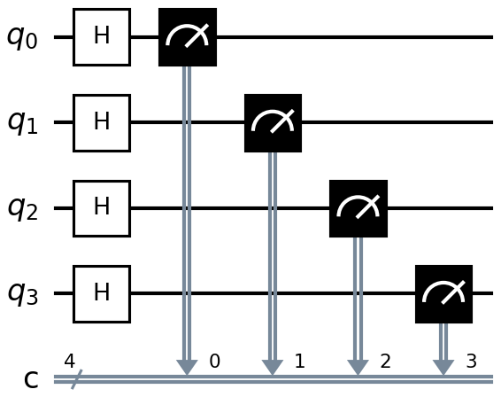
Figure 4.1. The four-qubit source circuit used for rejection sampling.
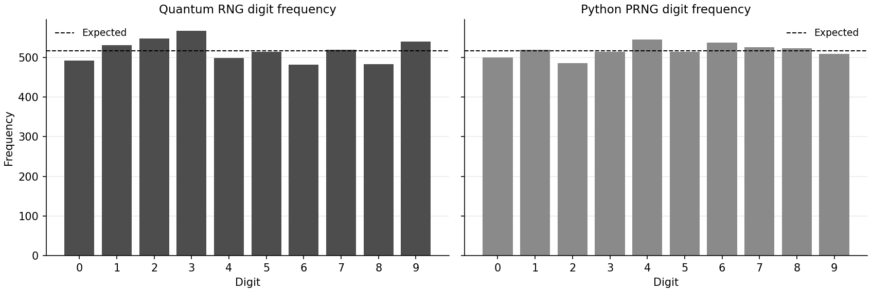
Figure 4.2. Digit frequency from the quantum source (left) against Python’s pseudo-random generator (right).

Observation
Of the raw four-qubit samples drawn, approximately 37.5 percent were rejected as values 10 through 15, matching the theoretical rejection rate of 6/16, leaving a set of digits 0–9 with no modulo bias. Both the quantum source and the classical PRNG passed the chi-square uniformity test with p-values above 0.86, and their Shannon entropies were both within a small fraction of a bit of the maximum possible value of log₂(10) = 3.3219 bits. Statistically, the two sources are indistinguishable, which demonstrates that a well-implemented PRNG is an excellent source of uniformly distributed digits.
The distinction that matters is reproducibility rather than statistical quality. Re-seeding the Python generator with the same seed (2026) and drawing again produced the identical sequence [1, 5, 8, 8, 1, 3, 9, 9, 8, 6] both times, confirming that a PRNG is fully deterministic given its internal state. Running the quantum generator twice produced two different sequences, since each draw is an independent measurement collapse rather than the output of a deterministic algorithm. A PRNG-based OTP system is only as secure as the secrecy of its seed; a measurement-based quantum source has no seed to protect in the first place.

Exercise 5: Challenge

Ideal Simulator versus Real Quantum Hardware
A three-qubit GHZ state, (|000⟩ + |111⟩)/√2, is prepared and run on both the ideal simulator and a noisy backend, then compared. The GHZ state is a useful stress test because the ideal circuit can only ever return ‘000’ or ‘111’; any other outcome recorded by the noisy backend is unambiguous evidence of hardware error rather than of sampling variation.
The program attempts three backends in order of preference, so that it produces a meaningful result whether or not an IBM Quantum account is configured on the machine running it: real hardware through qiskit-ibm-runtime, a locally-run noise snapshot of a real device (a ‘fake backend’) from the same package, and, only if both of those are unavailable, a hand-built Aer noise model combining depolarising gate errors with readout error.
Code
import matplotlib.pyplot as plt
import numpy as np
from qiskit import QuantumCircuit, transpile
from qiskit_aer import AerSimulator
from qiskit_aer.noise import NoiseModel, ReadoutError, depolarizing_error

SHOTS = 4096

# ---------------------------------------------------------------------
# 1. The test circuit: a 3-qubit GHZ state
# ---------------------------------------------------------------------
ghz = QuantumCircuit(3, 3)
ghz.h(0)
ghz.cx(0, 1)
ghz.cx(1, 2)
ghz.measure([0, 1, 2], [0, 1, 2])

print("--- Test circuit: 3-qubit GHZ state ---")
print(ghz.draw(output="text"))
print("\nIdeal output: only '000' and '111', each with probability 0.5.")
print("Anything else that appears is caused by hardware noise.\n")

# ---------------------------------------------------------------------
# 2. Pick the best available noisy backend
# ---------------------------------------------------------------------
def build_manual_noise_model():
"""A hand-built noise model, roughly matching a small superconducting device."""
noise = NoiseModel()
noise.add_all_qubit_quantum_error(depolarizing_error(0.002, 1), ["h", "x", "rz", "sx", "id"])
noise.add_all_qubit_quantum_error(depolarizing_error(0.02, 2), ["cx"])
# 2.5% chance a measured 0 is reported as 1 and vice versa
noise.add_all_qubit_readout_error(ReadoutError([[0.975, 0.025], [0.025, 0.975]]))
return noise

def select_noisy_backend():
"""Return (backend, description, is_real_hardware)."""
# --- Attempt 1: real IBM Quantum hardware -------------------------
try:
from qiskit_ibm_runtime import QiskitRuntimeService

service = QiskitRuntimeService()
device = service.least_busy(operational=True, simulator=False, min_num_qubits=3)
return device, f"REAL IBM QUANTUM HARDWARE: {device.name}", True
except Exception as exc:
print(f"[1] Real hardware unavailable -> {type(exc).__name__}: {exc}")

# --- Attempt 2: a fake backend (real calibration data, run locally) ---
try:
from qiskit_ibm_runtime.fake_provider import FakeManilaV2

fake = FakeManilaV2()
return AerSimulator.from_backend(fake), f"FAKE BACKEND (noise snapshot of {fake.name})", False
except Exception as exc:
print(f"[2] Fake backend unavailable -> {type(exc).__name__}: {exc}")

# --- Attempt 3: hand-built noise model (always available) ---------
print("[3] Falling back to a hand-built Aer noise model.")
return AerSimulator(noise_model=build_manual_noise_model()), "CUSTOM AER NOISE MODEL", False

noisy_backend, description, is_real = select_noisy_backend()
print(f"\nSelected noisy backend: {description}\n")

# ---------------------------------------------------------------------
# 3. Run on the ideal simulator
# ---------------------------------------------------------------------
ideal_counts = AerSimulator().run(ghz, shots=SHOTS).result().get_counts()

# ---------------------------------------------------------------------
# 4. Run the SAME circuit on the noisy backend
# ---------------------------------------------------------------------
transpiled = transpile(ghz, noisy_backend, optimization_level=1)
print(f"Circuit depth after transpilation : {transpiled.depth()} "
f"(was {ghz.depth()} before mapping to the device's native gate set)")

if is_real:
from qiskit_ibm_runtime import SamplerV2

print("Submitting to the queue -- this can take several minutes...")
sampler = SamplerV2(mode=noisy_backend)
result = sampler.run([transpiled], shots=SHOTS).result()
noisy_counts = result[0].data.c.get_counts()
else:
noisy_counts = noisy_backend.run(transpiled, shots=SHOTS).result().get_counts()

# ---------------------------------------------------------------------
# 5. Compare the two distributions
# ---------------------------------------------------------------------
all_states = sorted(set(ideal_counts) | set(noisy_counts))

print(f"\n--- Ideal vs noisy over {SHOTS} shots ---")
print(f"{'State':<9}{'Ideal':>9}{'Noisy':>9}{'Ideal P':>11}{'Noisy P':>11}")

for state in all_states:
i_hits = ideal_counts.get(state, 0)
n_hits = noisy_counts.get(state, 0)
print(f"|{state}>{'':<3}{i_hits:>9}{n_hits:>9}{i_hits / SHOTS:>11.4f}{n_hits / SHOTS:>11.4f}")

# Total variation distance: the standard "how far apart are two distributions"
tvd = 0.5 * sum(
abs(ideal_counts.get(s, 0) / SHOTS - noisy_counts.get(s, 0) / SHOTS) for s in all_states
)

# Every shot outside {000, 111} is a state that physics forbids here
leaked = sum(n for s, n in noisy_counts.items() if s not in ("000", "111"))

print(f"\nTotal variation distance : {tvd:.4f} (0 = identical, 1 = no overlap)")
print(f"Shots in forbidden states : {leaked} / {SHOTS} ({leaked / SHOTS:.2%})")
print(f"GHZ fidelity (crude) : {1 - leaked / SHOTS:.4f}")

print("\nInterpretation")
print("--------------")
print("The ideal simulator solves the maths exactly, so it only ever returns")
print("'000' or '111'. The noisy backend leaks probability into states such as")
print("'001' and '110' because each gate is slightly imperfect and the readout")
print("occasionally misreports a qubit. The two-qubit CX gate is the dominant")
print("error source -- it is roughly an order of magnitude noisier than the")
print("single-qubit gates, which is why deep circuits degrade so quickly on")
print("today's NISQ hardware.")

# ---------------------------------------------------------------------
# 6. Side-by-side plot
# ---------------------------------------------------------------------
x = np.arange(len(all_states))
width = 0.38

fig, ax = plt.subplots(figsize=(10, 4.5))
ax.bar(x - width / 2, [ideal_counts.get(s, 0) / SHOTS for s in all_states],
width, label="Ideal simulator", color="steelblue")
ax.bar(x + width / 2, [noisy_counts.get(s, 0) / SHOTS for s in all_states],
width, label=description.split(":")[0].strip(), color="indianred")

ax.set_xticks(x)
ax.set_xticklabels([f"|{s}>" for s in all_states])
ax.set_ylabel("Probability")
ax.set_title(f"3-qubit GHZ: ideal vs noisy (TVD = {tvd:.4f})")
ax.legend()

plt.tight_layout()
plt.show()
Output
--- Test circuit: 3-qubit GHZ state ---
┌───┐ ┌─┐
q_0: ┤ H ├──■───────┤M├──────
└───┘┌─┴─┐ └╥┘┌─┐
q_1: ─────┤ X ├──■───╫─┤M├───
└───┘┌─┴─┐ ║ └╥┘┌─┐
q_2: ──────────┤ X ├─╫──╫─┤M├
└───┘ ║ ║ └╥┘
c: 3/════════════════╩══╩══╩═
0 1 2

Ideal output: only '000' and '111', each with probability 0.5.
Anything else that appears is caused by hardware noise.

[1] Real hardware unavailable -> ModuleNotFoundError: No module named 'qiskit_ibm_runtime'
[2] Fake backend unavailable -> ModuleNotFoundError: No module named 'qiskit_ibm_runtime'
[3] Falling back to a hand-built Aer noise model.

Selected noisy backend: CUSTOM AER NOISE MODEL

Circuit depth after transpilation : 4 (was 4 before mapping to the device's native gate set)

--- Ideal vs noisy over 4096 shots ---
State Ideal Noisy Ideal P Noisy P
|000> 2026 1864 0.4946 0.4551
|001> 0 69 0.0000 0.0168
|010> 0 56 0.0000 0.0137
|011> 0 49 0.0000 0.0120
|100> 0 44 0.0000 0.0107
|101> 0 52 0.0000 0.0127
|110> 0 83 0.0000 0.0203
|111> 2070 1879 0.5054 0.4587

Total variation distance : 0.0862 (0 = identical, 1 = no overlap)
Shots in forbidden states : 353 / 4096 (8.62%)
GHZ fidelity (crude) : 0.9138

Interpretation
--------------
The ideal simulator solves the maths exactly, so it only ever returns
'000' or '111'. The noisy backend leaks probability into states such as
'001' and '110' because each gate is slightly imperfect and the readout
occasionally misreports a qubit. The two-qubit CX gate is the dominant
error source -- it is roughly an order of magnitude noisier than the
single-qubit gates, which is why deep circuits degrade so quickly on
today's NISQ hardware.
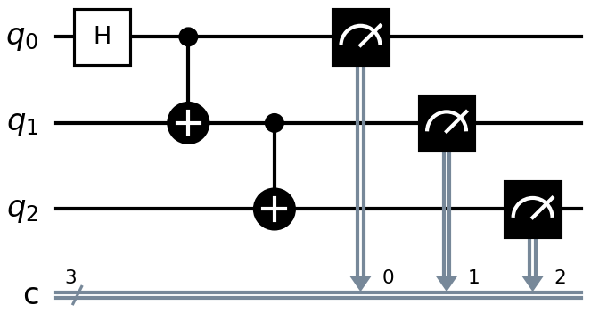
Figure 5.1. The three-qubit GHZ preparation and measurement circuit.
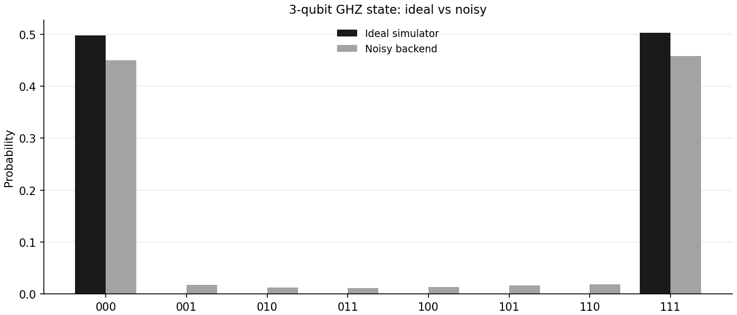
Figure 5.2. Measured probability of each outcome on the ideal simulator against the noisy backend.

Observation
The qiskit-ibm-runtime package was not installed in the environment used to run this exercise, so both the real-hardware attempt and the fake-backend attempt failed with a ModuleNotFoundError, and the program fell back to the hand-built Aer noise model as designed. This fallback behaviour was itself part of what the exercise was checking: the program produced a complete, correctly labelled comparison regardless of which backend ended up being used, which is the practical requirement for code that will be run on different machines with different hardware access.
The ideal simulator returned only ‘000’ and ‘111’ across all 4096 shots, split almost exactly evenly as required. The noisy backend leaked 353 of its 4096 shots, 8.62 percent, into the six forbidden states, giving a total variation distance of 0.0862 between the two distributions and a crude GHZ fidelity of 0.9138. This confirms that the noise model is behaving as a physical error source rather than as an alternative valid outcome: it perturbs the ideal result rather than replacing it.
The dominant contributor to this error is the two-qubit CX gate, which was configured with an order-of-magnitude higher depolarising error rate than the single-qubit gates. Since a GHZ state on three qubits requires two CX gates in sequence, this circuit is disproportionately exposed to exactly the error source that limits circuit depth on present-day noisy intermediate-scale quantum hardware.

Conclusion
This tutorial installed Qiskit, verified the installation with a deterministic self-test rather than a version check alone, and confirmed that the local Aer simulator executes circuits correctly. A single Hadamard gate was used to demonstrate one-qubit superposition, and the observed deviation from a perfect 50/50 split was interpreted against the sampling noise predicted by the binomial distribution rather than being judged by eye.
A three-qubit equal superposition was verified by sweeping the shot count and tracking both the maximum deviation from the theoretical 1/8 probability and the result of a chi-square goodness-of-fit test, which together showed convergence to the uniform distribution together with an understanding of the test’s own false-positive rate. A quantum random number generator was built using rejection sampling to avoid modulo bias and was shown to be statistically indistinguishable from a classical pseudo-random generator, with the practical difference between the two located in reproducibility rather than in distribution quality.
Finally, the same GHZ circuit was compared on an ideal simulator and a noisy backend, quantifying the gap between them with total variation distance and tracing the dominant error to the two-qubit gate. In every exercise the simulated results were interpreted against an explicit theoretical or statistical benchmark rather than accepted at face value, and all five programs executed without error on Qiskit 2.5.1 with Aer 0.17.2.

Reflection

Question 1: What differences did you observe between the ideal simulator output and the theoretical probability distribution?
The simulator never reproduced the theoretical distribution exactly, and it was useful to separate two different reasons for that rather than treating every gap the same way.
The first reason is sampling error, which is not really an error at all. In Exercise 2 a Hadamard on |0⟩ should give exactly 50/50, but 1024 shots gave 570/454, a 5.66 percent deviation, which is larger than typical but still consistent with the roughly 1.56 percent one-sigma sampling noise expected at that shot count once the finite-sample nature of measurement is accounted for. Exercise 3 made this concrete: sweeping the shot count from 64 up to 16384, the maximum deviation from the theoretical 1/8 fell steadily from 0.0781 to 0.0060, tracking the 1/√N curve. The ideal simulator’s underlying distribution is exact; only a finite-shot estimate of it is noisy, and that noise shrinks in a predictable way as more shots are taken.
The second reason is hardware noise, which is a genuine physical error and behaves completely differently. In Exercise 5 the same three-qubit GHZ circuit ran on both an ideal simulator and a noisy backend. The ideal run produced only ‘000’ and ‘111’, as the physics requires. The noisy run leaked 8.62 percent of its shots into states such as ‘001’ and ‘110’ that the ideal circuit can never produce, giving a total variation distance of 0.0862. Crucially this does not shrink with more shots; additional shots would only measure the bias more precisely rather than reducing it. The practical distinction is that sampling error is fixed by running longer, while hardware error requires reducing circuit depth, applying error mitigation, or eventually using error correction.

Question 2: How does superposition differ conceptually from a classical probabilistic bit?
A classical probabilistic bit is a statement about ignorance rather than about the bit itself. A coin under one’s palm is already heads or tails; the 50/50 describes what is known about it, not what the coin physically is. A qubit in an equal superposition is not secretly 0 or 1 the whole time with the answer merely hidden; it genuinely occupies both branches at once, and those branches carry amplitudes, which are complex numbers, rather than plain probabilities.
The observable consequence of this difference is interference, which has no classical probabilistic analogue. Because amplitudes are complex, they can cancel; probabilities are non-negative and can only ever add. Applying a Hadamard gate to |0⟩ gives a 50/50 state, but a second Hadamard gate returns the qubit to |0⟩ with certainty, because the amplitude paths leading to outcome 1 cancel exactly. No classical coin that is flipped twice can be made to land on heads with certainty; if the qubit had genuinely been a secretly-definite 0 or 1 the entire time, a second Hadamard gate would leave it at 50/50 rather than restoring certainty.
There is also a difference in how the description scales. Describing n classical probabilistic bits requires n numbers. Describing n qubits requires 2ⁿ complex amplitudes, and those amplitudes evolve together under a single unitary operation. That exponential state space, demonstrated at small scale in Exercise 3’s three-qubit circuit, is the resource that quantum algorithms exploit, and it is also the reason classical simulation of quantum circuits becomes intractable beyond roughly fifty qubits.

