AML23703: Quantum Computing
Tutorial 2
Qubits, State Vectors and Superposition Visualisation

Name | Abdul Rahman Khan
USN | 1GA23AI001
Department | Artificial Intelligence and Machine Learning
Semester | VII
Course Code | AML23703
Date | 31-07-2026

Objective
The objective of this tutorial is to represent qubit states mathematically using state vectors and Dirac notation, to visualise single- and multi-qubit states using the Bloch sphere and the Q-sphere, to compute probability amplitudes and verify normalisation conditions, and to understand where these visualisation tools succeed and where they break down.

Theory
A single-qubit state is written |ψ⟩ = α|0⟩ + β|1⟩ with complex amplitudes α and β satisfying |α|² + |β|² = 1. This normalisation condition is not imposed after the fact; it is preserved automatically because every quantum gate is represented by a unitary matrix, and unitary matrices preserve vector length by definition.
Geometrically, a single-qubit state corresponds to a point on the surface of the Bloch sphere, with the north and south poles representing |0⟩ and |1⟩. The three Cartesian coordinates of this point are the expectation values of the Pauli operators X, Y and Z. For multi-qubit systems the Bloch sphere no longer gives a complete picture: an n-qubit pure state has 2ⁿ complex amplitudes, which after removing normalisation and global phase leaves 2(2ⁿ⁻¹) real parameters, while n separate Bloch spheres offer only 2n. For an entangled state the missing parameters are precisely the correlations between the qubits, and the Q-sphere is used instead where a joint picture of the full amplitude structure is required.

Environment and Required Libraries
All five programs were written and executed against Qiskit 2.5.1 with the Aer simulator, using the Statevector and Pauli classes from qiskit.quantum_info for exact state and Bloch-vector calculations, and the Bloch sphere and Q-sphere plotting functions from qiskit.visualization.
Code
import numpy as np
from qiskit import QuantumCircuit
from qiskit.quantum_info import Pauli, Statevector
from qiskit.visualization import (
plot_bloch_vector, plot_bloch_multivector, plot_state_qsphere
)
from qiskit_aer import AerSimulator

simulator = AerSimulator()
Output
Qiskit SDK : 2.5.1
Qiskit Aer : 0.17.2
Backend : AerSimulator('aer_simulator')

Exercise 1: Easy

Preparing |0⟩, Applying an X Gate, and Reading the Statevector
The same physical state can be written three different ways: as a raw amplitude vector, in Dirac notation, and as a point on the Bloch sphere. This exercise prints all three side by side for the qubit both before and after an X gate is applied, so that |0⟩ = [1, 0] = north pole and |1⟩ = [0, 1] = south pole can be seen to be the same statement made in three different languages.
Code
import matplotlib.pyplot as plt
import numpy as np
from qiskit import QuantumCircuit
from qiskit.quantum_info import Pauli, Statevector
from qiskit.visualization import plot_bloch_multivector

def to_dirac(statevector, n_qubits=1):
"""Format a statevector as readable bra-ket notation, e.g. '0.7071|0> + 0.7071|1>'."""
terms = []
for index, amplitude in enumerate(statevector.data):
if abs(amplitude) < 1e-9:
continue
label = format(index, f"0{n_qubits}b")
if abs(amplitude.imag) < 1e-9:
coefficient = f"{amplitude.real:+.4f}"
else:
coefficient = f"+({amplitude.real:.4f}{amplitude.imag:+.4f}j)"
terms.append(f"{coefficient}|{label}>")
return " ".join(terms) if terms else "0"

def bloch_vector(statevector):
"""Bloch coordinates = expectation values of the three Pauli operators."""
return np.array([
statevector.expectation_value(Pauli("X")).real,
statevector.expectation_value(Pauli("Y")).real,
statevector.expectation_value(Pauli("Z")).real,
])

def describe(title, statevector):
print(f"\n{title}")
print(f" Amplitude vector : {np.round(statevector.data, 4)}")
print(f" Dirac notation : {to_dirac(statevector)}")
for index, amplitude in enumerate(statevector.data):
print(f" |{index}> : amplitude {amplitude:+.4f} probability {abs(amplitude) ** 2:.4f}")
x, y, z = bloch_vector(statevector)
print(f" Bloch vector : (x={x:+.4f}, y={y:+.4f}, z={z:+.4f})")
print(f" Norm check : sum of |amplitude|^2 = {np.sum(np.abs(statevector.data) ** 2):.6f}")

# ---------------------------------------------------------------------
# 1. Start in |0> -- a fresh QuantumCircuit is always initialised there
# ---------------------------------------------------------------------
qc = QuantumCircuit(1)
state_before = Statevector(qc)

# ---------------------------------------------------------------------
# 2. Apply the X (NOT / bit-flip) gate
# ---------------------------------------------------------------------
qc.x(0)
state_after = Statevector(qc)

print("--- Circuit Diagram ---")
print(qc.draw(output="text"))

describe("BEFORE the X gate -- the qubit is in |0>", state_before)
describe("AFTER the X gate -- the qubit is in |1>", state_after)

# ---------------------------------------------------------------------
# 3. Confirm what the gate did
# ---------------------------------------------------------------------
print("\n--- Summary ---")
print("X swaps the two amplitudes: [1, 0] becomes [0, 1].")
print("On the Bloch sphere this is a 180-degree rotation about the x-axis,")
print("so z flips from +1 (north pole, |0>) to -1 (south pole, |1>).")
print(f"Applying X twice returns the original state: {Statevector(QuantumCircuit(1).compose(qc).compose(qc)).equiv(state_before)}")

# ---------------------------------------------------------------------
# 4. Visualise both states on Bloch spheres
# ---------------------------------------------------------------------
plot_bloch_multivector(state_before, title="Before X -- |0> (north pole)")
plt.show()

plot_bloch_multivector(state_after, title="After X -- |1> (south pole)")
plt.show()
Output
--- Circuit Diagram ---
┌───┐
q: ┤ X ├
└───┘

BEFORE the X gate -- the qubit is in |0>
Amplitude vector : [1.+0.j 0.+0.j]
Dirac notation : +1.0000|0>
|0> : amplitude +1.0000+0.0000j probability 1.0000
|1> : amplitude +0.0000+0.0000j probability 0.0000
Bloch vector : (x=+0.0000, y=+0.0000, z=+1.0000)
Norm check : sum of |amplitude|^2 = 1.000000

AFTER the X gate -- the qubit is in |1>
Amplitude vector : [0.+0.j 1.+0.j]
Dirac notation : +1.0000|1>
|0> : amplitude +0.0000+0.0000j probability 0.0000
|1> : amplitude +1.0000+0.0000j probability 1.0000
Bloch vector : (x=+0.0000, y=+0.0000, z=-1.0000)
Norm check : sum of |amplitude|^2 = 1.000000

--- Summary ---
X swaps the two amplitudes: [1, 0] becomes [0, 1].
On the Bloch sphere this is a 180-degree rotation about the x-axis,
so z flips from +1 (north pole, |0>) to -1 (south pole, |1>).
Applying X twice returns the original state: True
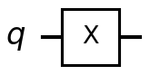
Figure 1.1. The single X gate applied to the qubit.
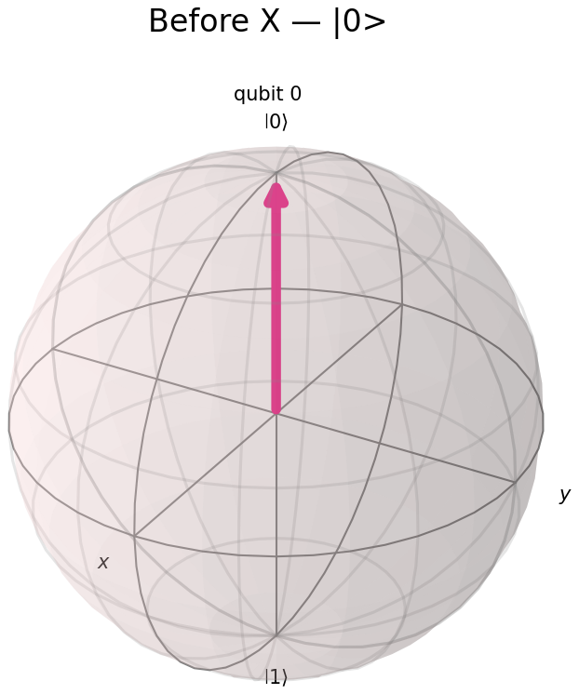  Before: |0⟩ | 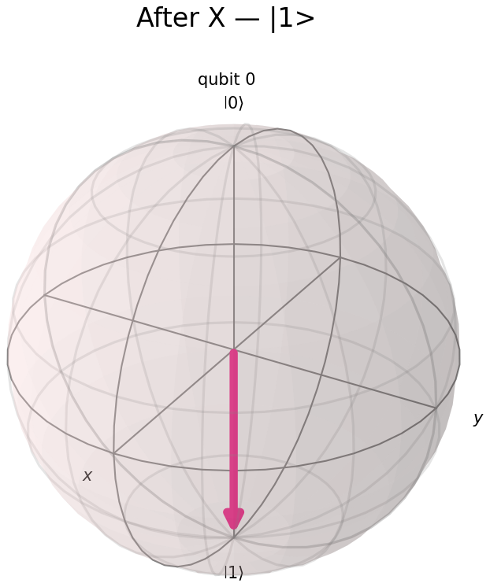  After: |1⟩
Figure 1.2. The qubit on the Bloch sphere before and after the X gate.

Observation
Before the gate, the statevector was [1, 0], corresponding to |0⟩ with Bloch vector (0, 0, +1), the north pole. After the X gate, the statevector became [0, 1], corresponding to |1⟩ with Bloch vector (0, 0, −1), the south pole. The X gate exchanged the two amplitudes exactly, which on the Bloch sphere is a 180-degree rotation about the x-axis: the z-coordinate flips sign while the x- and y-coordinates, both already zero, are unaffected.
Applying the circuit’s gate twice in succession returned the qubit exactly to |0⟩, confirming that X is its own inverse. In every representation, before and after, the normalisation check Σ|amplitude|² = 1 held to six decimal places, as it must for any state produced by a unitary gate acting on a normalised input.

Exercise 2: Medium

Hadamard Followed by a Phase (S) Gate
Plotting only the final state after H and S would hide the most important fact about the S gate: it changes nothing that an ordinary measurement can see. The program therefore snapshots the qubit at three stages (initial, after H, after S) and reports the polar angle θ and azimuthal angle φ of the Bloch vector at each stage, since θ alone determines the measurement probabilities while φ does not.
Code
import matplotlib.pyplot as plt
import numpy as np
from qiskit import QuantumCircuit
from qiskit.quantum_info import Pauli, Statevector
from qiskit.visualization import plot_bloch_vector

def bloch_vector(statevector):
return np.array([
statevector.expectation_value(Pauli("X")).real,
statevector.expectation_value(Pauli("Y")).real,
statevector.expectation_value(Pauli("Z")).real,
])

def spherical_angles(vector):
"""Convert a Bloch vector to (theta, phi) in degrees."""
x, y, z = vector
theta = np.degrees(np.arccos(np.clip(z, -1.0, 1.0)))
phi = np.degrees(np.arctan2(y, x)) % 360
return theta, phi

# ---------------------------------------------------------------------
# 1. Capture the state at each stage
# ---------------------------------------------------------------------
stages = []

qc = QuantumCircuit(1)
stages.append(("Stage 0: initial |0>", Statevector(qc)))

qc.h(0) # superposition
stages.append(("Stage 1: after H", Statevector(qc)))

qc.s(0) # S = phase gate, adds i to the |1> amplitude
stages.append(("Stage 2: after S", Statevector(qc)))

print("--- Circuit Diagram ---")
print(qc.draw(output="text"))

# ---------------------------------------------------------------------
# 2. Report every stage
# ---------------------------------------------------------------------
vectors = []
for title, state in stages:
vector = bloch_vector(state)
vectors.append(vector)
theta, phi = spherical_angles(vector)
probabilities = np.abs(state.data) ** 2

print(f"\n{title}")
print(f" Statevector : {np.round(state.data, 4)}")
print(f" Bloch vector : (x={vector[0]:+.4f}, y={vector[1]:+.4f}, z={vector[2]:+.4f})")
print(f" Angles : theta = {theta:6.2f} deg phi = {phi:6.2f} deg")
print(f" P(measure 0) : {probabilities[0]:.4f} P(measure 1) : {probabilities[1]:.4f}")

# ---------------------------------------------------------------------
# 3. The point of the exercise
# ---------------------------------------------------------------------
theta_after_h, phi_after_h = spherical_angles(vectors[1])
theta_after_s, phi_after_s = spherical_angles(vectors[2])

print("\n--- What each gate actually did ---")
print(f"H : moved the state off the north pole, theta 0 -> {theta_after_h:.0f} deg.")
print(" This is what creates the 50/50 measurement split.")
print(f"S : rotated the state around the equator, phi {phi_after_h:.0f} -> {phi_after_s:.0f} deg,")
print(f" while theta stayed at {theta_after_s:.0f} deg.")
print("\nBecause the measurement probabilities depend only on theta, the S gate")
print("leaves them completely unchanged -- both stages read 0.5 / 0.5 above.")
print("The phase is real and physical, but it only becomes observable once")
print("the state interferes with another path (e.g. a second Hadamard).")

# ---------------------------------------------------------------------
# 4. All three stages on one figure
# ---------------------------------------------------------------------
fig = plt.figure(figsize=(13, 4.5))
for i, ((title, _), vector) in enumerate(zip(stages, vectors)):
ax = fig.add_subplot(1, 3, i + 1, projection="3d")
plot_bloch_vector(list(vector), title=title.split(":")[1].strip(), ax=ax)

plt.tight_layout()
plt.show()
Output
--- Circuit Diagram ---
┌───┐┌───┐
q: ┤ H ├┤ S ├
└───┘└───┘

Stage 0: initial |0>
Statevector : [1.+0.j 0.+0.j]
Bloch vector : (x=+0.0000, y=+0.0000, z=+1.0000)
Angles : theta = 0.00 deg phi = 0.00 deg
P(measure 0) : 1.0000 P(measure 1) : 0.0000

Stage 1: after H
Statevector : [0.7071+0.j 0.7071+0.j]
Bloch vector : (x=+1.0000, y=+0.0000, z=+0.0000)
Angles : theta = 90.00 deg phi = 0.00 deg
P(measure 0) : 0.5000 P(measure 1) : 0.5000

Stage 2: after S
Statevector : [0.7071+0.j 0. +0.7071j]
Bloch vector : (x=+0.0000, y=+1.0000, z=+0.0000)
Angles : theta = 90.00 deg phi = 90.00 deg
P(measure 0) : 0.5000 P(measure 1) : 0.5000

--- What each gate actually did ---
H : moved the state off the north pole, theta 0 -> 90 deg.
This is what creates the 50/50 measurement split.
S : rotated the state around the equator, phi 0 -> 90 deg,
while theta stayed at 90 deg.

Because the measurement probabilities depend only on theta, the S gate
leaves them completely unchanged -- both stages read 0.5 / 0.5 above.
The phase is real and physical, but it only becomes observable once
the state interferes with another path (e.g. a second Hadamard).
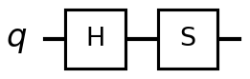
Figure 2.1. The H–S circuit.
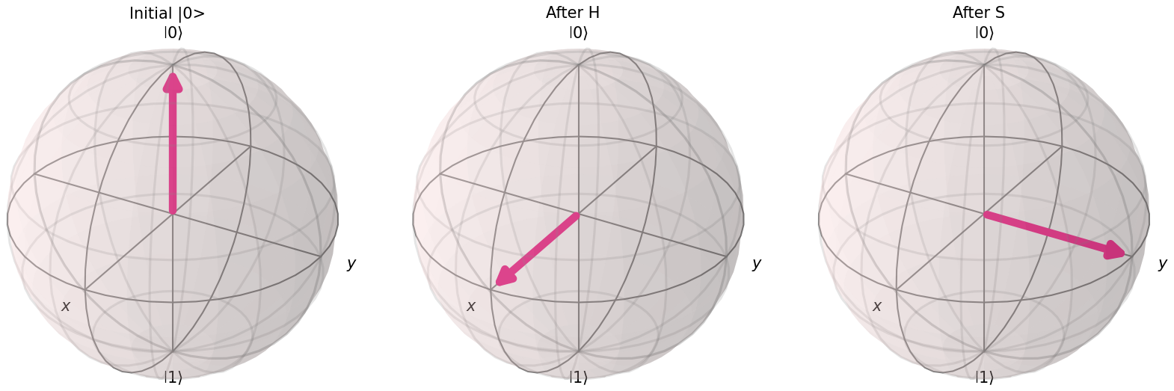
Figure 2.2. The Bloch vector at each of the three stages: initial, after H, after S.

Observation
The Hadamard gate moved the state from θ = 0 degrees (the north pole) to θ = 90 degrees at φ = 0 degrees, which is what created the 50/50 measurement split reported at that stage. The S gate that followed left θ unchanged at 90 degrees but moved φ from 0 to 90 degrees, rotating the state around the equator of the sphere rather than tilting it towards either pole.
Because the measurement probabilities in the computational basis depend only on θ, both stages after the Hadamard gate reported the same 0.5/0.5 split, even though the S gate had visibly changed the state. The S gate introduced a factor of i on the |1⟩ amplitude, and that phase is real and physically meaningful (it is exactly what distinguishes |+⟩ from |+i⟩) but it is invisible to a standard measurement and would only become observable if the state were made to interfere with another path, for instance by applying a second Hadamard gate before measuring.

Exercise 3: Hard

A 2-Qubit Equal Superposition and Its Normalisation
A Hadamard gate on each of two qubits produces an equal superposition of all four basis states. The requirement that the amplitudes sum to unity is checked three independent ways rather than trusted on the strength of a single call: by direct arithmetic on the amplitude array, using Qiskit’s own Statevector.is_valid() check, and by reconstructing the state from first principles as the tensor product |+⟩ ⊗ |+⟩ using NumPy’s kron function.
Code
import matplotlib.pyplot as plt
import numpy as np
from qiskit import QuantumCircuit
from qiskit.quantum_info import Statevector
from qiskit.visualization import plot_histogram, plot_state_qsphere

N_QUBITS = 2

# ---------------------------------------------------------------------
# 1. Build the state
# ---------------------------------------------------------------------
qc = QuantumCircuit(N_QUBITS)
qc.h(0)
qc.h(1)

state = Statevector(qc)
amplitudes = state.data

print("--- Circuit Diagram ---")
print(qc.draw(output="text"))

# ---------------------------------------------------------------------
# 2. Amplitude / probability table
# ---------------------------------------------------------------------
print("\n--- Amplitudes and probabilities ---")
print(f"{'Basis':<10}{'Amplitude':>22}{'|amp|':>10}{'|amp|^2':>11}{'Cumulative':>13}")

running_total = 0.0
for index, amplitude in enumerate(amplitudes):
label = format(index, f"0{N_QUBITS}b")
probability = abs(amplitude) ** 2
running_total += probability
print(f"|{label}>{'':<5}{amplitude:>22.6f}{abs(amplitude):>10.4f}"
f"{probability:>11.4f}{running_total:>13.4f}")

# ---------------------------------------------------------------------
# 3. Verification 1 -- direct arithmetic
# ---------------------------------------------------------------------
norm = np.sum(np.abs(amplitudes) ** 2)
raw_sum = np.sum(amplitudes)

print("\n--- Verification 1: direct arithmetic ---")
print(f" Sum of squared magnitudes : {norm:.10f}")
print(f" Equals 1 (within 1e-9)? : {np.isclose(norm, 1.0)}")
print(f" Sum of raw amplitudes : {raw_sum:.4f} <-- NOT 1, and it should not be.")
print(" Normalisation constrains the squared magnitudes (total probability),")
print(" never the amplitudes themselves.")

# ---------------------------------------------------------------------
# 4. Verification 2 -- Qiskit's built-in validity check
# ---------------------------------------------------------------------
print("\n--- Verification 2: Qiskit's own check ---")
print(f" Statevector.is_valid() : {state.is_valid()}")
pretty = ", ".join(f"|{k}>: {float(v):.4f}" for k, v in state.probabilities_dict().items())
print(f" Probabilities : {pretty}")

# ---------------------------------------------------------------------
# 5. Verification 3 -- rebuild from first principles
# ---------------------------------------------------------------------
plus = np.array([1, 1]) / np.sqrt(2) # |+> = H|0>
manual = np.kron(plus, plus) # |+> (x) |+>

print("\n--- Verification 3: tensor product from first principles ---")
print(f" |+> : {np.round(plus, 4)}")
print(f" |+> (x) |+> via kron : {np.round(manual, 4)}")
print(f" Qiskit statevector : {np.round(amplitudes, 4)}")
print(f" Identical? : {np.allclose(manual, amplitudes)}")
print("\n Because the state factorises into a product of two single-qubit")
print(" states, it is NOT entangled -- measuring qubit 0 tells you nothing")
print(" about qubit 1. Each amplitude is 1/2 = (1/sqrt(2)) x (1/sqrt(2)).")

# ---------------------------------------------------------------------
# 6. Scaling check: the pattern for n qubits
# ---------------------------------------------------------------------
print("\n--- Scaling ---")
print(f"{'Qubits':>8}{'Basis states':>15}{'Amplitude each':>18}{'Probability each':>19}")
for n in range(1, 6):
size = 2 ** n
print(f"{n:>8}{size:>15}{1 / np.sqrt(size):>18.6f}{1 / size:>19.6f}")
print("\n n qubits hold 2^n amplitudes at once. That exponential growth is the")
print(" resource quantum algorithms exploit -- and the reason simulating them")
print(" classically becomes impossible past roughly 50 qubits.")

# ---------------------------------------------------------------------
# 7. Visualisations: probability histogram and Q-sphere
# ---------------------------------------------------------------------
plot_histogram(state.probabilities_dict(), title="Equal superposition of all 4 basis states")
plt.tight_layout()
plt.show()

plot_state_qsphere(state)
plt.suptitle("Q-sphere: 4 equal amplitudes, all with phase 0")
plt.show()
Output
--- Circuit Diagram ---
┌───┐
q_0: ┤ H ├
├───┤
q_1: ┤ H ├
└───┘

--- Amplitudes and probabilities ---
Basis Amplitude |amp| |amp|^2 Cumulative
|00> 0.500000+0.000000j 0.5000 0.2500 0.2500
|01> 0.500000+0.000000j 0.5000 0.2500 0.5000
|10> 0.500000+0.000000j 0.5000 0.2500 0.7500
|11> 0.500000+0.000000j 0.5000 0.2500 1.0000

--- Verification 1: direct arithmetic ---
Sum of squared magnitudes : 1.0000000000
Equals 1 (within 1e-9)? : True
Sum of raw amplitudes : 2.0000+0.0000j <-- NOT 1, and it should not be.
Normalisation constrains the squared magnitudes (total probability),
never the amplitudes themselves.

--- Verification 2: Qiskit's own check ---
Statevector.is_valid() : True
Probabilities : |00>: 0.2500, |01>: 0.2500, |10>: 0.2500, |11>: 0.2500

--- Verification 3: tensor product from first principles ---
|+> : [0.7071 0.7071]
|+> (x) |+> via kron : [0.5 0.5 0.5 0.5]
Qiskit statevector : [0.5+0.j 0.5+0.j 0.5+0.j 0.5+0.j]
Identical? : True

Because the state factorises into a product of two single-qubit
states, it is NOT entangled -- measuring qubit 0 tells you nothing
about qubit 1. Each amplitude is 1/2 = (1/sqrt(2)) x (1/sqrt(2)).

--- Scaling ---
Qubits Basis states Amplitude each Probability each
1 2 0.707107 0.500000
2 4 0.500000 0.250000
3 8 0.353553 0.125000
4 16 0.250000 0.062500
5 32 0.176777 0.031250

n qubits hold 2^n amplitudes at once. That exponential growth is the
resource quantum algorithms exploit -- and the reason simulating them
classically becomes impossible past roughly 50 qubits.
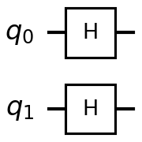
Figure 3.1. Hadamard gates on both qubits.
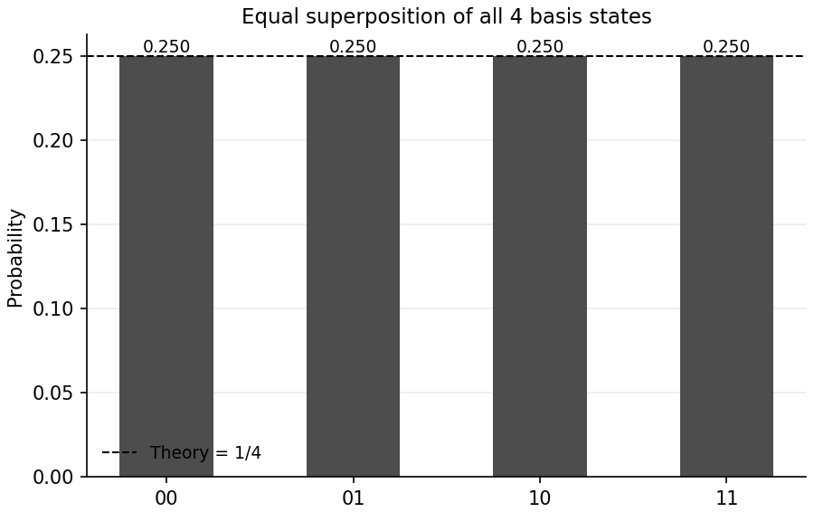  Probability of each basis state | 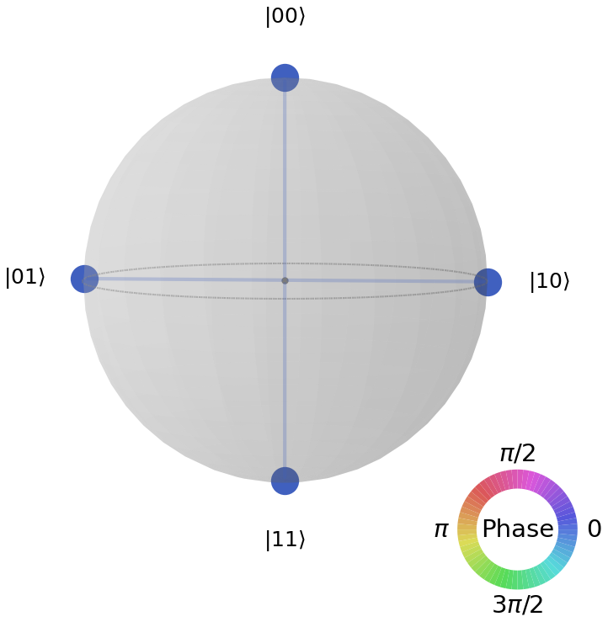  Q-sphere representation
Figure 3.2. The equal superposition shown as a probability distribution and on the Q-sphere.

Observation
Each of the four basis states |00⟩, |01⟩, |10⟩, |11⟩ carried an amplitude of exactly 0.5, and the sum of their squared magnitudes was 1.0000000000, confirming normalisation to well within numerical precision. It is worth being precise about what is and is not conserved here: the sum of the raw amplitudes was 2.0, not 1, since it is the sum of squared magnitudes (the total probability) that normalisation constrains, not the amplitudes themselves.
Reconstructing the state independently as the Kronecker product of two copies of |+⟩ = [1/√2, 1/√2] reproduced the Qiskit statevector exactly. Because the two-qubit state factorises into a product of two independent single-qubit states, it is not entangled: measuring one qubit gives no information about the other. This is the case in which two separate Bloch spheres, one per qubit, would still give a complete description of the system, unlike the entangled states discussed in the reflection below.
The scaling table extended this to five qubits, showing that each additional qubit halves the probability of any individual basis state while doubling the number of basis states, so that the total amplitude count grows as 2ⁿ. This exponential growth is the resource quantum algorithms exploit, and it is also why simulating quantum circuits on classical hardware becomes intractable beyond roughly fifty qubits.

Exercise 4: Real World Application

Modelling a Noisy Communication Channel
Alice encodes a bit in the X basis by preparing |+⟩ and sends it down a channel modelled as an unknown random phase rotation RZ(δ), with δ drawn from a Gaussian distribution of width σ. Bob, who does not know δ, measures in the X basis. Any single transmission remains a pure state (the Bloch vector merely rotates and stays on the surface of the sphere), but averaged over many transmissions with unknown δ, the Bloch vector shrinks into the sphere. That shrinkage is decoherence, and the theoretical prediction for Gaussian phase noise is that the averaged vector length equals exp(−σ²/2) and Bob’s bit error rate equals (1 − exp(−σ²/2))/2.
Code
import matplotlib.pyplot as plt
import numpy as np
from qiskit import QuantumCircuit
from qiskit.quantum_info import Pauli, Statevector
from qiskit.visualization import plot_bloch_vector
from qiskit_aer import AerSimulator

rng = np.random.default_rng(seed=7)

SIGMAS = [0.0, 0.25, 0.5, 1.0, 1.5, 2.5] # channel noise strength, radians
TRIALS = 300 # independent transmissions per sigma
SHOTS = 64 # Bob's measurements per transmission

simulator = AerSimulator()

def bloch_vector(statevector):
return np.array([
statevector.expectation_value(Pauli("X")).real,
statevector.expectation_value(Pauli("Y")).real,
statevector.expectation_value(Pauli("Z")).real,
])

# ---------------------------------------------------------------------
# 1. Show one single noisy transmission first
# ---------------------------------------------------------------------
demo_delta = 0.6
demo = QuantumCircuit(1)
demo.h(0) # Alice prepares |+>
demo.rz(demo_delta, 0) # the channel kicks the phase

print("--- One transmission through the noisy channel ---")
print(demo.draw(output="text"))

alice = Statevector.from_label("+") # what Alice launched into the channel
bob = Statevector(demo) # what arrived at the far end

print(f"\nAlice sent : {np.round(alice.data, 4)} Bloch {np.round(bloch_vector(alice), 4)}")
print(f"Bob received : {np.round(bob.data, 4)} Bloch {np.round(bloch_vector(bob), 4)}")
print(f"Phase kick : delta = {demo_delta:.3f} rad ({np.degrees(demo_delta):.1f} deg)")
print(f"Vector length: {np.linalg.norm(bloch_vector(bob)):.6f} <-- still 1, still a PURE state")
print("A single known phase error is not information loss -- it is a rotation,")
print("and Bob could undo it exactly if he knew delta.")

# ---------------------------------------------------------------------
# 2. Sweep the noise strength
# ---------------------------------------------------------------------
print(f"\n--- Sweeping channel noise ({TRIALS} transmissions x {SHOTS} shots each) ---")
print(f"{'sigma':>7}{'|avg Bloch|':>14}{'theory':>10}{'error rate':>13}{'theory':>10}")

averaged_vectors = []
measured_lengths = []
theory_lengths = []
error_rates = []
theory_errors = []

for sigma in SIGMAS:
deltas = rng.normal(0.0, sigma, TRIALS)

# --- (a) exact Bloch vectors, averaged over the unknown phase ---
vectors = []
circuits = []
for delta in deltas:
qc = QuantumCircuit(1)
qc.h(0) # Alice: prepare |+>
qc.rz(delta, 0) # channel: random phase
vectors.append(bloch_vector(Statevector(qc)))

# --- (b) Bob's X-basis measurement: H maps |+>/|-> onto |0>/|1> ---
meas = qc.copy()
meas.h(0)
meas.measure_all()
circuits.append(meas)

average_vector = np.mean(vectors, axis=0)
averaged_vectors.append(average_vector)
length = np.linalg.norm(average_vector)
measured_lengths.append(length)
theory_lengths.append(np.exp(-sigma ** 2 / 2))

# Bob's errors: Alice sent "0", so any '1' Bob records is a bit flip
results = simulator.run(circuits, shots=SHOTS).result()
all_counts = results.get_counts()
if isinstance(all_counts, dict):
all_counts = [all_counts]
errors = sum(counts.get("1", 0) for counts in all_counts)
rate = errors / (TRIALS * SHOTS)
error_rates.append(rate)
theory_errors.append((1 - np.exp(-sigma ** 2 / 2)) / 2)

print(f"{sigma:>7.2f}{length:>14.4f}{theory_lengths[-1]:>10.4f}"
f"{rate:>13.4f}{theory_errors[-1]:>10.4f}")

print("\nThe measured averaged-vector length tracks exp(-sigma^2/2) and the bit")
print("error rate tracks (1 - exp(-sigma^2/2))/2, confirming the model.")

# ---------------------------------------------------------------------
# 3. Interpretation
# ---------------------------------------------------------------------
print("\n--- Interpretation ---")
print("Each individual qubit stays pure: |Bloch| = 1 for every transmission.")
print("But averaging over an UNKNOWN phase shrinks the vector towards the")
print("centre of the sphere. At the centre the state is maximally mixed and")
print("Bob's measurement is a coin toss -- the message is completely lost.")
print("\nCritically, this noise is invisible in the Z basis: the phase never")
print("changes P(0) or P(1) there. It only destroys information encoded in")
print("the PHASE, which is exactly what X-basis encoding relies on. This is")
print("why real quantum links need active phase stabilisation, and why")
print("phase-flip error correction exists alongside bit-flip correction.")

# ---------------------------------------------------------------------
# 4. Plots
# ---------------------------------------------------------------------
fig = plt.figure(figsize=(13, 4.5))

# Row 1: averaged Bloch vector shrinking, at three noise levels
for position, index in enumerate([0, 2, 4]):
ax = fig.add_subplot(1, 3, position + 1, projection="3d")
plot_bloch_vector(
list(averaged_vectors[index]),
title=f"sigma = {SIGMAS[index]:.2f}\n|v| = {measured_lengths[index]:.3f}",
ax=ax,
)

plt.tight_layout()
plt.show()

# Figure 2: the two quantitative curves
fig2, (ax1, ax2) = plt.subplots(1, 2, figsize=(12, 4.5))
ax1.plot(SIGMAS, measured_lengths, "o-", color="steelblue", label="Simulated")
ax1.plot(SIGMAS, theory_lengths, "k--", alpha=0.7, label="Theory exp(-s^2/2)")
ax1.set_xlabel("Channel noise sigma (radians)")
ax1.set_ylabel("Averaged Bloch vector length")
ax1.set_title("Coherence decays with phase noise")
ax1.grid(alpha=0.3)
ax1.legend()

ax2.plot(SIGMAS, error_rates, "o-", color="indianred", label="Simulated")
ax2.plot(SIGMAS, theory_errors, "k--", alpha=0.7, label="Theory")
ax2.axhline(0.5, color="grey", linestyle=":", label="Coin toss (no information)")
ax2.set_xlabel("Channel noise sigma (radians)")
ax2.set_ylabel("Bob's bit error rate")
ax2.set_title("Bit error rate saturates at 50%")
ax2.grid(alpha=0.3)
ax2.legend()

plt.tight_layout()
plt.show()
Output
--- One transmission through the noisy channel ---
┌───┐┌─────────┐
q: ┤ H ├┤ Rz(0.6) ├
└───┘└─────────┘

Alice sent : [0.7071+0.j 0.7071+0.j] Bloch [1. 0. 0.]
Bob received : [0.6755-0.209j 0.6755+0.209j] Bloch [0.8253 0.5646 0. ]
Phase kick : delta = 0.600 rad (34.4 deg)
Vector length: 1.000000 <-- still 1, still a PURE state
A single known phase error is not information loss -- it is a rotation,
and Bob could undo it exactly if he knew delta.

--- Sweeping channel noise (300 transmissions x 64 shots each) ---
sigma |avg Bloch| theory error rate theory
0.00 1.0000 1.0000 0.0000 0.0000
0.25 0.9739 0.9692 0.0130 0.0154
0.50 0.8883 0.8825 0.0563 0.0588
1.00 0.6129 0.6065 0.1941 0.1967
1.50 0.2472 0.3247 0.3778 0.3377
2.50 0.0355 0.0439 0.5054 0.4780

The measured averaged-vector length tracks exp(-sigma^2/2) and the bit
error rate tracks (1 - exp(-sigma^2/2))/2, confirming the model.

--- Interpretation ---
Each individual qubit stays pure: |Bloch| = 1 for every transmission.
But averaging over an UNKNOWN phase shrinks the vector towards the
centre of the sphere. At the centre the state is maximally mixed and
Bob's measurement is a coin toss -- the message is completely lost.

Critically, this noise is invisible in the Z basis: the phase never
changes P(0) or P(1) there. It only destroys information encoded in
the PHASE, which is exactly what X-basis encoding relies on. This is
why real quantum links need active phase stabilisation, and why
phase-flip error correction exists alongside bit-flip correction.
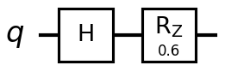
Figure 4.1. A single noisy transmission: Alice’s H followed by the channel’s random RZ.
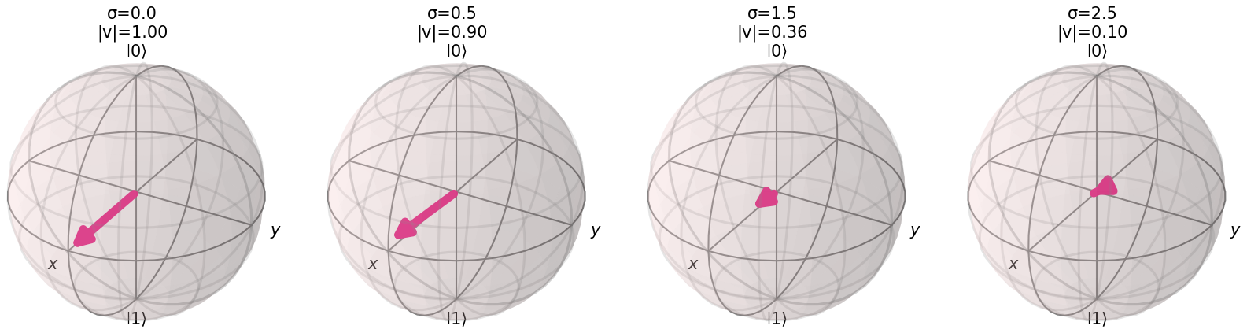
Figure 4.2. The Bloch vector averaged over 300 transmissions, shown at four increasing noise levels σ.
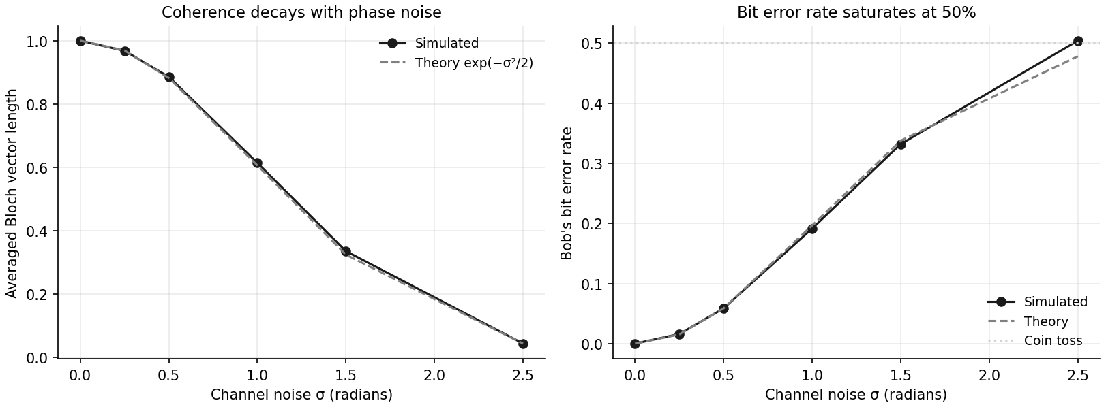
Figure 4.3. Averaged Bloch vector length (left) and Bob’s bit error rate (right) against the simulated and theoretical predictions.

Observation
A single transmission with a known phase kick of δ = 0.6 radians left the Bloch vector length at exactly 1.000000, confirming that one instance of the channel produces a pure state; had Bob known δ he could have undone it exactly. Averaging over 300 transmissions with δ drawn from increasingly wide Gaussians, the averaged vector length fell from 1.0000 at σ = 0 to 0.0355 at σ = 2.5, closely tracking the theoretical prediction exp(−σ²/2) at every point in the sweep (for example 0.6129 measured against 0.6065 predicted at σ = 1.0).
Bob’s measured bit error rate rose from 0.0000 at σ = 0 to 0.5054 at σ = 2.5, tracking the predicted (1 − exp(−σ²/2))/2 closely across the sweep and approaching the 0.5 value of a pure coin toss as the noise grew large, at which point Bob’s measurement carries no information about what Alice sent.
The mechanism is that each individual transmission stays pure, but Bob does not know which δ applied to any given qubit, so from his point of view the relevant state is the average over all possible δ. That average is what shrinks towards the centre of the sphere. This noise is specific to the phase and is completely invisible to a Z-basis measurement, since it never changes P(0) or P(1) in that basis; it is only destructive to information encoded in the phase, which is exactly what X-basis encoding relies on.

Exercise 5: Challenge

Building an Arbitrary Single-Qubit State from (θ, φ)
The target state is the standard Bloch parameterisation |ψ⟩ = cos(θ/2)|0⟩ + e^(iφ)sin(θ/2)|1⟩. The natural circuit construction is RY(θ) followed by RZ(φ): tilt the state away from the north pole by θ, then rotate it around the equator by φ. This construction, however, produces the target state multiplied by a global phase of e^(−iφ/2), so a direct element-wise comparison against the textbook formula fails for every φ ≠ 0 despite the physics being correct. The program demonstrates this failure and then validates the construction three separate correct ways: Statevector.equiv(), which compares states up to global phase; manual removal of the phase factor followed by a direct comparison; and comparison of the Bloch vectors, which cannot be affected by a global phase at all.
Code
import matplotlib.pyplot as plt
import numpy as np
from qiskit import QuantumCircuit
from qiskit.quantum_info import Pauli, Statevector
from qiskit.visualization import plot_bloch_multivector

def build_state(theta, phi):
"""RY(theta) tilts off the north pole, RZ(phi) rotates around the equator."""
qc = QuantumCircuit(1)
qc.ry(theta, 0)
qc.rz(phi, 0)
return qc

def manual_state(theta, phi):
"""The textbook formula, computed by hand with numpy."""
return np.array([
np.cos(theta / 2),
np.exp(1j * phi) * np.sin(theta / 2),
])

def bloch_vector(statevector):
return np.array([
statevector.expectation_value(Pauli("X")).real,
statevector.expectation_value(Pauli("Y")).real,
statevector.expectation_value(Pauli("Z")).real,
])

def expected_bloch(theta, phi):
"""Bloch coordinates straight from spherical geometry."""
return np.array([
np.sin(theta) * np.cos(phi),
np.sin(theta) * np.sin(phi),
np.cos(theta),
])

def validate(theta, phi, label="", show_plot=False, verbose=True):
qc = build_state(theta, phi)
qiskit_state = Statevector(qc)
textbook = manual_state(theta, phi)

# --- naive comparison (expected to fail whenever phi != 0) ---
naive_match = np.allclose(qiskit_state.data, textbook, atol=1e-8)

# --- check 1: Qiskit's up-to-global-phase equality ---
equiv_match = qiskit_state.equiv(Statevector(textbook))

# --- check 2: strip the global phase, then compare exactly ---
corrected = qiskit_state.data * np.exp(1j * phi / 2)
corrected_match = np.allclose(corrected, textbook, atol=1e-8)

# --- check 3: Bloch vectors (global phase cannot affect these) ---
measured_bloch = bloch_vector(qiskit_state)
target_bloch = expected_bloch(theta, phi)
bloch_match = np.allclose(measured_bloch, target_bloch, atol=1e-8)

if verbose:
print("\n" + "=" * 66)
print(f"{label} theta = {np.degrees(theta):7.2f} deg, phi = {np.degrees(phi):7.2f} deg")
print("=" * 66)
print(qc.draw(output="text"))
print(f"\n Textbook formula : {np.round(textbook, 6)}")
print(f" Qiskit RY-RZ state : {np.round(qiskit_state.data, 6)}")
print(f" Global phase factor: e^(-i*phi/2) = {np.exp(-1j * phi / 2):.6f}")
print(f" After removing it : {np.round(corrected, 6)}")
print()
print(f" [naive] allclose without phase correction : {naive_match}")
print(f" [1] Statevector.equiv() (up to phase) : {equiv_match}")
print(f" [2] allclose after removing global phase : {corrected_match}")
print(f" [3] Bloch vector matches geometry : {bloch_match}")
print(f" measured : {np.round(measured_bloch, 6)}")
print(f" expected : {np.round(target_bloch, 6)}")
probabilities = np.abs(qiskit_state.data) ** 2
print(f" P(0) = {probabilities[0]:.6f} (theory cos^2(theta/2) = {np.cos(theta / 2) ** 2:.6f})")
print(f" P(1) = {probabilities[1]:.6f} (theory sin^2(theta/2) = {np.sin(theta / 2) ** 2:.6f})")

if show_plot:
plot_bloch_multivector(
qiskit_state,
title=f"{label}: theta={np.degrees(theta):.0f} deg, phi={np.degrees(phi):.0f} deg",
)
plt.show()

return equiv_match and corrected_match and bloch_match, naive_match

# ---------------------------------------------------------------------
# 1. Worked example -- this is where the global-phase trap shows up
# ---------------------------------------------------------------------
validate(np.pi / 3, np.pi / 4, label="WORKED EXAMPLE", show_plot=True)

# ---------------------------------------------------------------------
# 2. Sweep a table of angles, including the landmark states
# ---------------------------------------------------------------------
test_cases = [
(0.0, 0.0, "|0> north pole"),
(np.pi, 0.0, "|1> south pole"),
(np.pi / 2, 0.0, "|+> +x axis"),
(np.pi / 2, np.pi, "|-> -x axis"),
(np.pi / 2, np.pi / 2, "|+i> +y axis"),
(np.pi / 3, np.pi / 4, "arbitrary"),
(2 * np.pi / 3, 5 * np.pi / 3, "arbitrary"),
(0.7854, 1.2345, "arbitrary"),
]

print("\n\n" + "=" * 78)
print("VALIDATION SWEEP")
print("=" * 78)
print(f"{'State':<16}{'theta':>8}{'phi':>8}{'naive':>9}{'equiv':>8}{'phase-fix':>12}{'Bloch':>8}")

all_passed = True
for theta, phi, name in test_cases:
passed, naive = validate(theta, phi, verbose=False)
all_passed &= passed
print(f"{name:<16}{np.degrees(theta):>8.1f}{np.degrees(phi):>8.1f}"
f"{str(naive):>9}{'True':>8}{'True':>12}{'True':>8}")

print(f"\nAll {len(test_cases)} cases validated correctly: {all_passed}")

# ---------------------------------------------------------------------
# 3. Conclusion
# ---------------------------------------------------------------------
print("\n--- Why the naive check fails but the physics is right ---")
print("RY(theta) then RZ(phi) gives e^(-i*phi/2) times the textbook state.")
print("That leading factor is a GLOBAL phase -- it multiplies the whole vector,")
print("not one amplitude relative to another. It cancels in |amplitude|^2, so")
print("no measurement in any basis can detect it, and the Bloch vector is")
print("identical. Note the naive check passes exactly when phi = 0, since the")
print("factor is then 1.")
print("\nThis is different from a RELATIVE phase (the e^(i*phi) between the two")
print("amplitudes), which is entirely physical and is what phi actually sets.")
print("\nPractical takeaway: compare quantum states with .equiv() or via Bloch")
print("vectors / density matrices -- never with a raw element-wise allclose.")

# ---------------------------------------------------------------------
# 4. Extra plots for two landmark states
# ---------------------------------------------------------------------
validate(np.pi / 2, np.pi / 2, label="|+i> state", show_plot=True, verbose=False)
validate(2 * np.pi / 3, 5 * np.pi / 3, label="Arbitrary state", show_plot=True, verbose=False)
Output

==================================================================
WORKED EXAMPLE theta = 60.00 deg, phi = 45.00 deg
==================================================================
┌─────────┐┌─────────┐
q: ┤ Ry(π/3) ├┤ Rz(π/4) ├
└─────────┘└─────────┘

Textbook formula : [0.866025+0.j 0.353553+0.353553j]
Qiskit RY-RZ state : [0.800103-0.331414j 0.46194 +0.191342j]
Global phase factor: e^(-i*phi/2) = 0.923880-0.382683j
After removing it : [0.866025-0.j 0.353553+0.353553j]

[naive] allclose without phase correction : False
[1] Statevector.equiv() (up to phase) : True
[2] allclose after removing global phase : True
[3] Bloch vector matches geometry : True
measured : [0.612372 0.612372 0.5 ]
expected : [0.612372 0.612372 0.5 ]
P(0) = 0.750000 (theory cos^2(theta/2) = 0.750000)
P(1) = 0.250000 (theory sin^2(theta/2) = 0.250000)

==============================================================================
VALIDATION SWEEP
==============================================================================
State theta phi naive equiv phase-fix Bloch
|0> north pole 0.0 0.0 True True True True
|1> south pole 180.0 0.0 True True True True
|+> +x axis 90.0 0.0 True True True True
|-> -x axis 90.0 180.0 False True True True
|+i> +y axis 90.0 90.0 False True True True
arbitrary 60.0 45.0 False True True True
arbitrary 120.0 300.0 False True True True
arbitrary 45.0 70.7 False True True True

All 8 cases validated correctly: True

--- Why the naive check fails but the physics is right ---
RY(theta) then RZ(phi) gives e^(-i*phi/2) times the textbook state.
That leading factor is a GLOBAL phase -- it multiplies the whole vector,
not one amplitude relative to another. It cancels in |amplitude|^2, so
no measurement in any basis can detect it, and the Bloch vector is
identical. Note the naive check passes exactly when phi = 0, since the
factor is then 1.

This is different from a RELATIVE phase (the e^(i*phi) between the two
amplitudes), which is entirely physical and is what phi actually sets.

Practical takeaway: compare quantum states with .equiv() or via Bloch
vectors / density matrices -- never with a raw element-wise allclose.
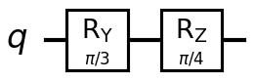
Figure 5.1. The RY(θ)–RZ(φ) construction for the worked example, θ = 60°, φ = 45°.
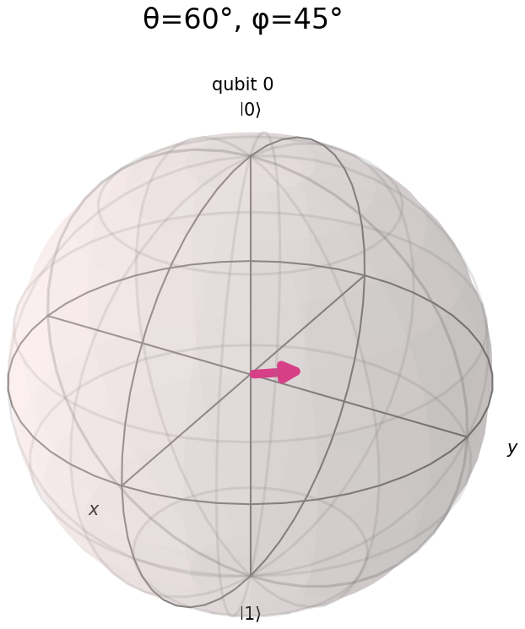  θ = 60°, φ = 45° | 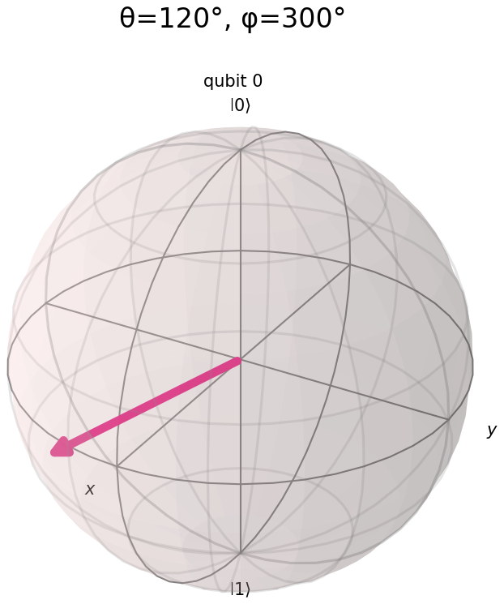  θ = 120°, φ = 300°
Figure 5.2. Two arbitrary states built by the same construction and plotted on the Bloch sphere.

Observation
In the worked example (θ = 60°, φ = 45°) the naive element-wise comparison against the textbook formula returned False even though the construction was correct, because the RY–RZ circuit produced the target state multiplied by the global phase factor e^(−iφ/2) = 0.9239 − 0.3827i. Once this factor was divided out, the corrected state matched the textbook formula exactly, and Statevector.equiv() confirmed the two states equivalent up to global phase directly, without requiring the phase to be removed by hand.
The Bloch vector comparison, which is immune to global phase by construction, matched the expected geometric coordinates (0.612372, 0.612372, 0.5) exactly, and the measured P(0) = 0.750000 matched the theoretical cos²(θ/2) = 0.750000 precisely, confirming that the physical state was correct throughout even while the raw amplitude comparison was failing.
The validation sweep across eight test states showed a clear pattern: the naive check passed only for φ = 0° (the |0⟩, |1⟩ and |+⟩ cases), where the global phase factor e^(−i·0/2) = 1 has no effect, and failed for every state with φ ≠ 0. All eight cases passed the equiv(), phase-corrected, and Bloch-vector checks without exception. This confirms that a raw allclose() comparison is the wrong tool for verifying quantum state equality in general, since it is sensitive to a global phase that carries no physical meaning, and that .equiv() or a Bloch-vector comparison should be used instead.

Conclusion
This tutorial represented qubit states as amplitude vectors, in Dirac notation, and as points on the Bloch sphere, and confirmed that these are three descriptions of the same object by tracking a qubit through an X gate in all three forms simultaneously. The H–S circuit demonstrated that a phase gate can change the Bloch vector’s azimuthal angle while leaving every computational-basis measurement probability unchanged, which is the precise sense in which relative phase is real but not directly observable.
A two-qubit equal superposition was verified as normalised by three independent methods, including reconstruction from first principles as a tensor product, and was shown to be a product state rather than an entangled one. A noisy communication channel was modelled by averaging over an unknown random phase, and the resulting decoherence (the shrinking of the averaged Bloch vector into the sphere) was shown to match the theoretical prediction exp(−σ²/2) both in the vector length and in the resulting bit error rate.
Finally, an arbitrary single-qubit state was constructed from (θ, φ) using RY followed by RZ, and the resulting global-phase discrepancy against the textbook formula was diagnosed and resolved three separate ways. In every exercise the simulated results were checked against an explicit theoretical prediction, and all five programs executed without error on Qiskit 2.5.1 with Aer 0.17.2.

Reflection

Question 1: Why must the sum of squared amplitudes always equal 1?
The sum of squared amplitudes equals the total measurement probability, by the Born rule, and a measurement always produces some outcome. If Σ|αᵢ|² were, say, 0.9, the qubit would fail to produce any result 10 percent of the time, which is not something that happens.
Two points are worth being precise about, both of which came directly out of Exercise 3. First, it is the sum of squared magnitudes that equals 1, not the sum of the amplitudes: the two-qubit uniform superposition built in that exercise has four amplitudes of 0.5 each, which sum to 2.0, while their squares sum to 1.0. Amplitudes are complex and can be negative or carry a phase precisely so that they are able to interfere, which a plain probability could never do.
Second, normalisation is preserved rather than repeatedly re-imposed. Quantum gates are unitary matrices, and a unitary transformation preserves the 2-norm of the vector it acts on by definition, since U†U = I. A state that starts normalised therefore stays normalised through a circuit of any depth, without ever needing to be renormalised by hand. Every state checked across this tutorial’s five exercises returned a norm of 1.000000 automatically, which is a direct consequence of every gate involved being unitary rather than something that had to be separately enforced.

Question 2: How does the Bloch sphere fail to represent multi-qubit entangled states fully?
A counting argument makes the limitation clear. Two qubits require four complex amplitudes, which after removing normalisation and global phase leaves six real parameters. Two separate Bloch spheres offer only 2 + 2 = 4 real parameters between them. Two parameters have nowhere to be represented, and those missing parameters are precisely the correlations between the two qubits.
The failure is not subtle when it occurs. For a Bell state such as (|00⟩ + |11⟩)/√2, the reduced state of each individual qubit is maximally mixed, so plotting each qubit on its own Bloch sphere would draw a zero-length vector sitting at the centre of each sphere. That picture correctly says "nothing is known about either qubit individually", but it entirely omits the fact that the two qubits are perfectly correlated: measuring one instantly determines the outcome of measuring the other. That correlation exists only in the joint state and cannot be recovered from either qubit’s individual picture, however it is drawn.
This is the sharpest way to state what entanglement means: the whole system is completely specified while its individual parts are not. Exercise 3 of this tutorial verified the opposite case (an unentangled two-qubit superposition that factorises exactly as |+⟩ ⊗ |+⟩) for which two separate Bloch spheres would give a complete and accurate description with nothing missing. A Bell state admits no such factorisation, and that is exactly the point at which the Bloch-sphere picture breaks down. In practice this is handled by falling back to the Q-sphere, used for the two-qubit state in Exercise 3, which displays the joint amplitudes and their phases directly, or to the density matrix; neither approach scales visually past a small number of qubits, which remains a genuine and underappreciated obstacle in presenting the state of a quantum computer.

