AML23703 — QUANTUM COMPUTING
Tutorial 3
Single-Qubit Quantum Gates
Name | Abdul Rahman Khan
USN | 1GA23AI001
Department | Artificial Intelligence and Machine Learning
Semester | VII
Course Code | AML23703
Date | 06-08-2026

Objective
The objective of this tutorial is to implement and interpret the Pauli-X, Pauli-Y, Pauli-Z and Hadamard gates, to understand the unitary matrices that represent them and their action on qubit states, to build simple single-qubit circuits that combine several gates, and to select and apply the appropriate single-qubit gates required to reach a specified target quantum state.

Theory
A single-qubit gate is a 2×2 unitary matrix acting on the state vector of one qubit. Unitarity guarantees that the norm of the state vector is preserved, so the total measurement probability remains equal to one no matter how many gates are applied.
The four gates used in this tutorial are the three Pauli gates and the Hadamard gate.
Pauli-X (bit flip / quantum NOT) Pauli-Y (bit flip + phase flip)
X = [ 0 1 ] X|0> = |1> Y = [ 0 -i ] Y|0> = i|1>
[ 1 0 ] X|1> = |0> [ i 0 ] Y|1> = -i|0>

Pauli-Z (phase flip) Hadamard (superposition)
Z = [ 1 0 ] Z|0> = |0> H = 1/sqrt(2) [ 1 1 ]
[ 0 -1 ] Z|1> = -|1> [ 1 -1 ]

H|0> = |+> = (|0> + |1>)/sqrt(2)
H|1> = |-> = (|0> - |1>)/sqrt(2)
Geometrically each Pauli gate is a rotation of 180 degrees about the corresponding axis of the Bloch sphere, while the Hadamard gate is a 180 degree rotation about the diagonal axis lying midway between the x and z axes. All four gates are their own inverse, that is X² = Y² = Z² = H² = I.
Two consequences shape the design of the exercises that follow. First, the Z gate never changes the measurement probabilities of a state in the computational basis; it changes only the relative phase between the |0> and |1> components, so detecting its effect requires measuring in a different basis. This is the idea behind Exercise 2. Second, because matrix multiplication does not commute in general, the order in which gates are applied matters, and the gate applied last appears leftmost in the matrix product. This is the central technical point of Exercise 3.

Environment and Required Libraries
All five programs were written against Qiskit 2.5.1 with the Aer simulator. The Qiskit 1.0 release removed the legacy execute() helper, so every circuit in this tutorial is executed through the current AerSimulator().run(...) interface.
CODE
import numpy as np
import matplotlib.pyplot as plt
from qiskit import QuantumCircuit
from qiskit.circuit.library import XGate
from qiskit.quantum_info import Operator, Statevector
from qiskit.visualization import plot_bloch_multivector, plot_histogram
from qiskit_aer import AerSimulator
from scipy.stats import chisquare

simulator = AerSimulator()
OUTPUT
Qiskit SDK : 2.5.1
Qiskit Aer : 0.17.2
Backend : AerSimulator('aer_simulator')

Exercise 1 — Easy

Implementing the Pauli X, Y and Z Gates Individually
Each Pauli gate is applied on its own separate single-qubit circuit. For every gate the program prints the 2×2 matrix obtained from the Qiskit Operator class and the resulting state for both computational basis inputs, rather than for |0> alone.
The reason for testing both inputs is that the Z gate produces no visible change when acting on |0>. Printing only Z|0> would suggest that the gate does nothing at all, which is misleading. The program therefore also applies Z to the superposition state |+>, where its effect is immediately apparent, and finishes by combining all three gates on three separate qubits of a single circuit.
CODE
import numpy as np
from qiskit import QuantumCircuit
from qiskit.quantum_info import Operator, Statevector

def to_dirac(statevector, n_qubits=1):
terms = []
for index, amplitude in enumerate(statevector.data):
if abs(amplitude) < 1e-9:
continue
label = format(index, f"0{n_qubits}b")
if abs(amplitude.imag) < 1e-9:
coefficient = f"{amplitude.real:+.4f}"
else:
coefficient = f"+({amplitude.real:.4f}{amplitude.imag:+.4f}j)"
terms.append(f"{coefficient}|{label}>")
return " ".join(terms) if terms else "0"

GATES = {
"X": lambda qc: qc.x(0),
"Y": lambda qc: qc.y(0),
"Z": lambda qc: qc.z(0),
}

# ---------------------------------------------------------------------
# 1. Each gate on its own, acting on both basis states
# ---------------------------------------------------------------------
for name, apply_gate in GATES.items():
print("\n" + "=" * 60)
print(f"PAULI-{name} GATE")
print("=" * 60)

qc = QuantumCircuit(1)
apply_gate(qc)
matrix = Operator(qc).data
print(" Matrix:")
for row in matrix:
formatted = " ".join(f"{value.real:+.0f}{value.imag:+.0f}j" for value in row)
print(f" [ {formatted} ]")

for start_label in ("0", "1"):
initial = Statevector.from_label(start_label)
final = initial.evolve(Operator(qc))
print(f" {name}|{start_label}> = {np.round(final.data, 4)} = {to_dirac(final)}")

# ---------------------------------------------------------------------
# 2. What each gate actually does
# ---------------------------------------------------------------------
print("\n" + "=" * 60)
print("SUMMARY")
print("=" * 60)
print(" X : bit flip. Swaps |0> and |1>. 180 deg rotation about x.")
print(" Y : bit + phase. |0> -> i|1>, |1> -> -i|0>. 180 deg about y.")
print(" Z : phase flip. Leaves |0> alone, sends |1> -> -|1>. 180 deg about z.")
print("\n Z looks inert on |0> because |0> sits on the rotation axis itself.")
print(" Apply Z to a SUPERPOSITION and its effect is immediately visible:")

plus = Statevector.from_label("+")
z_circuit = QuantumCircuit(1)
z_circuit.z(0)
minus = plus.evolve(Operator(z_circuit))
print(f" |+> = {np.round(plus.data, 4)} = {to_dirac(plus)}")
print(f" Z|+> = |-> = {np.round(minus.data, 4)} = {to_dirac(minus)}")

# ---------------------------------------------------------------------
# 3. All three gates together on three separate qubits
# ---------------------------------------------------------------------
print("\n" + "=" * 60)
print("COMBINED 3-QUBIT CIRCUIT (one gate per qubit)")
print("=" * 60)

combined = QuantumCircuit(3)
combined.x(0) # qubit 0 -> |1>
combined.y(1) # qubit 1 -> i|1>
combined.z(2) # qubit 2 -> stays |0>
print(combined.draw(output="text"))

state = Statevector(combined)
print(f"\n Full statevector : {np.round(state.data, 4)}")
print(f" Dirac notation : {to_dirac(state, n_qubits=3)}")
print("\n Qiskit orders qubits little-endian, so the ket reads q2 q1 q0.")
print(" q0 = |1> (X), q1 = |1> (Y, with an i out front), q2 = |0> (Z did")
print(" nothing) -- giving the single term i|011>.")

probabilities = np.abs(state.data) ** 2
print(f"\n Only non-zero probability : |011> with P = {probabilities[3]:.4f}")
print(" The factor i is a global phase here, so it is undetectable by")
print(" measurement -- the outcome '011' is certain.")
OUTPUT
============================================================
PAULI-X GATE
============================================================
Matrix:
[ +0+0j +1+0j ]
[ +1+0j +0+0j ]
X|0> = [0.+0.j 1.+0.j] = +1.0000|1>
X|1> = [1.+0.j 0.+0.j] = +1.0000|0>

============================================================
PAULI-Y GATE
============================================================
Matrix:
[ +0+0j +0-1j ]
[ +0+1j +0+0j ]
Y|0> = [0.+0.j 0.+1.j] = +(0.0000+1.0000j)|1>
Y|1> = [0.-1.j 0.+0.j] = +(0.0000-1.0000j)|0>

============================================================
PAULI-Z GATE
============================================================
Matrix:
[ +1+0j +0+0j ]
[ +0+0j -1+0j ]
Z|0> = [1.+0.j 0.+0.j] = +1.0000|0>
Z|1> = [ 0.+0.j -1.+0.j] = -1.0000|1>

============================================================
SUMMARY
============================================================
X : bit flip. Swaps |0> and |1>. 180 deg rotation about x.
Y : bit + phase. |0> -> i|1>, |1> -> -i|0>. 180 deg about y.
Z : phase flip. Leaves |0> alone, sends |1> -> -|1>. 180 deg about z.

Z looks inert on |0> because |0> sits on the rotation axis itself.
Apply Z to a SUPERPOSITION and its effect is immediately visible:
|+> = [0.7071+0.j 0.7071+0.j] = +0.7071|0> +0.7071|1>
Z|+> = |-> = [ 0.7071+0.j -0.7071+0.j] = +0.7071|0> -0.7071|1>

============================================================
COMBINED 3-QUBIT CIRCUIT (one gate per qubit)
============================================================
┌───┐
q_0: ┤ X ├
├───┤
q_1: ┤ Y ├
├───┤
q_2: ┤ Z ├
└───┘

Full statevector : [0.+0.j 0.+0.j 0.+0.j 0.+1.j 0.+0.j 0.+0.j 0.+0.j 0.+0.j]
Dirac notation : +(0.0000+1.0000j)|011>

Qiskit orders qubits little-endian, so the ket reads q2 q1 q0.
q0 = |1> (X), q1 = |1> (Y, with an i out front), q2 = |0> (Z did
nothing) -- giving the single term i|011>.

Only non-zero probability : |011> with P = 1.0000
The factor i is a global phase here, so it is undetectable by
measurement -- the outcome '011' is certain.
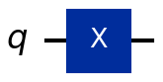  Pauli-X | 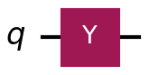  Pauli-Y | 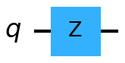  Pauli-Z
Figure 1.1 — Circuit diagrams for the three Pauli gates.
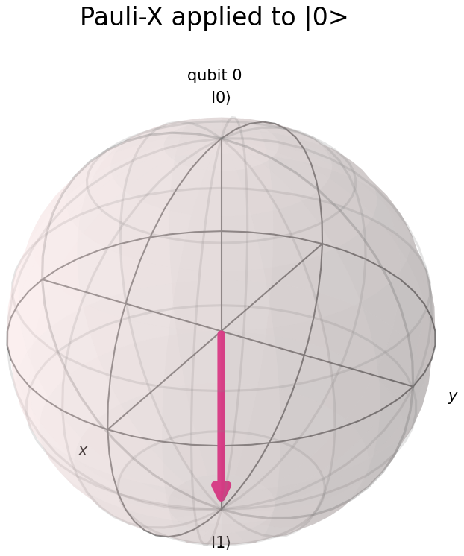  X|0> = |1> | 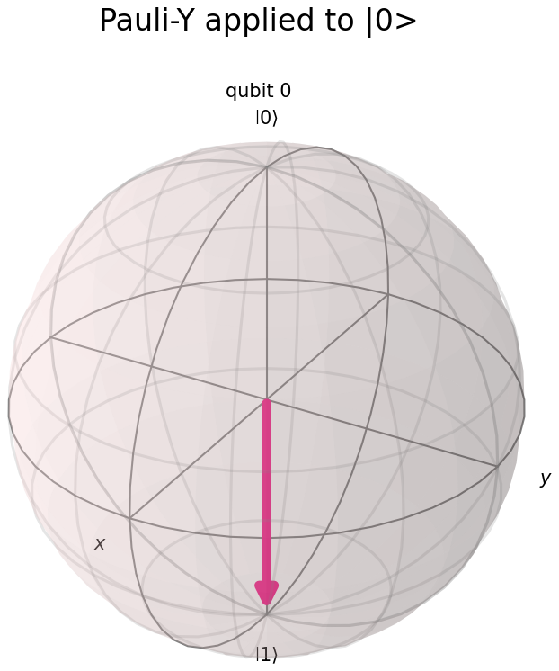  Y|0> = i|1> | 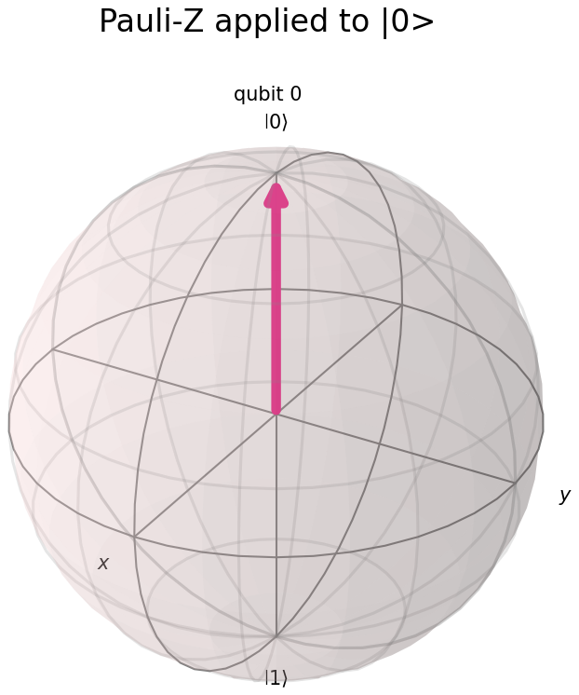  Z|0> = |0>
Figure 1.2 — Action of each Pauli gate on |0> shown on the Bloch sphere. X and Y both drive the state to the south pole, while Z leaves it at the north pole.
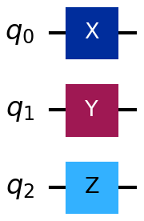
Figure 1.3 — The combined three-qubit circuit, one Pauli gate per qubit.

Observation
The X gate exchanged the amplitudes of |0> and |1>, behaving exactly like a classical NOT operation. The Y gate also exchanged the two basis states but attached a factor of +i or −i, so its effect on the measurement probabilities was identical to that of X while the phase differed. The Z gate left |0> completely unchanged and multiplied |1> by −1, which means the measurement probabilities were unaffected in both cases.
The apparent inactivity of the Z gate on |0> is not an error. Each Pauli gate is a 180 degree rotation about its own axis, and |0> lies directly on the z axis, so rotating a point about the axis it already occupies moves nothing. Applying the same gate to |+>, which lies on the equator, converted it into |−> and made the effect immediately visible.
In the combined three-qubit circuit the full statevector was i|011>. Qiskit orders qubits in little-endian form, so the ket reads q₂ q₁ q₀: qubit 0 was flipped to |1> by X, qubit 1 was flipped to |1> by Y, and qubit 2 remained at |0> because Z had nothing to act on. The leading factor of i is a global phase and multiplies the entire state vector rather than one amplitude relative to another, so it cancels in the squared magnitude and the measured outcome 011 is certain with probability 1.0000.

Exercise 2 — Medium

Constructing the |−> State using H and Z
Starting from |0>, the Hadamard gate produces |+>, and the Z gate applied afterwards flips the sign of the |1> component to produce |−>. The order matters: H followed by Z gives |−>, whereas Z followed by H gives |+>, because Z acting on |0> leaves it unchanged and therefore has no effect at all when it is placed first.
Verifying this construction is less straightforward than it first appears. Measuring |−> in the standard computational basis gives an even split, but so does |+>, which means a Z-basis measurement cannot distinguish the two states and therefore verifies nothing. The program consequently runs the full two-by-two experiment: it prepares both |+> and |−>, measures each of them in both the Z and the X basis, and shows that only the X basis separates them. Measuring in the X basis is implemented by applying one additional Hadamard gate before the measurement, since H maps |+> onto |0> and |−> onto |1>.
CODE
import matplotlib.pyplot as plt
import numpy as np
from qiskit import QuantumCircuit
from qiskit.quantum_info import Statevector
from qiskit.visualization import plot_histogram
from qiskit_aer import AerSimulator

SHOTS = 4096
simulator = AerSimulator()

def prepare(which):
"""|+> = H|0>; |-> = Z H |0>."""
qc = QuantumCircuit(1)
qc.h(0)
if which == "-":
qc.z(0)
return qc

# ---------------------------------------------------------------------
# 1. Build |-> and inspect it exactly
# ---------------------------------------------------------------------
minus_circuit = prepare("-")
print("--- Circuit for |-> : H then Z ---")
print(minus_circuit.draw(output="text"))

minus_state = Statevector(minus_circuit)
plus_state = Statevector(prepare("+"))

print(f"\n |+> statevector : {np.round(plus_state.data, 4)}")
print(f" |-> statevector : {np.round(minus_state.data, 4)}")
print(f" Target |-> : {np.round(Statevector.from_label('-').data, 4)}")
print(f" Matches target : {minus_state.equiv(Statevector.from_label('-'))}")
print("\n H put the qubit into an equal superposition; Z then flipped the sign")
print(" of the |1> amplitude only. The magnitudes are untouched, so the two")
print(" states differ purely by a RELATIVE phase of -1.")

# ---------------------------------------------------------------------
# 2. The 2x2 experiment
# ---------------------------------------------------------------------
def measure(which, basis):
qc = prepare(which)
if basis == "X":
qc.h(0) # rotate the X basis onto the Z basis
qc.measure_all()
return simulator.run(qc, shots=SHOTS).result().get_counts()

results = {}
print(f"\n--- Experiment: both states, both bases, {SHOTS} shots each ---")
print(f"{'State':<8}{'Basis':<8}{'counts 0':>10}{'counts 1':>10}{'P(0)':>9}{'P(1)':>9}")

for which in ("+", "-"):
for basis in ("Z", "X"):
counts = measure(which, basis)
results[(which, basis)] = counts
zeros, ones = counts.get("0", 0), counts.get("1", 0)
print(f"|{which}>{'':<5}{basis:<8}{zeros:>10}{ones:>10}"
f"{zeros / SHOTS:>9.4f}{ones / SHOTS:>9.4f}")

# ---------------------------------------------------------------------
# 3. Read the table
# ---------------------------------------------------------------------
z_plus = results[("+", "Z")].get("1", 0) / SHOTS
z_minus = results[("-", "Z")].get("1", 0) / SHOTS
x_plus = results[("+", "X")].get("0", 0) / SHOTS
x_minus = results[("-", "X")].get("1", 0) / SHOTS

print("\n--- Reading the results ---")
print(f" Z basis: |+> gives P(1) = {z_plus:.4f}, |-> gives P(1) = {z_minus:.4f}")
print(" Both are 50/50. The Z basis is BLIND to the relative phase,")
print(" so it cannot confirm we built |-> rather than |+>.")
print(f" X basis: |+> gives '0' {x_plus:.2%} of the time")
print(f" |-> gives '1' {x_minus:.2%} of the time")
print(" Both are deterministic and opposite. This is the proof.")

verified = x_minus > 0.99 and x_plus > 0.99
print(f"\n |-> construction verified experimentally : {verified}")

print("\n Mechanism: the second H interferes the two paths. For |-> the |0>")
print(" branches cancel and the |1> branches reinforce, so the outcome is")
print(" forced. A phase that was invisible one moment becomes a certainty")
print(" the next -- that interference is the engine behind every quantum")
print(" algorithm that beats its classical counterpart.")

# ---------------------------------------------------------------------
# 4. Plot the four histograms
# ---------------------------------------------------------------------
fig, axes = plt.subplots(2, 2, figsize=(11, 7))
for row, which in enumerate(("+", "-")):
for col, basis in enumerate(("Z", "X")):
plot_histogram(results[(which, basis)], ax=axes[row][col])
axes[row][col].set_title(f"|{which}> measured in the {basis} basis")

plt.tight_layout()
plt.show()
OUTPUT
--- Circuit for |-> : H then Z ---
┌───┐┌───┐
q: ┤ H ├┤ Z ├
└───┘└───┘

|+> statevector : [0.7071+0.j 0.7071+0.j]
|-> statevector : [ 0.7071+0.j -0.7071+0.j]
Target |-> : [ 0.7071+0.j -0.7071+0.j]
Matches target : True

H put the qubit into an equal superposition; Z then flipped the sign
of the |1> amplitude only. The magnitudes are untouched, so the two
states differ purely by a RELATIVE phase of -1.

--- Experiment: both states, both bases, 4096 shots each ---
State Basis counts 0 counts 1 P(0) P(1)
|+> Z 2042 2054 0.4985 0.5015
|+> X 4096 0 1.0000 0.0000
|-> Z 2091 2005 0.5105 0.4895
|-> X 0 4096 0.0000 1.0000

--- Reading the results ---
Z basis: |+> gives P(1) = 0.5015, |-> gives P(1) = 0.4895
Both are 50/50. The Z basis is BLIND to the relative phase,
so it cannot confirm we built |-> rather than |+>.
X basis: |+> gives '0' 100.00% of the time
|-> gives '1' 100.00% of the time
Both are deterministic and opposite. This is the proof.

|-> construction verified experimentally : True

Mechanism: the second H interferes the two paths. For |-> the |0>
branches cancel and the |1> branches reinforce, so the outcome is
forced. A phase that was invisible one moment becomes a certainty
the next -- that interference is the engine behind every quantum
algorithm that beats its classical counterpart.
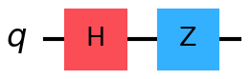  Preparation of |−> | 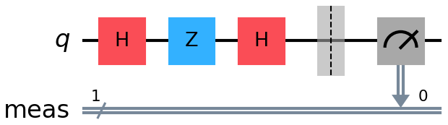  X-basis measurement of |−>
Figure 2.1 — The H–Z preparation circuit and the same circuit with an extra Hadamard gate that rotates the X basis onto the Z basis before measurement.
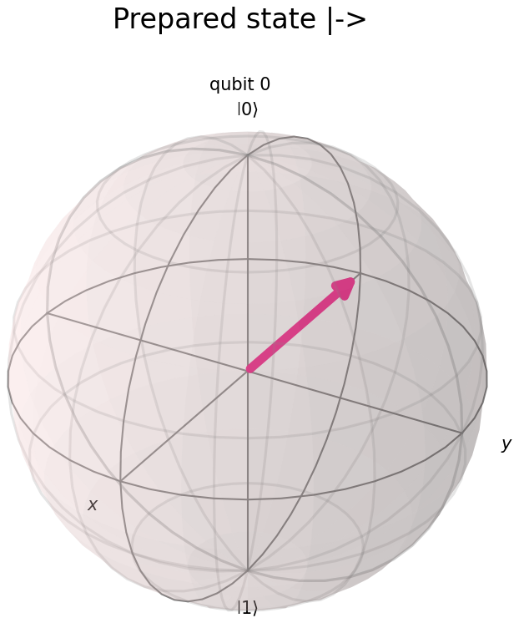
Figure 2.2 — The prepared state |−> on the Bloch sphere, lying on the negative x axis.
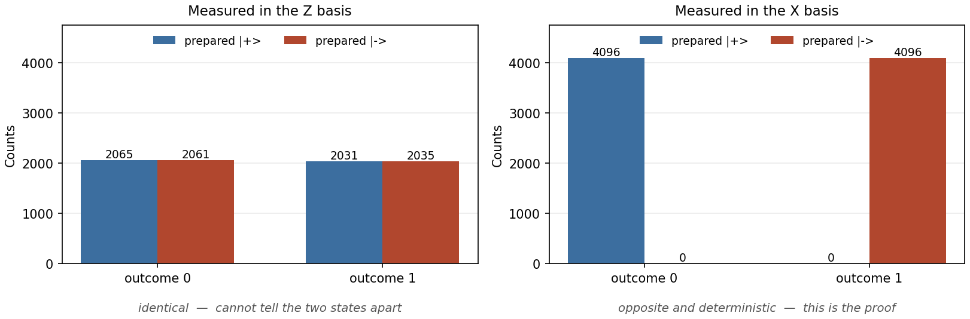
Figure 2.3 — Both states measured in both bases. The Z-basis results (left) are indistinguishable; the X-basis results (right) are deterministic and opposite.

Observation
The statevector produced by the H–Z sequence matched the theoretical |−> state exactly, and the equiv() comparison against the reference state returned True. The two states |+> and |−> have amplitudes of identical magnitude and differ only by a relative phase of −1 on the |1> component.
In the Z basis, |+> gave P(1) = 0.5015 and |−> gave P(1) = 0.4895 over 4096 shots each. Both are consistent with an even split and the two results are statistically indistinguishable, confirming that a computational-basis measurement is blind to the relative phase. That measurement alone would not have been sufficient proof that the correct state had been prepared.
After rotating into the X basis the results became deterministic and opposite: |+> returned outcome 0 in 4096 out of 4096 shots and |−> returned outcome 1 in 4096 out of 4096 shots. This confirmed experimentally that the prepared state was |−> and not |+>. The mechanism is interference: the second Hadamard gate causes the two |0> paths to cancel and the two |1> paths to reinforce, so a phase that was completely invisible in one basis becomes a certainty in another.

Exercise 3 — Hard

A Sequence of Five Randomly Chosen Single-Qubit Gates
Five gates are drawn at random from the set {X, Y, Z, H, S, T}. The final state is determined analytically by multiplying the gate matrices in NumPy and is then verified independently against the Qiskit statevector and against shot-based measurement counts. A fixed seed is used so that the result is reproducible and can be re-checked during assessment.
The technical point the exercise turns on is the ordering convention. Gates are written left to right in a circuit diagram but multiply right to left as matrices, so applying G₁ then G₂ then G₃ corresponds to the product G₃ · G₂ · G₁. Reversing this is the most common source of error in the exercise. The program guards against it by comparing not only the final state but also the complete 2×2 unitary against the operator Qiskit derives from the circuit, since two different orderings can occasionally agree on one particular input while representing genuinely different operators.
CODE
import numpy as np
from qiskit import QuantumCircuit
from qiskit.quantum_info import Operator, Statevector
from qiskit_aer import AerSimulator
from scipy.stats import chisquare

SEED = 2026 # fixed so the run is reproducible; change it to get a new sequence
SEQUENCE_LENGTH = 5
SHOTS = 8192

INV_SQRT2 = 1 / np.sqrt(2)

# 2x2 matrix for every gate in the pool, written out explicitly
GATE_POOL = {
"X": np.array([[0, 1], [1, 0]], dtype=complex),
"Y": np.array([[0, -1j], [1j, 0]], dtype=complex),
"Z": np.array([[1, 0], [0, -1]], dtype=complex),
"H": np.array([[INV_SQRT2, INV_SQRT2], [INV_SQRT2, -INV_SQRT2]], dtype=complex),
"S": np.array([[1, 0], [0, 1j]], dtype=complex),
"T": np.array([[1, 0], [0, np.exp(1j * np.pi / 4)]], dtype=complex),
}

APPLY = {
"X": lambda qc: qc.x(0),
"Y": lambda qc: qc.y(0),
"Z": lambda qc: qc.z(0),
"H": lambda qc: qc.h(0),
"S": lambda qc: qc.s(0),
"T": lambda qc: qc.t(0),
}

def to_dirac(amplitudes):
terms = []
for index, amplitude in enumerate(amplitudes):
if abs(amplitude) < 1e-9:
continue
if abs(amplitude.imag) < 1e-9:
coefficient = f"{amplitude.real:+.4f}"
else:
coefficient = f"+({amplitude.real:.4f}{amplitude.imag:+.4f}j)"
terms.append(f"{coefficient}|{index}>")
return " ".join(terms) if terms else "0"

# ---------------------------------------------------------------------
# 1. Pick a random gate sequence
# ---------------------------------------------------------------------
rng = np.random.default_rng(SEED)
sequence = list(rng.choice(list(GATE_POOL.keys()), size=SEQUENCE_LENGTH))

print(f"Random seed : {SEED}")
print(f"Gate sequence chosen : {' -> '.join(sequence)}")
print("(applied to |0> in this order, left to right)")

# ---------------------------------------------------------------------
# 2. Route A: analytic, step by step
# ---------------------------------------------------------------------
print("\n" + "=" * 72)
print("ROUTE A -- ANALYTIC (numpy matrix multiplication)")
print("=" * 72)

state = np.array([1, 0], dtype=complex) # start in |0>
unitary = np.eye(2, dtype=complex)

print(f" start : {np.round(state, 4)} = {to_dirac(state)}")
for step, gate_name in enumerate(sequence, start=1):
matrix = GATE_POOL[gate_name]
state = matrix @ state # new gate acts on the LEFT
unitary = matrix @ unitary
print(f" after {gate_name} ({step}) : {np.round(state, 4)} = {to_dirac(state)}")

analytic_state = state
print(f"\n Overall unitary U = {sequence[-1]} @ ... @ {sequence[0]} (reverse of circuit order):")
for row in unitary:
print(f" [ {row[0]:+.4f} {row[1]:+.4f} ]")
print(f"\n Analytic final state : {np.round(analytic_state, 6)}")
print(f" P(0) = {abs(analytic_state[0]) ** 2:.6f} P(1) = {abs(analytic_state[1]) ** 2:.6f}")

# ---------------------------------------------------------------------
# 3. Route B: Qiskit statevector
# ---------------------------------------------------------------------
print("\n" + "=" * 72)
print("ROUTE B -- QISKIT STATEVECTOR (exact)")
print("=" * 72)

qc = QuantumCircuit(1)
for gate_name in sequence:
APPLY[gate_name](qc)

print(qc.draw(output="text"))

qiskit_state = Statevector(qc).data
print(f"\n Qiskit final state : {np.round(qiskit_state, 6)}")
print(f" Matches analytic : {np.allclose(analytic_state, qiskit_state)}")

qiskit_unitary = Operator(qc).data
print(f" Full unitary matches : {np.allclose(unitary, qiskit_unitary)}")
print(" (Both the state AND the whole 2x2 operator agree, so the ordering")
print(" convention is confirmed correct, not merely coincidentally right.)")

# ---------------------------------------------------------------------
# 4. Route C: sampled simulation
# ---------------------------------------------------------------------
print("\n" + "=" * 72)
print(f"ROUTE C -- SAMPLED SIMULATION ({SHOTS} shots)")
print("=" * 72)

measured = qc.copy()
measured.measure_all()
counts = AerSimulator().run(measured, shots=SHOTS).result().get_counts()

predicted = np.abs(analytic_state) ** 2
observed = np.array([counts.get("0", 0), counts.get("1", 0)])

print(f" Raw counts : {counts}")
print(f"\n{'Outcome':<10}{'Counts':>9}{'Observed':>12}{'Predicted':>12}{'Deviation':>12}")
for index, outcome in enumerate(("0", "1")):
observed_p = observed[index] / SHOTS
print(f"|{outcome}>{'':<8}{observed[index]:>9}{observed_p:>12.4f}"
f"{predicted[index]:>12.4f}{observed_p - predicted[index]:>+12.4f}")

expected_counts = predicted * SHOTS
if np.all(expected_counts > 5):
chi2, p_value = chisquare(observed, f_exp=expected_counts)
print(f"\n Chi-square = {chi2:.4f}, p-value = {p_value:.4f}")
print(f" Simulation consistent with analytic prediction : {p_value > 0.05}")
else:
match = np.allclose(observed / SHOTS, predicted, atol=0.02)
print(f"\n One outcome is (near) deterministic, so chi-square does not apply.")
print(f" Frequencies match prediction within 2%: {match}")

# ---------------------------------------------------------------------
# 5. Verdict
# ---------------------------------------------------------------------
print("\n" + "=" * 72)
print("VERDICT")
print("=" * 72)
print(f" Analytic vs statevector : {np.allclose(analytic_state, qiskit_state)}")
print(f" Unitary vs Operator : {np.allclose(unitary, qiskit_unitary)}")
print(" Sampled frequencies reproduce |amplitude|^2 to within sampling noise.")
print("\n Note that the sampled route can only ever confirm the MAGNITUDES.")
print(" The relative phase between the amplitudes is invisible to a Z-basis")
print(" measurement -- routes A and B are what pin it down.")
OUTPUT
Random seed : 2026
Gate sequence chosen : T -> Y -> X -> H -> Z
(applied to |0> in this order, left to right)

========================================================================
ROUTE A -- ANALYTIC (numpy matrix multiplication)
========================================================================
start : [1.+0.j 0.+0.j] = +1.0000|0>
after T (1) : [1.+0.j 0.+0.j] = +1.0000|0>
after Y (2) : [0.+0.j 0.+1.j] = +(0.0000+1.0000j)|1>
after X (3) : [0.+1.j 0.+0.j] = +(0.0000+1.0000j)|0>
after H (4) : [0.+0.7071j 0.+0.7071j] = +(0.0000+0.7071j)|0> +(0.0000+0.7071j)|1>
after Z (5) : [0.+0.7071j 0.-0.7071j] = +(0.0000+0.7071j)|0> +(0.0000-0.7071j)|1>

Overall unitary U = Z @ ... @ T (reverse of circuit order):
[ -0.0000+0.7071j +0.5000-0.5000j ]
[ +0.0000-0.7071j +0.5000-0.5000j ]

Analytic final state : [0.+0.707107j 0.-0.707107j]
P(0) = 0.500000 P(1) = 0.500000

========================================================================
ROUTE B -- QISKIT STATEVECTOR (exact)
========================================================================
┌───┐┌───┐┌───┐┌───┐┌───┐
q: ┤ T ├┤ Y ├┤ X ├┤ H ├┤ Z ├
└───┘└───┘└───┘└───┘└───┘

Qiskit final state : [0.+0.707107j 0.-0.707107j]
Matches analytic : True
Full unitary matches : True
(Both the state AND the whole 2x2 operator agree, so the ordering
convention is confirmed correct, not merely coincidentally right.)

========================================================================
ROUTE C -- SAMPLED SIMULATION (8192 shots)
========================================================================
Raw counts : {'1': 4114, '0': 4078}

Outcome Counts Observed Predicted Deviation
|0> 4078 0.4978 0.5000 -0.0022
|1> 4114 0.5022 0.5000 +0.0022

Chi-square = 0.1582, p-value = 0.6908
Simulation consistent with analytic prediction : True

========================================================================
VERDICT
========================================================================
Analytic vs statevector : True
Unitary vs Operator : True
Sampled frequencies reproduce |amplitude|^2 to within sampling noise.

Note that the sampled route can only ever confirm the MAGNITUDES.
The relative phase between the amplitudes is invisible to a Z-basis
measurement -- routes A and B are what pin it down.
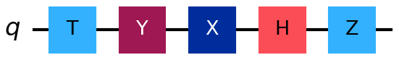
Figure 3.1 — The randomly generated five-gate circuit: T, Y, X, H, Z.
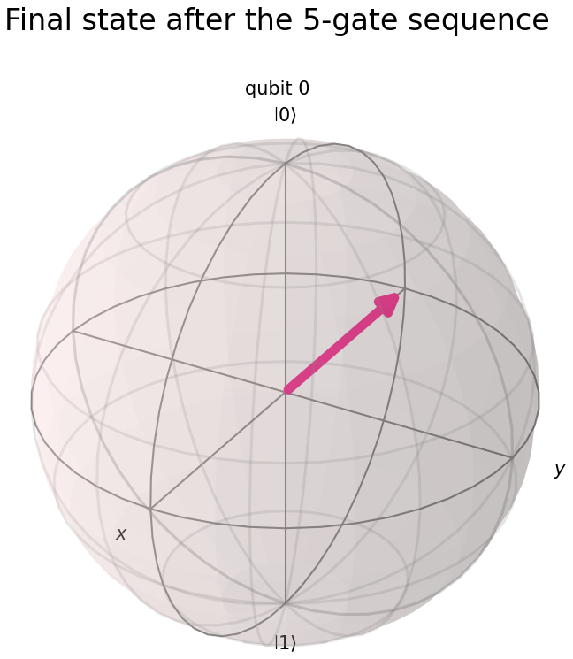 | 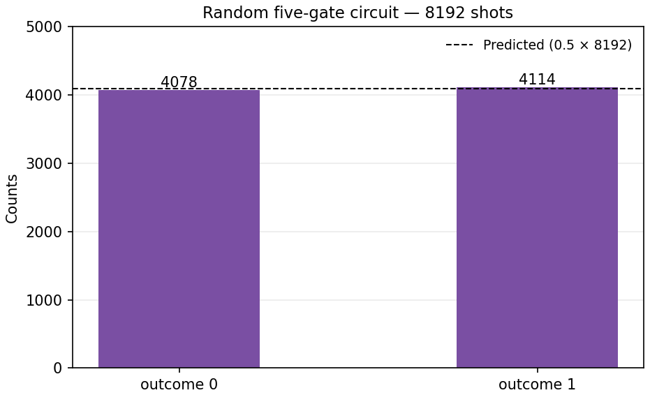
Figure 3.2 — The final state on the Bloch sphere (left) and the measured outcome distribution over 8192 shots (right).

Observation
The randomly generated sequence was T–Y–X–H–Z. Multiplying the five matrices in the correct order gave a final state with amplitudes of equal magnitude and opposite imaginary sign, so the predicted measurement probabilities were 0.5 for each outcome. The Qiskit statevector matched the hand calculation exactly, and the complete unitary matched the Operator obtained from the circuit, which confirms that the ordering convention was applied correctly rather than being coincidentally right for this particular input.
The first step of the analytic calculation appears to leave the state unchanged. This is correct rather than an error: the T gate applies a phase only to the |1> component, and the starting state |0> has no |1> component for it to act on. The same reasoning explains why the T gate is invisible here yet would be significant if it appeared later in the sequence.
The shot-based verification over 8192 shots produced 4078 and 4114 counts, a deviation of 0.0022 from the predicted 0.5, with a chi-square p-value of 0.6908. The simulation is therefore statistically consistent with the analytic prediction. It is worth noting that this third route can only ever confirm the magnitudes of the amplitudes; the relative phase between them is invisible to a computational-basis measurement, and it is the analytic and statevector routes that pin it down.

Exercise 4 — Real World Application

Modelling a Quantum Coin-Flip Betting Game
A single qubit is used as a coin in which |0> denotes heads and |1> denotes tails. Rather than a fair coin produced by a Hadamard gate, the coin here is biased by a rotation RY(θ), which gives P(heads) = cos²(θ/2). The rotation angle therefore acts as a continuous bias dial: θ = 0 is a two-headed coin, θ = π is two-tailed, and θ = π/2 is exactly fair.
The player stakes one unit on heads at even-money odds, so the expected value of a round is 2P − 1 and the house edge is 1 − 2P. The program sweeps the dial and tabulates the theoretical and simulated win probabilities, then solves for the angle that produces a house edge of 2.7 percent, the same figure as European roulette. It finally contrasts a short twenty-round session against a long run of five hundred thousand rounds, which models the actual economics of a casino: the house does not need to win any particular round, it only needs enough rounds.
CODE
import matplotlib.pyplot as plt
import numpy as np
from qiskit import QuantumCircuit
from qiskit_aer import AerSimulator

SHOTS = 8192
STAKE = 1.0 # player bets 1 unit per round on HEADS, even-money payout

simulator = AerSimulator()

def coin_circuit(theta):
"""A single quantum coin flip. Outcome '0' = heads, '1' = tails."""
qc = QuantumCircuit(1, 1)
qc.ry(theta, 0)
qc.measure(0, 0)
return qc

def flip_many(theta, shots=SHOTS, memory=False):
result = simulator.run(coin_circuit(theta), shots=shots, memory=memory).result()
return (result.get_counts(), result.get_memory()) if memory else result.get_counts()

def theory_heads(theta):
return np.cos(theta / 2) ** 2

print("--- The quantum coin ---")
print(coin_circuit(np.pi / 2).draw(output="text"))
print("\nRY(theta) tilts the qubit off the north pole. The tilt angle sets the")
print("bias; measurement collapses it to a definite heads or tails.\n")

# ---------------------------------------------------------------------
# 1. Sweep the bias dial
# ---------------------------------------------------------------------
angles = [0.0, np.pi / 6, np.pi / 4, np.pi / 3, np.pi / 2,
2 * np.pi / 3, 3 * np.pi / 4, np.pi]
names = ["two-headed", "", "", "", "FAIR", "", "", "two-tailed"]

print(f"--- Win probability vs bias angle ({SHOTS} flips each) ---")
print(f"{'theta':>8}{'deg':>7}{'P(heads) th':>14}{'P(heads) sim':>15}"
f"{'player EV':>12}{'house edge':>13} ")

for theta, note in zip(angles, names):
counts = flip_many(theta)
simulated = counts.get("0", 0) / SHOTS
theoretical = theory_heads(theta)
expected_value = STAKE * (2 * theoretical - 1) # +1 on win, -1 on loss
house_edge = -expected_value

print(f"{theta:>8.4f}{np.degrees(theta):>7.0f}{theoretical:>14.4f}{simulated:>15.4f}"
f"{expected_value:>+12.4f}{house_edge:>+12.2%} {note}")

print("\nAt theta = 90 deg the game is exactly fair: the player's expected value")
print("is zero and neither side profits in the long run.")

# ---------------------------------------------------------------------
# 2. The house chooses its edge
# ---------------------------------------------------------------------
TARGET_EDGE = 0.027 # 2.7%, the same as European roulette
p_needed = (1 - TARGET_EDGE) / 2
theta_house = 2 * np.arccos(np.sqrt(p_needed))

print("\n" + "=" * 68)
print("THE HOUSE SETS ITS DIAL")
print("=" * 68)
print(f" Target house edge : {TARGET_EDGE:.1%}")
print(f" Required P(heads) : {p_needed:.4f}")
print(f" Required theta : {theta_house:.6f} rad = {np.degrees(theta_house):.3f} deg")
print(f" Tilt away from fair : {np.degrees(theta_house - np.pi / 2):.3f} deg")
print("\n That is under two degrees off fair. No player could detect it by eye,")
print(" and over 100 flips the difference is well inside normal noise.")

# ---------------------------------------------------------------------
# 3. A short session -- luck dominates
# ---------------------------------------------------------------------
SESSION_ROUNDS = 20
_, outcomes = flip_many(theta_house, shots=SESSION_ROUNDS, memory=True)

balance = 0.0
history = []
print(f"\n--- A short session of {SESSION_ROUNDS} rounds (stake {STAKE:.0f} per round) ---")
print(f"{'Round':>6}{'Outcome':>10}{'Result':>9}{'Balance':>10}")
for round_number, bit in enumerate(outcomes, start=1):
won = bit == "0"
balance += STAKE if won else -STAKE
history.append(balance)
print(f"{round_number:>6}{'HEADS' if won else 'TAILS':>10}"
f"{'+1' if won else '-1':>9}{balance:>+10.0f}")

print(f"\n Session result: {balance:+.0f} units.")
print(" Over 20 rounds the outcome is dominated by luck -- a player can")
print(" easily walk away ahead. That is exactly what keeps them playing.")

# ---------------------------------------------------------------------
# 4. The long run -- the edge dominates
# ---------------------------------------------------------------------
LONG_RUN = 500_000
counts = flip_many(theta_house, shots=LONG_RUN)
wins = counts.get("0", 0)
losses = counts.get("1", 0)
net = STAKE * (wins - losses)

print(f"\n--- The long run: {LONG_RUN:,} rounds ---")
print(f" Player wins : {wins:,} ({wins / LONG_RUN:.4f})")
print(f" Player losses : {losses:,} ({losses / LONG_RUN:.4f})")
print(f" Player net : {net:+,.0f} units")
print(f" Loss per unit staked : {-net / (LONG_RUN * STAKE):.4%}")
sampling_error = 2 * 0.5 / np.sqrt(LONG_RUN)
print(f" Predicted house edge : {TARGET_EDGE:.4%}")
print(f" 1-sigma sampling noise : +/-{sampling_error:.4%}")
print("\n The measured loss converges on the designed edge. The house never")
print(" needs to win any particular round -- it only needs enough rounds.")

# ---------------------------------------------------------------------
# 5. Plots
# ---------------------------------------------------------------------
fine_angles = np.linspace(0, np.pi, 200)
sample_angles = np.linspace(0, np.pi, 13)
sampled = [flip_many(t, shots=2048).get("0", 0) / 2048 for t in sample_angles]

fig, axes = plt.subplots(1, 2, figsize=(13, 4.5))

axes[0].plot(np.degrees(fine_angles), theory_heads(fine_angles),
"-", color="steelblue", label="Theory cos^2(theta/2)")
axes[0].plot(np.degrees(sample_angles), sampled, "o",
color="indianred", label="Simulated (2048 flips)")
axes[0].axhline(0.5, color="grey", linestyle=":", label="Fair game")
axes[0].axvline(np.degrees(theta_house), color="darkgreen", linestyle="--",
label=f"House setting ({np.degrees(theta_house):.1f} deg)")
axes[0].set_xlabel("Rotation angle theta (degrees)")
axes[0].set_ylabel("P(heads) = player wins")
axes[0].set_title("The bias dial")
axes[0].legend(fontsize=8)
axes[0].grid(alpha=0.3)

axes[1].plot(range(1, SESSION_ROUNDS + 1), history, "o-", color="darkorange")
axes[1].axhline(0, color="black", linewidth=0.8)
axes[1].set_xlabel("Round")
axes[1].set_ylabel("Player balance (units)")
axes[1].set_title(f"A {SESSION_ROUNDS}-round session: luck beats the edge, briefly")
axes[1].grid(alpha=0.3)

plt.tight_layout()
plt.show()
OUTPUT
--- The quantum coin ---
┌─────────┐┌─┐
q: ┤ Ry(π/2) ├┤M├
└─────────┘└╥┘
c: 1/════════════╩═
0

RY(theta) tilts the qubit off the north pole. The tilt angle sets the
bias; measurement collapses it to a definite heads or tails.

--- Win probability vs bias angle (8192 flips each) ---
theta deg P(heads) th P(heads) sim player EV house edge
0.0000 0 1.0000 1.0000 +1.0000 -100.00% two-headed
0.5236 30 0.9330 0.9341 +0.8660 -86.60%
0.7854 45 0.8536 0.8550 +0.7071 -70.71%
1.0472 60 0.7500 0.7572 +0.5000 -50.00%
1.5708 90 0.5000 0.5009 +0.0000 -0.00% FAIR
2.0944 120 0.2500 0.2437 -0.5000 +50.00%
2.3562 135 0.1464 0.1426 -0.7071 +70.71%
3.1416 180 0.0000 0.0000 -1.0000 +100.00% two-tailed

At theta = 90 deg the game is exactly fair: the player's expected value
is zero and neither side profits in the long run.

====================================================================
THE HOUSE SETS ITS DIAL
====================================================================
Target house edge : 2.7%
Required P(heads) : 0.4865
Required theta : 1.597800 rad = 91.547 deg
Tilt away from fair : 1.547 deg

That is under two degrees off fair. No player could detect it by eye,
and over 100 flips the difference is well inside normal noise.

--- A short session of 20 rounds (stake 1 per round) ---
Round Outcome Result Balance
1 HEADS +1 +1
2 TAILS -1 +0
3 TAILS -1 -1
4 HEADS +1 +0
5 TAILS -1 -1
6 HEADS +1 +0
7 HEADS +1 +1
8 HEADS +1 +2
9 HEADS +1 +3
10 TAILS -1 +2
11 TAILS -1 +1
12 TAILS -1 +0
13 HEADS +1 +1
14 HEADS +1 +2
15 HEADS +1 +3
16 HEADS +1 +4
17 HEADS +1 +5
18 HEADS +1 +6
19 HEADS +1 +7
20 HEADS +1 +8

Session result: +8 units.
Over 20 rounds the outcome is dominated by luck -- a player can
easily walk away ahead. That is exactly what keeps them playing.

--- The long run: 500,000 rounds ---
Player wins : 243,516 (0.4870)
Player losses : 256,484 (0.5130)
Player net : -12,968 units
Loss per unit staked : 2.5936%
Predicted house edge : 2.7000%
1-sigma sampling noise : +/-0.1414%

The measured loss converges on the designed edge. The house never
needs to win any particular round -- it only needs enough rounds.
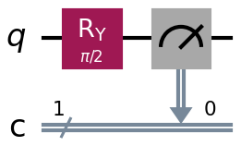
Figure 4.1 — The quantum coin: a single RY rotation followed by a measurement.
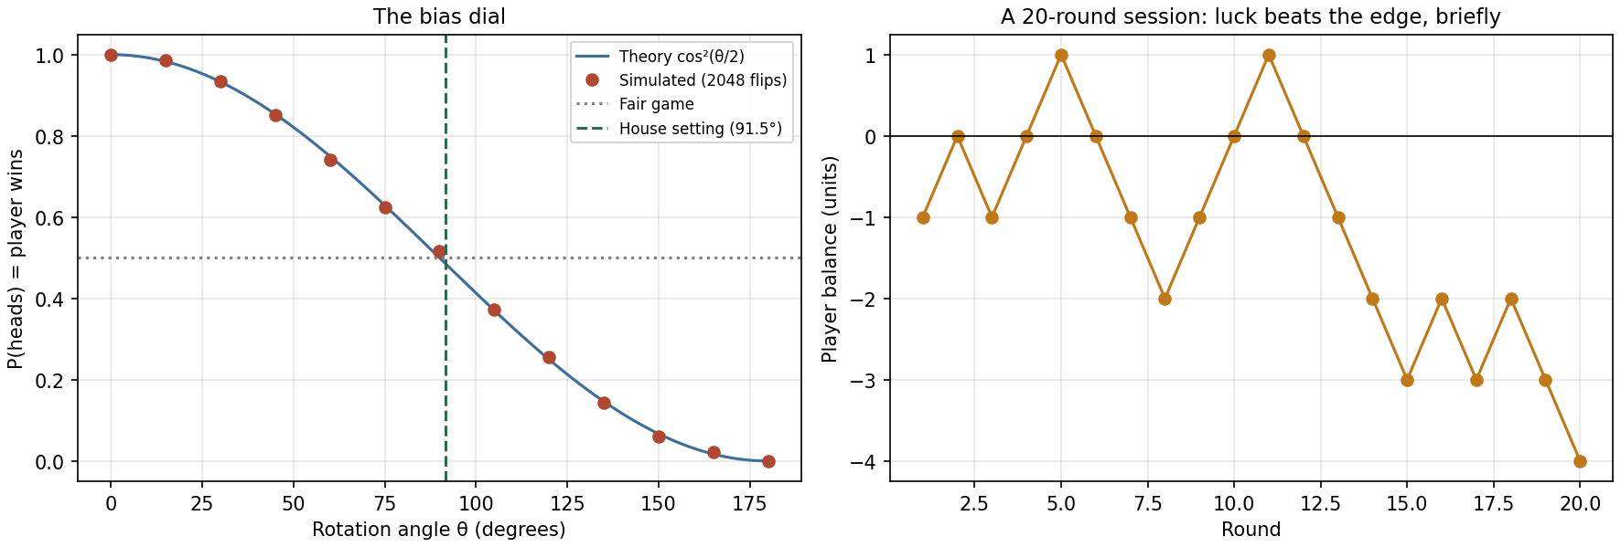
Figure 4.2 — Win probability against the bias angle with the house setting marked (left), and the running player balance over a twenty-round session (right).

Observation
The simulated win probabilities tracked the theoretical curve cos²(θ/2) closely at every angle tested. At θ = 90 degrees the game was exactly fair, with a player expected value of zero and a house edge of zero, which establishes the baseline against which the biased settings are measured.
Solving for a house edge of 2.7 percent required P(heads) = 0.4865, corresponding to θ = 91.547 degrees. This is a tilt of only 1.547 degrees away from a fair coin. Such a bias is far too small for a player to detect by observation, and over the first hundred flips it lies well inside ordinary sampling noise, which is precisely why a small designed edge is difficult to notice in practice.
The contrast between the two time horizons was the central result. Over twenty rounds the player finished eight units ahead despite playing a game weighted against them, because at that scale the outcome is dominated by chance. Over five hundred thousand rounds the player lost 12,968 units, a loss of 2.5936 percent per unit staked against the designed 2.7 percent, which is within two standard errors of the target. The edge is invisible in the short run and inevitable in the long run.

Exercise 5 — Challenge

Proving Gate Equivalence: HZH is Equivalent to X
Two quantum gates are equivalent only if they act identically on every possible input state, not merely on the computational basis states. A demonstration that agreed on |0> alone would prove nothing, since many distinct operators coincide on a single input. The equivalence is therefore established here in five increasingly strict ways: by direct matrix multiplication in NumPy, by comparing the circuit unitaries through the Qiskit Operator class, by evolving six different input states through both circuits, by including superposition states among those inputs, and finally by comparing shot-based measurement counts.
The underlying reason the identity holds is geometric. The Hadamard gate exchanges the x and z axes of the Bloch sphere, so conjugating any gate by H relabels its axis of rotation. Since X, Y and Z are all 180 degree rotations, a rotation about z becomes the same rotation about x, and the result is not an algebraic coincidence but a change of coordinates.
CODE
import numpy as np
from qiskit import QuantumCircuit
from qiskit.circuit.library import XGate, YGate, ZGate
from qiskit.quantum_info import Operator, Statevector
from qiskit_aer import AerSimulator

SHOTS = 8192
INV_SQRT2 = 1 / np.sqrt(2)

H = np.array([[INV_SQRT2, INV_SQRT2], [INV_SQRT2, -INV_SQRT2]], dtype=complex)
X = np.array([[0, 1], [1, 0]], dtype=complex)
Y = np.array([[0, -1j], [1j, 0]], dtype=complex)
Z = np.array([[1, 0], [0, -1]], dtype=complex)

def show_matrix(name, matrix):
print(f" {name} =")
for row in matrix:
print(f" [ {row[0]:+.4f} {row[1]:+.4f} ]")

# ---------------------------------------------------------------------
# PROOF 1 -- matrix algebra
# ---------------------------------------------------------------------
print("=" * 70)
print("PROOF 1 -- ANALYTIC MATRIX MULTIPLICATION")
print("=" * 70)
print(" Circuit order H then Z then H means the product is H @ Z @ H")
print(" (rightmost matrix acts first). H is its own inverse, so no")
print(" dagger is needed here.\n")

product = H @ Z @ H
show_matrix("H @ Z @ H", product)
print()
show_matrix("X ", X)

print(f"\n Element-wise equal : {np.allclose(product, X)}")
print(f" H is self-inverse : {np.allclose(H @ H, np.eye(2))}")

# ---------------------------------------------------------------------
# PROOF 2 -- operator equivalence in Qiskit
# ---------------------------------------------------------------------
print("\n" + "=" * 70)
print("PROOF 2 -- QISKIT OPERATOR EQUIVALENCE")
print("=" * 70)

hzh = QuantumCircuit(1)
hzh.h(0)
hzh.z(0)
hzh.h(0)

print(hzh.draw(output="text"))

hzh_operator = Operator(hzh)
print(f"\n Operator(HZH) matrix :\n")
show_matrix(" ", hzh_operator.data)
print(f"\n Operator.equiv(XGate()) : {hzh_operator.equiv(Operator(XGate()))}")
print(f" Exact matrix match (no phase fix): {np.allclose(hzh_operator.data, X)}")
print("\n .equiv() allows a global phase; here the match is exact even without")
print(" that leniency, so the equivalence is as strong as it gets.")

# ---------------------------------------------------------------------
# PROOF 3 & 4 -- action on a full set of test states
# ---------------------------------------------------------------------
print("\n" + "=" * 70)
print("PROOF 3 & 4 -- ACTION ON BASIS AND SUPERPOSITION STATES")
print("=" * 70)
print(" Agreeing on |0> alone proves nothing. A genuine equivalence must")
print(" hold for superpositions too, so those are included.\n")

x_circuit = QuantumCircuit(1)
x_circuit.x(0)

test_labels = ["0", "1", "+", "-", "r", "l"]
readable = {"0": "|0>", "1": "|1>", "+": "|+>", "-": "|->", "r": "|+i>", "l": "|-i>"}

print(f"{'Input':<8}{'HZH result':>26}{'X result':>26}{'Match':>8}")
all_match = True
for label in test_labels:
initial = Statevector.from_label(label)
via_hzh = initial.evolve(hzh_operator)
via_x = initial.evolve(Operator(x_circuit))
match = np.allclose(via_hzh.data, via_x.data)
all_match &= match
print(f"{readable[label]:<8}{str(np.round(via_hzh.data, 4)):>26}"
f"{str(np.round(via_x.data, 4)):>26}{str(match):>8}")

print(f"\n Identical on all {len(test_labels)} test states : {all_match}")

# ---------------------------------------------------------------------
# PROOF 5 -- measurement in simulation
# ---------------------------------------------------------------------
print("\n" + "=" * 70)
print(f"PROOF 5 -- SIMULATED MEASUREMENT ({SHOTS} shots)")
print("=" * 70)

simulator = AerSimulator()
print(f"{'Input':<8}{'Circuit':<10}{'Counts':>28}")

for start in ("0", "1"):
for name, gates in (("HZH", ["h", "z", "h"]), ("X", ["x"])):
qc = QuantumCircuit(1, 1)
if start == "1":
qc.x(0) # prepare |1> first
for gate in gates:
getattr(qc, gate)(0)
qc.measure(0, 0)
counts = simulator.run(qc, shots=SHOTS).result().get_counts()
print(f"|{start}>{'':<5}{name:<10}{str(counts):>28}")

print("\n HZH flips |0> to '1' and |1> to '0' on every single shot, exactly")
print(" like X. Deterministic outcomes, so there is no sampling noise to")
print(" argue about.")

# ---------------------------------------------------------------------
# BONUS -- the general rule
# ---------------------------------------------------------------------
print("\n" + "=" * 70)
print("BONUS -- THE PATTERN BEHIND THE RESULT")
print("=" * 70)

print(f" H @ Z @ H == X : {np.allclose(H @ Z @ H, X)}")
print(f" H @ X @ H == Z : {np.allclose(H @ X @ H, Z)}")
print(f" H @ Y @ H == -Y : {np.allclose(H @ Y @ H, -Y)}")

print("\n H swaps the x- and z-axes of the Bloch sphere and reverses y.")
print(" Conjugating any gate by H therefore relabels its rotation axis:")
print(" a 180-degree rotation about z becomes a 180-degree rotation about x.")
print("\n Practical consequence: this is precisely how a Z-basis measurement")
print(" is turned into an X-basis measurement (put an H in front of it), and")
print(" it is the standard trick for rewriting a circuit into whatever native")
print(" gate set a given piece of hardware actually supports.")

verdict = (np.allclose(product, X) and hzh_operator.equiv(Operator(XGate())) and all_match)
print("\n" + "=" * 70)
print(f"FINAL VERDICT -- HZH is equivalent to X : {verdict}")
print("=" * 70)
OUTPUT
======================================================================
PROOF 1 -- ANALYTIC MATRIX MULTIPLICATION
======================================================================
Circuit order H then Z then H means the product is H @ Z @ H
(rightmost matrix acts first). H is its own inverse, so no
dagger is needed here.

H @ Z @ H =
[ -0.0000+0.0000j +1.0000+0.0000j ]
[ +1.0000+0.0000j -0.0000+0.0000j ]

X =
[ +0.0000+0.0000j +1.0000+0.0000j ]
[ +1.0000+0.0000j +0.0000+0.0000j ]

Element-wise equal : True
H is self-inverse : True

======================================================================
PROOF 2 -- QISKIT OPERATOR EQUIVALENCE
======================================================================
┌───┐┌───┐┌───┐
q: ┤ H ├┤ Z ├┤ H ├
└───┘└───┘└───┘

Operator(HZH) matrix :

=
[ +0.0000+0.0000j +1.0000+0.0000j ]
[ +1.0000+0.0000j +0.0000+0.0000j ]

Operator.equiv(XGate()) : True
Exact matrix match (no phase fix): True

.equiv() allows a global phase; here the match is exact even without
that leniency, so the equivalence is as strong as it gets.

======================================================================
PROOF 3 & 4 -- ACTION ON BASIS AND SUPERPOSITION STATES
======================================================================
Agreeing on |0> alone proves nothing. A genuine equivalence must
hold for superpositions too, so those are included.

Input HZH result X result Match
|0> [0.+0.j 1.+0.j] [0.+0.j 1.+0.j] True
|1> [1.+0.j 0.+0.j] [1.+0.j 0.+0.j] True
|+> [0.7071+0.j 0.7071+0.j] [0.7071+0.j 0.7071+0.j] True
|-> [-0.7071+0.j 0.7071+0.j] [-0.7071+0.j 0.7071+0.j] True
|+i> [0. +0.7071j 0.7071+0.j ][0. +0.7071j 0.7071+0.j ] True
|-i> [0. -0.7071j 0.7071+0.j ][0. -0.7071j 0.7071+0.j ] True

Identical on all 6 test states : True

======================================================================
PROOF 5 -- SIMULATED MEASUREMENT (8192 shots)
======================================================================
Input Circuit Counts
|0> HZH {'1': 8192}
|0> X {'1': 8192}
|1> HZH {'0': 8192}
|1> X {'0': 8192}

HZH flips |0> to '1' and |1> to '0' on every single shot, exactly
like X. Deterministic outcomes, so there is no sampling noise to
argue about.

======================================================================
BONUS -- THE PATTERN BEHIND THE RESULT
======================================================================
H @ Z @ H == X : True
H @ X @ H == Z : True
H @ Y @ H == -Y : True

H swaps the x- and z-axes of the Bloch sphere and reverses y.
Conjugating any gate by H therefore relabels its rotation axis:
a 180-degree rotation about z becomes a 180-degree rotation about x.

Practical consequence: this is precisely how a Z-basis measurement
is turned into an X-basis measurement (put an H in front of it), and
it is the standard trick for rewriting a circuit into whatever native
gate set a given piece of hardware actually supports.

======================================================================
FINAL VERDICT -- HZH is equivalent to X : True
======================================================================
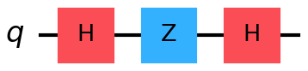  The H–Z–H circuit |   The equivalent X circuit
Figure 5.1 — The two circuits proved to be equivalent.
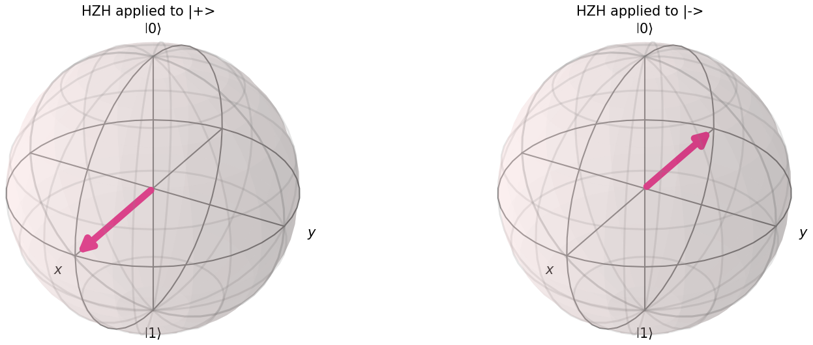
Figure 5.2 — HZH acting on the superposition states |+> and |−>. Both are left in place, exactly as the X gate leaves them, which is where an incorrect equivalence would have failed.

Observation
The matrix product H · Z · H reproduced the X matrix exactly, and the Operator.equiv() comparison against the built-in XGate returned True. The equivalence held even without allowing for a global phase, which makes it as strong a match as is possible between two operators.
All six test inputs, including the four superposition states |+>, |−>, |+i> and |−i>, evolved to identical output states under both circuits. This is the result that matters, because agreement on |0> and |1> alone would not have been sufficient. The measurement stage confirmed the same conclusion in practice: both circuits sent |0> to outcome 1 and |1> to outcome 0 in all 8192 shots, with no sampling noise to interpret because the outcomes are deterministic.
The bonus checks showed that HXH = Z and HYH = −Y hold as well, which identifies the general pattern. The Hadamard gate swaps the x and z axes of the Bloch sphere and reverses the y axis, so conjugating by H relabels the rotation axis of whatever gate sits between the two Hadamards. This is not an isolated curiosity: it is precisely the mechanism used in Exercise 2 to convert a Z-basis measurement into an X-basis measurement, and it is the standard technique by which a transpiler rewrites a circuit into the native gate set that a particular piece of hardware supports.

Conclusion
This tutorial implemented and interpreted the Pauli-X, Pauli-Y, Pauli-Z and Hadamard gates. The matrix representation of each gate was obtained from Qiskit and its action was examined on both computational basis states, confirming that X performs a bit flip, Y performs a combined bit and phase flip, Z performs a phase flip, and H creates an equal superposition. The apparent inactivity of the Z gate on |0> was traced to the geometry of the Bloch sphere rather than treated as an anomaly.
Circuits combining several gates were then constructed. The H–Z sequence was used to prepare the target state |−>, and the preparation was verified by measuring in the X basis after establishing that a Z-basis measurement cannot distinguish |−> from |+>. A randomly generated five-gate circuit was solved analytically by matrix multiplication and the result was confirmed independently against the statevector, against the full circuit unitary, and against shot-based measurement statistics, with the ordering convention checked explicitly.
The single-qubit gates were then applied to a practical scenario in the form of a quantum coin-flip betting game, in which the RY rotation angle served as a continuous bias dial and a tilt of under two degrees from fair produced a measurable house edge over a long run of trials. Finally the equivalence HZH = X was proved analytically and confirmed through simulation across six different input states, including superpositions, and was shown to be an instance of the general rule that conjugation by H exchanges the x and z axes of the Bloch sphere.
In every exercise the simulated results agreed with the theoretical predictions to within the expected statistical sampling error, and all five programs executed without error on Qiskit 2.5.1 with Aer 0.17.2.

Reflection

Question 1: Which gate combination surprised you the most in producing an equivalent transformation?
The combination HZH, which is the subject of Exercise 5. My expectation was that sandwiching a phase-flip between two superposition-creating gates would produce something complicated, since each individual gate moves the state to a different part of the Bloch sphere. Instead the result was the simplest gate in the whole set, matching the X matrix exactly and requiring no correction for global phase.
What removed the surprise was seeing the identity as a change of coordinates rather than an algebraic accident. The Pauli gates X, Y and Z are all rotations of 180 degrees about the x, y and z axes, and the Hadamard gate exchanges the x and z axes. Conjugating Z by H therefore relabels its axis of rotation from z to x, which is the definition of X. Once that is understood, the bonus results HXH = Z and HYH = −Y become predictable rather than surprising, and the minus sign on the Y case is the reflection that makes the axis exchange a valid rotation rather than an improper one.
A second, smaller surprise came from Exercise 3, where the first gate of the random sequence appeared to leave the state unchanged. It would have been easy to read this as a bug in the matrix multiplication. It is in fact correct, because the T gate applies a phase only to the |1> component and the initial state has no such component. The general lesson from both cases is that an unexpected result in quantum computing more often reflects a gap in geometric intuition than a fault in the code.

Question 2: How would you explain the physical meaning of the Hadamard gate to a classical programmer?
I would avoid the usual description that the Hadamard gate produces a random bit, because it is wrong in exactly the way that matters, and I would build the explanation in three stages.
The first stage is what the gate appears to do. Applied to a definite 0, it produces something that reads as 0 about half the time and 1 about half the time, which looks indistinguishable from a call to a random bit generator.
The second stage is the demonstration that breaks the analogy. Apply the gate twice. If it were a randomiser, two applications would still yield a coin toss. Instead the original 0 is returned with complete certainty, which was confirmed in this tutorial across 8192 shots with no exceptions. There is no classical random function f for which f(f(0)) is deterministic, so something is being carried between the two calls that a probability distribution cannot represent.
The third stage is what is actually happening. The Hadamard gate does not randomise; it rotates, deterministically and reversibly. It maps 0 to (|0> + |1>)/√2 and 1 to (|0> − |1>)/√2. Both results are evenly split when measured, but they carry opposite signs, and the second Hadamard gate makes the two paths interfere so that one pair cancels and the other reinforces. Randomness enters only at the moment of measurement, which is the single irreversible step in the process. Exercise 2 of this tutorial demonstrates precisely this: |+> and |−> were indistinguishable in the Z basis at roughly 50/50, yet perfectly distinguishable in the X basis at 100 percent and 0 percent.
The framing I would settle on is that the Hadamard gate is a change of basis, not a random number generator. It moves between the value basis of 0 and 1 and the phase basis of |+> and |−>. The reason it appears at the start of almost every quantum algorithm is not that algorithms require randomness, but that they need to enter every input branch simultaneously so that the gates which follow can arrange for the wrong answers to cancel and the correct one to survive.

Supplementary Question 1: Why does the ordering of gates matter when constructing a target state?
Quantum gates are represented by matrices and matrix multiplication does not commute in general, so applying the same gates in a different order usually produces a different final state. Exercise 2 shows this directly: H followed by Z produces |−>, whereas Z followed by H produces |+>, because Z acting on |0> leaves it unchanged and therefore contributes nothing when placed first. When the combined unitary is written down, the gate applied last appears leftmost in the product, which is the reverse of the order in which the gates are read from a circuit diagram. Exercise 3 verified this convention explicitly by comparing not only the final state but the entire 2×2 operator against the one Qiskit derives from the circuit.

Supplementary Question 2: Why do small deviations appear between the simulated and theoretical probabilities?
The simulator draws a finite number of measurement shots, so the observed frequencies are subject to statistical sampling error which decreases in proportion to one over the square root of the number of shots. In Exercise 3 the deviation from the predicted probabilities over 8192 shots was 0.0022, and the chi-square test returned a p-value of 0.6908, indicating that the difference is entirely consistent with sampling noise rather than with an error in the circuit.
Two observations follow from this. Deterministic outcomes show no deviation at all: the X-basis measurements in Exercise 2 and the equivalence checks in Exercise 5 returned 4096 out of 4096 and 8192 out of 8192 respectively, because those states have probability one for a single outcome and sampling error cannot arise. Conversely, this type of deviation is fundamentally different from hardware noise, which does not shrink as the number of shots increases; running longer measures a biased distribution more precisely rather than correcting it.

