AML23703: Quantum Computing
Tutorial 4
Multi-Qubit Gates and Circuit Composition

Name | Abdul Rahman Khan
USN | 1GA23AI001
Department | Artificial Intelligence and Machine Learning
Semester | VII
Course Code | AML23703
Date | 12-08-2026

Objective
The objective of this tutorial is to implement two-qubit gates such as CNOT and CZ along with the three-qubit Toffoli gate, to construct multi-qubit circuits and interpret the entanglement that they generate, to emulate classical reversible logic using quantum gates, and to use Qiskit's circuit composition and visualisation tools to check every result against an explicit theoretical prediction rather than accepting the simulator output at face value.

Theory
A controlled gate divides the qubits it acts on into a control and a target. The CNOT gate applies an X gate to the target only when the control is |1⟩, which gives the truth table target' = control XOR target with the control itself left unchanged, and which is written as a 4 × 4 permutation matrix that simply exchanges the last two rows of the identity. The CZ gate follows the same pattern but applies a phase of −1 to the |11⟩ component instead of flipping a bit. On basis states this is nothing more than ordinary classical logic. The behaviour that matters appears only when the control is itself placed in a superposition, because the gate then acts on both branches at once and the resulting two-qubit state can no longer be written as a product of two separate single-qubit states.
This is exactly how a Bell state is generated: a Hadamard gate on the control followed by a CNOT produces (|00⟩ + |11⟩)/√2, in which neither qubit has a state of its own but the pair is completely specified. Extending the same idea with one more CNOT gives the three-qubit GHZ state (|000⟩ + |111⟩)/√2. The Toffoli or CCX gate flips its target only when both of its controls are |1⟩, which makes it a reversible AND, and reversibility is precisely what allows classical logic to be rebuilt inside a quantum circuit. Circuit depth and gate count must be read with some care here, because the Toffoli gate is not a native hardware operation and is compiled down into six CNOTs together with several single-qubit rotations, so the depth of a circuit as written is considerably smaller than the depth that actually runs.

Environment and Required Libraries
All five programs were written and executed against Qiskit 2.5.1 with the Aer simulator, using the Statevector, DensityMatrix, Operator and Pauli classes from qiskit.quantum_info for the exact state calculations, partial_trace for the entanglement checks in the final exercise, and plot_histogram from qiskit.visualization for the shot distributions.
Code
import qiskit
import qiskit_aer
import numpy as np
from qiskit import QuantumCircuit, transpile
from qiskit.quantum_info import (
DensityMatrix, Operator, Pauli, Statevector, partial_trace, state_fidelity
)
from qiskit.visualization import plot_histogram
from qiskit_aer import AerSimulator

print('Qiskit SDK :', qiskit.__version__)
print('Qiskit Aer :', qiskit_aer.__version__)
print('Backend :', AerSimulator())
Output
Qiskit SDK : 2.5.1
Qiskit Aer : 0.17.2
Backend : AerSimulator('aer_simulator')

Exercise 1: Easy

Applying a CNOT Gate with the Control Qubit in |1⟩
A single run of a CNOT gate only demonstrates one row of its truth table, so the program does two things. It runs the case that was asked for, with the control prepared in |1⟩ and the target in |0⟩, and prints the state before and after so that the flip can be seen directly. It then sweeps all four basis inputs, so that the complete truth table is produced by the circuit itself instead of being copied out of the notes.
One point of care is needed while reading the output. Qiskit labels a two-qubit basis state as |q1 q0⟩, with the rightmost character being qubit 0, so the control appears on the right of the label and not on the left as one would naturally write it. Every label printed by this program follows that convention and is marked as such.
Code
import matplotlib.pyplot as plt
import numpy as np
from qiskit import QuantumCircuit
from qiskit.quantum_info import Operator, Statevector

CONTROL, TARGET = 0, 1

def label_of(statevector):
"""Return the basis-state label of a state that sits on one basis vector."""
index = int(np.argmax(np.abs(statevector.data)))
return format(index, "02b") # "q1q0"

def build(control_bit, target_bit, apply_cnot=True):
"""Prepare |control, target>, then optionally apply CNOT(q0 -> q1)."""
qc = QuantumCircuit(2)
if control_bit:
qc.x(CONTROL)
if target_bit:
qc.x(TARGET)
if apply_cnot:
qc.cx(CONTROL, TARGET)
return qc

# ---------------------------------------------------------------------
# 1. The gate itself -- CNOT as a 4x4 matrix
# ---------------------------------------------------------------------
print("--- CNOT matrix (control q0, target q1) ---")
print(np.real(Operator(build(0, 0)).data).astype(int))

# ---------------------------------------------------------------------
# 2. The asked-for case: control = |1>, target = |0>
# ---------------------------------------------------------------------
before = Statevector(build(1, 0, apply_cnot=False))
after = Statevector(build(1, 0, apply_cnot=True))

qc = build(1, 0)
print("\n--- Circuit Diagram ---")
print(qc.draw(output="text"))

def report(tag, statevector):
amplitudes = np.round(statevector.data.real, 3)
print(f" {tag} : |q1 q0> = |{label_of(statevector)}> amplitudes {amplitudes}")

first, second = label_of(before), label_of(after)
print("\n--- Control in |1> ---")
report("Before CNOT", before)
report("After CNOT", after)
print(f" Control q0 : {first[1]} -> {second[1]} (unchanged, as expected)")
print(f" Target q1 : {first[0]} -> {second[0]} (flipped, as expected)")
print(f" Target flipped : {first[0] != second[0]}")

# ---------------------------------------------------------------------
# 3. The complete truth table, generated from the circuit
# ---------------------------------------------------------------------
print("\n--- CNOT truth table (generated, not quoted) ---")
print(" control target -> control' target' matches XOR rule")
all_correct = True
for control_bit in (0, 1):
for target_bit in (0, 1):
out = label_of(Statevector(build(control_bit, target_bit)))
out_control, out_target = int(out[1]), int(out[0])
expected = control_bit ^ target_bit
ok = (out_control == control_bit) and (out_target == expected)
all_correct &= ok
print(f" {control_bit} {target_bit} -> {out_control}"
f" {out_target} {ok}")

print(f"\n All four rows match target' = control XOR target : {all_correct}")
twice = Operator(build(0, 0).compose(build(0, 0)))
print(f" CNOT applied twice is the identity : "
f"{twice.equiv(Operator(np.eye(4)))}")

# ---------------------------------------------------------------------
# 4. Circuit diagram figure
# ---------------------------------------------------------------------
qc.draw(output="mpl")
plt.show()
Output
--- CNOT matrix (control q0, target q1) ---
[[1 0 0 0]
[0 0 0 1]
[0 0 1 0]
[0 1 0 0]]

--- Circuit Diagram ---
┌───┐
q_0: ┤ X ├──■──
└───┘┌─┴─┐
q_1: ─────┤ X ├
└───┘

--- Control in |1> ---
Before CNOT : |q1 q0> = |01> amplitudes [0. 1. 0. 0.]
After CNOT : |q1 q0> = |11> amplitudes [0. 0. 0. 1.]
Control q0 : 1 -> 1 (unchanged, as expected)
Target q1 : 0 -> 1 (flipped, as expected)
Target flipped : True

--- CNOT truth table (generated, not quoted) ---
control target -> control' target' matches XOR rule
0 0 -> 0 0 True
0 1 -> 0 1 True
1 0 -> 1 1 True
1 1 -> 1 0 True

All four rows match target' = control XOR target : True
CNOT applied twice is the identity : True
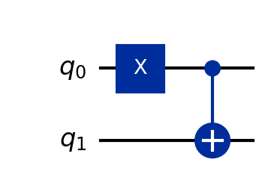
Figure 1.1. The CNOT circuit with the control qubit prepared in |1⟩.

Observation
With the control in |1⟩ and the target in |0⟩, the state |01⟩ became |11⟩ after the CNOT was applied. Read in Qiskit's ordering, the control qubit q0 stayed at 1 while the target qubit q1 went from 0 to 1, which is exactly the flip that was to be verified. The amplitude vector moved from position 1 to position 3 of the four-element statevector, with no amplitude appearing anywhere else, confirming that the gate produced a single definite basis state and not a superposition.
The generated truth table matched target' = control XOR target on all four rows. The two rows with the control at 0 left the target untouched, while the two rows with the control at 1 flipped it, and in every row the control itself was returned unchanged. The printed matrix showed the same fact in another form, being the identity with its last two rows exchanged. Applying the gate twice was confirmed to give the identity, which is the expected result since CNOT is its own inverse, and it is also the reason the gate can be used freely in reversible circuits without any information being lost.

Exercise 2: Medium

Generating a Bell State and Measuring It Over 1024 Shots
The statement that only 00 and 11 are observed is really a claim about two separate things, so the program checks both. The statevector is printed first, showing that the amplitudes on |01⟩ and |10⟩ are exactly zero, which is the theoretical half of the claim. The circuit is then measured over 1024 shots to show that neither outcome ever turns up in practice either.
The split between 00 and 11 is also compared against the expected 512 each, because a genuinely fair state still produces a small wobble away from an exact half, and it is worth knowing in advance that such a wobble is ordinary sampling noise and not a mistake in the circuit.
Code
import matplotlib.pyplot as plt
import numpy as np
from qiskit import QuantumCircuit, transpile
from qiskit.quantum_info import Statevector
from qiskit.visualization import plot_histogram
from qiskit_aer import AerSimulator

SHOTS = 1024
SEED = 4321

# ---------------------------------------------------------------------
# 1. Build the Bell state |Phi+> = (|00> + |11>) / sqrt(2)
# ---------------------------------------------------------------------
bell = QuantumCircuit(2)
bell.h(0) # put the control into an equal superposition
bell.cx(0, 1) # copy that superposition onto the target

print("--- Circuit Diagram ---")
print(bell.draw(output="text"))

# ---------------------------------------------------------------------
# 2. Theory: read the exact amplitudes before any measurement
# ---------------------------------------------------------------------
state = Statevector(bell)
print("\n--- Statevector (exact, no shots involved) ---")
for index, amplitude in enumerate(state.data):
label = format(index, "02b")
probability = abs(amplitude) ** 2
print(f" |{label}> : amplitude {amplitude.real:+.4f} "
f"probability {probability:.4f}")
print(f" Amplitude on |01> and |10> is exactly zero : "
f"{np.isclose(abs(state.data[1]), 0) and np.isclose(abs(state.data[2]), 0)}")
print(f" Norm check : sum of |amplitude|^2 = {np.sum(np.abs(state.data) ** 2):.6f}")

# ---------------------------------------------------------------------
# 3. Practice: measure both qubits, 1024 shots
# ---------------------------------------------------------------------
measured = bell.copy()
measured.measure_all()

simulator = AerSimulator(seed_simulator=SEED)
job = simulator.run(transpile(measured, simulator), shots=SHOTS)
counts = job.result().get_counts()

print(f"\n--- Measurement results ({SHOTS} shots) ---")
for outcome in sorted(counts):
share = 100 * counts[outcome] / SHOTS
print(f" {outcome} : {counts[outcome]:4d} shots ({share:5.2f} %)")

# ---------------------------------------------------------------------
# 4. Verify the claim
# ---------------------------------------------------------------------
forbidden = {"01", "10"}
observed = set(counts)
print("\n--- Verification ---")
print(f" Outcomes observed : {sorted(observed)}")
print(f" Forbidden outcomes 01 / 10 seen: {sorted(observed & forbidden) or 'none'}")
print(f" Only 00 and 11 appeared : {observed <= {'00', '11'}}")
print(f" Total shots accounted for : {sum(counts.values())} of {SHOTS}")

expected = SHOTS / 2
deviation = abs(counts.get("00", 0) - expected)
print(f" Expected split : {expected:.0f} / {expected:.0f}")
percent = 100 * deviation / SHOTS
print(f" Deviation from an even split : {deviation:.0f} shots ({percent:.2f} %)")
print(" A small deviation is ordinary sampling noise, not a fault in the circuit.")

# ---------------------------------------------------------------------
# 5. Histogram
# ---------------------------------------------------------------------
plot_histogram(counts, title=f"Bell state |Phi+> -- {SHOTS} shots")
plt.show()
Output
--- Circuit Diagram ---
┌───┐
q_0: ┤ H ├──■──
└───┘┌─┴─┐
q_1: ─────┤ X ├
└───┘

--- Statevector (exact, no shots involved) ---
|00> : amplitude +0.7071 probability 0.5000
|01> : amplitude +0.0000 probability 0.0000
|10> : amplitude +0.0000 probability 0.0000
|11> : amplitude +0.7071 probability 0.5000
Amplitude on |01> and |10> is exactly zero : True
Norm check : sum of |amplitude|^2 = 1.000000

--- Measurement results (1024 shots) ---
00 : 483 shots (47.17 %)
11 : 541 shots (52.83 %)

--- Verification ---
Outcomes observed : ['00', '11']
Forbidden outcomes 01 / 10 seen: none
Only 00 and 11 appeared : True
Total shots accounted for : 1024 of 1024
Expected split : 512 / 512
Deviation from an even split : 29 shots (2.83 %)
A small deviation is ordinary sampling noise, not a fault in the circuit.
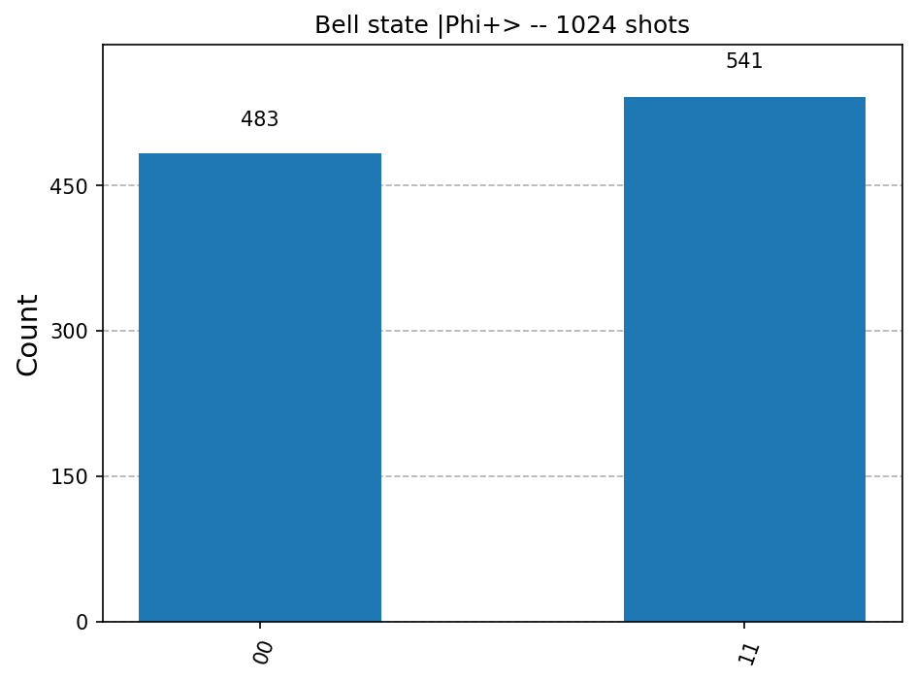
Figure 2.1. Measurement histogram of the Bell state over 1024 shots.

Observation
The statevector carried an amplitude of +0.7071 on both |00⟩ and |11⟩, giving a probability of 0.5000 for each, and exactly zero on |01⟩ and |10⟩. The norm check returned 1.000000 as expected. Over 1024 shots the outcomes were 483 counts of 00 and 541 counts of 11, with no occurrence of 01 or 10 at all, so the forbidden outcomes were absent in the simulated data as well as in the theory.
The split deviated from the ideal 512 / 512 by 29 shots, that is by 2.83 percent. This is sampling noise of the size one should expect, since the standard deviation of a fair 1024-shot binomial count is 16 shots and a deviation of 29 is under two standard deviations. It is worth noting that this noise affects only the balance between 00 and 11 and never produces a 01 or a 10, because the forbidden outcomes have zero amplitude rather than a small one. The correlation in a Bell state is therefore exact, while the individual outcome remains genuinely random.

Exercise 3: Hard

A Three-Qubit GHZ State and Its Perfect Three-Way Correlation
Perfect three-way correlation means that in every single shot all three qubits agree, so the program checks the results shot by shot rather than only looking at the totals. Two further checks are added, because the shot totals on their own would not distinguish a GHZ state from an ordinary classical coin whose value has simply been copied onto three bits.
The first of these computes the pairwise correlation ⟨ZiZj⟩ for all three pairs of qubits, and the second reports how each qubit behaves when it is looked at on its own. Taken together these show that the three qubits are perfectly locked to one another while no individual qubit is predictable, which is the combination that makes the state interesting.
Code
import matplotlib.pyplot as plt
import numpy as np
from qiskit import QuantumCircuit, transpile
from qiskit.quantum_info import Statevector
from qiskit.visualization import plot_histogram
from qiskit_aer import AerSimulator

SHOTS = 1024
SEED = 4321

# ---------------------------------------------------------------------
# 1. Build the GHZ state (|000> + |111>) / sqrt(2)
# ---------------------------------------------------------------------
ghz = QuantumCircuit(3)
ghz.h(0) # one qubit into superposition
ghz.cx(0, 1) # entangle it with the second
ghz.cx(0, 2) # and with the third -- one shared superposition

print("--- Circuit Diagram ---")
print(ghz.draw(output="text"))
print(f"\n Circuit depth : {ghz.depth()} Gate count : {dict(ghz.count_ops())}")

# ---------------------------------------------------------------------
# 2. Exact state before measurement
# ---------------------------------------------------------------------
state = Statevector(ghz)
print("\n--- Statevector ---")
for index, amplitude in enumerate(state.data):
if abs(amplitude) > 1e-9:
print(f" |{format(index, '03b')}> : amplitude {amplitude.real:+.4f} "
f"probability {abs(amplitude) ** 2:.4f}")
print(f" Non-zero amplitudes : {int(np.sum(np.abs(state.data) > 1e-9))} out of 8")
print(f" Norm check : {np.sum(np.abs(state.data) ** 2):.6f}")

# ---------------------------------------------------------------------
# 3. Measure all three qubits, 1024 shots
# ---------------------------------------------------------------------
measured = ghz.copy()
measured.measure_all()

simulator = AerSimulator(seed_simulator=SEED)
job = simulator.run(transpile(measured, simulator), shots=SHOTS)
counts = job.result().get_counts()

print(f"\n--- Measurement results ({SHOTS} shots) ---")
for outcome in sorted(counts):
share = 100 * counts[outcome] / SHOTS
print(f" {outcome} : {counts[outcome]:4d} shots ({share:5.2f} %)")

# ---------------------------------------------------------------------
# 4. Three-way correlation, checked shot by shot
# ---------------------------------------------------------------------
agreeing = sum(n for outcome, n in counts.items() if len(set(outcome)) == 1)
print("\n--- Three-way correlation ---")
print(f" Shots where all three qubits agree : {agreeing} of {SHOTS} "
f"({100 * agreeing / SHOTS:.2f} %)")
print(f" Mixed outcomes (001, 010, ... 110) : {SHOTS - agreeing}")
print(f" Perfect three-way correlation : {agreeing == SHOTS}")

# Bit i of the label counted from the right is qubit i (Qiskit ordering).
def correlation(first, second):
"""<Zi Zj> estimated from the counts: +1 if the pair always agrees."""
total = 0
for outcome, n in counts.items():
bit_i = int(outcome[::-1][first])
bit_j = int(outcome[::-1][second])
total += n * (1 if bit_i == bit_j else -1)
return total / SHOTS

print("\n Pairwise correlation <Zi Zj>:")
for first, second in ((0, 1), (0, 2), (1, 2)):
print(f" q{first} with q{second} : {correlation(first, second):+.4f}")

# ---------------------------------------------------------------------
# 5. Each qubit on its own is still completely random
# ---------------------------------------------------------------------
print("\n--- Each qubit taken individually ---")
for qubit in range(3):
ones = sum(n for outcome, n in counts.items() if outcome[::-1][qubit] == "1")
print(f" q{qubit} : P(1) = {ones / SHOTS:.4f} (a fair coin on its own)")
print(" Knowing one qubit fixes the other two, yet no qubit is predictable alone.")
print(" That is the part a classical shared random bit cannot reproduce in full.")

# ---------------------------------------------------------------------
# 6. Histogram
# ---------------------------------------------------------------------
plot_histogram(counts, title=f"GHZ state -- {SHOTS} shots")
plt.show()
Output
--- Circuit Diagram ---
┌───┐
q_0: ┤ H ├──■────■──
└───┘┌─┴─┐ │
q_1: ─────┤ X ├──┼──
└───┘┌─┴─┐
q_2: ──────────┤ X ├
└───┘

Circuit depth : 3 Gate count : {'cx': 2, 'h': 1}

--- Statevector ---
|000> : amplitude +0.7071 probability 0.5000
|111> : amplitude +0.7071 probability 0.5000
Non-zero amplitudes : 2 out of 8
Norm check : 1.000000

--- Measurement results (1024 shots) ---
000 : 508 shots (49.61 %)
111 : 516 shots (50.39 %)

--- Three-way correlation ---
Shots where all three qubits agree : 1024 of 1024 (100.00 %)
Mixed outcomes (001, 010, ... 110) : 0
Perfect three-way correlation : True

Pairwise correlation <Zi Zj>:
q0 with q1 : +1.0000
q0 with q2 : +1.0000
q1 with q2 : +1.0000

--- Each qubit taken individually ---
q0 : P(1) = 0.5039 (a fair coin on its own)
q1 : P(1) = 0.5039 (a fair coin on its own)
q2 : P(1) = 0.5039 (a fair coin on its own)
Knowing one qubit fixes the other two, yet no qubit is predictable alone.
That is the part a classical shared random bit cannot reproduce in full.
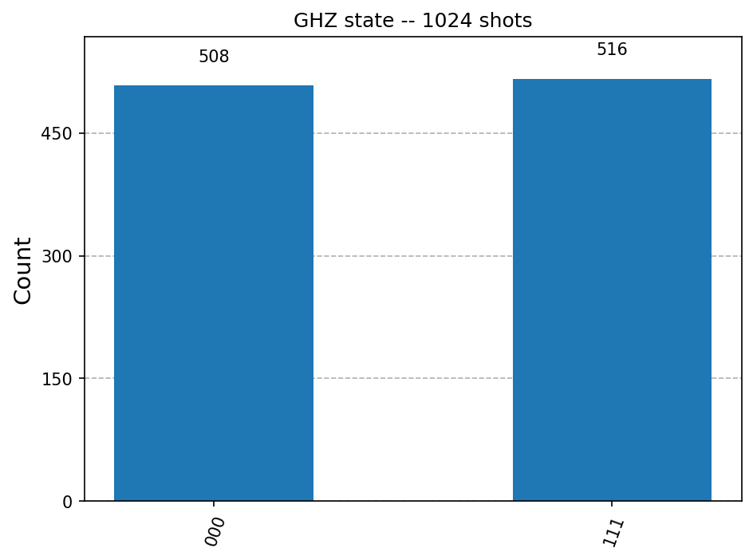
Figure 3.1. Measurement histogram of the GHZ state over 1024 shots.

Observation
The statevector contained only two non-zero amplitudes out of eight, both equal to +0.7071 and sitting on |000⟩ and |111⟩, with the remaining six components exactly zero. The circuit required only three gates, one Hadamard and two CNOTs, giving a depth of 3, which shows that the state is far simpler to prepare than its correlations might suggest.
Across 1024 shots the results were 508 counts of 000 and 516 counts of 111. All 1024 shots had every qubit in agreement, so the three-way correlation was 100 percent with not a single mixed outcome such as 001 or 110 appearing. The pairwise correlation ⟨ZiZj⟩ came out as exactly +1.0000 for all three pairs, confirming that the agreement holds for every pair and not merely on average.
At the same time each qubit taken on its own gave P(1) = 0.5039, which is a fair coin within sampling noise. This is the point worth holding on to from this exercise: measuring any one qubit fixes the other two with certainty, and yet no qubit is predictable by itself. The information is stored in the relationship between the qubits rather than in any of them individually.

Exercise 4: Real World Application

A Reversible Full Adder Built from Toffoli and CNOT Gates
A full adder takes two bits A and B along with a carry-in, and produces a sum bit and a carry-out. The classical version is built from AND and XOR gates, neither of which is reversible, since knowing the output of an AND gate does not tell you what went into it. Both are therefore rebuilt here in reversible form: XOR becomes a CNOT, and AND becomes a Toffoli writing its result onto a spare qubit.
The qubits are mapped as q0 = A, q1 = B, q2 = carry-in and q3 = carry-out, where q3 starts in |0⟩ as an ancilla. After the four gates have run, the sum bit is left in q2 and the carry-out in q3. The circuit is then run for all eight input combinations and each result is compared against ordinary Python arithmetic, so that the adder is properly verified and not merely demonstrated on one favourable case.
Code
from itertools import product

import matplotlib.pyplot as plt
from qiskit import ClassicalRegister, QuantumCircuit, QuantumRegister, transpile
from qiskit_aer import AerSimulator

SHOTS = 256
A, B, CIN, COUT = 0, 1, 2, 3

def full_adder(a_bit, b_bit, cin_bit):
"""Build a full adder for one fixed input triple, with measurements."""
q = QuantumRegister(4, "q")
c = ClassicalRegister(2, "out") # out[0] = sum, out[1] = carry
qc = QuantumCircuit(q, c)

# -- load the classical inputs -------------------------------------
for bit, wire in ((a_bit, A), (b_bit, B), (cin_bit, CIN)):
if bit:
qc.x(wire)
qc.barrier(label="inputs")

# -- the adder itself ----------------------------------------------
qc.ccx(A, B, COUT) # carry generated by A AND B
qc.cx(A, B) # q1 now holds A XOR B
qc.ccx(B, CIN, COUT) # carry generated by (A XOR B) AND Cin
qc.cx(B, CIN) # q2 now holds A XOR B XOR Cin = sum
qc.barrier(label="adder")

qc.measure(CIN, 0) # sum
qc.measure(COUT, 1) # carry-out
return qc

# ---------------------------------------------------------------------
# 1. Show one representative circuit (the 1 + 1 + 1 case)
# ---------------------------------------------------------------------
example = full_adder(1, 1, 1)
print("--- Circuit Diagram (A=1, B=1, Cin=1) ---")
print(example.draw(output="text"))

print(f"\n Gate count (as written) : {dict(example.count_ops())}")
print(f" Circuit depth : {example.depth()}")
decomposed = transpile(example, basis_gates=["cx", "u"], optimization_level=0)
print(f" Depth after decomposing into 1- and 2-qubit gates : {decomposed.depth()}")
print(f" CNOTs after decomposition : {decomposed.count_ops().get('cx', 0)}")
print(" Each Toffoli is not a hardware gate; it is compiled into 6 CNOTs plus")
print(" single-qubit rotations, which is why the real depth is much larger.")

# ---------------------------------------------------------------------
# 2. Run all eight input combinations
# ---------------------------------------------------------------------
simulator = AerSimulator()
print(f"\n--- Full adder truth table ({SHOTS} shots per input) ---")
print(" A B Cin | Sum Cout | Expected | Deterministic Correct")

all_correct = True
for a_bit, b_bit, cin_bit in product((0, 1), repeat=3):
qc = full_adder(a_bit, b_bit, cin_bit)
job = simulator.run(transpile(qc, simulator), shots=SHOTS)
counts = job.result().get_counts()

outcome = max(counts, key=counts.get) # bitstring reads as "carry sum"
carry, total = int(outcome[0]), int(outcome[1])

classical = a_bit + b_bit + cin_bit
expected_sum, expected_carry = classical % 2, classical // 2

deterministic = len(counts) == 1
correct = deterministic and total == expected_sum and carry == expected_carry
all_correct &= correct

print(f" {a_bit} {b_bit} {cin_bit} | {total} {carry} |"
f" {expected_carry}{expected_sum} = {classical} |"
f" {str(deterministic):5s} {correct}")

print(f"\n All eight rows correct : {all_correct}")
print(" Every run landed on a single outcome with no spread, which is what a")
print(" reversible circuit on basis-state inputs should do -- no superposition")
print(" was created anywhere, so there is nothing for the measurement to sample.")

# ---------------------------------------------------------------------
# 3. Why bother, if a classical adder already exists
# ---------------------------------------------------------------------
print("\n--- Note ---")
print(" On basis-state inputs this is only a slower classical adder. Its value")
print(" is that being reversible, it also runs on superposed inputs: feeding A")
print(" and B as superpositions adds every pair of numbers in one pass, which is")
print(" how arithmetic appears inside Shor's algorithm.")

# ---------------------------------------------------------------------
# 4. Circuit diagram figure
# ---------------------------------------------------------------------
example.draw(output="mpl", fold=-1)
plt.show()
Output
--- Circuit Diagram (A=1, B=1, Cin=1) ---
┌───┐ inputs adder
q_0: ┤ X ├───░──────■────■───────────────░─────────
├───┤ ░ │ ┌─┴─┐ ░
q_1: ┤ X ├───░──────■──┤ X ├──■────■─────░─────────
├───┤ ░ │ └───┘ │ ┌─┴─┐ ░ ┌─┐
q_2: ┤ X ├───░──────┼─────────■──┤ X ├───░───┤M├───
└───┘ ░ ┌─┴─┐ ┌─┴─┐└───┘ ░ └╥┘┌─┐
q_3: ────────░────┤ X ├─────┤ X ├────────░────╫─┤M├
░ └───┘ └───┘ ░ ║ └╥┘
out: 2/═════════════════════════════════════════╩══╩═
0 1

Gate count (as written) : {'x': 3, 'barrier': 2, 'ccx': 2, 'cx': 2, 'measure': 2}
Circuit depth : 6
Depth after decomposing into 1- and 2-qubit gates : 24
CNOTs after decomposition : 14
Each Toffoli is not a hardware gate; it is compiled into 6 CNOTs plus
single-qubit rotations, which is why the real depth is much larger.

--- Full adder truth table (256 shots per input) ---
A B Cin | Sum Cout | Expected | Deterministic Correct
0 0 0 | 0 0 | 00 = 0 | True True
0 0 1 | 1 0 | 01 = 1 | True True
0 1 0 | 1 0 | 01 = 1 | True True
0 1 1 | 0 1 | 10 = 2 | True True
1 0 0 | 1 0 | 01 = 1 | True True
1 0 1 | 0 1 | 10 = 2 | True True
1 1 0 | 0 1 | 10 = 2 | True True
1 1 1 | 1 1 | 11 = 3 | True True

All eight rows correct : True
Every run landed on a single outcome with no spread, which is what a
reversible circuit on basis-state inputs should do -- no superposition
was created anywhere, so there is nothing for the measurement to sample.

--- Note ---
On basis-state inputs this is only a slower classical adder. Its value
is that being reversible, it also runs on superposed inputs: feeding A
and B as superpositions adds every pair of numbers in one pass, which is
how arithmetic appears inside Shor's algorithm.
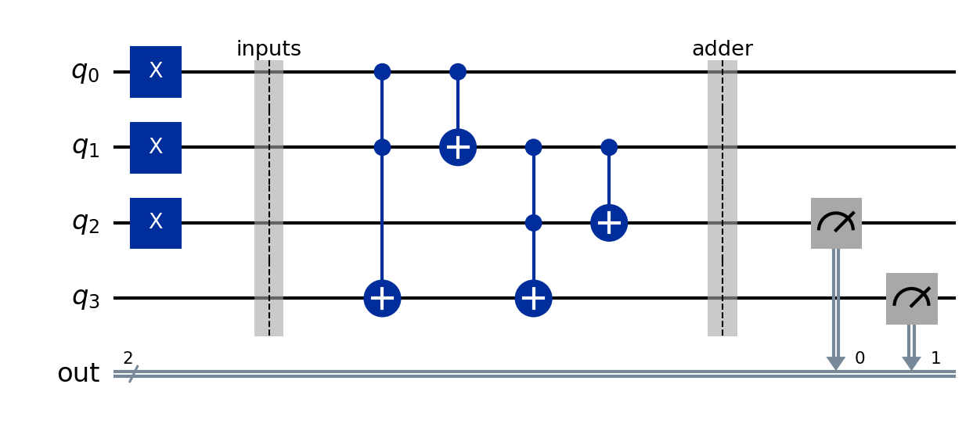
Figure 4.1. The reversible full adder circuit, shown for the input A = 1, B = 1, Cin = 1.

Observation
All eight rows of the truth table were produced correctly, with the sum and carry-out matching A + B + Cin in every case, including the 1 + 1 + 1 case which must give a sum of 1 with a carry of 1. Every one of the eight runs landed on a single outcome across all 256 shots with no spread whatsoever. This is the correct behaviour for a reversible circuit acting on basis state inputs, because no superposition is created anywhere in the circuit and there is consequently nothing for the measurement to sample randomly.
The gate count and depth deserve a closer look. As written, the circuit uses two Toffoli gates and two CNOTs and has a depth of 6. After being decomposed into one- and two-qubit gates the depth rose to 24 with 14 CNOTs, since each Toffoli is compiled into six CNOTs plus several single-qubit rotations. The cost of a circuit as written can therefore be quite misleading, and the Toffoli gate in particular is far more expensive on real hardware than its single symbol in the diagram suggests.
On basis-state inputs this adder is only a slower version of a classical one, and there would be no reason to prefer it. Its value lies in being reversible, which means it also runs correctly on superposed inputs. Preparing A and B as superpositions would add every pair of numbers in a single pass, and it is in this form that arithmetic appears inside larger algorithms such as Shor's.

Exercise 5: Challenge

An Arbitrary Entangled State Verified by State Tomography
The state chosen for this exercise is the partially entangled |ψ⟩ = cos(t)|00⟩ + sin(t)|11⟩ with t = 30 degrees, which gives amplitudes of 0.8660 and 0.5000. It is built by replacing the Hadamard gate of the Bell recipe with an RY(2t) rotation, so that the control qubit begins unevenly weighted and the CNOT then carries that same imbalance across to the second qubit.
Three things are then checked. The state is confirmed to be entangled using the concurrence and the purity of the reduced state, it is confirmed not to be any of the four standard Bell states by computing the fidelity against each of them, and finally the full density matrix is reconstructed from the sixteen Pauli expectation values, which is what state tomography actually computes in practice.
Code
import matplotlib.pyplot as plt
import numpy as np
from qiskit import QuantumCircuit, transpile
from qiskit.quantum_info import (
DensityMatrix, Pauli, Statevector, partial_trace, state_fidelity
)
from qiskit.visualization import plot_histogram
from qiskit_aer import AerSimulator

THETA = np.pi / 6 # 30 degrees
SHOTS = 1024
SEED = 4321

# ---------------------------------------------------------------------
# 1. Build the state
# ---------------------------------------------------------------------
qc = QuantumCircuit(2)
qc.ry(2 * THETA, 0) # 0.8660|0> + 0.5000|1> on the control
qc.cx(0, 1) # carry the imbalance across

print("--- Circuit Diagram ---")
print(qc.draw(output="text"))
print(f"\n Chosen angle t = {np.degrees(THETA):.0f} degrees")
print(f" Target state : {np.cos(THETA):.4f}|00> + {np.sin(THETA):.4f}|11>")

state = Statevector(qc)
target = np.array([np.cos(THETA), 0, 0, np.sin(THETA)])

print("\n--- Statevector produced ---")
for index, amplitude in enumerate(state.data):
probability = abs(amplitude) ** 2
print(f" |{format(index, '02b')}> : amplitude {amplitude.real:+.4f} "
f"probability {probability:.4f}")
print(f" Matches the target amplitudes : {np.allclose(state.data, target)}")

# ---------------------------------------------------------------------
# 2. Is it entangled, and how strongly?
# ---------------------------------------------------------------------
a, b, c, d = state.data
concurrence = 2 * abs(a * d - b * c)
reduced = partial_trace(state, [1])
purity = np.real(np.trace(reduced.data @ reduced.data))

print("\n--- Entanglement check ---")
print(f" Concurrence : {concurrence:.4f} (0 = separable, 1 = maximal)")
print(f" Purity of qubit 0 alone: {purity:.4f} (below 1 means entangled)")
print(f" Entangled : {concurrence > 1e-9}")
print(f" Maximally entangled : {np.isclose(concurrence, 1.0)}")

# ---------------------------------------------------------------------
# 3. Confirm it is not one of the four standard Bell states
# ---------------------------------------------------------------------
r2 = 1 / np.sqrt(2)
bell_states = {
"|Phi+> = (|00>+|11>)/sqrt2": [r2, 0, 0, r2],
"|Phi-> = (|00>-|11>)/sqrt2": [r2, 0, 0, -r2],
"|Psi+> = (|01>+|10>)/sqrt2": [0, r2, r2, 0],
"|Psi-> = (|01>-|10>)/sqrt2": [0, r2, -r2, 0],
}
print("\n--- Fidelity against the four Bell states ---")
for name, vector in bell_states.items():
print(f" {name} : {state_fidelity(state, Statevector(vector)):.4f}")
print(" None reaches 1.0, so the state is entangled but is not a Bell state.")

# ---------------------------------------------------------------------
# 4. State tomography -- rebuild the density matrix from Pauli measurements
# ---------------------------------------------------------------------
# Any 2-qubit density matrix can be written as
# rho = (1/4) * sum over all 16 Pauli pairs of <P> * P
# so measuring those 16 expectation values determines the state completely.
labels = [first + second for first in "IXYZ" for second in "IXYZ"]
expectations = {label: state.expectation_value(Pauli(label)).real for label in labels}

print("\n--- Pauli expectation values (the tomography data) ---")
for label in labels:
if abs(expectations[label]) > 1e-9:
print(f" <{label}> = {expectations[label]:+.4f}")
print(f" {sum(abs(v) > 1e-9 for v in expectations.values())} of 16 are non-zero; "
"the rest are exactly zero.")

terms = (expectations[label] * Pauli(label).to_matrix() for label in labels)
reconstructed = sum(terms) / 4
true_rho = DensityMatrix(state).data

print("\n--- Reconstruction ---")
print(" Reconstructed density matrix (real part):")
for row in np.round(np.real(reconstructed), 4):
print(" " + " ".join(f"{value:+.4f}" for value in row))
print(f" Max difference from the true density matrix : "
f"{np.max(np.abs(reconstructed - true_rho)):.2e}")
print(f" Fidelity of reconstruction : "
f"{state_fidelity(DensityMatrix(reconstructed), state):.6f}")
print(" The two off-diagonal corners are the entanglement; a separable state")
print(" would have zeros there while keeping the same diagonal.")

# ---------------------------------------------------------------------
# 5. Sanity check against 1024 actual shots
# ---------------------------------------------------------------------
measured = qc.copy()
measured.measure_all()
simulator = AerSimulator(seed_simulator=SEED)
job = simulator.run(transpile(measured, simulator), shots=SHOTS)
counts = job.result().get_counts()

print(f"\n--- Measured counts ({SHOTS} shots) ---")
for outcome in sorted(counts):
observed = counts[outcome] / SHOTS
theory = abs(state.data[int(outcome, 2)]) ** 2
print(f" {outcome} : {counts[outcome]:4d} observed {observed:.4f} "
f"theory {theory:.4f}")
print(f" Only |00> and |11> appeared : {set(counts) <= {'00', '11'}}")
print(" The correlation is still perfect; only the 50/50 split is gone.")

plot_histogram(counts, title="Partially entangled state -- 1024 shots")
plt.show()
Output
--- Circuit Diagram ---
┌─────────┐
q_0: ┤ Ry(π/3) ├──■──
└─────────┘┌─┴─┐
q_1: ───────────┤ X ├
└───┘

Chosen angle t = 30 degrees
Target state : 0.8660|00> + 0.5000|11>

--- Statevector produced ---
|00> : amplitude +0.8660 probability 0.7500
|01> : amplitude +0.0000 probability 0.0000
|10> : amplitude +0.0000 probability 0.0000
|11> : amplitude +0.5000 probability 0.2500
Matches the target amplitudes : True

--- Entanglement check ---
Concurrence : 0.8660 (0 = separable, 1 = maximal)
Purity of qubit 0 alone: 0.6250 (below 1 means entangled)
Entangled : True
Maximally entangled : False

--- Fidelity against the four Bell states ---
|Phi+> = (|00>+|11>)/sqrt2 : 0.9330
|Phi-> = (|00>-|11>)/sqrt2 : 0.0670
|Psi+> = (|01>+|10>)/sqrt2 : 0.0000
|Psi-> = (|01>-|10>)/sqrt2 : 0.0000
None reaches 1.0, so the state is entangled but is not a Bell state.

--- Pauli expectation values (the tomography data) ---
<II> = +1.0000
<IZ> = +0.5000
<XX> = +0.8660
<YY> = -0.8660
<ZI> = +0.5000
<ZZ> = +1.0000
6 of 16 are non-zero; the rest are exactly zero.

--- Reconstruction ---
Reconstructed density matrix (real part):
+0.7500 +0.0000 +0.0000 +0.4330
+0.0000 +0.0000 +0.0000 +0.0000
+0.0000 +0.0000 +0.0000 +0.0000
+0.4330 +0.0000 +0.0000 +0.2500
Max difference from the true density matrix : 5.55e-17
Fidelity of reconstruction : 1.000000
The two off-diagonal corners are the entanglement; a separable state
would have zeros there while keeping the same diagonal.

--- Measured counts (1024 shots) ---
00 : 754 observed 0.7363 theory 0.7500
11 : 270 observed 0.2637 theory 0.2500
Only |00> and |11> appeared : True
The correlation is still perfect; only the 50/50 split is gone.
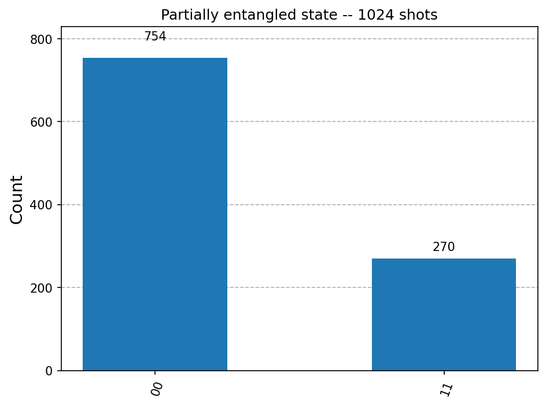
Figure 5.1. Measurement histogram of the partially entangled state over 1024 shots.

Observation
The circuit produced amplitudes of +0.8660 on |00⟩ and +0.5000 on |11⟩, matching the target exactly, with probabilities of 0.7500 and 0.2500. The concurrence came out as 0.8660, which is clearly non-zero and therefore confirms entanglement, but is equally clearly below 1 and so the state is not maximally entangled. The purity of qubit 0 taken alone was 0.6250, below the value of 1 that a pure single-qubit state would have, which is the same conclusion reached from the other direction.
The fidelity against the four Bell states was 0.9330, 0.0670, 0.0000 and 0.0000 respectively. The value of 0.9330 against |Φ+⟩ is high, which is only to be expected since the two states occupy the same |00⟩ and |11⟩ subspace, but it does not reach 1 and so the requirement of choosing a state other than a standard Bell state is satisfied.
The tomography step found only 6 of the 16 Pauli expectation values to be non-zero, these being ⟨II⟩ = +1, ⟨ZZ⟩ = +1, ⟨ZI⟩ = ⟨IZ⟩ = +0.5 and ⟨XX⟩ = −⟨YY⟩ = +0.8660. Rebuilding the density matrix from these values reproduced the true one with a maximum element-wise difference of 5.55 × 10⁻¹⁷, which is machine precision, and a fidelity of 1.000000. The reconstructed matrix carried 0.4330 in its two off-diagonal corners, and it is these corners that represent the entanglement, since a separable mixture with the same 0.75 and 0.25 diagonal would show zeros there. Over 1024 shots the measured frequencies were 0.7363 and 0.2637 against the theoretical 0.7500 and 0.2500, and only 00 and 11 ever appeared, showing that the correlation remained perfect even though the 50/50 balance of a Bell state was gone.

Conclusion
This tutorial built up multi-qubit circuits starting from the CNOT gate, whose full truth table was generated from the circuit itself rather than quoted, and whose action was confirmed to leave the control unchanged while flipping the target exactly when the control is |1⟩. Placing a Hadamard before that same CNOT turned it from a piece of classical logic into an entangling operation, producing a Bell state in which the amplitudes on |01⟩ and |10⟩ were exactly zero and in which 1024 shots produced no forbidden outcome even once.
The GHZ state extended this to three qubits, where every one of the 1024 shots showed all three qubits in agreement and all three pairwise correlations came out as exactly +1, while each qubit taken individually remained an unbiased coin. A reversible full adder was then built from two Toffoli gates and two CNOTs and verified against Python arithmetic on all eight input combinations, which also brought out how sharply the gate count rises once a Toffoli is decomposed into hardware-level gates.
Finally a partially entangled state was designed deliberately away from the standard Bell states, and was verified three separate ways: by concurrence and reduced purity, by fidelity against each Bell state, and by reconstructing its density matrix from all sixteen Pauli expectation values, which returned a fidelity of 1.000000. In every exercise the simulated result was checked against an explicit theoretical prediction, and all five programs executed without error on Qiskit 2.5.1 with Aer 0.17.2.

Reflection

Question 1: How does entanglement differ from classical correlation?
Classical correlation is simply shared information. If two sealed envelopes are prepared, both containing the same randomly chosen bit, and one is carried to another city, then opening one envelope tells you what is inside the other. The correlation is perfect, but nothing surprising has happened. The answer was decided when the envelopes were prepared, and reading one only reveals a fact that was already fixed.
The GHZ state of Exercise 3 looks identical to this if only the counts are examined. All three qubits always agreed, and each one on its own gave P(1) close to 0.5, which is exactly what three copied envelopes would give. The difference does not show up in the Z basis at all, and this is worth being honest about. It shows up when the qubits are measured in a different basis, and the reason can be seen directly in Exercise 5, where ⟨XX⟩ came out as +0.8660 alongside ⟨ZZ⟩ = +1. A classical mixture of |00⟩ and |11⟩ would reproduce the ⟨ZZ⟩ value but would give ⟨XX⟩ = 0, because it has no definite phase relationship between the two branches. The entangled state is correlated in more than one basis at once; the envelopes are correlated in only one.
The practical way to put it is that classical correlation is a record of a decision already taken, whereas in an entangled state no decision has been taken yet, and the outcome is genuinely created at the moment of measurement while still coming out correlated. This is also why the tomography in Exercise 5 mattered: the off-diagonal terms of 0.4330 in the density matrix are the part that a classical mixture cannot produce, and a separable mixture with the same diagonal would have shown zeros there.

Question 2: What practical difficulties did you face in scaling the circuit to 3 qubits?
The first difficulty was qubit ordering. Qiskit labels a state as |q2 q1 q0⟩, with qubit 0 on the right, which is the reverse of the order in which the qubits are written in the code. With two qubits this was already a nuisance in Exercise 1, and with three it became a real source of errors, particularly while extracting individual bits from a measurement string. The fix used here was to reverse the string once, using outcome[::-1][i] to obtain qubit i, and to keep that one convention everywhere rather than reasoning about it afresh at each step.
The second difficulty was that the state space grows much faster than the circuit does. Going from two qubits to three took the statevector from 4 amplitudes to 8, and the histogram from 4 possible outcomes to 8, while the circuit itself grew by only one CNOT. Printing all eight amplitudes was already cluttered, and six of them were zero, so the program was changed to print only the non-zero ones. This is manageable at three qubits but clearly will not survive many more, since ten qubits would mean 1024 amplitudes.
The third difficulty was that verification could no longer be done by eye. With two qubits it is enough to look at the histogram and see two bars. With three qubits the claim of perfect three-way correlation is a claim about every single shot, so the check had to be written as code, first by counting the shots in which all three bits agreed and then by computing ⟨ZiZj⟩ for all three pairs. The related difficulty seen in Exercise 4 was gate cost: the Toffoli gate needed for three-qubit logic decomposed into six CNOTs, which took the circuit depth from 6 to 24 and made it clear why deep multi-qubit circuits are hard to run on real hardware.

