**B3 Program Data Profiling Report:**

**Sales Opportunities**

|  |  |  |  |
| --- | --- | --- | --- |
| **Document Information** |  |  |  |
| **Document Name** | Sales Opportunities Profiling Report | | |
| **Document Author** | Saroja Nimmagadda | | |
| **Document Version** | 1.0 | | |
| **Document Status** | Draft | | |
| **Date Released** | 06.27.2013 | | |
| **Reviewed By** | Kamal Upreti | | |
| **Approved By** |  | | |
| **Approval Date** |  | | |
| **Approver Signature** |  | | |

# Table of Contents

Table of Contents 3

1. Opportunities- Profiling Report 5

2. Executive Summary 5

2.1 Data Profiling Scope 5

2.2 Summary of findings 5

3. Data Insight 7

3.1 Opportunity Category 7

3.2 BU Type Analysis 7

3.3 Approval Status Analysis 8

4. Entity Relationship Analysis 9

5. Detailed Data Profiling Findings 10

5.1 Opportunities 10

6. APPENDIX 12

6.1 Data Profiling Requirements 12

6.1.1 Data Mapping Sheet 12

6.1.2 X-Reference Source Data 12

6.1.3 Data Extracts used for Profiling 12

6.2 Key Sales Opportunites Fields in SAP ECC 13

6.3 Types of data cleansing 13

**1.0 Document Change History**

|  |  |  |  |
| --- | --- | --- | --- |
| **Date** | **Created / Modified By** | **Brief Description of Change** | **Doc version** |
| 27.06.2013 | Saroja Nimmagadda | Initial Draft | 1.0 |
|  |  |  |  |
|  |  |  |  |
|  |  |  |  |

# Opportunities- Profiling Report

The purpose of this document is to report the findings of the data profiling activity performed on Sales Opportunities data. This document provides detailed information along with statistics at the table level and column level thus helping us establish the SAP compatibility of Sales Opportunities data.

This document is intended to project the data anomalies and issues that need to be addressed in order for clean and usable data to be pushed to SAP ECC.

# Executive Summary

## Data Profiling Scope

Broadcom data resides only in Peoplesoft.

|  |  |  |  |  |
| --- | --- | --- | --- | --- |
| Data category | **Source system** | **Volume** | **Included in profiling scope** | **Comments** |
| **Opportunity** | PeopleSoft | 19395 |  | All active Opportunities are profiled |

## Summary of findings

The activity of data profiling included the following steps in chronological order:

1. Identify the core set of legacy tables based on knowledge of legacy SME and IT contacts listed by Business Analysts
2. Mapping of the critical SAP columns to legacy columns, and vice versa with the help of functional team and business analysts
3. Conduct *Data Insight Analysis* based on legacy info., *Entity Relationship Analysis* based on legacy table relationships and provide Detailed Data Profiling findings that help determine the SAP compatibility of data

The findings can be categorized as Critical and Non-Critical and here’s how we define them:

1. **Critical**: Any error that
   1. Prevents data from being created in SAP during conversion,
   2. Affects the scope of the conversion
   3. Leads to duplication of data.

This type of error will adversely affect the business processes in SAP

1. **Non-Critical**: Any error that leads to incomplete information being passed to any entity in SAP. This type of error *may* adversely affect the business processes in SAP. This requires further analysis and may be qualified as critical based on the extent to which business is affected

There were **8** data profiling findings for Sales Opportunities, with **7** of them leading to Critical errors. The charts below summarize the number of critical and non-critical errors for Sales Opportunites.

Please note that the numbers above signify count of errors. The details and data dumps for the above is provided in *Section 5: Detailed Data Profiling Findings*

# Data Insight

This section of the document details the different dimensions of data we observed in the legacy systems I.e. CRMOD. Any findings and data dump from this section will be listed in the Detailed Data Profiling Findings i.e. section 5

## Opportunity Category

We found 6 different types of Opportunities in CRMOD, The below table and chart shows the different types of Opportunities and their corresponding record counts. The diagram depicts a visual representation of the same.

We also found that 81 Opportunities were not assigned with Opportunity Category.

|  |  |
| --- | --- |
| **Opportunity Category** | **Count** |
| Disti Demand | 3299 |
| Disti Demand+Fulfillment | 8 |
| Disti Fulfillment | 1328 |
| ODM | 712 |
| OEM | 13967 |
| Blank/Not Assigned | 81 |

## BU Type Analysis

We found 5 different types of BU’s in CRMOD, The below diagram and chart shows the different types of Opportunities and their corresponding record counts. The diagram depicts a visual representation of the same.

We also found that 82 Opportunities were not assigned with BU

|  |  |
| --- | --- |
| **BU Type** | **Count** |
| Broadband Communications | 6678 |
| Corp | 89 |
| Infrastructure and Networking | 15688 |
| Mobile and Wireless Group | 7956 |
| Blank/Not assigned | 82 |

## Approval Status Analysis

We found 6 different types of Approval Statuses in CRMOD, The below diagram and chart shows the different types of Approvals and their corresponding record counts. The diagram depicts a visual representation of the same.

|  |  |
| --- | --- |
| **Approval Status** | **Count** |
| Approved | 16644 |
| Lost | 2 |
| Awaiting VP Approval | 14 |
| Open | 2433 |
| Pending Approval | 291 |
| Blank/Not Assigned | 11 |

# Entity Relationship Analysis

This analysis helps us validate the various joins of PeopleSoft tables and their corresponding counts. This is helpful i determining the effect of various attributes(columns) on the volume of data to be converted.

The tables that are being accessed for this purpose are:-

Opportunity, Opportunity Product.

The flow diagram provides us insight into the various tables that are involved, and the way each table is joined to another table. There are two tables mentioned in the flow that are joined using different joins.

Opportunity(19395)

Inner Join

Opportunity

Opportunity Product(30493)

# Detailed Data Profiling Findings

This analysis helps us to understand all of the issues for each field in the table and provide recommendations and appropriate actions. The column level analysis also provides guidance to understand business rules, patterns associated with each attribute of master data.

The data profiling reports at column level will be reviewed by Business and IT SMEs which will help them to understand the data standards, rules, cleansing and enrichment requirements in multiple cycles. These requirements will drive the data conversion strategy.

## Opportunities

The charts and the table below show the summary and details respectively for the errors at column level for Opportunities.

|  |  |  |  |  |  |
| --- | --- | --- | --- | --- | --- |
| Issue # | **Critical/**  **Non-Critical** | **Description** | **#Failures** | **Field** | **Record Dump** |
| 1 | Critical | Sales Opportunities has Inactive materials | 29182 | Product # |  |
| 2 | Critical | Sales Opportunities has Inactive Customers | 445 | Account Location |  |
| 3 | Critical | Sales Opportunities have no value for the field APPROVAL STATUS | 11 | APPROVAL_STATUS |  |
| 4 | Critical | Sales Opportunities have no value for the field OPPORTUNITY ID | 360 | OPPORTUNITY_ID |  |
| 5 | Critical | Sales Opportunities have special charecters for the field OPPORTUNITY_ID | 4 | OPPORTUNITY_ID |  |
| 6 | Critical | Sales Opportunites have no values for the field ACCOUNT_LOCATION | 26 | ACCOUNT_LOCATION |  |
| 7 | Critical | Sales Opportunites have no values for the field BU | 82 | BU |  |
| 8 | Non Critical | Sales Opportunites have null value for the field Expected Revenue. | 383 | EXPECTED REVENUE |  |

# APPENDIX

## Data Profiling Requirements

### Data Mapping Sheet

Attached is the Sales opportunites data definition sheet. This was used as the reference for assessing the quality of data received from respective source systems.



### X-Reference Source Data

N/A

### Data Extracts used for Profiling

The tables that are being accessed for this purpose are:-

OPPORTUNITY, OPPORTUNITY_PRODUCT

The entire data of Materials is coming from **PeopleSoft**, below are the system details

|  |  |
| --- | --- |
| **Legacy Source Info** | Peoplesoft |
| **Source Data for Data Analysis** | Production Copy |
| **Data Extract Date** | Complete Data as of 2-Jun-2013 |
| **Sensitive/Non-sensitive** | Non-Sensitive |

However, the data for this activity was provided via data files. Here are the details of the files and the subsequent volumes:

|  |  |
| --- | --- |
| **Source file** | **Number of Records** |
| Opportunity | 19395 |
| Opportunity Porduct | 30493 |

## Key Sales Opportunites Fields in SAP ECC

This information is captured in the Profiling Mapping sheet in section 6.1.

## Types of data cleansing

The following options will be used for the purposes of data cleanup in the B3 program:

* OPTION 1: Automated Cleanup in legacy production system
* OPTION 2: Manual Cleanup in legacy production system
* OPTION 3: Staged Cleanup (outside legacy production system)

The figure below shows the selection criteria that will be followed for selecting the cleanup option.

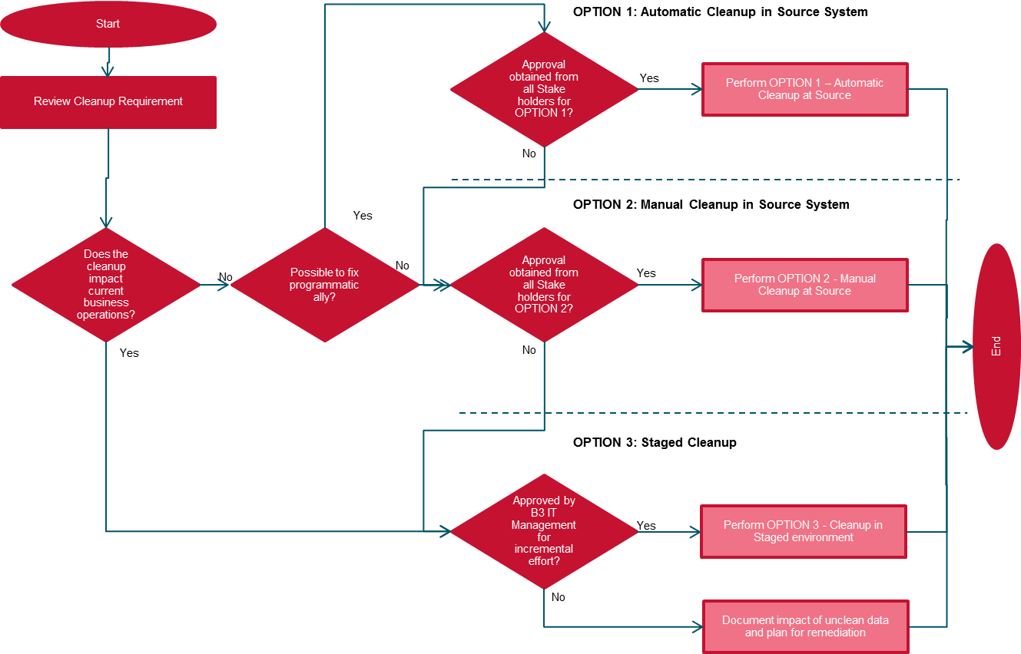

**Data Cleanup Options Selection Criteria**

Any deviation to the selection criteria (above figure) will require B3 IT Management approval.

For further details please refer to *Section* *8.3:* *Data Cleanup Options* in the Data Cleansing Approach document.