AI ASSISTED CODING

sriram 2303A51191
BATCH – 03 30 – 01 – 2026

ASSIGNMENT – 5.5

Lab 5: Ethical Foundations – Responsible AI Coding Practices.

TASK - 01 : (Transparency in Algorithm Optimization)

Prompt : Generate Python code for two prime-checking methods and explain how the optimized version improves performance.

Code:

- Basic Prime Checking Function
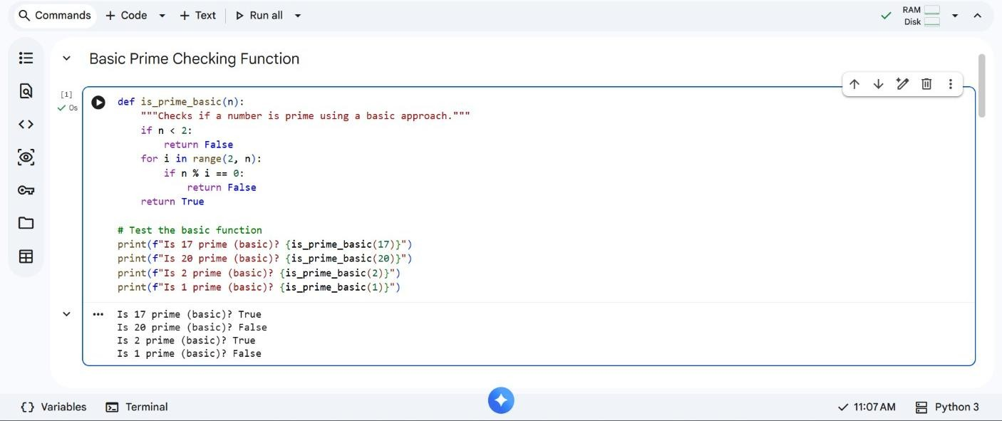

- Optimized Prime Checking Function
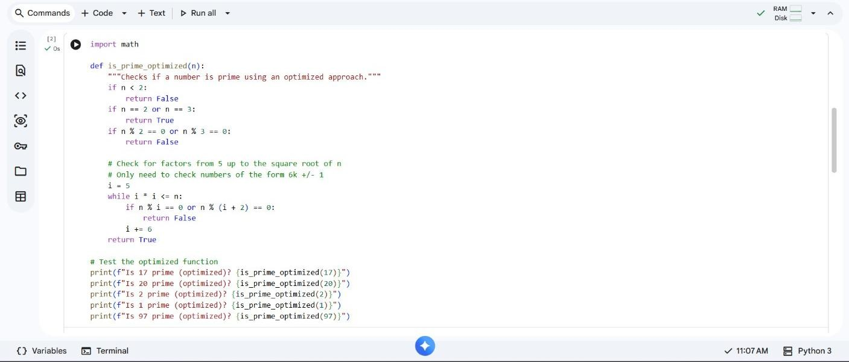

Transparent Explanation

:

Naive Method Time Complexity: O(n) → Checks all numbers from 2 to n-1.
Optimized Method Time Complexity: O(√n) → Only checks up to square root of n.

Comparison :
Method Time Complexity Performance
Naive O(n) Slower
Optimized O(√n) Faster

Task – 02 : Transparency in Recursive Algorithms.

Prompt : Give me the Recursive Fibonacci code with clear comments.

Code:
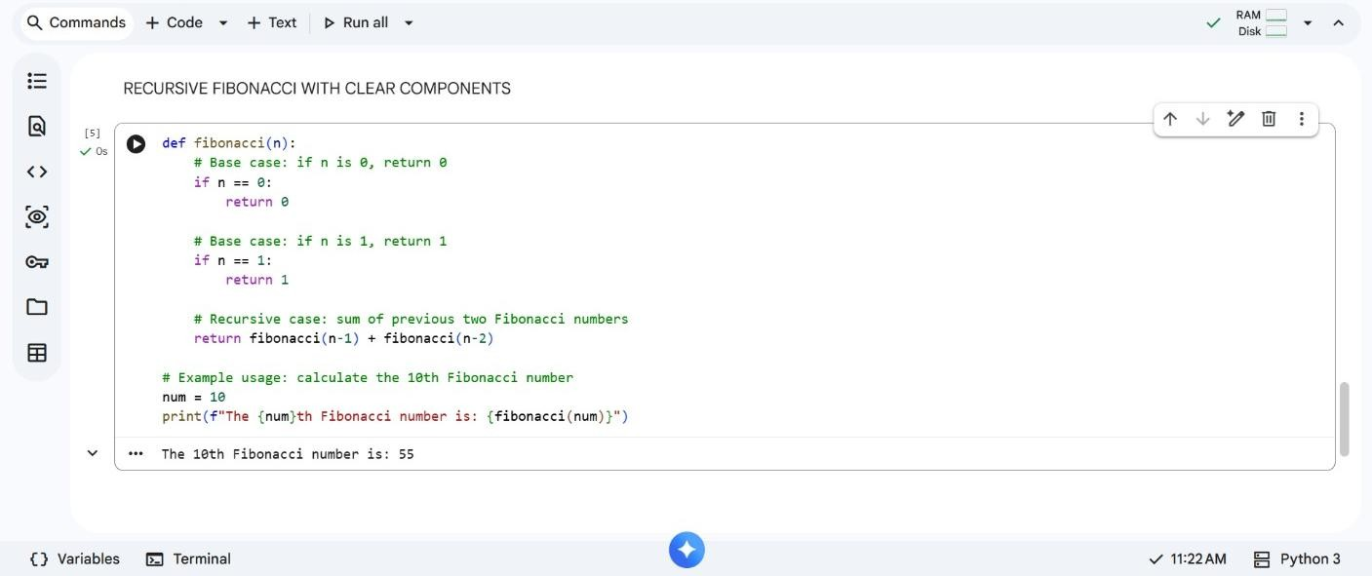

Explanation:

•

Base Cases:

o fibonacci(0) → 0 _{o} fibonacci(1) → 1
• Recursive Call:
o fibonacci(n) = fibonacci(n-1) + fibonacci(n-
2)

Task – 03 : Transparency in Error Handling.

Prompt : Generate code with proper error handling and clear explanations for each exception.

Code:
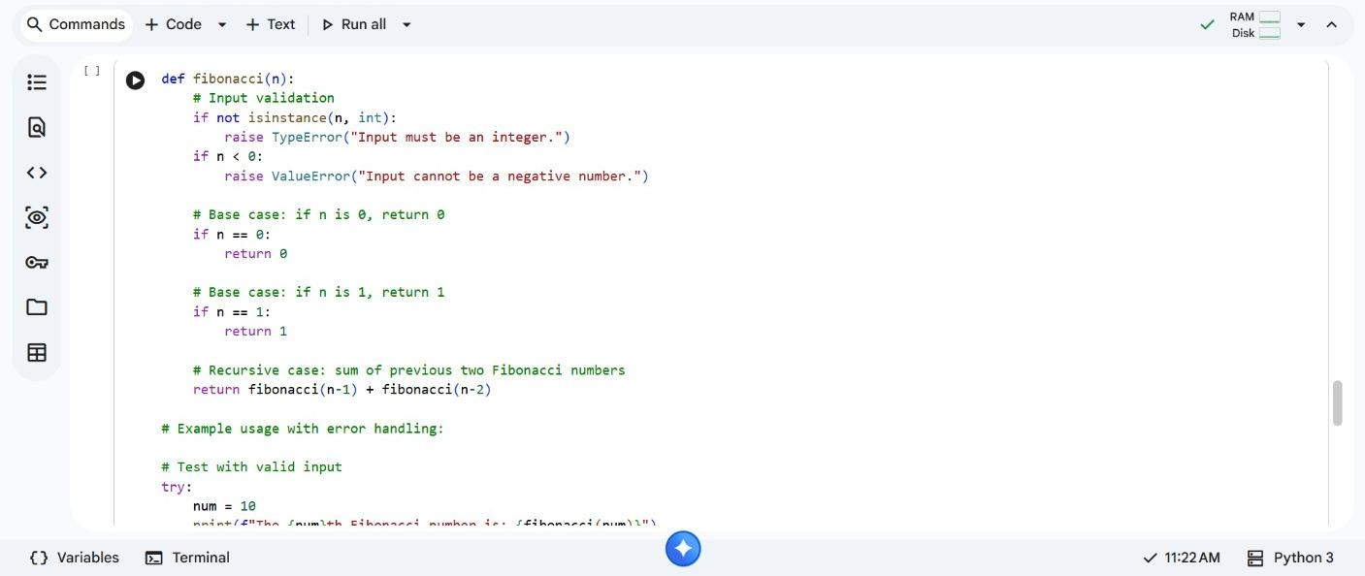

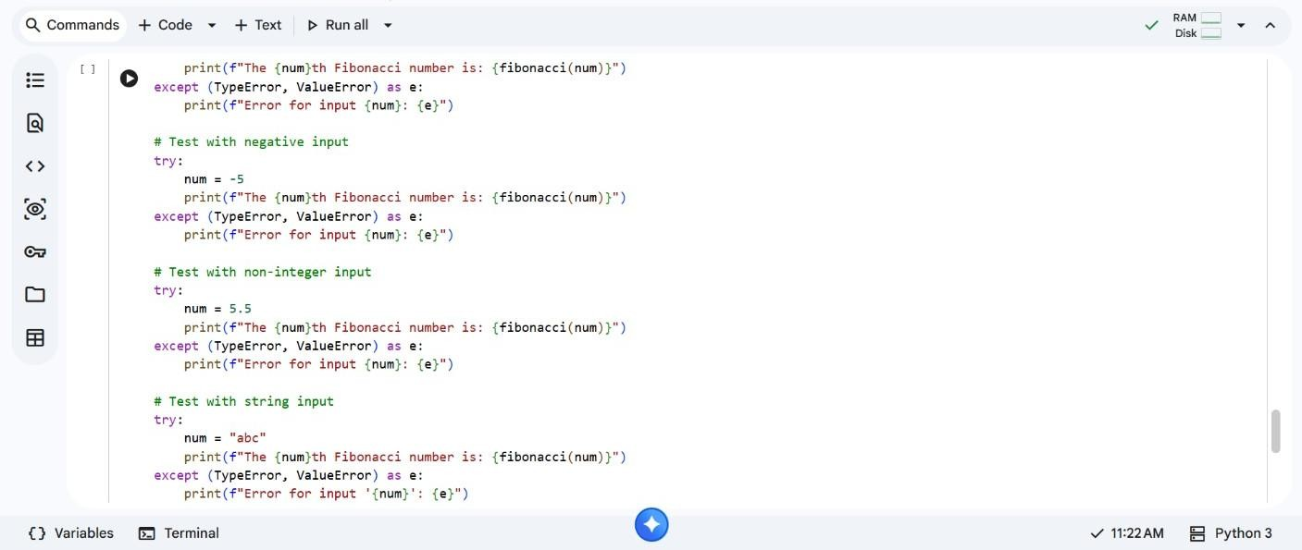

Exp

laining the Errors:

Exception Meaning
FileNotFoundError File does not exist
PermissionError No permission to read file Exception Any other unknown error Task – 04 : Security in User Authentication. Code:

Insecure Version:
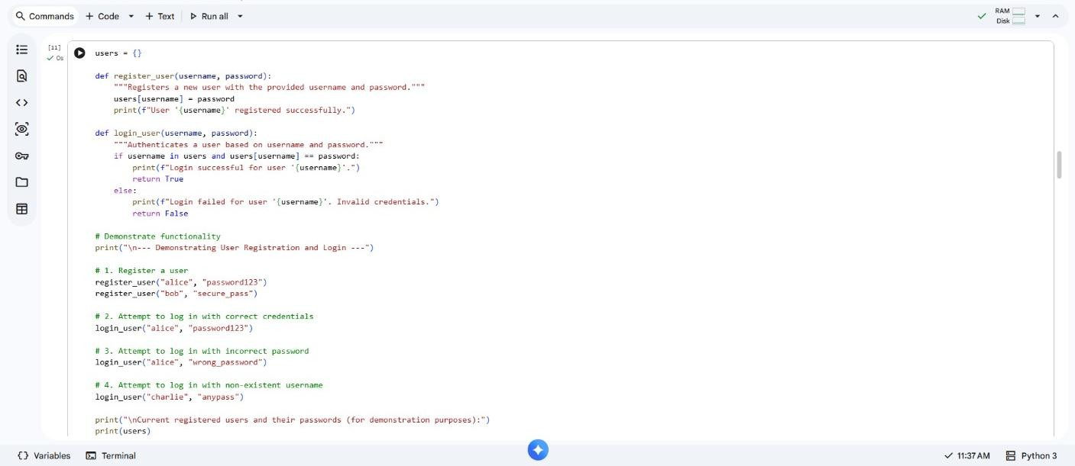

Secure Version:

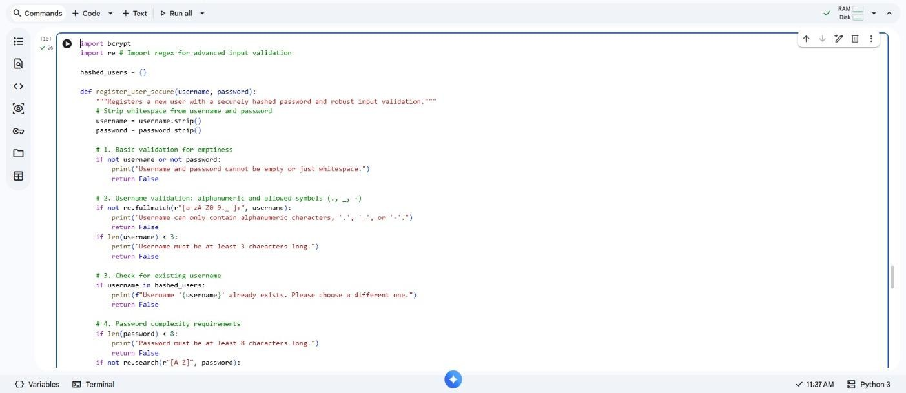

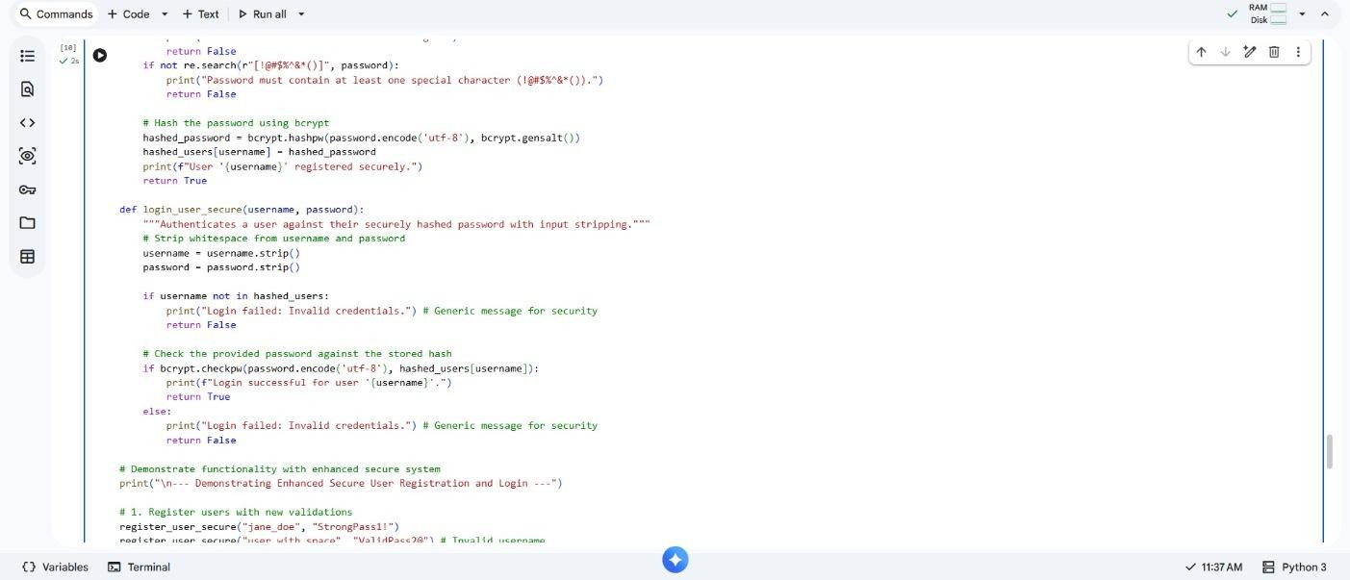

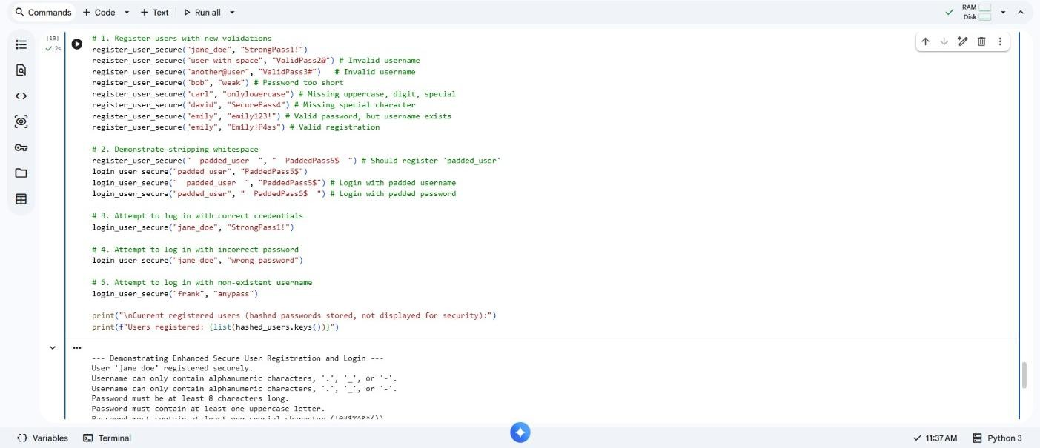

✓

Always hash passwords

✓

Never store plain
-
text passwords

E

xplaination :

- Validate user input
- Use strong hashing algorithms

Task – 05 : Privacy in Data Logging.
Prompt – 01 : Create a basic Python script that simulates logging user activity, including username, IP address, and timestamp, to a file or console.
Code:
Privacy and Risky Logging:
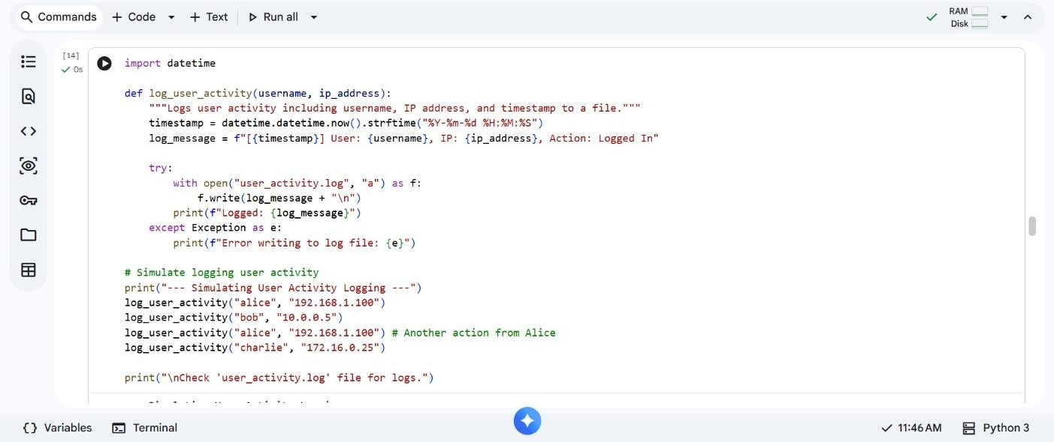

Prompt – 02 : Examine the initial logging script to identify specific privacy risks associated with logging sensitive data like usernames and IP addresses directly. Detail potential negative impacts.
Code:
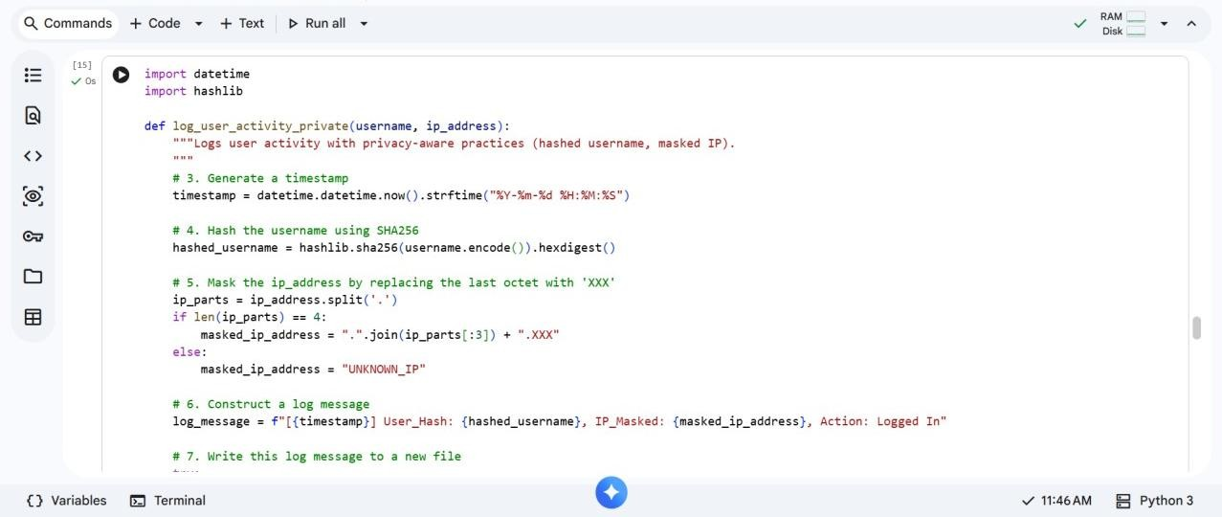

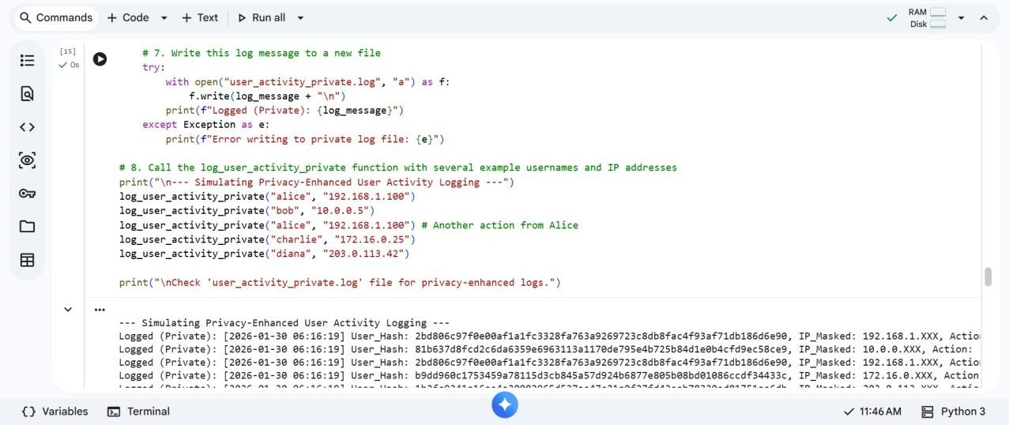

✓

Mask or anonymize sensitive data

✓

Log only what is necessary

Explaination :

- Avoid storing personal identifiers
- Protect log files from unauthorized access

THANK YOU!!

