AI ASSISTED CODING
POOJA CHITTALURI 2303A51186
BATCH – 03 24 – 02 – 2026

ASSIGNMENT – 11.2

Lab – 11 : Data Structures with AI : Implementing Fundamental Structures.
Task – 01 : Stack Using AI Guidance.
Prompt : Generate a Python class implementation of a Stack data structure with push, pop, peek, and is_empty methods. Add proper docstrings, comments, and a small example demonstrating usage.
Code :
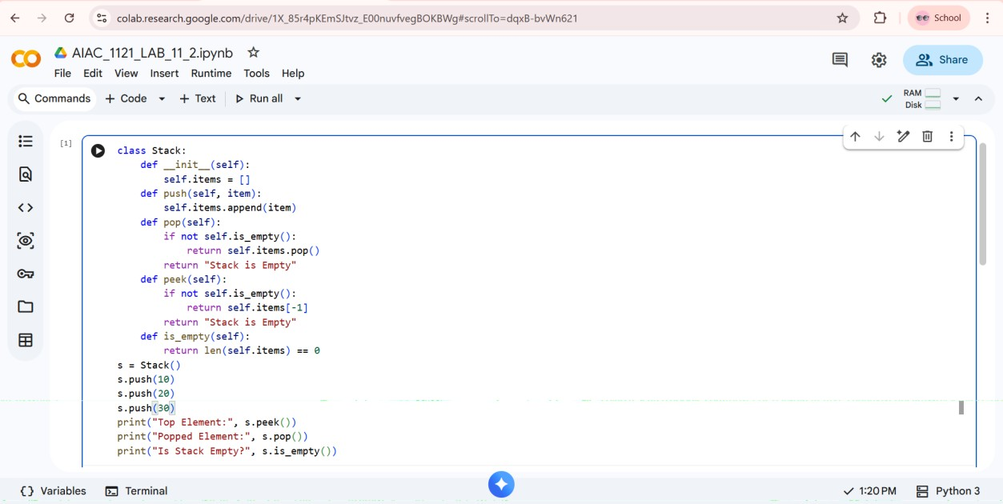
Output:
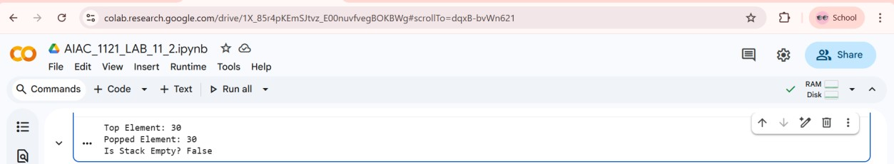

Explanation :
The Stack follows the LIFO (Last In First Out) principle. Elements are added using push() and removed using pop(). The peek() method returns the top element without removing it, and is_empty() checks whether the stack contains elements.

Task – 02 : Queue Design.
Prompt : Create a Python Queue class implementing FIFO behaviour with enqueue, dequeue, front, and size methods. Include comments and sample usage.
Code :
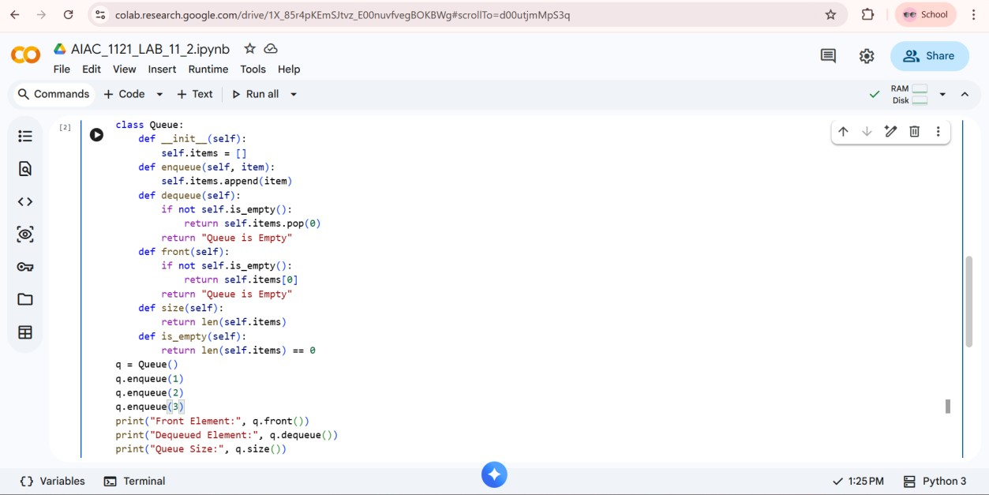
Output :
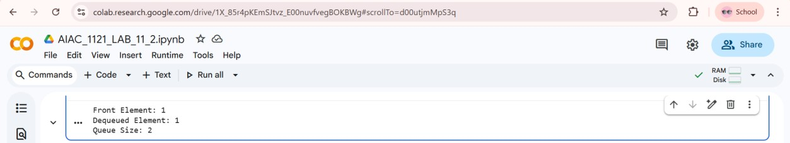

Explanation :
The Queue follows the FIFO (First In First Out) principle. Elements are inserted using enqueue() and removed using dequeue(). The front() method returns the first element, and size() gives the total number of elements.

Task – 03 : Singly Linked List Construction.
Prompt : Design a Singly Linked List in Python with a Node class, insertion at the end, and traversal/display functionality. Add comments explaining each part.
Code & Output :
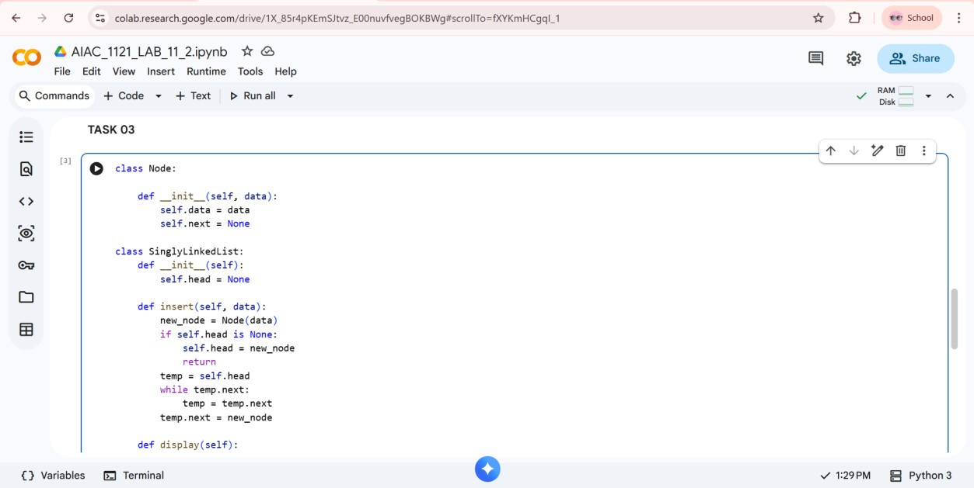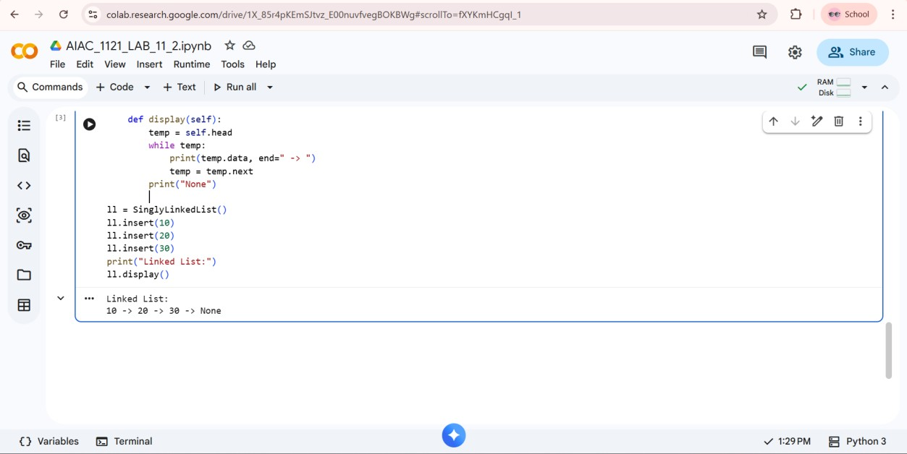
Explanation :
A Singly Linked List consists of nodes where each node stores data and a reference to the next node. Insertion adds a new node at the end of the list. Traversal iterates through nodes sequentially to display all elements.

Task – 04 : Binary Search Tree Operations.
Prompt : Implement a Binary Search Tree in Python with insertion and inorder traversal methods. Include comments explaining how BST property is maintained.
Code & Output :
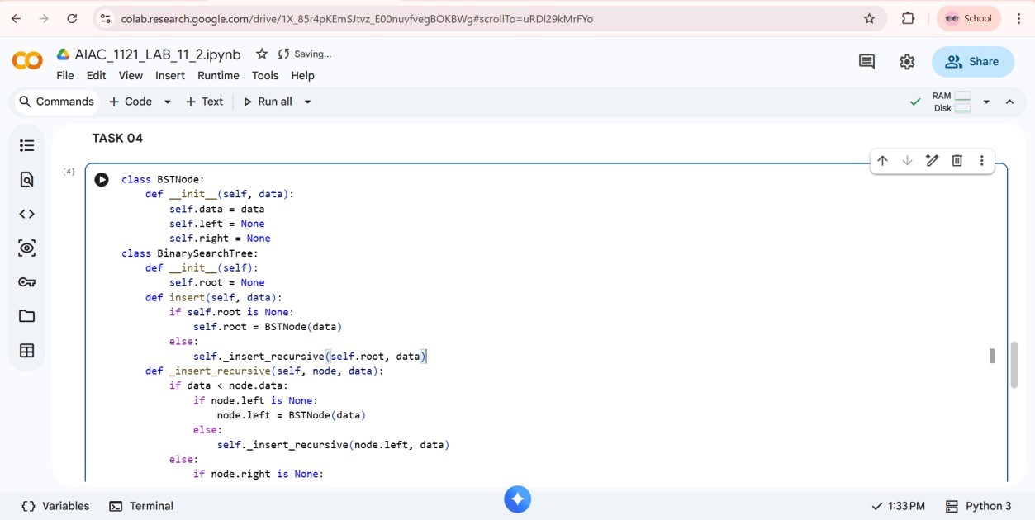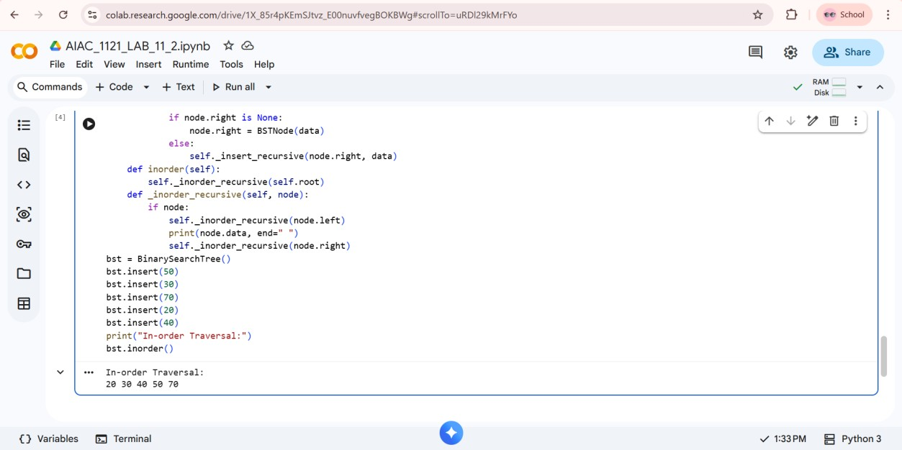
Explanation :
A Binary Search Tree maintains the property: Left child < Root < Right child. Insertion places elements according to this rule, and in-order traversal prints elements in sorted order.

Task – 05 : Hash Table Implementation.
Prompt : Create a Hash Table in Python using chaining for collision handling. Implement insert, search, and delete operations with comments and example usage.
Code & Output :
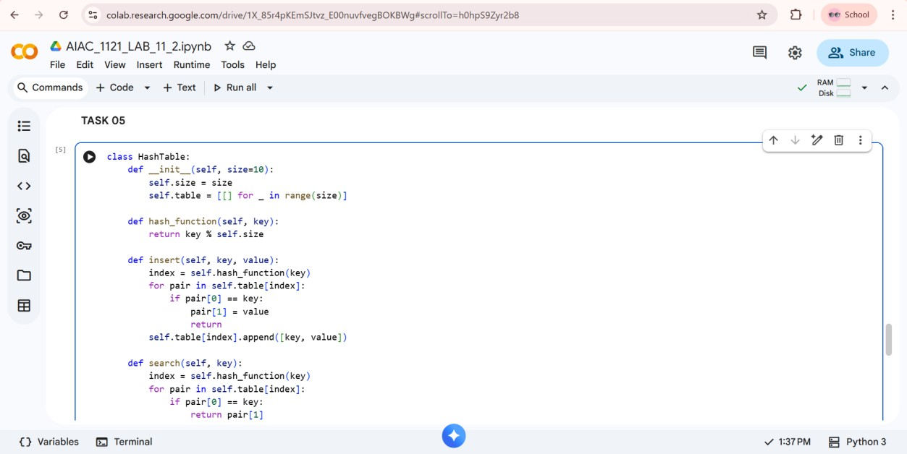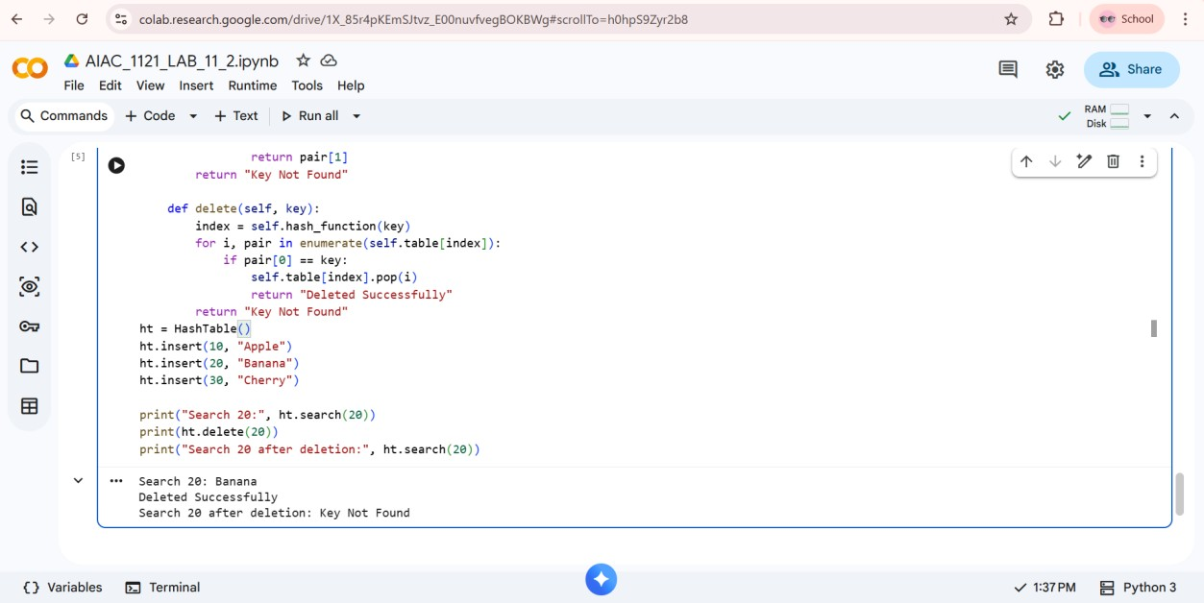
Explanation :
A Hash Table stores data using a hash function to compute an index. Collisions are handled using chaining (linked lists at each index). It supports fast insertion, searching, and deletion operations.
Task : Over Flow and Under Flow.
Prompt : Generate a Python program to implement a fixed-size Stack with push, pop, peek, is_empty, and is_full methods. The program should display “Stack Overflow” when full and “Stack Underflow” when empty, with proper comments and example usage.
Code:
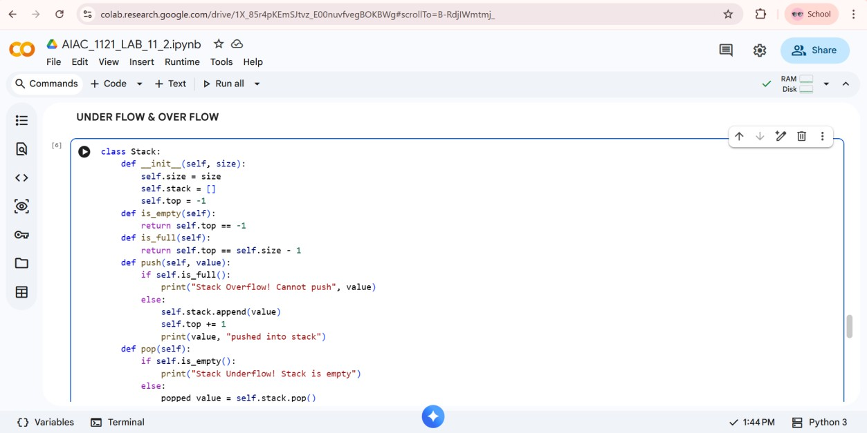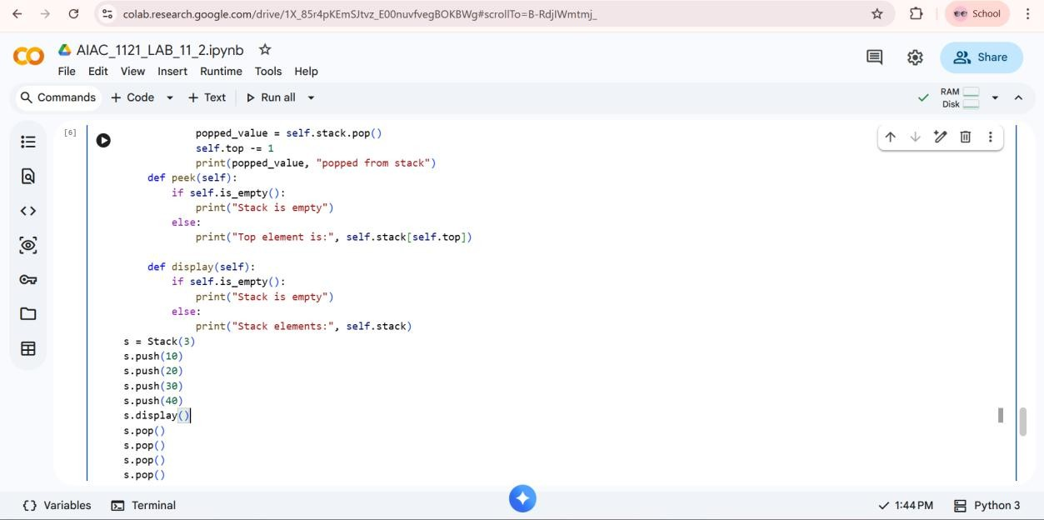
Output :
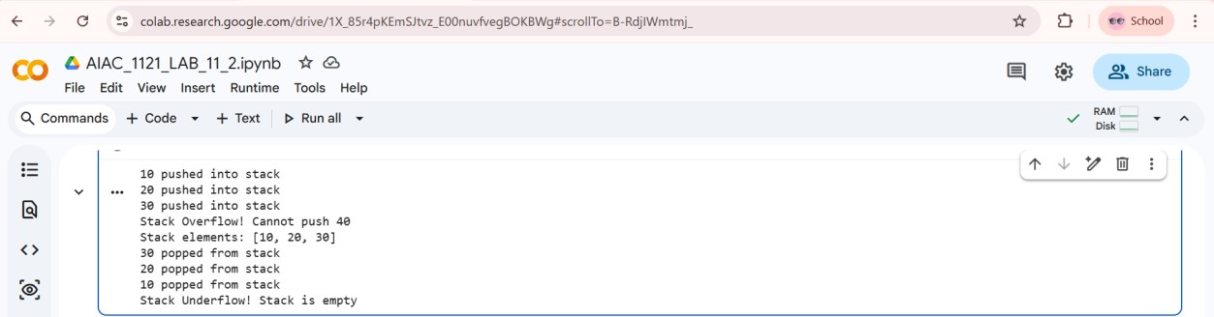
Explanation :
The program implements a fixed-size Stack following the LIFO (Last In First Out) principle using a list and a top pointer. The push() method checks if the stack is full and displays “Stack Overflow”, while pop() checks if it is empty and displays “Stack Underflow”. Helper methods like is_empty() and is_full() ensure proper boundary checking and safe stack operations.

THANK YOUU!!

