Poland Pipeline Runbook (Poland/Slaskie/2023)

This runbook describes the full user workflow for the RGB orthophoto land cover pipeline for Poland/Slaskie/2023. The pipeline code is based on the AIML4OS WP7_landcover repository, while S3 authentication is handled through AWS-style environment variables supported by Boto3 and CloudFerro Object Storage.
0) Environment – S3 Credentials
Before running the pipeline, set the S3 credentials in the terminal. CloudFerro documents that access to private Object Storage requires user-generated EC2 credentials, and Boto3 supports using environment variables such as AWS_ACCESS_KEY_ID and AWS_SECRET_ACCESS_KEY for authentication.
Windows CMD
set AWS_ACCESS_KEY_ID=<your-access-key>
set AWS_SECRET_ACCESS_KEY=<your-secret-key>
set AWS_S3_ENDPOINT_URL=https://s3.waw3-2.cloudferro.com
set AWS_S3_ENDPOINT=s3.waw3-2.cloudferro.com
set S3_BUCKET=Poland
PowerShell
$env:AWS_ACCESS_KEY_ID="<your-access-key>"
$env:AWS_SECRET_ACCESS_KEY="<your-secret-key>"
$env:AWS_S3_ENDPOINT_URL="https://s3.waw3-2.cloudferro.com"
$env:AWS_S3_ENDPOINT="s3.waw3-2.cloudferro.com"
$env:S3_BUCKET="Poland"
Linux / macOS
export AWS_ACCESS_KEY_ID="<your-access-key>"
export AWS_SECRET_ACCESS_KEY="<your-secret-key>"
export AWS_S3_ENDPOINT_URL="https://s3.waw3-2.cloudferro.com"
export AWS_S3_ENDPOINT="s3.waw3-2.cloudferro.com"
export S3_BUCKET="Poland"
Important notes:
- The user must generate their own Access Key and Secret Key before the first run.
- These variables are valid only for the current shell session and must be set again in a new terminal.
- Real credentials must never be written into documentation, scripts, or version-controlled files.

* How to create an EC2 Access Key and Secret Key in OpenStack
** Tip: Make sure that Python and Git Bash are installed before starting the setup process.

- Download the OpenStack CLI application credentials.
- Install Git for Windows:
  - Git for Windows
- Register the application credentials in CloudFerro Horizon:
  - CloudFerro Horizon – Application Credentials
- Open Git Bash and navigate to the project directory:
cd ~/CF/openstack_cli

- Activate the Python virtual environment:
source Scripts/activate

- Install the OpenStack CLI client:

python -m pip install python-openstackclient

- Load the OpenStack application credentials:
source AIML4OS_WP7-openrc-app-credentials.sh

- Verify that the OpenStack CLI is working:

openstack flavor list

- Create the EC2 Access Key and Secret Key:

openstack ec2 credentials create -c access -c secret

10. Save the generated Access Key and Secret Key securely for future use.
1) Clone the Repository
git clone https://github.com/AIML4OS/WP7_landcover.git
cd WP7_landcover
The WP7_landcover repository is the code base used for this pipeline.
2) Create the Conda Environment
conda create -n landcover python=3.10
conda activate landcover
conda install -c conda-forge gdal
conda install boto3
conda install pyaml
* In the remote VS Code environment, a prepared environment such as FLAIR-1 may be activated
conda activate FLAIR-1

before running the main command. This means the local bootstrap environment and the remote runtime environment may differ depending on how the VM has been prepared for the Poland workflow.
3) Create the Configuration File
Create a file named configLC.yml in the WP7_landcover folder:
# =====================================================
# Land Cover Pipeline – Master Configuration (v1)
# WP7 / AIML4OS
# =====================================================
project:
country: PL
region: Slaskie
year: 2023
description: >
Land cover classification based on RGB orthophotos
processed within the WP7 land cover pipeline for Poland.
model:
framework: FLAIR
task: land_cover
variant: RGB # RGB | IRG
For Poland, the project path is Poland/Slaskie/2023.
4) Check Orthophoto Resolution
Before preprocessing and quality assessment, verify the spatial resolution of the orthophoto images and confirm that all input files have the same resolution. This is important because inconsistent raster resolution may affect statistics, crop generation, and quality assessment outputs in downstream steps.
For Poland, the working resolution is 0.25 m. The resolution can be checked in an appropriate GIS or raster inspection program before running the pipeline.
5) Run Preprocessing
Run preprocessing using the configuration file and the local path to the RGB orthophoto data.
Local command examples
Windows CMD
python -m landcover_pipeline.cli.preprocess --config configLC.yml --rgb "C:\path\to\RGB"
PowerShell
python -m landcover_pipeline.cli.preprocess --config .\configLC.yml --rgb "C:\path\to\RGB"
Relative path example
python -m landcover_pipeline.cli.preprocess --config ./configLC.yml --rgb "../path/to/RGB"
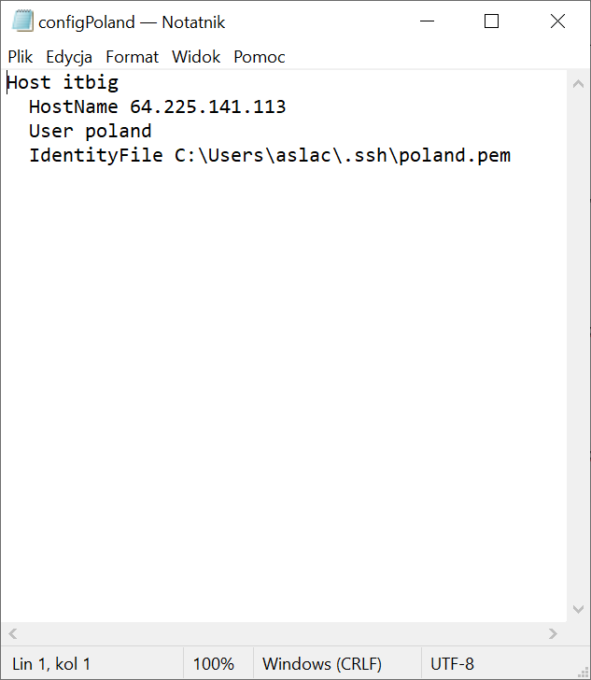
Project-based example
python -m landcover_pipeline.cli.preprocess --project Poland/Slaskie/2023
These commands prepare the local input data and project metadata before model execution.
Remote preprocessing workflow in VS Code
There are some practical tips for a remote workflow for preprocessing through VS Code. According to that workflow, the user should:
- Open VS Code.
- Press Ctrl+Shift+P to open the command palette.
- Search for Remote-SSH .
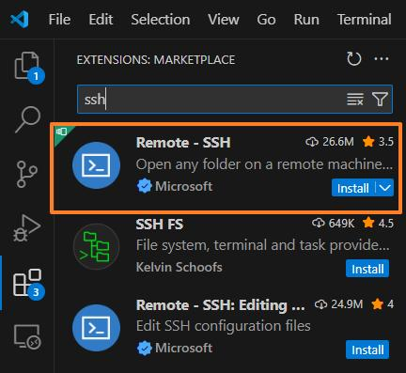
- Choose the the remote machine e.g. IT-big machine.
- Choose WP7_landcover and confirm with OK.
- Open the WP7 folder in the remote workspace.
After connecting, it is recommended to prepare the runtime environment as follows.
- Open a new terminal in VS Code.
- Run conda activate FLAIR-1.
- Run .environment.sh.
- Run the main preprocessing command.
6) Start the VM Before Inference
Before running inference for Poland, start the required remote instance or virtual machine, for example IT-big, in the CloudFerro platform. The attached Poland document confirms that inference should be run on a remote instance rather than directly from the local workstation for this project setup.
Open the CloudFerro panel at new.cloudferro.com and complete the login flow.

Authenticator-based confirmation is also needed for this access path.
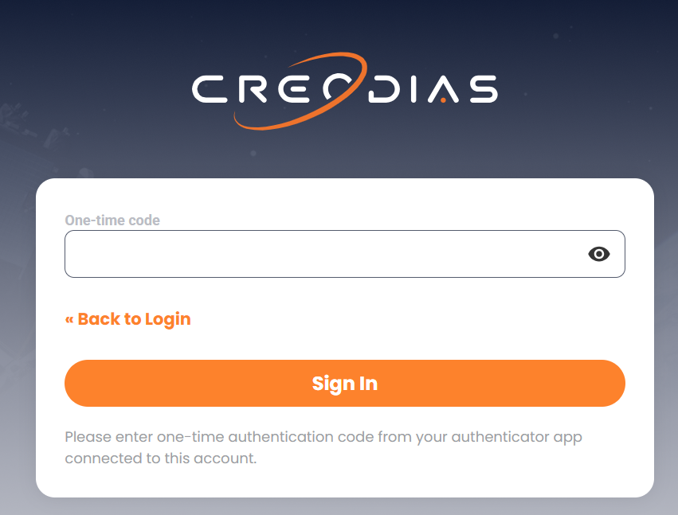
Log in to the platform.
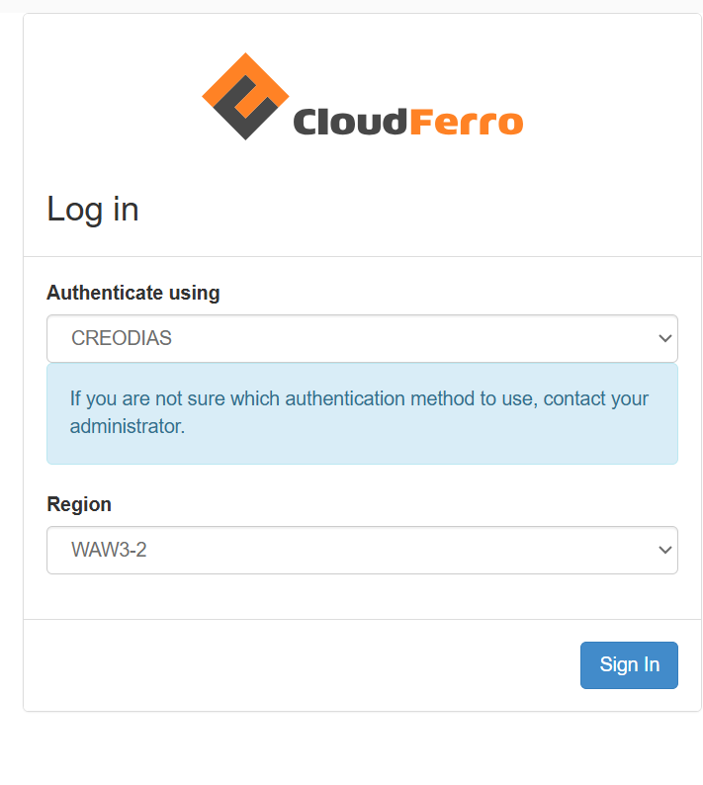
Example connection details used in the Italy workflow for a IT-dev machine:
Host itbig
HostName 64.225.137.248
User eouser
IdentityFile C:\Users\UTENTE\.ssh\poland.pem
Alternative example for Poland for IT-big machine:
Host itbig
HostName 64.225.141.113
User poland
IdentityFile C:\Users\slachciaka\.ssh\poland.pem
You can also start the machine clicking the button Start Instance.
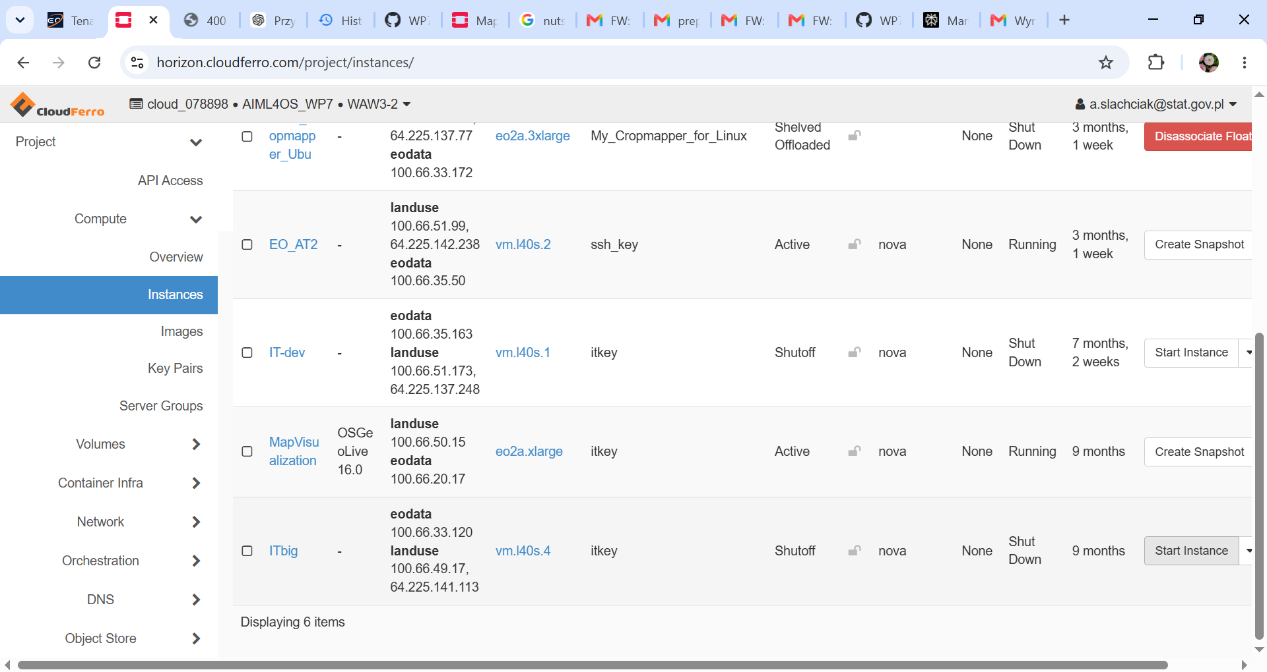
In practice, the exact IP, username, and local .pem path may vary by user, so these values should be treated as Poland-specific operational examples.
As next, create folders for input and output data in catalog of your country in Containers section.
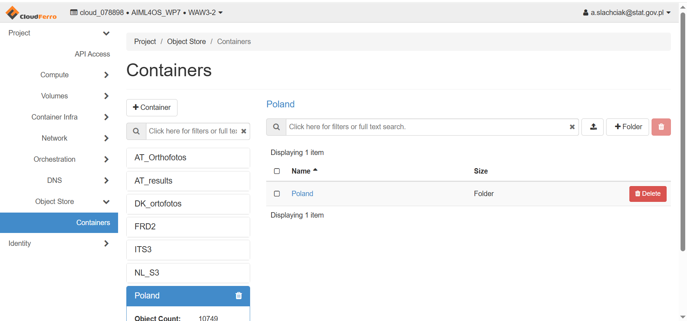
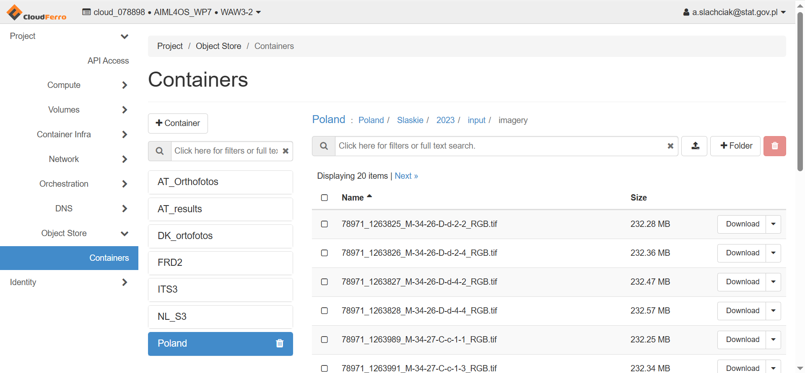
7) Run Inference
Once the remote VM is started and the SSH session is active, run inference:
python -m landcover_pipeline.cli.inference --project Poland/Slaskie/2023 --model large
* For long-running processes, the attached document recommends using:
screen -R Slaskie
This command reattaches to an existing session or creates it if it does not already exist.
**Another operational option mentioned in the attached document is:
nohup python app.py &
This is included as a general example of keeping a process alive after closing the terminal, although the exact target command should be adapted to the pipeline command actually being executed.
8) Build Raster Footprint
Create the tile footprint used by quality crop selection.
python -m landcover_pipeline.cli.build_raster_footprints --project Poland/Slaskie/2023
Check your result in QGIS if there are any gaps.
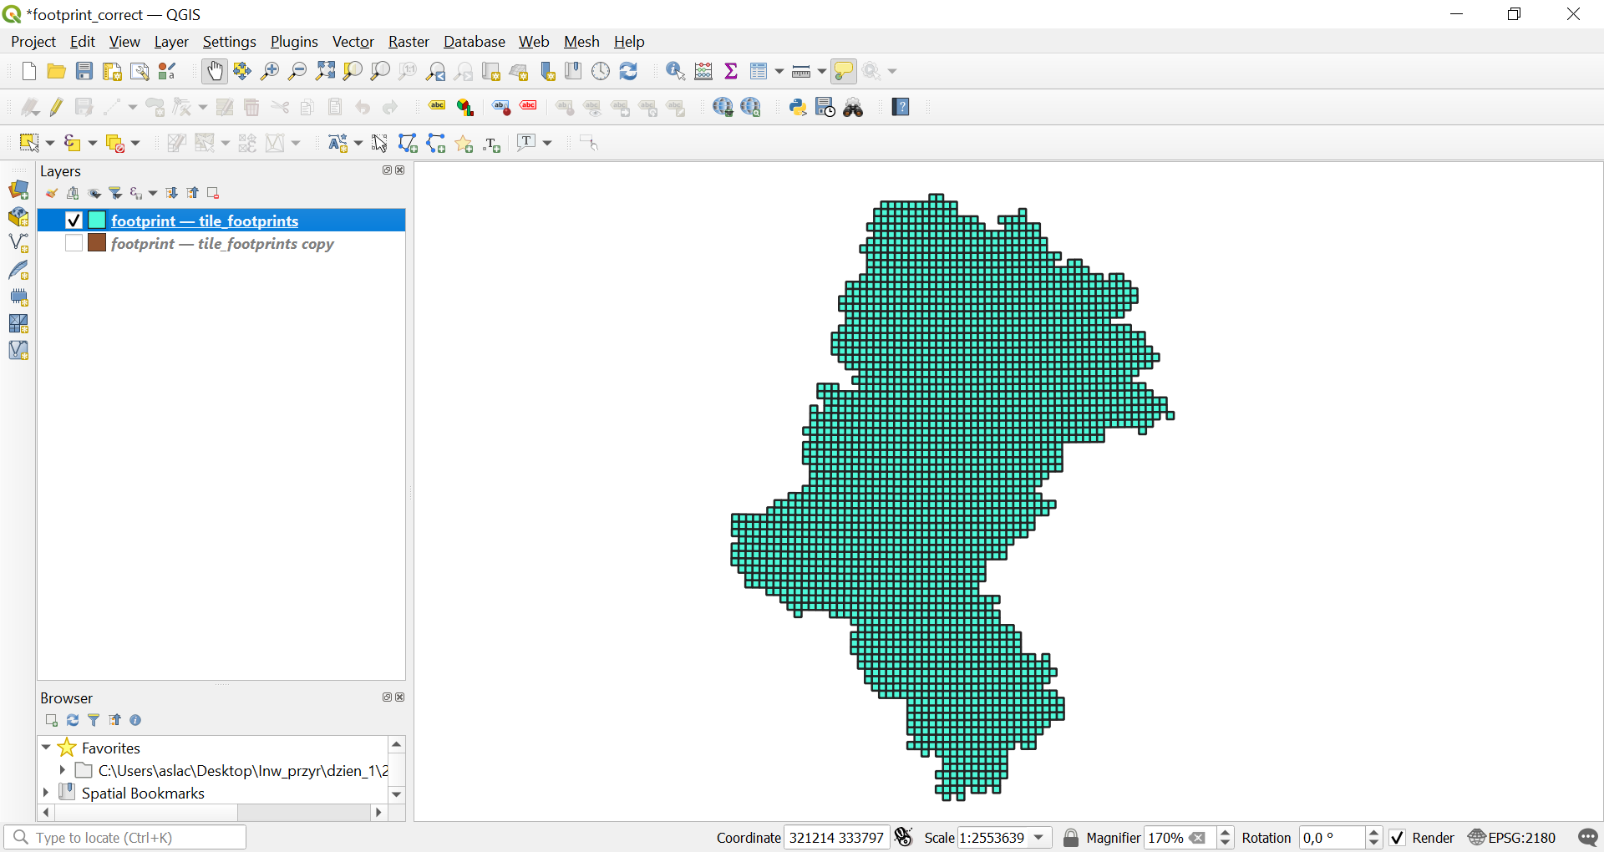
* Always verify that all orthophoto files have the same resolution before running the quality workflow. You can use a special code using gdal to read resolution in all geotiff for this challenge.
9) Output Stats
Compute output statistics products for the project using the AOI .gpkg file and raster resolution.
python -m landcover_pipeline.cli.compute_stats --project Poland/Slaskie/2023 --aoi "slaskie2023.gpkg" --resolution 0.25
For Poland the --resolution value should be 0.25.
The results for Poland/ Slaskie Voivodship are illustrated below.
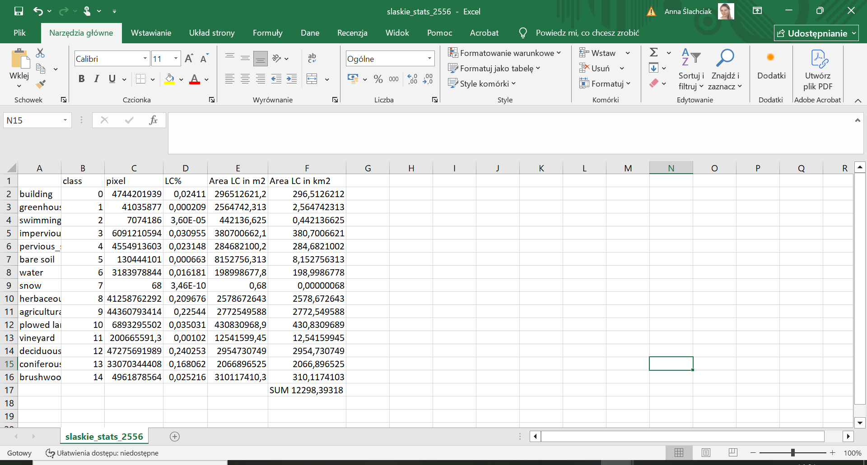
10) Quality – Crop Tiles
Select LUCAS points in the AOI and generate point-centered crops.
python -m landcover_pipeline.cli.quality_crop --project Poland/Slaskie/2023 --lucas-csv "landcover_pipeline/Pipeline code for accuracy assessment/PL_LUCAS_2022.csv" --aoi "slaskie2023.gpkg" --crop-size 2176
LUCAS file is to download from the page https://ec.europa.eu/eurostat/web/lucas/database/2022
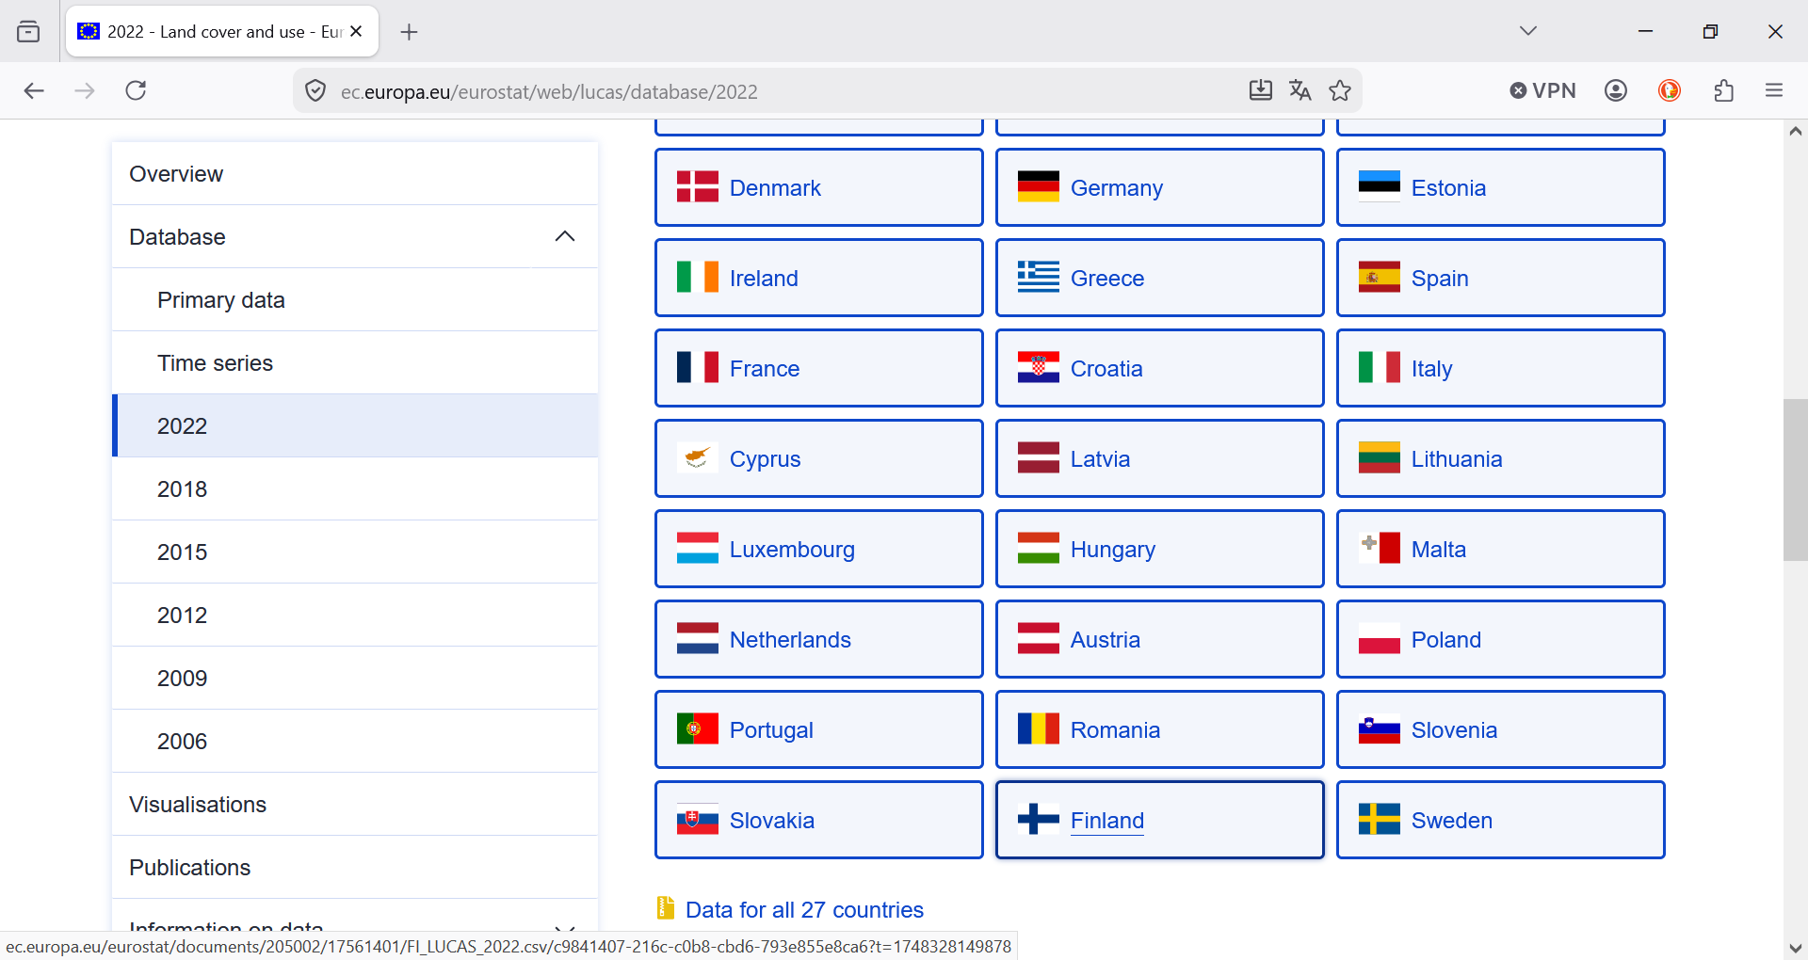
It is necessary to choose data for Poland and download the data in csv format. Below you find the data imported as an Excel fil 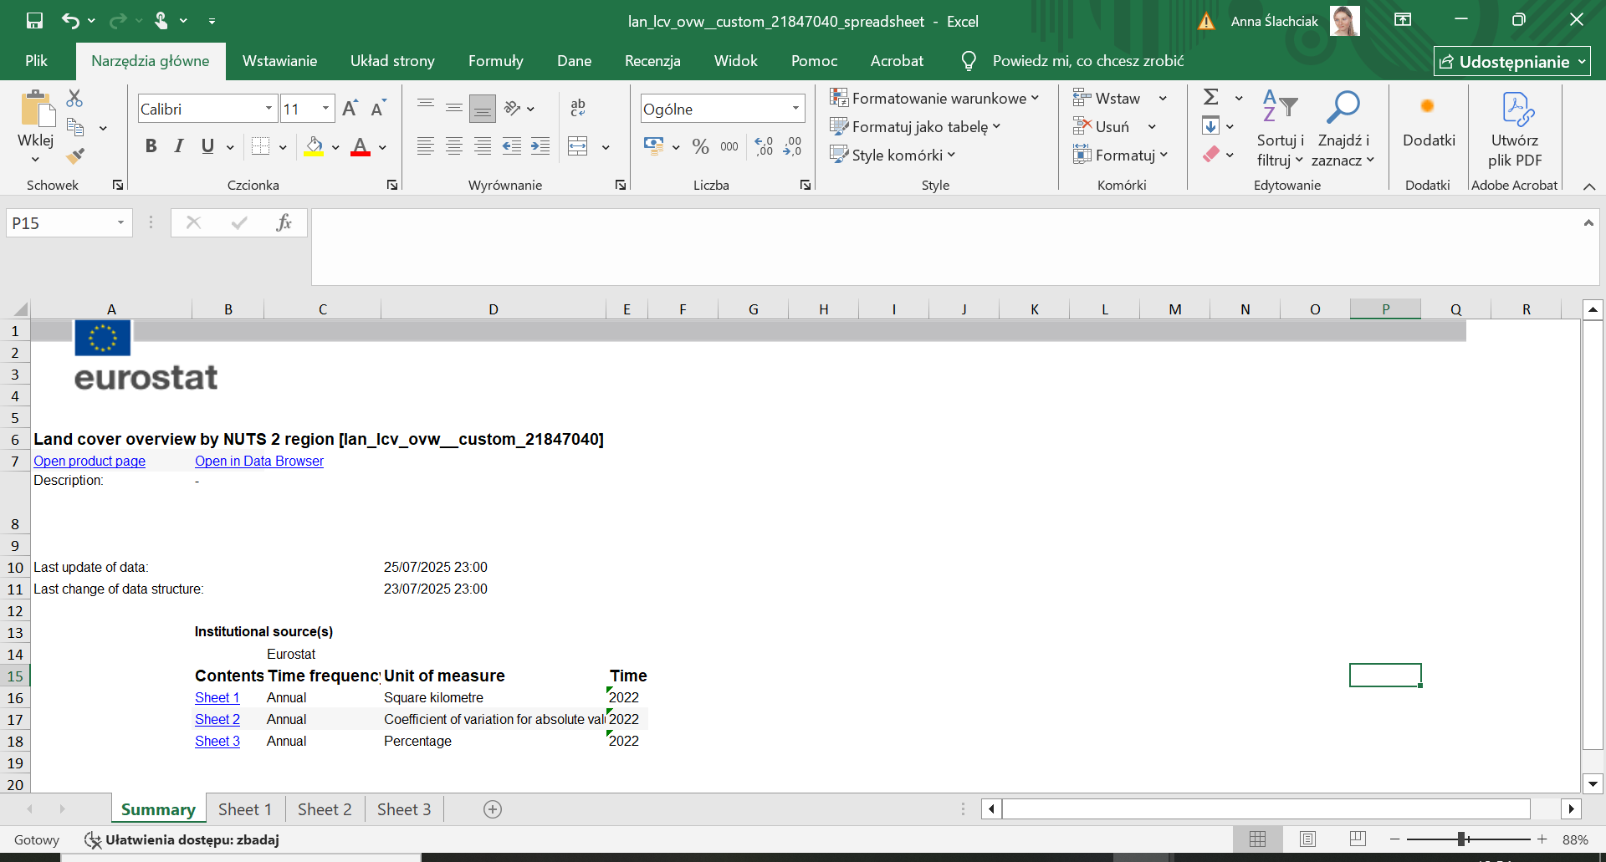e.

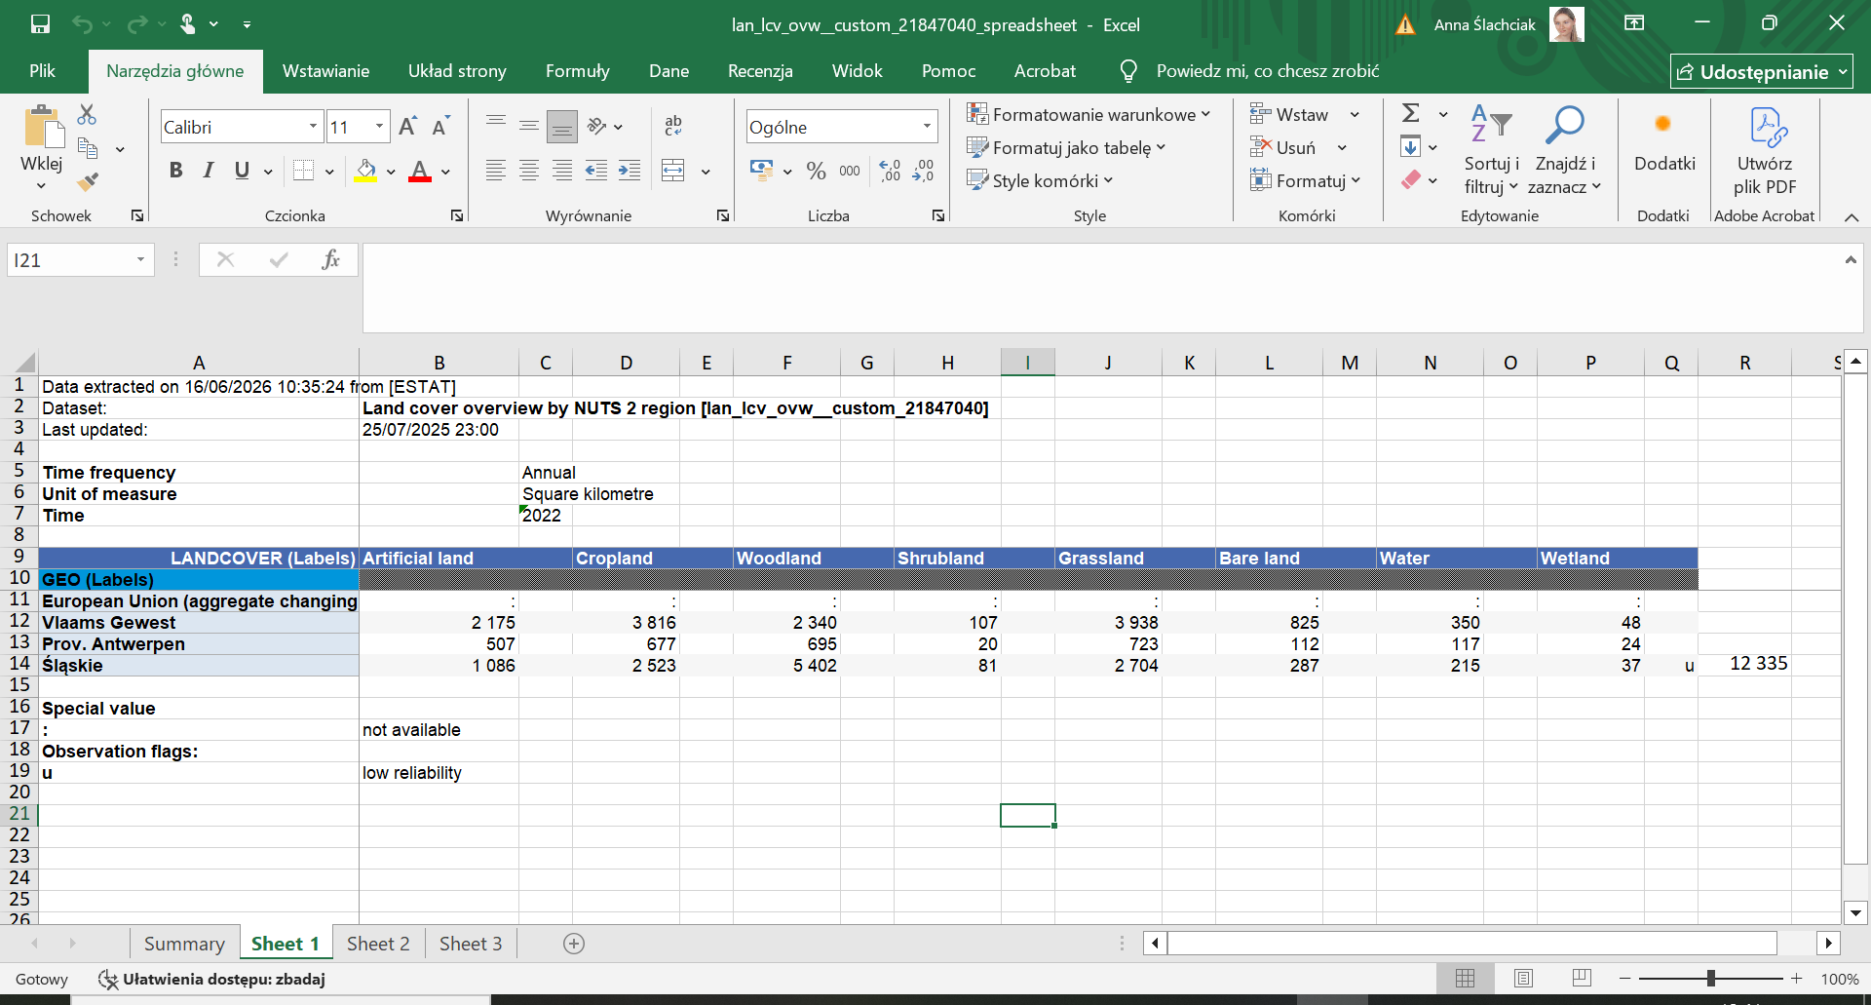
Import the CSV file into Excel using Power Query.
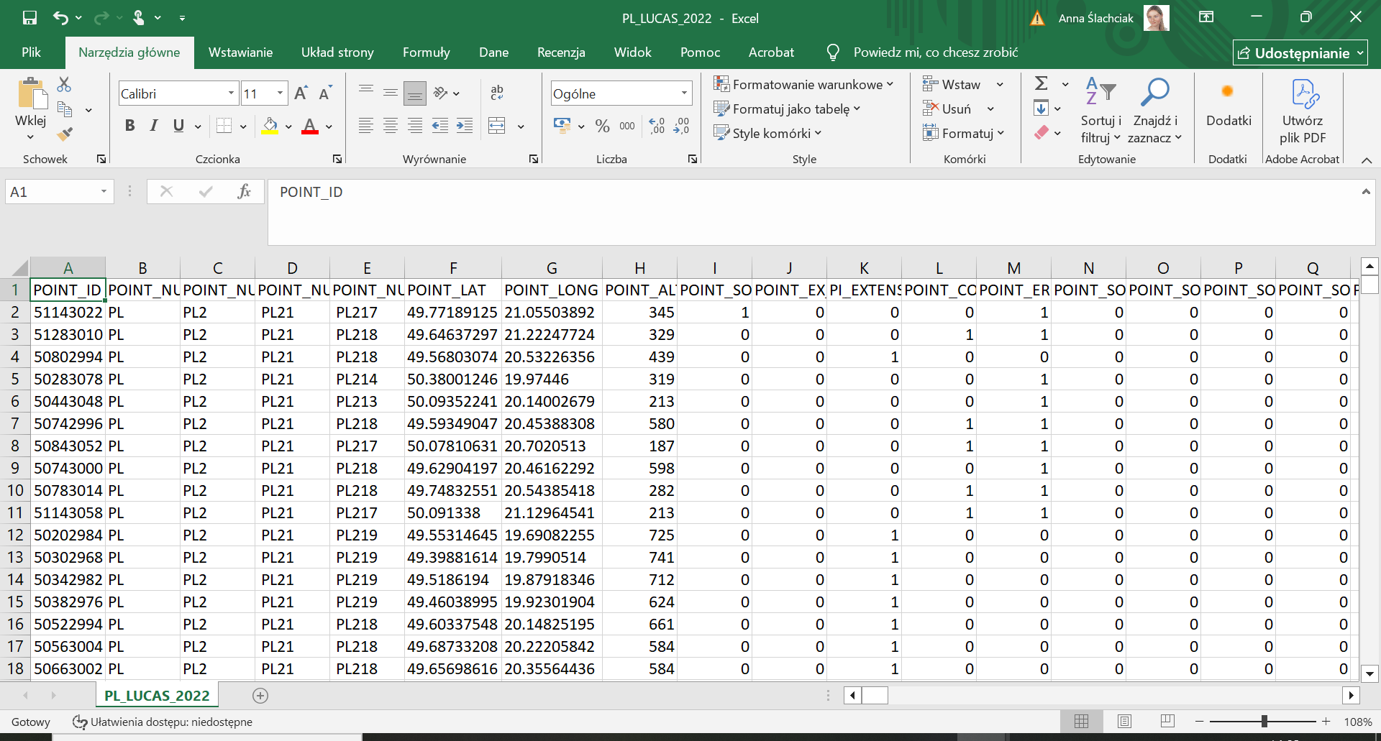
The reference year for the check was 2022.
11) Quality – Probabilities
Run FLAIR probabilities on crop tiles by use command below.
python -m landcover_pipeline.cli.quality_probabilities --project Poland/Slaskie/2023 --crop-size 2176 --model large
Optional: run only a random sample of missing crops.
python -m landcover_pipeline.cli.quality_probabilities --project Poland/Slaskie/2023 --crop-size 2176 --model large--nsample 100
12) Quality – Coordinate Conversion
Convert LUCAS coordinates to the projected CRS used for extraction.
python -m landcover_pipeline.cli.quality_convert_coords --epsg EPSG:2180 --nuts2 PL22 --input-file "landcover_pipeline/Pipeline code for accuracy assessment/PL_LUCAS_2022.csv" --modality LUCAS
For Poland, the EPSG code and NUTS2 code must match the actual extraction setup used for Slaskie/2023. The example above should therefore be validated against the real AOI and target CRS before production use.
13) Quality – Predictions Extraction
Extract probability band values at converted point coordinates.
python -m landcover_pipeline.cli.quality_extract_predictions --project Poland/Slaskie/2023 --crop-size 2176 --coord-file "landcover_pipeline/Pipeline code for accuracy assessment/PL_LUCAS_2022_PL22_EPSG2180.txt" --output-folder "landcover_pipeline/Pipeline code for accuracy assessment"
*For Poland, Slaskie Voivodship code in LUCAS is PL22.

Three different files are generated for download, as shown below.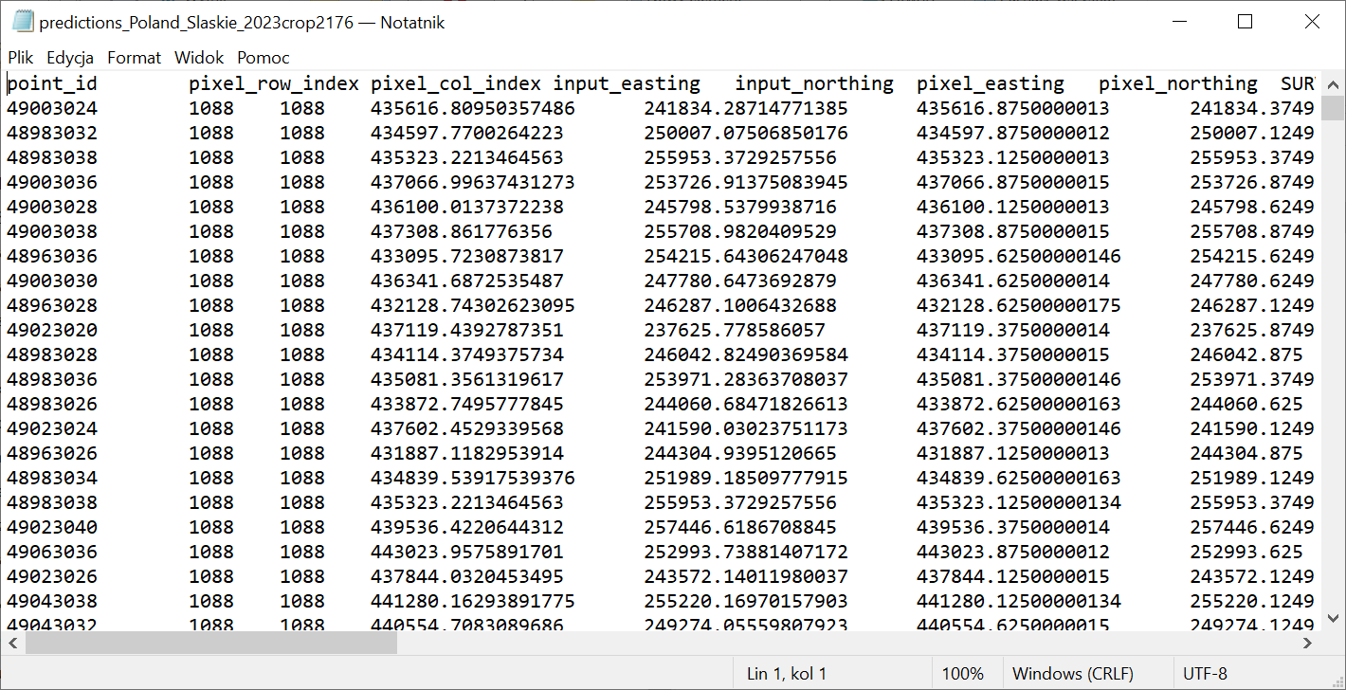
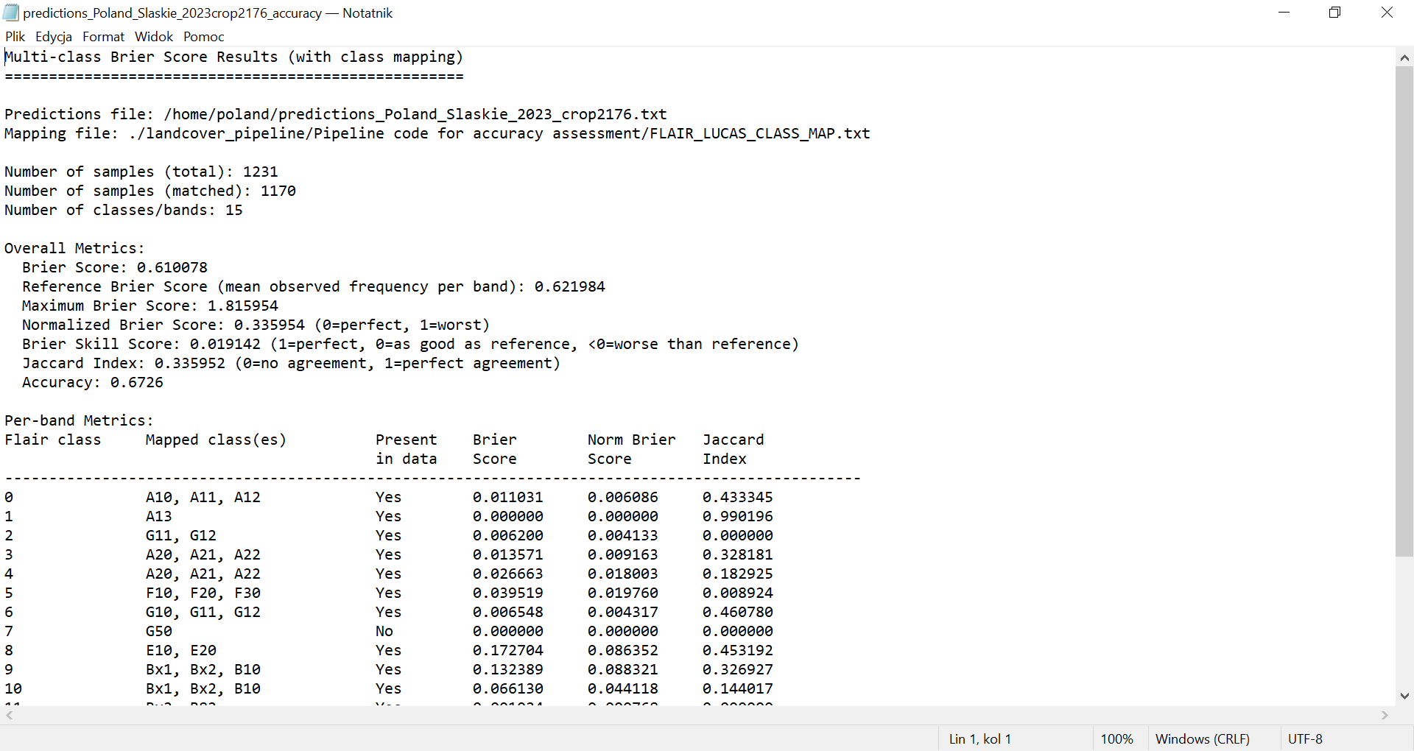
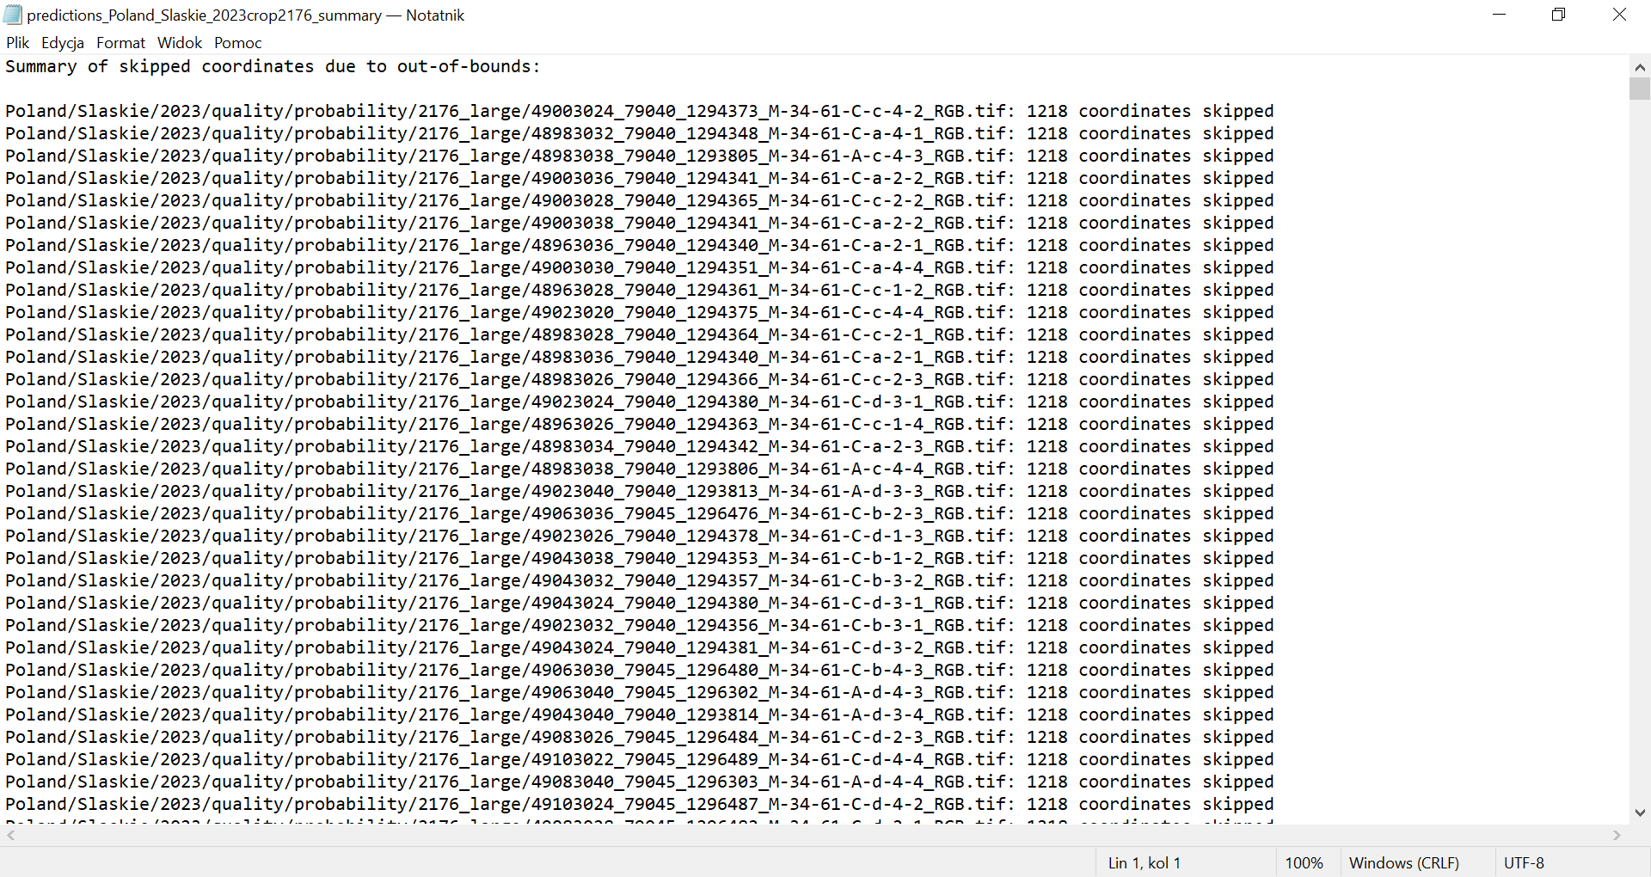
The files are to be copied from the VSC folders.
14) Quality – Accuracy Assessment
Compute quality metrics from extracted predictions. Use the command below.
python -m landcover_pipeline.cli.quality_accuracy_measures --predictions-file "landcover_pipeline/Pipeline code for accuracy assessment/predictions_PL_slaskie_2023_crop2176.txt"
This final step computes the quality metrics from the extracted prediction values for the Poland project.
15) Land Cover Comparison: FLAIR vs LUCAS (Copernicus)
Mapping is needed for the comparison. Mapping links the 15 FLAIR land cover classes to 7 harmonised land cover classes.This makes it possible to compare FLAIR results with LUCAS/Copernicus reference data.
FLAIR class | LUCAS class(es)
0 – building | A10, A11, A12, A30
1 – greenhouse | A13
2 – swimming_pool | G11, G12
3 – impervious surface | A20, A21, A22, A30
4 – pervious surface | A20, A21, A22, A30
5 – bare soil | F10, F20, F30, F40
6 – water | G10, G11, G12, G20, G21, G22, G30, G40
7 – snow | G50
8 – herbaceous vegetation | E10, E20
9 – agricultural land | Bx1, Bx2, B10–B19, B21–B23, B30–B37, B40–B45, B50–B55, B70–B77, B80, B81, B83, B84
10 – plowed land | Bx1, Bx2, B10–B19, B21–B23, B30–B37, B40–B45, B50–B55, B70–B77, B80, B81, B83, B84
11 – vineyard | Bx2, B82
12 – deciduous | C10
13 – coniferous | C20, C21, C22, C23
14 – brushwood | D10, D20, E30
The project should be evaluated using Brier Score (BS), Brier Skill Score (BSS)/ Norm Brier Score, Jaccard Index, and Accuracy, with results compared across countries in tables and simple bar charts.
16) Reuse Previous Commands in Terminal
To find previously used commands in the terminal history, use:
history | grep comp
This command searches shell history for matching entries and is useful when repeating or troubleshooting pipeline steps. It does not disable history expansion; it only filters past commands.

