**Configure Deployment Slots**

Note: this demo is continuing with last demo – How to Deploy Web App on Microsoft Azure.

**Step 1:** Click on **Resource Group** -> Select **WebAppDemoRG**

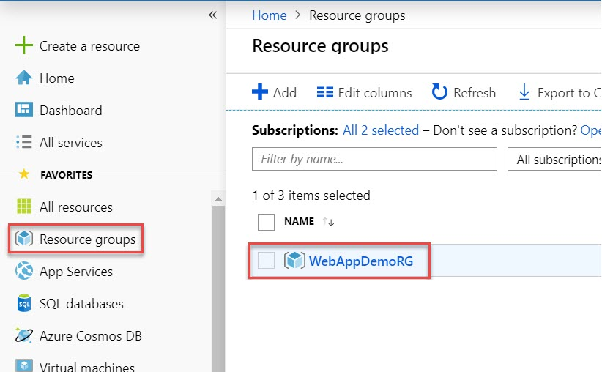

**Step 2:** Select **Web App** you have deployed in last demo.

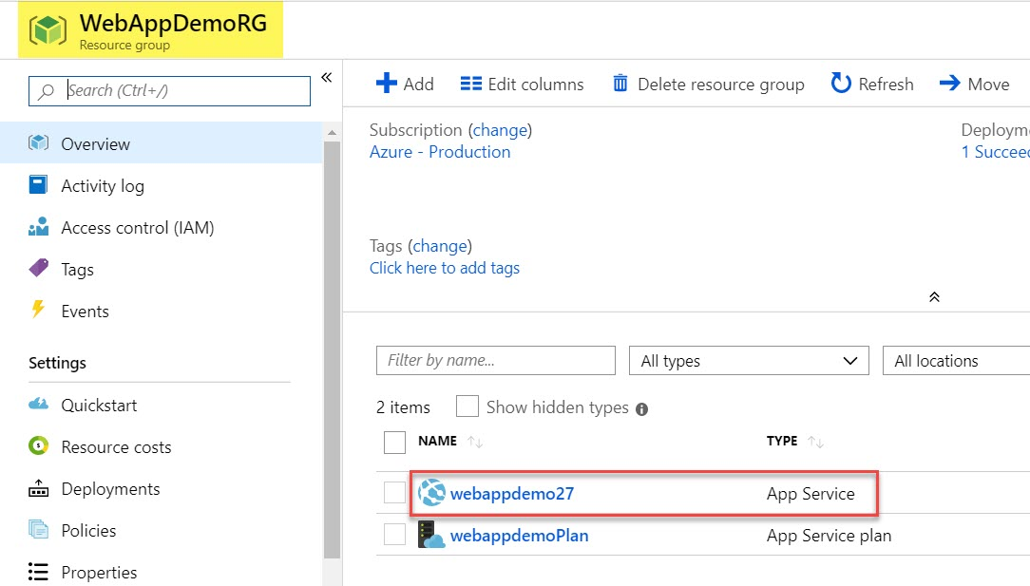

**Step 3:** Click on **Browse** option

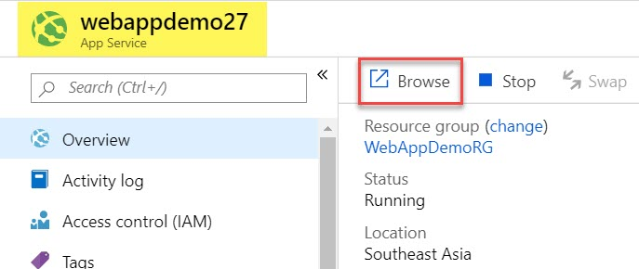

Site will load with Content – **Azure Web App Demo v1.0**

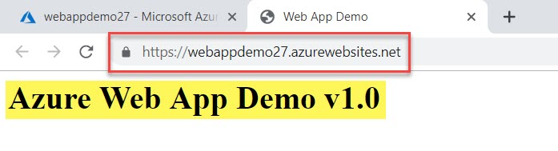

**Step 4:** Now add **Deployment Slot**

Select **Deployment slots** and click on **+ Add Slot** option

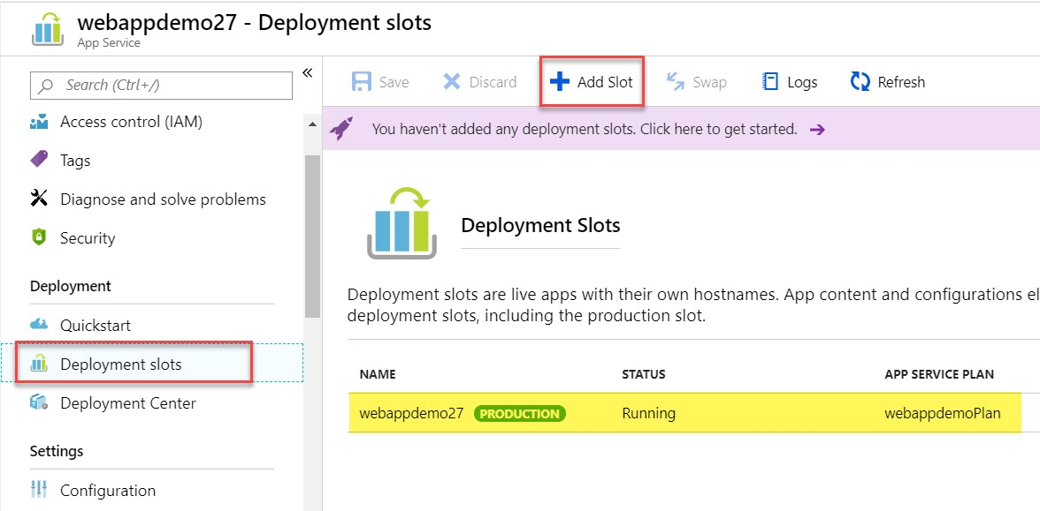

**Step 5:** Add a slot

Name: **dev**

Clone Settings from: **Choose from drop-down menu**

Click on **Add** button.

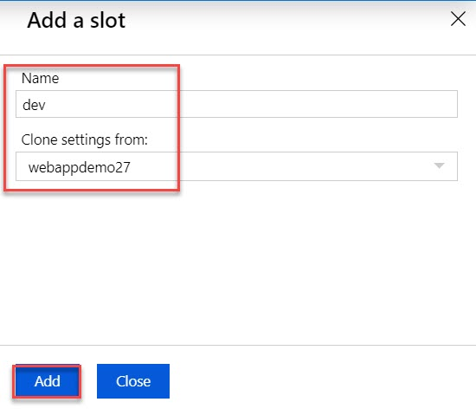

**Step 6:** In Deployment Slots another Web App available as below. Click on that. Ex. webappdemo-dev

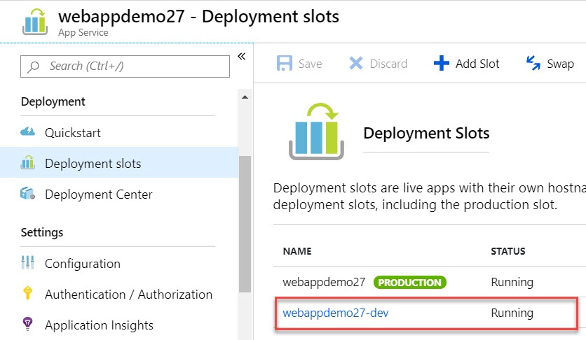

**Step 7:** Click on **Browse** option of dev web app.

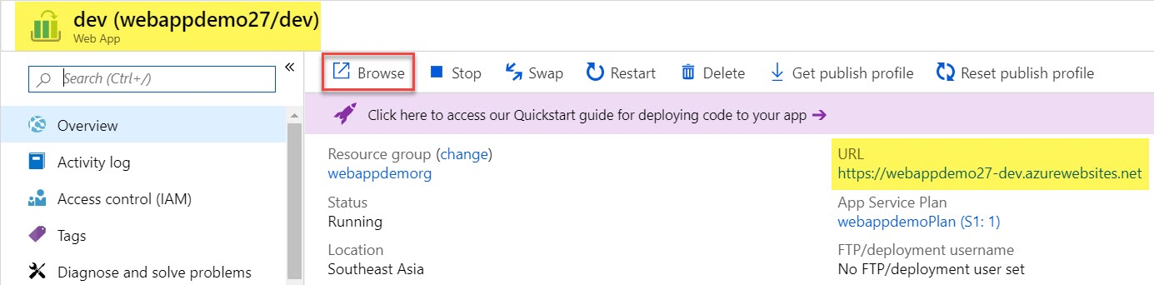

**Step 8:** You can notice URL will be combination of web app and slot name. Default page will run

Ex. webappdemo-dev.azurewebsites.net

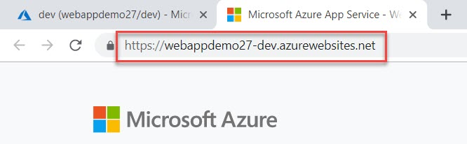

**Step 9:** Now time to deploy website content by another method via **Github**. So Open Github site and sign up if you don’t have account otherwise direct sign in with credentials.

[https://github.com](https://github.com/)

**Step 10:** If you have logged in click on **+** icon (top-right side) and Click on **New repository** option

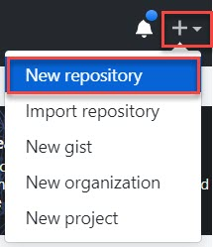

**Step 11:** Create New Repository

Repository Name: **webappdemo**

Access: **Public**

**Check mark of Initialize this repository with a README**

Click on **Create repository** button.

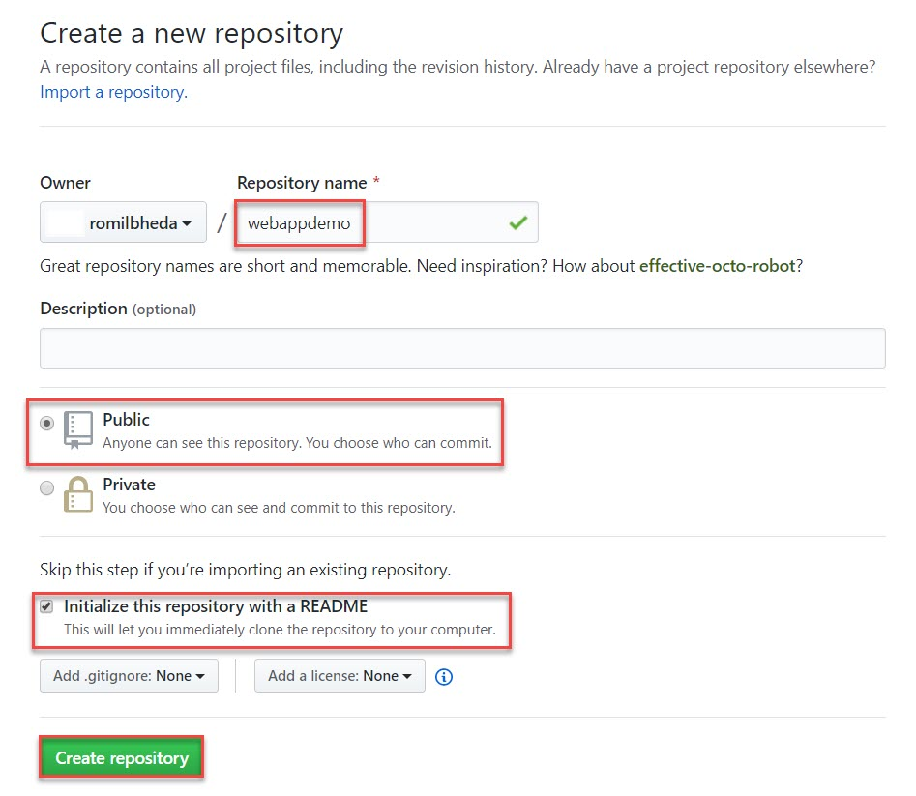

**Step 12:** Now open **index.html** page and change content from **v1.0 to v1.1**

Save it.

**<h1>Azure Web App Demo v1.0</h1>**

Replace with below code:

**<h1>Azure Web App Demo v1.1</h1>**

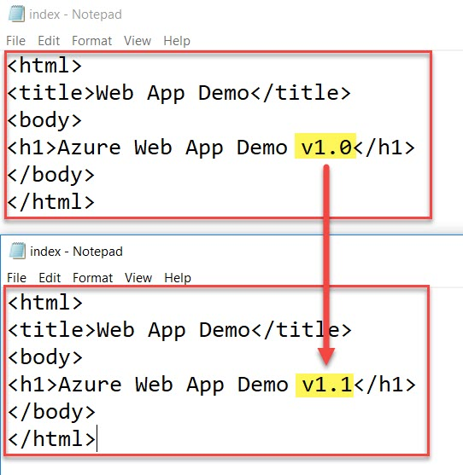

**Step 13:** Back to **Github** site and click on **Upload files** option

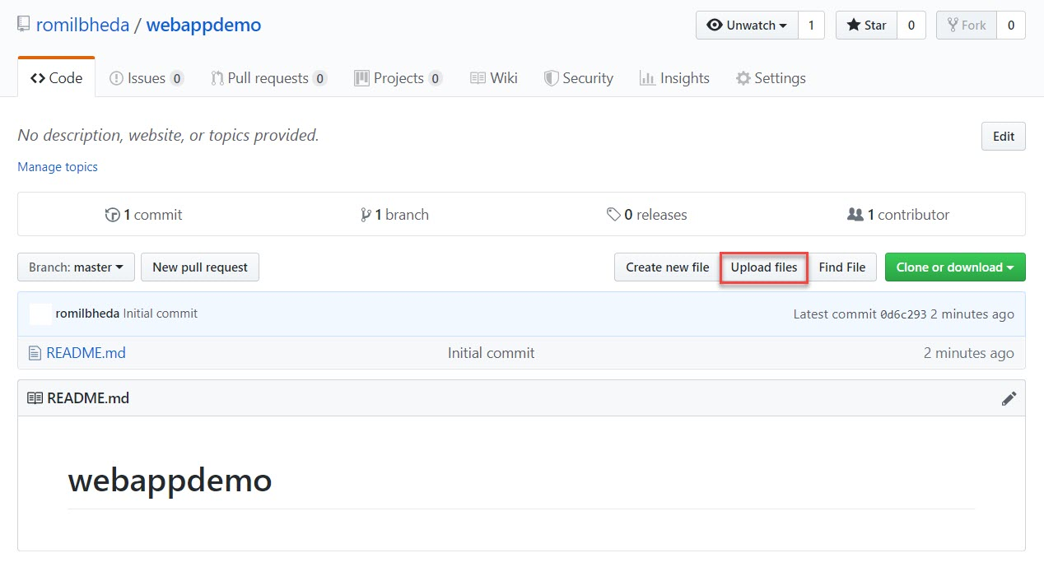

**Step 14:** First click on choose your files option of Github site and browse that **index.html** file from local machine.

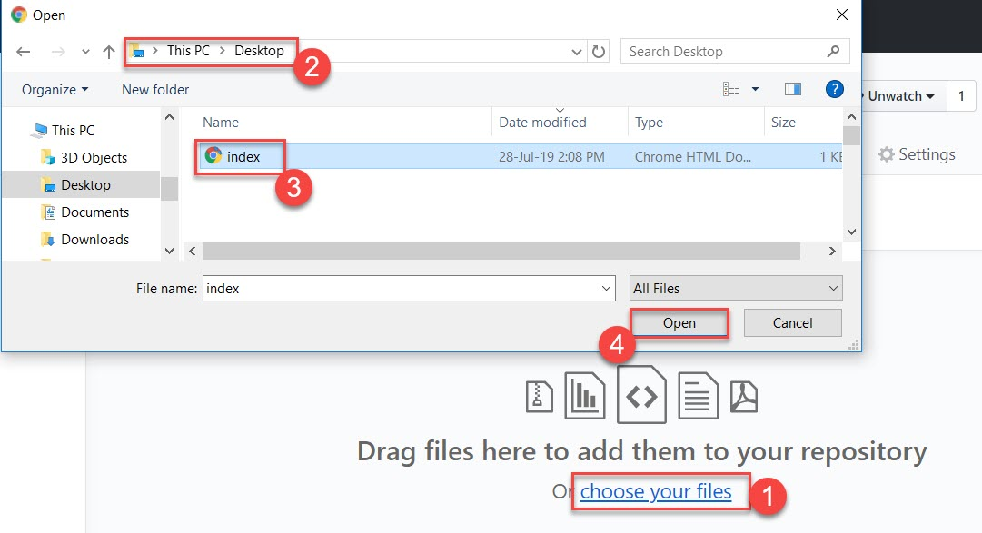

**Step 15:** Add comment of changes and click on **Commit Changes** button.

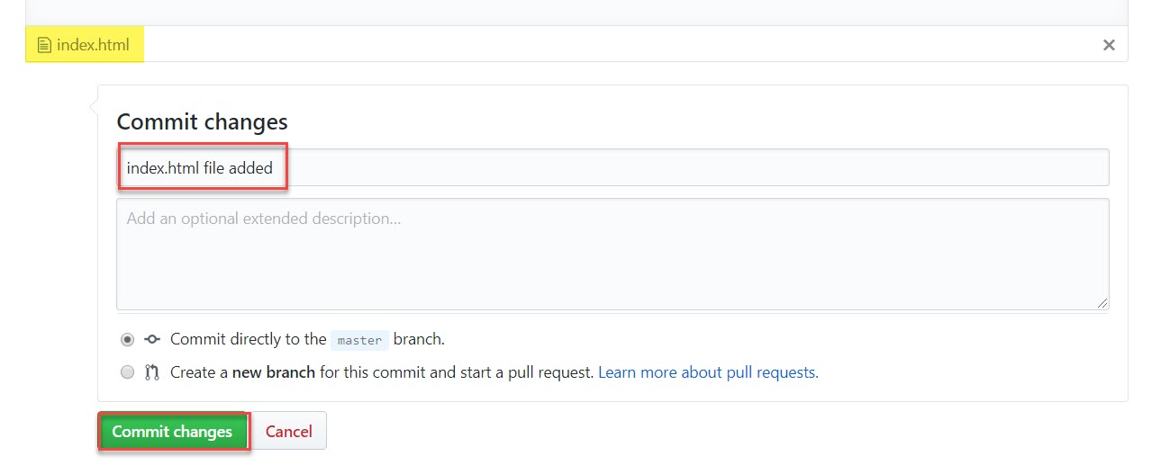

Verify **index.html** page uploaded successfully as below:

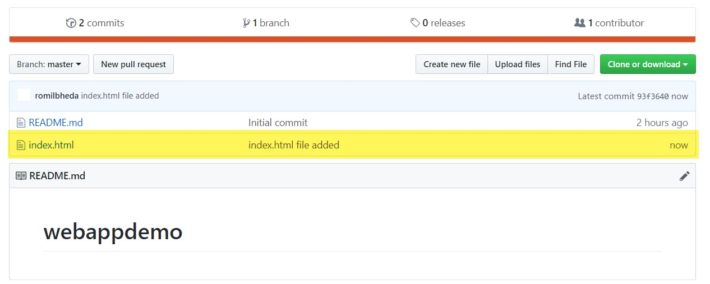

**Step 16:** Now configure Github with deployment slot – dev.

Click on **Deployment Center** option and you can see complete list of source control available.

For this demo we are selecting **Github** and click **Authorize** button.

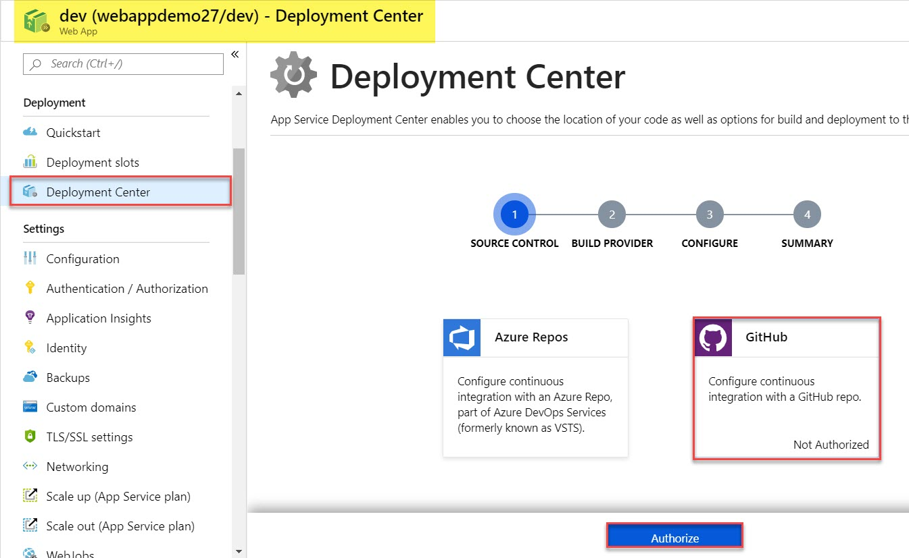

**Step 17:** Enter Github credentials and Authorize app. Username will load in Github and click on **Continue**.

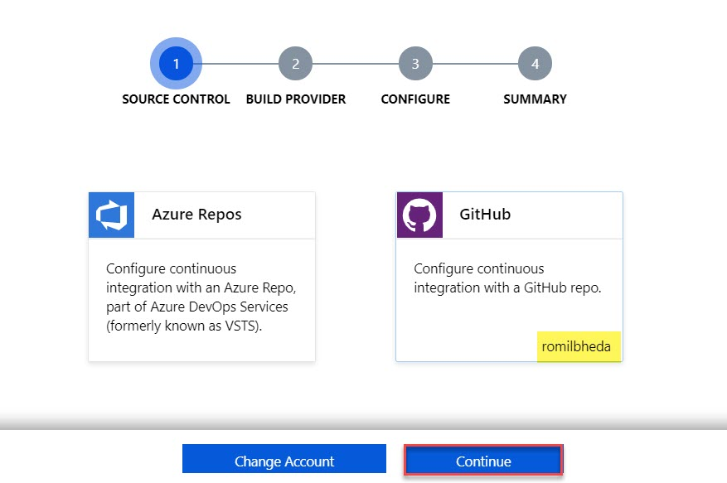

**Note: if name is not coming refresh page.**

**Step 18:** Select Source Provider: **App Service Build Service**. Click on **Continue**.

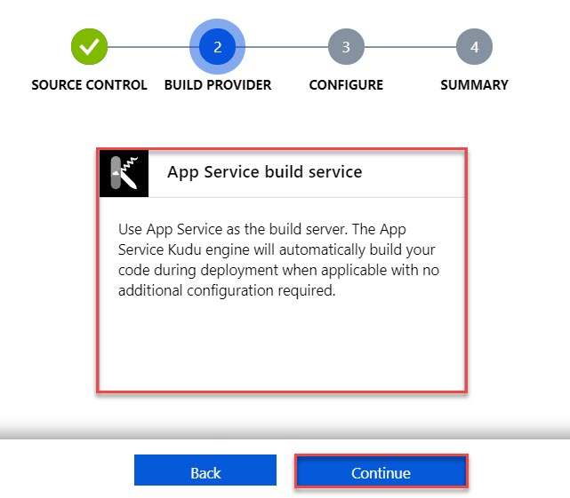

**Step 19:** Configure Github repo and click on Configure button.

Organization: **select your username**

Repository: **webappdemo**

Branch: **master**

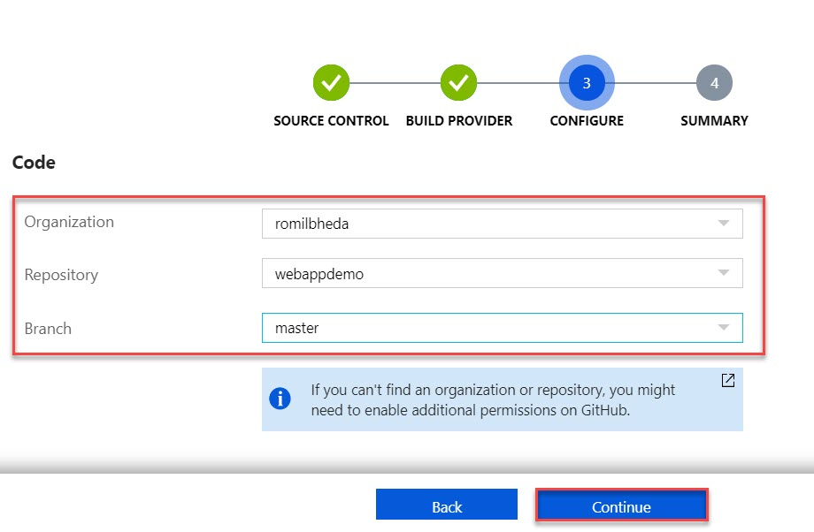

**Note: if organization or repository is not coming refresh page.**

**Step 20:** Click on **Finish** button.

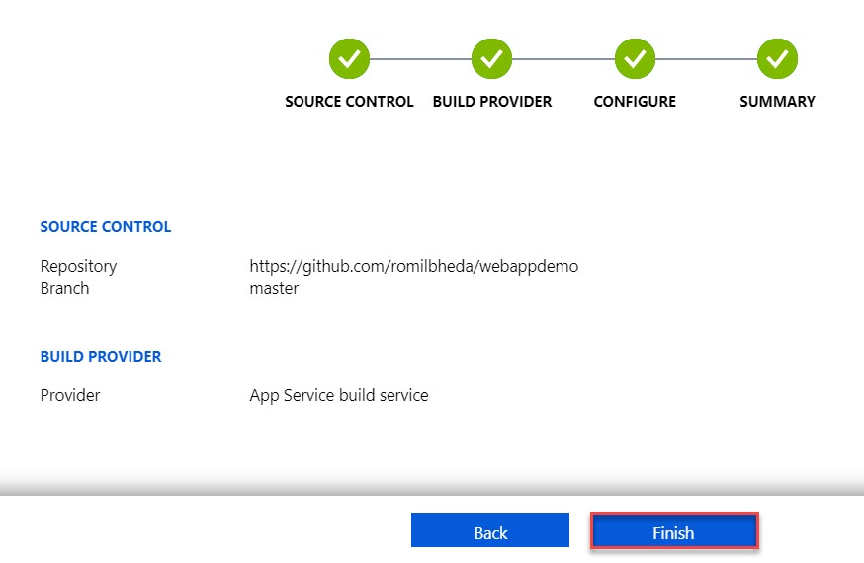

Under Deployment Center you can see all log about configure github.

Click on **Browse** option to check Web App URL

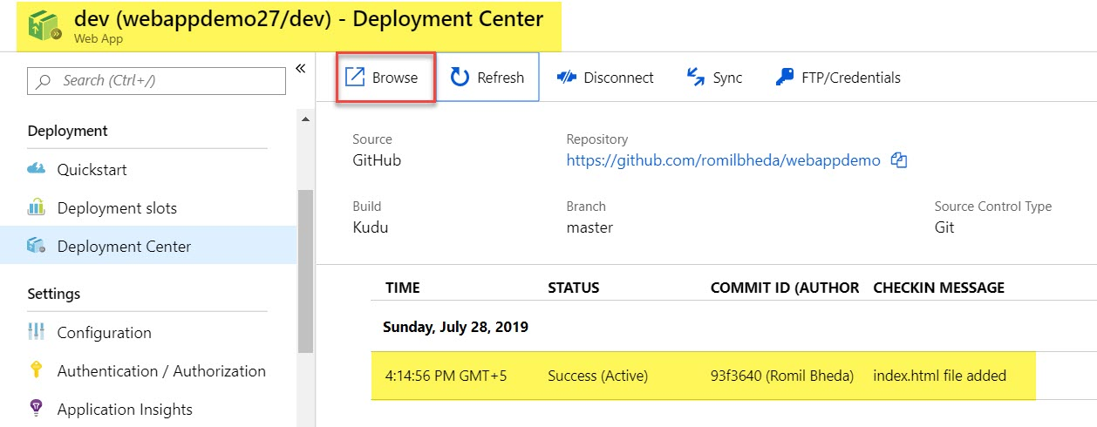

**Step 21:** Now see both Web App URL with Content

<https://webappdemo.azurewebsites.net> -> Azure Web App Demo v1.0

<https://webappdemo-dev.azurewebsites.net> -> Azure Web App Demo v1.1

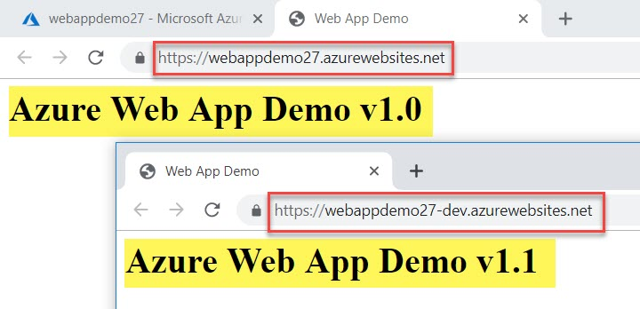

**Step 22:** Now time to replace both the content from **Dev environment to production**.

Click on **Swap** option from Dev webapp

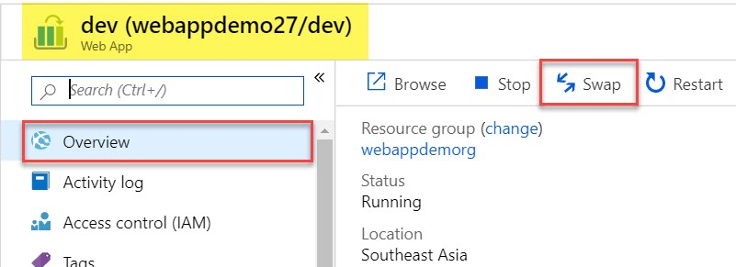

**Step 23:** Verify Source and Target and click on **Swap** button.

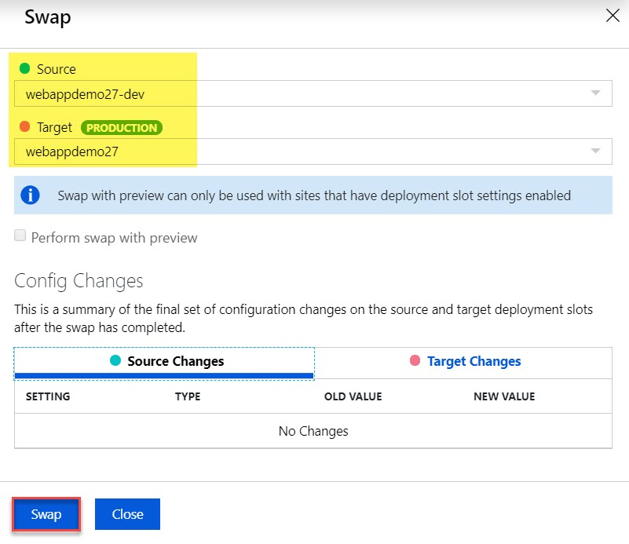

**Step 24:** It will take few seconds to swap the content and if its done message will be there as below:

Click on **Close** button.

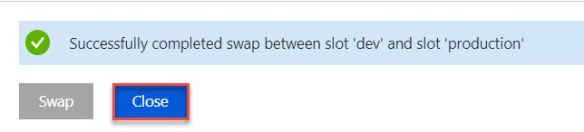

**Step 25:** Now check both Web App URL

<https://webappdemo.azurewebsites.net> -> Azure Web App Demo v1.1

<https://webappdemo-dev.azurewebsites.net> -> Azure Web App Demo v1.0

