**Manage Azure Resource using Azure Portal**

**Lab Scenario**

You need to explore the basic Azure administration capabilities associated with provisioning resources and organizing them based on resource groups, including moving resources between resource groups. You also want to explore options for protecting disk resources from being accidentally deleted, while still allowing for modifying their performance characteristics and size.

**Objectives**

In this lab, we will:

* Task 1: Create resource groups and deploy resources to resource groups
* Task 2: Verify Resource Tags
* Task 3: Move resources between resource groups
* Task 4: Implement and test resource locks

# **Task 1: Create resource groups and deploy resources to resource groups**

**Step 1:** Open **Microsoft Azure Portal**

<https://portal.azure.com/>

**Step 2:** Create **Resource Group**

Click on **Resource groups** -> **+ Add** option

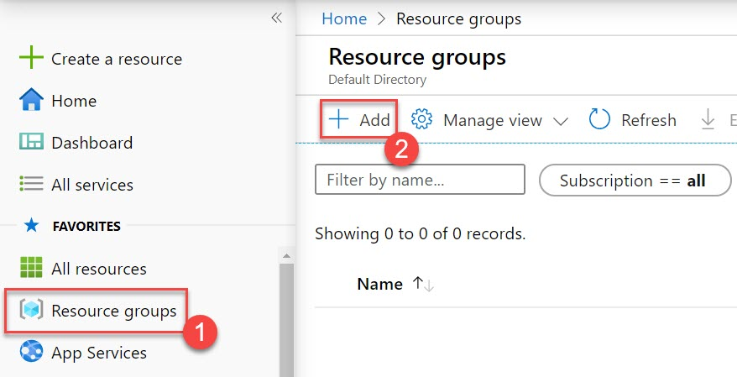

**Step 3:** Create Resource Group

Subscription: **Choose active Subscription**

Resource Group: **Enter Resource Group Name** Ex. **MyResourceGroupLab**

Region: **Choose nearest region** Ex. **Southeast Asia**

Click on **Next: Tags >** button

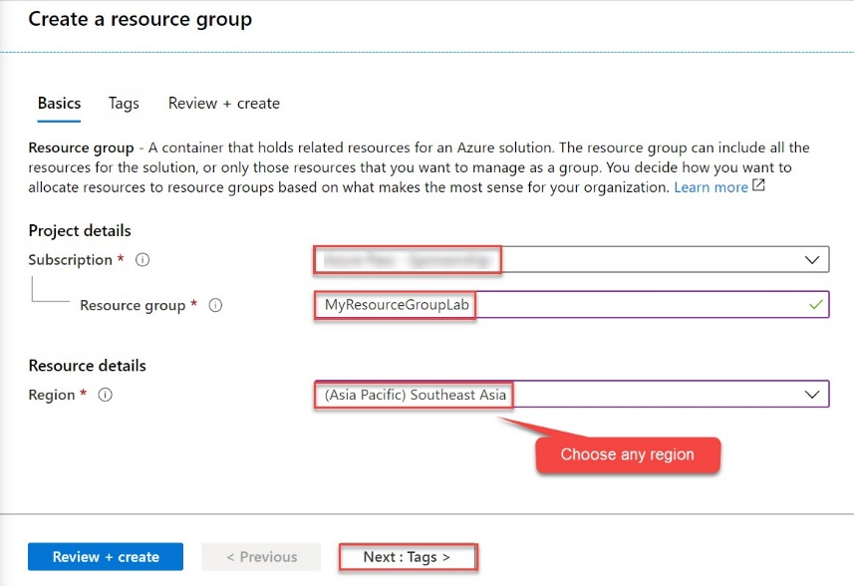

**Step 4:** Create Resource Tags

Name: **Env**

Value: **Production**

Click on **Next: Review + create >** button

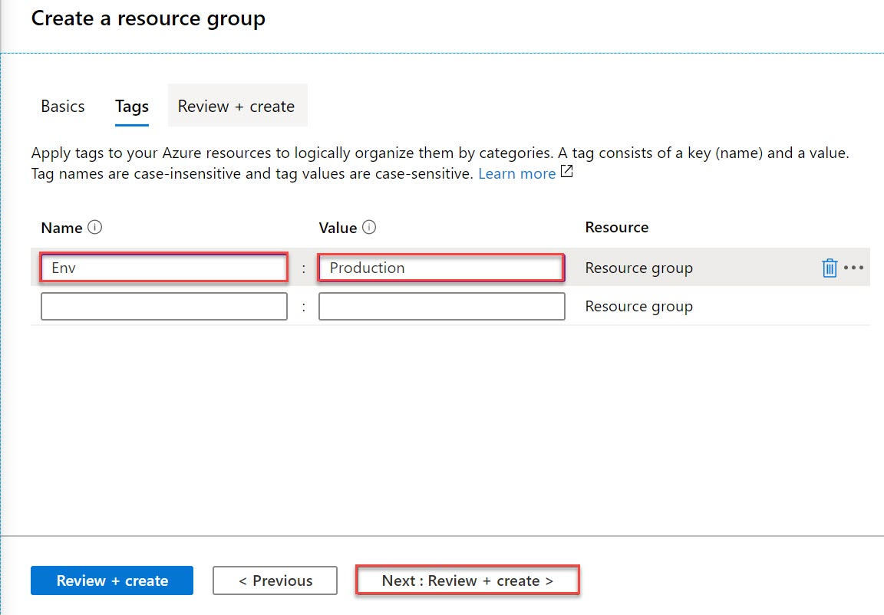

**Step 5:** Click on **Create** button.

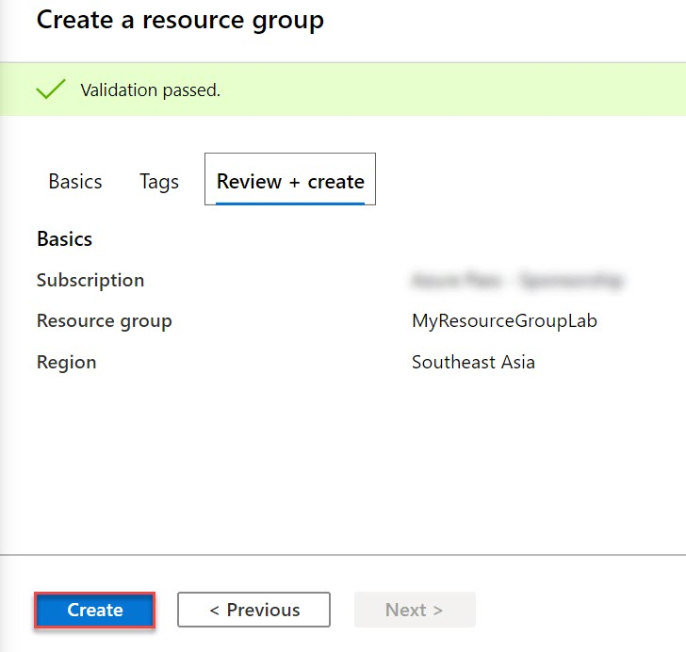

**Step 6:** Within next second it will prompt to Resource Group created notification So click on **Go to resource group** button

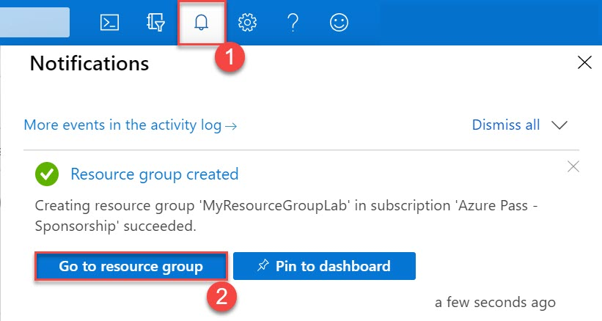

**Step 7:** Now add resource under Resource Group

Click on **+ Add** option

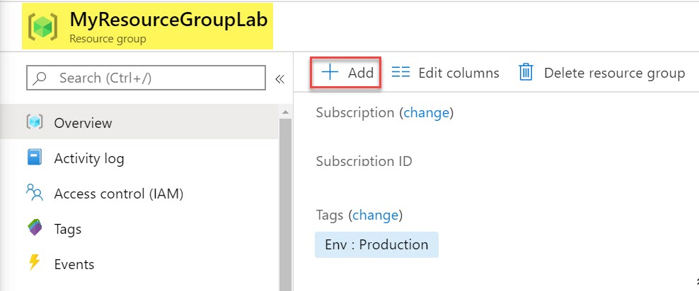

**Step 8:** Search for resource ex “**disks**” and **hit enter key**

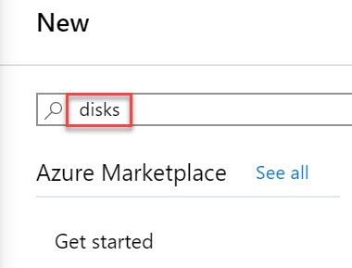

**Step 9:** Click on **Managed Disks**

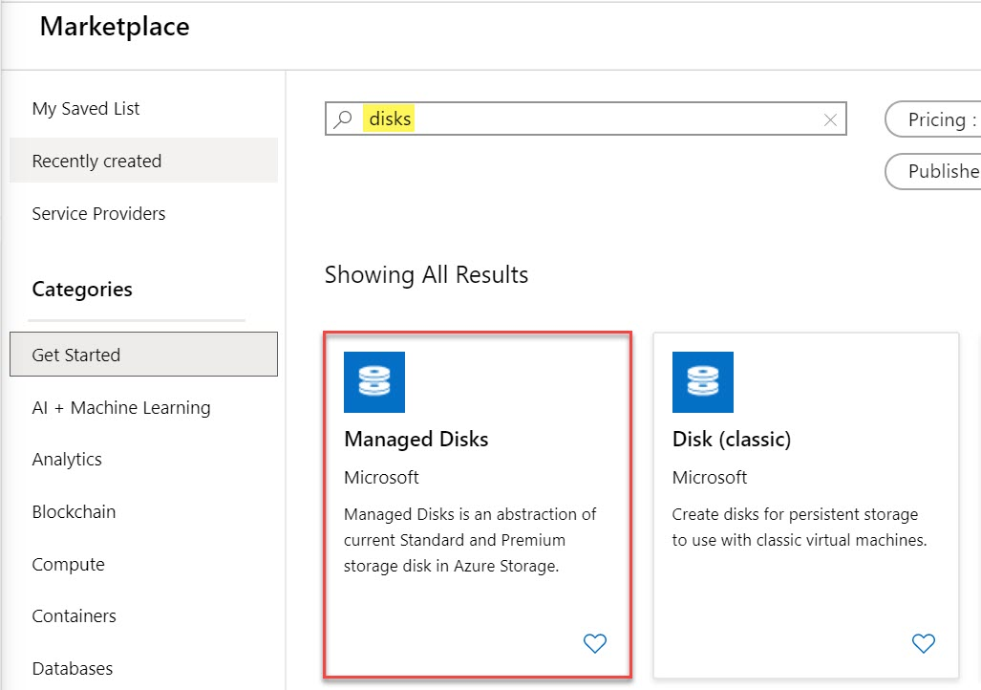

Click on **Create** button to deploy on Azure

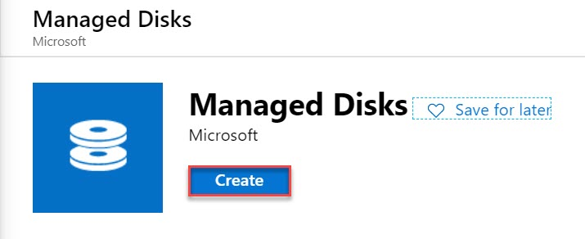

**Step 10:** Create a managed disks

Subscription: **Choose same Subscription**

Resource Group: **Choose existing Resource Group** Ex. **MyResourceGroupLab**

Disk name: **mydisk1**

Region: **Choose same location where resource group deployed** Ex. **Southeast Asia**

Availability zone: **None**

Source type: **None**

Size: Click on **Change size** option

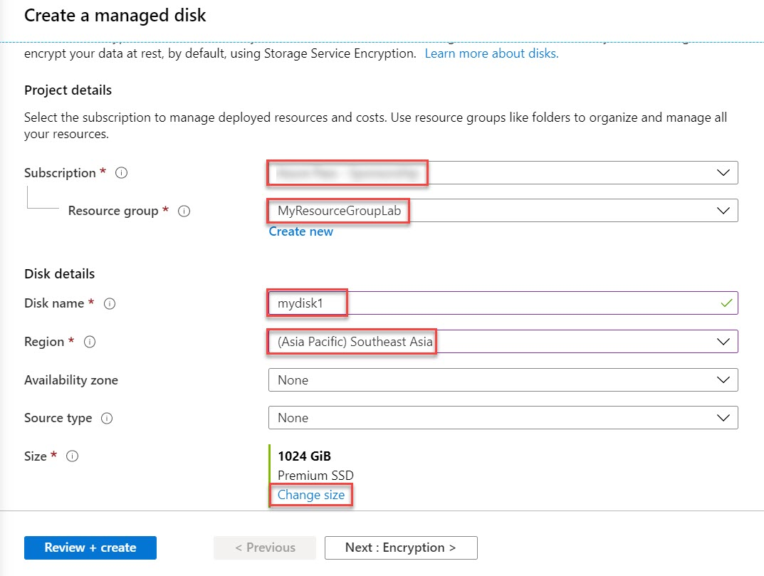

**Step 11:** Select disk size

Storage type: **Standard HDD**

Size: **32 GiB**

Click on **OK** button

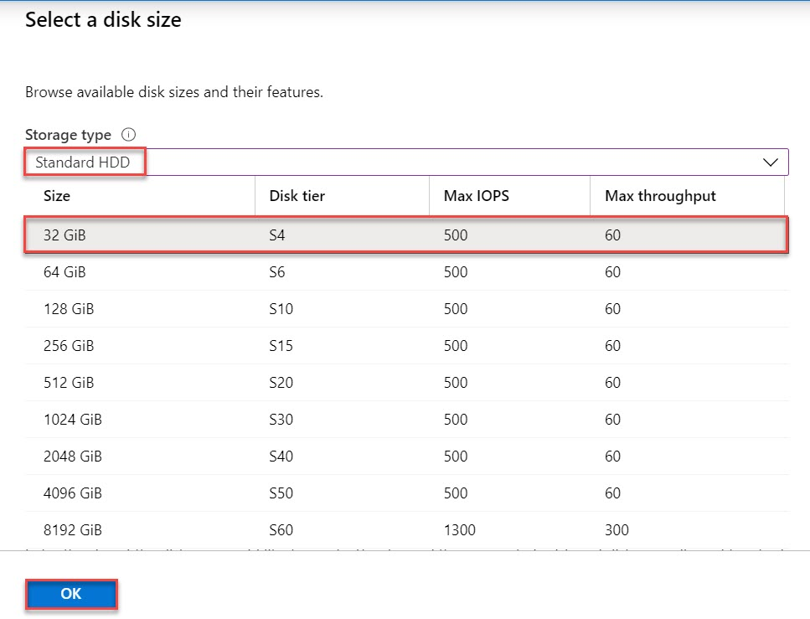

**Step 12:** Click on **Review + Create** button

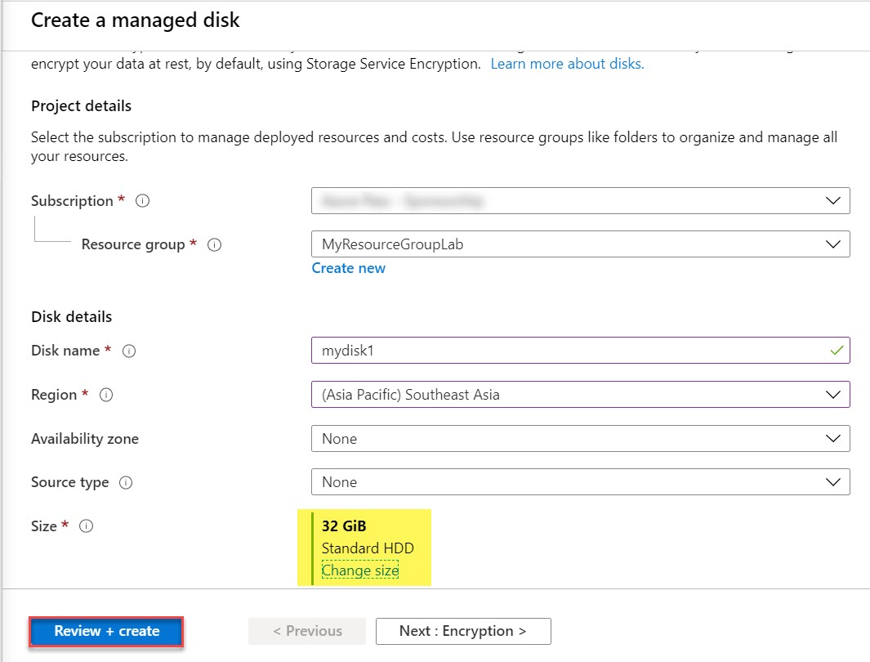

**Step 13:** Click on **Create** button

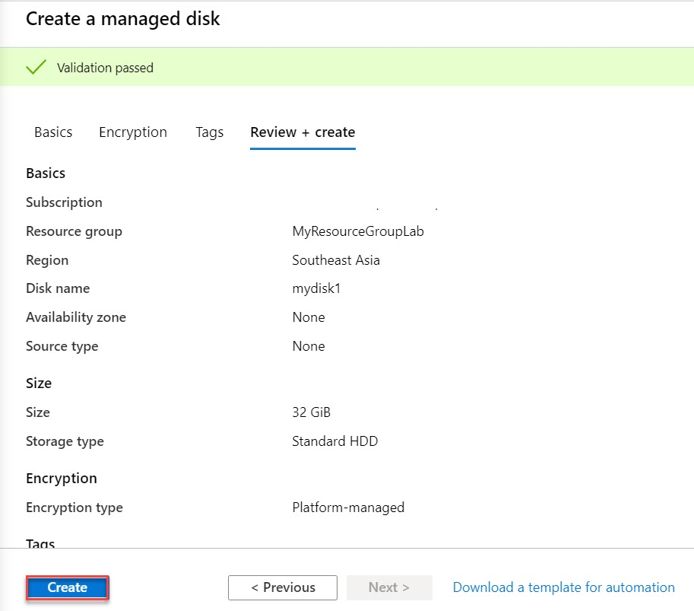

**Step 14:** Click on **Go to resource** button

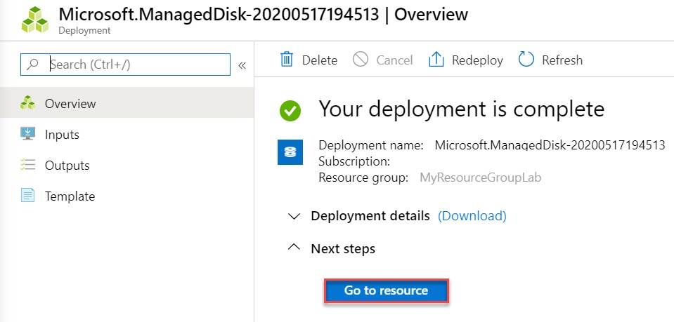

# **Task 2: Verify Resource Tags**

**Step 15:** Click on **All services**

Search for **tags** and click on **Tags** from result.

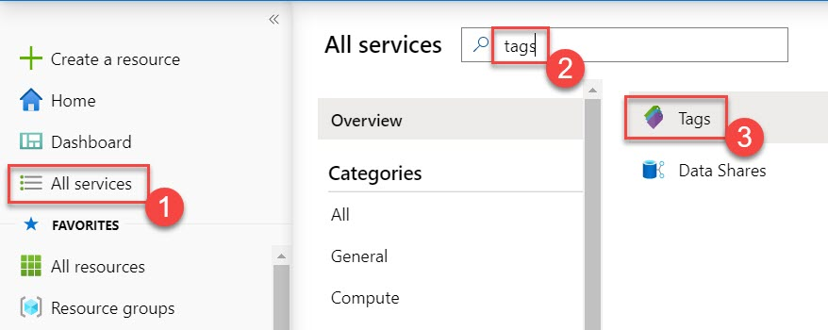

**Step 16:** Click on Tags Ex. **Env: Production**

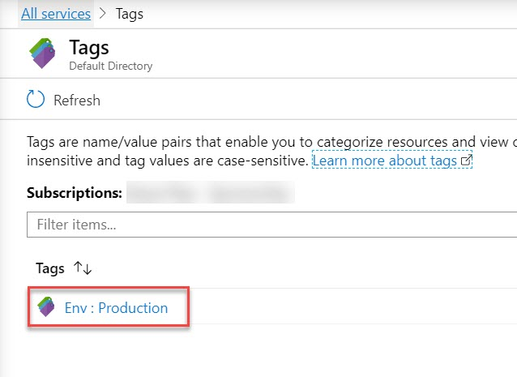

As a result, you can see resource group available

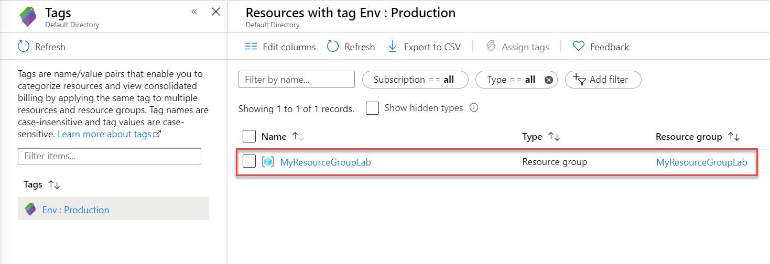

# **Task 3: Move resources between resource groups**

**Step 17:** Click on **-> Move** option

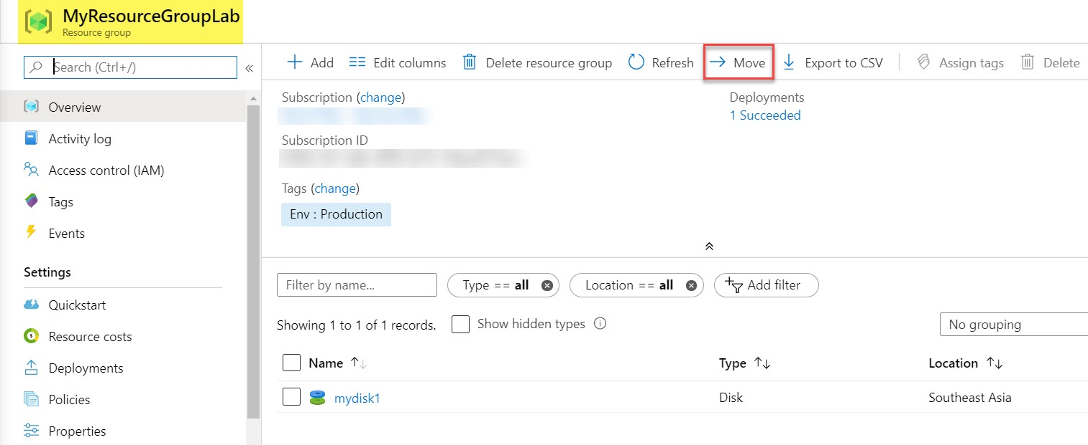

**Step 18:** For this demo we will select **Move to another resource group** option

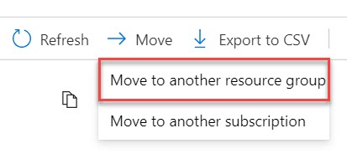

**Step 19:** Select resources to move

Resource Group: **Create New Resource Group** Ex. **MyResourceGroupLab2**

Select the checkbox **I understand that tools and scripts associated with moved resources will not work until I update them to use new resource IDs**

Click on **OK** button

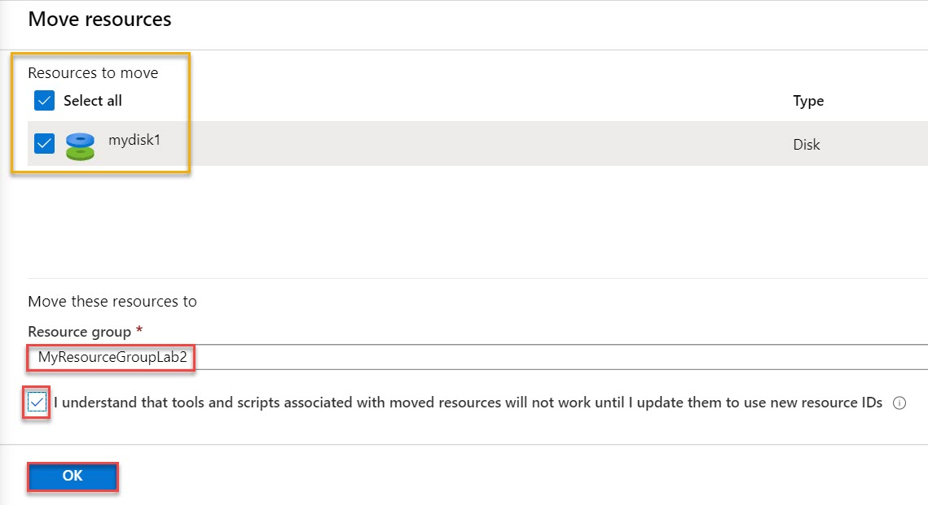

**Note: Do not wait for the move to complete but instead proceed to the next task. The move might take about 10 minutes. You can determine that the operation was completed by monitoring activity log entries of the source or target resource group. Revisit this step once you complete the next task.**

# **Task 4: Implement and test resource locks**

**Step 20:** Once again click on **All services**

Search for **disk** and select **Disks**

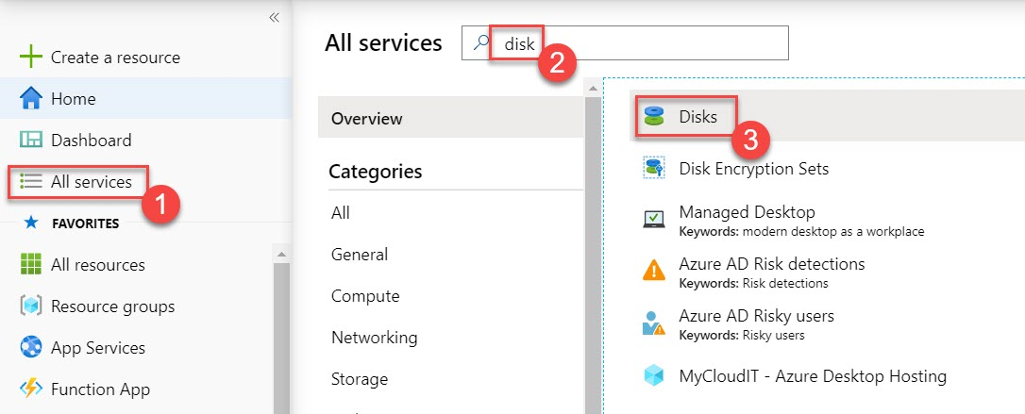

**Step 21:** Add one more Disks. Click on **+ Add** option

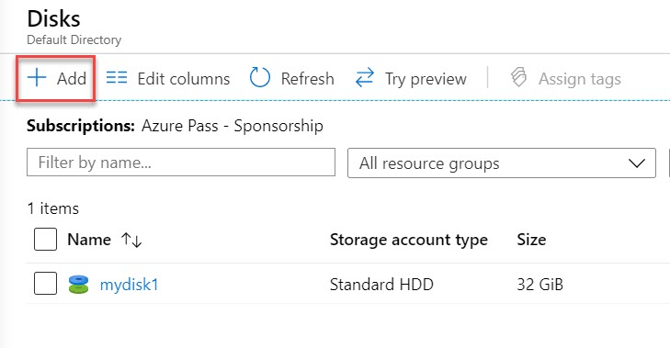

**Step 22:** Resource Group: **Create New** Ex. **MyResourceGroupLab3**

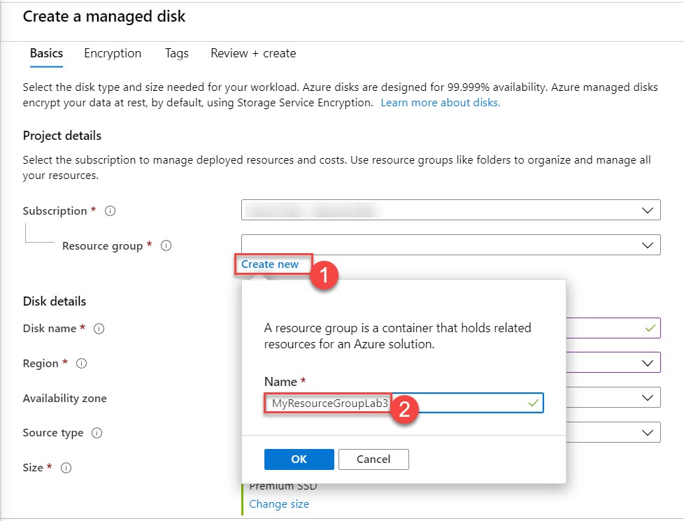

Disk name: **mydisk2**

Region: **Choose same region as selected for others**. Ex. **Southeast Asia**

Availability zone: **None**

Source type: **None**

Size: Click on **Change size** option

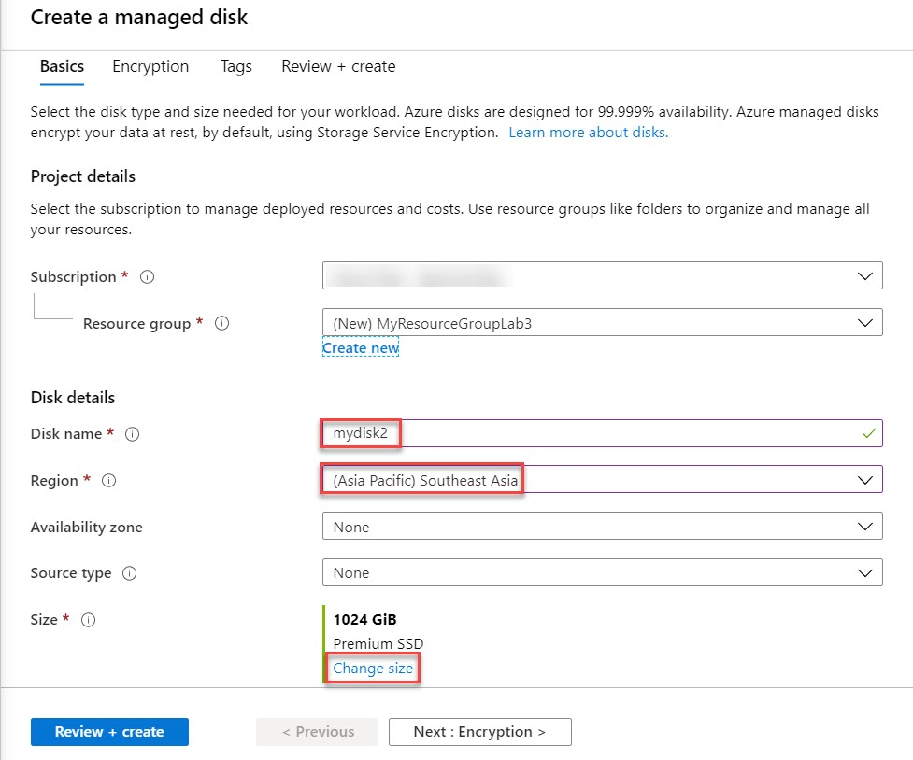

**Step 23:** Select a disk size

Storage type: **Standard HDD**

Size: **32 GiB**

Click on **OK** button

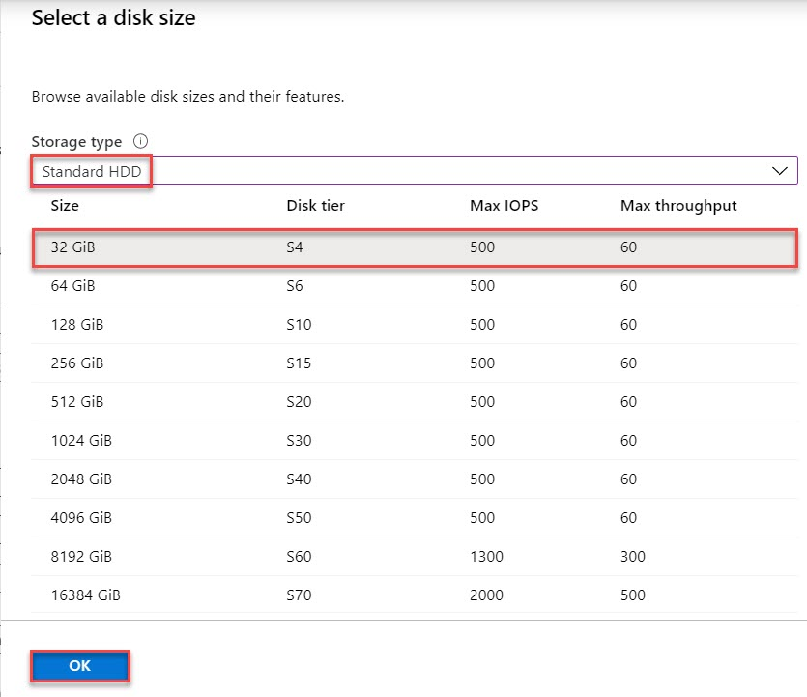

**Step 24:** Click on **Review + Create** button

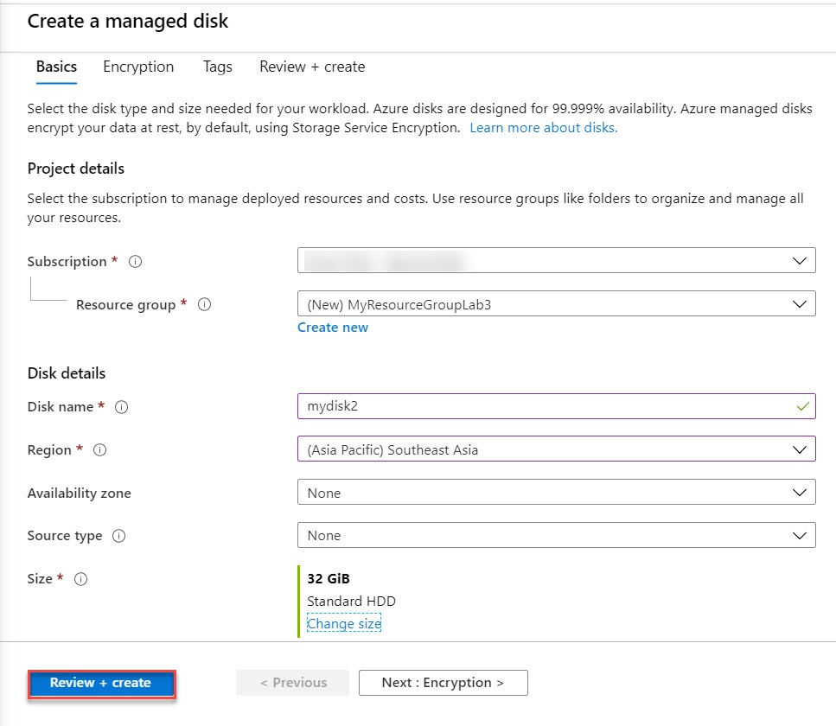

**Step 25:** Click on **Create** button

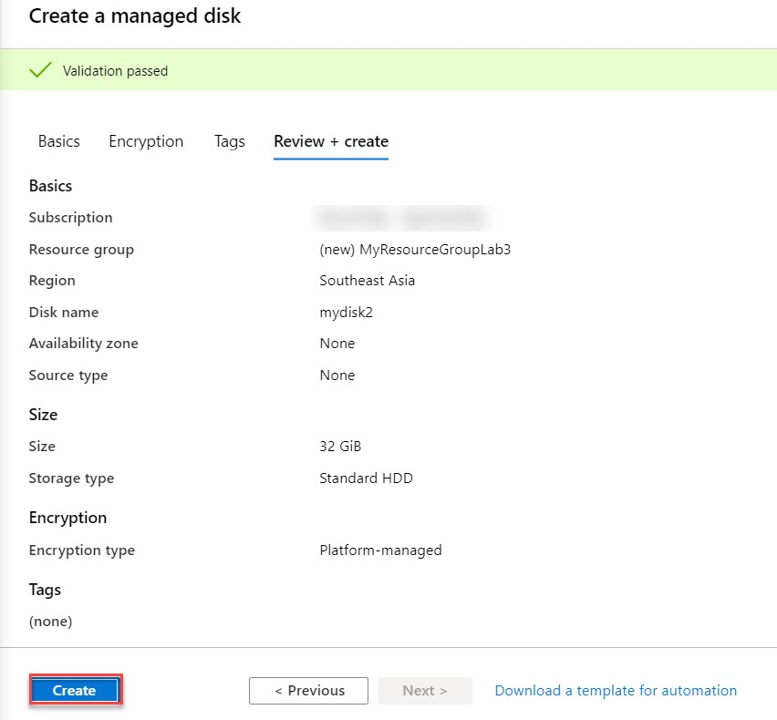

**Step 26:** Click on **Go to resource** button

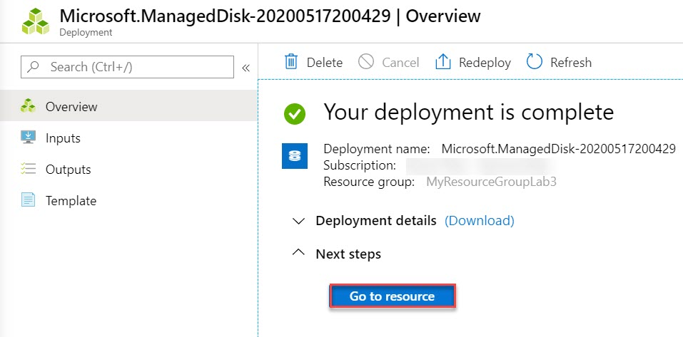

**Step 27:** Select **Locks** option under **Settings**

Click on **+ Add** button

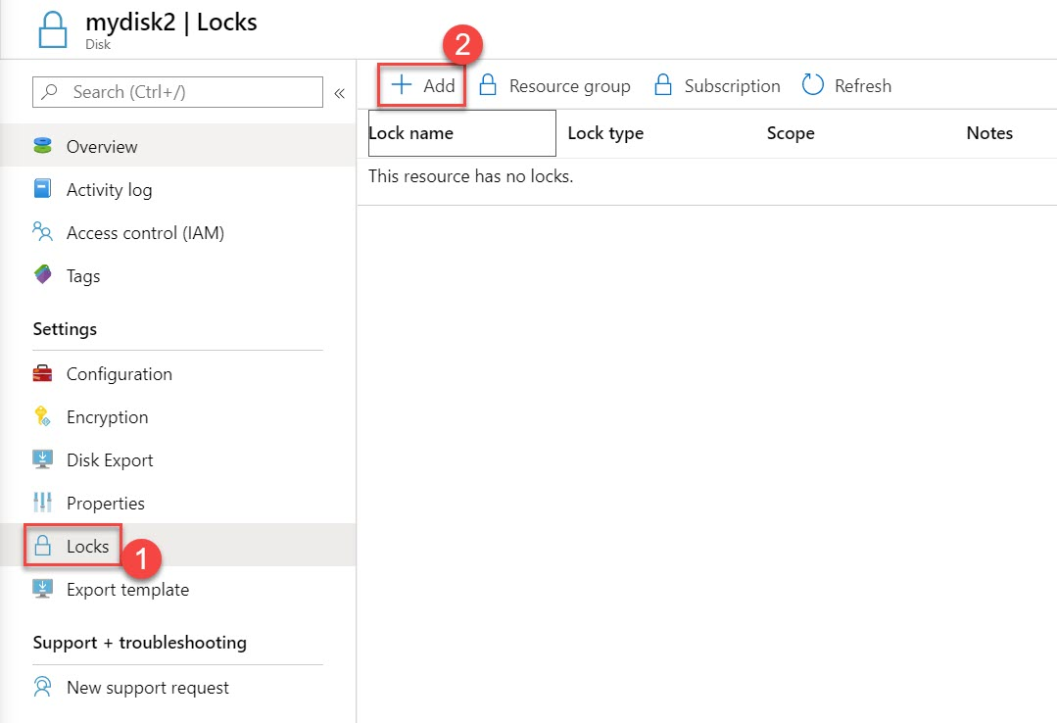

Lock name: **DeleteLock**

Lock type: **Delete**

Click on **OK** button

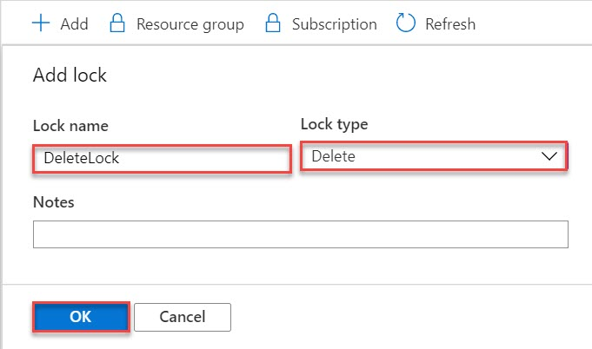

**Step 28:** Now time to test Locks.

Click on **Resource groups** -> Click on **MyResourceGroupLab3**

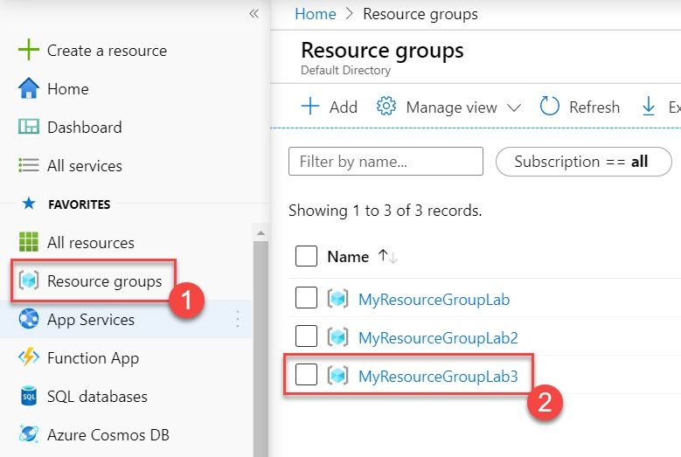

**Step 29:** Click on **Delete resource group** option

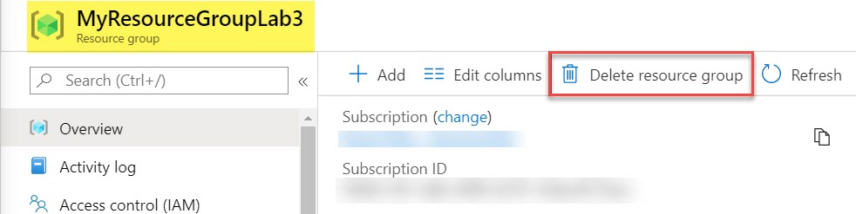

Enter **resource group name** and click on **Delete** button

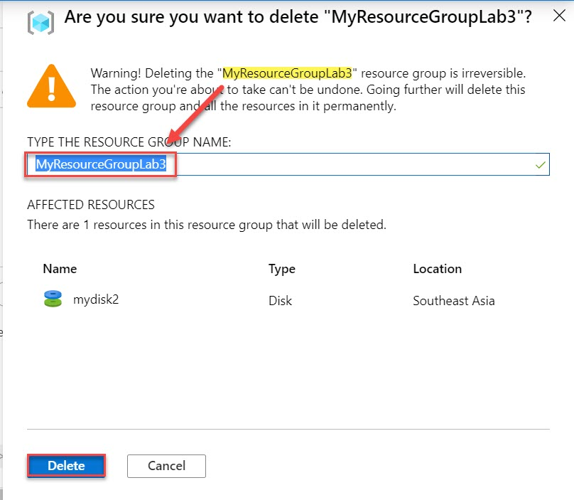

Within next second it will prompt error. Verify in **Notifications**.

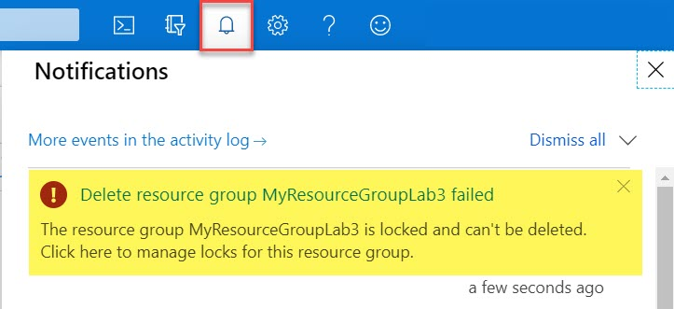

**Step 30:** Change configuration of Disk. Just to verify resource group-level lock applies to delete operations only.

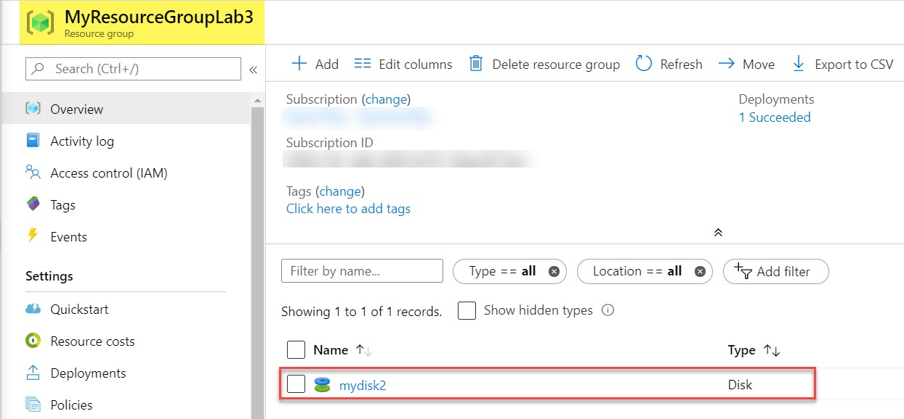

**Step 31:** Select **Configurations** under **Settings**

Storage type: **Standard SSD**

Size: **64 GiB**

Click on **Save** button

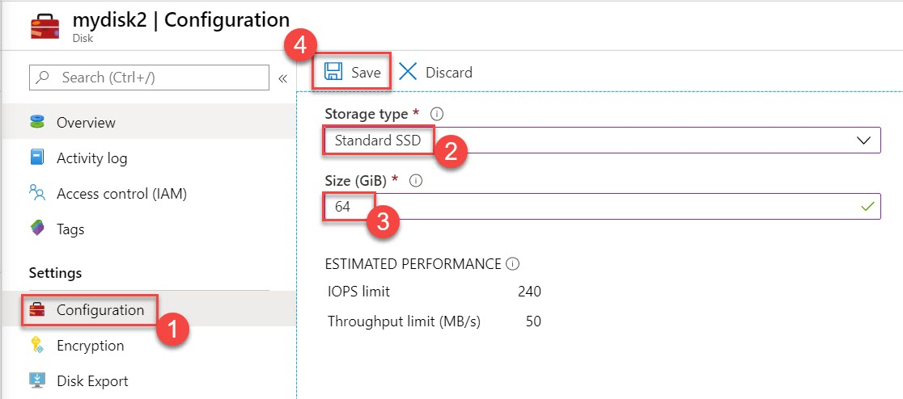

**Step 32:** To Delete Lock, follow below steps:

Select **Locks**

Navigate to **DeleteLock** and click on **Delete** button

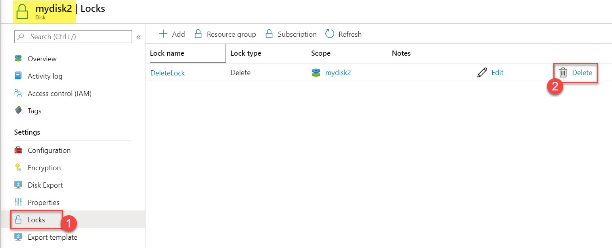

**Step 33:** Now Locks removed so possible to delete Resource Group

Click on **Resource groups** and Select any resource group ex. **MyResourceGroupLab**

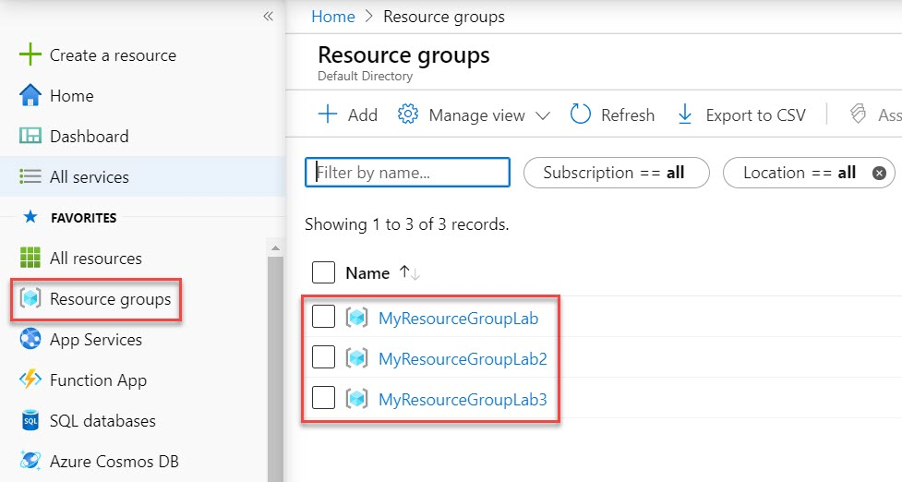

**Step 34:** Select **Delete resource group** option

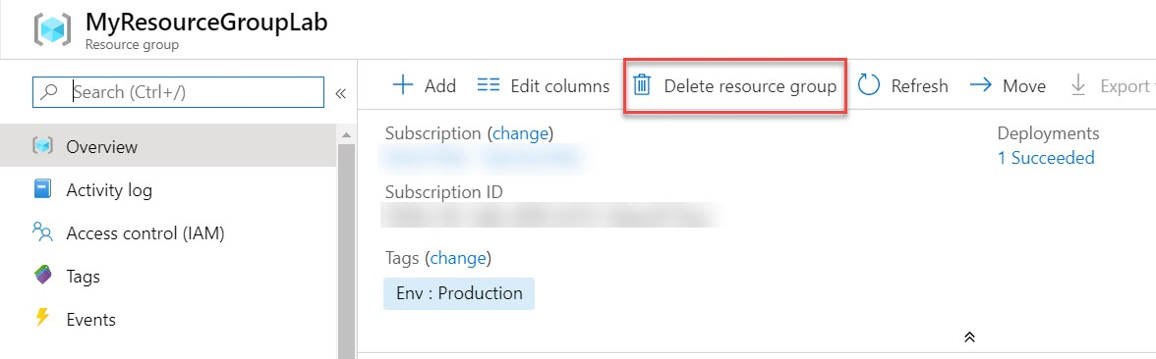

Enter **Resource group name** and click on **Delete** button

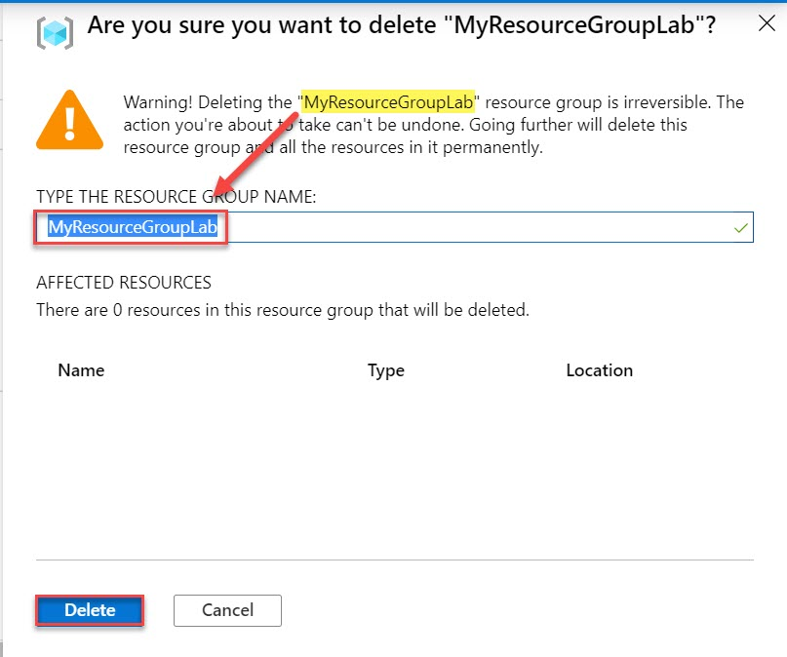

**Note: Repeat same steps of other 2 resource groups.**