**Create Visual Studio Lab Environment**

**Step 1:** Open Microsoft Azure Portal

[https://portal.azure.com](https://portal.azure.com/)

**Step 2:** Click on **+ Create a resource**.

Search for “**visual studio 2019 latest**” and hit enter key.

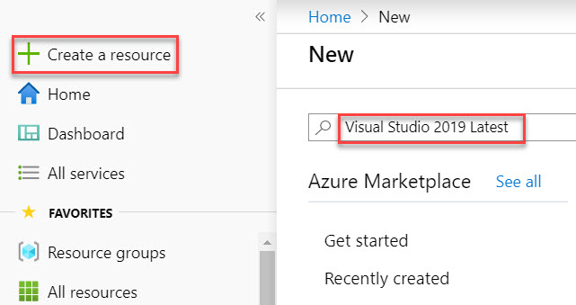

Select **Visual Studio 2019 Latest** from Result

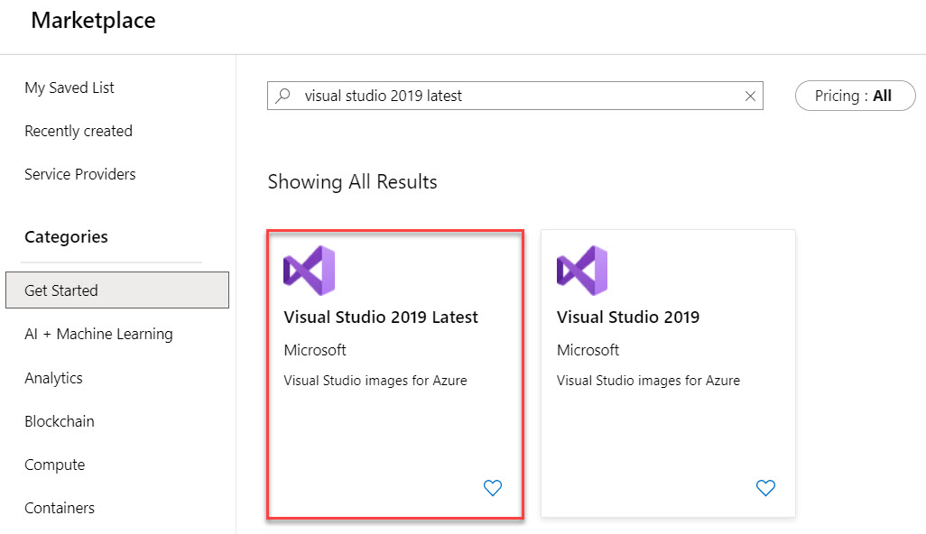

Select Software plan: **Visual Studio 2019 Community (latest release) on Windows Server 2019 (x64)**

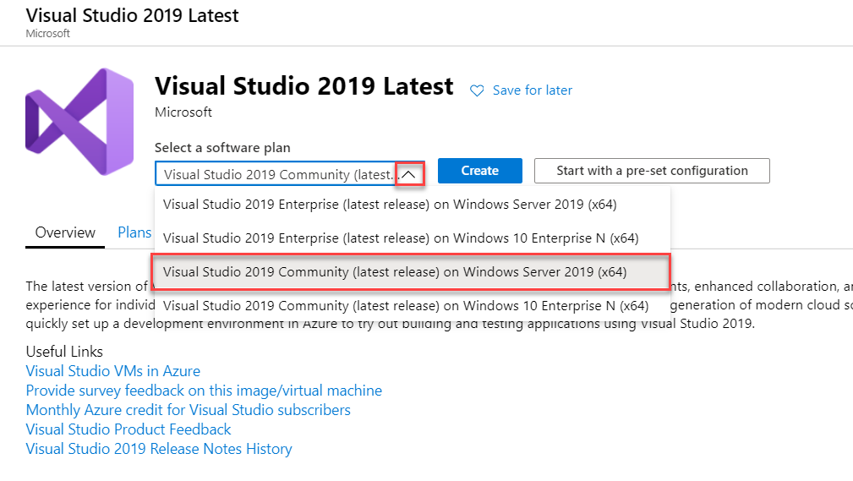

**Step 3:** Create Virtual Machine

Subscription: **Choose active Subscription**

Resource Group: **Create New** Ex. **VSLabVMRG**

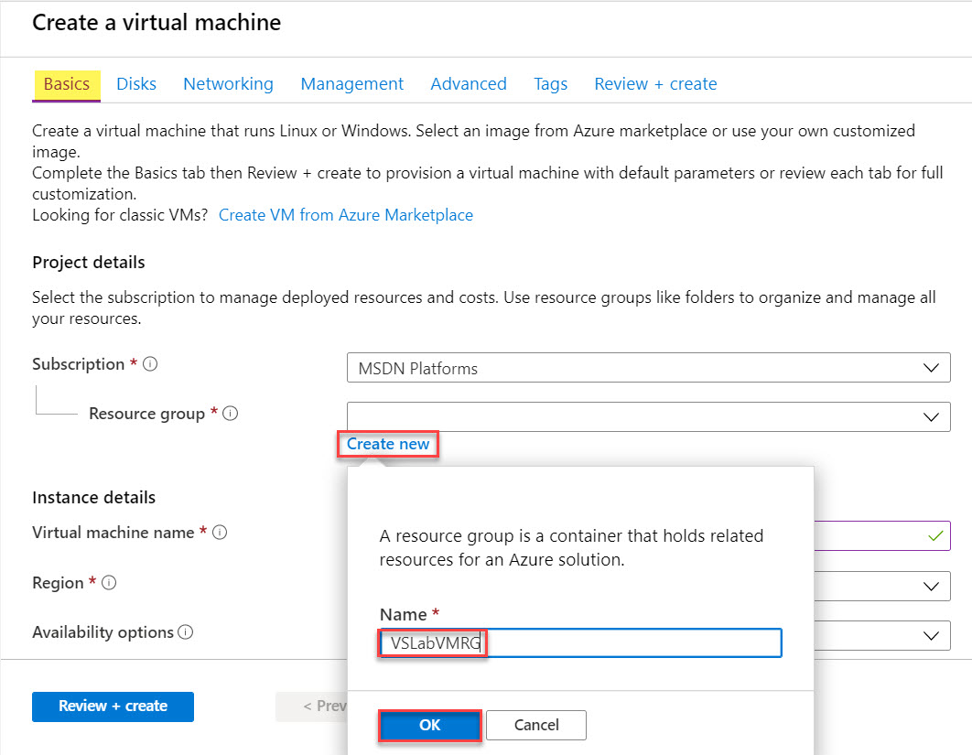

Virtual Machine Name: **demovsvm**

Region: **Choose any nearest region**

Image: **Visual Studio 2019 Community (latest release) on Windows Server 2019 (x64)**

Size: **Standard D4s v3** or more size

Username: **demouser**

Password: **demo@pass123**

Public inbound ports: **Allow Selected ports**.

Select inbound ports: **RDP (3389)**

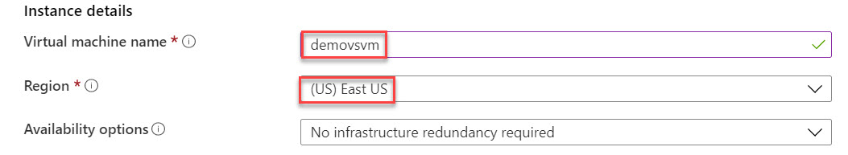

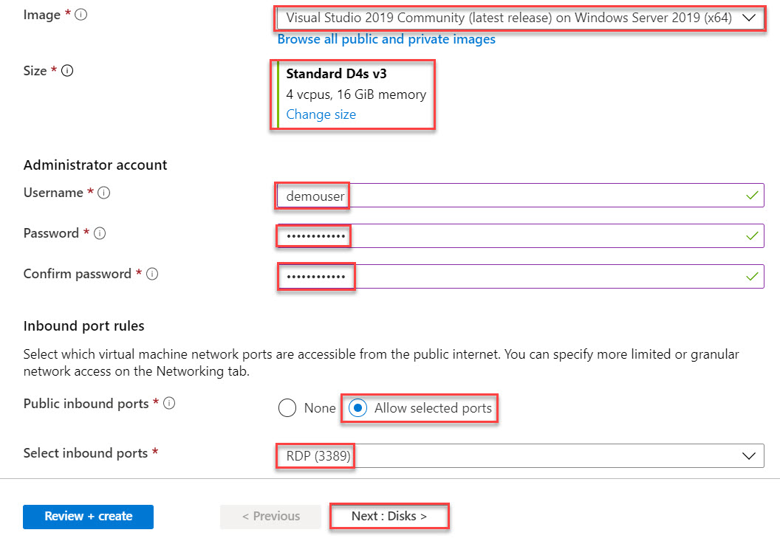

Click on **Next: Disks >**

**Step 4:** Disk tab

OS disk type: **Standard SSD**

Click on **Next: Networking >**

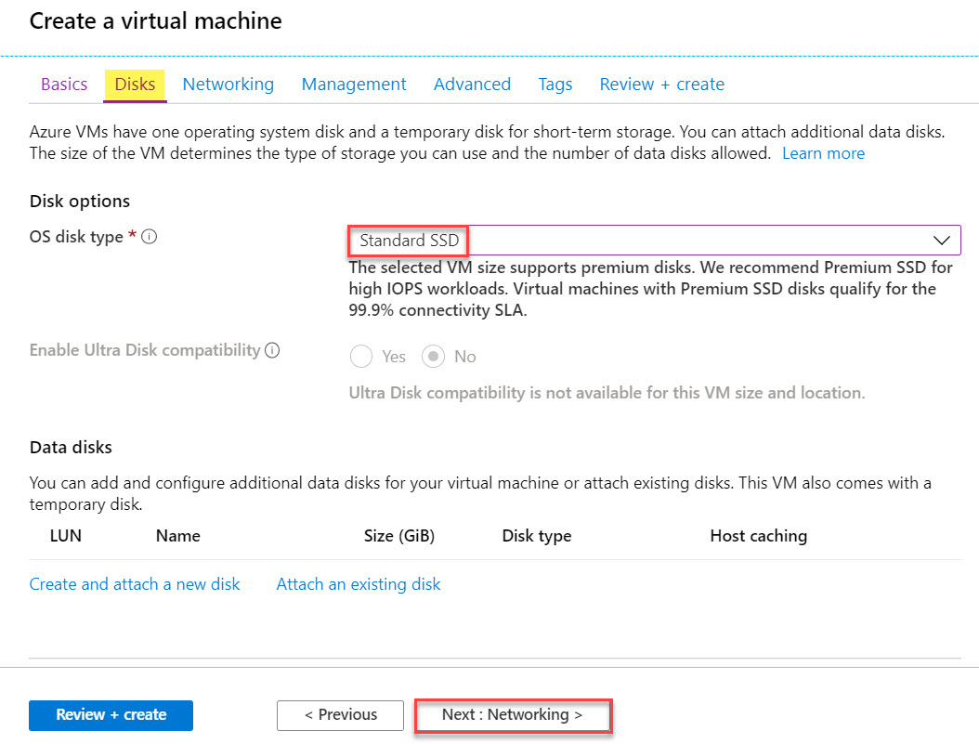

**Step 5:** Networking tab

Click on **Next: Management >**

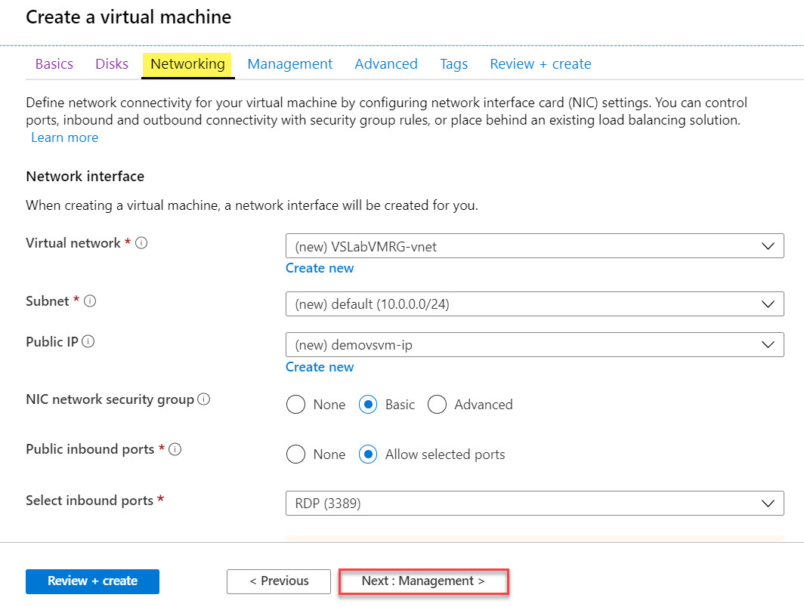

**Step 6:** Management tab

Enable Auto-shutdown: **Off**

Click on **Next: Advanced >**

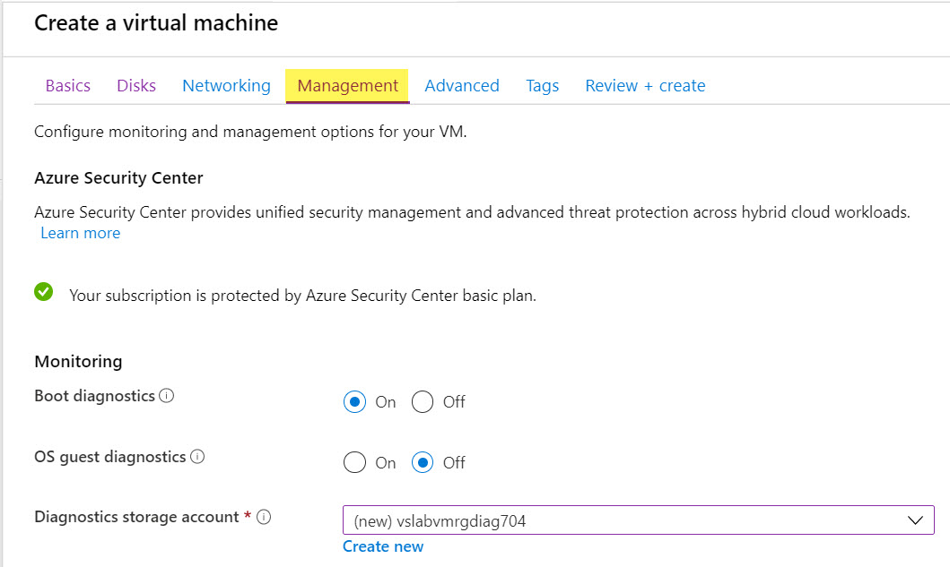

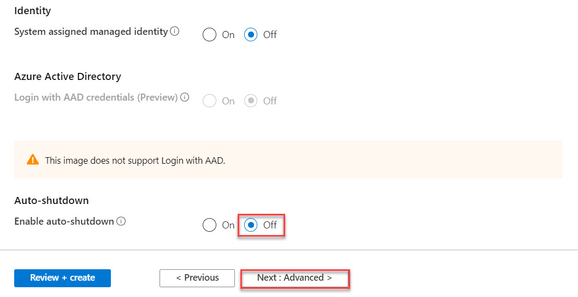

**Step 7:** Advanced tab

Click on **Review + Create** button.

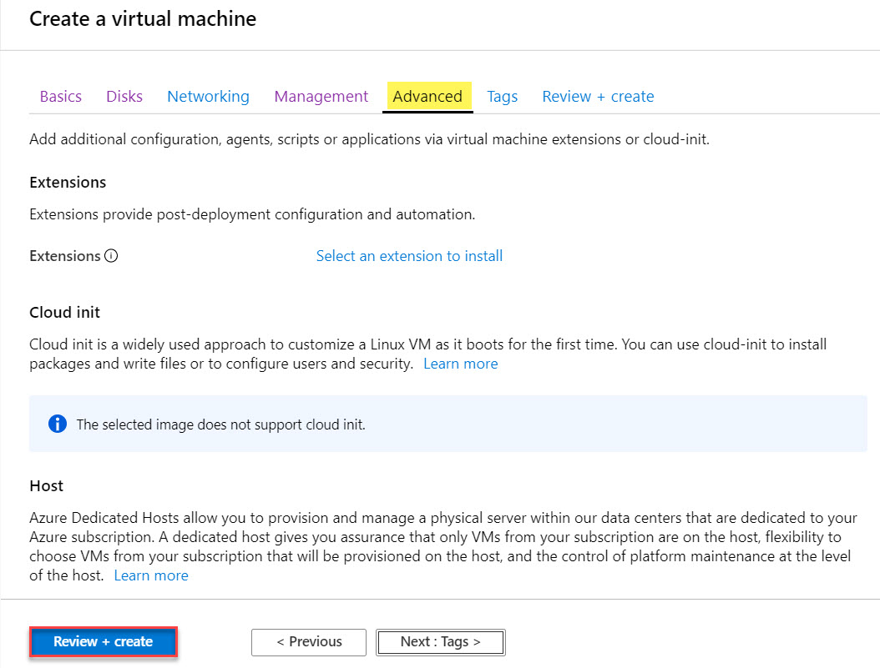

**Step 8:** Review + create tab

Click on **Create** button.

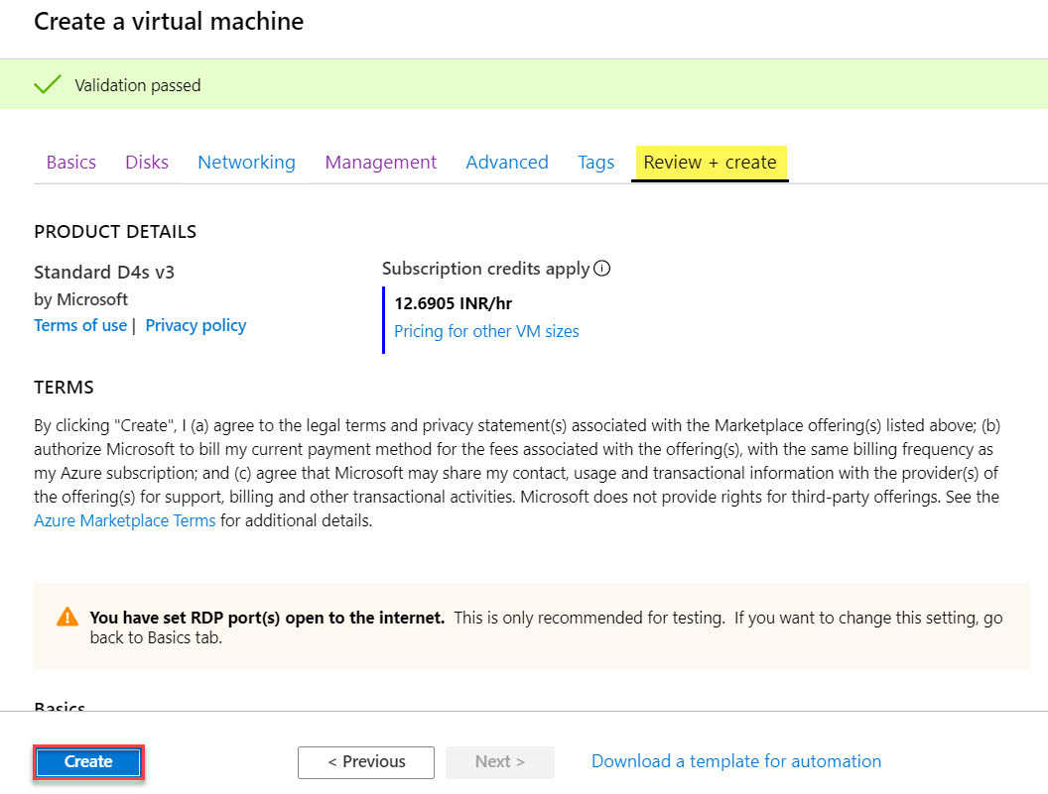

Wait for minutes to deploy Visual Studio Virtual Machine on Microsoft Azure. Click on **Go to resource**.

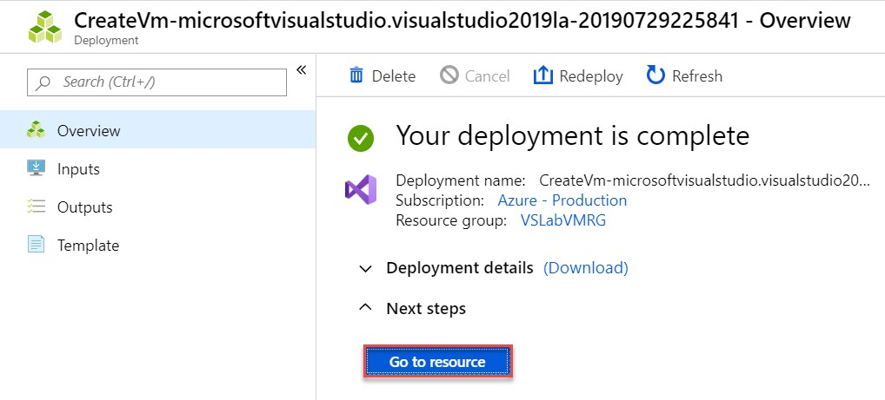

**Step 9:** Virtual Machine Blade will open. Click on **Connect** option.

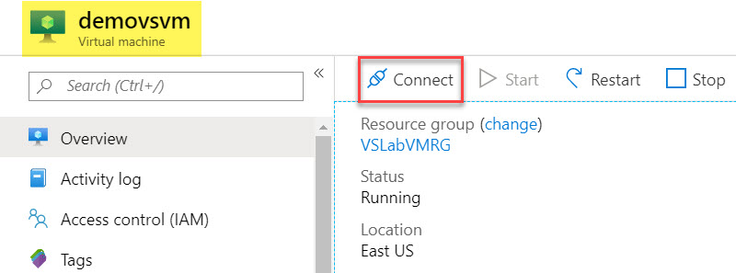

**Step 10:** Click on **Download RDP File** button.

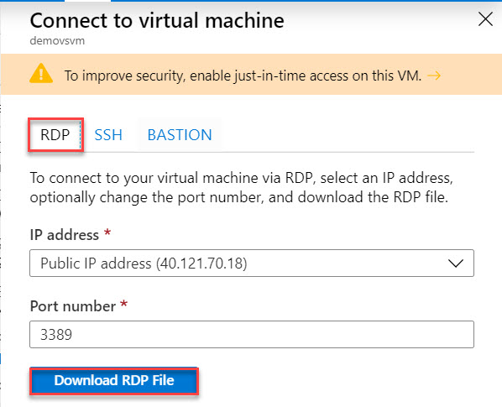

Click on **demovsvm.rdp** file or run file.

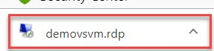

**Step 11:** Click on **Connect** button.

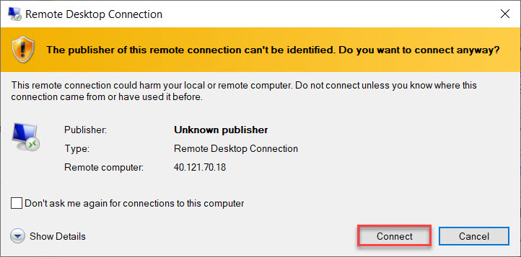

Enter Virtual Machine Credentials:

Username: **demouser**

Password: **demo@pass123**

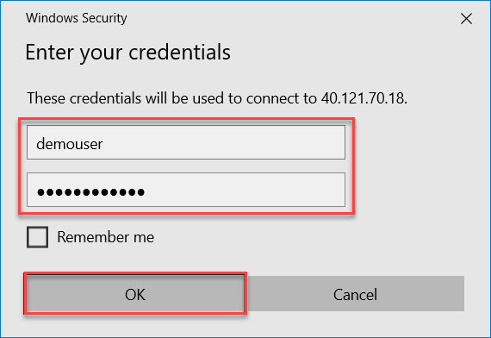

Click on **Yes**.

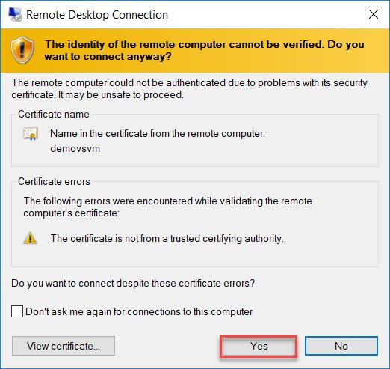

Windows Server 2019 will load. Wait for few minutes to load OS. Click on **No** option in Networks

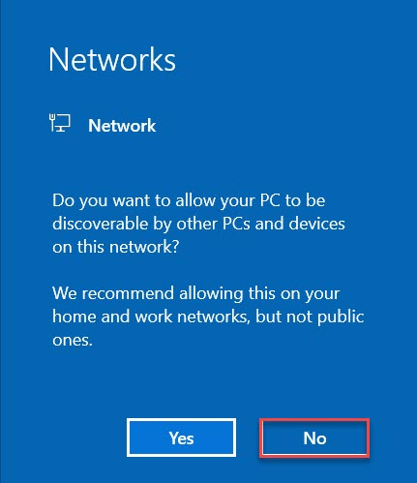

**Also, close Server Manager.**