**Azure Storage – File Share**

**Note: Continue with Storage Blob demo or if you don’t have storage account so create fresh.**

**Step 1:** Select **Filer shares** under **File service**

Click on **+ File share** option

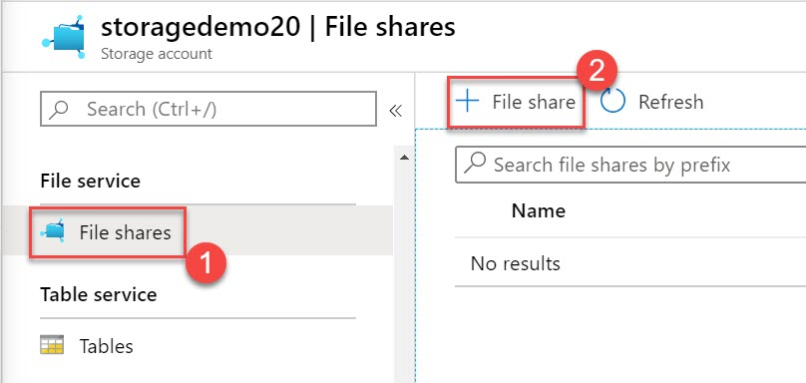

**Step 2:** New file share

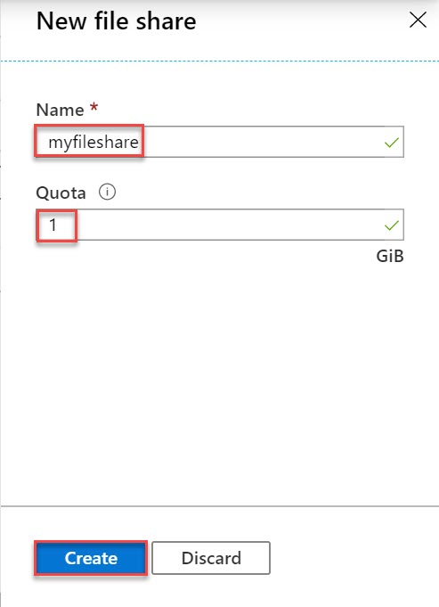

Name: **myfileshare**

Quota: **1**

Click on **Create** button

**Step 3:** Click on **myfileshare**

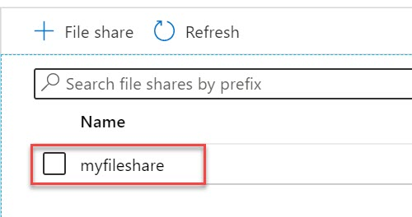

**Step 4:** Create New directory under file share

Click on **+ Add directory**

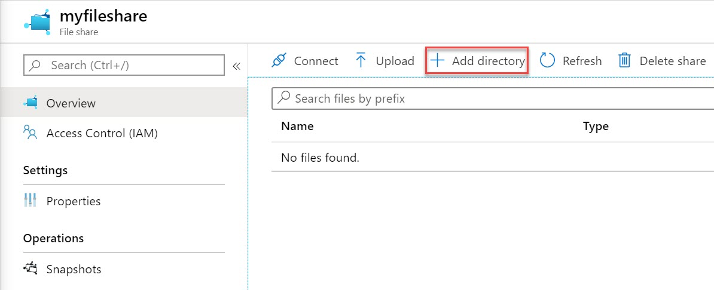

**Step 5:** Name: **myfiles**

Click on **OK** button

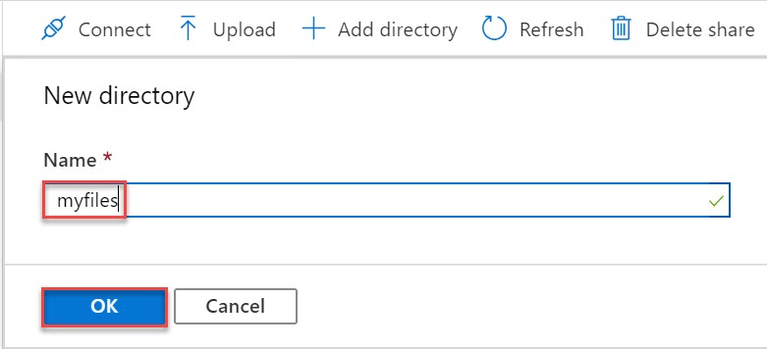

**Step 6:** Click on new directory

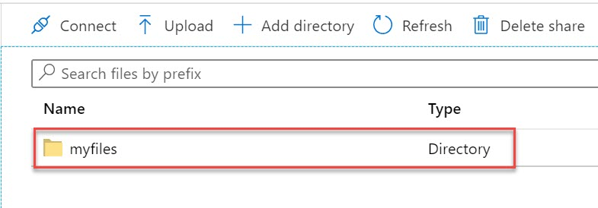

**Step 7:** Click on **Upload** option

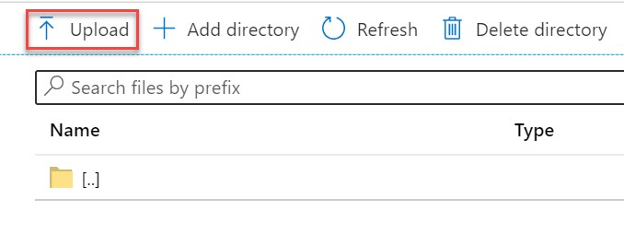

**Step 8:** Click on **Browse** option

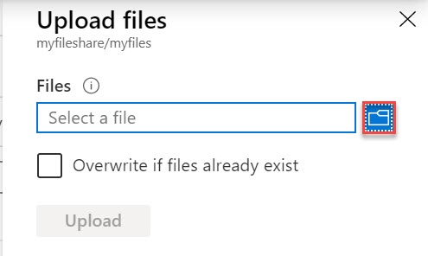

**Step 9:** Choose any file from system and click on **Upload** button

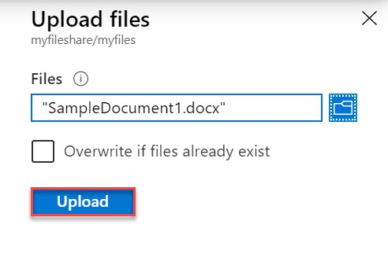

**Step 10:** File successfully uploaded and click on back option or navigate to root directory

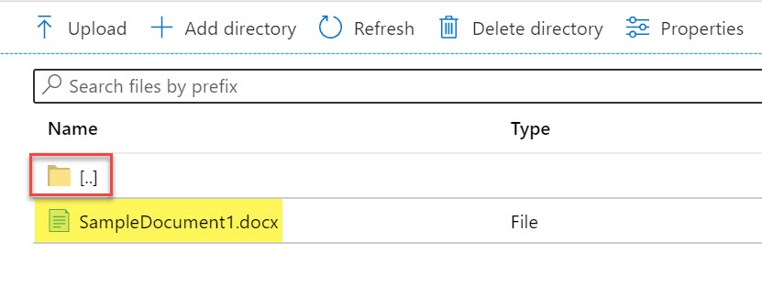

**Step 11:** Click on **Connect** option

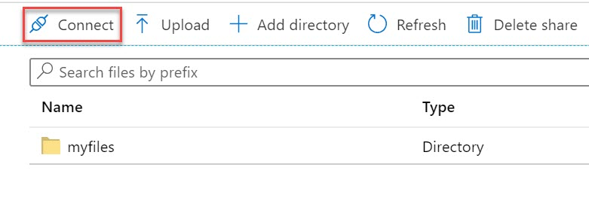

**Step 12:** Choose **Operating** and **Drive letter**

Copy complete script

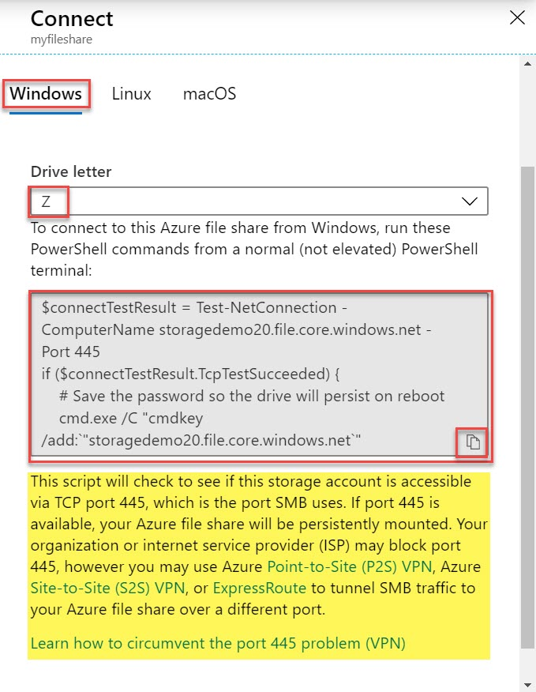

**Step 13:** Open **Run (Windows + R)**

Type **powershell** and click on **OK** button

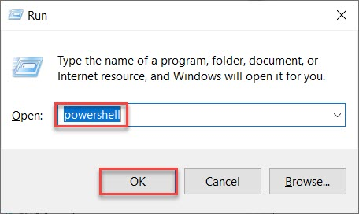

**Step 14:** Paste Storage File Share script

Within couple of seconds output will prompt

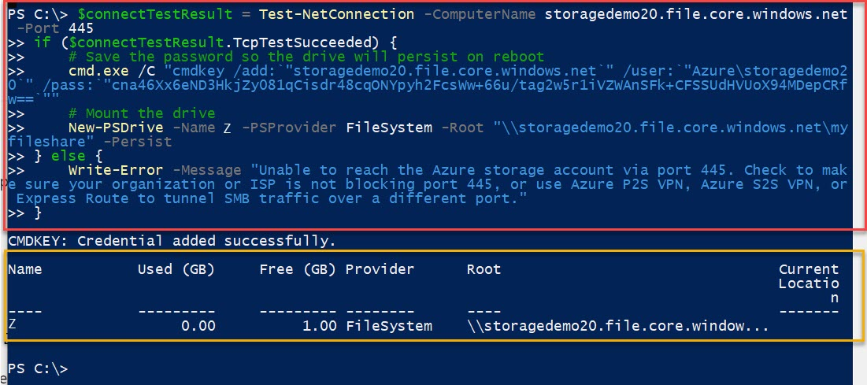

**Step 15:** Open This PC or computer and check one extra drive available

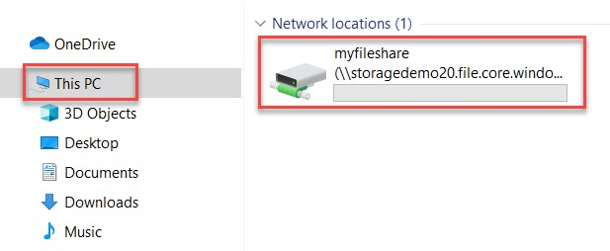

**Step 16:** Verify sample document

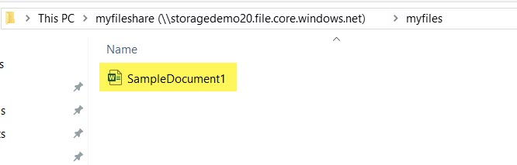

**Step 17:** Add few more files from system to current drive

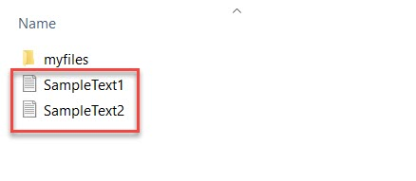

**Step 18:** Navigate to **Azure Portal**

Check **File Share** and click on **Refresh** button. Sample files also update here.

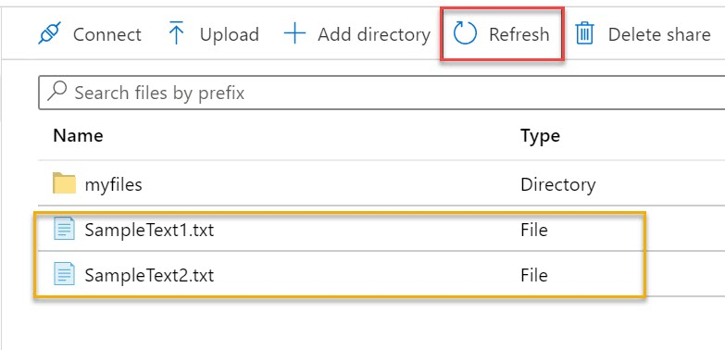

For unmount drive run below command:

Remove-PSDrive -Name <drive-letter>