**Create Storage Account and work with Blob Service – Azure Portal**

**Step 1:** Open Microsoft Azure Portal

[https://portal.azure.com](https://portal.azure.com/)

**Step 2:** Create Storage account

**+ Create a resource -> Storage -> Storage account**

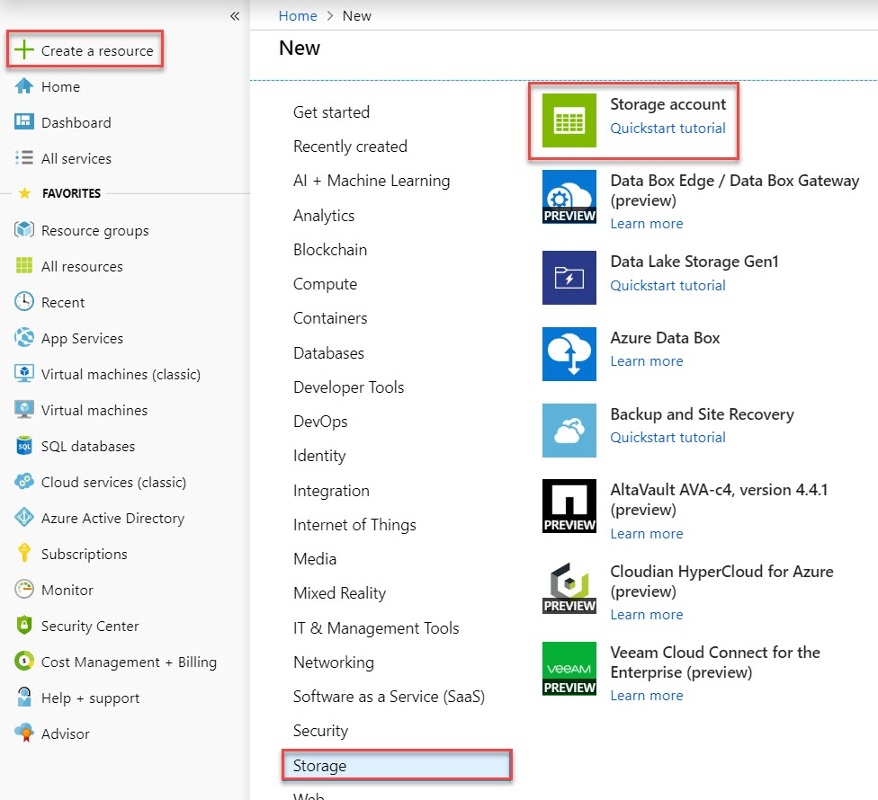

**Step 3:** **Basics** tab

Subscription: **Choose any active subscription**

Resource Group: **Create New Resource Group Ex. storagedemoRG**

Storage account name: **Enter unique name with lowercase Ex. storagedemo20**

Location: **Choose any nearest location**

Performance: **Standard**

Replication: **Locally-Redundant Storage (LRS)**

Access tier**: Go with default because for this demo it’s not required.**

Click on **Next: Advanced >** button

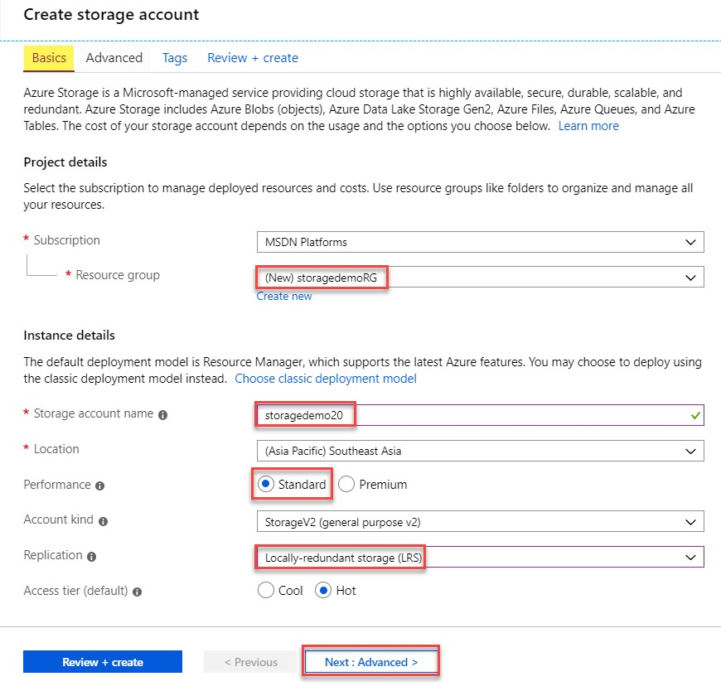

**Step 4: Networking** tab

If you wish you can change connectivity method as per your requirement but for this demo you can skip or go with default option.

Click on **Next: Advanced >** button

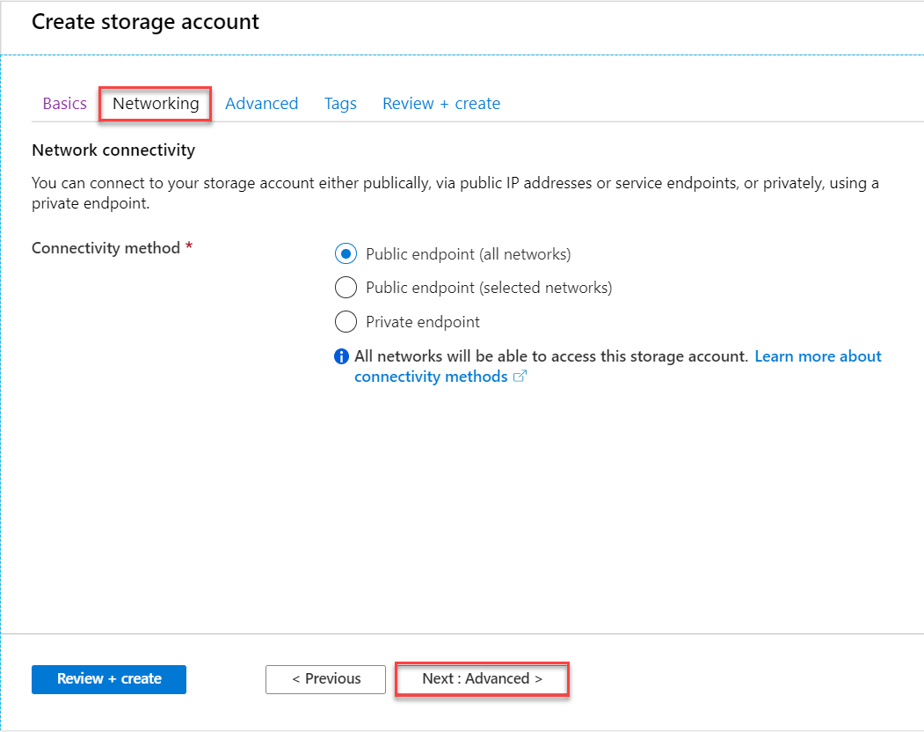

**Step 5: Advanced** tab

Go with default option

Click on **Next: Tags >** button.

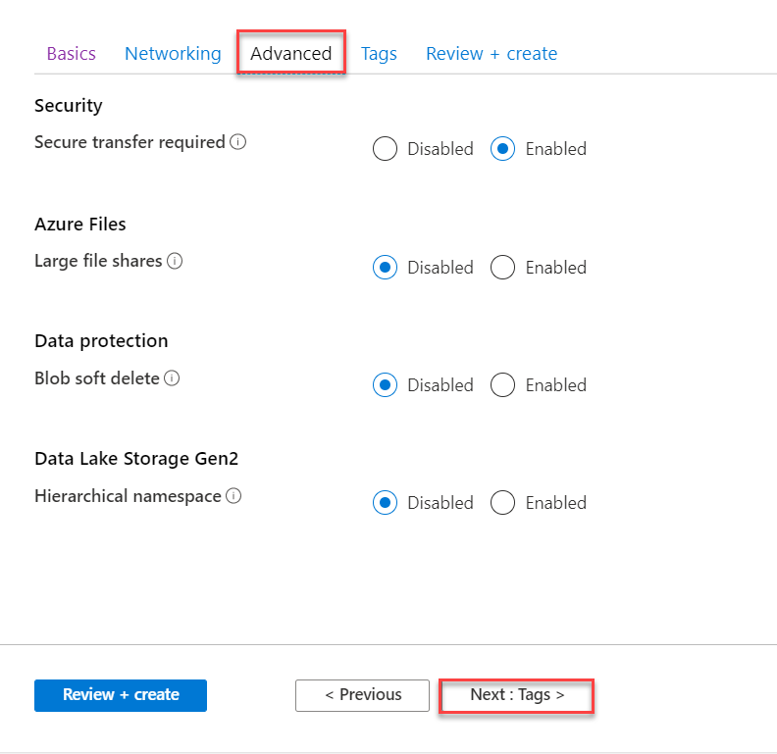

**Step 6: Tags** tab

Click on **Next: Review + Create** button

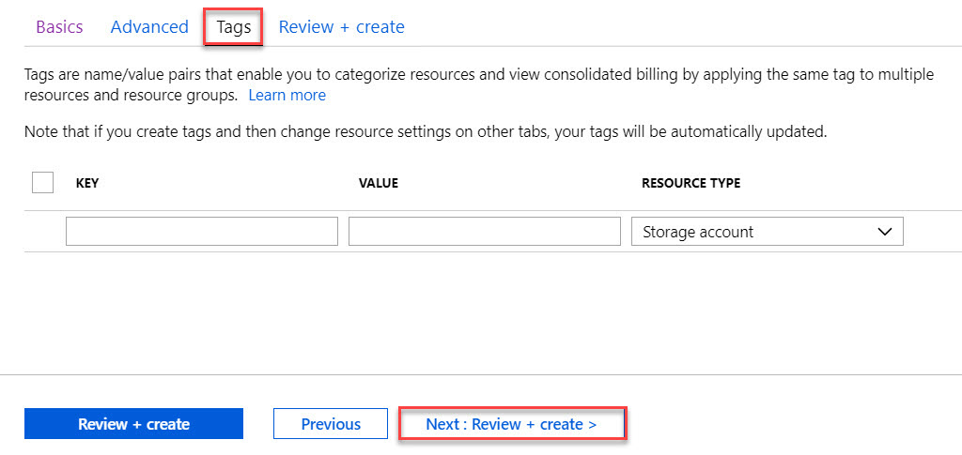

**Step 7:** Review + Create tab

Wait for validation passed and click on **Create** button.

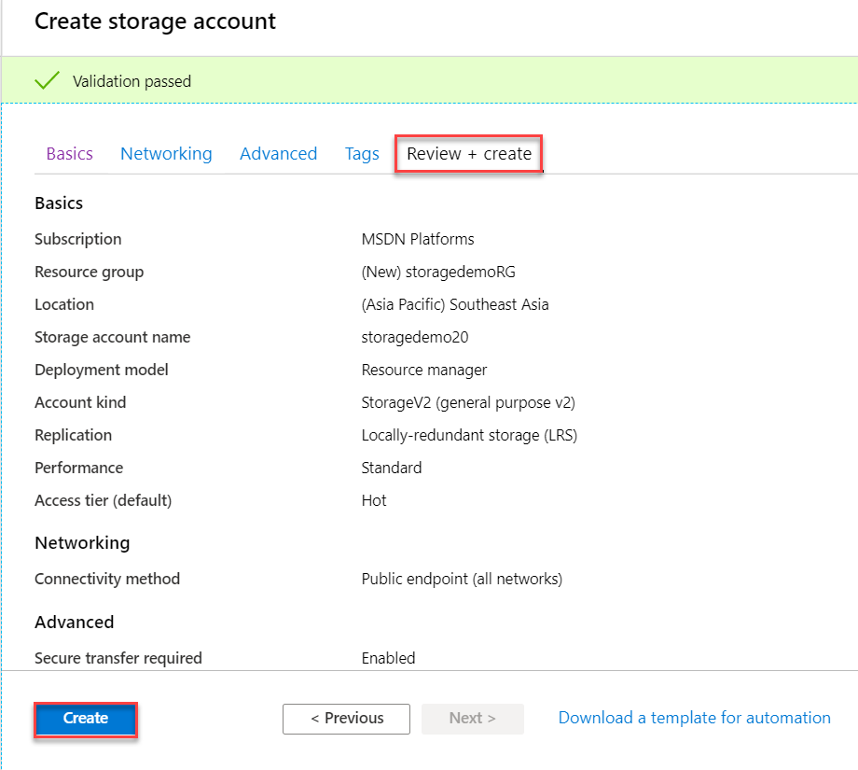

**Step 8:** Wait for few seconds to create storage account.

Click on **Go to resource** button.

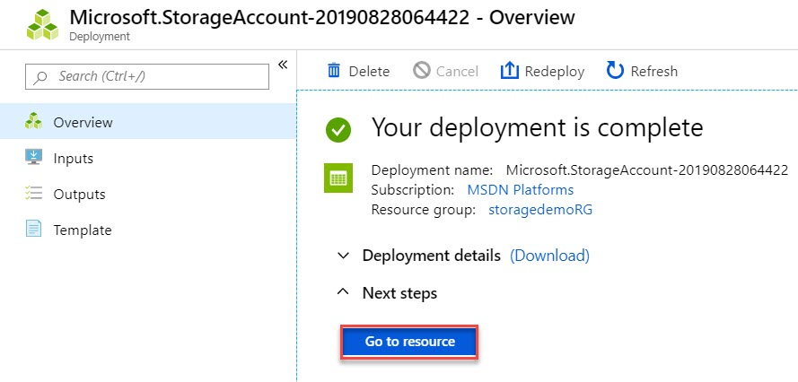

**Step 9:** Scroll down and navigate to **Blob Service** section. Click on **Containers**

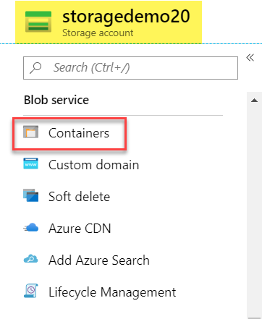

**Step 10:** Create New Container

Click on **+ Container** option

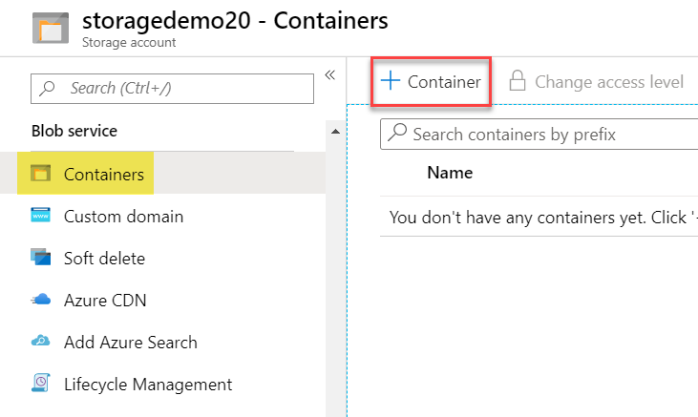

**Step 11:** Create container with Public access level

Name: **images**

Public access level: **Private (no anonymous access)**

Click on **OK** button.

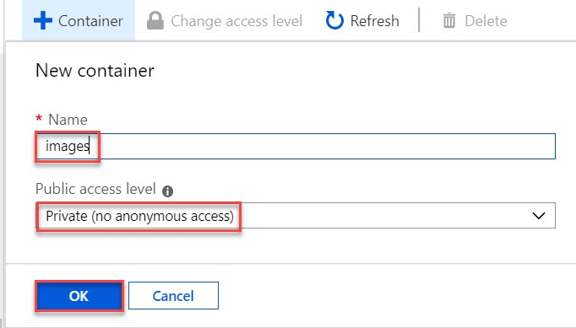

**Step 12:** Click on **Images** container

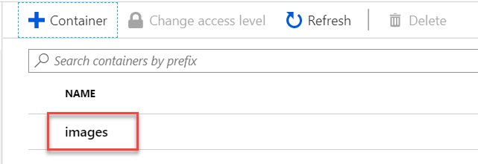

**Step 13:** Click on **Upload** button to upload Blob into storage account

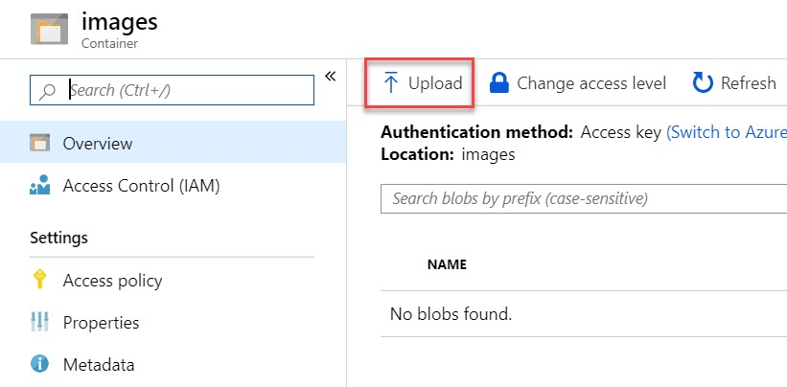

**Step 14:** Click on **Browse** option

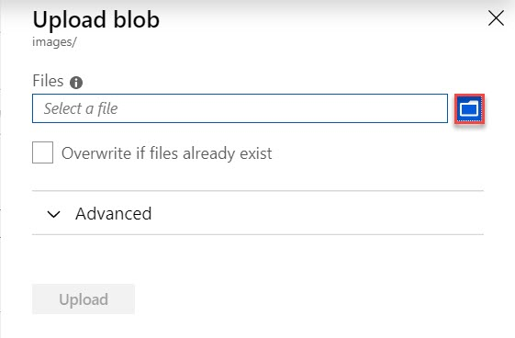

**Step 15:** Browse any image from local system or from internet.

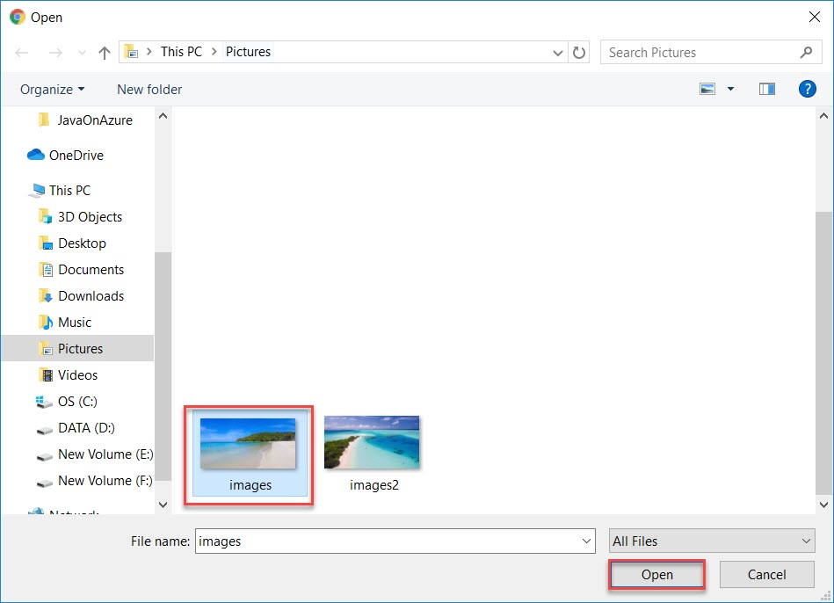

**Step 16:** Click on **Upload** button.

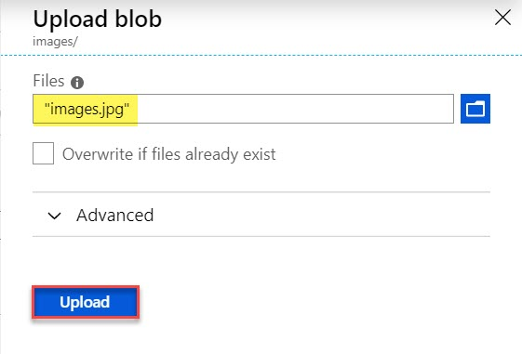

**Step 17:** Verify selected image successfully uploaded.

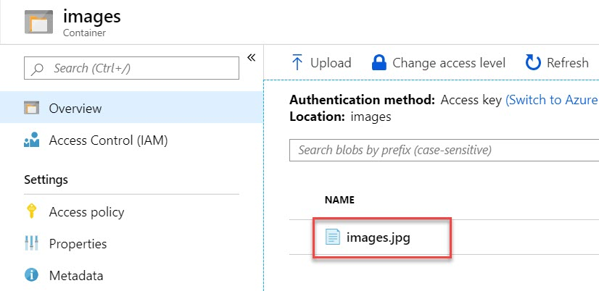

**Step 18:** Summary of Blob (images.jpg) will be there as below:

Click on **Copy** option

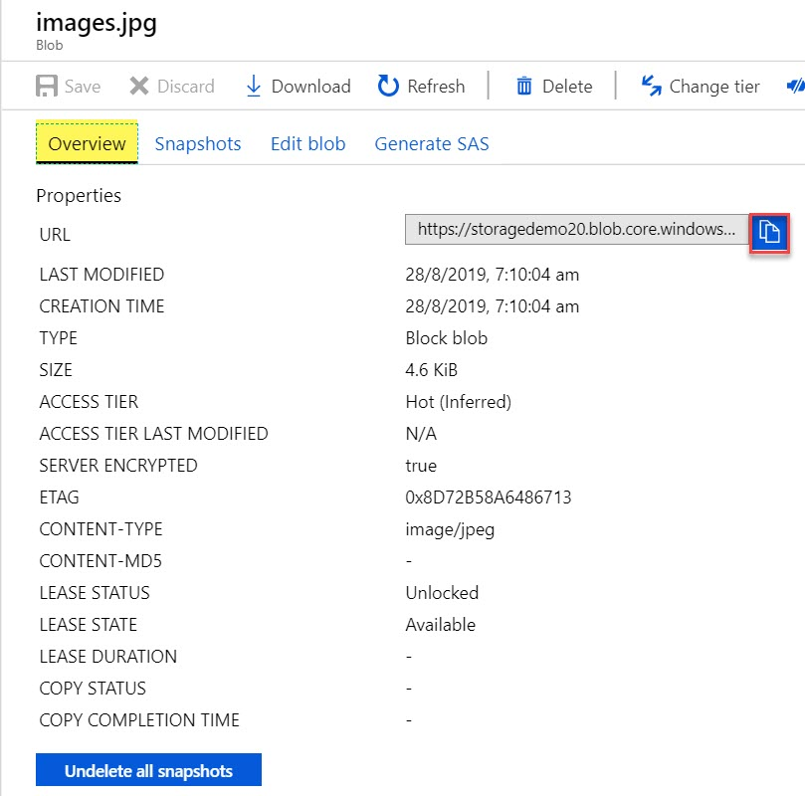

**Step 19:** Paste Blob URL into browser.

You will receive error because we have selected Private Container.

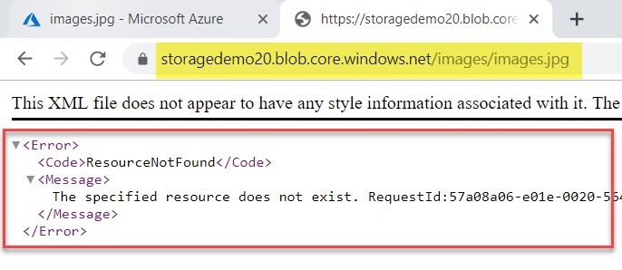

**Step 20:** Back to Container **settings**. Click on **Change access level** option

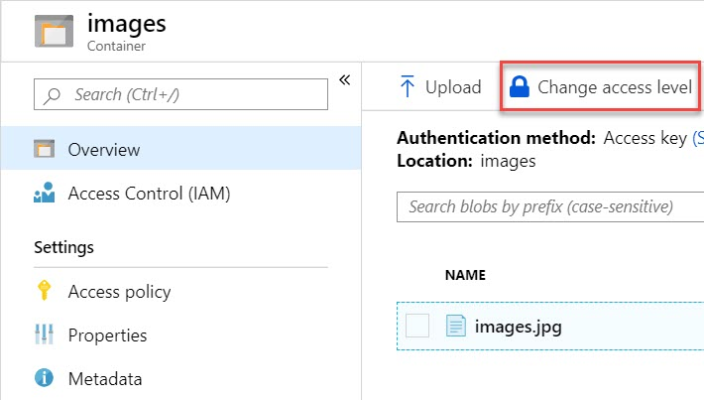

**Step 21:** Change **Private** to **Container** option and click on **OK** button.

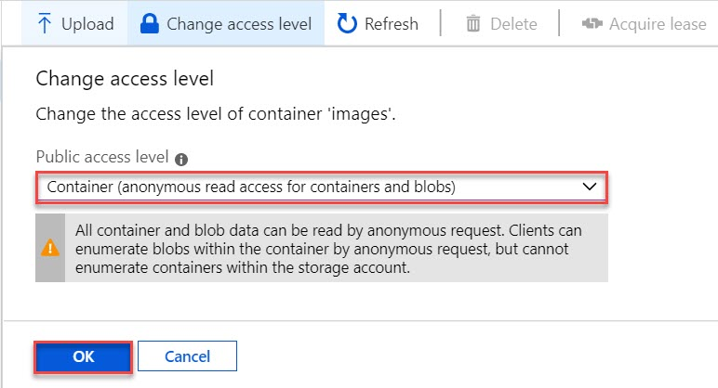

**Step 22:** Once again click on uploaded image file



**Step 23:** Refresh or paste one more time blob URL. Now you can see image is visible.

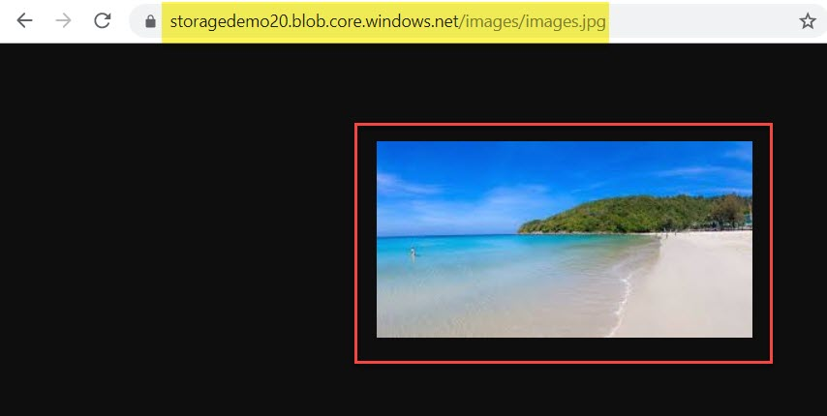

**Step 24:** To Download blob follow below Steps:

Click on **Download** option

